Supporting Information

Differential bumble bee gene expression associated with pathogen infection and pollen diet

Jonathan J. Giacomini^{1*}, Lynn S. Adler^{2a}, Benjamin J. Reading^{1b}, and Rebecca E. Irwin^{1c}

¹ Department of Applied Ecology, North Carolina State University, Raleigh, NC, 27695 USA
² Department of Biology, University of Massachusetts Amherst, Amherst, MA 01003 USA
*Corresponding author: Jonathan J. Giacomini, email: jjgiacom@ncsu.edu, ORCID: 0000-0002-0151-894X
ª ORCID: 0000-0003-2125-5582
^{b} ORCID: 0000-0002-0778-4069
^{c} ORCID: 0000-0002-1394-4946

Supplementary Text: Timing of sunflower pollen effect methods.

Experimental Design. The purpose of this experiment was to help determine the timing of the effect of sunflower pollen on Crithidia bombi infection within Bombus impatiens workers. The results were used in conjunction with another study (1) to determine when the abdomens of each experimental bee should be dissected for RNA sequencing. Worker bumble bees were hand-inoculated with a standardized dose of live Crithidia cells mixed into a sucrose solution and provided either sunflower pollen or control wildflower pollen (hereafter referred to as pollen type) for 24 hours, 48 hours, 72 hours, 96 hours or 168 hours (hereafter referred to as timing treatment). Each timing treatment corresponds to an amount of time in which a bee was allowed to consume pollen. For the remainder of the time (until 168 hours post-inoculation), a wildflower pollen mixture was provided to each bee. This protocol ensured that all bees were dissected on the same day, which allowed Crithidia infection intensity to reach representative levels within all bees for comparison.

Preparing pollen diets. We prepared two pollen diet treatments – sunflower and control wildflower. Honey bee-collected sunflower pollen pellets were obtained from Changge Hauding Wax Industry (China) and sorted by color to remove impurities. We verified a pure batch of sunflower pollen by staining five samples with basic fuschin dye (2) and visually confirming only sunflower pollen was present with a compound microscope at 400X magnification. Honey bee-collected mixed wildflower pollen pellets were obtained from Koppert Biological Systems (Howell, MI, USA) and microscopically confirmed to contain < 5% Asteraceae pollen, identified by having spines on the exine (3). Experimental pollen diets were provided to bees as a paste produced by mixing ground pollen pellets with distilled water to achieve a uniform consistency.

Inoculation methods. Three Bombus impatiens colonies were purchased from Koppert Biological Systems (Howell, MI, USA). We screened each colony for pre-existing Crithidia infection two days after receipt by dissecting five workers from each colony using previously established protocols (4–6). Colonies were fed with 30% sucrose solution and mixed wildflower pollen throughout their lifetimes and housed in a dark room at 21 – 24ºC and ~50% rh. We removed 36 workers from two of the colonies and 60 workers from the third colony (total = 132 workers). Each bee was placed into a 7-dram snap cap vial and allowed to rest on the lab bench for approximately 4 hours. This resting period starves the bees and helps facilitate consumption of the inoculum. During the starving period, we made Crithidia inoculum using an established protocol (4,6,7). Briefly, bee digestive tracts of 15 workers, excluding the honey crop, were removed with forceps, placed into 1.5 mL microcentrifuge tubes with 300 μL of distilled water, and ground with a pestle. We allowed each sample to rest at room temperature for 4-5 hours so that gut material settled and the Crithidia cells could ascend into the supernatant. Crithidia cells were counted from a 0.02 μL sample of supernatant per bee with a Neubauer hemacytometer under a compound light microscope at 400X magnification. We then mixed 150 μL of the supernatant with distilled water to achieve a concentration of 2400 cells μL⁻¹. The sample was then mixed with an equal volume of 50% sucrose solution to yield inoculum with 1200 cells μL⁻¹ in 25% sucrose. After the starving period, each bee was fed a 10 μL drop of a 25% sucrose solution that contained 1200 cells per μL (Total cells = 12,000). Consumption of the inoculum was visually confirmed for each bee. Each bee was randomly assigned to a pollen type (sunflower or wildflower pollen) and a timing treatment, then housed in a 7.6 cm x 12.7 cm plastic container with a mesh bottom for the remainder of the experiment. All bees were fed fresh sucrose and their respective pollen daily until dissection 168 hours post-inoculation.

Pollen Consumption. To ensure that all bees consumed pollen, the amount of daily pollen consumption (mg/day) was measured for each bee. On a day-by-day basis, bees that consumed pollen, as determined by a net positive amount of pollen consumption after accounting for evaporation, were randomly assigned to a time treatment (24 hours, 48 hours, 72 hours, or 96 hours) or allowed to continue on in the experiment until 168 hours post-inoculation. To estimate net pollen consumption, we produced a set of evaporation controls for each feeding day by including 10 bee containers alongside the experimental bees that contained 6 pollen feeders each (3 sunflower and 3 control wildflower) and a nectar feeder, but lacked a bee. We calculated evaporation-adjusted net consumption for each bee by fitting separate linear regressions for each day and pollen type, with initial weight of evaporation control pollen feeder regressed against the weight of the evaporation control pollen feeder 24-hr later. We then used the predict function in R to calculate an evaporation-adjusted feeder weight for feeders provided to each bee, yielding a net consumption estimate for each bee each day. Bees that did not consume pollen (net negative pollen consumption) at any point during their timing treatment were removed from the experiment. In other words, only bees that consumed a net positive amount of pollen for each day during their respective timing treatment were included in the final analysis. This method allowed us to infer effects of sunflower pollen consumption and avoid confounding effects of staggered or missing consumption throughout the treatment feeding period. We were unable to accurately estimate nectar consumption and thus excluded nectar consumption from the analysis.

Measuring parasite load. Each bee was dissected as in Inoculation methods, with the addition that all tools were washed with 70% ethanol and thoroughly dried between bees to prevent cross-contamination. Crithidia cells from a 0.02 μL sample of supernatant per bee were counted with a Neubauer hemacytometer at 400X magnification with a compound light microscope (4,6,7). We measured prevalence as the presence (1 or more Crithidia cells) or the absence of Crithidia cells per 0.02 μL of each sample, and Crithidia infection intensity as the number of flagellate Crithidia cells per 0.02 μL. We also removed the right forewing of each bee to measure marginal cell length, a proxy for bee size (8).

Statistical analyses. Statistical analyses were conducted using R version 4.0.2 (9). We used generalized linear models to analyze how pollen diets and timing treatments affected Crithidia infection prevalence and intensity. The Crithidia prevalence model was fit with a binomial distribution, and the infection intensity model was fit with a negative binomial distribution using the “MASS” package (10). Pollen type, timing treatment, and the interaction between pollen type and timing treatment were included as fixed effects in each model. Pairwise contrasts were evaluated separately for each combination of pollen type and timing treatment using the “emmeans” package (11). Due to low sample size (Table S4.11), we were unable to fit mixed-effect models with a random effect term for colony origin. In total, 45 sunflower-fed and 42 wildflower-fed bees were included in the analysis, which resulted in 5 to 13 bees per pollen type per timing treatment.

Timing of sunflower pollen effect results. We detected Crithidia infection in approximately 85% of bees fed control wildflower-fed throughout the entire experiment (168 hours post-inoculation; Figure S1a), indicating successful inoculation. In comparison, only 21% of sunflower-fed bees had detectable infection by the end of the experiment. A generalized linear model indicated a significant effect of pollen type on Crithidia prevalence (χ² = 14.101, df = 2, p = 0.001), but not the timing treatment or their interaction (χ² < 7.2, p > 0.2; df = 5 and 4, respectively). Pairwise contrasts indicated a significant difference in prevalence between sunflower pollen and control wildflower pollen for the timing treatments of 96 hours and 168 hours post-inoculation (t = -2.417, p = 0.018; t = -2.874, p = 0.005; respectively), but not 24 hours, 48 hours or 72 hours post-inoculation (t < 0.001, p > 0.999; for all). Similar to prevalence, infection intensity was greatest in bees fed control wildflower-fed bees throughout the entire experiment (168 hours post-inoculation; Figure S1b). The generalized linear model indicated a significant effect of pollen type and timing treatment on infection intensity (χ² > 30.549, p < 0.0001 for both; df = 1 and 4, respectively), but not their interaction (χ² = 0.993, df = 4, p = 0.911). Similar to prevalence, pairwise contrasts indicated a significant difference in infection intensity between sunflower pollen and control wildflower pollen at 96 hours and 168 hours post-inoculation (t = -2.890, p = 0.004; t = -3.979, p = 0.0001; respectively), but not at 24 hours, 48 hours or 72 hours post-inoculation (t < 0.004, p > 0.997; for all). Taken together, these results suggest that Crithidia growth within host bumble bees diverges due to diet between 72 and 96 hours post-inoculation.

Supplemental Figures and Tables
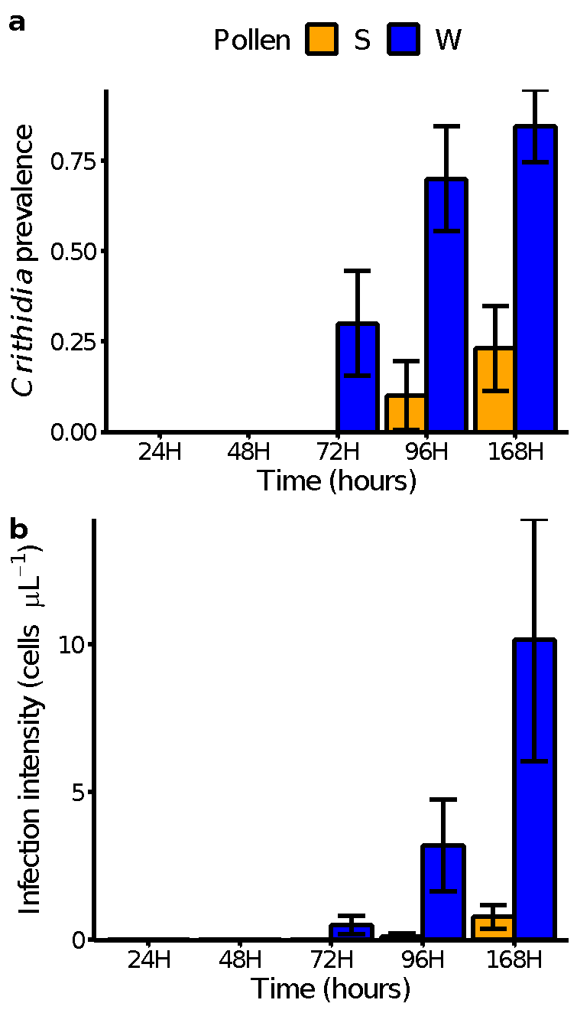
Figure S1. Mean proportion Bombus impatiens workers with detectable Crithidia bombi infection (a) and infection intensity (b). Bees were provided either sunflower pollen (S; orange bars) or control wildflower pollen (W; blue bars) for a period of 24, 48, 72, 96 or 168 hours (H) post-inoculation. Bars and error bars represent model adjusted means and one standard error, respectively.
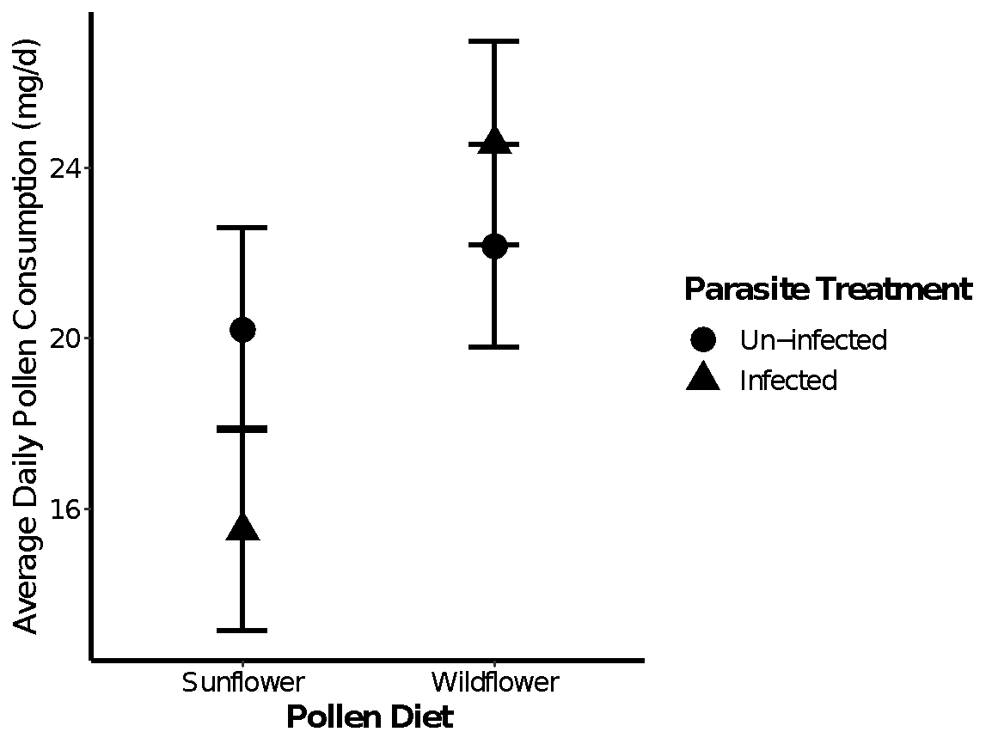
Figure S2. Average daily rate of sunflower or wildflower pollen consumption by Bombus impatiens workers either un-infected (circles) or infected with Crithidia bombi (triangles), and submitted for RNA sequencing. Points represent model adjusted means and errors bars 1 SE ± of the mean.

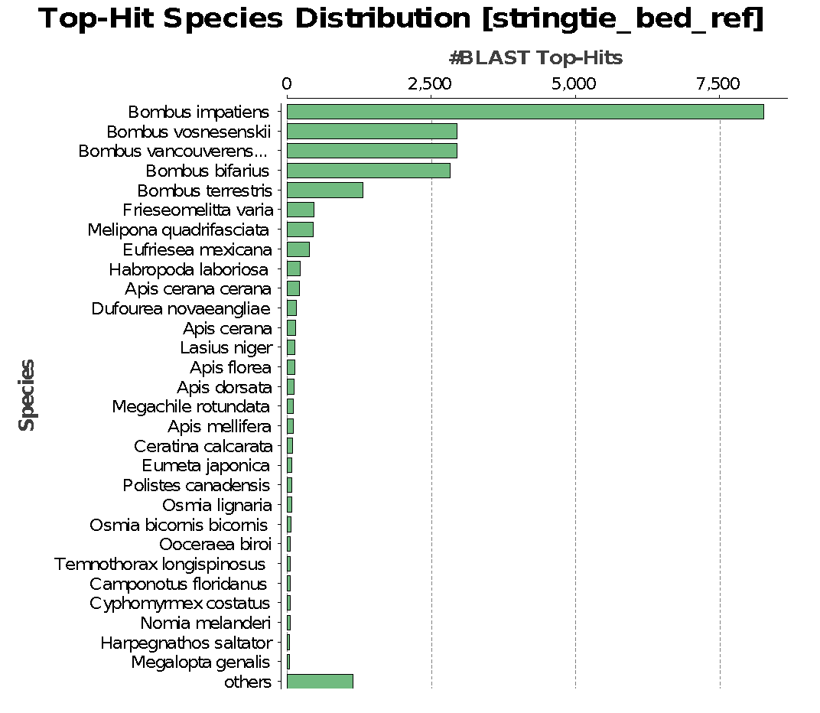
Figure S3. Species distribution of top BLAST hits from a blastx (OmicsBox) search using E-value of 10⁻²⁵ against all arthropod sequences in the NCBI non-redundant database, with the number of hits restricted to 20. Out of 17077 hits the greatest number of top BLAST hits were found in B. impatiens, with the top five being Bombus, thus giving us confidence in our RNA sequence read quality.

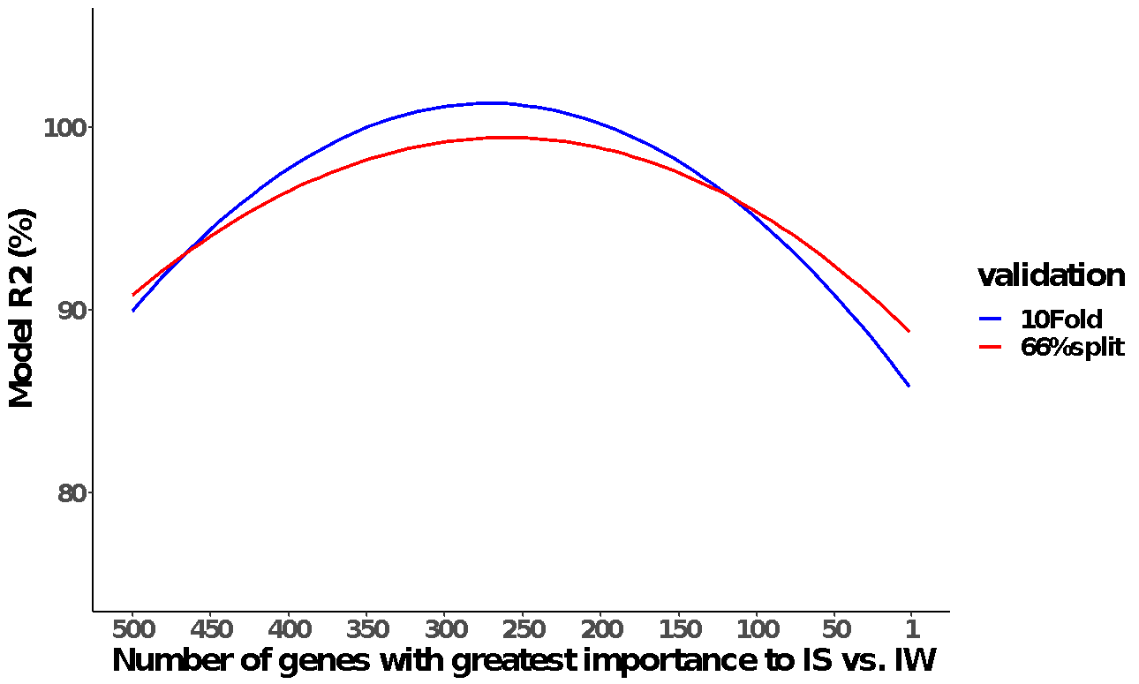
Figure S4. Machine learning model performance of support vector machine (SMO) ability to correctly classify pollen diet (sunflower (S) or wildflower (W)) based on transcriptomes of Bombus impatiens workers infected (I) with Crithidia bombi. Two cross-validation methods were used: 10-fold stratified hold-out (blue) and 66% percent split (red). Vertical dashed blue lines indicate convergence between both validation methods in the number of genes that produced greatest model performance. Genes were selected from the DESeq2 models that were differentially expressed based on an un-corrected p-value < 0.05 and ranked based on Shannon's entropy using the InfoGain attribute evaluator and Ranker search method.

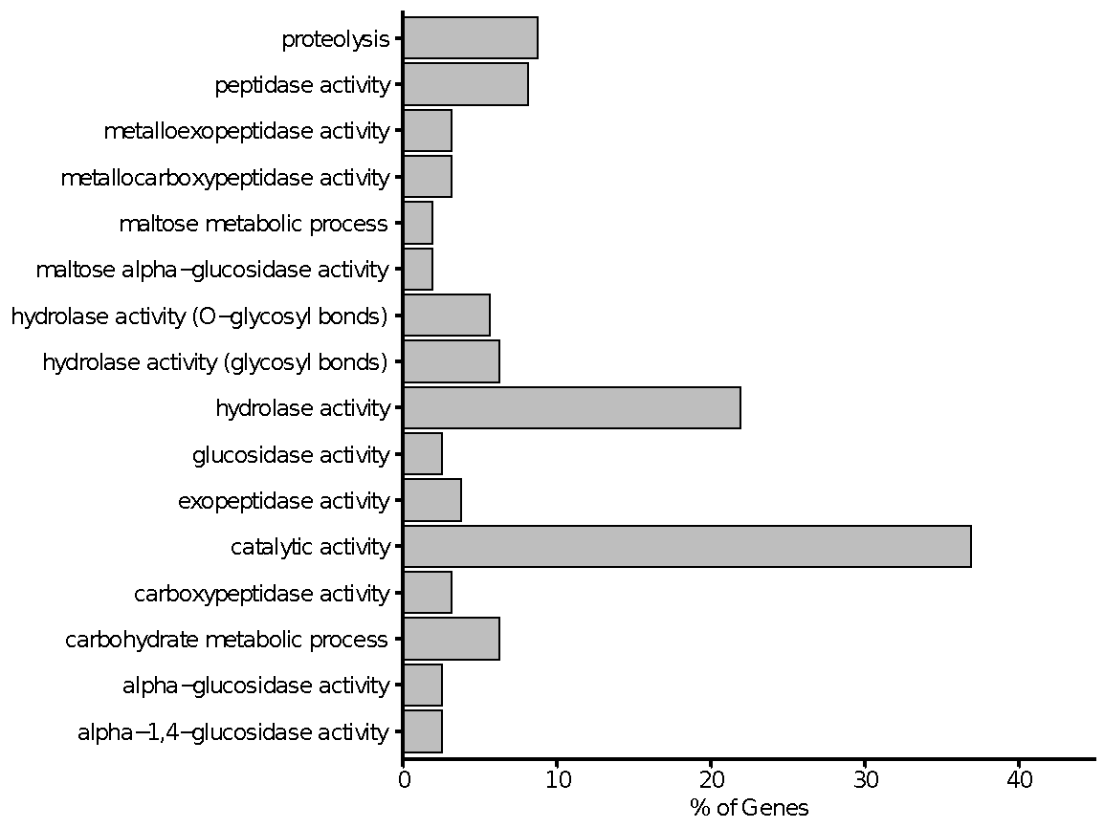
Figure S5. GO terms (biological processes and molecular activity) enriched in the machine learning DEG list for infected bees fed either sunflower or wildflower pollen. All terms are significant at an FDR < 0.05.

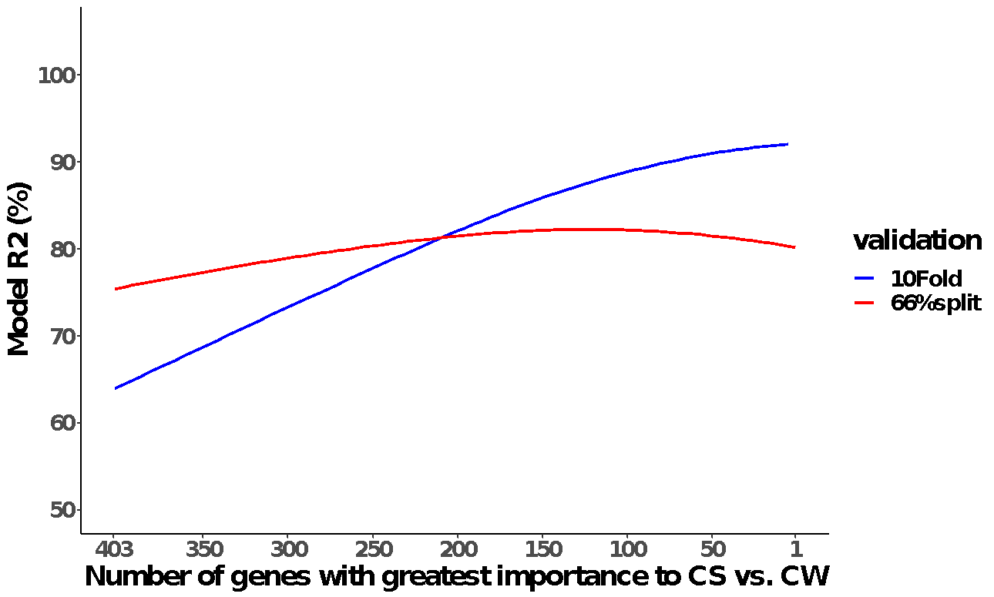
Figure S6. Machine learning model performance of support vector machine (SMO) ability to correctly classify pollen diet (sunflower (S) or wildflower (W)) based on transcriptomes of control (C) un-infected Bombus impatiens. Two cross-validation methods were used: 10-fold stratified hold-out (blue) and 66% percent split (red). Vertical dashed blue lines indicate convergence between both validation methods in the number of genes that produced greatest model performance. Genes were selected from the DESeq2 models that were differentially expressed based on an un-corrected p-value < 0.05 and ranked based on Shannon's entropy using the InfoGain attribute evaluator and Ranker search method.

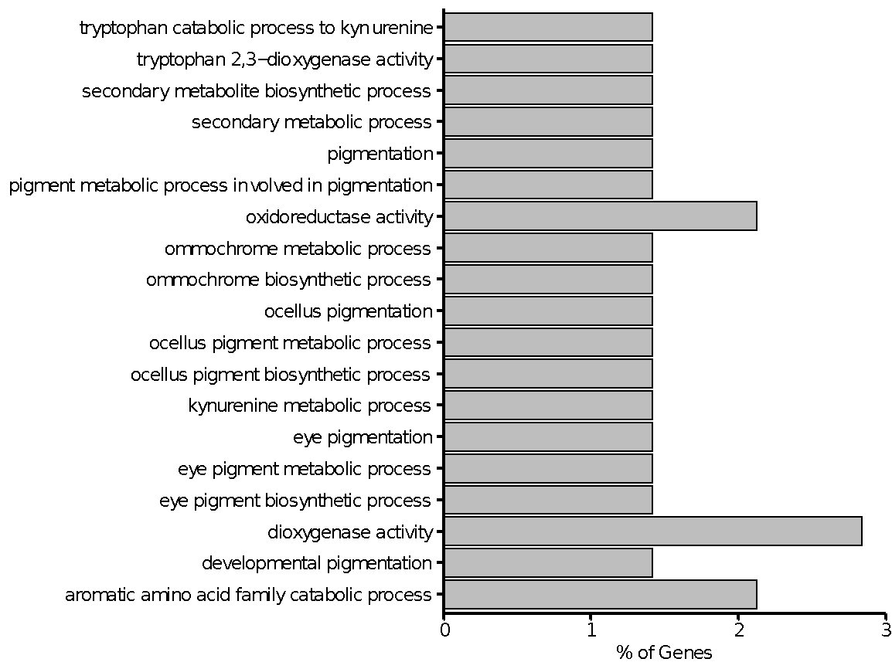Figure S7. GO terms (biological processes and molecular activity) enriched in the machine learning DEG list for un-infected bees fed either sunflower or wildflower pollen. All terms are significant at an FDR < 0.05.

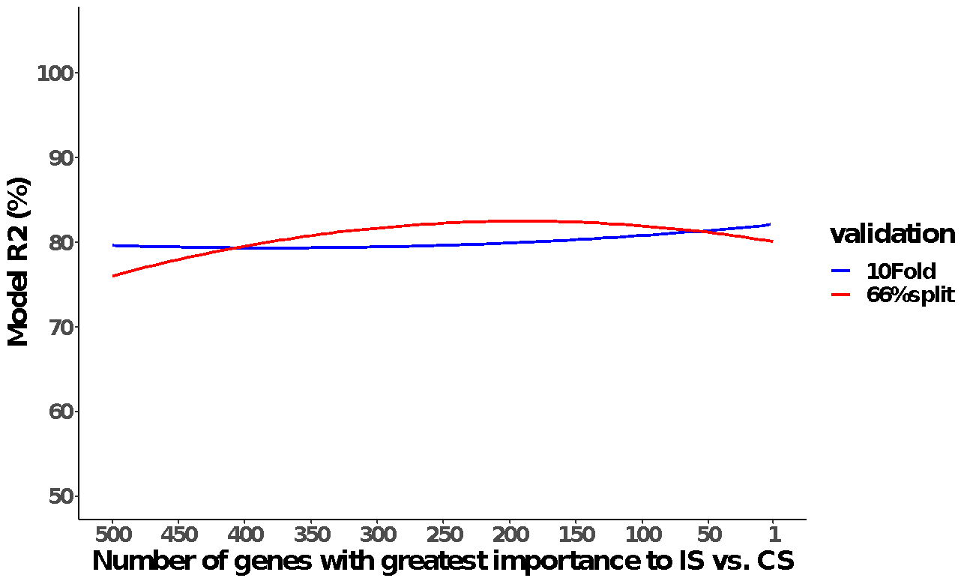
Figure S8. Machine learning model performance of support vector machine (SMO) ability to correctly classify infection treatment (inoculated with shame control (C) or Crithidia bombi (I)) based on transcriptomes of Bombus impatiens fed sunflower pollen (S). Two cross-validation methods were used: 10-fold stratified hold-out (blue) and 66% percent split (red). Genes were selected from the DESeq2 models that were differentially expressed based on an un-corrected p-value < 0.05 and ranked based on Shannon's entropy using the InfoGain attribute evaluator and Ranker search method.

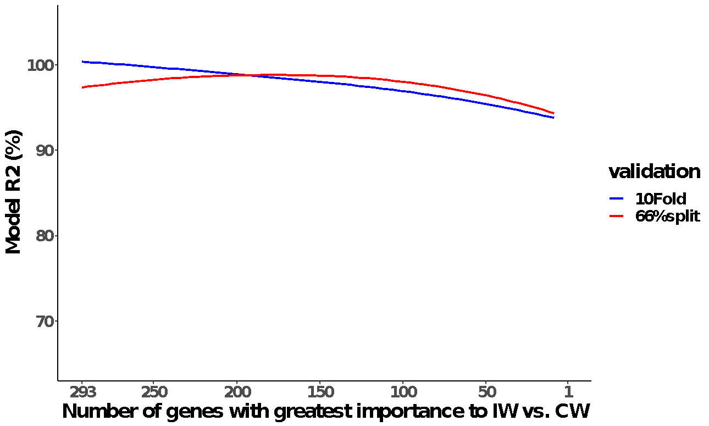
Figure S9. Machine learning model performance of support vector machine (SMO) ability to correctly classify infection treatment (inoculated with shame control (C) or Crithidia bombi (I)) based on transcriptomes of Bombus impatiens fed wildflower pollen (W). Two cross-validation methods were used: 10-fold stratified hold-out (blue) and 66% percent split (red). Vertical dashed blue lines indicate convergence between both validation methods in the number of genes that produced greatest model performance. Genes were selected from the DESeq2 models that were differentially expressed based on an un-corrected p-value < 0.05 and ranked based on Shannon's entropy using the InfoGain attribute evaluator and Ranker search method.

Table S1. Transcriptome assembly statistics for Bombus impatiens workers inoculated with either a sham control (C) or Crithidia bombi (I) and fed either sunflower pollen (S) or wildflower pollen (W). Clean reads were mapped to the B. impatiens genome (NCBI B. impatiens BIMP 2.2; GCA_000188095.4) with HiSat2 version 2.1.0.
Inf. | Pollen | Clean reads | Uniquely mapped reads | Uniquely mapped rate | Reads mapped >1 times | Mapped >1 time rate | Un-mapped reads | Un-mapped rate | Overall map rate
C | S | 23335668 | 21316818 | 91.35% | 275766 | 1.18% | 1743084 | 7.47% | 92.53%
C | S | 22280940 | 20208002 | 90.70% | 240041 | 1.08% | 1832897 | 8.23% | 91.77%
C | S | 20563334 | 17855936 | 86.83% | 232087 | 1.13% | 2475311 | 12.04% | 87.96%
C | S | 21876134 | 19955912 | 91.22% | 274382 | 1.25% | 1645840 | 7.52% | 92.48%
C | S | 50201346 | 46094685 | 91.82% | 569847 | 1.14% | 3536814 | 7.05% | 92.95%
I | S | 23857146 | 21456697 | 89.94% | 319383 | 1.34% | 2081066 | 8.72% | 91.28%
I | S | 21081260 | 19202098 | 91.09% | 255888 | 1.21% | 1623274 | 7.70% | 92.30%
I | S | 29145053 | 26418761 | 90.65% | 317152 | 1.09% | 2409140 | 8.27% | 91.73%
I | S | 60011808 | 54555874 | 90.91% | 697392 | 1.16% | 4758542 | 7.93% | 92.07%
I | S | 15836186 | 14128277 | 89.22% | 173275 | 1.09% | 1534634 | 9.69% | 90.31%
C | W | 16426934 | 14658243 | 89.23% | 158521 | 0.97% | 1610170 | 9.80% | 90.20%
C | W | 41982749 | 38203936 | 91.00% | 421431 | 1.00% | 3357382 | 8.00% | 92.00%
C | W | 19376962 | 17621534 | 90.94% | 234904 | 1.21% | 1520524 | 7.85% | 92.15%
C | W | 31979220 | 29143727 | 91.13% | 362991 | 1.14% | 2472502 | 7.73% | 92.27%
C | W | 19639797 | 17274582 | 87.96% | 241821 | 1.23% | 2123394 | 10.81% | 89.19%
I | W | 25383002 | 22830985 | 89.95% | 264720 | 1.04% | 2287297 | 9.01% | 90.99%
I | W | 20691247 | 18770572 | 90.72% | 253799 | 1.23% | 1666876 | 8.06% | 91.94%
I | W | 42245908 | 38187736 | 90.39% | 463582 | 1.10% | 3594590 | 8.51% | 91.49%
I | W | 13702311 | 12166254 | 88.79% | 150068 | 1.10% | 1385989 | 10.12% | 89.88%
I | W | 22198707 | 20172087 | 90.87% | 265959 | 1.20% | 1760661 | 7.93% | 92.07%
Mean |  | 27090786 | 24511136 | 90.23% | 308650 | 1.14% | 2270999 | 8.62% | 91.38%
Std. Dev. |  | 12255014 | 112651623 | 1.25% | 137170 | 0.09% | 891882 | 1.27% | 1.27%

Table S2. Differentially expressed genes between infected sunflower- and infected wildflower-fed bees based on the DESeq2 model (FDR < 0.05). Gene descriptions based on top BLAST hits (E-value of 10⁻²⁵) against all arthropod sequences in the NCBI non-redundant database.
StringTie ID | Fold Change (log2) | FDR | Description
MSTRG.21535 | 4.8157 | 0.0270 | hymenoptaecin
MSTRG.20285 | -2.4744 | 0.0355 | prohormone-3
MSTRG.11358 | 21.2532 | 0.0000 | glutamate receptor 3.2-like
MSTRG.8149 | 30.1294 | 0.0000 | uncharacterized protein LOC117204693
MSTRG.3654 | -2.0130 | 0.0153 | PREDICTED: uncharacterized protein LOC105662916
MSTRG.14101 | 5.9837 | 0.0380 | uncharacterized protein LOC117233211 isoform X8
MSTRG.8725 | -1.4158 | 0.0380 | uncharacterized protein LOC100748164 isoform X3
MSTRG.9723 | 3.9849 | 0.0380 | uncharacterized protein LOC100749322 isoform X2
MSTRG.3174 | 6.5770 | 0.0153 | cytochrome P450 9e2-like
MSTRG.11066 | 11.4536 | 0.0017 | probable endochitinase
MSTRG.5278 | -1.8675 | 0.0425 | TWiK family of potassium channels protein 7
MSTRG.14467 | 44.3295 | 0.0000 | RNaN-directed DNaN polymerase from mobile element jockey-like
MSTRG.7865 | -36.7045 | 0.0000 | ejaculatory bulb-specific protein 3-like
MSTRG.19478 | 25.1746 | 0.0000 | glucose dehydrogeNaNse [FAD, quinone]-like
MSTRG.11147 | 8.0354 | 0.0000 | alkaline phosphatase 4-like
MSTRG.12016 | 4.7762 | 0.0110 | maltase A2 isoform X1
MSTRG.6331 | -1.5704 | 0.0189 | enzymatic polyprotein endonuclease reverse
MSTRG.16362 | 1.2463 | 0.0355 | putative inorganic phosphate cotransporter
MSTRG.19383 | 23.0473 | 0.0078 | digestive cysteine proteinase 1
MSTRG.872 | -2.8824 | 0.0001 | piggyBac transposable element-derived protein 4-like
LOC105680309 | 24.8898 | 0.0023 | probable ATP-dependent RNA helicase DDX46
MSTRG.8718 | 6.6666 | 0.0056 | TM2 domain-containing protein
MSTRG.18222 | 0.8339 | 0.0149 | nicastrin isoform X2
MSTRG.20614 | 5.8225 | 0.0149 | mitochondrial potassium channel ATP-binding subunit
MSTRG.14747 | 9.4394 | 0.0153 | beta-1,4-glucuronyltransferase 1
MSTRG.4550 | -1.0866 | 0.0190 | ATP-binding cassette sub-family G member 1
MSTRG.8519 | 7.3143 | 0.0223 | oxidation resistance protein 1 isoform X9
MSTRG.8539 | 6.8131 | 0.0355 | NPC intracellular cholesterol transporter 2-like
MSTRG.8520 | 5.1741 | 0.0452 | oxidation resistance protein 1 isoform X6
MSTRG.18428 | 0.6567 | 0.0467 | cholinephosphotransferase 1 isoform X3
MSTRG.9363 | -1.4573 | 0.0467 | carbohydrate sulfotransferase 11
MSTRG.362 | 46.4711 | 0.0000 | NaN
MSTRG.12884 | 29.4999 | 0.0000 | NaN
MSTRG.996 | 15.2676 | 0.0002 | NaN
MSTRG.2541 | -3.2737 | 0.0153 | NaN
MSTRG.3872 | 5.8753 | 0.0153 | serine protease inhibitor dipetalogastin
MSTRG.21434 | 5.1708 | 0.0212 | NaN
MSTRG.16497 | 21.2627 | 0.0256 | hypothetical protein ALC62_09346
MSTRG.20557 | 4.8864 | 0.0380 | NaN
MSTRG.7729 | -1.2714 | 0.0425 | NaN
NaN = no available annotation.

Table S3. Top-ranked 160 genes that differentiate infected sunflower- and infected wildflower-fed bees based on a 100% correct classification rate using Machine Learning. A subset of genes from the DESeq2 model with an uncorrected p-value < 0.05 were ranked (Rank) based on information gain with respect to the treatment using the InfoGain attribute evaluator and Ranker search method in Weka. Gene descriptions based on top BLAST hits (E-value of 10⁻²⁵) against all arthropod sequences in the NCBI non-redundant database.
StringTie ID | Fold Change (log2) | FDR | Rank | Description
MSTRG.8520 | 5.1741 | 0.0452 | 1 | oxidation resistance protein 1 isoform X6
MSTRG.11543 | 2.2353 | 0.3857 | 2 | cyclin-A2
MSTRG.5752 | -1.1313 | 0.3471 | 3 | ABC transporter G family member 23
MSTRG.13004 | -1.2471 | 0.2864 | 4 | flexible cuticle protein 12-like
MSTRG.14101 | 5.9837 | 0.0380 | 5 | uncharacterized protein LOC117233211 isoform X8
LOC105681892 | -1.4653 | 0.3503 | 6 | uncharacterized protein LOC117233964 isoform X1
MSTRG.11112 | -2.6979 | 0.1358 | 7 | endocuticle structural glycoprotein SgAbd-4-like
MSTRG.9141 | 1.8054 | 0.3051 | 8 | solute carrier organic anion transporter family member 1A5 isoform X3
MSTRG.5223 | -2.3864 | 0.3477 | 9 | NaN
MSTRG.8539 | 6.8131 | 0.0355 | 10 | NPC intracellular cholesterol transporter 2-like
MSTRG.1888 | 2.9456 | 0.3657 | 11 | thioredoxin reductase 1, mitochondrial isoform X3
MSTRG.15603 | -1.8601 | 0.1575 | 12 | probable serine/threonine-protein kinase samkC isoform X3
MSTRG.2194 | 3.7519 | 0.2785 | 13 | NaN
MSTRG.10445 | 1.6140 | 0.3948 | 14 | Neuropilin and tolloid-like protein 1
MSTRG.20639 | 4.9580 | 0.2468 | 15 | transmembrane protease serine 9-like
MSTRG.15194 | 2.8636 | 0.1990 | 16 | putative inhibitor of apoptosis isoform X2
MSTRG.5323 | -1.0620 | 0.1990 | 17 | Nose resistant to fluoxetine protein 6
MSTRG.7877 | 2.1562 | 0.2441 | 18 | peptide transporter family 1 isoform X2
MSTRG.3173 | 2.3805 | 0.0763 | 19 | cytochrome P450 9e2-like
MSTRG.1167 | 4.0506 | 0.2864 | 20 | homeobox protein ARX-like
MSTRG.20082 | 2.3136 | 0.2740 | 21 | protein regulator of cytokinesis 1-like
MSTRG.11252 | 2.7142 | 0.2984 | 22 | protein spaetzle 4
MSTRG.5775 | 1.7092 | 0.3560 | 23 | max dimerization protein 1 isoform X2
MSTRG.6180 | 5.1841 | 0.1805 | 24 | aminopeptidase N
MSTRG.10178 | 4.3293 | 0.2409 | 25 | farnesol dehydrogenase-like
MSTRG.328 | 0.9206 | 0.4595 | 26 | cytochrome P450 9e2-like
MSTRG.10176 | 3.2853 | 0.1679 | 27 | farnesol dehydrogenase-like
MSTRG.11845 | 2.4372 | 0.4031 | 28 | probable multidrug resistance-associated protein lethal(2)03659
MSTRG.7691 | 2.0235 | 0.4729 | 29 | NaN
MSTRG.3174 | 6.5770 | 0.0153 | 30 | cytochrome P450 9e2-like
MSTRG.10693 | 3.1739 | 0.2740 | 31 | Coiled-coil domain-containing protein 13
MSTRG.5531 | -1.8260 | 0.4651 | 32 | uncharacterized protein LOC105189360 isoform X1
MSTRG.128 | 1.6859 | 0.4363 | 33 | NaN
MSTRG.7209 | 2.3821 | 0.2639 | 34 | spectrin beta chain, non-erythrocytic 2 isoform X4
MSTRG.20055 | 4.6991 | 0.2162 | 35 | Alpha-amylase 4N
MSTRG.4011 | 1.8716 | 0.4755 | 36 | sporozoite surface protein 2-like
MSTRG.3529 | -2.0199 | 0.4250 | 37 | homeobox protein rough
MSTRG.18721 | 2.7970 | 0.4063 | 38 | Haloacid dehalogenase-like hydrolase domain-containing protein 2
MSTRG.16555 | 2.3924 | 0.4287 | 39 | NaN
MSTRG.20058 | 5.3531 | 0.2616 | 40 | Alpha-amylase-related protein
MSTRG.15815 | 1.3312 | 0.4646 | 41 | E3 ubiquitin-protein ligase MARCH5 isoform X1
MSTRG.1625 | 4.3249 | 0.2785 | 42 | chymotrypsin-1
MSTRG.18320 | 4.3598 | 0.3620 | 43 | maltase 2-like
MSTRG.8221 | 2.6658 | 0.0817 | 44 | probable ATP-dependent RNA helicase DDX28
MSTRG.10703 | 4.9882 | 0.2409 | 45 | facilitated trehalose transporter Tret1-like
MSTRG.13224 | 1.8790 | 0.4421 | 46 | aconitate hydratase, mitochondrial
MSTRG.9658 | 1.9252 | 0.3182 | 47 | E3 ubiquitin-protein ligase MIB2
MSTRG.13228 | 2.0740 | 0.2312 | 48 | piggyBac transposable element-derived protein 4-like
MSTRG.13229 | 3.0219 | 0.2740 | 49 | NaN
MSTRG.14832 | -1.2801 | 0.2035 | 50 | NaN
MSTRG.17560 | 3.0003 | 0.1791 | 51 | NaN
MSTRG.2166 | 1.5898 | 0.4171 | 52 | uncharacterized protein LOC100740206
LOC100742005 | -3.0339 | 0.1232 | 53 | cytoplasmic dynein 2 heavy chain 1
MSTRG.5369 | -1.8027 | 0.3725 | 54 | NaN
SWRh | 5.4940 | 0.4250 | 55 | opsin, ultraviolet-sensitive
MSTRG.8521 | 5.9837 | 0.1550 | 56 | oxidation resistance protein 1 isoform X7
MSTRG.9087 | 2.8125 | 0.1861 | 57 | uncharacterized protein LOC100740339 isoform X3
MSTRG.19203 | 1.2584 | 0.2188 | 58 | transmembrane protein KIAA1109 isoform X4
MSTRG.7899 | 2.1301 | 0.3739 | 59 | actin-5C
MSTRG.17374 | 4.0633 | 0.2785 | 60 | zinc carboxypeptidase-like
MSTRG.16597 | 1.6762 | 0.3899 | 61 | nucleolysin TIAR
MSTRG.12194 | 5.5899 | 0.0699 | 62 | uncharacterized threonine-rich GPI-anchored glycoprotein PJ4664.02-like
MSTRG.2280 | -3.3144 | 0.1371 | 63 | hypothetical protein WH47_09040
LOC105681602 | 2.4282 | 0.2434 | 64 | balbiani ring protein 3-like
MSTRG.1889 | 1.9904 | 0.4500 | 65 | thioredoxin reductase 1, mitochondrial isoform X2
MSTRG.20788 | 1.5486 | 0.3310 | 66 | uncharacterized protein LOC117161787
MSTRG.14270 | 0.7698 | 0.4488 | 67 | ADP-ribosylation factor 1
MSTRG.13139 | 2.7488 | 0.1812 | 68 | 39S ribosomal protein S30, mitochondrial
MSTRG.1623 | 4.1955 | 0.2441 | 69 | NaN
MSTRG.3881 | 3.4611 | 0.4590 | 70 | Alpha-mannosidase 2
MSTRG.5154 | 1.5403 | 0.4031 | 71 | ATP synthase subunit alpha, mitochondrial
MSTRG.5150 | 3.2674 | 0.2125 | 72 | ubiquitin carboxyl-terminal hydrolase 14
MSTRG.11968 | 4.2689 | 0.3222 | 73 | maltase 1
MSTRG.10179 | 2.8962 | 0.2149 | 74 | farnesol dehydrogenase-like
MSTRG.4519 | 4.0014 | 0.0852 | 75 | protein FAM151B isoform X2
MSTRG.11969 | 4.5654 | 0.2740 | 76 | maltase 1
MSTRG.2068 | 3.4386 | 0.4076 | 77 | partitioning defective 3 homolog isoform X3
MSTRG.11965 | 6.5062 | 0.1150 | 78 | alpha-glucosidase-like isoform X1
MSTRG.15256 | 1.3959 | 0.3208 | 79 | NaN
MSTRG.4704 | 3.9405 | 0.1679 | 80 | Zinc finger CCHC domain-containing protein 9
MSTRG.8718 | 6.6666 | 0.0056 | 81 | TM2 domain-containing protein
MSTRG.825 | 1.8657 | 0.3894 | 82 | Catenin alpha
MSTRG.11065 | 2.8331 | 0.0699 | 83 | probable WRKY transcription factor protein 1
MSTRG.15789 | 2.7328 | 0.2526 | 84 | protein angel
MSTRG.8955 | 3.4081 | 0.4514 | 85 | SET and MYND domain-containing protein 4-like
MSTRG.8369 | 2.4431 | 0.2468 | 86 | Proteasome subunit alpha type-4
MSTRG.10733 | 2.4446 | 0.4262 | 87 | hexosaminidase D-like
MSTRG.8362 | 3.0582 | 0.3822 | 88 | tRNA modification GTPase GTPBP3, mitochondrial
MSTRG.4863 | -1.4910 | 0.2188 | 89 | Myosin light chain alkali
MSTRG.17373 | 4.8870 | 0.1358 | 90 | zinc carboxypeptidase-like
MSTRG.10731 | -1.0858 | 0.3083 | 91 | F-box/LRR-repeat protein 2 isoform X1
MSTRG.19715 | 3.0427 | 0.3003 | 92 | farnesol dehydrogenase-like
MSTRG.4264 | -2.3357 | 0.3619 | 93 | hypothetical protein WN51_00414
MSTRG.21292 | 3.7904 | 0.1813 | 94 | UDP-glucuronosyltransferase 2B17-like
MSTRG.3872 | 5.8753 | 0.0153 | 95 | serine protease inhibitor dipetalogastin
MSTRG.12016 | 4.7762 | 0.0110 | 96 | maltase A2 isoform X1
MSTRG.14663 | -3.9664 | 0.4147 | 97 | Polypyrimidine tract-binding protein 2
MSTRG.8913 | 2.9344 | 0.1659 | 98 | RRP12-like protein
MSTRG.2534 | 1.5899 | 0.3476 | 99 | RNA-directed DNA polymerase from mobile element jockey
MSTRG.9637 | 3.2075 | 0.1812 | 100 | lysosomal aspartic protease
MSTRG.17231 | 1.0199 | 0.2713 | 101 | uridine diphosphate glucose pyrophosphatase
MSTRG.19349 | 2.6199 | 0.3857 | 102 | Dopamine N-acetyltransferase
MSTRG.413 | 3.6691 | 0.2795 | 103 | adenylate cyclase type 2 isoform X2
MSTRG.14772 | 4.7662 | 0.3075 | 104 | NaN
MSTRG.20638 | 8.2439 | 0.0763 | 105 | transmembrane protease serine 9-like
MSTRG.4575 | 3.2980 | 0.1288 | 106 | NaN
MSTRG.16410 | 1.2762 | 0.4180 | 107 | uncharacterized protein LOC100747659 isoform X4
MSTRG.75 | -1.5967 | 0.4352 | 108 | insulin-like peptide receptor isoform X1
MSTRG.14907 | 2.4632 | 0.1679 | 109 | NaN
MSTRG.16918 | 1.7859 | 0.4312 | 110 | E3 ubiquitin-protein ligase AMFR-like
MSTRG.17464 | 1.0745 | 0.4590 | 111 | uncharacterized protein LOC117162246
MSTRG.13552 | 4.6985 | 0.3332 | 112 | protein mesh isoform X1
MSTRG.5826 | 1.6990 | 0.3136 | 113 | NaN
MSTRG.9723 | 3.9849 | 0.0380 | 114 | uncharacterized protein LOC100749322 isoform X2
MSTRG.13589 | 1.7596 | 0.2856 | 115 | NaN
MSTRG.7600 | -2.8205 | 0.4100 | 116 | NaN
MSTRG.14601 | 1.9655 | 0.2911 | 117 | NaN
MSTRG.13252 | 5.0504 | 0.2800 | 118 | carboxypeptidase B-like
MSTRG.502 | 1.2860 | 0.4500 | 119 | tyrosine-protein phosphatase non-receptor type 2 isoform X2
MSTRG.3516 | 2.6846 | 0.4408 | 120 | NaN
MSTRG.9055 | -2.0090 | 0.4100 | 121 | NaN
MSTRG.1626 | 5.5920 | 0.0852 | 122 | chymotrypsin-1
LOC105681186 | 2.8943 | 0.2785 | 123 | G-protein coupled receptor Mth2-like
MSTRG.8482 | 4.7322 | 0.3452 | 124 | chitinase-3-like protein 1
MSTRG.890 | 4.8198 | 0.3112 | 125 | trypsin-1 isoform X1
MSTRG.1577 | 2.0329 | 0.2468 | 126 | uncharacterized protein LOC117241145 isoform X2
MSTRG.8481 | 6.3376 | 0.3657 | 127 | chitinase-3-like protein 1
MSTRG.3866 | 2.2856 | 0.3012 | 128 | dnaJ homolog subfamily C member 11
MSTRG.16385 | 2.0737 | 0.4683 | 129 | NaN
MSTRG.11414 | 4.8044 | 0.4702 | 130 | NaN
MSTRG.20549 | 3.5421 | 0.2820 | 131 | NaN
MSTRG.5529 | 1.6367 | 0.3343 | 132 | uncharacterized protein LOC102671994
MSTRG.19259 | -1.2239 | 0.2964 | 133 | Retrovirus-related Pol polyprotein from transposon 17.6
MSTRG.8211 | 1.9139 | 0.3081 | 134 | kxDL motif-containing protein CG10681
MSTRG.12622 | 1.6176 | 0.4646 | 135 | NaN
MSTRG.695 | -3.7479 | 0.3051 | 136 | NaN
MSTRG.9636 | 3.3960 | 0.3332 | 137 | lysosomal aspartic protease
MSTRG.10504 | 1.9854 | 0.3551 | 138 | NaN
MSTRG.9634 | 4.2748 | 0.0577 | 139 | NaN
MSTRG.14366 | 1.2306 | 0.4514 | 140 | FACT complex subunit spt16 isoform X2
MSTRG.9870 | 3.8966 | 0.2280 | 141 | cGMP-dependent protein kinase 1-like
MSTRG.6877 | 1.1398 | 0.2666 | 142 | cholinesterase isoform X1
MSTRG.1099 | 4.3402 | 0.1581 | 143 | NaN
MSTRG.14600 | 1.0146 | 0.3973 | 144 | NaN
MSTRG.102 | 2.1415 | 0.3042 | 145 | V-type proton ATPase subunit D
MSTRG.18165 | 2.2897 | 0.3267 | 146 | uncharacterized protein LOC117152339
MSTRG.20647 | -2.2205 | 0.4423 | 147 | NaN
MSTRG.424 | -1.6504 | 0.4512 | 148 | probable cytochrome P450 305a1
MSTRG.1730 | 1.9570 | 0.4259 | 149 | NaN
MSTRG.9255 | 2.1475 | 0.2964 | 150 | carbonyl reductase [NADPH] 1-like
MSTRG.19626 | 5.0703 | 0.1328 | 151 | facilitated trehalose transporter Tret1 isoform X2
MSTRG.18876 | 3.2078 | 0.4399 | 152 | meiosis regulator and mRNA stability factor 1 isoform X7
MSTRG.1938 | -2.6216 | 0.0862 | 153 | circadian clock-controlled protein
MSTRG.4646 | 1.7799 | 0.3437 | 154 | NaN
MSTRG.889 | 4.6928 | 0.2468 | 155 | trypsin-3
MSTRG.15486 | 1.7693 | 0.3940 | 156 | alanine--glyoxylate aminotransferase 2-like
MSTRG.9453 | 1.8858 | 0.4648 | 157 | complement component 1 Q subcomponent-binding protein, mitochondrial
MSTRG.20877 | -2.5394 | 0.2358 | 158 | mitotic apparatus protein p62
MSTRG.5302 | 2.5046 | 0.3442 | 159 | 40S ribosomal protein S17
MSTRG.4742 | -2.0975 | 0.4040 | 160 | sodium- and chloride-dependent GABA transporter 2-like
NaN = no available annotation.

Table S4. Enrichment of canonical metabolic and signaling pathways identified by Qiagen’s IPA for pairwise treatment comparisons using the machine learning DEG lists. Bombus impatiens workers were inoculated with either a sham control (Uninfected) or Crithidia bombi (Infected) and fed either sunflower or wildflower pollen. Numeric values indicate log(p-value) for each gene set and a canonical pathway and red indicates significant enrichment based on a p-value of overlap calculated using a right-tailed Fisher’s Exact Test.
Canonical Pathways | Wildflower: Infected vs. Uninfected | Infected: Sunflower vs. Wildflower | Uninfected: Sunflower vs. Wildflower
NRF2-mediated Oxidative Stress Response | 1.297 | 6.668 | 1.638
SPINK1 Pancreatic Cancer Pathway | 0.000 | 5.571 | 0.000
LPS/IL-1 Mediated Inhibition of RXR Function | 1.235 | 2.599 | 1.547
Estrogen Biosynthesis | 0.000 | 4.311 | 0.880
Epithelial Adherens Junction Signaling | 0.000 | 2.550 | 2.092
Acetone Degradation I (to Methylglyoxal) | 0.000 | 3.410 | 1.021
Aryl Hydrocarbon Receptor Signaling | 0.652 | 2.502 | 1.173
Cellular Effects of Sildenafil (Viagra) | 0.000 | 2.531 | 1.187
Neuroprotective Role of THOP1 in Alzheimer's Disease | 0.763 | 2.954 | 0.000
Protein Ubiquitination Pathway | 0.459 | 2.446 | 0.795
Nicotine Degradation III | 0.000 | 2.799 | 0.825
Stearate Biosynthesis I (Animals) | 1.013 | 0.663 | 1.891
Bupropion Degradation | 0.000 | 2.362 | 1.174
Melatonin Degradation I | 0.000 | 2.633 | 0.772
RhoA Signaling | 0.000 | 1.957 | 1.381
Thioredoxin Pathway | 0.000 | 3.332 | 0.000
Nicotine Degradation II | 0.000 | 2.566 | 0.751
Vitamin-C Transport | 0.000 | 2.165 | 1.078
Superpathway of Melatonin Degradation | 0.000 | 2.400 | 0.698
Dilated Cardiomyopathy Signaling Pathway | 0.000 | 1.770 | 1.256
Unfolded protein response | 0.892 | 1.369 | 0.685
Tight Junction Signaling | 0.000 | 1.562 | 1.116
Regulation of Actin-based Motility by Rho | 0.000 | 1.160 | 1.433
LXR/RXR Activation | 0.745 | 0.422 | 1.357
Hepatic Fibrosis / Hepatic Stellate Cell Activation | 0.000 | 1.445 | 1.037
Polyamine Regulation in Colon Cancer | 0.000 | 1.653 | 0.825
Sertoli Cell-Sertoli Cell Junction Signaling | 0.000 | 2.105 | 0.373
Estrogen-Dependent Breast Cancer Signaling | 0.000 | 2.457 | 0.000
Glycogen Degradation III | 0.000 | 1.152 | 1.300
Remodeling of Epithelial Adherens Junctions | 0.000 | 1.591 | 0.795
Protein Kinase A Signaling | 0.000 | 0.716 | 1.663
Gap Junction Signaling | 0.000 | 1.376 | 0.991
Mitochondrial Dysfunction | 0.000 | 2.309 | 0.000
eNOS Signaling | 0.636 | 1.600 | 0.000
Actin Cytoskeleton Signaling | 0.000 | 0.638 | 1.582
Phagosome Maturation | 0.000 | 1.640 | 0.459
Apelin Cardiomyocyte Signaling Pathway | 0.000 | 0.500 | 1.533
Hepatic Cholestasis | 0.572 | 1.412 | 0.000
Choline Degradation I | 1.974 | 0.000 | 0.000
Huntington's Disease Signaling | 0.000 | 1.678 | 0.281
Calcium Signaling | 0.000 | 0.252 | 1.701
PRPP Biosynthesis I | 1.917 | 0.000 | 0.000
Sorbitol Degradation I | 0.000 | 0.000 | 1.894
PAK Signaling | 0.000 | 0.449 | 1.419
Gα12/13 Signaling | 0.000 | 0.411 | 1.333
Neuroinflammation Signaling Pathway | 0.000 | 1.485 | 0.241
MSP-RON Signaling Pathway | 0.000 | 1.706 | 0.000
Glycine Biosynthesis III | 0.000 | 1.664 | 0.000
Thyroid Hormone Biosynthesis | 0.000 | 1.598 | 0.000
Tetrahydrofolate Salvage from 5,10-methenyltetrahydrofolate | 0.000 | 0.000 | 1.596
Superoxide Radicals Degradation | 0.000 | 0.000 | 1.596
SPINK1 General Cancer Pathway | 0.000 | 1.580 | 0.000
NAD Phosphorylation and Dephosphorylation | 1.523 | 0.000 | 0.000
Assembly of RNA Polymerase III Complex | 0.000 | 0.000 | 1.484
Urate Biosynthesis/Inosine 5'-phosphate Degradation | 1.463 | 0.000 | 0.000
Guanosine Nucleotides Degradation III | 1.463 | 0.000 | 0.000
Tyrosine Degradation I | 0.000 | 0.000 | 1.452
DNA Double-Strand Break Repair by Homologous Recombination | 0.000 | 0.000 | 1.452
Tryptophan Degradation to 2-amino-3-carboxymuconate Semialdehyde | 0.000 | 0.000 | 1.395
Adenosine Nucleotides Degradation II | 1.394 | 0.000 | 0.000
Crosstalk between Dendritic Cells and Natural Killer Cells | 0.000 | 1.351 | 0.000
Mismatch Repair in Eukaryotes | 0.000 | 0.000 | 1.345
Glycogen Degradation II | 0.000 | 0.000 | 1.345
5-aminoimidazole Ribonucleotide Biosynthesis I | 0.000 | 0.000 | 1.345
Death Receptor Signaling | 0.000 | 1.318 | 0.000
FXR/RXR Activation | 0.000 | 0.000 | 1.316
Fatty Acid Activation | 0.000 | 0.000 | 1.300

Table S5. Differentially expressed genes between uninfected sunflower- and uninfected wildflower-fed bees based on the DESeq2 model (FDR < 0.05). Gene descriptions based on top BLAST hits (E-value of 10⁻²⁵) against all arthropod sequences in the NCBI non-redundant database.
String Tie ID | Fold Change (log2) | FDR | Description
MSTRG.19477 | 29.9440 | 0.0000 | glucose dehydrogenase [FAD, quinone]-like
MSTRG.9983 | 29.9894 | 0.0000 | uncharacterized protein LOC112212842
MSTRG.14467 | 29.5606 | 0.0000 | RNA-directed DNA polymerase from mobile element jockey-like
MSTRG.20466 | -22.4594 | 0.0006 | NaN
MSTRG.20478 | -22.2347 | 0.0008 | dynein beta chain, ciliary-like
MSTRG.10459 | 18.5702 | 0.0018 | NaN
MSTRG.362 | -20.8330 | 0.0030 | NaN
MSTRG.17182 | 20.8841 | 0.0035 | putative odorant receptor 92a
MSTRG.15434 | 14.9761 | 0.0055 | NaN
MSTRG.19495 | 13.5107 | 0.0265 | jerky protein homolog-like
NaN = no available annotation.

Table S6. Top-ranked 141 genes that differentiate uninfected sunflower- and uninfected wildflower-fed bees based on a 100% correct classification rate using Machine Learning. A subset of genes from the DESeq2 model with an un-corrected p-value < 0.05 were ranked (Rank) based on information gain with respect to the treatment using the InfoGain attribute evaluator and Ranker search method in Weka. Gene descriptions based on top BLAST hits (E-value of 10⁻²⁵) against all arthropod sequences in the NCBI non-redundant database.
String Tie ID | Fold Change (log2) | FDR | Rank | Description
MSTRG.235 | -1.1252 | 1.0000 | 1 | lamin Dm0-like isoform X1
MSTRG.7221 | -1.3343 | 1.0000 | 2 | NaN
MSTRG.9187 | 3.2432 | 1.0000 | 3 | NaN
MSTRG.502 | -1.2114 | 1.0000 | 4 | tyrosine-protein phosphatase non-receptor type 2 isoform X2
MSTRG.4864 | -2.1114 | 1.0000 | 5 | myosin light chain alkali isoform X2
MSTRG.17055 | 0.7114 | 1.0000 | 6 | NaN
MSTRG.15488 | -2.7218 | 1.0000 | 7 | vitellogenin
MSTRG.15843 | 1.9997 | 1.0000 | 8 | Transposon Tf2-9 polyprotein
MSTRG.14903 | -4.3002 | 1.0000 | 9 | distal membrane-arm assembly complex protein 2
MSTRG.9958 | -1.0144 | 1.0000 | 10 | trifunctional purine biosynthetic protein adenosine-3 isoform X1
MSTRG.21068 | 1.4029 | 1.0000 | 11 | uncharacterized protein LOC105666051
MSTRG.16550 | -1.5799 | 1.0000 | 12 | Nucleolar and coiled-body phosphoprotein 1
MSTRG.19724 | -1.9075 | 1.0000 | 13 | myosin regulatory light chain 2
MSTRG.1019 | -1.7131 | 1.0000 | 14 | Tubulin alpha-1 chain
MSTRG.19252 | -3.3987 | 1.0000 | 15 | uncharacterized protein LOC100642617 isoform X3
MSTRG.20047 | -3.0857 | 1.0000 | 16 | PAN2-PAN3 deadenylation complex catalytic subunit PAN2 isoform X3
MSTRG.15344 | 1.8679 | 1.0000 | 17 | gag-pol polyprotein
MSTRG.15387 | -2.2987 | 1.0000 | 18 | ankyrin repeat and KH domain-containing protein 1 isoform X4
MSTRG.17583 | -3.8835 | 1.0000 | 19 | NaN
MSTRG.4852 | 2.1813 | 1.0000 | 20 | membrane-associated protein Hem
MSTRG.8766 | 2.7234 | 1.0000 | 21 | balbiani ring protein 3-like
MSTRG.5796 | -1.3817 | 1.0000 | 22 | NaN
MSTRG.15482 | -1.8351 | 1.0000 | 23 | zinc finger SWIM domain-containing protein 8 isoform X1
MSTRG.18933 | 0.7795 | 0.4627 | 24 | odorant receptor 46a-like
MSTRG.21015 | -3.5586 | 1.0000 | 25 | NaN
MSTRG.12442 | 3.6998 | 0.0759 | 26 | zinc finger protein YER130C isoform X2
MSTRG.7733 | 0.8942 | 1.0000 | 27 | protein yippee-like 5
MSTRG.9564 | 2.5118 | 1.0000 | 28 | uncharacterized protein LOC110119883
MSTRG.21342 | 2.0539 | 1.0000 | 29 | NaN
MSTRG.8780 | 1.8734 | 1.0000 | 30 | uncharacterized protein LOC112212704
MSTRG.10709 | -4.0532 | 1.0000 | 31 | NaN
MSTRG.14066 | -3.7618 | 1.0000 | 32 | 4-coumarate--CoA ligase 1-like
MSTRG.18133 | -2.4614 | 1.0000 | 33 | NaN
LOC105681602 | 1.3488 | 1.0000 | 34 | balbiani ring protein 3-like
MSTRG.20562 | -2.1733 | 1.0000 | 35 | RNA-directed DNA polymerase from mobile element jockey
MSTRG.2074 | 2.0966 | 1.0000 | 36 | NaN
MSTRG.2249 | -2.7250 | 1.0000 | 37 | putative uncharacterized protein DDB_G0277057
MSTRG.18073 | -1.5528 | 1.0000 | 38 | E3 ubiquitin-protein ligase SIAH1-like
MSTRG.3573 | -2.7096 | 1.0000 | 39 | cartilage oligomeric matrix protein
MSTRG.11468 | 1.5309 | 1.0000 | 40 | ectonucleoside triphosphate diphosphohydrolase 5 isoform X2
MSTRG.1825 | 1.4801 | 1.0000 | 41 | NaN
LOC105681186 | 2.5126 | 1.0000 | 42 | G-protein coupled receptor Mth2-like
MSTRG.15013 | 2.2747 | 1.0000 | 43 | NaN
MSTRG.11652 | -1.7649 | 1.0000 | 44 | NaN
MSTRG.9455 | -2.5856 | 1.0000 | 45 | replication protein A 70 kDa DNA-binding subunit
MSTRG.14915 | -3.1361 | 1.0000 | 46 | LIM/homeobox protein Lhx3 isoform X1
MSTRG.7774 | -2.7167 | 1.0000 | 47 | NaN
MSTRG.4585 | -1.7744 | 1.0000 | 48 | receptor-type guanylate cyclase gcy-4-like isoform X2
MSTRG.9773 | -1.0251 | 1.0000 | 49 | NaN
MSTRG.9630 | 1.1200 | 1.0000 | 50 | lysoplasmalogenase-like protein TMEM86A isoform X2
MSTRG.3173 | 1.7870 | 0.8383 | 51 | cytochrome P450 9e2-like
MSTRG.13662 | -3.0904 | 1.0000 | 52 | proteasome activator complex subunit 4-like isoform X2
MSTRG.16794 | 0.7455 | 1.0000 | 53 | NaN
MSTRG.21207 | -1.4786 | 1.0000 | 54 | serine/threonine-protein kinase SMG1 isoform X2
MSTRG.18616 | -1.0445 | 1.0000 | 55 | NaN
MSTRG.4982 | -2.3372 | 1.0000 | 56 | transferrin
MSTRG.12519 | 3.3959 | 1.0000 | 57 | NaN
MSTRG.6801 | 1.5653 | 1.0000 | 58 | NaN
MSTRG.726 | -2.4791 | 1.0000 | 59 | NaN
MSTRG.18858 | 2.4604 | 1.0000 | 60 | NaN
MSTRG.18797 | -2.7311 | 1.0000 | 61 | coronin-1C-A
MSTRG.19964 | 3.2008 | 1.0000 | 62 | thyrotropin-releasing hormone-degrading ectoenzyme isoform X1
MSTRG.2170 | -3.1263 | 1.0000 | 63 | hypothetical protein WH47_01332
MSTRG.10517 | 3.5554 | 1.0000 | 64 | NaN
MSTRG.19220 | -3.3635 | 1.0000 | 65 | fatty acyl-CoA reductase wat-like
LOC100746040 | -3.2034 | 1.0000 | 66 | uncharacterized protein LOC100746040
MSTRG.15012 | 3.9300 | 1.0000 | 67 | uncharacterized protein LOC100742276
MSTRG.4831 | 1.0353 | 1.0000 | 68 | tachykinin-like peptides receptor 99D
MSTRG.14849 | 1.3630 | 1.0000 | 69 | NaN
MSTRG.9706 | 0.2902 | 1.0000 | 70 | gem-associated protein 2
MSTRG.8508 | 0.5304 | 1.0000 | 71 | N-acetylgalactosaminyltransferase 6-like
MSTRG.21143 | -2.1638 | 1.0000 | 72 | carcinine transporter isoform X1
MSTRG.3257 | -0.9088 | 1.0000 | 73 | Alpha-tocopherol transfer protein-like
MSTRG.21140 | -1.7618 | 1.0000 | 74 | NaN
MSTRG.21147 | -2.4463 | 1.0000 | 75 | 4-coumarate--CoA ligase 1
MSTRG.5822 | -1.7236 | 1.0000 | 76 | NaN
MSTRG.21367 | 3.3807 | 1.0000 | 77 | glucose dehydrogenase [FAD, quinone]-like
MSTRG.16294 | 3.3230 | 1.0000 | 78 | band 7 protein AGAP004871 isoform X2
MSTRG.15870 | -1.7701 | 1.0000 | 79 | (11Z)-hexadec-11-enoyl-CoA conjugase-like isoform X2
MSTRG.8040 | 0.3449 | 1.0000 | 80 | pre-mRNA-splicing factor Syf2
MSTRG.19005 | -3.6169 | 1.0000 | 81 | hypothetical protein WN51_02805
MSTRG.13659 | -0.6371 | 1.0000 | 82 | proteasome activator complex subunit 4-like isoform X2
MSTRG.10306 | -0.2700 | 1.0000 | 83 | ATP-dependent RNA helicase dbp2-like isoform X1
MSTRG.4191 | -0.6581 | 1.0000 | 84 | NaN
MSTRG.1654 | -0.7423 | 1.0000 | 85 | sprT-like domain-containing protein Spartan
MSTRG.500 | 0.5563 | 1.0000 | 86 | tyrosine-protein phosphatase non-receptor type 1-like
MSTRG.2679 | -6.0332 | 1.0000 | 87 | NaN
MSTRG.20466 | -22.4594 | 0.0006 | 88 | NaN
MSTRG.10750 | -1.3781 | 1.0000 | 89 | hrp65 protein isoform X2
MSTRG.18718 | -1.9180 | 1.0000 | 90 | WD repeat-containing protein 48
MSTRG.14760 | 2.9057 | 1.0000 | 91 | uncharacterized protein LOC100743799
MSTRG.15016 | 0.5677 | 1.0000 | 92 | 2-oxoglutarate-dependent dioxygenase htyE isoform X2
MSTRG.19334 | -1.4883 | 1.0000 | 93 | NaN
MSTRG.11504 | 1.5113 | 1.0000 | 94 | NaN
MSTRG.13194 | 5.8735 | 0.8383 | 95 | uncharacterized protein LOC117237235 isoform X1
MSTRG.2038 | -0.6181 | 1.0000 | 96 | NaN
MSTRG.7590 | 0.3070 | 1.0000 | 97 | transcription initiation factor TFIID subunit 6-like
MSTRG.6059 | -1.8860 | 1.0000 | 98 | Homogentisate 1,2-dioxygenase
MSTRG.15298 | 1.7787 | 1.0000 | 99 | NaN
MSTRG.14539 | 14.4897 | 0.1562 | 100 | NaN
MSTRG.3500 | -1.0535 | 1.0000 | 101 | uncharacterized protein LOC100747314
MSTRG.18601 | -1.7324 | 1.0000 | 102 | synaptic vesicle membrane protein VAT-1 homolog-like
MSTRG.7659 | -0.3846 | 1.0000 | 103 | Protein disulfide-isomerase A6
MSTRG.11065 | 1.2769 | 1.0000 | 104 | probable WRKY transcription factor protein 1
MSTRG.18840 | -1.9928 | 1.0000 | 105 | ubiquitin carboxyl-terminal hydrolase 4-like isoform X3
MSTRG.436 | 2.1747 | 1.0000 | 106 | forkhead box protein I1
MSTRG.12434 | -1.0282 | 1.0000 | 107 | hypothetical protein WN48_10360
MSTRG.9240 | -0.6025 | 1.0000 | 108 | hypoxia up-regulated protein 1 isoform X1
MSTRG.12416 | -1.7447 | 1.0000 | 109 | tryptophan 2,3-dioxygenase
MSTRG.12777 | -1.1247 | 1.0000 | 110 | elongation of very long chain fatty acids protein AAEL008004
MSTRG.19526 | 1.9357 | 1.0000 | 111 | GDP-D-glucose phosphorylase 1-like
MSTRG.12415 | -1.0023 | 1.0000 | 112 | tryptophan 2,3-dioxygenase
MSTRG.21242 | -1.1534 | 1.0000 | 113 | ATP-binding cassette sub-family G member 4
MSTRG.362 | -20.8330 | 0.0030 | 114 | NaN
MSTRG.10890 | -2.0671 | 1.0000 | 115 | protein amnionless-like
LOC100744673 | -2.0474 | 1.0000 | 116 | green-sensitive opsin-like isoform X2
MSTRG.11307 | 0.4356 | 1.0000 | 117 | methionine aminopeptidase 1
MSTRG.487 | 0.9258 | 1.0000 | 118 | NaN
MSTRG.4977 | -1.7477 | 1.0000 | 119 | putative glutamate receptor
MSTRG.4784 | 0.2956 | 1.0000 | 120 | transcription factor IIIB 90 kDa subunit isoform X1
MSTRG.8818 | -1.6297 | 1.0000 | 121 | uncharacterized protein LOC100740289 isoform X3
MSTRG.4093 | 0.2892 | 1.0000 | 122 | E3 ubiquitin-protein ligase Bre1 isoform X2
MSTRG.5949 | -2.1720 | 1.0000 | 123 | cell division cycle and apoptosis regulator protein 1-like
MSTRG.435 | 1.7094 | 1.0000 | 124 | NaN
MSTRG.12382 | 0.5350 | 1.0000 | 125 | Putative oxidoreductase GLYR1 like protein
MSTRG.10145 | -1.7454 | 1.0000 | 126 | uncharacterized protein LOC117162488
MSTRG.19183 | 2.8764 | 1.0000 | 127 | patronin isoform X1
MSTRG.4714 | -1.6354 | 1.0000 | 128 | Sorbitol dehydrogenase
MSTRG.209 | -2.2832 | 1.0000 | 129 | scavenger receptor class B member 1-like
MSTRG.12778 | -1.5820 | 1.0000 | 130 | elongation of very long chain fatty acids protein AAEL008004
MSTRG.12847 | -1.6736 | 1.0000 | 131 | uncharacterized protein LOC100643622 isoform X3
MSTRG.69 | 1.4398 | 1.0000 | 132 | uncharacterized protein LOC100744309 isoform X3
MSTRG.360 | -1.4387 | 1.0000 | 133 | uncharacterized protein LOC117236781 isoform X2
MSTRG.4262 | -6.6602 | 0.0818 | 134 | NaN
MSTRG.12190 | -2.0753 | 1.0000 | 135 | apolipophorin III-like protein
MSTRG.20782 | -1.3227 | 1.0000 | 136 | uncharacterized protein LOC110120041
MSTRG.8423 | 0.4228 | 1.0000 | 137 | WD repeat domain-containing protein 83
MSTRG.9880 | 1.9316 | 1.0000 | 138 | NaN
MSTRG.3256 | -2.3439 | 1.0000 | 139 | NaN
MSTRG.18758 | 4.3435 | 1.0000 | 140 | major royal jelly protein 1
MSTRG.1056 | -2.3511 | 1.0000 | 141 | NaN
NaN = no available annotation.

Table S7. Differentially expressed genes between infected sunflower- and uninfected sunflower-fed bees based on the DESeq2 model (FDR < 0.05). Gene descriptions based on top BLAST hits (E-value of 10⁻²⁵) against all arthropod sequences in the NCBI non-redundant database.
String Tie ID | Fold Change (log2) | FDR | Description
MSTRG.19477 | -29.5358 | 0.0000 | glucose dehydrogenase [FAD, quinone]-like
MSTRG.20478 | 24.3540 | 0.0004 | dynein beta chain, ciliary-like
MSTRG.20557 | 5.6167 | 0.0010 | NaN
MSTRG.21434 | 5.6302 | 0.0010 | NaN
MSTRG.11066 | 10.8113 | 0.0010 | probable endochitinase
MSTRG.9983 | -22.9533 | 0.0010 | uncharacterized protein LOC112212842
MSTRG.20466 | 22.1348 | 0.0015 | NaN
MSTRG.21535 | 5.1220 | 0.0015 | hymenoptaecin
MSTRG.872 | -2.2853 | 0.0033 | piggyBac transposable element-derived protein 4-like
MSTRG.11147 | 5.9210 | 0.0046 | alkaline phosphatase 4-like
MSTRG.13521 | 12.0889 | 0.0167 | trypsin alpha-3-like
MSTRG.21576 | 10.6097 | 0.0479 | P-loop NTP hydrolase
NaN = no available annotation.

Table S8. Top-ranked 80 genes that differentiate infected sunflower- and uninfected sunflower-fed bees based on an 80% correct classification rate using Machine Learning. A subset of genes from the DESeq2 model with an un-corrected p-value < 0.05 were ranked (Rank) based on information gain with respect to the treatment using the InfoGain attribute evaluator and Ranker search method in Weka. Gene descriptions based on top BLAST hits (E-value of 10⁻²⁵) against all arthropod sequences in the NCBI non-redundant database.
String Tie ID | Fold Change (log2) | FDR | Rank | Description
MSTRG.10385 | -1.5601 | 1.0000 | 1 | NaN
MSTRG.13547 | 3.6600 | 1.0000 | 2 | NaN
MSTRG.357 | 1.7713 | 1.0000 | 3 | hypothetical protein WN51_13669
MSTRG.2188 | 1.1836 | 1.0000 | 4 | E3 ubiquitin-protein ligase ZNF598
MSTRG.10693 | 2.7794 | 0.9421 | 5 | Coiled-coil domain-containing protein 13
MSTRG.4069 | 2.3744 | 1.0000 | 6 | angiotensin-converting enzyme-like
MSTRG.21015 | 2.9713 | 0.9409 | 7 | NaN
MSTRG.16171 | 1.2401 | 1.0000 | 8 | NaN
MSTRG.9133 | -1.6655 | 1.0000 | 9 | NaN
MSTRG.17084 | -1.4333 | 0.8988 | 10 | Probable RNaN-directed DNaN polymerase from transposon X-element
MSTRG.17231 | 0.9306 | 0.8868 | 11 | uridine diphosphate glucose pyrophosphatase
MSTRG.21291 | -1.0694 | 1.0000 | 12 | NaN
MSTRG.17222 | 1.3303 | 1.0000 | 13 | dolichyl-diphosphooligosaccharide--protein glycosyltransferase subunit STT3B isoform X1
MSTRG.8981 | 1.1631 | 1.0000 | 14 | glycogen phosphorylase
MSTRG.16822 | -1.1778 | 1.0000 | 15 | NaN
MSTRG.13989 | 1.6588 | 1.0000 | 16 | leucine-rich repeat-containing protein 19 isoform X1
MSTRG.7691 | 1.8210 | 1.0000 | 17 | NaN
MSTRG.12016 | 3.3784 | 0.2777 | 18 | maltase A2 isoform X1
MSTRG.17560 | 2.2373 | 0.9201 | 19 | NaN
MSTRG.12597 | 1.3021 | 1.0000 | 20 | NaN
MSTRG.20336 | -1.5421 | 0.8868 | 21 | katanin p60 ATPase-containing subunit A1-like
MSTRG.3573 | 2.8266 | 1.0000 | 22 | cartilage oligomeric matrix protein
MSTRG.5135 | -0.9204 | 1.0000 | 23 | NaN
MSTRG.18933 | -0.5069 | 1.0000 | 24 | odorant receptor 46a-like
MSTRG.8881 | -2.3558 | 0.8868 | 25 | NaN
MSTRG.2074 | -3.3456 | 0.6639 | 26 | NaN
MSTRG.19080 | 1.0317 | 1.0000 | 27 | RNaN-binding protein 5-like isoform X1
MSTRG.17603 | 3.4766 | 0.6639 | 28 | NaN
MSTRG.18344 | 1.8623 | 1.0000 | 29 | uncharacterized protein LOC117207620
MSTRG.9723 | 2.3227 | 0.8988 | 30 | uncharacterized protein LOC100749322 isoform X2
MSTRG.7554 | 1.3987 | 1.0000 | 31 | Low-density lipoprotein receptor-related protein 2
MSTRG.14740 | -5.8033 | 0.9409 | 32 | NaN
MSTRG.4810 | 3.9253 | 1.0000 | 33 | NaN
MSTRG.707 | -1.4494 | 0.8868 | 34 | dynein heavy chain 8, axonemal
MSTRG.14903 | 5.0391 | 0.3783 | 35 | distal membrane-arm assembly complex protein 2
MSTRG.388 | -1.1395 | 0.9895 | 36 | katanin p60 ATPase-containing subunit A1-like
MSTRG.20762 | -2.7651 | 0.8988 | 37 | uncharacterized protein LOC112212704
MSTRG.502 | 1.2064 | 1.0000 | 38 | tyrosine-protein phosphatase non-receptor type 2 isoform X2
MSTRG.3171 | -0.8400 | 1.0000 | 39 | NaN
MSTRG.8877 | 3.8289 | 1.0000 | 40 | NaNtterin-4-like isoform X1
MSTRG.15843 | -3.1405 | 0.6639 | 41 | Transposon Tf2-9 polyprotein
MSTRG.20532 | 1.9928 | 0.9026 | 42 | polyubiquitin-B
MSTRG.7483 | 1.2665 | 1.0000 | 43 | RNaN-binding protein cabeza-like isoform X3
MSTRG.19397 | -1.8033 | 1.0000 | 44 | alpha-tocopherol transfer protein-like
MSTRG.6121 | 1.7780 | 1.0000 | 45 | G-protein coupled receptor Mth2-like
MSTRG.18057 | 1.6273 | 1.0000 | 46 | NaN
MSTRG.8291 | -4.4958 | 0.3197 | 47 | protein hairy
MSTRG.4520 | 2.3034 | 1.0000 | 48 | protein FAM151B isoform X2
MSTRG.13756 | -0.7557 | 1.0000 | 49 | titin isoform X4
MSTRG.11824 | -1.3117 | 1.0000 | 50 | uncharacterized protein LOC117177545
MSTRG.10505 | -0.9930 | 1.0000 | 51 | uncharacterized protein LOC100745137
MSTRG.8298 | 1.3425 | 0.8868 | 52 | NaN
MSTRG.1008 | 5.0477 | 0.8825 | 53 | carbohydrate sulfotransferase 11-like
MSTRG.7122 | 3.1141 | 0.9501 | 54 | NaN
MSTRG.15344 | -2.7529 | 0.8825 | 55 | gag-pol polyprotein
MSTRG.4646 | 1.4957 | 1.0000 | 56 | NaN
MSTRG.20507 | 2.4118 | 1.0000 | 57 | uncharacterized protein LOC100750217
MSTRG.7358 | -1.7270 | 0.9499 | 58 | uncharacterized protein LOC105680532
MSTRG.6080 | 2.3889 | 1.0000 | 59 | protein obstructor-E-like
MSTRG.14101 | 4.6054 | 0.3706 | 60 | uncharacterized protein LOC117233211 isoform X8
MSTRG.8779 | -3.0158 | 0.8868 | 61 | gag-pol polyprotein
MSTRG.21481 | -1.7375 | 0.8868 | 62 | Copia protein
MSTRG.15256 | 1.0433 | 1.0000 | 63 | NaN
MSTRG.9880 | -2.0864 | 1.0000 | 64 | NaN
MSTRG.10022 | -1.2107 | 1.0000 | 65 | NaN
MSTRG.21583 | 2.5511 | 1.0000 | 66 | reverse transcriptase
MSTRG.5446 | 1.7112 | 1.0000 | 67 | NaN
MSTRG.901 | -1.1467 | 1.0000 | 68 | hypothetical protein WN48_03057
MSTRG.14495 | -1.8503 | 1.0000 | 69 | uncharacterized protein LOC112212704
MSTRG.1182 | -1.2470 | 1.0000 | 70 | Ly6/PLAUR domain-containing protein 6B
MSTRG.4982 | 2.6530 | 1.0000 | 71 | transferrin
MSTRG.4114 | -1.9552 | 0.9992 | 72 | monocarboxylate transporter 12 isoform X1
MSTRG.18601 | 1.5015 | 1.0000 | 73 | syNaNptic vesicle membrane protein VAT-1 homolog-like
MSTRG.5689 | 3.4669 | 1.0000 | 74 | NaN
MSTRG.7747 | 1.5130 | 1.0000 | 75 | uncharacterized protein LOC100740617 isoform X5
MSTRG.11803 | 2.8612 | 1.0000 | 76 | glycine receptor subunit alpha-3-like isoform X1
MSTRG.11112 | -1.9007 | 0.9477 | 77 | endocuticle structural glycoprotein SgAbd-4-like
MSTRG.2986 | -2.0885 | 0.8868 | 78 | hypothetical protein RF55_3628
MSTRG.3431 | 2.4782 | 1.0000 | 79 | NaN
MSTRG.13494 | 4.4347 | 0.8965 | 80 | NaN
NaN = no available annotation.

Table S9. Differentially expressed genes between infected wildflower- and uninfected wildflower-fed bees based on the DESeq2 model (FDR < 0.05). Gene descriptions based on top BLAST hits (E-value of 10⁻²⁵) against all arthropod sequences in the NCBI non-redundant database.
String Tie ID | Fold Change (log2) | FDR | Description
MSTRG.362 | -50.8282 | 0.0000 | NaN
MSTRG.11358 | -19.1894 | 0.0000 | glutamate receptor 3.2-like
MSTRG.7865 | 36.4587 | 0.0000 | ejaculatory bulb-specific protein 3-like
MSTRG.996 | -16.3274 | 0.0000 | NaN
MSTRG.15434 | 19.6215 | 0.0000 | NaN
LOC105680309 | -26.1608 | 0.0000 | probable ATP-dependent RNA helicase DDX46
MSTRG.19495 | 17.7464 | 0.0000 | jerky protein homolog-like
MSTRG.12884 | -24.8345 | 0.0000 | NaN
MSTRG.8149 | -24.2671 | 0.0000 | uncharacterized protein LOC117204693
MSTRG.9983 | 24.0341 | 0.0000 | uncharacterized protein LOC112212842
MSTRG.14539 | 20.3251 | 0.0001 | NaN
MSTRG.19478 | -19.9946 | 0.0001 | glucose dehydrogenase [FAD, quinone]-like
MSTRG.18410 | -17.6068 | 0.0049 | NaN
MSTRG.19383 | -19.1270 | 0.0120 | digestive cysteine proteinase 1
MSTRG.12886 | -18.5406 | 0.0219 | LOW QUALITY PROTEIN: uncharacterized protein LOC117236038
LOC100747481 | -18.4691 | 0.0219 | LIM/homeobox protein Awh-like isoform X1
MSTRG.15744 | 16.6987 | 0.0267 | uncharacterized protein LOC112213491
NaN = no available annotation.

Table S10. Top-ranked 98 genes that differentiate infected wildflower- and uninfected wildflower-fed bees based on an 100% correct classification rate using Machine Learning. A subset of genes from the DESeq2 model with an un-corrected p-value < 0.05 were ranked (Rank) based on information gain with respect to the treatment using the InfoGain attribute evaluator and Ranker search method in Weka. Gene descriptions based on top BLAST hits (E-value of 10⁻²⁵) against all arthropod sequences in the NCBI non-redundant database.
String Tie ID | Fold Change (log2) | FDR | Rank | Description
MSTRG.2970 | -0.9920 | 1.0000 | 1 | striatin-interacting protein 1
MSTRG.4529 | 1.0832 | 1.0000 | 2 | NaN
MSTRG.6215 | 1.0238 | 1.0000 | 3 | lachesin-like isoform X2
MSTRG.2011 | 1.3924 | 1.0000 | 4 | protein BTG2-like
MSTRG.20954 | 0.6861 | 1.0000 | 5 | uncharacterized protein LOC117157497 isoform X2
MSTRG.8475 | 1.3709 | 1.0000 | 6 | proclotting enzyme-like
MSTRG.19449 | 1.1841 | 1.0000 | 7 | NaN
MSTRG.12964 | 0.5895 | 1.0000 | 8 | NaN
MSTRG.15486 | -2.2736 | 0.7421 | 9 | alanine--glyoxylate aminotransferase 2-like
MSTRG.15384 | -0.9837 | 1.0000 | 10 | NaN
MSTRG.3256 | -1.9381 | 1.0000 | 11 | NaN
MSTRG.6710 | -1.5980 | 1.0000 | 12 | rho GTPase-activating protein 44 isoform X3
MSTRG.298 | 3.7106 | 1.0000 | 13 | RNA-binding protein squid
MSTRG.16875 | 1.6594 | 1.0000 | 14 | elongation of very long chain fatty acids protein 6-like
MSTRG.4708 | 1.0848 | 0.8668 | 15 | anoctamin-4 isoform X1
MSTRG.10982 | 1.5617 | 1.0000 | 16 | NaN
MSTRG.3512 | -2.6495 | 1.0000 | 17 | NaN
MSTRG.18718 | -3.3143 | 1.0000 | 18 | WD repeat-containing protein 48
MSTRG.19948 | -2.1623 | 1.0000 | 19 | SH3 domain-binding protein 5 homolog
MSTRG.12451 | 0.8816 | 1.0000 | 20 | uncharacterized protein LOC117162246
MSTRG.6794 | -1.1977 | 1.0000 | 21 | NaN
MSTRG.6618 | 1.1992 | 1.0000 | 22 | transposase
MSTRG.9655 | 1.0977 | 1.0000 | 23 | NaN
MSTRG.8015 | -1.8438 | 1.0000 | 24 | ras-related GTP-binding protein A
LOC100740223 | 2.2893 | 1.0000 | 25 | homeobox protein B-H2-like
MSTRG.695 | 2.7745 | 1.0000 | 26 | NaN
MSTRG.5529 | -1.3283 | 1.0000 | 27 | uncharacterized protein LOC102671994
MSTRG.5302 | -2.6243 | 1.0000 | 28 | 40S ribosomal protein S17
MSTRG.14346 | 0.7129 | 1.0000 | 29 | ATP-binding cassette sub-family G member 4-like isoform X3
MSTRG.12432 | 1.1147 | 1.0000 | 30 | Zinc finger protein Xfin
MSTRG.16211 | -0.8547 | 1.0000 | 31 | NaN
MSTRG.2498 | -2.5501 | 1.0000 | 32 | HAUS augmin-like complex subunit 3
MSTRG.7174 | -2.7355 | 1.0000 | 33 | NaN
MSTRG.8538 | -1.3196 | 1.0000 | 34 | NPC intracellular cholesterol transporter 2-like
MSTRG.16762 | 1.4006 | 1.0000 | 35 | hexamerin-like
MSTRG.4948 | -1.0546 | 1.0000 | 36 | Pupal cuticle protein C1B
MSTRG.3866 | -2.0170 | 1.0000 | 37 | dnaJ homolog subfamily C member 11
MSTRG.15012 | 4.0038 | 1.0000 | 38 | uncharacterized protein LOC100742276
MSTRG.2919 | -1.5749 | 1.0000 | 39 | mitochondrial import receptor subunit TOM20 homolog
MSTRG.8766 | 4.1261 | 0.7299 | 40 | balbiani ring protein 3-like
LOC105681602 | -1.5017 | 1.0000 | 41 | balbiani ring protein 3-like
MSTRG.1111 | -2.5279 | 1.0000 | 42 | NaN
MSTRG.12405 | -2.1173 | 1.0000 | 43 | multidrug resistance protein homolog 49 isoform X1
MSTRG.17808 | -1.3422 | 1.0000 | 44 | asparagine--tRNA ligase, cytoplasmic
MSTRG.13109 | -1.0957 | 1.0000 | 45 | DDB1- and CUL4-associated factor 12
MSTRG.14625 | -2.2510 | 1.0000 | 46 | NaN
MSTRG.6962 | 2.8354 | 1.0000 | 47 | NaN
MSTRG.7220 | -3.9030 | 1.0000 | 48 | serine/threonine-protein phosphatase 1 regulatory subunit GAC1-like
MSTRG.19964 | 4.2505 | 1.0000 | 49 | thyrotropin-releasing hormone-degrading ectoenzyme isoform X1
MSTRG.19027 | 1.5203 | 1.0000 | 50 | uncharacterized protein C553.10-like, partial
MSTRG.13943 | -1.3350 | 1.0000 | 51 | reverse transcriptase
MSTRG.10598 | -1.7071 | 1.0000 | 52 | TBC1 domain family member 25
MSTRG.15604 | -3.4310 | 1.0000 | 53 | uncharacterized protein LOC100746190
MSTRG.20722 | 1.1636 | 1.0000 | 54 | Retrovirus-related Pol polyprotein from transposon TNT 1-94
MSTRG.119 | 1.5195 | 1.0000 | 55 | conserved hypothetical protein
MSTRG.14073 | -2.7443 | 1.0000 | 56 | luciferin 4-monooxygenase-like isoform X6
MSTRG.10435 | -1.5915 | 1.0000 | 57 | NaN
MSTRG.1380 | -2.2248 | 1.0000 | 58 | NaN
MSTRG.11539 | -2.6621 | 1.0000 | 59 | nuclear fragile X mental retardation-interacting protein 1-like
MSTRG.7048 | 2.0188 | 1.0000 | 60 | piggyBac transposable element-derived protein 4-like
MSTRG.8362 | -3.5896 | 1.0000 | 61 | tRNA modification GTPase GTPBP3, mitochondrial isoform X2
LOC112213846 | -3.4330 | 1.0000 | 62 | Protein lozenge
MSTRG.20983 | 5.7743 | 1.0000 | 63 | NaN
MSTRG.8229 | 4.3588 | 1.0000 | 64 | hypothetical protein WN48_05001
MSTRG.13254 | 1.3363 | 1.0000 | 65 | zinc finger CCHC domain-containing protein 24-like
LOC100747736 | 1.6070 | 1.0000 | 66 | circadian locomoter output cycles protein kaput
MSTRG.14055 | 2.4815 | 1.0000 | 67 | NaN
MSTRG.15013 | 1.9031 | 1.0000 | 68 | NaN
MSTRG.4355 | -0.7193 | 1.0000 | 69 | inhibitor of nuclear factor kappa-B kinase subunit epsilon
MSTRG.15018 | -0.2317 | 1.0000 | 70 | translation initiation factor IF-2, mitochondrial
MSTRG.14908 | -1.5226 | 1.0000 | 71 | NaN
LOC100747481 | -18.4691 | 0.0219 | 72 | LIM/homeobox protein Awh-like isoform X1
MSTRG.20614 | -2.6889 | 1.0000 | 73 | mitochondrial potassium channel ATP-binding subunit
MSTRG.9393 | 1.3862 | 1.0000 | 74 | NaN
MSTRG.8499 | -0.3870 | 1.0000 | 75 | growth hormone-regulated TBC protein 1
MSTRG.4751 | -0.7321 | 1.0000 | 76 | COP9 signalosome complex subunit 4
MSTRG.2588 | 1.7677 | 1.0000 | 77 | NaN
MSTRG.3654 | 0.7925 | 1.0000 | 78 | PREDICTED: uncharacterized protein LOC105662916
MSTRG.8149 | -24.2671 | 0.0000 | 79 | uncharacterized protein LOC117204693
MSTRG.6434 | 0.9958 | 1.0000 | 80 | ribose-phosphate pyrophosphokinase 1 isoform X2
MSTRG.16362 | -0.6239 | 1.0000 | 81 | putative inorganic phosphate cotransporter
MSTRG.1744 | 0.9534 | 1.0000 | 82 | NaN
MSTRG.1112 | 3.0768 | 1.0000 | 83 | cytochrome P450 307a1-like
MSTRG.8141 | 1.1538 | 1.0000 | 84 | NaN
MSTRG.10228 | 2.8567 | 1.0000 | 85 | NaN
MSTRG.2597 | -0.2316 | 1.0000 | 86 | conserved oligomeric Golgi complex subunit 5
MSTRG.19478 | -19.9946 | 0.0001 | 87 | glucose dehydrogenase [FAD, quinone]-like
MSTRG.435 | 1.7020 | 1.0000 | 88 | NaN
MSTRG.2368 | -0.8815 | 1.0000 | 89 | NaN
MSTRG.15256 | -0.9675 | 1.0000 | 90 | NaN
MSTRG.21259 | 2.0608 | 1.0000 | 91 | putative uncharacterized protein DDB_G0289041
MSTRG.6137 | 0.9310 | 1.0000 | 92 | aquaporin AQPAn.G isoform X3
MSTRG.2534 | -1.2250 | 1.0000 | 93 | RNA-directed DNA polymerase from mobile element jockey-like
MSTRG.16044 | -2.4720 | 1.0000 | 94 | uncharacterized protein LOC105681292
MSTRG.1526 | 1.8967 | 1.0000 | 95 | NaN
MSTRG.2166 | -1.2922 | 1.0000 | 96 | uncharacterized protein LOC100740206
MSTRG.10306 | -0.3938 | 1.0000 | 97 | ATP-dependent RNA helicase dbp2-like isoform X1
MSTRG.868 | 1.5115 | 1.0000 | 98 | Mitogen-activated protein kinase kinase kinase 15
NaN = no available annotation.

Table S11. Final sample sizes for Timing of sunflower pollen effect pilot experiment. Numeric values indicate the number of bees that consumed a net positive amount of pollen per each pollen type (sunflower or wildflower) per each timing treatment (24H, 48H, 72H, 96H and 168H).

Pollen type | 24H | 48H | 72H | 96H | 168H
Sunflower | 5 | 7 | 10 | 10 | 13
Wildflower | 5 | 4 | 10 | 10 | 13

References

1. LoCascio GM, Pasquale R, Amponsah E, Irwin RE, Adler LS. Effect of timing and exposure of sunflower pollen on a common gut pathogen of bumble bees. Ecological Entomology. 2019;44(5):702–10.
2. Kearns CA, Inouye DW. Techniques for pollination biologists. Niwot, CO: University Press of Colorado; 1993.
3. Blackmore S, Wortley AH, Skvarla JJ, Rowley JR. Pollen wall development in flowering plants. New Phytologist. 2007 May 1;174(3):483–98.
4. Richardson LL, Adler LS, Leonard AS, Andicoechea J, Regan KH, Anthony WE, et al. Secondary metabolites in floral nectar reduce parasite infections in bumblebees. Proceedings of the Royal Society B. 2015 Mar 22;282(1803):20142471.
5. Giacomini JJ, Connon SJ, Marulanda D, Adler LS, Irwin RE. The costs and benefits of sunflower pollen diet on bumble bee colony disease and health. Ecosphere. 2021;00(00):e03663.
6. Giacomini JJ, Leslie J, Tarpy DR, Palmer-Young EC, Irwin RE, Adler LS. Medicinal value of sunflower pollen against bee pathogens. Scientific Reports. 2018;8(1):14394.
7. Manson JS, Otterstatter MC, Thomson JD. Consumption of a nectar alkaloid reduces pathogen load in bumble bees. Oecologia. 2010 Jan 1;162(1):81–9.
8. Nooten SS, Rehan SM. Historical changes in bumble bee body size and range shift of declining species. Biodiversity and Conservation. 2020;29(2):451–67.
9. R Core Team. R: A Language and Environment for Statistical Computing [Internet]. Vienna, Austria: R Foundation for Statistical Computing; 2020. Available from: https://www.R-project.org/
10. Venables WN, Ripley BD. Modern Applied Statistics with S [Internet]. Fourth. New York: Springer; 2002. Available from: http://www.stats.ox.ac.uk/pub/MASS4/
11. Lenth R. emmeans: Estimated Marginal Means, aka Least-Squares Means. [Internet]. 2020. Available from: https://CRAN.R-project.org/package=emmeans

