Supplementary Information for “Nearly half of Greenland's post-Little Ice Age area loss occurred since 2000”
Mohammad Salmani^{1*}, Beata Csatho¹, Jason P. Briner¹, Sophie Nowicki¹, Ivan Parmuzin¹, Heidi Eberhardt², Hui Gao¹, Ana Carolina Luzardi¹, Golsa Talebigheshlaghi¹
¹Department of Earth Sciences, University at Buffalo, Buffalo, NY, USA. ²Department of Geography, University at Buffalo, Buffalo, NY, USA. *e-mail: msalmani@buffalo.edu

Supplementary Methods

SM1. Coastline Classification Methodology
Marine vs. Land Classification. We classified the Greenland Ice Sheet perimeter into marine-terminating and land-terminating segments using the GIMP Land Ice and Ocean Classification Mask¹. Ocean pixels were vectorized and buffered to create a continuous ocean polygon. The LIA trimline was intersected with this buffered ocean polygon: segments in contact were classified as “marine-terminating” (class = 1), while segments with no contact were classified as “land-terminating” (class = 0). Complex fjord mouths were manually inspected and refined in QGIS using high-resolution imagery.
Class Transfer to Contemporary Ice Masks. To classify ice margins in later periods (1980s, 2000s, 2022), we used a distance-based approach applied separately to each outlet glacier. We first calculated the ice margin change distance between the LIA margin and each subsequent ice mask. For marine segments identified in the LIA margin, we applied a variable distance search radius. Segments in the newer ice masks located within this search distance from LIA marine segments were also classified as marine-terminating. This glacier-specific process was applied to each outlet glacier individually. Following automated classification, we manually refined the marine-terminating glacier boundaries to ensure geometric accuracy and consistency with observed terminus positions.
Marine-Influenced Classification. We introduced a third class to capture land-terminating margins that retreat along with nearby tidewater outlets². Marine segments were grouped into individual glaciers using endpoint connectivity (2 km threshold). For each glacier of length L, we defined an influence radius R = min(1.0 × L, 15 km). Land segments within distance R of their nearest marine segment were reclassified as “marine-influenced”.
Results of this classification are visualized in Supplementary Figs. S1-S3, showing mean changes by class (S1), total perimeter length distribution (S2), and regional radar charts comparing marine versus land/marine-influenced behavior (S3).

SM2. Ice Margin Change Quantification Algorithm
Distance Computation. We quantified retreat and advance rates between paired ice margin datasets. The algorithm extracts boundary linestrings and samples points at 500–1000 m intervals along the older margin. We computed margin change distances using a hybrid approach to address geometric complexities in narrow fjords where simple minimum distance analysis often underestimates retreat. For major outlet glaciers, we manually digitized central flowlines guided by ice velocity vectors from the MEaSUREs Multi-year Greenland Ice Sheet Velocity Mosaic³ and visual inspection of sequential ice masks. For sample points intersecting these flowlines, the algorithm calculates the curvilinear distance along the flow path to the newer boundary. Where no flowlines were defined (e.g., non-dynamic land-terminating margins), the algorithm defaults to computing the minimum Euclidean distance to the nearest point on the newer boundary.
Coastline Linearization. To enable temporal comparison, we transformed the 2D ice sheet perimeter into a 1D curvilinear coordinate system. Starting from Greenland’s northernmost point, we computed cumulative arc-length distances clockwise around the reference boundary. Each change segment’s centroid was projected onto the nearest boundary point, inheriting its arc-length position and assigned IMBIE (Ice Sheet Mass Balance Inter‑comparison Exercise) subregion⁴. Arc-length positions were normalized to 0-100% to standardize comparisons across different ice extents.

SM3. Regional Workflow Details
The spatial distribution of data sources and their proportional contributions within each operational subregion are shown in Supplementary Fig. S4.
Southwest, Southeast_Small, and Northwest_Small Regions. These regions exhibited clear vegetation-aided spectral contrast enabling direct manual digitization. We used the CCI⁵ ice mask for gap-filling (selected over PROMICE⁶ in Southwest due to superior geometric accuracy), integrated terminus positions from the 1978-1987 dataset⁷, and incorporated most extensive TermPicks^{8,9} positions to extend margins to maximum observable extent.
Southeast Region. Complex topography with numerous nunataks and high precipitation causing persistent snow cover limited trimline identification. We merged the PROMICE ice boundary with the moraine dataset, incorporated 1930s terminus locations from Bjørk et al.¹⁰, and verified results against most extensive TermPicks polylines.
East Region. The extensive nunatak landscape required specialized handling. We merged PROMICE boundaries with the moraine dataset¹¹, selectively adjusted boundaries based on manual digitization evidence, and applied equal attention to interior (nunatak) and exterior ice boundaries.
Northwest Region. Large ice shelves required comprehensive manual digitization using diverse data sources. We note that the LIA extent for some ice shelves in this region contains higher uncertainty due to the scarcity of pinning points (e.g., islands) and the lack of processed photogrammetric surveys prior to the 1980s. We compared multiple ice masks (PROMICE 1980s, CCI, and GIMP) to identify regions experiencing rapid retreat versus relative stability. The manually-digitized PROMICE_NW¹² mask provided superior geometric accuracy.
North Region. Floating‑tongue and rapidly retreating outlets required glacier‑specific sources. Examples include ERS‑1 SAR (1991) for Petermann; 1978 aerials for Steensby and Ryder; 2000 Landsat for C.H. Ostenfeld; 1978 aerials for Hagen Bræ; 1947 US military aerials for Humboldt and Harder; and 1989–1994 Landsat for Marie Sophie, Academy, Brikkerne, and 79 North (see Table S3). Baseline boundary derived from PROMICE merged with moraines and supplemented by historical maps and targeted satellite imagery.

SM4. Monte Carlo Uncertainty Quantification for Area Change Rates
We estimated ice-sheet area-change rates for the four ice margin comparison periods within each basin. While basin areas are geometrically fixed and computed once per period, observation years for several datasets exhibit temporal uncertainty or basin-specific variation, introducing uncertainty into rate calculations that we quantified using Monte Carlo sampling. Dataset observation years were defined based on documented acquisition periods and metadata. The LIA trimline represents the maximum observable historical ice extent. Although most mapped features predominantly date to the LIA, maximum positions are not synchronous across Greenland: in southern West Greenland they commonly predate 1850, whereas in parts of the north they can be as late as ~1920¹³. For Monte Carlo sampling, observation years were uniformly distributed between 1850 and 1900 CE¹⁴, reflecting the period during which the majority of mapped maximum extents were attained. The PROMICE ice boundary from the 1980s has basin-specific fixed years: 1985 for Southwest, Central West, Northwest, and Central East regions; 1981 for Southeast; and 1978 for North and Northeast regions¹⁵. The CCI ice mask observation year was uniformly distributed between 1999 and 2004, reflecting the temporal span of source imagery used in mask compilation⁵. The PROMICE 2022 ice boundary has a fixed observation year of 2022¹⁶.
We conducted 10,000 trials, sampling start and end years to calculate basin rates (ΔA/dt, where ΔA is the basin area change, and dt is duration) and then summing these for ice-sheet total rates. This approach preserves timing correlations. We report means and 90% confidence intervals (5th-95th percentiles) from rate distributions. This sample size ensures stable statistics, and basin-specific timing is maintained, preventing spurious uncertainty cancellation. All reported uncertainties reflect timing variability only.

Supplementary Tables
Table S1. Basin-resolved area-change rates with 90% confidence intervals
Region | LIA to 1980s | 1980s to 2000s | 2000s to 2022 | LIA to 2022
CE | -13.3 [-16.4, -10.8] | 2.2 [1.9, 2.5] | -120.0 [-134.0, -107.6] | -26.4 [-30.9, -22.7]
CW | -5.9 [-7.2, -4.8] | 3.0 [2.6, 3.4] | -23.3 [-26.1, -20.9] | -7.3 [-8.5, -6.3]
NE | -30.4 [-38.1, -24.4] | 55.9 [50.9, 61.6] | -86.9 [-97.1, -77.9] | -24.3 [-28.3, -20.8]
NO | -19.4 [-24.3, -15.6] | -2.3 [-2.6, -2.1] | -105.1 [-117.5, -94.2] | -28.5 [-33.4, -24.5]
NW | -34.1 [-42.0, -27.8] | -30.3 [-34.9, -26.5] | -97.3 [-108.7, -87.2] | -42.3 [-49.5, -36.4]
SE | -17.3 [-21.6, -14.0] | 22.1 [19.8, 24.7] | -109.9 [-122.9, -98.6] | -24.7 [-28.9, -21.2]
SW | -11.7 [-14.4, -9.5] | -17.3 [-19.9, -15.1] | -34.2 [-38.2, -30.7] | -15.4 [-18.0, -13.2]
Total | -131.9 [-145.1, -119.5] | 33.2 [25.1, 41.2] | -576.7 [-604.8, -548.8] | -168.9 [-180.4, -157.7]
Description: Values represent mean [5th percentile, 95th percentile] km² yr⁻¹ derived from Monte Carlo sampling of observation year uncertainties. Negative values indicate net ice area loss (retreat); positive values indicate net ice area gain (advance). Period definitions: LIA (1850-1900), 1980s (1978-1987), 2000s (1999-2004), 2022 (fixed). Basin abbreviations: NO (North), NE (Northeast), CE (Central East), SE (Southeast), SW (Southwest), CW (Central West), NW (Northwest).
Table S2. Total area change by basin and period
Region | LIA to 1980s | 1980s to 2000s | 2000s to 2022 | LIA to 2022
CE | -1431 | 36 | -2446 | -3841
CW | -634 | 48 | -476 | -1062
NE | -3069 | 1309 | -1772 | -3532
NO | -1952 | -55 | -2143 | -4150
NW | -3680 | -497 | -1984 | -6161
SE | -1801 | 451 | -2243 | -3593
SW | -1260 | -283 | -697 | -2241
Total | -13828 | 1009 | -11761 | -24579

Description: Values in km². Negative values indicate net ice area loss; positive values indicate net ice area gain. Same period definitions and basin abbreviations as Table S1.

Table S3. Data sources for Northern Greenland glacier terminus mapping
Glacier | Date | Data Source | Ref. | Notes
Petermann | Aug 19, 1991 | ERS-1 SAR imagery | ¹⁷ | Most seaward extent compared to 1923 historical maps or 1989 Landsat imagery
Steensby | Jul 3, 1978 | Aerial Photography | ⁷ | Terminus positions 1978-1987 dataset
Ryder | Jul 24, 1978 | Aerial Photography | ⁷ | Terminus positions 1978-1987 dataset
CH Ostenfeld | Dec 31, 2000 | Landsat | ⁹ | Long, narrow floating ice tongue; significant digitization uncertainties
Hagen Brae | Jul 28, 1978 | Aerial Photography | ⁷ | Terminus positions 1978-1987 dataset
Humboldt | 1947 | Aerial Photography | ¹⁸ | Historical aerial survey
Harder | 1947 | Aerial Photography | ¹⁸ | Historical aerial survey
Marie Sophie | Aug 11, 1989 | Landsat TM | ¹⁹ | Slightly larger extent than Hill et al.²⁰ selection
Academy | Aug 11, 1989 | Landsat TM | ¹⁹ | Larger extent on western side than Hill et al.²⁰ selection
Brikkerne | Aug 21, 1989 | Landsat TM | ¹⁹ | New selection for this study
79 North | Jul 30, 1994 | Landsat TM | ¹⁹ | New selection for this study

Table S4. Comprehensive data sources for Greenland LIA trimline mapping (Extended version of main text Table 1)
 | Data Source | Ref. | DOI/URL | Application
Primary Remote Sensing Data | Satellite orthophoto mosaic (Sentinel-2, SPOT, Asiaq) | ²¹ | https://dataforsyningen.dk/data/4783 | Multi-spectral (MS) imagery and primary visual basis for manual digitization
Primary Remote Sensing Data | Sentinel-2 Satellite Imagery | ²² | https://sentinel.esa.int/web/sentinel/missions/sentinel-2 | MS imagery and visual interpretation and spectral analysis
Primary Remote Sensing Data | Greenland orthophotographs | ²³ | https://doi.org/10.1038/sdata.2016.32 | Black-and-White (BW) historical aerial imagery and terrain modeling
Primary Remote Sensing Data | Arctic DEM Mosaic | ²⁴ | https://doi.org/10.7910/DVN/3VDC4W | Shaded relief for digitizing and moraine identification
Ice Mask Datasets | PROMICE ice mask | ⁶ | https://doi.org/10.22008/FK2/PRWITW | Primary ice boundary reference
Ice Mask Datasets | PROMICE_NW Mask | ¹² | https://doi.org/10.22008/FK2/RTSYDD | Guidance for digitization and consistency checking
Ice Mask Datasets | CCI ice mask | ⁵ | https://doi.org/10.5194/tc-6-1483-2012 | Gap filling and guidance for digitizing
Ice Mask Datasets | GIMP 2015 | ¹ | https://doi.org/10.5067/B8X58MQBFUPA | Guidance for digitization and consistency checking
Ice Mask Datasets | PROMICE 2022 | ¹⁶ | https://doi.org/10.22008/FK2/O8CLRE | For the analysis of area change rate and Ice margin changes during different time periods
Glacier Terminus | Terminus Positions | ⁷ | https://doi.org/10.22008/FK2/B2JYVC | Manually digitized historical terminus positions
Glacier Terminus | TermPicks "Most Extensive" Dataset | ⁹ | https://doi.org/10.5281/zenodo.6557981 | Maximum historical extent of outlet glaciers
Glacier Terminus | Bjork et al. Supplementary Data | ¹⁰ | https://doi.org/10.1038/ngeo1481 (Table S7) | 1930s terminus positions
Maps and Historical Imagery | Danish Geodetic Institute topographic maps | ¹¹ | https://dataforsyningen.dk/data/990 | Guidance for digitization
Maps and Historical Imagery | US Army Map Service maps | ¹⁸ | https://maps.apps.pgc.umn.edu/arctic | Guidance for Humboldt and Harder glaciers
Maps and Historical Imagery | Landsat Geocover 2000 | ²⁵ | https://doi.org/10.14358/PERS.70.3.313 | Orthorectified MS imagery for digitization
Maps and Historical Imagery | Higgins Petermann Glacier map | ²⁶ | http://hdl.handle.net/10013/epic.29643.d001 (Fig. 3 in publication) | Historical calving front position
Additional Resources | Sentinel Mosaic and Classification | ²⁷ | https://doi.org/10.22541/essoar.177177422.24617832/v1 | MS imagery and trimzone classification as a guide for manual digitizing
Additional Resources | Moraine Dataset | ¹¹ | https://dataforsyningen.dk/data/990 | Extension of trimlines based on geomorphological evidence

Table S5. Major outlet glacier retreat statistics by period
Provided as a Supplementary Table (Table_S5.csv).
Description: Maximum ice margin change (m) for outlet glaciers across four temporal periods (LIA-1980s, 1980s-2000s, 2000-2022, LIA-2022). Negative values indicate landward retreat; positive values indicate seaward advance. Measurements derived from ice margin segmentation analysis within manually delineated glacier polygons.

Supplementary Figures
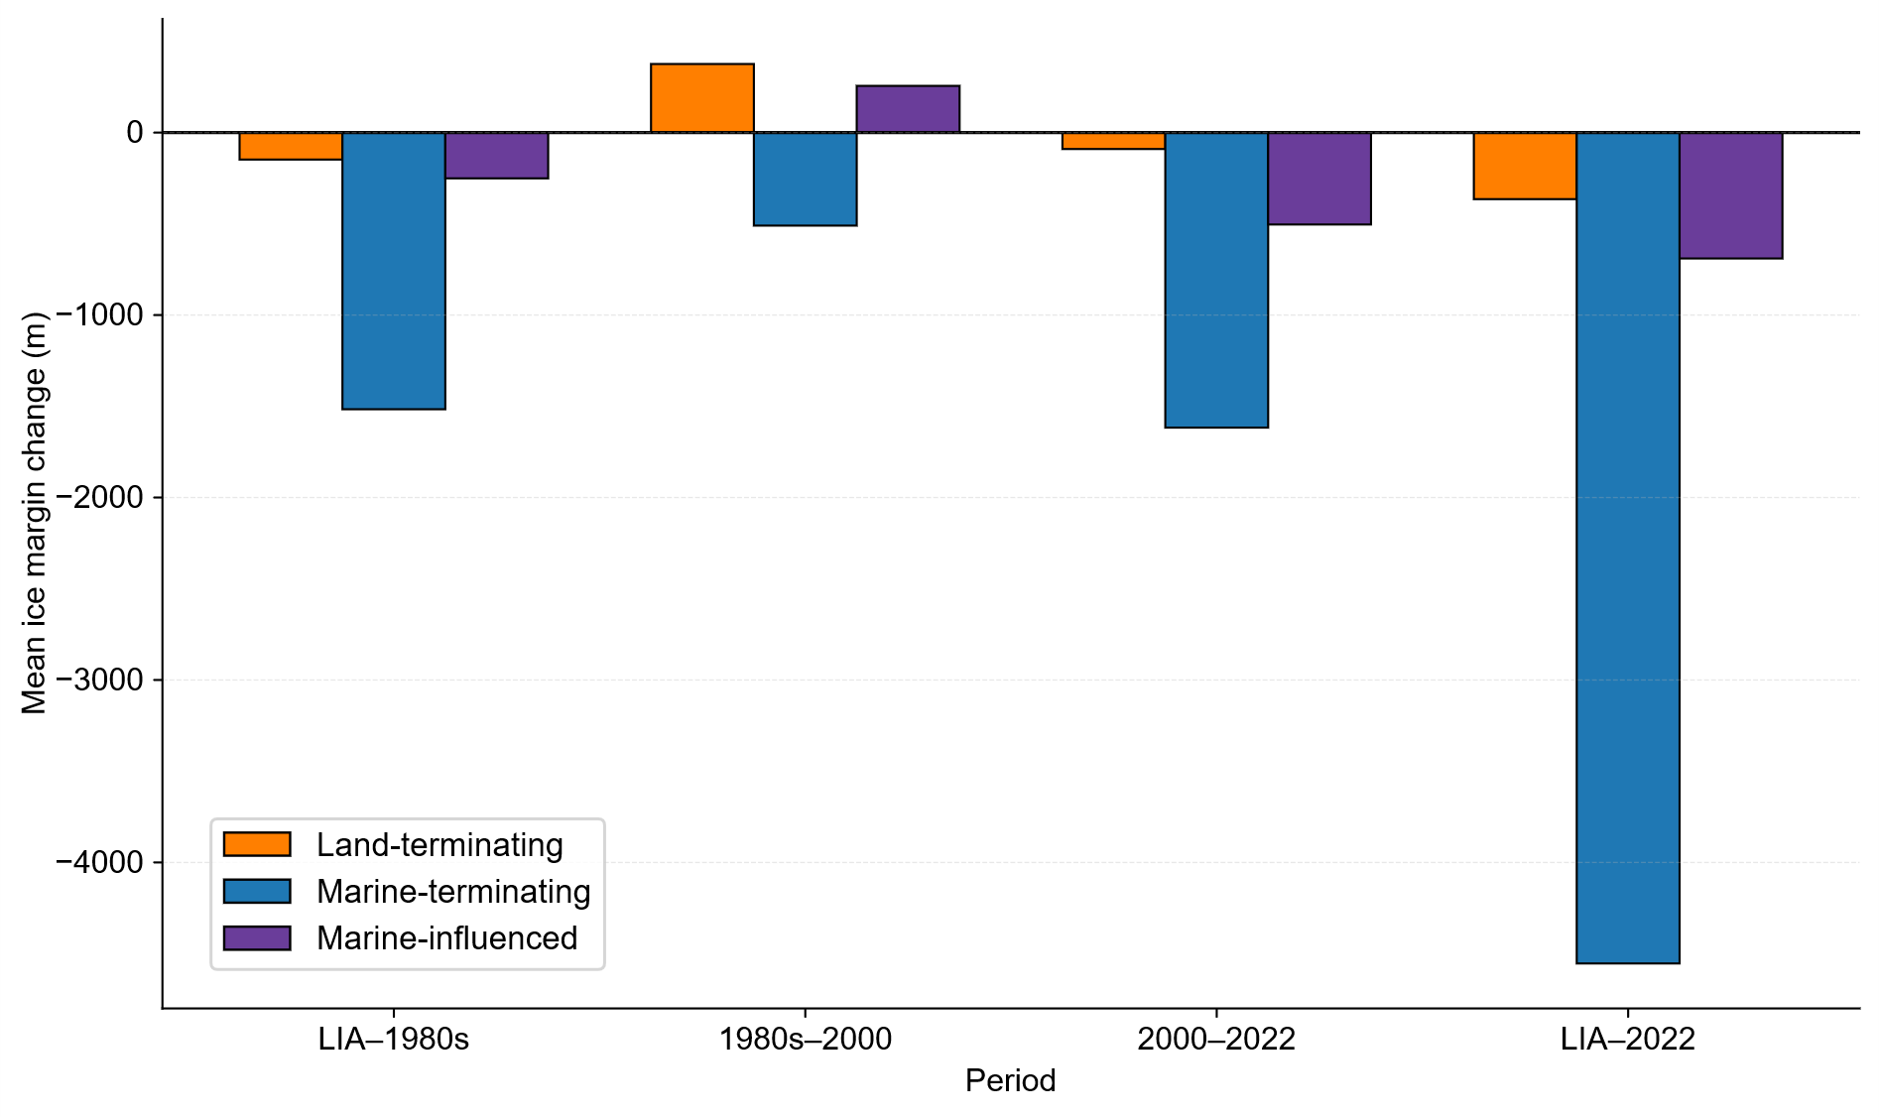
Fig. S1. Mean ice margin change for each coastline class across four periods. Negative values indicate retreat (ice loss) and positive values indicate advance. Marine-terminating margins (blue) exhibit substantially greater retreat than land-terminating (orange) and marine-influenced (purple) margins across all periods.

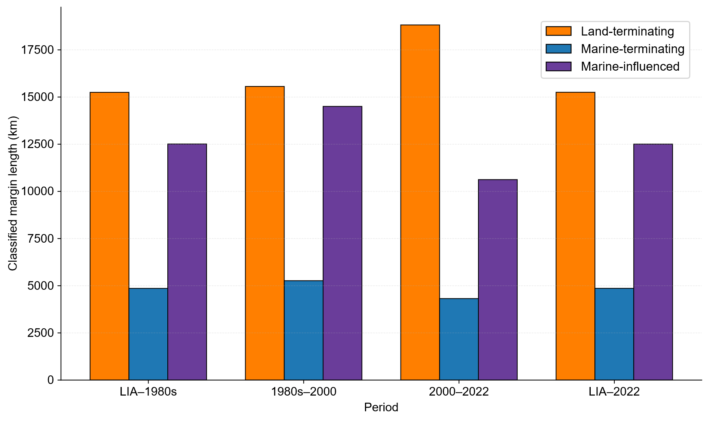Fig. S2. Total length of classified ice margins. Land-terminating margins (orange) account for the majority of Greenland's ice margin, representing approximately 15,000-18,700 km across periods. Marine-terminating margins (blue) comprise roughly 4,000-5,300 km, while marine-influenced margins (purple) range between approximately 10,700-14,500 km.

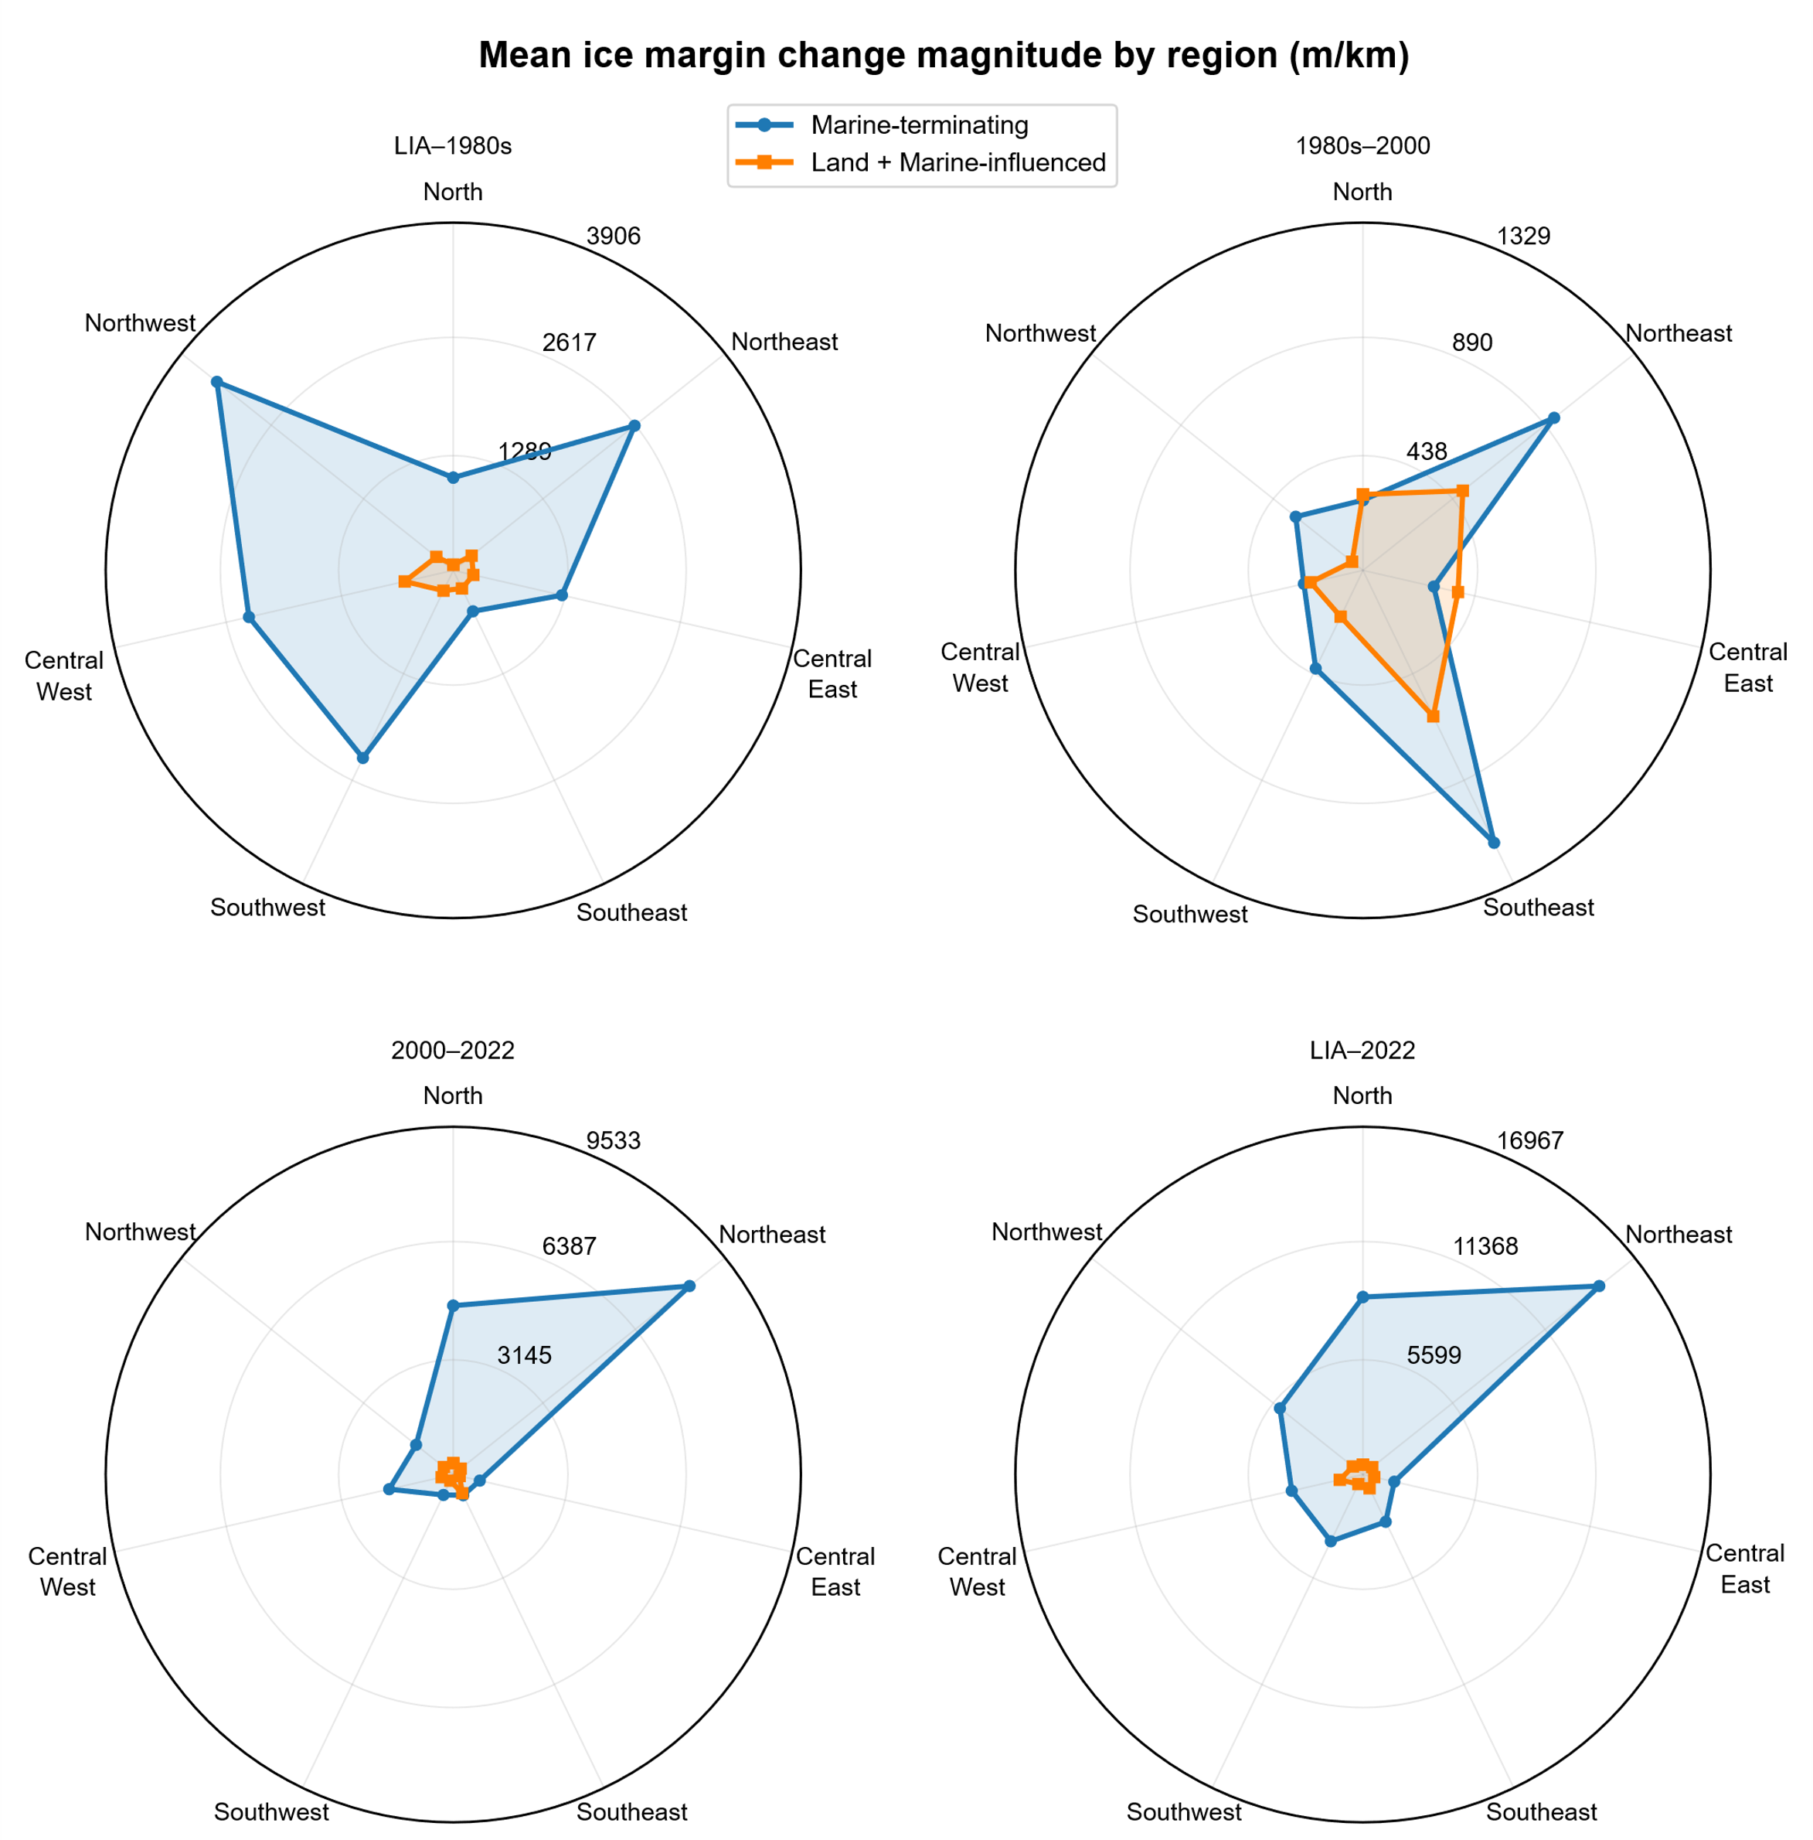
Fig. S3. Regional patterns of ice margin change magnitude (m/km) across four time periods. Each radar chart compares marine-terminating margins (blue) with land-terminating plus marine-influenced margins (orange) across seven IMBIE regions. Distance from center indicates change in magnitude. Each period uses an independent scale to highlight regional patterns.
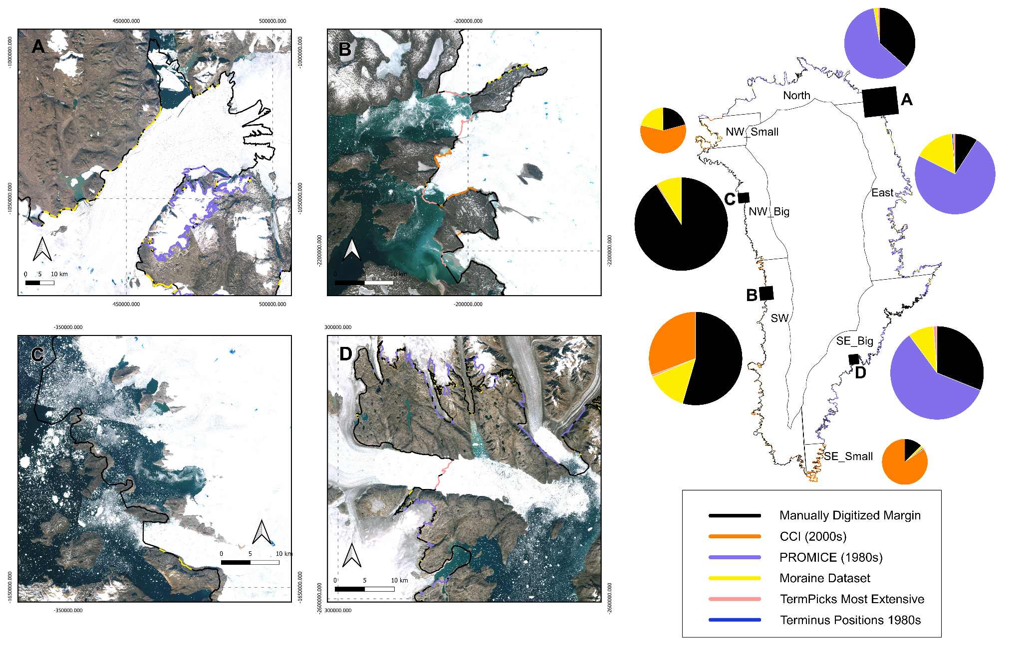
Fig. S4. Source datasets and regional workflows used to reconstruct the LIA maximum ice margin. The central map shows the seven operational subregions (North, East, Southeast_Big, Southeast_Small, Northwest_Big, Northwest_Small, Southwest); pie charts summarize the proportional contribution of each dataset within each subregion. Panels A-D are representative examples from different parts of Greenland, illustrating how sources were combined locally. Colors follow the legend. Together, the map, pies, and examples show the region‑specific workflow used to assemble the maximum observable historical margin.

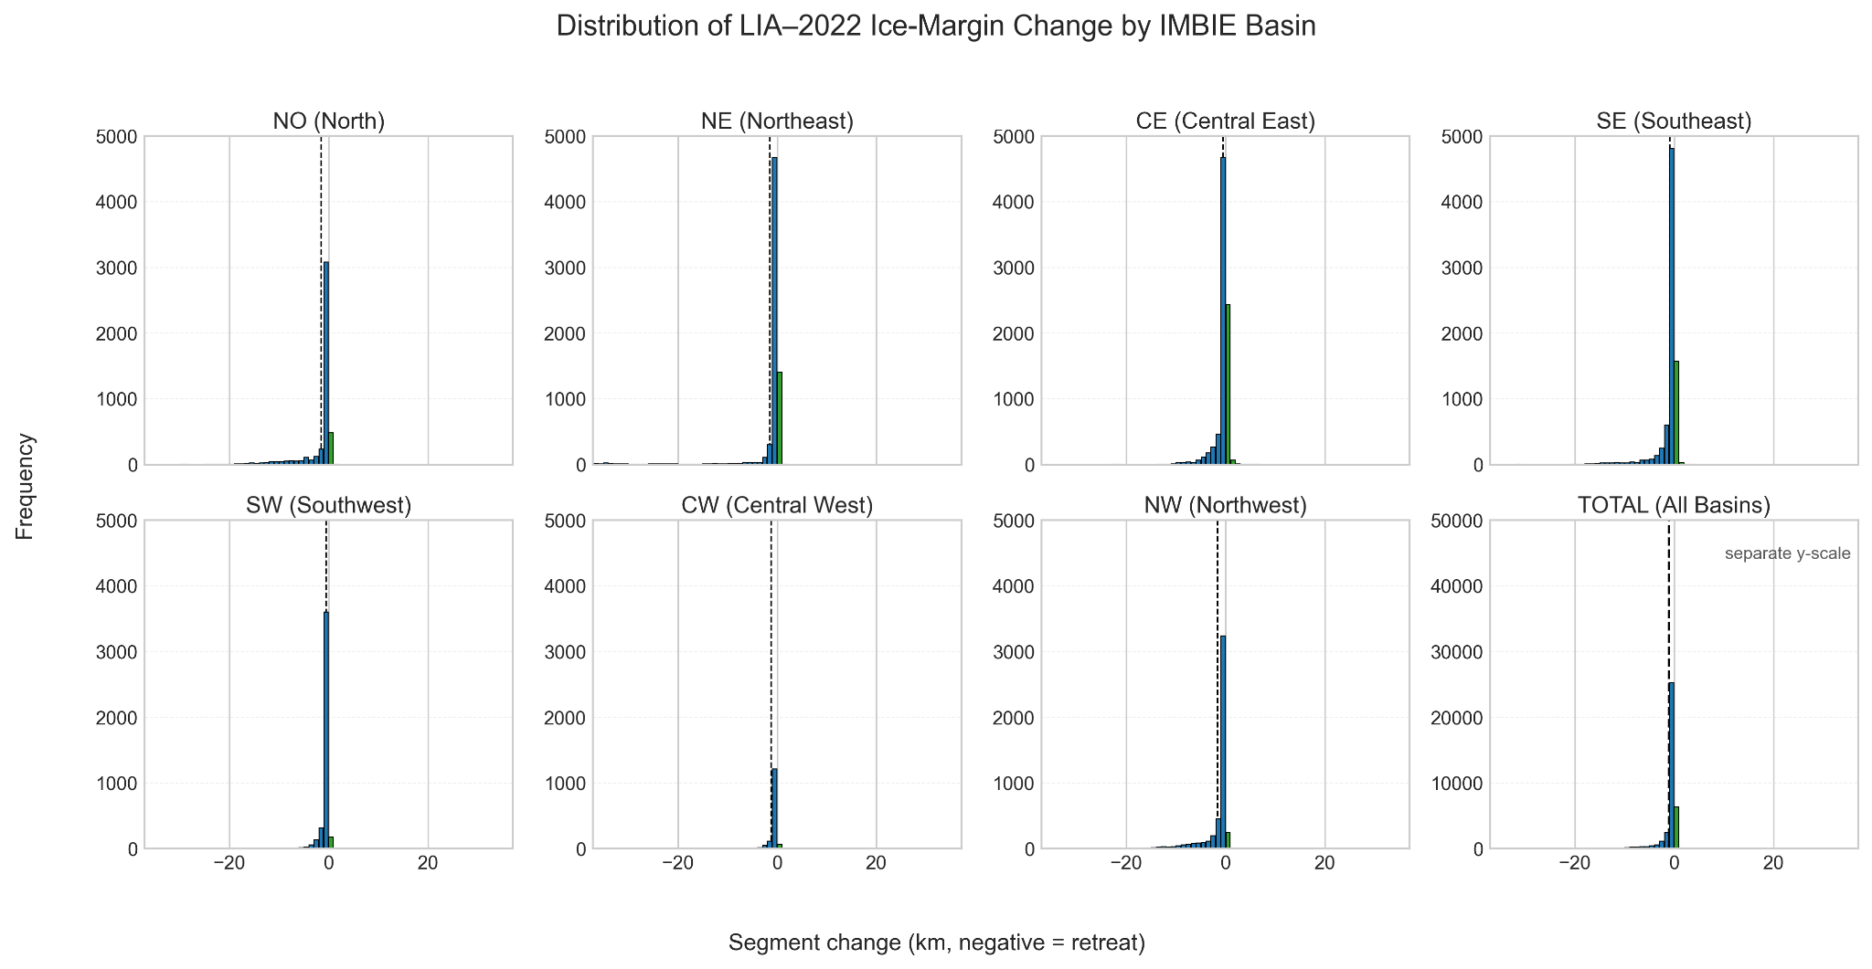
Fig. S5. Distribution of LIA-2022 ice-margin change by IMBIE basin. Histograms show the frequency distribution of segment-level change values for seven IMBIE basins plus an overall total. Panels show 1-km bins. Blue bars indicate retreating segments (negative change), green bars advancing (positive change). Dashed lines mark the mean change per basin. Glacier retreat is widespread across all basins, with most segments showing little change but some experiencing over 20 km of retreat. The NW and SE basins display the most varied behavior. The TOTAL panel combines all basins, using a different y-axis for clarity.

References
1. Howat, I. MEaSUREs Greenland Ice Mapping Project (GIMP) Land Ice and Ocean Classification Mask, Version 1. NASA National Snow and Ice Data Center Distributed Active Archive Center https://doi.org/10.5067/B8X58MQBFUPA (2017).
2. Carnahan, E., Catania, G. & Bartholomaus, T. C. Observed mechanism for sustained glacier retreat and acceleration in response to ocean warming around Greenland. The Cryosphere 16, 4305–4317 (2022).
3. Joughin, I., Smith, B., Howat, I. & Scambos, T. MEaSUREs Multi-year Greenland Ice Sheet Velocity Mosaic, Version 1. NASA National Snow and Ice Data Center Distributed Active Archive Center https://doi.org/10.5067/QUA5Q9SVMSJG (2016).
4. Mouginot, J. & Rignot, E. Glacier catchments/basins for the Greenland Ice Sheet. 4156976 bytes Dryad https://doi.org/10.7280/D1WT11 (2019).
5. Rastner, P. et al. The first complete inventory of the local glaciers and ice caps on Greenland. The Cryosphere 6, 1483–1495 (2012).
6. Citterio, M. & Ahlstrøm, A. P. Ice extent. GEUS Dataverse https://doi.org/10.22008/FK2/PRWITW (2022).
7. Korsgaard, N. Greenland Ice Sheet outlet glacier terminus positions 1978-1987 from aero-photogrammetric map data. GEUS Dataverse https://doi.org/10.22008/FK2/B2JYVC (2022).
8. Goliber, S. et al. TermPicks: a century of Greenland glacier terminus data for use in scientific and machine learning applications. The Cryosphere 16, 3215–3233 (2022).
9. Goliber, S. & Black, T. TermPicks: A century of Greenland glacier terminus data for use in machine learning applications. Zenodo https://doi.org/10.5281/ZENODO.6557981 (2021).
10. Bjørk, A. A. et al. An aerial view of 80 years of climate-related glacier fluctuations in southeast Greenland. Nature Geosci 5, 427–432 (2012).
11. Klimadatastyrelsen. Grønlands topografiske kortværk. Dataforsyningen (2001).
12. Kjeldsen, K. K. North-west Greenland ice mask. GEUS Dataverse https://doi.org/10.22008/FK2/RTSYDD (2022).
13. Weidick, A. Observations on some Holocene glacier fluctuations in West Greenland. bullggu 73, 1–202 (1968).
14. Kjær, K. H. et al. Glacier response to the Little Ice Age during the Neoglacial cooling in Greenland. Earth-Science Reviews 227, (2022).
15. Citterio, M. & Ahlstrøm, A. P. Brief communication“The aerophotogrammetric map of Greenland ice masses”. The Cryosphere 7, 445–449 (2013).
16. Luetzenburg, G. et al. PROMICE-2022 Ice Mask. GEUS Dataverse https://doi.org/10.22008/FK2/O8CLRE (2025).
17. Johannessen, O. M., Babiker, M. & Miles, M. W. Petermann Glacier, North Greenland: massive calving in 2010 and the past half century. Preprint at https://doi.org/10.5194/tcd-5-169-2011 (2011).
18. U.S. Army Map Service. AMS C501 Greenland 1:250,000 Topographic Series. Polar Geospatial Center (1947).
19. Earth Resources Observation and Science (EROS) Center. Landsat 4-5 Thematic Mapper Level-2, Collection 2. U.S. Geological Survey https://doi.org/10.5066/P9IAXOVV (2020).
20. Hill, E. A., Carr, J. R., Stokes, C. R. & Gudmundsson, G. H. Dynamic changes in outlet glaciers in northern Greenland from 1948 to 2015. The Cryosphere 12, 3243–3263 (2018).
21. Klimadatastyrelsen. Satellite photo Greenland. Dataforsyningen (2020).
22. European Space Agency. Sentinel-2 MSI Level-2A BOA Reflectance. https://doi.org/10.5270/S2_-znk9xsj (2022).
23. Korsgaard, N. J. et al. Digital elevation model and orthophotographs of Greenland based on aerial photographs from 1978–1987. Scientific Data 3, 160032 (2016).
24. Porter, C. et al. ArcticDEM - Mosaics, Version 4.1. Harvard Dataverse https://doi.org/10.7910/DVN/3VDC4W (2023).
25. Tucker, C. J., Grant, D. M. & Dykstra, J. D. NASA’s Global Orthorectified Landsat Data Set. photogramm eng remote sensing 70, 313–322 (2004).
26. Higgins, A. K. North Greenland Glacier Velocities and Calf Ice Production. Polarforschung, Bremerhaven, Alfred Wegener Institute for Polar and Marine Research & German Society of Polar Research 60, 1–23 (1991).
27. Salmani, M. et al. A Machine-Learning Framework for Mapping Little Ice Age Maximum Glacial Extents. Preprint at https://doi.org/10.22541/essoar.177177422.24617832/v1 (2026).

