SUPPLEMENTARY MATERIAL
Appendix 1. Flowchart of selection of the Peruvian population with tuberculosis included
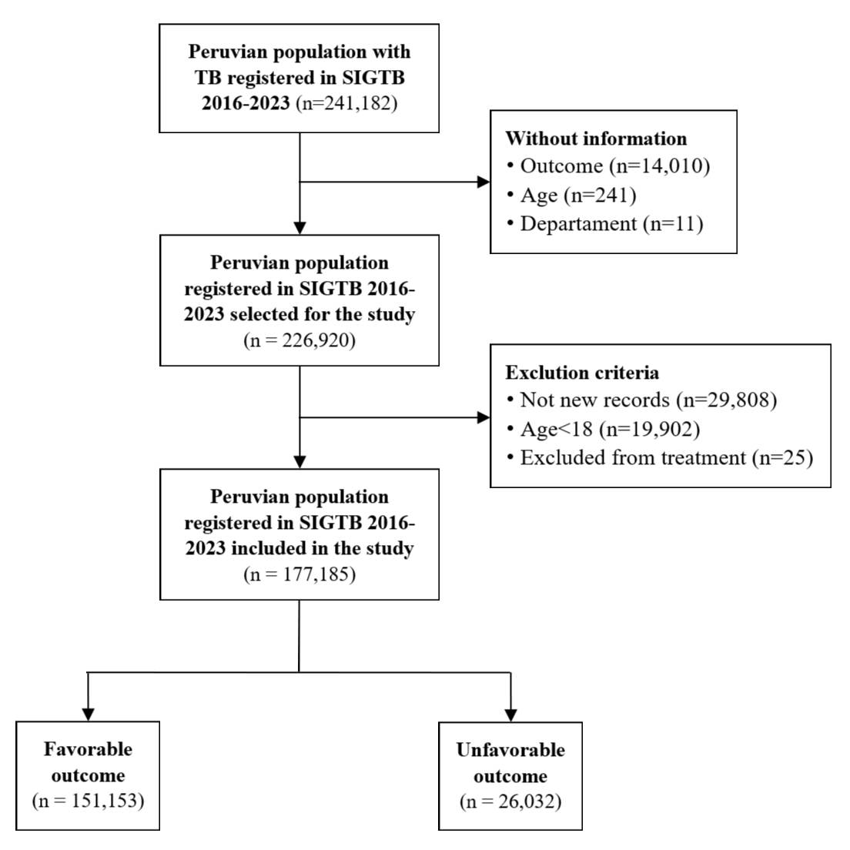
Appendix 2. Characteristics of Peruvian population with tuberculosis and incomplete information for many variables
Variables | Complete | HIV/AIDS Incomplete | Diabetes Incomplete | Insurance Incomplete | Alcoholism Incomplete | Smoking Incomplete | Drug Use Incomplete
Variables | (n=177,185) | (n=2,885) | (n=3,204) | (n=118) | (n=14,737) | (n=515) | (n=14,742)
Sex
Female | 111,184 (62.75) | 1988 (68.91) | 2364 (73.78) | 74 (62.71) | 9698 (65.81) | 9694 (65.76) | 320 (62.14)
Males | 66,001 (37.25) | 897 (31.09) | 840 (26.22) | 44 (37.29) | 5039 (34.19) | 5048 (34.24) | 195 (37.86)
Age Group
<60 years | 142,738 (80.56) | 2201 (76.29) | 2706 (84.46) | 95 (80.51) | 12638 (85.76) | 12641 (85.75) | 428 (83.11)
60+ years | 34,447 (19.44) | 684 (23.71) | 498 (15.54) | 23 (19.49) | 2099 (14.24) | 2101 (14.25) | 87 (16.89)
Area of Residence
Urban | 85,896 (48.48) | 1159 (40.17) | 1250 (39.01) | 69 (58.47) | 4779 (32.43) | 4778 (32.41) | 201 (39.03)
Rural | 91,289 (51.52) | 1726 (59.83) | 1954 (60.99) | 49 (41.53) | 9958 (67.57) | 9964 (67.59) | 314 (60.97)
Place of Residence
Lima | 153,920 (86.87) | 2511 (87.04) | 2828 (88.26) | 102 (86.44) | 12966 (87.98) | 12967 (87.96) | 458 (88.93)
Outside | 23,265 (13.13) | 374 (12.96) | 376 (11.74) | 16 (13.56) | 1771 (12.02) | 1775 (12.04) | 57 (11.07)
Health Insurance
No | 40,013 (7.08) | 287 (9.99) | 296 (9.26) |  | 884 (6) | 883 (5.99) | 27 (5.29)
Yes | 525394 (92.92) | 2585 (90.01) | 2901 (90.74) |  | 13847 (94) | 13854 (94.01) | 483 (94.71)
DM Comorbidity
No | 162149 (93.2) | 1430 (88.27) |  | 100 (90.09) | 13090 (90.06) | 13095 (90.06) | 355 (89.65)
Yes | 11832 (6.8) | 190 (11.73) |  | 11 (9.91) | 1444 (9.94) | 1445 (9.94) | 41 (10.35)
HIV/AIDS Coinfection
No | 166910 (95.76) |  | 1815 (93.6) | 104 (99.05) | 13783 (94.67) | 13786 (94.65) | 453 (94.38)
Yes | 7390 (4.24) |  | 124 (6.4) | 1 (0.95) | 776 (5.33) | 779 (5.35) | 27 (5.63)
Alcoholism
No | 149673 (92.14) | 2475 (91.43) | 2800 (93.3) | 102 (91.07) |  | 28 (73.68) | 53 (89.83)
Yes | 12775 (7.86) | 232 (8.57) | 201 (6.7) | 10 (8.93) |  | 10 (26.32) | 6 (10.17)
Smoking
No | 152335 (93.78) | 2517 (92.95) | 2861 (95.3) | 105 (92.92) | 11 (33.33) |  | 45 (65.22)
Yes | 10108 (6.22) | 191 (7.05) | 141 (4.7) | 8 (7.08) | 22 (66.67) |  | 24 (34.78)
Drug Use
No | 163054 (92.29) | 2520 (88.42) | 2470 (80.06) | 107 (94.69) | 12831 (89.85) | 12842 (89.83)
Yes | 13616 (7.71) | 330 (11.58) | 615 (19.94) | 6 (5.31) | 1450 (10.15) | 1454 (10.17)

