Supporting Information
Soft Segment Engineering of Bio-Based Poly(propylene 2,5-furandicarboxylate) for Enhanced Toughness and Spinnability

Hsu-I Mao^{1,2,†}, Sheng-Yuan Chiu^{1,†}, Shang-Hua Yu¹, Ke-Ling Tuan¹, Kuan-Yi Wu³, Chin-Yen Wang², and Chin-Wen Chen^{1,*}

¹ Department of Molecular Science and Engineering, Institute of Organic and Polymeric Materials, Research and Development Center of Smart Textile Technology, National Taipei University of Technology, Taipei 10608, Taiwan
² Climate Change Research Center, National Environmental Research Academy, Taoyuan City 320680, Taiwan
³ Department of Chemical Engineering and Biotechnology, National Taipei University of Technology, Taipei 10608, Taiwan

† Hsu-I Mao and Sheng-Yuan Chiu equally contributed to this work.

Corresponding author
Prof. C.-W. Chen: cwchen@ntut.edu.tw

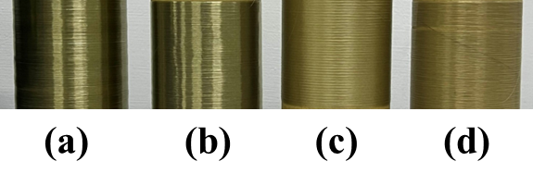
Fig. S1 The appearance of the PPF-PTMEG fibers: (a) PPF, (b) PPF-10PTMEG, (c) PPF-20PTMEG, and (d) PPF-30PTMEG.
As shown in Fig. S1, the macroscopic appearance and surface texture of the PPF-PTMEG fibers vary with composition. Neat PPF and PPF-10PTMEG fibers exhibit relatively smooth and glossy surfaces with higher apparent transparency under visual inspection. In contrast, PPF-20PTMEG and PPF-30PTMEG fibers show increased surface roughness with visible granular textures, resulting in a more matte appearance. Overall, the PPF-PTMEG copolyester fibers display a pale yellow, semi-transparent appearance.

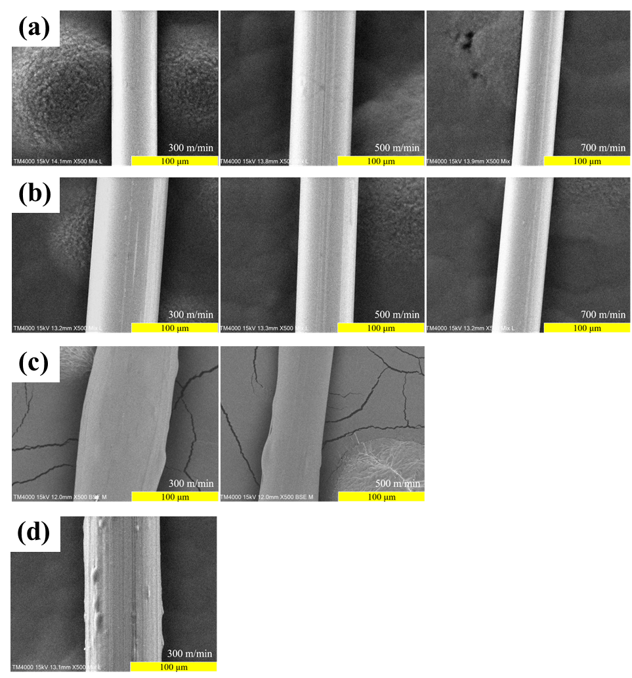
Fig. S2 The SEM surface morphologies observation of the PPF-PTMEG fibers: (a) PPF, (b) PPF-10PTMEG, (c) PPF-20PTMEG, and (d) PPF-30PTMEG.
As shown in Fig. S2, the SEM surface morphologies of the PPF-PTMEG fibers vary markedly with PTMEG content. Neat PPF and PPF-10PTMEG fibers exhibit relatively smooth surfaces with more uniform fiber diameters and fewer observable surface defects, suggesting that at low soft-segment loadings, the copolyester maintains a more homogeneous morphology and stable processability.
In contrast, PPF-20PTMEG and PPF-30PTMEG fibers show increased surface roughness, with more pronounced irregular features and microscale defects. Such morphology evolution implies that higher soft-segment content may promote structural heterogeneity and surface defect formation during fiber drawing. In conjunction with the spinning outcomes, it is reasonable to infer that increasing PTMEG content reduces melt strength and the load-bearing capability of the forming filament, potentially accompanied by enhanced phase heterogeneity, thereby impairing spinnability. As a result, PPF-20PTMEG and PPF-30PTMEG could not be stably formed at higher take-up speeds (500 m/min and 700 m/min), and PPF-40PTMEG failed to be continuously spun. A similar composition-dependent reduction in spinnability has been reported for PEF–PEG copolyesters, where increasing soft-segment content significantly affects the spinnability of furan-based polyesters, consistent with the present observations.

