Advanced hybrid machine learning algorithms for multistep lake water level forecasting

Elham Fijani^{1,*}, Khabat Khosravi², Rahim Barzegar^{3,4}, John Quilty⁵, Jan Adamowski³, Homa Kheyrollah-Pour⁴
1- School of Geology, College of Science, University of Tehran, Tehran, Iran.
2- Department of Watershed Management Engineering, Ferdowsi University of Mashhad, Mashhad, Iran
3- Department of Bioresource Engineering, McGill University, Ste-Anne-de-Bellevue, Canada.
4- Department of Geography & Environmental Studies, Wilfrid Laurier University, Waterloo, Canada.
5- Department of Civil and Environmental Engineering, University of Waterloo, Waterloo, Canada.
*Corresponding author: efijani@ut.ac.ir

Supplementary Material
Additional figures S1-S5 are included here to supplement Fig. 3 in-text.

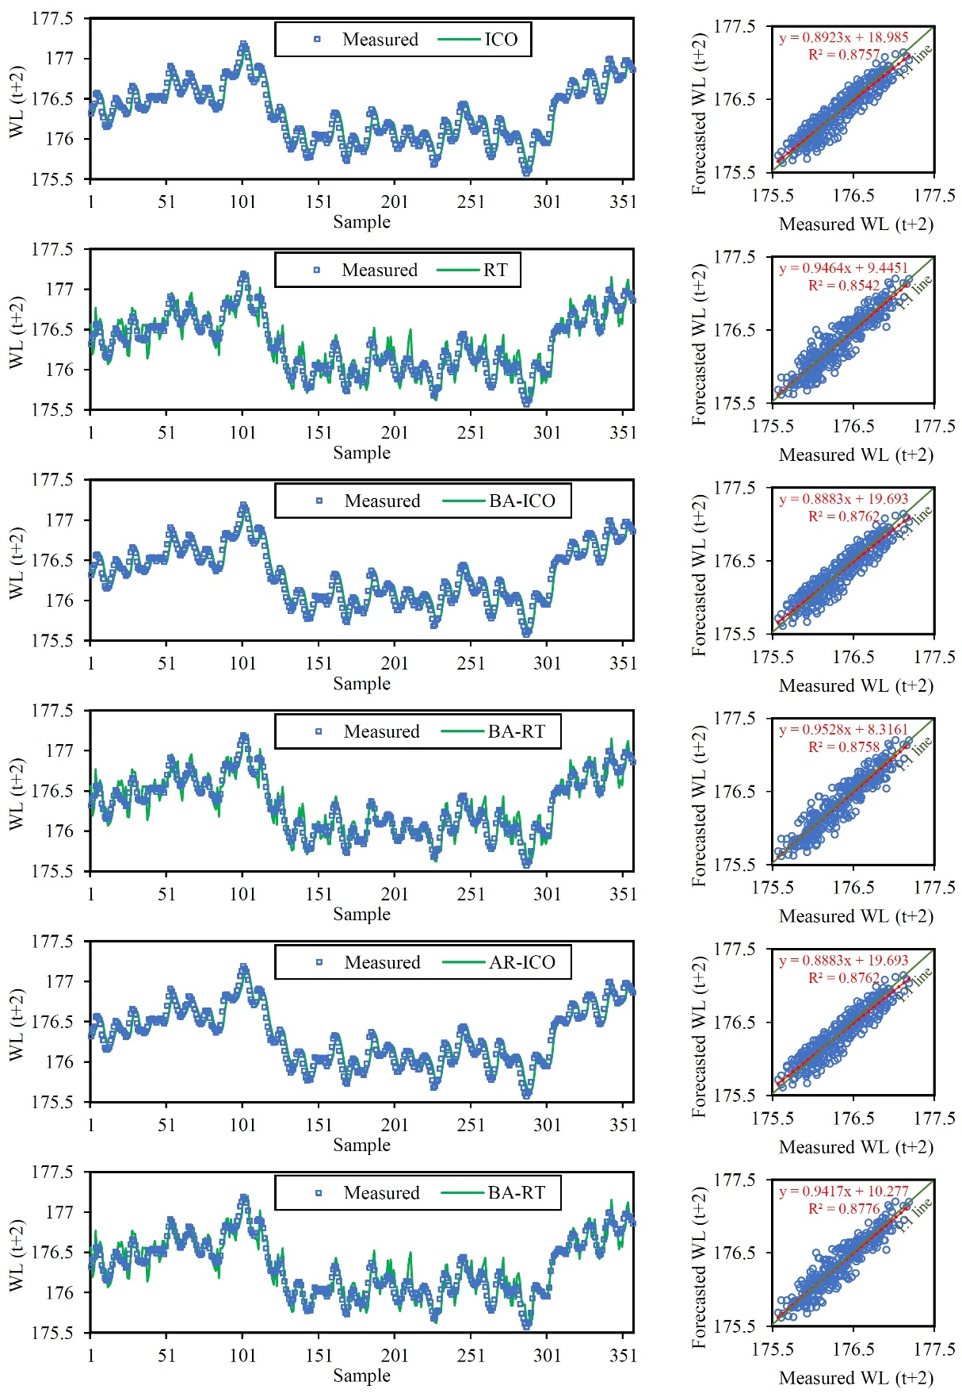
Fig. S1 Comparative temporal series and scatter plots of measured and test period forecasted WL_{(t+2)} for Lake Michigan

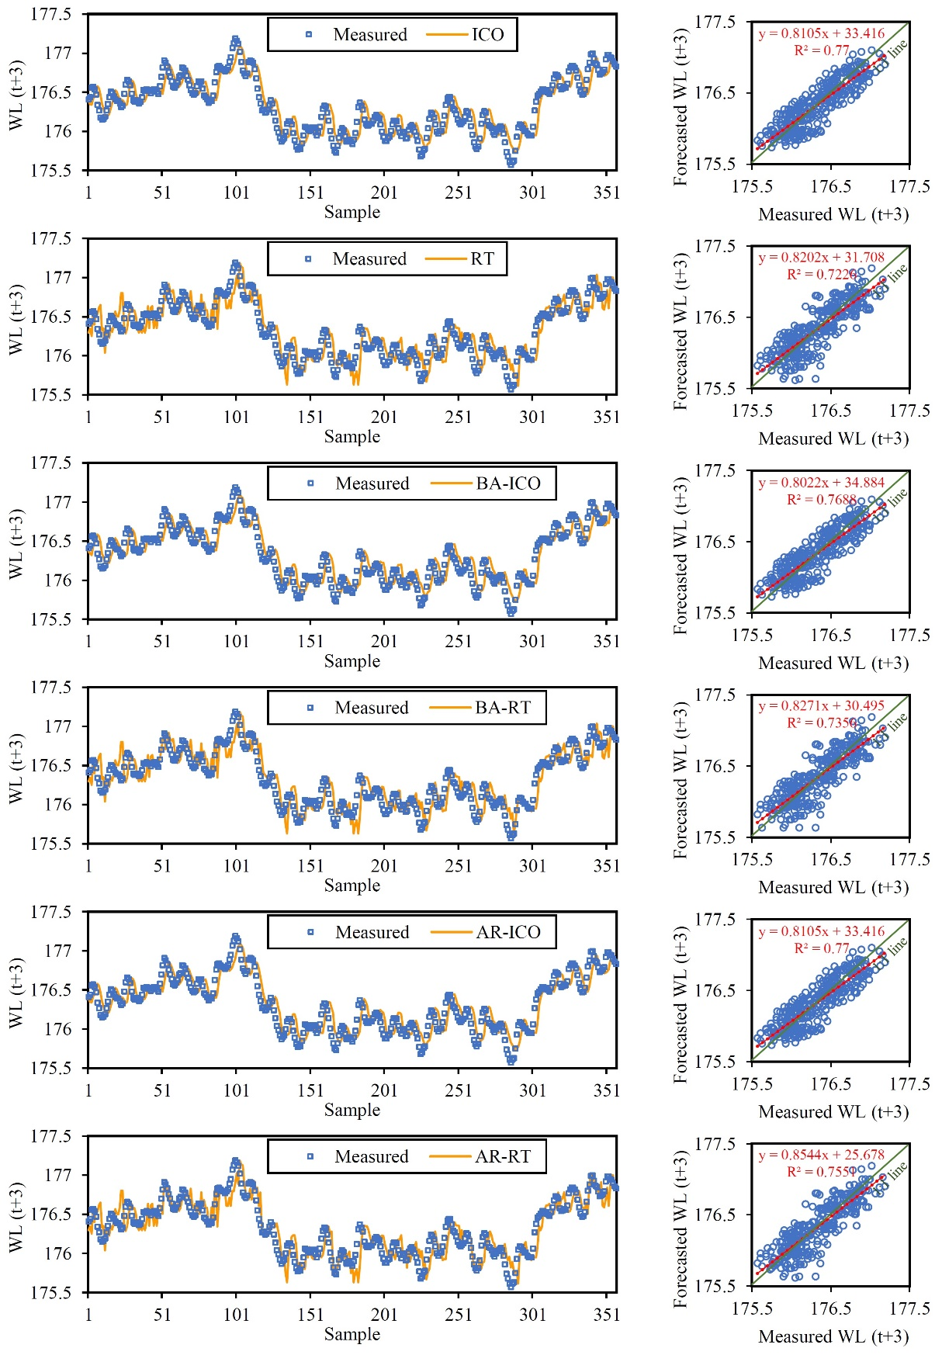
Fig. S2 Comparative temporal series and scatter plots of measured and test period forecasted WL_{(t+3)} for Lake Michigan

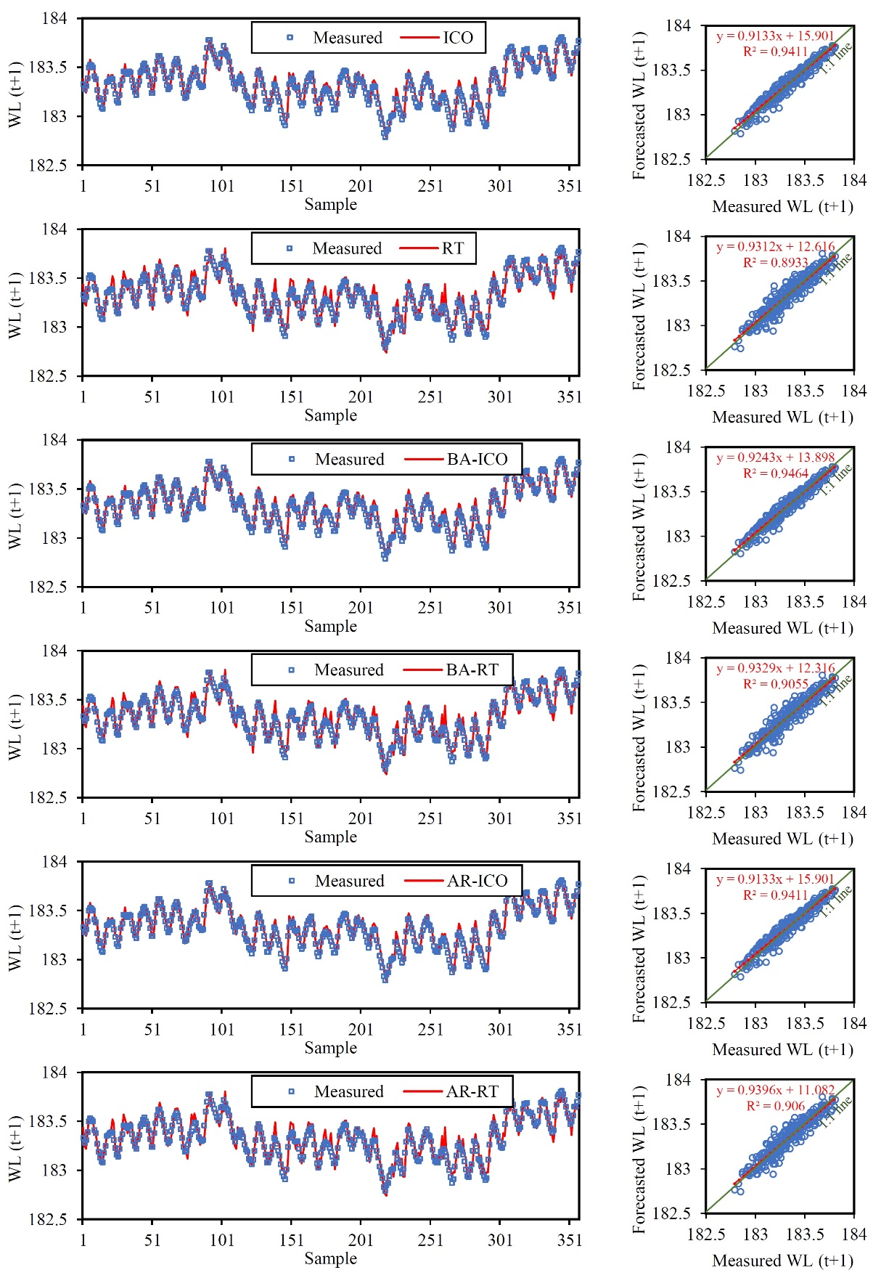
Fig. S3 Comparative temporal series and scatter plots of measured and test period forecasted WL_{(t+1)} for Lake Superior

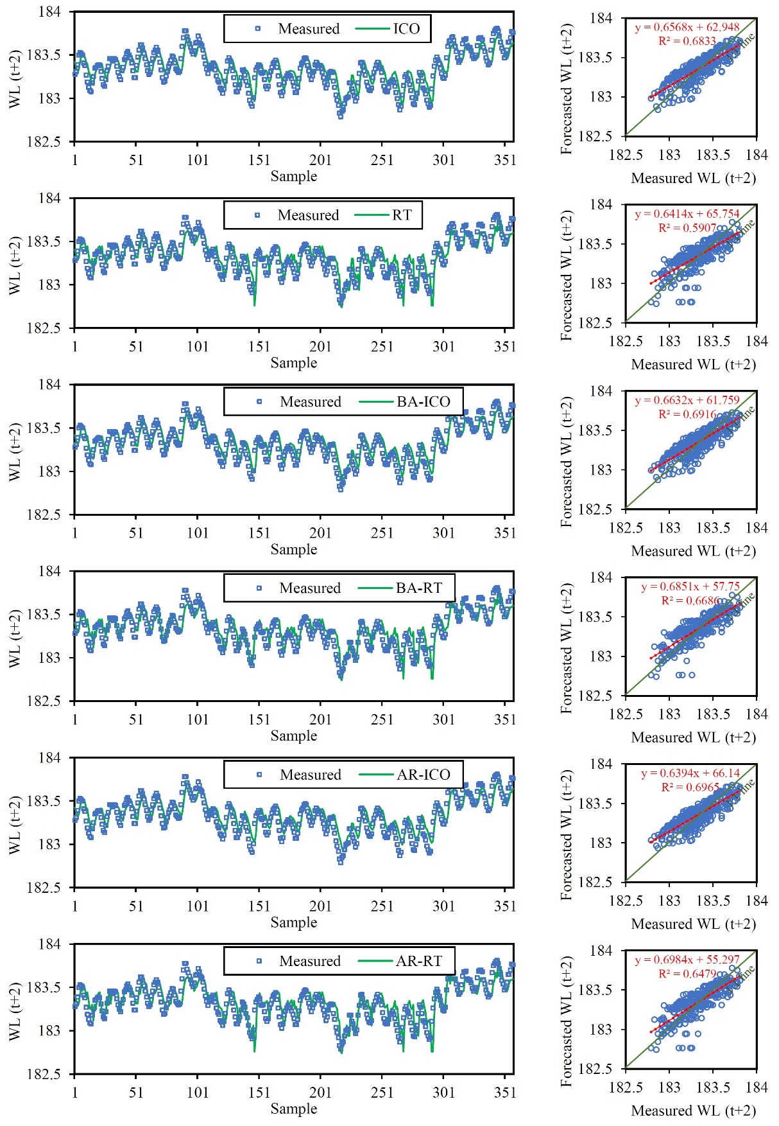
Fig. S4 Comparative temporal series and scatter plots of measured and test period forecasted WL_{(t+2)} for Lake Superior

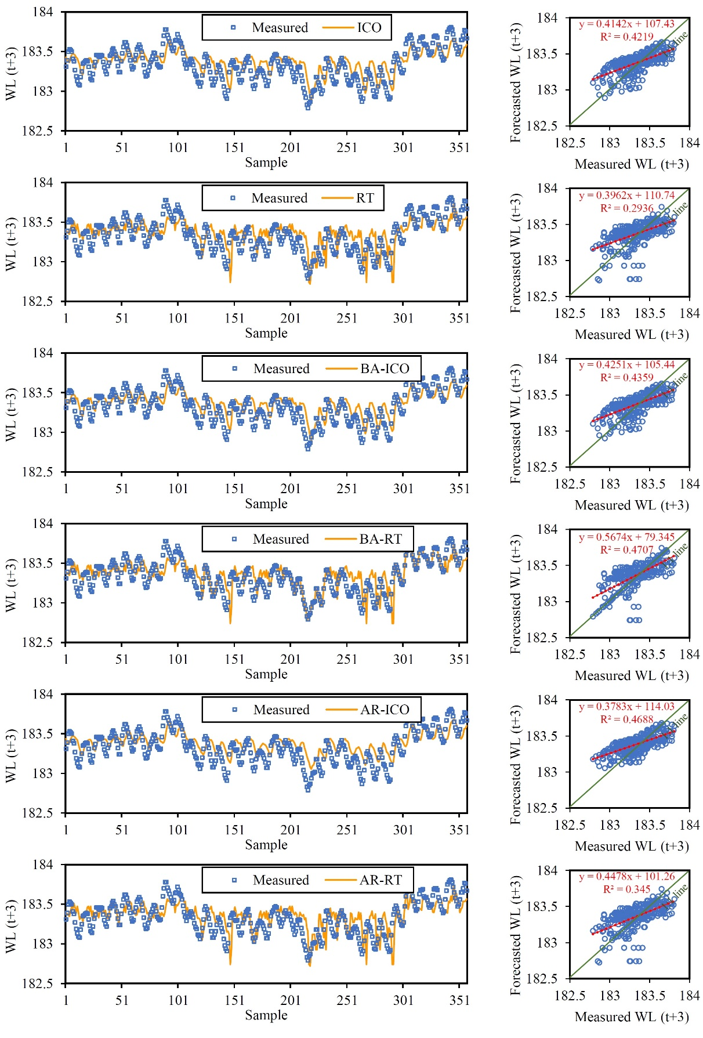
Fig. S5 Comparative temporal series and scatter plots of measured and test period forecasted WL_{(t+3)} for Lake Superior

