SUPPLEMENTARY MATERIALS
Supplementary figure 1 – Proportion of dengue serotypes identified by each year from 2014 to 2024 in Brazil.
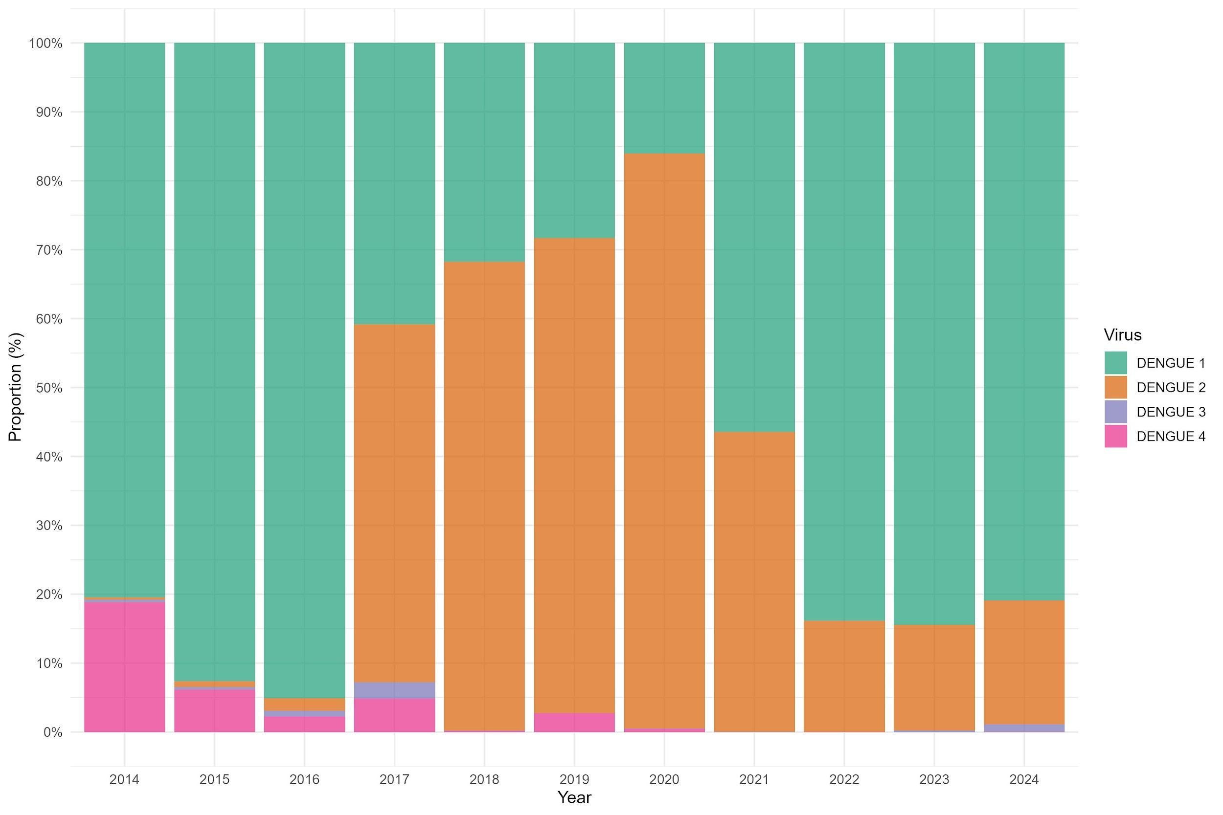

Supplementary figure 2 – Proportion of dengue serotypes identified by each year from Brazilian federative unit from 2014 to 2024.
