Supplementary material
1 Figure S1 Cloning and sequence analysis of the CsLAC17 gene.
2 Figure S2 Construction of the pTRV2-CsLAC17 VIGS vector.
3 Figure S3 Screening and validation of transgenic tobacco lines overexpressing CsLAC17.
4 Figure S4 Codon optimization and vector construction for yeast heterologous expression of CsLAC17.
5 Figure S5 PCR validation of Mut⁺ recombinant yeast strains.
6 Table S1 Primer sequences

a
b

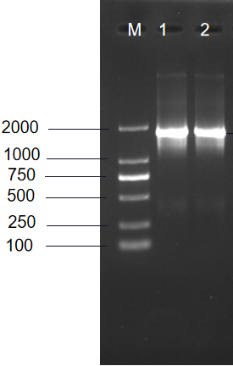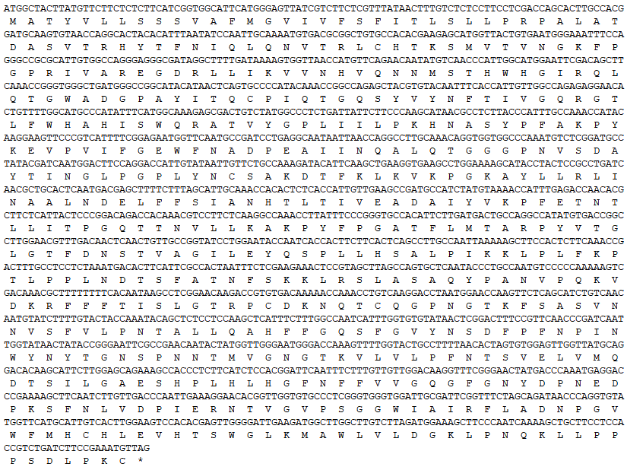

Figure S1 Cloning and analysis of CsLAC17 laccase gene. (a) Amplification results of CsLAC17 laccase gene, M: DL2000 DNA marker, 1-Target gene. (b) Nucleotide sequence and amino acid sequence of CsLAC17

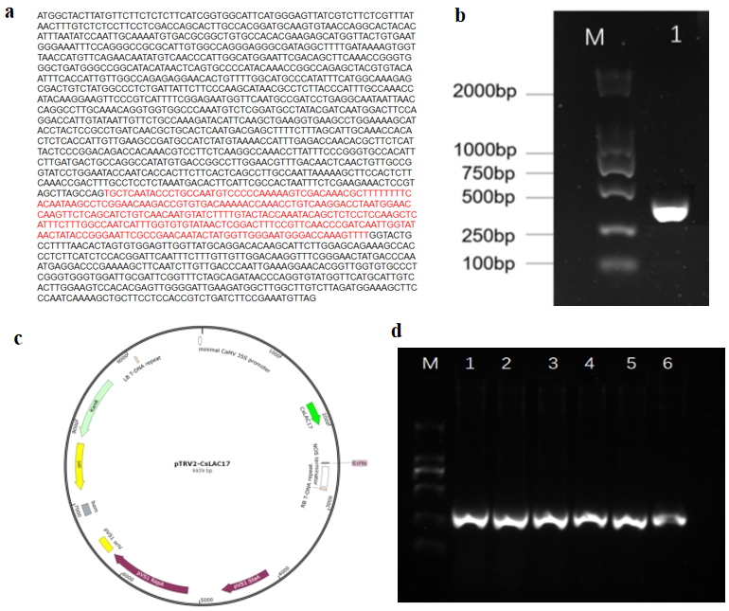
Figure S2 Construction of the pTRV2-CsLAC17 VIGS vector.(a) Selection of a specific fragment from the conserved region of CsLAC17 for VIGS. (b) Amplification of the target fragment by PCR. M: DL 2000 DNA Marker; Lane 1: The amplified gene fragment. (c) Schematic diagram of the recombinant pTRV2-CsLAC17 vector. (d) Verification of the recombinant plasmids by colony PCR. M: DL 2000 DNA Marker; Lanes 1-6: PCR validation

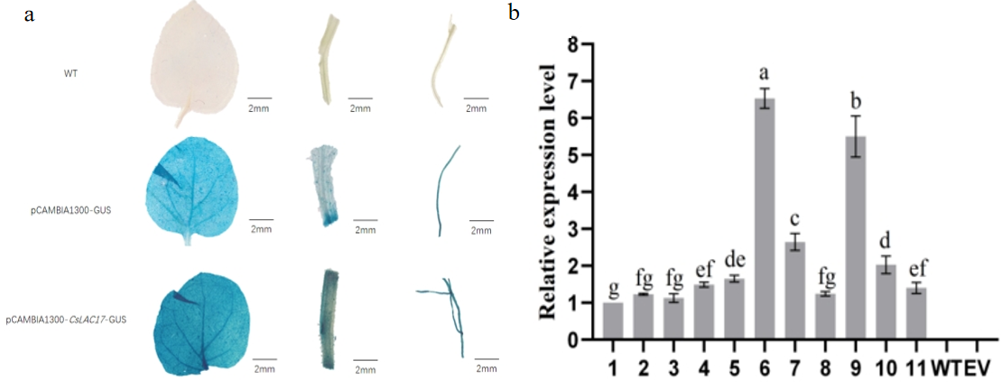
Figure S3 Screening and validation of transgenic tobacco lines overexpressing CsLAC17. (a) Histochemical GUS staining of leaves from wild-type (WT), empty vector control (EV), and representative CsLAC17-transgenic lines. Blue staining indicates GUS activity, confirming the integration of the T-DNA. Scale bar = 1 cm. (b) Relative expression levels of the CsLAC17 gene in different transgenic lines (TP1-TP11) as determined by qRT-PCR. Data are presented as the mean ± standard deviation (SD) from three biological replicates.

b
a

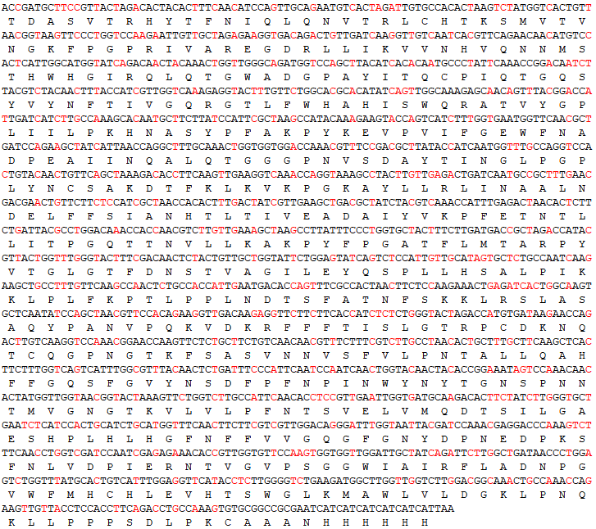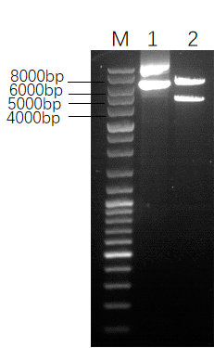

Figure S4 (a) The sequence after codon optimization, the red part are the optimized sites. (b) Verification of double digestion of recombinant expression vector Note: M: DNA marker, 1: Recombinant plasmid, 2: Double enzyme digestion plasmid.
Note: M: DNA Marker; 1: Plasmid; 2: Double enzyme digestion plasmid

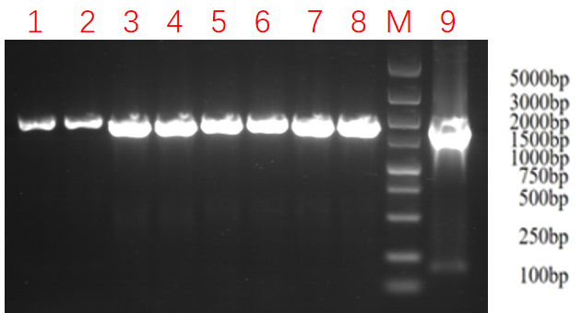
Figure S5 PCR validation results for Mut⁺ type recombinant yeast engineering strain
Note: M: DL5000 DNA marker, 1-8: PCR validation results of different single colonies,
9: pPIC9K

Table S1 Primer sequences
Primer name | Sequence (5’-3’) | Purpose
CsGAPDH | F: CACGGTCAATGGAAGCATCAT  R: GCAGCAGCCTTATCCTTATCAG | Reference gene in tea plants
CsLAC17 | F: ATGGCTACTTATGTTCTTCTCT  R: ACATTTCGGAAGATCAGACGG | Gene cloning
CsLAC17 | F: ggacgagctcggggtaccccATGGCTACTTATGTTCTTCTCT  R: gctcaccatgtcgacgctctagagcACATTTCGGAAGATCAGACGG | Overexpression Vector Construction
Hyg（481） | F: CTGCCCGCTGTTCTACAACCGG  R: GGAGCATATACGCCCGGAGTC | Validation of Transgenic Tobacco
TRV-CsLAC17 | F: tgagtaaggttaccgaattcTGCTCAATACCCTGCCAATG  R: ggacatgcccgggcctcgagAAAACTTTGGTCCCATTCC | VIGS Vector Construction
CsLAC17(qRT-PCR) | F: TCAATACCCTGCCAATGTCC  R: GGTTTTTGTCACACGGTCTTG | Silencing Validation in tea plant
β-actin(qRT-PCR) | F: AGCTTCACCTCCCAGGTCATC  R: AGAACGCCTGTCAATCTTGG | Reference Gene in Tobacco

