Supplementary Fig. S1. Heatmaps of a portion of 7-mers for the BLSOM of 16,384 types of 7-mers presented in Fig. 2a. The choice of the “T” base was made for compatibility reasons with the NCBI reference genome notation, while the actual RNA base in the SARS-CoV-2 genome is a “U”.
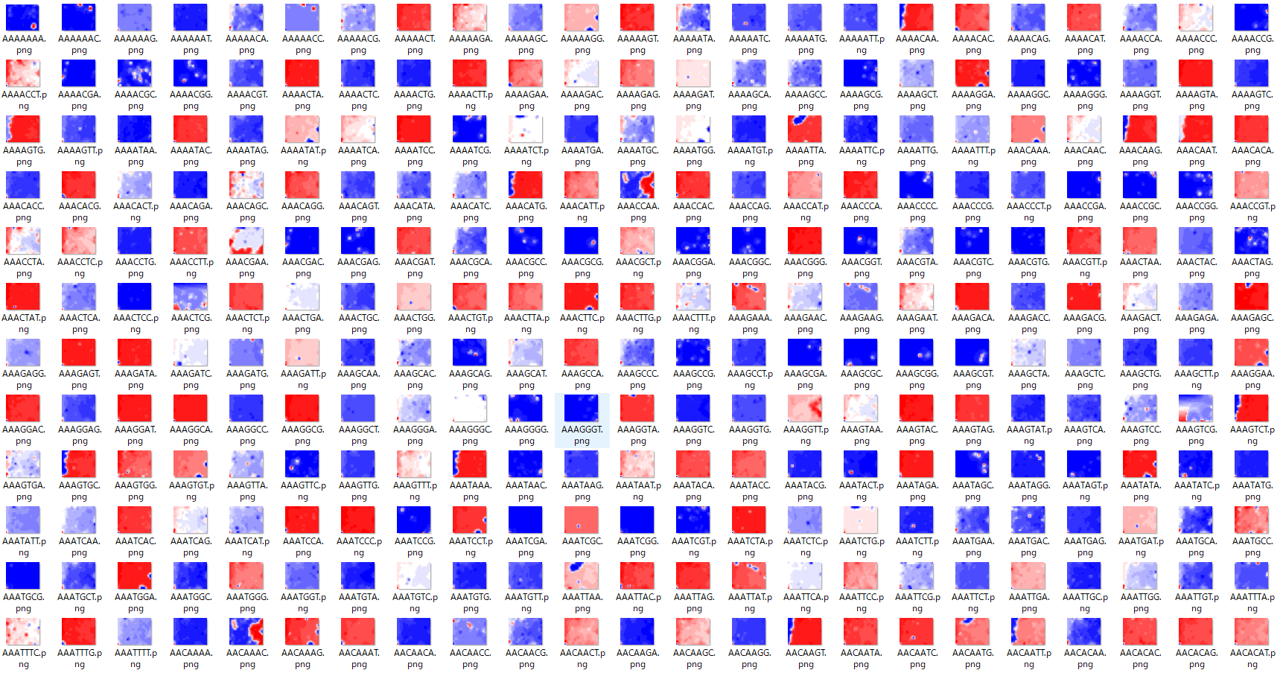

Supplementary Fig. S2. Heatmaps of all 7-mers for the BLSOM of 377 different 7-mers presented in Fig. 2c.
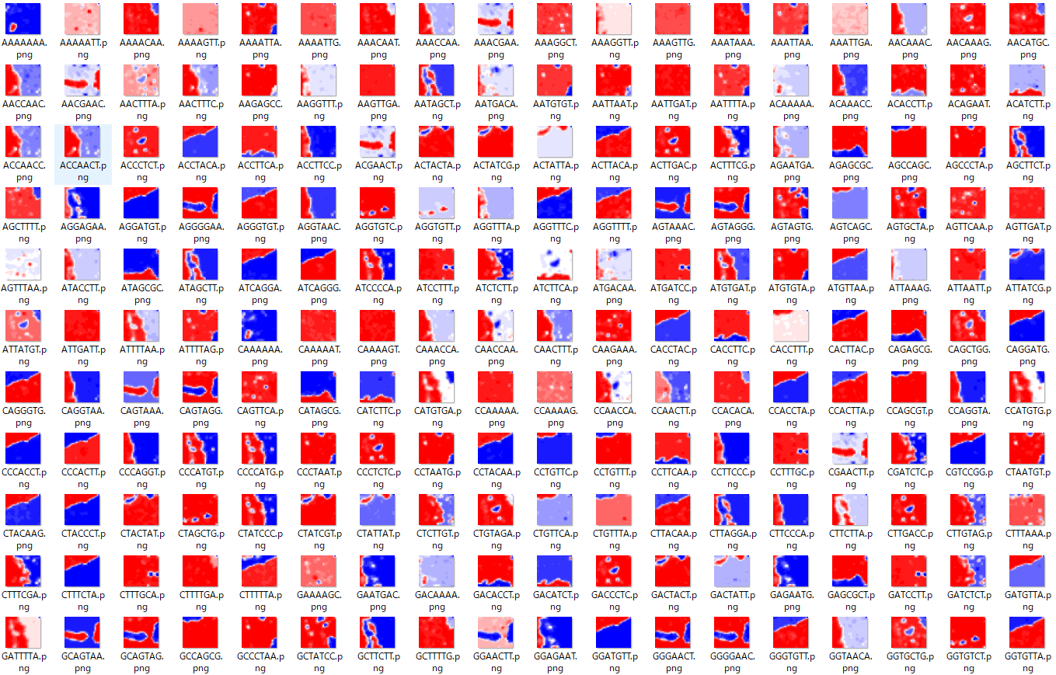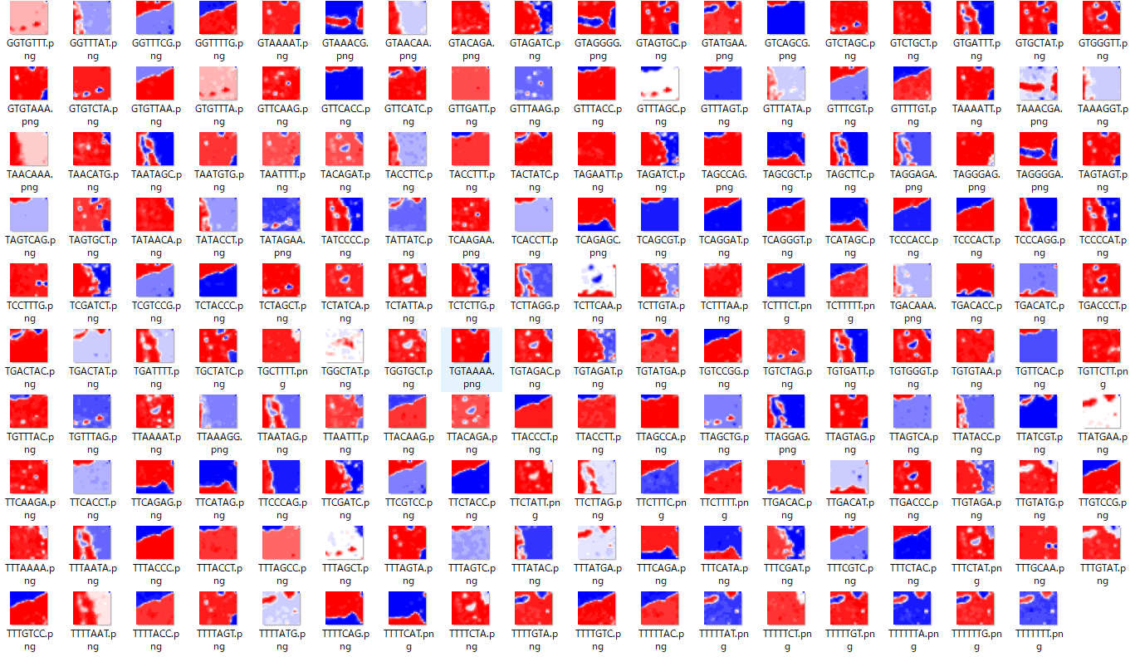

Supplementary Fig. S3. Pre- and postmutation sequences of 29-mers with the mutation listed in Table 1: 31-mers for M7. The mutated bases are shown in parentheses; N1 is not a mutation. The 15-mers used for time-series analyses were derived from these sequences.

M1: GCACAUCUAGGUUUC(U)GUCCGGGUGUGACC
M2: AUGUAUUGUUCUUUC(U)UACCCUCCAGAUGA
M3: UACAGUGUUCCCACC(U)UACAAGUUUUGGAC
M4: UGUUCUUUAUCAGGA(G)UGUUAACUGCACAG
M5: CUUGCUGUUUUUCAG(U)AGCGCUUCCAAAAU
M6: AAAGAAAUUUGACAC(U)CUUCAAUGGGGAAU
M7: UCCAGGCAGCAGUAGGG(AAC)GAACUUCUCCUGCU
M8: UCAUGACUAGGUGUC(U)UAGCUGUCCACGAG
M9: UUGUUCUUUUUUUUG(U)UAUGAAAAUGCCUU
M10: UACAGUUUCCUGUUU(C)ACCUUUUACAAUUA
M11: GACACAUGGUUUAGC(U)CAGCGUGGUGGUAG
M12: AGCGAUUAUGACUAC(U)UAUCGUUAUAAUCU
M13: UAGUCGCAACAGUUC(U)AAGAAAUUCAACUC
N1: ACAGUUUAUGAUCCU(NN)UUGCAACCUGAAU

Supplementary Fig. S4. BLSOM of 2087 types of 15-mers.
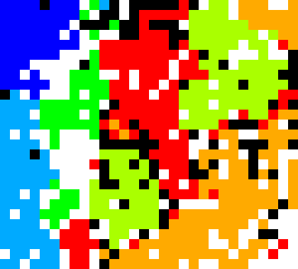
The number of nodes was set as described in Fig. 2a. Nodes are colored as described in Fig. 1.

