Title: A microbial tale of farming, invasion and conservation: on the gut bacteria of European and American mink in Western Europe
Running title: Gut bacteria of European and American mink in Western Europe
Authors and affiliations: Pauline van Leeuwen^{1,2}, Albrecht I. Schulte-Hostedde¹, Christine Fournier-Chambrillon³, Pascal Fournier³, Lise-Marie Pigneur², Carmen M. Aranda⁴, Fermín Urra-Maya⁵, Johan R. Michaux²
¹ Department of Biology, Laurentian University, Sudbury, ON, Canada;
² Conservation Genetics Laboratory, University of Liège, Liège, Belgium;
³ Groupe de Recherche et d’Etude pour la Gestion de l’Environnement, Uzeste, France
⁴ Fundación para la Investigación en Etología y Biodiversidad, Madrid, Spain
⁵ Gestión Ambiental de Navarra S.A., Área de Biodiversidad, Pamplona-Iruñea, Spain
Corresponding autor: pvan_leeuwen@laurentian.ca

Supplementary figures and tables

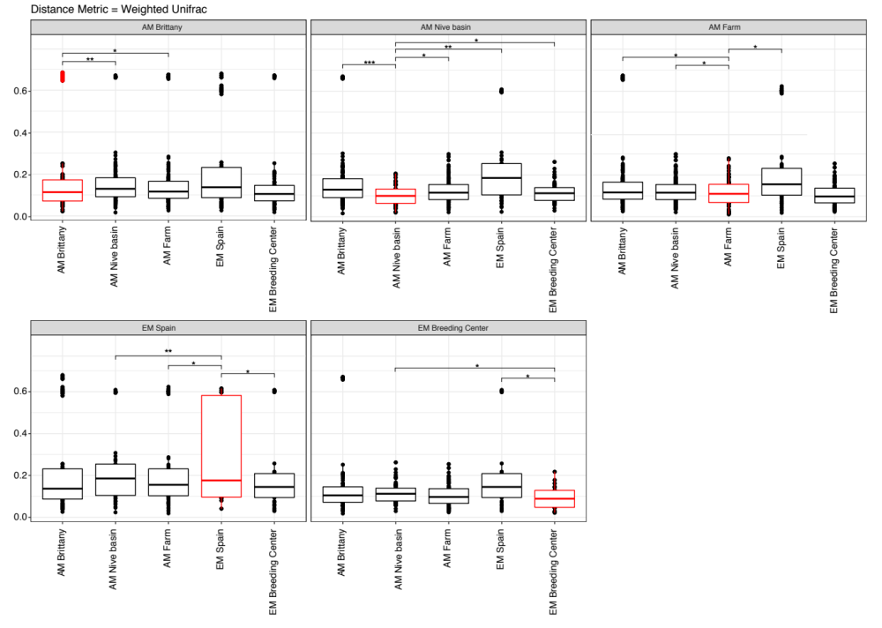
Figure S1. Weighted Unifrac distances comparison boxplots of all samples between and within populations. The boxplot in red represents the beta dispersion within the group and in black of the said red group between all the other groups. *** represents the p-value meeting the standard cutoff p<0.001, ** p<0.01, and * p<0.05.

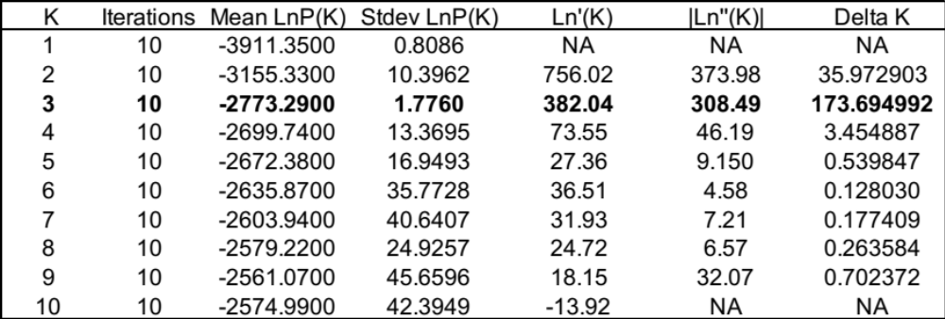
Table S1. Evanno method output values for Best K from Structure results.

Table S2. Additional file. Results from the DESEQ2 differential abundance analysis between mink populations. Each number represents the number of phylotype from each taxon, organized according to their classification, either significantly lower (decrease) or higher (increase) in abundance in the first population compared to another population documented in each column.

