Supplementary information
Giant piezoelectric response and electromechanical coupling in AlScN thin films via multi-scale lattice engineering
Zhenyue Cheng, Tong Liu, Daojian Su, Changhong Yang*, Chuancheng Wu, Yao Liu*, Wei Sun, Shifeng Huang* & Zhenxiang Cheng*
Z. Y. Cheng, D. Su, C. Wu, C. Yang, W. Sun, S. Huang
Shandong Provincial Key Laboratory of Green and Intelligent Building Materials University of Jinan
Jinan 250022, China
E-mail: mse_yangch@ujn.edu.cn; mse_huangsf@ujn.edu.cn
T. Liu
Laoshan Laboratory,
Qingdao 266237, China
Y. Liu
School of Materials Science & Engineering
Shandong University
Jinan 250061, China
E-mail: liuyao@sdu.edu.cn
Z. X. Cheng
Institute for Superconducting and Electronic Materials Faculty of Engineering and Information Sciences
University of Wollongong, Innovation Campus
North Wollongong, NSW 2500, Australia
E-mail: cheng@uow.edu.au

Fig. S1 | Schematic diagram of lattice structure diagrams of AlScN with various Sc contents. a) 0 at.% (pure AlN), b) 2 × 2 × 3 supercell for 4.17 at.% AlScN , c) 2 × 2 × 2 supercell for 6.25 at.% AlScN, d) 2 × 2 × 1 supercell for 12.5 at.% AlScN, e) 2 × 2 × 3 supercell for 16.6 at.% AlScN. f) Valence electron density distribution (arrows indicate minimum electron density (MED)) and electron localization function (ELF) on (100) plane for both AlN and Al_{0.875}Sc_{0.125}N.

Table S1 | Physical parameters of AlScN with various Sc contents of DFT calculated results.
Sc content (at. %) | Elastic constant  (c₃₃)  [kBar] | Piezoelectric coefficient (e₃₃)  [C m⁻²] | Piezoelectric coefficient (d₃₃)  [pC N⁻¹] | Relative permittivity  (ɛ_{r}) | The ratio of piezoelectric coefficient (d₃₃) to relative permittivity (ɛ_{r}) | The rate of change for the ratio (d₃₃/ɛ_{r})
0 | 3581 | 1.46 | 5.25 | 8.68 | 0.605 | -
4.17 | 3369 | 1.50 | 5.94 | 9.01 | 0.659 | 0.013
6.25 | 3267 | 1.52 | 6.34 | 9.15 | 0.693 | 0.016
12.5 | 3003 | 1.70 | 8.01 | 9.60 | 0.834 | 0.023
16.6 | 2746 | 1.77 | 9.70 | 11.04 | 0.879 | 0.011

Table S2 | Piezo/dielectric performance for AlScN thin films with various Sc contents of experimental results.
AlN-based thin films | Piezoelectric coefficient(d₃₃)  [pC/N] | Relative permittivity  (ɛ_{r}) | The ratio of piezoelectric coefficient to relative permittivity | Ref.
AlN | 4 | 10.1 | 0.396 | 1,2
Al_{0.97}Sc_{0.03}N | 4.8 | 10.9 | 0.440 | 1
Al_{0.9}Sc_{0.1}N | 7.5 | 12.6 | 0.595 | 2,3
Al_{0.9}Sc_{0.1}N | 7.79 | 12.6 | 0.618 | 2,3
Al_{0.85}Sc_{0.15}N | 7.92 | 14.1 | 0.562 | 1

Fig. S2 | Variation curve of d₃₃/ɛ_{r} with Sc concentration for experimental results extracted from some references.
We employed density functional theory (DFT) to investigate the effect of Sc doping on the physical parameters of AlN thin films, including elastic constant, piezoelectric coefficient, and relative permittivity. The structural models, constructed using different supercells for AlScN with various Sc concentrations, are shown in Fig. S1a-e, and the corresponding calculated DFT results are summarized in Table S1. The ratio of d₃₃/ɛ_{r}, as an important parameter, is directly proportional to the receiving sensitivity of the MEMS device^{4,5}. It is observed that d₃₃, ɛ_{r}, and their ratio increase with increasing Sc content. Furthermore, the rate of change for the ratio (d₃₃/ɛ_{r}) reaches its maximum at a concentration of 12.5 at.%.
By consulting many reported experimental results, the piezo/dielectric performances of AlScN with different Sc concentrations are shown in Table S2 and Fig. S2. The ratio d₃₃/ɛ_{r} increases as the Sc content increases from 0 at. % to 10 at. %, followed by a declining trend as the Sc content further increases to 15 at. %. Therefore, the optimal ratio is achieved at approximately 10 at. %, indicating peak receiving performance at this concentration.
Based on the above discussion, the following findings are summarized. (i) Both computational and experimental results indicate that piezoelectric performance significantly improves with Sc doping. This enhancement is attributed to the reduced ferroelectric switching barrier, which originates from the increased ionicity (or weakened covalency) of the N-Al(Sc) bond upon Sc incorporation. As quantitatively illustrated in Fig. S1f, the substitution of Al by Sc leads to a distinct reduction in the minimum electron density (MED) and electron localization function (ELF) values along the bond saddle point. Specifically, the MED decreases from 0.195 in pure AlN to 0.178 in Al_{0.875}Sc_{0.125}N, providing direct evidence of lattice softening and increased structural sensitivity to external strain. (ii) In our DFT calculations for free-standing films, the clamping effect of the underlying substrate is neglected, which typically results in predicted d₃₃ values that are inherently higher than those observed in experimental thin-film counterparts. (iii) Under the mechanical clamping conditions of an actual thin film, the effective d₃₃ is generally suppressed more severely than the dielectric constant. This competitive suppression leads to the emergence of an optimal d₃₃/ɛ_{r} ratio in experimental samples. Consequently, by integrating the theoretical rate-of-change maximum (at 12.5 at.%) with the experimentally observed peak performance and film quality considerations, we selected a Sc concentration of 10 at.% for the development of our high-sensitivity MEMS receiver.
Fig. S3 | a) Surface morphology and b) cross-sectional SEM images of AG-AlScN.
Fig. S4 | Relationship between piezoelectric film thickness, resonant frequency, and charge quantity.
Usually, a reduction in the thickness of the piezoelectric film facilitates the shift of the resonant frequency toward the lower frequency band, but results in a significant attenuation of the induced charge density. Computer simulations show a monotonic increase in both resonant frequency and charge output with increasing AlScN film thickness (Fig. S4), confirming the strong dependence of the electromechanical response on this key parameter. Notably, reducing the AlScN thickness from 1.5 μm to 1 μm resulted in a 12.7% more uniform surface charge distribution and a 19.3% lower peak charge density. This configuration also yields a resonant frequency below 390 kHz, meeting the prerequisite for low-frequency detection. These combined advantages led to the selection of the 1 μm thickness for all further simulations.
Fig. S5 | a) The SEM surface image, and the corresponding EDS elemental map of b) Al, c) N, d) Sc. e) EDS spectrum and atomic ratio of RTA-AlScN.

Fig. S6 | XPS analysis of the AlScN: a) Survey spectra. b) Sc 2p_{1/2}, Sc 2p_{3/2} and N 1s, c) Al 2p, d) Sc 2s.
X-ray photoelectron spectroscopy (XPS) analysis was conducted to examine the chemical composition and electronic states of the synthesized AlScN. The survey scan (Fig. S6a) confirms the presence of Al, Sc, and N. High-resolution spectra were collected for each element. As shown in Fig. S6b, the Sc 2p spectrum displays a doublet with the Sc 2p_{3/2} and Sc 2p_{1/2} peaks located at 403.05 and 399.70 eV, respectively, while the N 1s peak was observed at 395.90 eV. Furthermore, the Sc 2s peak was found at 502.15 eV, and the Al 2s and Al 2p peaks were located at 119.55 and 72.95 eV, respectively (Fig. S6c, S6d).
Fig. S7 | a) Cross-sectional TEM and b) HAADF-STEM images of AG-AlScN film. c) FFT pattern of the image in b). d) Parallel lattice spacings along the a-axis. e) Calculated value for parameter of a in AG-AlScN. f) Parallel lattice spacings along the c-axis. g) Calculated value for the lattice parameter of c in AG-AlScN.
Based on the TEM image of the AG-AlScN film (Fig. S7a), several regions were randomly selected. Following this, HAADF-STEM was performed on these areas for dimensional calibration and fast Fourier transform (FFT) analysis (Fig. S7b). The corresponding FFT patterns in Fig. S7c show distinct bright spots, which correspond to the periodic diffraction points of the crystal. After determining the crystal axis direction and selecting the target diffraction spots, an inverse Fourier transform was applied to obtain the lattice spacing, as shown in Fig. S7d and Fig. S7f. By profiling the intensity perpendicular to the lattice fringes and measuring the average spacing between adjacent peaks, the lattice constants a and c were determined, as shown in Fig. S7e and Fig. S7g, respectively.
Fig. S8 | a) Cross-sectional TEM and b) HAADF-STEM images of RTA-AlScN film. c) FFT pattern of the image in b). d) Parallel lattice spacings along the a-axis. e) Calculated value for parameter of a in RTA-AlScN. f) Parallel lattice spacings along the c-axis. g) Calculated value for the lattice parameter of c in RTA-AlScN.
A similar methodology was applied to obtain the lattice parameters of RTA-AlScN film, corresponding to the approach shown in Fig. S8.

Table S3 | The average values of a and c lattice parameters, and the corresponding c/a value.
Lattice parameter | a(Å) | c(Å) | c/a
AG-AlScN | 3.163 | 4.931 | 1.559
RTA-AlScN | 3.279 | 4.951 | 1.510

Fig. S9 | Illustration of a) the experimental setup for RTA and b) transformation of lattice parameters during the RTA process.
As illustrated in Fig. S9a and Fig. S9b, the RTA setup achieved a temperature of 700 °C with a heating rate of up to 900 °C min⁻¹, maintaining this temperature for 10 min. This high-temperature environment provided sufficient energy for the diffusion and rearrangement of Al and Sc atoms, resulting in a more uniform and ordered lattice structure throughout the film. Consequently, the slightly distorted unit cells relaxed toward a more ideal equilibrium state, leading to a decrease in the lattice parameter ratio (c/a). Through the subsequent rapid water-cooling process, this high-temperature c/a ratio was effectively frozen at room temperature, a conclusion further corroborated by HAADF-STEM images analysis.

The electromechanical coupling coefficient calculation
To quantify the electromechanical coupling performance in Fig. 2a, capacitance loops (i.e., C-V) are measured using triangular pulses at 1kHz, applied to capacitors with diameter of 500 μm on thin-film samples.
A linear fit was used to extract the relative permittivity (ε₃₃) of the AlScN, yielding a value of 15.6 for the RTA-AlScN film. The value of $k_{t}^{2}$ was calculated using Equation S1,
$k_{t}^{2}≈\frac{d_{33}^{2} c_{33}}{d_{33}^{2} c_{33}+ε_{0}ε_{33}}$ (S1)
Where d₃₃ and ε₃₃ are the piezoelectric coefficient and relative permittivity along the crystallographic c-axis, respectively, c₃₃ is the elastic stiffness constant along the crystallographic c-axis, with a value of 330 GPa (9.6 at.% Sc)¹, ε₀ is the vacuum permittivity, with an approximate value of 8.854 × 10⁻¹² F m⁻¹.

Fig. S10 | d₃₃ values of a) AlN, b) AG-AlScN and c) RTA-AlScN thin films.
Fig. S11 | a) 6-inch AlScN thin film. b) The coordinates of the selected points in the 6-inch Si wafer. c) d₃₃ values at different positions.
Fig. S12 | Dielectric constants and dielectric loss of AlN, AG-AlScN and RTA-AlScN.
Fig. S13 | a) The P-E loops and J-E curves of AlScN thin films at a frequency of 10 Hz. b) The endurance test of AlScN films.
As shown in Fig. S13a, both AG- AlScN and RTA-AlScN thin films display clear box-like hysteresis loops due to the ferroelectric characteristic of Sc-doped AlN. After RTA, the remnant polarization P_{r} is markedly increased, reaching approximately 107 μC cm⁻². The incomplete closure of the P-E loop for RTA-AlScN thin films is mainly due to the non-negligible leakage currents under the extremely high electric fields. Reliable stability is also a critical parameter for evaluating the performance of piezoelectric thin films. The corresponding J-E curves are plotted in Fig. S13a. The ferroelectricity of both ScAlN films is further confirmed by the presence of distinct switching current peaks.
Fig. S14 | Surface-induced a) charge and b) stress distribution for R_{C&PF}/R_{TE} = 1.
Fig. S15 | Surface-induced a) charge and b) stress distribution for R_{C}/R_{PF&TE} = 1.5
For R_{C}/R_{PF&TE} = 1, the simultaneous generation of positive and negative charges on the top electrode (Fig. S14a) leads to charge recombination, thereby reducing the total charge. This charge reduction also stems from the piezoelectric film and top electrode being under opposing stress components (Fig. S14b). As the ratio decreases to 1.25, the top electrode surface generates only positive charges and reaches the maximum total charge (Fig. 3c). This is attributed to the entire electrode being located within a region of positive (compressive) stress (Fig. 3d). However, when the R_{C}/R_{PF&TE} ratio exceeds 1.25, the back cavity becomes excessively large relative to the membrane itself, thereby weakening the membrane's deformation capability and reducing the total charge induced on the electrode surface (Fig. S15a). Additionally, a reduction in the top electrode area further contributes to the decline in total charge (Fig. S15b).
Fig. S16 | Surface-induced a) charge and b) stress distribution for R_{C&PF}/R_{TE}=1
Fig. S17 | Surface-induced a) charge and b) stress distribution for R_{C&PF}/R_{TE} = 1.5.
At a ratio of R_{C&PF}/R_{TE} =1.0, the generation of both positive and negative charges on the top electrode (Fig. S16a) leads to charge recombination. This reduces the total charge and consequently diminishes the acoustic pressure sensitivity, which is attributed to the presence of opposing stress components in film (Fig. S16b). In contrast, at a ratio of 1.25, only positive charges are presented (Fig. 3e). Here, the charges are fully concentrated within the electrode area, maximizing the total charge and enhancing the sensitivity, while the entire electrode is under compressive stress (Fig. 3f). However, at a ratio of 1.5, although only positive charges are generated (Fig. S17a), the total charge decreases compared to the ratio of 1.25 due to a reduced electrode area. The electrode remains entirely within a compressive stress region in this case as well (Fig. S17b).

Fig. S18 | Physical photos of three photomasks: a) M1, b) M2, c) M3.
Fig. S19 | Mask layouts for a unit according to a) M1, b) M2, c) M3, respectively.

Fig. S20 | Photograph of bare MEMS chip with an area of approximately 36 mm².

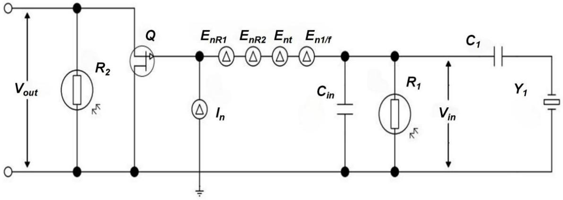
Fig. S21 | Schematic diagram of the low-noise pre-amplifier circuit.
When external acoustic pressure signals are received by the MEMS unit, it is equivalent to applying external force on its surface. Due to the piezoelectric effect, electric charges are generated on the upper and lower metal electrodes of each unit. To amplify these charges effectively for output, the design of a low-noise preamplification circuit is required.
The noise of the preamplifier circuit primarily originates from two sources: operational amplifier noise and resistor thermal noise. Among these, operational amplifier noise mainly stems from the inherent noise of transistor structures, while resistor thermal noise arises from the random thermal motion of electrons within resistors. The voltage noise spectral density is given by
$E_{t}=\sqrt{4k_{B}TR}$ (S2)
In the equation: k_{B} represents the Boltzmann constant (k_{B} ≈ 1.38×10⁻²³ J·K⁻¹); T denotes the thermodynamic absolute temperature of the resistor, and R signifies the resistance value of the resistor.
In the design of this study, a low-noise preamplifier circuit is implemented through a two-stage amplification architecture, as illustrated in Fig. S21. The noise performance of the first-stage amplifier directly determines the overall circuit’s characteristics. To mitigate predominant low-frequency noise (1/f noise) in the operational band, this design employs a JFET (junction field-effect transistor) operational amplifier configuration, effectively reducing 1/f noise by approximately 3 dB. The second-stage amplification utilizes a low-noise operational amplifier complemented by small-value feedback resistors, maintaining the preamplifier’s low-frequency noise performance while compensating for the gain of the first-stage amplifier.
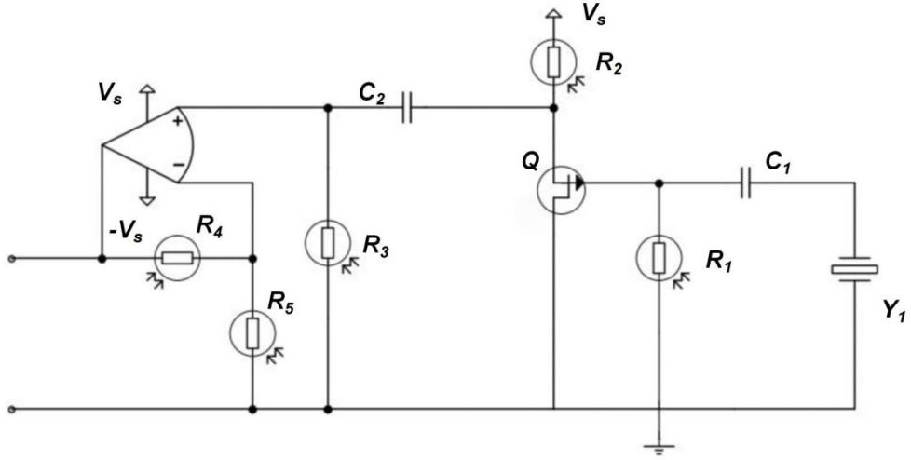
Fig. S22 | En-In noise model for the low-noise preamplifier.
From the above analysis, it can be concluded that the noise of the preamplifier circuit primarily originates from the first-stage amplifier circuit. By analyzing the noise contribution of each component within the circuit, an equivalent noise model diagram was obtained as shown in Fig. S22. Through calculations, the equivalent voltage noise of the pre-amplification circuit ${\text{e}}_{\text{ni}}^{\text{2}}$ was determined to be
$$\overline{e_{ni}^{2}}=\overline{e_{nR1}^{2}}+\overline{e_{nR2}^{2}}+\overline{e_{nt}^{2}}+\overline{e_{n(\frac{1}{f})}^{2}}+\overline{v_{ns}^{2}}$$
$=\frac{4k_{B}TR1}{1+{(wR_{1}C_{1})}^{2}}+\frac{k_{B}T}{{\text{g}}_{fs}^{2}R_{2}}+\frac{2k_{B}TA}{{\text{g}}_{fs}}+\frac{aqV_{G}^{∗}}{4C_{in}f}+4qI_{GSS}\frac{R_{1}^{2}}{1+{(wR_{1}C_{1})}^{2}}$ (S3)
In the equation: ${\text{e}}_{\text{nR}\text{1}}^{\text{2}}$和${\text{e}}_{\text{nR}\text{2}}^{\text{2}}$ represent the equivalent input noise voltage spectral densities of bias resistor R₁ and load resistor R₂ respectively; ${\text{e}}_{\text{nt}}^{\text{2}}$denotes the channel thermal noise voltage spectral density of the JFET; ${\text{e}}_{\text{n}\text{(}\frac{\text{1}}{\text{f}}\text{)}}^{\text{2}}$represents the 1/f noise voltage spectral density of the JFET;${\text{v}}_{\text{ns}}^{\text{2}}$is the equivalent input noise voltage spectral density generated by the shot noise current flowing through the impedance in the gate; g_{fs} is the forward transconductance of the FET; A (empirical constant) typically approximates 0.67; IGSS represents the reverse leakage current of the JFET; q signifies the charge of a single electron (~1.6×10⁻¹⁹C).
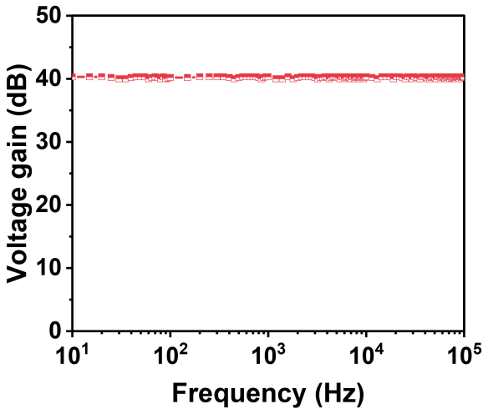
Fig. S23 | Voltage gain of low-noise preamplifier.
In Fig. S23, the signal amplification circuit demonstrates excellent amplification capability within the 10 Hz-100 kHz range, achieving a signal gain of 40 dB. This indicates that the amplifier provides relatively uniform amplification for signals across the tested frequency spectrum.
During the fabrication process, the operational amplifier employed was the LTC 6241 from LINEAR. To achieve optimal impedance matching, resistor R₁ and R₂ were selected with values of 10 kΩ, while capacitor C was chosen as 100 nF. Experimental results demonstrate that the designed low-noise preamplifier circuit delivers a maximum gain of 40 dB, with an equivalent input noise of 8.2 nV Hz^{-0.5} at 1 kHz.

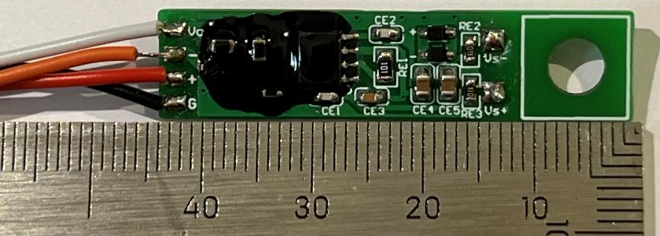
Fig. S24 | Photograph of pre-amplifier PCB.

Fig. S25 | Wire bonding: a) Gold wire ball bonder; b) Bare die with completed bonding wires.

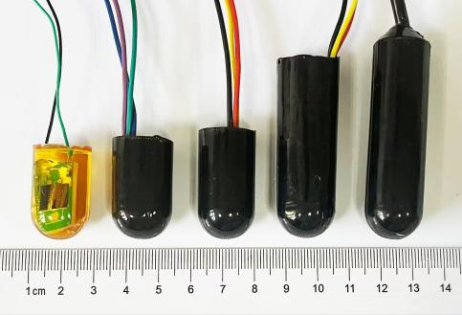

Fig. S26 | The fabricated piezoelectric MEMS sensors.

Fig. S27 | Schematic of the sensitivity measurement setup.

Fig. S28 | Temporal response of output voltage.

Table S4 | Acoustic impedance properties of different media materials.
Materials | Density ρ  (g cm⁻³) | Sound Velocity V  (m s⁻¹) | Acoustic Impedance  (MRayl)
Silicone oil | 0.97 | 1300 | 1.26
Polyurethane | 1.07 | 1520 | 1.62
Seawater | 1.25 | 1531 | 1.57
Ceramic panel | 7.8 | 4000 | 31.2
Acoustic impedance describes a medium's resistance to sound propagation. Impedance matching is a key factor determining the energy conversion efficiency of a sensor⁶. For piezoelectric MEMS acoustic receivers, the degree of impedance coupling between media determines whether acoustic energy can be efficiently transmitted through the sensor, thereby directly affecting the reception sensitivity and peak-to-peak voltage output.
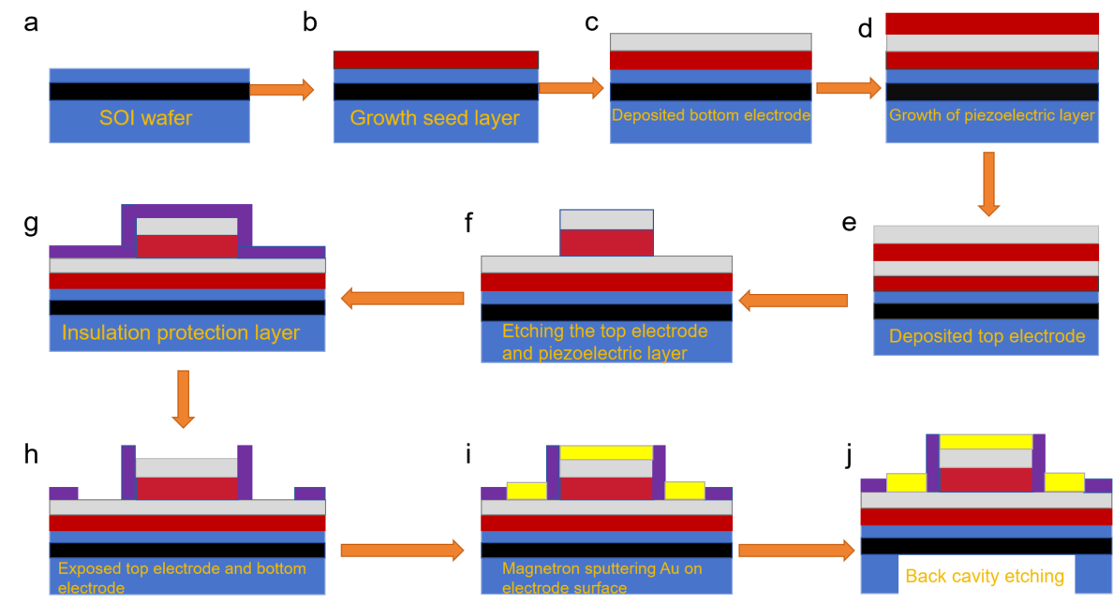
Fig. S29 | A flow chart for fabricating MEMS device: a-d) Deposition process of AlScN piezoelectric thin film on 6-inch SOI wafer; e-j) Micromachining procedure of device.
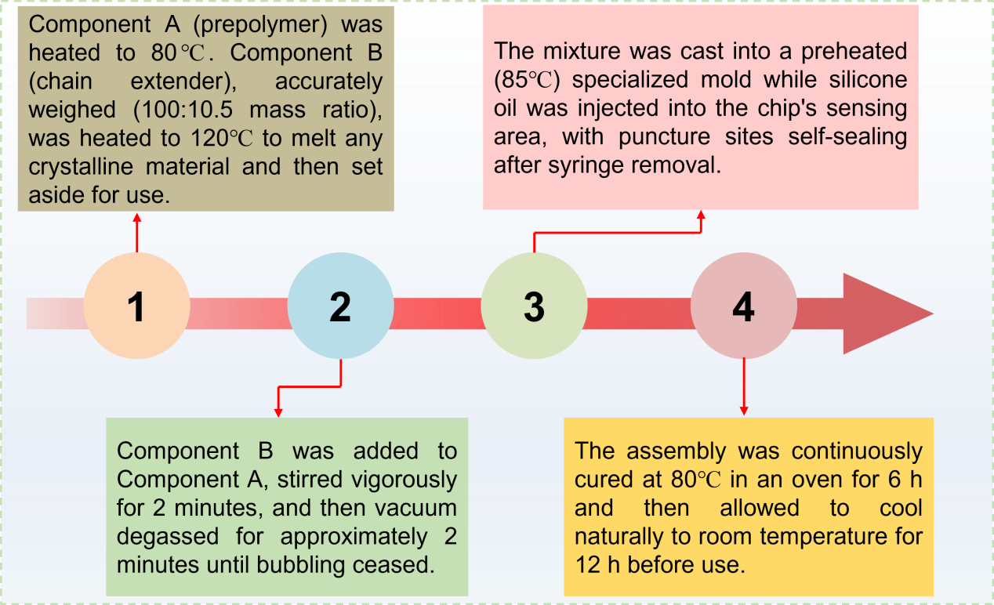
Fig. S30 | Procedure for packaging of piezoelectric MEMS receiver.

References

- Moreira, M., Bjurström, J., Katardjev, I. & Yantchev, V. Aluminum scandium nitride thin-film bulk acoustic resonators for wide band applications. Vacuum 86, 23–26 (2011).
- Matloub, R. et al. Piezoelectric Al_{1−x}Sc_{x}N thin films: A semiconductor compatible solution for mechanical energy harvesting and sensors. Appl. Phys. Lett. 102, 152903 (2013)
- Jiang, W. et al. In Situ Synchrotron XRD Characterization of Piezoelectric Al_{1−x}Sc_{x}N Thin Films for MEMS Applications. Materials 16, 1781 (2023).
- Ledesma, E., Zamora, I., Uranga, A. & Barniol, N. 9.5 % scandium doped ALN PMUT compatible with pre-processed CMOS substrates. In: 2021 IEEE 34th International Conference on Micro Electro Mechanical Systems (MEMS)) , 887-890 (2021).
- Akiyama, M., Umeda, K., Honda, A. & Nagase, T. Influence of scandium concentration on power generation figure of merit of scandium aluminum nitride thin films. Appl. Phys. Lett. 102, 021915 (2013).
- Zhou, P. et al. Water–air acoustic communication based on broadband impedance matching. Appl. Phys. Lett. 123, 191701 (2023).

