Assessing the effects of greenness on disability-adjusted life years (DALYs) for depressive disorder: a global analysis
Aji Kusumaning Asri¹, Hui-Ju Tsai², Hsiao-Yun Lee³, Hao-Ting Chang⁴, Pei-Yi Wong⁴, Shih-Chun Candice Lung^{5,6,7}, Wen-Chi Pan⁸, Yue-Liang Leon Guo^{9,10}, Chia-Pin Yu¹¹, Chi-Shin Wu¹², Huey-Jen Su⁴, Chih-Da Wu^{1,10,*}, John D. Spengler¹³

¹ Department of Geomatics, National Cheng Kung University, Tainan, Taiwan.
² Institute of Population Health Sciences, National Health Research Institutes, Miaoli, Taiwan.
³ Department of Leisure Industry and Health Promotion, National Taipei University of Nursing and Health Sciences, Taipei, Taiwan.
⁴ Department of Environmental and Occupational Health, College of Medicine, National Cheng Kung University, Tainan, Taiwan.
⁵ Research Center for Environmental Changes, Academia Sinica, Taipei, Taiwan.
⁶ Department of Atmospheric Sciences, National Taiwan University, Taipei, Taiwan.
⁷ Institute of Environmental Health, School of Public Health, National Taiwan University, Taipei, Taiwan.
⁸ Institute of Environmental and Occupational Health Sciences, National Yang Ming Chiao Tung University, Taipei, Taiwan.
⁹ Department of Environmental and Occupational Medicine, National Taiwan University (NTU) and NTU Hospital, Taipei, Taiwan.
¹⁰ National Institute of Environmental Health Sciences, National Health Research Institutes, Miaoli, Taiwan.
¹¹ School of Forestry and Resource Conservation, National Taiwan University, Taipei, Taiwan.
¹² Department of Psychiatry, National Taiwan University Hospital, National Taiwan University, Taiwan.
¹³ Department of Environmental Health, Harvard T.H. Chan School of Public Health, Boston, MA, United States of America.

* Correspondence to Professor Chih-Da Wu,
No. 1 University Road, Tainan 70101, Taiwan
Telephone: (886) 6-275-7575 ext 63841. Fax: (886) 6-237-5764.
E-mail: chidawu@mail.ncku.edu.tw

Supplementary Information
Table of Contents
Table S1. Datasets of variables/covariates.
Table S2. Spearman correlation analysis between depressive disorders and the burden of comorbidities.
Table S3. The results of generalized variance-inflation factors (GVIFs).
Table S4. Significance of spatial autocorrelation tests.
Table S5. Positive-negative exposures and outcomes controls.
Figure S1. Spatial distribution of DALY loss due to depressive disorders (years/100 000 population) after adjusting for the population size of each country.

Table S1. Datasets of variables/covariates.
Variable/ covariate | Description | Data Source | Year of data
PM_{2.5} | We estimated PM_{2.5} concentration variations on a global scale with spatial resolution 1x1 km. PM_{2.5} data is a daily total column of aerosol optical depth retrievals from satellites that was coupled with the GEOS-Chem transport model and geographically weighted regression model (van den Berg et al., 2016) | The Atmosphere Composition Analysis Group established by Prof. Randall Martin from Dalhousie University. | 2000, 2010, 2015, and 2016
Demographic factors (population size, age, gender) | We used country-level demographics data including population size, age, and sex. In line with the DALY database, we used proportion values from seven age groups in the analysis (0-4, 5-14, 15-29, 30-49, 50-59, 60-69, and >70 years). Sex is represented by percentage of females; females had a higher risk of depression than males (Bebbington, 1996) | United Nations, Department of Economic and Social Affairs. | 2000, 2010, 2015, and 2016
Economic status | We applied three levels of economic status, including low-income, middle-income, and high-income countries. Classification of economic status for each country was based on the 2016 Atlas gross national income per capita | World Bank Group | 2000, 2010, 2015, and 2016
Education | We analyzed the proportion/ percentage of the educated population on a country-level | World Bank Group | 2000, 2010, 2015, and 2016
Urbanization level | We categorized the urbanization level into three groups: low-urbanization, middle-urbanization, and high-urbanization. Level was determined based on the prevalence rate of the urban population in each country. | World Bank Group | 2000, 2010, 2015, and 2016
Variable/ covariate | Description | Data Source | Year of data
No religion | We used data on the prevalence rates of populations without religion identified in each country | United Nations Statistics Division | 2000 - 2016
Divorce rate | We used the prevalence of divorce data in each country that has been standardized by populations aged 15+ years old | United Nations, Department of Economic and Social Affairs | 2008
Continent | We established five regional categories by continent including Africa, America, Asia, Europe, and Oceania to represent the different population characteristics. | United Nations Statistics Division | 2016
Alcohol consumption | We used the average number of alcohol consumption in litres per population | World Bank Group | 2016
Smoking | We used the prevalence rate of smoking data at the country-level | World Bank Group | 2016
Blood pressure | We collected the mean systolic blood pressure data at the country-level | World Health Organization | 2000, 2010, 2015, and 2016
Chronic diseases/ comorbidity | We considered the burden of other chronic diseases, such as malignant neoplasms (ICD-10, C00-C97), diabetes mellitus (ICD-10, E10-E14), cardiovascular disease (ICD-10, I00-I99), and respiratory disease (ICD). -10, J30-J98) as covariates and represented by the DALY numbers | World Health Organization | 2000, 2010, 2015, and 2016

Table S2. Spearman correlation analysis between depressive disorders and the burden of comorbidities.
Year | Malignant neoplasms | Cardiovascular diseases | Respiratory diseases | Diabetes mellitus | All comorbidities
Year | ρ | ρ | ρ | ρ | ρ
2000-2016 | 0.357*** | 0.203*** | 0.100** | 0.073* | 0.314***
2000 | 0.360*** | 0.302*** | 0.129* | 0.073* | 0.363***
2010 | 0.334*** | 0.206** | 0.092 | 0.060 | 0.311***
2015 | 0.352*** | 0.177* | 0.108 | 0.060 | 0.295***
2016 | 0.356*** | 0.182** | 0.107 | 0.062 | 0.295***
* p-value <0.05; ** p-value <0.01; and *** p-value <0.001

Table S3. The result of generalized variance-inflation factors (GVIFs).
Variables | GVIFs
Comorbidities– DALY (years/100 000 population) | -
DALY loss due to malignant neoplasms | 2.969
DALY loss due to diabetes mellitus | 1.395
DALY loss due to cardiovascular diseases | 1.882
DALY loss due to respiratory diseases | 1.385
Environmental exposures | -
Greenness (NDVI) | 1.817
PM_{2.5} (µg/m³) | 1.782
Covariates | -
Population size ('000) | 1.112
Sex (female %) | 1.924
Age 0-4 (yrs, %) | 2.587
Age 5 - 14 (yrs, %) | 3.687
Age 15 - 29 (yrs, %) | 2.340
Age 30 - 49 (yrs, %) | 3.014
Age 50 - 59 (yrs, %) | 2.065
Age 60 - 69 (yrs, %) | 1.897
Age > 70 (yrs, %) | 2.308
Economic status | 2.270
Education (%) | 1.901
Urbanization level (%) | 1.617
No religion (%) | 1.121
Divorce rate (%) | 1.485
Continent | 1.555
Alcohol consumption (liters/population) | 1.399
Smoking (%) | 1.361
Mean systolic blood pressure (mmHg) | 1.528

Table S4. Significance of spatial autocorrelation tests.
Year | Moran's Index | z-score | p-value
2000 | 0.011 | 1.179 | 0.238
2010 | 0.003 | 0.616 | 0.538
2015 | 0.003 | 0.593 | 0.553
2016 | 0.002 | 0.560 | 0.575

Table S5. Positive-negative exposures and outcomes controls.
Positive – negative exposures control
 | CO₂ related to depressive disorders (positive) |  | Wind speed related to depressive disorders (negative)
 | Coefficient of CO₂ ^{d}  (95% CI) | p-value | Coefficient of  Wind speed ^{d}  (95% CI) | p-value
Model 1 ª | 0.034  (0.006, 0.060) | <0.05 | 0.122  (-0.002, 0.245) | 0.10
Model 2 ^{b} | 0.038  (0.003, 0.072) | <0.05 | 0.099  (-0.028, 0.227) | 0.14
Positive – negative outcomes control
 | Greenness related to CD  (positive) |  | Greenness related to HIV  (negative)
 | Coefficient of NDVI ^{d}  (95% CI) | p-value | Coefficient of NDVI ^{d} (95% CI) | p-value
Model 1 ª | -20.869  (-30.790, -10.950) | <0.001 | 0.009  (-0.021, 0.041) | 0.53
Model 2 ^{c} | -16.820  (-25.890, -7.756) | <0.001 | 0.006  (-0.026, 0.037) | 0.73
Abbreviations: CD= Cardiovascular diseases; HIV= Human Immunodeficiency Virus; CI= Confidence Interval
- Additionally, adjusted for population size, sex (% of females), age, and year.
- Control variables included population size, sex (% of females), age, economic status, the prevalence rate of education, urbanization rates, no religion, the prevalence rate of smoking, alcohol consumption, systolic blood pressure, divorce rate, burden of comorbidities, and year.
- Control variables included population size, sex (% of females), age, economic status (level of income), the prevalence rate of education, the prevalence rate of smoking, alcohol consumption, urbanization rates, systolic blood pressure, and year.
- Continuous variable

Figure S1. Spatial distribution of DALY loss due to depressive disorders (years/100 000 population) after adjusting for the population size of each country.
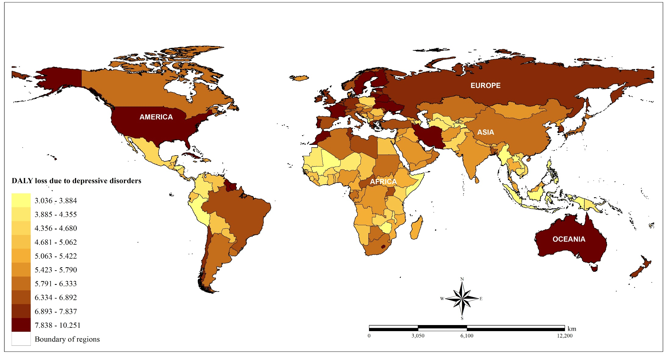

References
Bebbington, P., 1996. The origins of sex differences in depressive disorder: bridging the gap. International Review of Psychiatry. 8(4), 295-332. https://doi.org/10.3109/09540269609051547.
van den Berg, M., et al., 2016. Visiting green space is associated with mental health and vitality: A cross-sectional study in four european cities. Health & Place. 38, 8-15. https://doi.org/10.1016/j.healthplace.2016.01.003.

