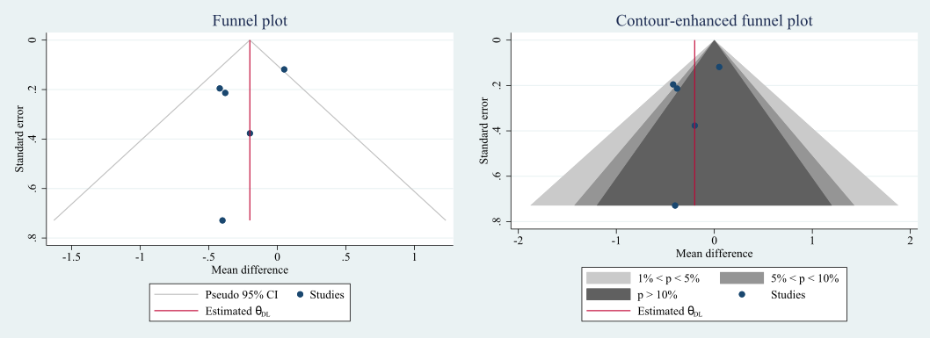
Figure 1. Funnel plot for pooling of semen volume

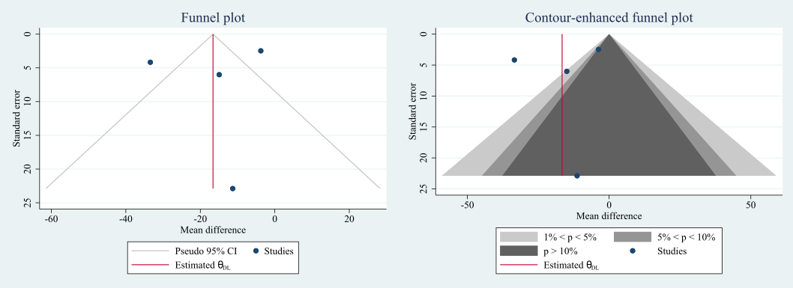
Figure 2. Funnel plot for pooling of sperm concentration

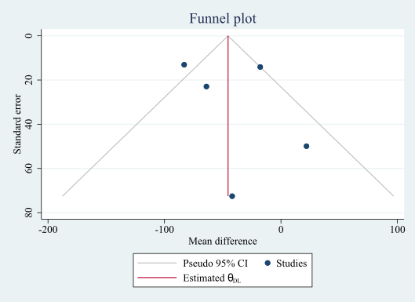
Figure 3. Funnel plot for total sperm number
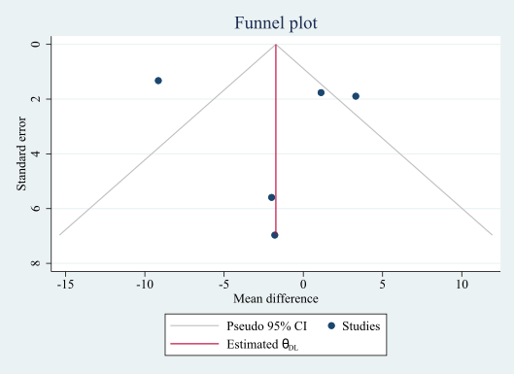
Figure 4. Funnel plot for progressive sperm motility

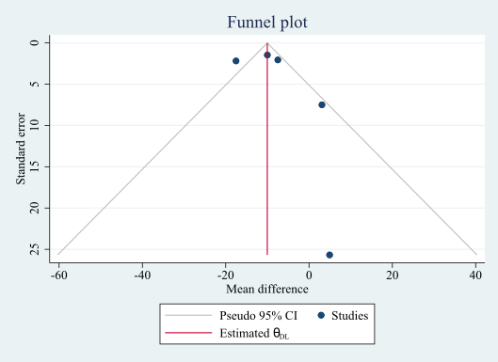
Figure 5. Funnel plot for sperm motility

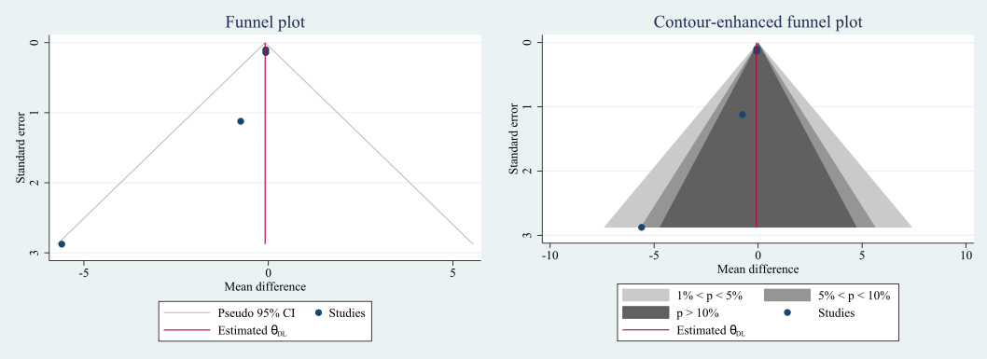
Figure 6. Funnel plot for Follicle stimulating hormone

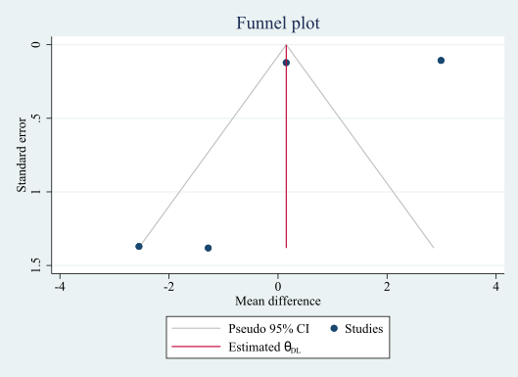
Figure 7. Funnel plot for Luteinizing hormone

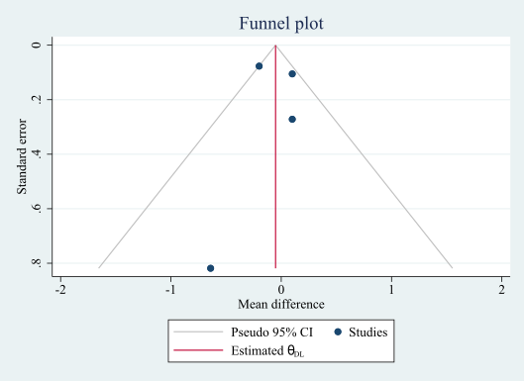
Figure 8. Funnel plot for Testosterone

