Supplementary Information for
Self-guided reinforcement learning enables HLA-presented peptide vaccine candidate design
Guanqiao Zhang^{1#}, Yaqi Fu^{1#}, Damiano Buratto^{1,2}, Kevin C. Chan⁵, Hanyao Wang¹, Yuanling Huang^{1,6}, Shi-Meng Gong¹, Chuanxi Xu¹, Xufan Gao¹, Liquan Huang^{1,2}, Zaixing Yang¹, Ruhong Zhou^{1,2,3,4}*

¹ College of Physics, Institute of Quantitative Biology, and College of Life Sciences, Zhejiang University, Hangzhou 310027, China
² Zhejiang Key Laboratory of Cell and Molecular Intelligent Design and Development, Zhejiang University, Hangzhou 310058, China
³ The First Affiliated Hospital, School of Medicine, Zhejiang University, Hangzhou 310058, China
⁴ Department of Chemistry, Columbia University, New York, NY 10027, USA
⁵ Department of Biosciences and Bioinformatics, School of Science, Xi’an Jiaotong-Liverpool University, Suzhou, China
⁶ Institute WUT-AMU, Wuhan University of Technology, Wuhan 430070, China

#These authors contribute equally to the work
*Correspondence should be addressed to rhzhou@zju.edu.cn

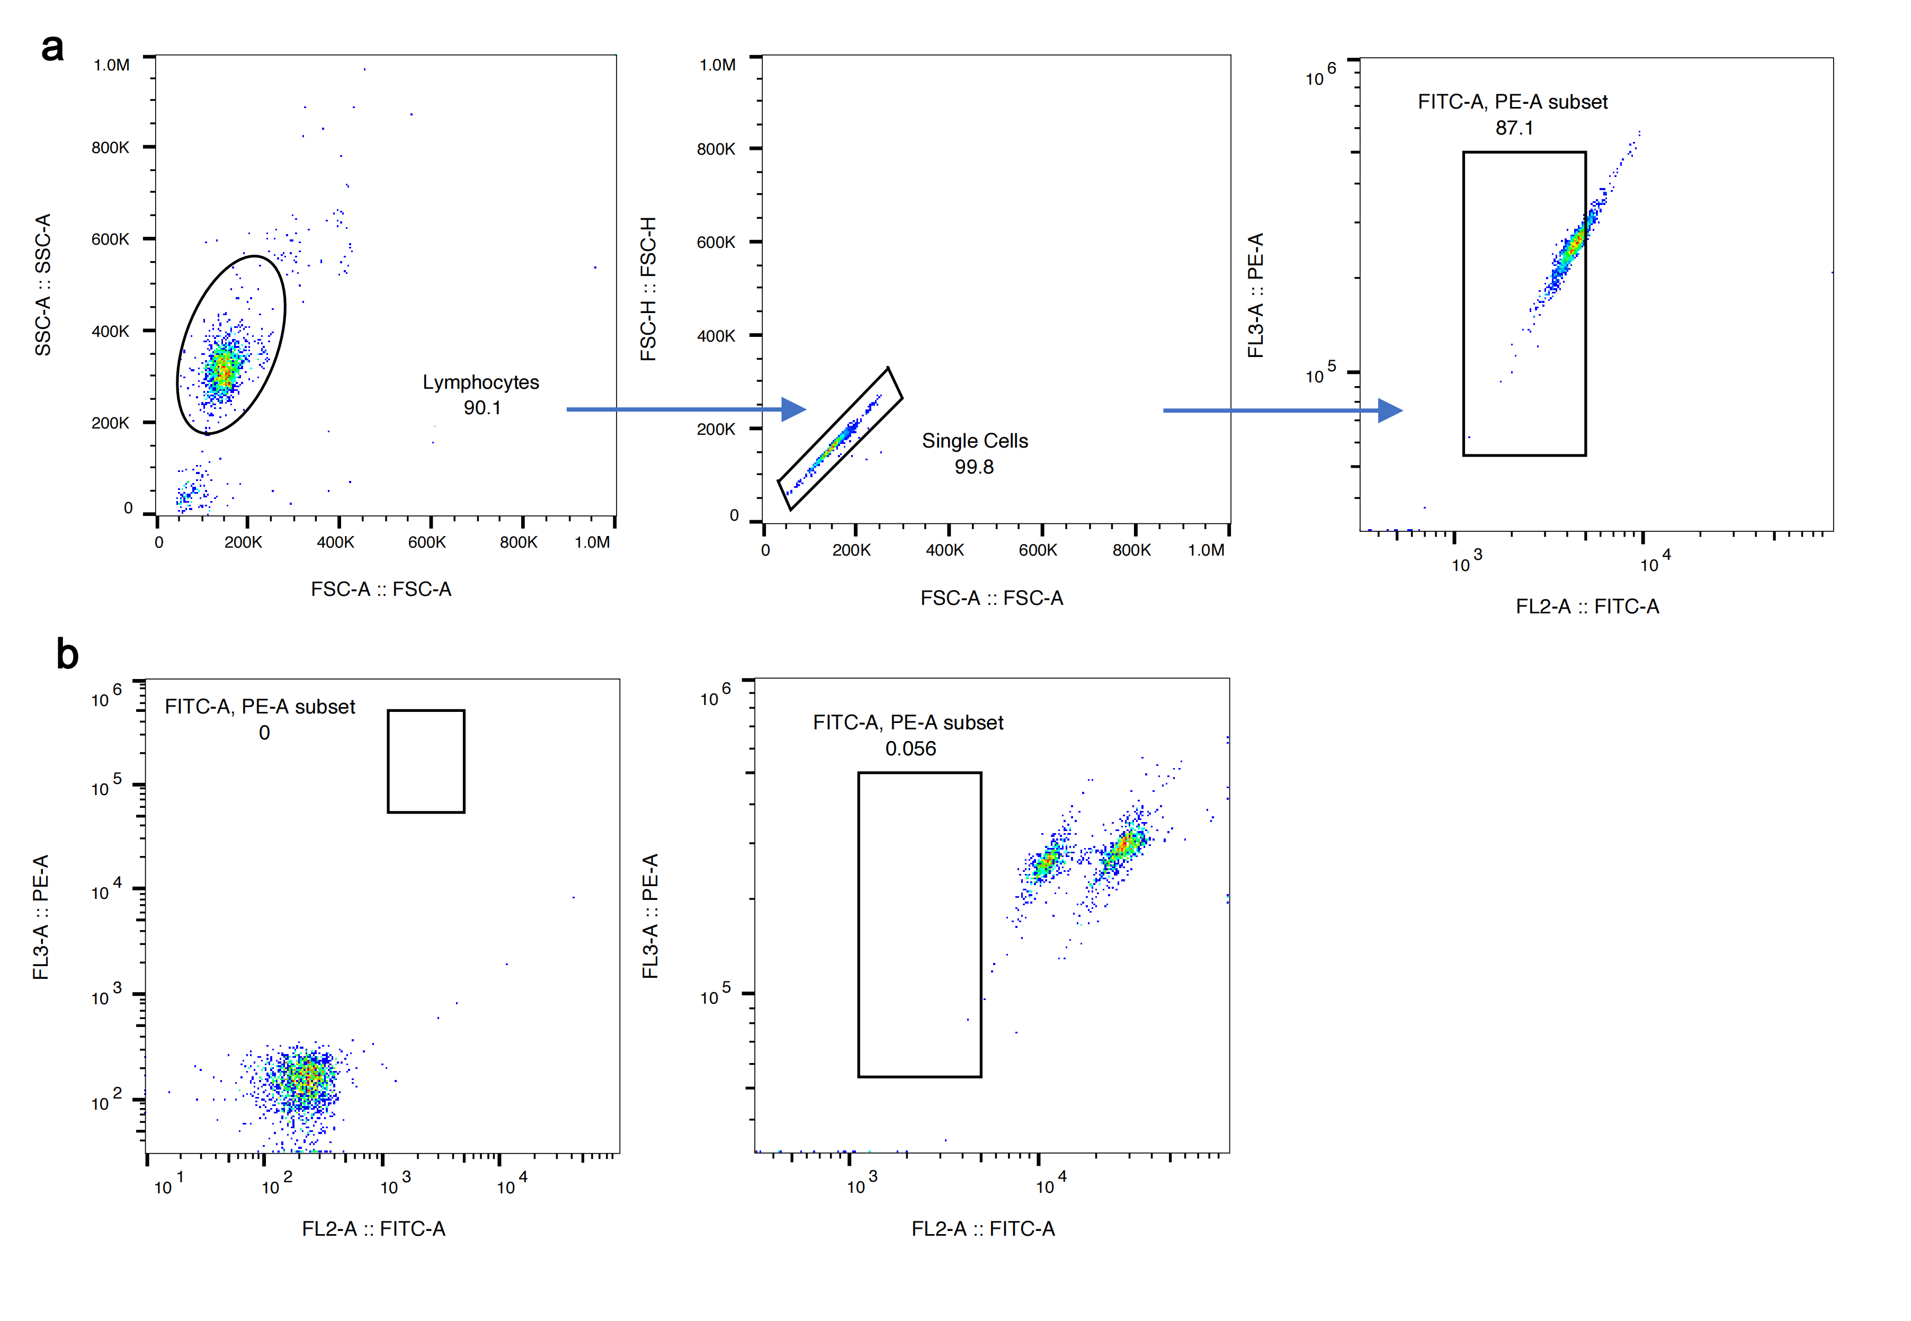
Supplementary Fig. 1 Gating strategy of the peptide exchange assay in strategy validation. (a) Gating strategy for Peptide exchange assay. (b) Flow cytometric plots of 0% and 100% exchange rates, respectively.

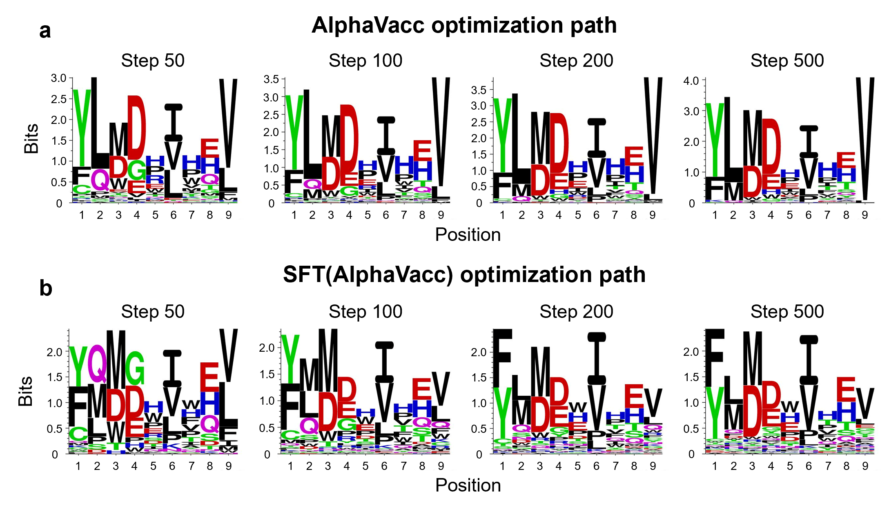
Supplementary Fig. 2 Ablation experiments validate the importance of MCTS performance in AlphaVacc. (a) The computed motifs of the datasets generated by AlphaVacc were collected along the optimization path. (b) The computed motifs of the datasets generated by SFT(AlphaVacc) were collected along the optimization path.

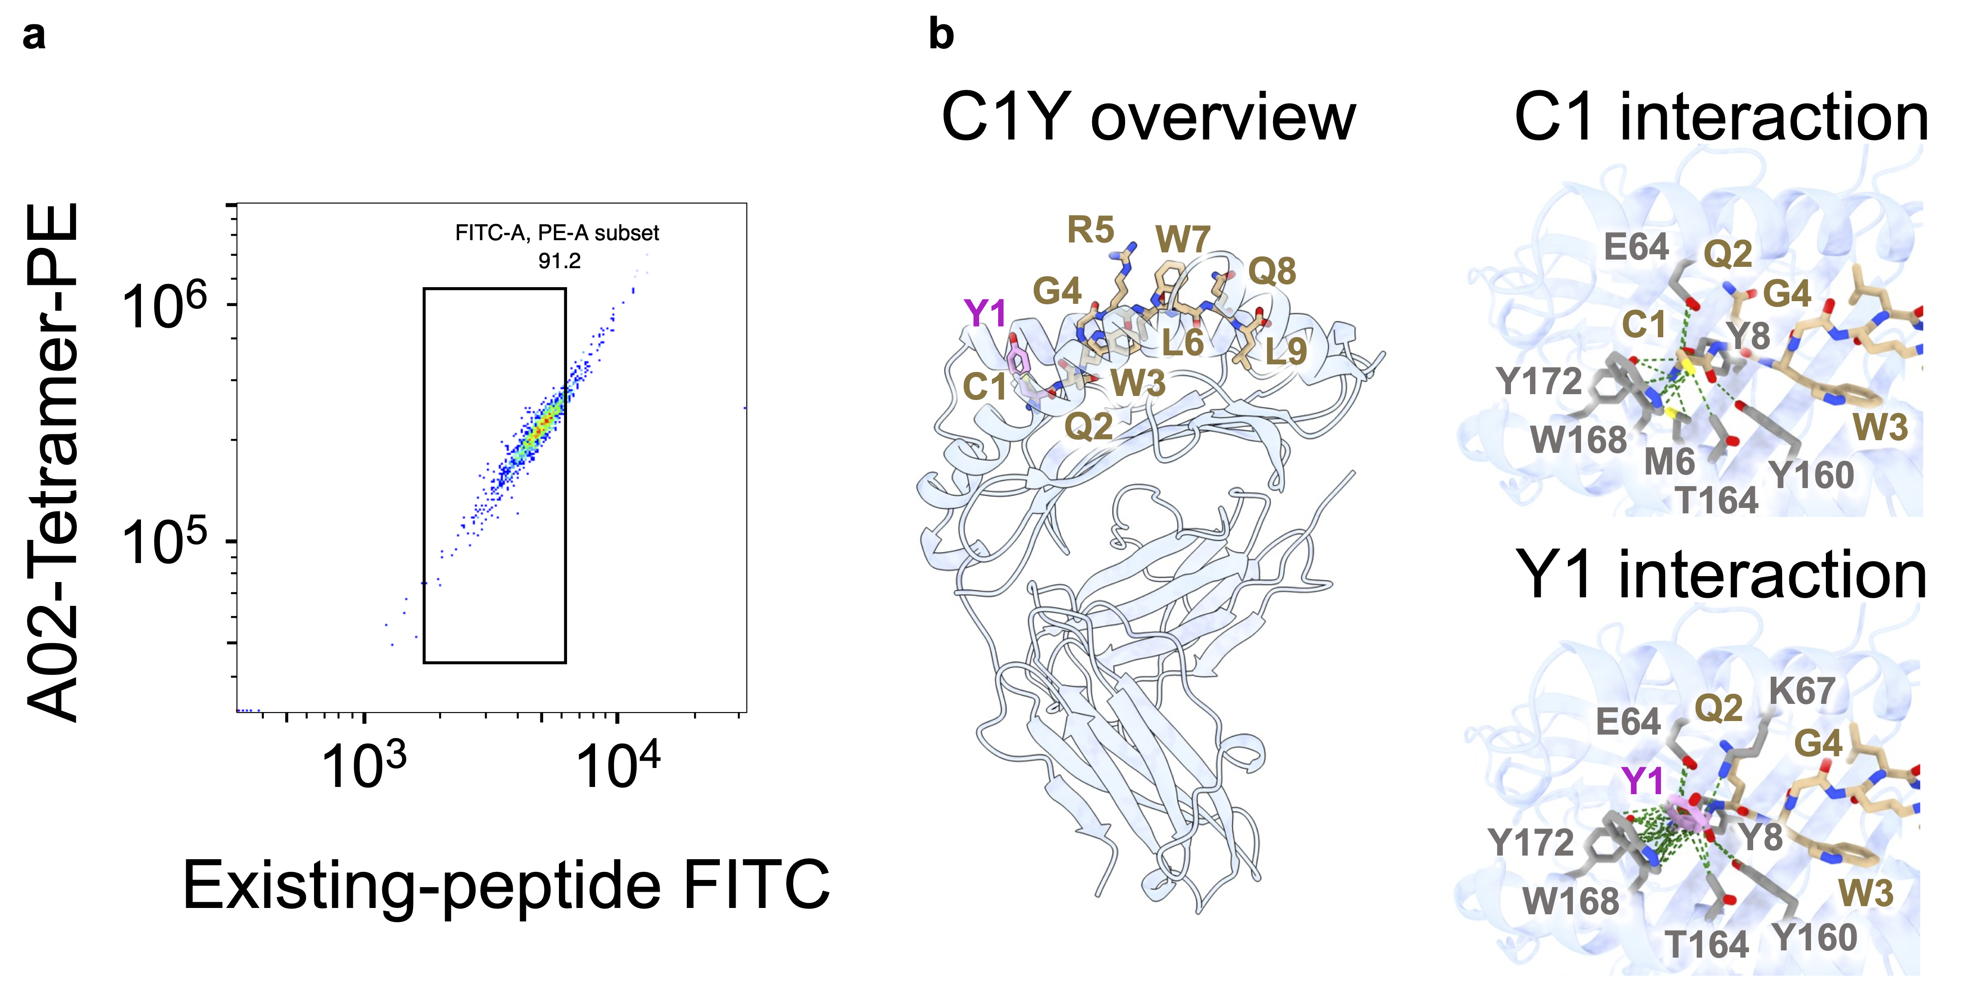
Supplementary Fig. 3 Representative flow cytometry plot for BING-4 peptide and interaction of representative single-mutant variant. (a) Representative flow cytometry plot for BING-4 peptide CQWGRLWQL (WT). (b) Comparison of hydrogen bonding interactions between WT (cysteine in position 1, C1) and pep1 (tyrosine in position 1, Y1).

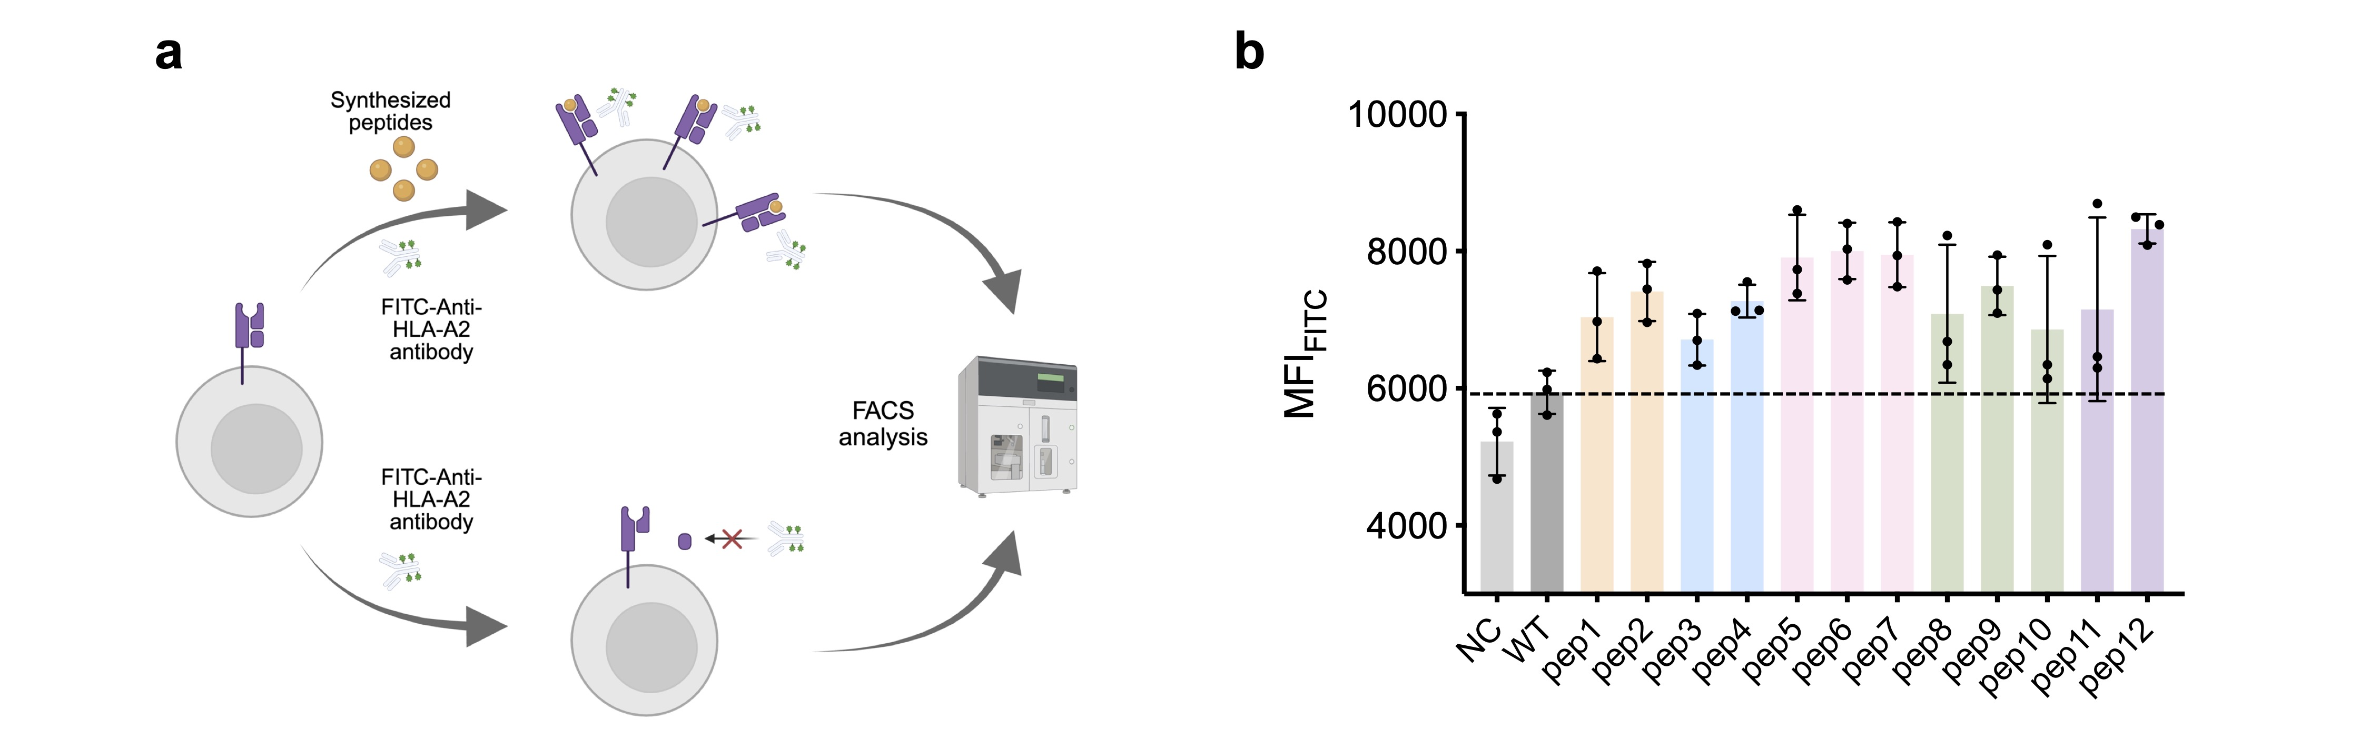
Supplementary Fig. 4 Gating strategy for the CQW and candidate peptide exchange assay and T2 binding assay. (a) Schematic diagram of the T2 peptide-binding assay. Created in https://BioRender.com. (b) The bar plot depicts the MFI_{FITC} of HLA-A*02:01 staining. The dashed line indicates the fluorescence intensity level of WT.

Supplementary Fig. 5 Gating strategy for the CQW and candidate peptide exchange assay and T2 binding assay. (a) Gating strategy for the peptide exchange assay. (b) Flow cytometric plots of 0% and 100% exchange rates, respectively. (c) Gating strategy of the T2 binding assay.

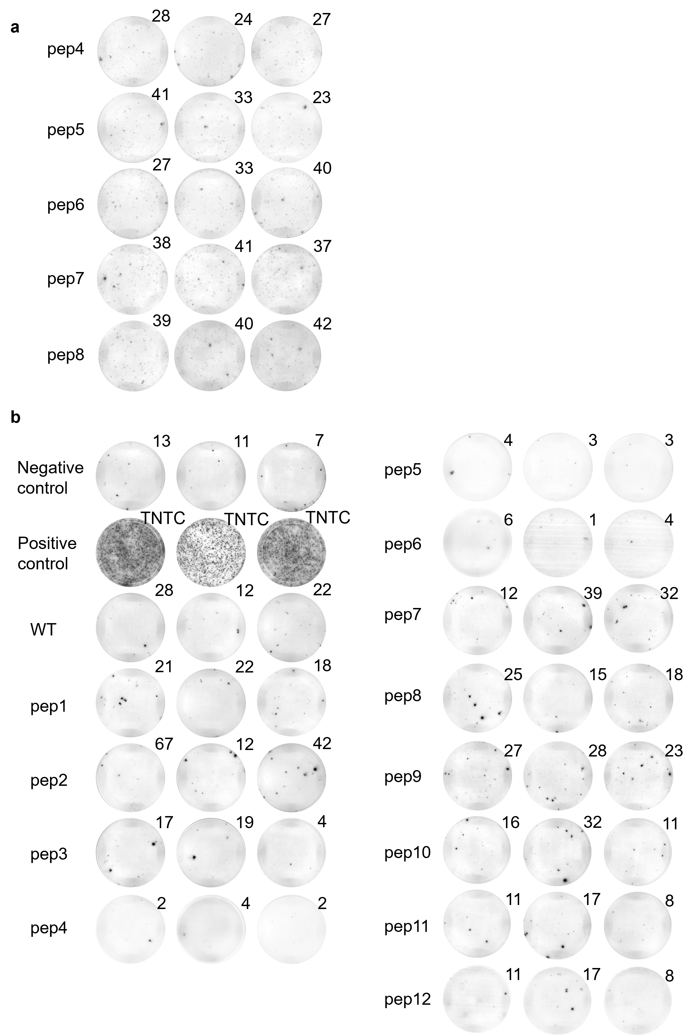
Supplementary Fig. 6 ELISpot images. (a) ELISpot images from donor 1 with no obvious activation. (b) ELISpot images from donor 2 show the same activation trend as donor 1.

Supplementary Table 1 Biologically-derived peptides.
Sequence | Resource | Abbreviation | Reference
CQWGRLWQL | BING-4 peptide | CQW | Rosenberg et al., 2002¹
GILGFVFTL | influenza virus peptide MP_{58–66} | GIL | Stewart-Jones et al., 2003²
ILAKFLHWL | Human telomerase reverse transcriptase (residues 540-548) | ILA | Cole et al., 2017³
ILCETCLIV | PH domain and leucine-rich repeat protein phosphatase 1 (residues 563-571) | ILC | Sachs et al., 2020⁴
RMFPNAPYL | Wilms tumor antigen WT_{126–134} | RMF | Holland et al., 2020⁵
SLLMWITQC | pMHC tumor epitope NY-ESO_{157–165} | SLL | Sami et al., 2007⁶
VMNILLQYV | Glutamic acid decarboxylase GAD65₁₁₄₋₁₂₂ | VMN | Knight et al., 2014⁷
YLQPRTFLL | SARS-CoV-2 spike protein epitopes (residues 269-277) | YLQ | Wu et al., 2022⁸
AATPVGSLY | AT-rich interactive domain-containing protein 5B peptide | AAT | Oliveira et al., 2021⁹
GERQNATEI | Influenza A virus nucleoprotein (NP.17) | GER | Alexander et al., 2010¹⁰
LEDRDRSEL | Hepatitis C virus NS5A (2152–2160) | LED | Lauer et al., 2002¹¹
QDIEITCVY | HPV18 E6 (26–34) | QDI | Alexander et al., 2010¹⁰
REVLLLKSL | E3 ubiquitin-protein ligase DTX3L (450-458) | REV | Oliveira et al., 2021⁹
RQWAQDLTL | Yellow fever virus EnvE (207–215) | RQW | Lund et al., 2011¹²
SENDRLRLL | Epstein–Barr virus BZLF1 (209–217) | SEN | Rist et al., 2014¹³
YEKKLALYL | Yellow fever virus NS4B (167–175) | YEK | Lund et al., 2011¹²
Supplementary Table 2 Benchmark for biologically-derived peptide optimization task.
Biologically-derived peptide optimization task for HLA-A*02:01
Model | Score_{Consensus} | Score_{SMMPMBEC} | Score_{MHCflurry 2.0} | Score_{NetMHC 4.0} | Richness
Random | 0.009 ± 0.009 | 0.009 ± 0.010 | 0.010 ± 0.013 | 0.011 ± 0.012 | 0.999 ± 0.000
IEDB+BLOSUM62 | 0.019 ± 0.020 | 0.019 ± 0.020 | 0.025 ± 0.031 | 0.025 ± 0.026 | 0.999 ± 0.000
TransPHLA-AOMP | 0.343 ± 0.175 | 0.391 ± 0.196 | 0.390 ± 0.212 | 0.402 ± 0.160 | N.A.
pepPPO | 0.603 ± 0.160 | 0.629 ± 0.136 | 0.605 ± 0.206 | 0.645 ± 0.136 | 0.711 ± 0.034
AlphaVacc | 0.988 ± 0.005 | 0.989 ± 0.004 | 0.895 ± 0.110 | 0.984 ± 0.011 | 0.765 ± 0.004

Biologically-derived peptide optimization task for HLA-B*40:02
Model | Score_{Consensus} | Score_{SMMPMBEC} | Score_{MHCflurry 2.0} | Score_{NetMHC 4.0} | Richness
Random | 0.124 ± 0.261 | 0.119 ± 0.235 | 0.059 ± 0.117 | 0.134 ± 0.311 | 0.999 ± 0.000
IEDB+BLOSUM62 | 0.310 ± 0.319 | 0.326 ± 0.298 | 0.310 ± 0.260 | 0.300 ± 0.322 | 0.999 ± 0.000
TransPHLA-AOMP | 0.271 ± 0.316 | 0.278 ± 0.297 | 0.300 ± 0.303 | 0.269 ± 0.335 | N.A.
pepPPO | 0.626 ± 0.341 | 0.691 ± 0.265 | 0.864 ± 0.135 | 0.691 ± 0.278 | 0.278 ± 0.029
AlphaVacc | 0.781 ± 0.342 | 0.819 ± 0.276 | 0.826 ± 0.242 | 0.805 ± 0.298 | 0.824 ± 0.014

Supplementary Table 3 Single AlphaVacc-generated mutation dataset size.
Name | Size (Mutation pair number)
Poor binder → Strong binder | 4211
Poor binder → Normal binder | 12407
Normal binder → Strong binder | 10111
Normal binder → Normal binder | 25094
Strong binder → Strong binder | 162106
Total | 213929

Supplementary Table 4 Poor binder sequences and their corresponding strong binder sequences.
Poor Binder  Sequence |  | Strong Binder  Sequence
YMPKYVISE | Z1 | YMPKYVISV | Z2
YVMPWIVLD | Z3 | YVMPWIVLV | Z4
FLIYPVPTN | Z5 | FLIYPVPTV | Z6
ALVEYVPTH | Z7 | ALVEYVPTV | Z8
THMDLIILV | Z9 | TLMDLIILV | Z10
YKIPALIAV | Z11 | YMIPALIAV | Z12
FDMDHPTYL | Z13 | FLMDHPTYL | Z14
FIMGHVLEW | Z15 | FIMGHVLEV | Z16

Supplementary Table 5 Normal binder sequences and their corresponding strong binder sequences.
Normal Binder  Sequence |  | Strong Binder  Sequence
ALRDILPHL | Z17 | ALMDILPHL | Z18
KADDIRIFV | Z19 | KAMDIRIFV | Z20
YIHDPVQHV | Z21 | YIMDPVQHV | Z22
NLIGIRVQV | Z23 | NLIGIRVYV | Z24
YLMGILIPE | Z25 | YLMDILIPE | Z26
NLANPIVHV | Z27 | NLANPIFHV | Z28
FAIDPVVHL | Z29 | FAIDLVVHL | Z30
NLIFHQIIV | Z31 | NLIEHQIIV | Z32

Supplementary Table 6 Peptide exchange efficiency of all peptides.
Analyzed sample | MFI_{FITC}
Control #2: 0% Exiting peptide or 100% peptide exchange | 395
Control #3: 100% Exiting peptide or 0% peptide exchange | 22208

Analyzed sample | MFI_{FITC} | %Peptide exchange efficiency
Standard peptide | 3535 | 85.60
Z1 | 18886 | 15.23
Z2 | 3727 | 84.72
Z3 | 10371 | 54.27
Z4 | 4269 | 82.24
Z5 | 8357 | 63.5
Z6 | 3630 | 85.17
Z7 | 15329 | 31.54
Z8 | 3594 | 85.33
Z9 | 6360 | 72.65
Z10 | 3335 | 86.52
Z11 | 12649 | 43.82
Z12 | 3260 | 86.87
Z13 | 11739 | 47.99
Z14 | 4521 | 81.08
Z15 | 13392 | 40.42
Z16 | 3630 | 85.17
Z17 | 8028 | 65.01
Z18 | 3096 | 87.62
Z19 | 3465 | 85.93
Z20 | 3228 | 87.01
Z21 | 3890 | 83.98
Z22 | 3399 | 86.23
Z23 | 3741 | 84.66
Z24 | 3917 | 83.85
Z25 | 5188 | 78.03
Z26 | 3385 | 86.29
Z27 | 4685 | 80.33
Z28 | 3870 | 84.07
Z29 | 8056 | 64.88
Z30 | 3708 | 84.81
Z31 | 9461 | 58.44
Z32 | 3630 | 85.17

Supplementary Table 7 Ablation analysis for the contribution of the peptide hallucination process.
Biologically-derived peptide optimization task
Model | Score_{Consensus} | Score_{SMMPMBEC} | Score_{MHCflurry 2.0} | Score_{NetMHC 4.0} | Richness
AlphaVacc | 0.988 ± 0.005 | 0.989 ± 0.004 | 0.895 ± 0.110 | 0.984 ± 0.011 | 0.765 ± 0.004
SFT(AlphaVacc) | 0.539 ± 0.109 | 0.544 ± 0.119 | 0.419 ± 0.167 | 0.517 ± 0.117 | 0.991 ± 0.003

Supplementary Table 8 Amino acid sequences and abbreviations of candidate peptides from CQW.
Abbreviation | Sequence
WT/CQW | CQWGRLWQL
pep1 | YQWGRLWQL
pep2 | CQWGWLWQL
pep3 | YQWGWLWQL
pep4 | YQMGRLWQL
pep5 | YLMGRLWQL
pep6 | YQWGRFWHL
pep7 | YQWGRPYQL
pep8 | YQWWRFWHL
pep9 | SQWGFPYQL
pep10 | YQWGFPYQL
pep11 | YLWAQLWQV
pep12 | YLWAIIWQL

Supplementary Table 9 Peptide exchange efficiency of CQW and candidates.
Analyzed sample | MFI_{FITC}
Control #2: 0% Exiting peptide or 100% peptide exchange | 449
Control #3: 100% Exiting peptide or 0% peptide exchange | 35445

Analyzed sample | MFI_{FITC} | %Peptide exchange efficiency
Standard peptide | 2903 | 92.99
WT/CQW | 4618 | 85.89
WT/CQW | 4381 | 86.69
WT/CQW | 4381 | 86.69
pep1 | 2779 | 92.13
pep1 | 3318 | 90.30
pep1 | 3355 | 90.18
pep2 | 3950 | 88.15
pep2 | 4236 | 87.18
pep2 | 3915 | 88.27
pep3 | 3136 | 90.92
pep3 | 3065 | 91.16
pep3 | 2983 | 91.44
pep4 | 3179 | 90.77
pep4 | 3399 | 90.03
pep4 | 3503 | 89.67
pep5 | 3526 | 89.59
pep5 | 3352 | 90.19
pep5 | 3207 | 90.68
pep6 | 3459 | 89.82
pep6 | 3204 | 90.69
pep6 | 3580 | 89.41
pep7 | 3713 | 88.96
pep7 | 3637 | 89.22
pep7 | 3783 | 88.72
pep8 | 4475 | 90.36
pep8 | 5161 | 91.51
pep8 | 4832 | 90.90
pep9 | 3229 | 86.37
pep9 | 3596 | 84.04
pep9 | 3848 | 85.16
pep10 | 3300 | 90.60
pep10 | 2963 | 89.36
pep10 | 3142 | 88.50
pep11 | 3088 | 91.08
pep11 | 2542 | 92.94
pep11 | 2930 | 91.62
pep12 | 3470 | 89.79
pep12 | 3488 | 89.72
pep12 | 3650 | 89.17

Supplementary Table 10 MFI_{FITC} of all peptides in the T2 binding assay.
Analyzed sample | MFI_{FITC}
Only APC | 4651 | 5592 | 5318
WT/CQW | 5589 | 6211 | 5930
pep1 | 6402 | 6932 | 7653
pep2 | 7751 | 6919 | 7404
pep3 | 6669 | 7054 | 6367
pep4 | 7103 | 7117 | 7514
pep5 | 7691 | 7353 | 8555
pep6 | 7520 | 7969 | 8344
pep7 | 7422 | 7880 | 8385
pep8 | 6313 | 6653 | 8176
pep9 | 7885 | 7397 | 7052
pep10 | 6103 | 6399 | 8035
pep11 | 6254 | 6419 | 8608
pep12 | 8441 | 7943 | 8326

