Paper Related Materials
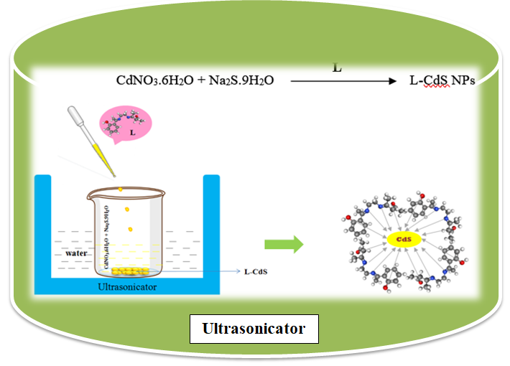
Fig. 2. Scheme for the preparation of Schiff base caped CdS NPs

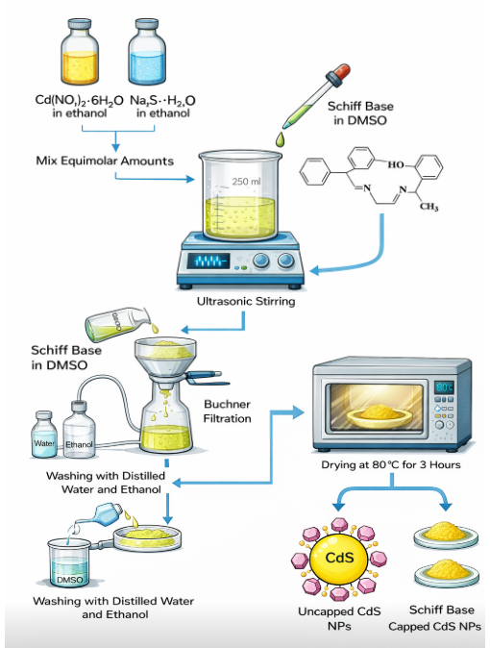
Fig. 2 Scheme for diagrammatic picture of CdS capped ligand

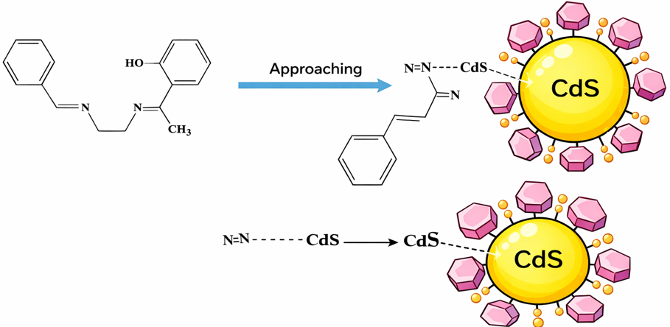

Fig. 3. Preparation of Schiff base caped CdS NPs

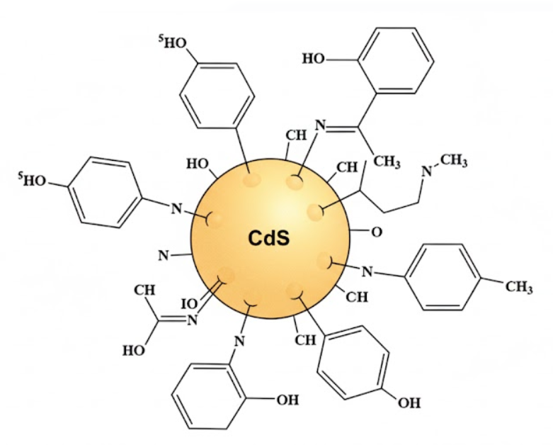
Fig. 6, Schematic image of Schiff base caped CdS NPs

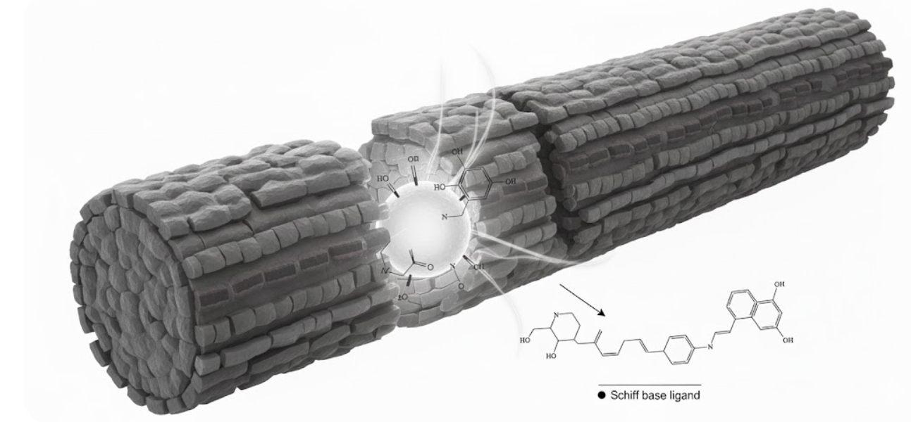
Cell wall
Fig. 7. Scheme for the penetration of CdS capped NP into the cell wall

