Annexure 02: Part 02 (K10 Test English version)

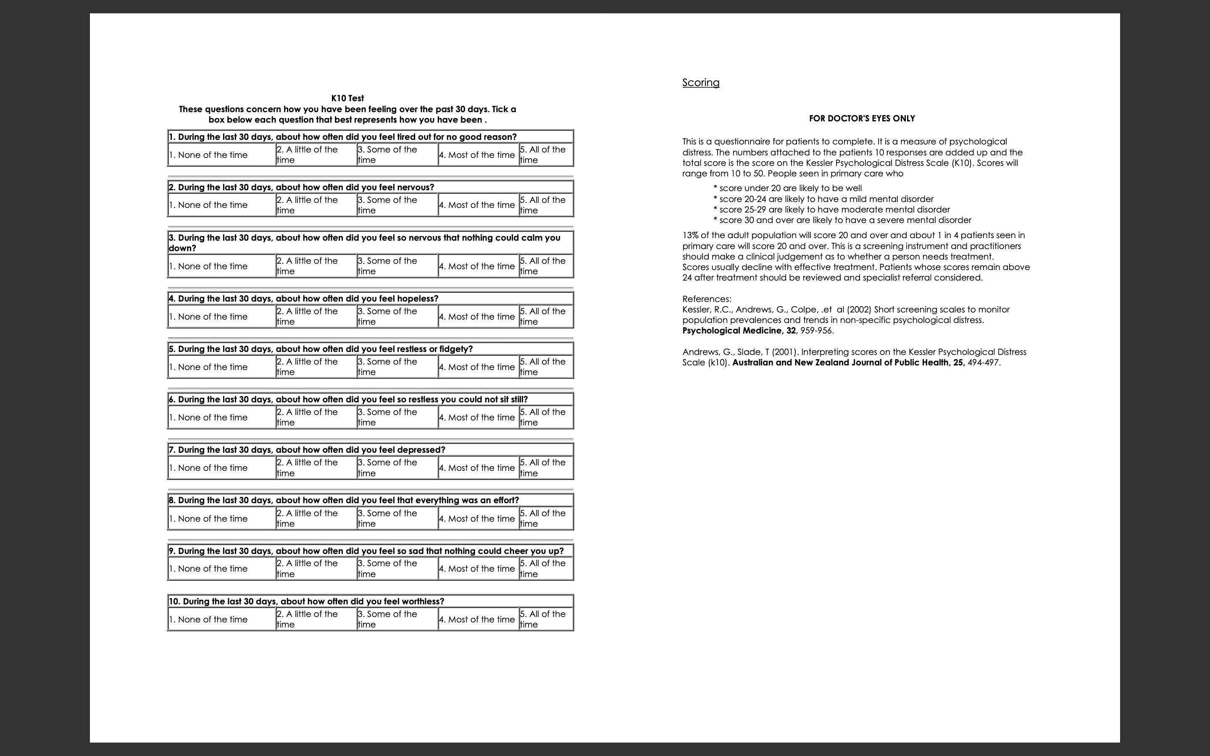

Annexure 03: Part 02 (K10 Test Sinhala version)

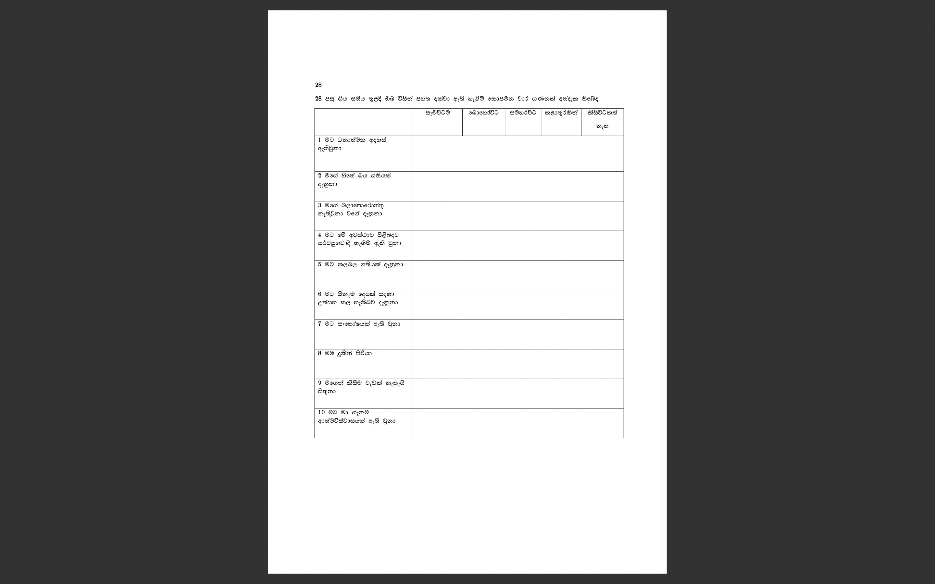

Annexure 04: Part 02 (K10 Test Tamil version)
