Supplementary Material
Supplementary Table 1. The International Classification of Diseases codes used in the study
Disease | Version | ICD code
Acute Myocardial Infarction | ICD-9 | 41000, 41001, 41002, 41010, 41011, 41012, 41020, 41021, 41022, 41030, 41031, 41032, 41040, 41041, 41042, 41050, 41051, 41052, 41060, 41061, 41062, 41070, 41071, 41072, 41080, 41081, 41082, 41090, 41091, 41092
Acute Myocardial Infarction | ICD-10 | I21, I210, I2101, I2102, I2109, I211, I2111, I2119, I212, I2121, I2129 , I213, I214, I219, I21A, I21A1, I21A9, I22, I220, I221, I222, I228, I229
Abbreviations: ICD, International Classification of Diseases

Supplementary Figure 1. The proportion of missing data for variables in the original cohort.
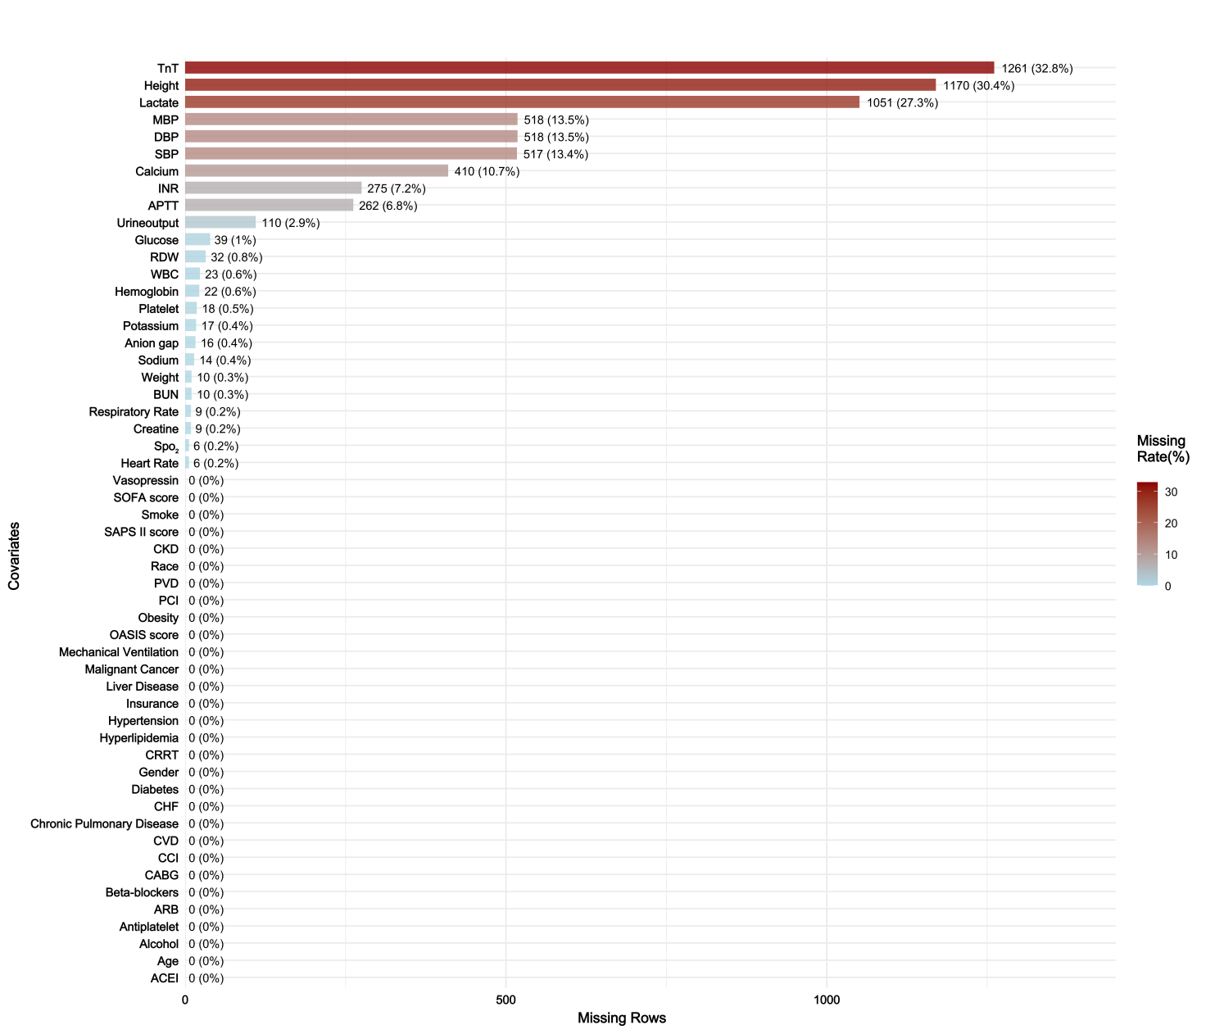
Abbreviations: SBP, Systolic Blood Pressure; DBP, Diastolic Blood Pressure; MBP, Mean Blood Pressure; Spo2, Peripheral Capillary Oxygen Saturation; WBC, White Blood Cell; BUN, Blood Urea Nitrogen; RDW, Red Blood Cell Distribution Width; INR,International Normalized Ratio; APTT, Activated Partial Thromboplastin Time; TnT: Troponin T; CHF, Congestive Heart Failure; PVD, Peripheral Vascular Disease; CVD, Cerebrovascular Disease; CKD, Chronic Kidney Disease; SOFA score, Sequential Organ Failure Assessment score; OASIS score, Oxford Acute Severity of Illness Score; SAPS II score, Simplified Acute Physiology Score II; CCI, Charlson Comorbidity Index; CRRT, Continuous Renal Replacement Therapy; PCI, Percutaneous Coronary Intervention; CABG, Coronary Artery Bypass Grafting; ACEI, Angiotensin-Converting Enzyme Inhibitor; ARB, Angiotensin II Receptor Blocker.

Supplementary Figure 2. Standardized mean differences in variables for the original cohort (red circles), the matched cohort (blue triangles), and the weighted cohort (green squares)
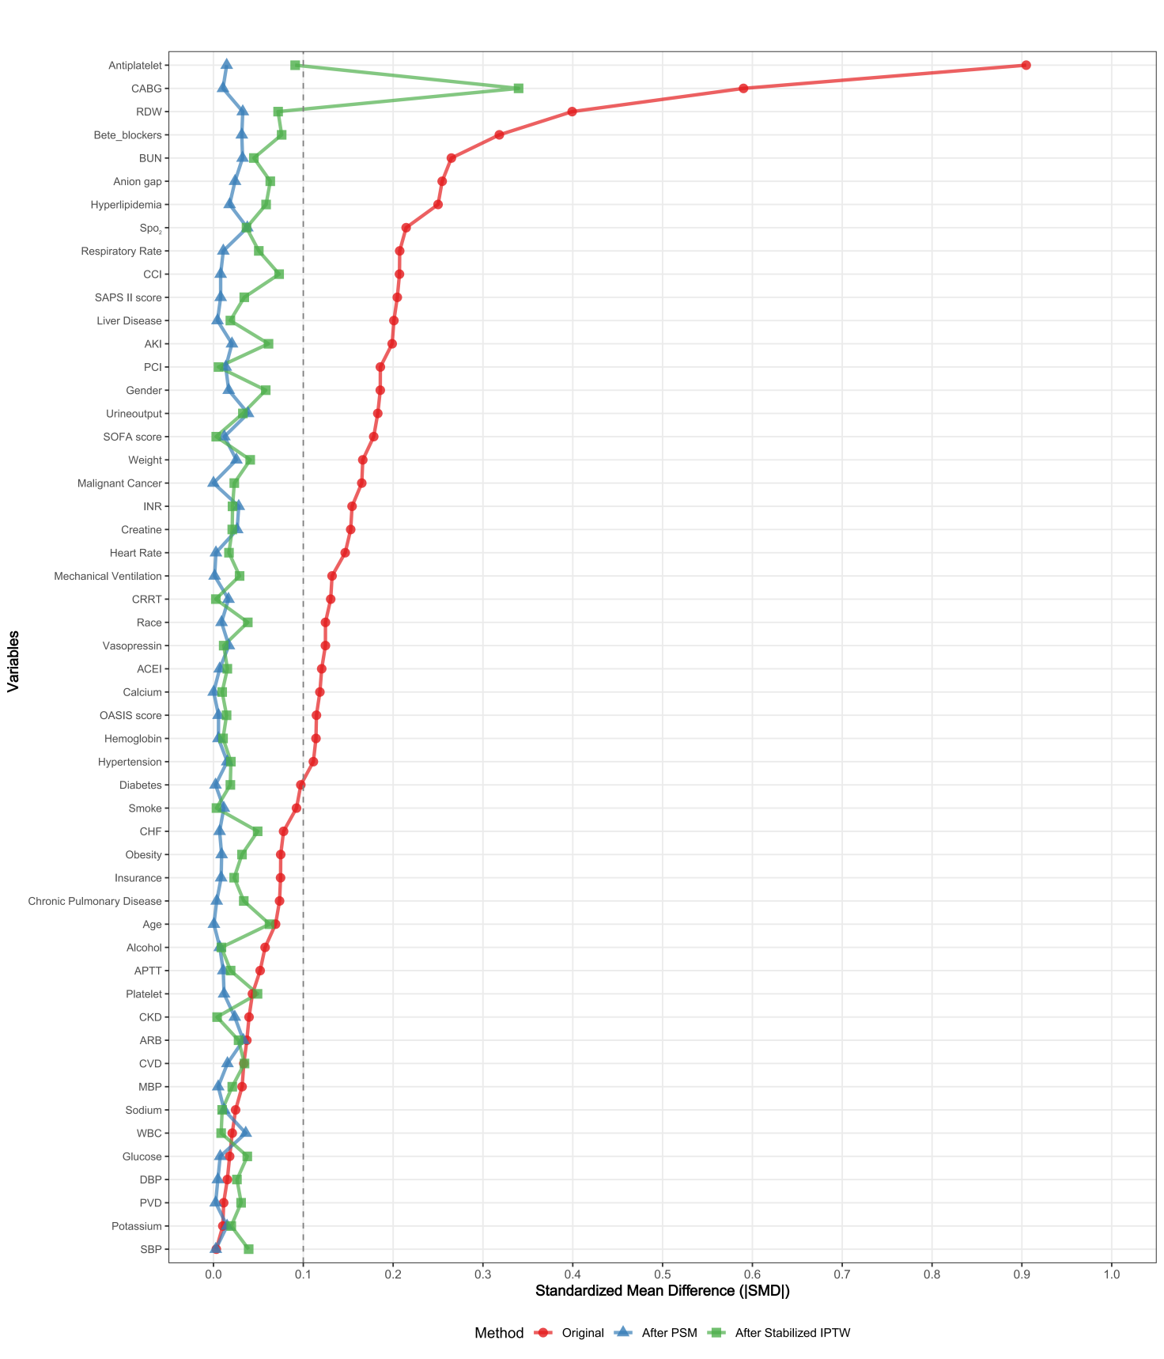
Abbreviations: SBP, Systolic Blood Pressure; DBP, Diastolic Blood Pressure; MBP, Mean Blood Pressure; Spo2, Peripheral Capillary Oxygen Saturation; WBC, White Blood Cell; BUN, Blood Urea Nitrogen; RDW, Red Blood Cell Distribution Width; INR,International Normalized Ratio; APTT, Activated Partial Thromboplastin Time; CHF, Congestive Heart Failure; PVD, Peripheral Vascular Disease; CVD, Cerebrovascular Disease; CKD, Chronic Kidney Disease; SOFA score, Sequential Organ Failure Assessment score; OASIS score, Oxford Acute Severity of Illness Score; SAPS II score, Simplified Acute Physiology Score II; CCI, Charlson Comorbidity Index; CRRT, Continuous Renal Replacement Therapy; PCI, Percutaneous Coronary Intervention; CABG, Coronary Artery Bypass Grafting; ACEI, Angiotensin-Converting Enzyme Inhibitor; ARB, Angiotensin II Receptor Blocker.

Supplementary Figure 3. Density function showing the distribution balance for the variables Before and After PSM and IPTW
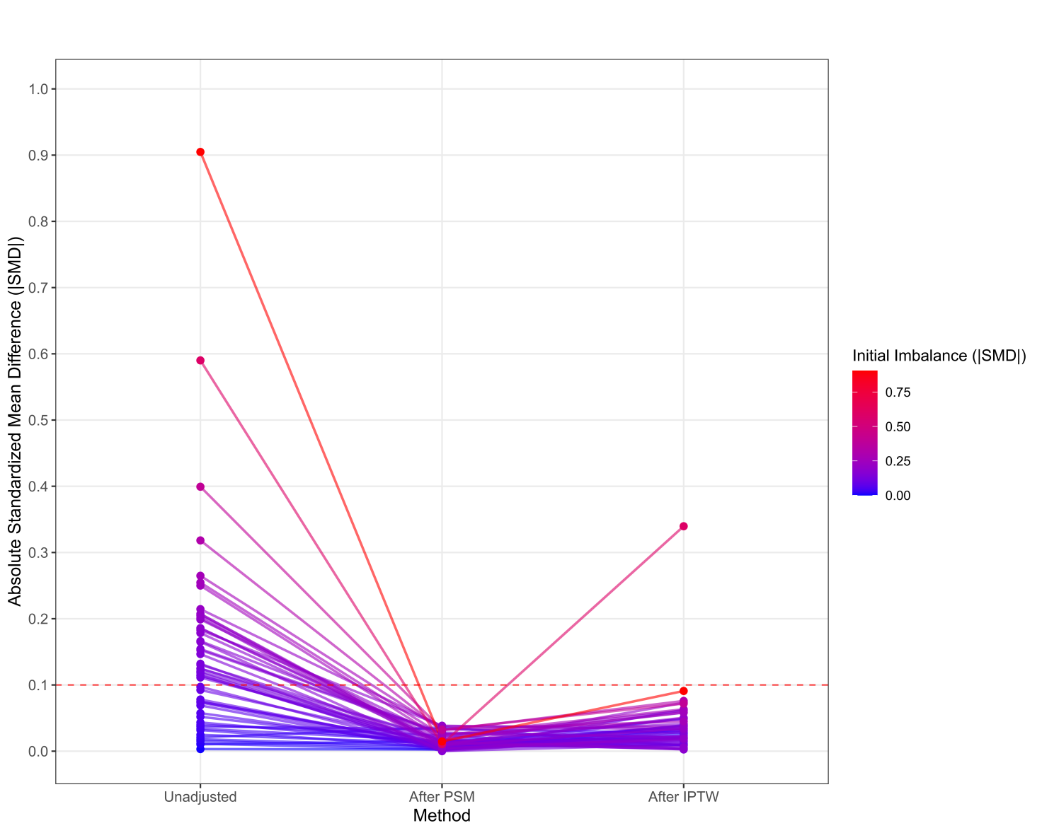
Abbreviations: PSM, propensity score matching; IPTW, Inverse Probability of Treatment Weighting.

Supplementary Figure 4. Density function showing the distribution balance for the variables before and after matching
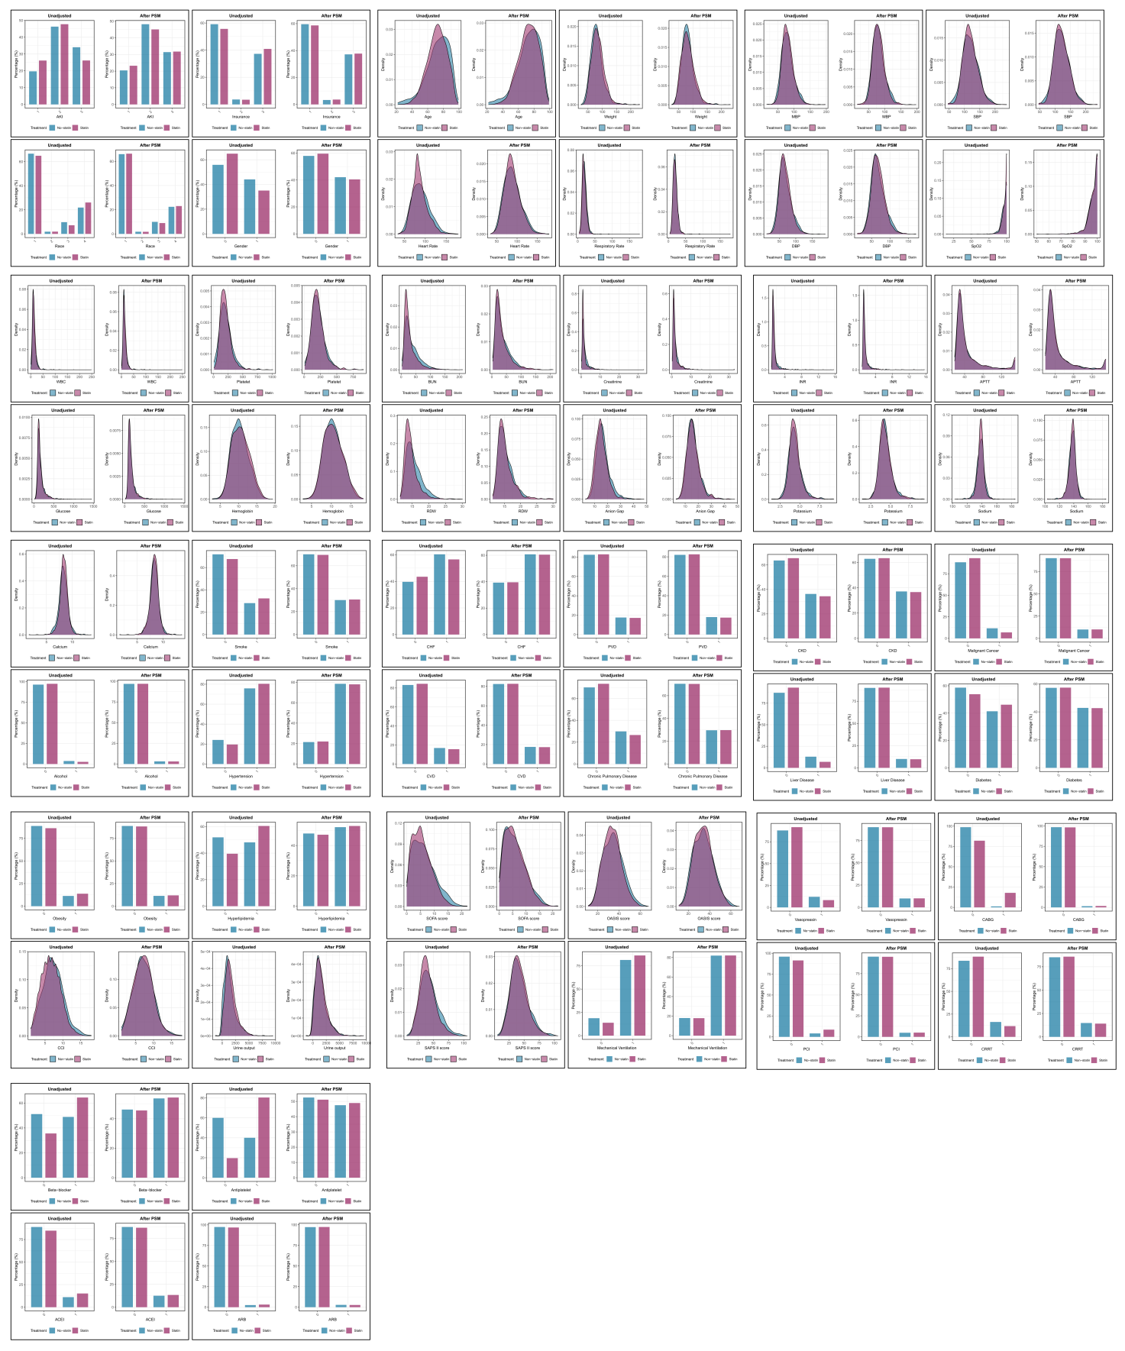
Abbreviations: SBP, Systolic Blood Pressure; DBP, Diastolic Blood Pressure; MBP, Mean Blood Pressure; Spo2, Peripheral Capillary Oxygen Saturation; WBC, White Blood Cell; BUN, Blood Urea Nitrogen; RDW, Red Blood Cell Distribution Width; INR,International Normalized Ratio; APTT, Activated Partial Thromboplastin Time; CHF, Congestive Heart Failure; PVD, Peripheral Vascular Disease; CVD, Cerebrovascular Disease; CKD, Chronic Kidney Disease; SOFA score, Sequential Organ Failure Assessment score; OASIS score, Oxford Acute Severity of Illness Score; SAPS II score, Simplified Acute Physiology Score II; CCI, Charlson Comorbidity Index; CRRT, Continuous Renal Replacement Therapy; PCI, Percutaneous Coronary Intervention; CABG, Coronary Artery Bypass Grafting; ACEI, Angiotensin-Converting Enzyme Inhibitor; ARB, Angiotensin II Receptor Blocker; PSM, propensity score matching.

Supplementary Figure 5. Variance inflation factor to examine the presence of
multicollinearity among variables.
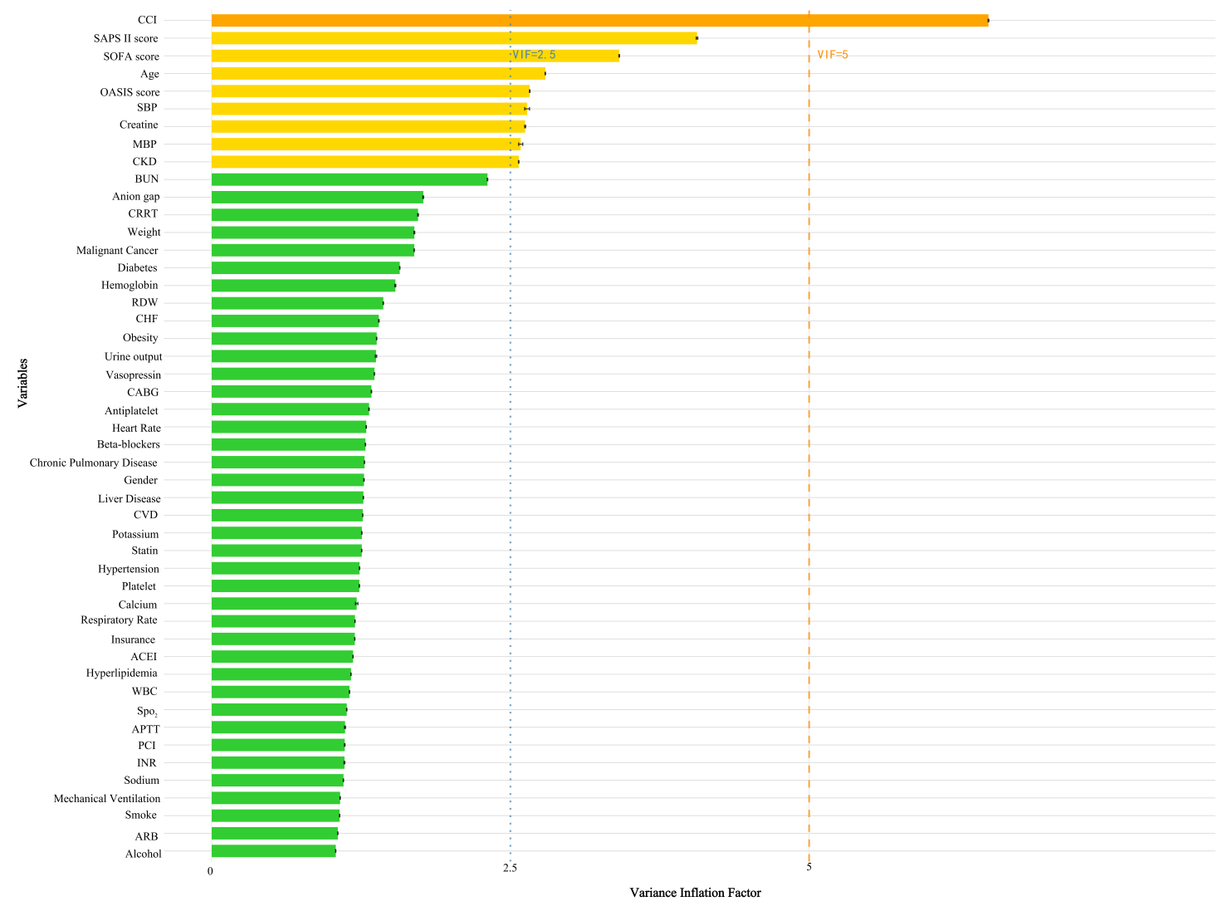
Abbreviations: SBP, Systolic Blood Pressure; MBP, Mean Blood Pressure; Spo2, Peripheral Capillary Oxygen Saturation; WBC, White Blood Cell; BUN, Blood Urea Nitrogen; RDW, Red Blood Cell Distribution Width; INR,International Normalized Ratio; APTT, Activated Partial Thromboplastin Time; CHF, Congestive Heart Failure; PVD, Peripheral Vascular Disease; CVD, Cerebrovascular Disease; CKD, Chronic Kidney Disease; SOFA score, Sequential Organ Failure Assessment score; OASIS score, Oxford Acute Severity of Illness Score; SAPS II score, Simplified Acute Physiology Score II; CCI, Charlson Comorbidity Index; CRRT, Continuous Renal Replacement Therapy; PCI, Percutaneous Coronary Intervention; CABG, Coronary Artery Bypass Grafting; ACEI, Angiotensin-Converting Enzyme Inhibitor; ARB, Angiotensin II Receptor Blocker; PSM, propensity score matching.

