SUPPLEMENTARY MATERIAL
Development of Solid Lipid Nanoparticles Containing Budesonide for Inflammatory Bowel Disease (IBD) Based on the Quality by Design (QbD) Approach

Evaluation and Selection of Solidification Adsorbents for BUD-SLNs
Table S1. Flowability assessment of tested adsorbents, pure BUD, and BUD-SLN formulation (mean±SD, n=3).
Powder | Bulk Density (g/mL) | Tapped Density (g/mL) | Hausner Ratio | Carr’s Index | Angle of repose (θ) | Flowability
Florite® R | 0.08 ±0.001 | 0.12 ±0.001 | 1.5 | 33.3 | 47.0 | Poor
Florite PS-200 | 0.08 ±0.001 | 0.11 ±0.002 | 1.4 | 27.3 | 40.0 | Fair
Neusilin US2 | 0.17 ±0.02 | 0.2 ±0.01 | 1.2 | 15.0 | 30.0 | Excellent
Neusilin UFL2 | 0.1 ±0.01 | 0.13 ±0.00 | 1.3 | 23.0 | 45.0 | Passable
Syloid® XDP 3050 | 0.24 ±0.02 | 0.29 ±0.00 | 1.2 | 17.2 | 26.0 | Excellent
Syloid® XDP 3150 | 0.24 ±0.07 | 0.28 ±0.01 | 1.2 | 14.3 | 26.0 | Excellent
Pure BUD | 0.3 ±0.00 | 0.5 ±0.00 | 1.7 | 40.0 | 43.0 | Passable
BUD-SLNs: Syloid® XDP 3150 (1:0.1g) | 0.59 ±0.05 | 0.6 ±0.00 | 1.0 | 3.3 | 37.0 | Fair

QbD Approach and Preliminary Studies
Table S2. QTPP for the capsule of BUD-SLNs.
QTPP Elements | Target | Justification
Dosage form | SLNs inside Capsule | Increasing the therapeutic effect with a low risk of adverse effects, a solid dosage form is a desired choice for the patient
Dosage design | Delayed release capsule (pH-dependent) | The most suitable for ileum targeting
Route of administration | Oral | Dosage form designed to administer orally, the most preferred route for delivery
Dosage strength | 3mg budesonide | Commonly accepted strength
Stability (physically, chemically, biologically) | During the preparation and after 3 months under different conditions no vision of gelation or aggregation, maintenance of the same content of uniformity during the storage period | Retain the therapeutic effect during the shelf-life
Pharmacokinetics | Delayed release enabling Tmax in 1-10 hours or less bioequivalent to RLD* | Bioequivalence requirement
Drug product quality attributes:  Physical Attributes  Particle Size  Polydispersity Index  Zeta Potential  Entrapment Efficiency  Lipolysis  Dissolution | Must meet the same compendial or other applicable (quality) standards
Container closure system | Appropriate for storage of dosage form | Required to achieve the target shelf life
^{*RLD: Reference Listed Drug}

Table S3. Risk assessment of BUD-SLNs.
Target | Material attribute,  process parameter, failure mode, or independent variable | Critical quality attribute (CQAs), failure effect, response, or dependent variable | Risk Description | Severity | Occurrence | Detectability | RPN | Risk degree | Action
SLNs | Homogenization time (HT) (min) | Particle size and polydispersity index | Difficult to obtain nanoparticles, uniformity of size distribution, and a stable system. Particle size can affect directly drug release | 5 | 5 | 5 | 125 | Medium | Regular monitoring
SLNs | Homogenization speed (rpm) | Particle size and polydispersity index | Insufficient mixing can lead to gelation and an unstable system | 7 | 1 | 5 | 35 | Low | Regular monitoring and maintenance
SLNs | Speed of magnetic stirrer | Particle size, polydispersity index, and entrapment efficiency | Insufficient mixing might lead to preparing non-homogeneous emulsion and depositing lipid | 5 | 3 | 1 | 15 | Low | No action
SLNs | Temperature | Particle size and polydispersity index | Low temperature might lead to lipid solidification, high temperature might lead to any effect | 3 | 5 | 1 | 15 | Low | No action
SLNs | Concentration of lipid | Particle size, entrapment efficiency, and dissolution | Lipid's concentration can affect directly particle size, drug encapsulation, and drug release | 9 | 5 | 7 | 315 | High | Chosen solid lipid with high solubility of drug, small particle size, and high entrapment efficiency
SLNs | Concentration of surfactant | Particle size, polydispersity index | Surfactant's concentration can affect directly particle size, drug release, and stability | 9 | 5 | 5 | 225 | High | Chosen surfactant with high solubility of drug, providing small particle size and stable system
*RPN: Risk Priority Number

Low | Additional investigation is not necessary since the risk is widely acceptable.
Medium | Additional investigation is recommended to reduce risk although the risk is acceptable.
High | Additional investigation is required to reduce the risk since the risk is unacceptable.

Note: The RPN = (Severity) * (Occurrence) *(Detectability)
According to the RPN, the risk was classified as low, medium, and high, (1–97, indicated as green), (98–218, indicated as yellow), (219–729, indicated as red), respectively
Particle Size (PS) and Polydispersity Index (PDI) Determination
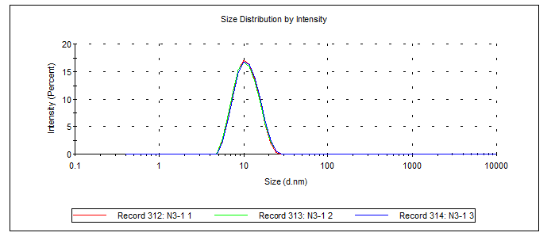
Figure S1. PS and PDI analysis of optimized liquid BUD-SLNs.

Differential Scanning Calorimetry (DSC)
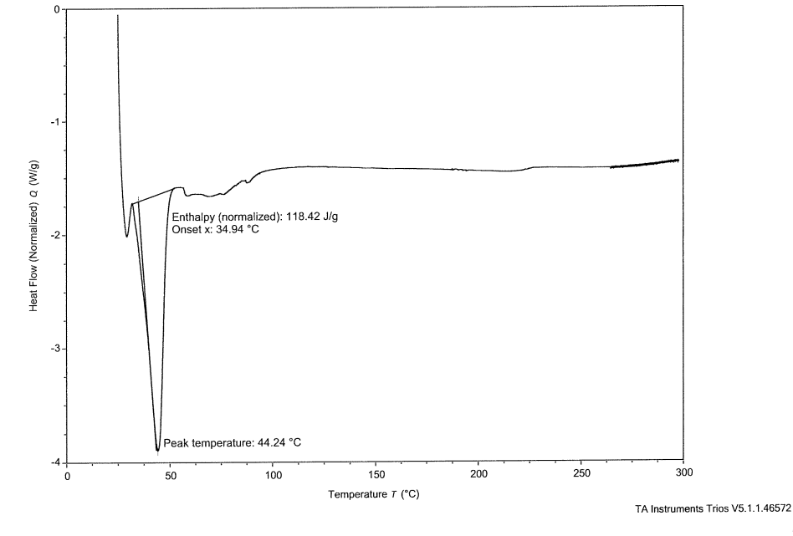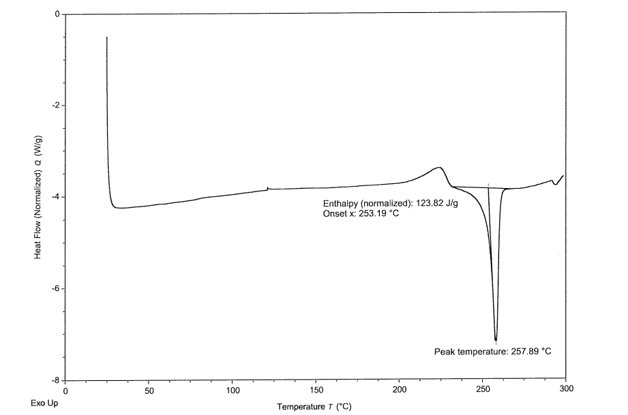
Pure Bud
Optimized Bud-SLNs
Figure S2. DSC study of Pure BUD and Optimized BUD-SLNs.

In Vitro Cytotoxicity Studies
(b)
(a)
Figure S3. (a) IC₅₀ value for BUD in Caco-2 cells, and (b) the effect of formulations containing BUD on cellular viability.

