Supplementary Information
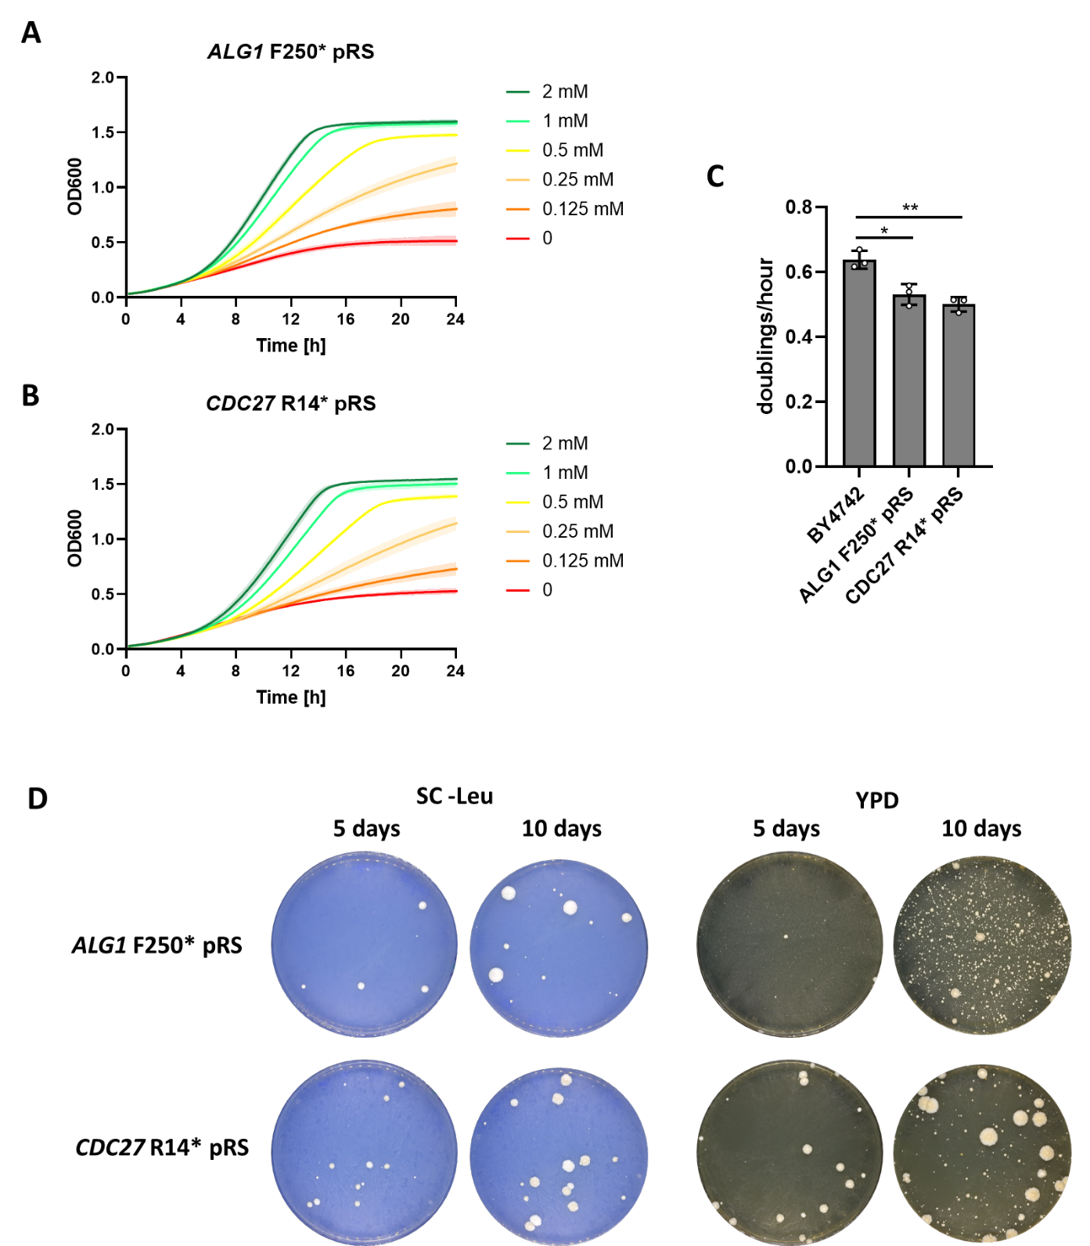
Supplementary Figure S1: Characterization of TAG edits ALG1 F250* and CDC27 R14* with OTS on centromeric plasmid. Edits were chosen because of wild type-like growth in permissive medium in [6], and made as genomic mutations. Growth of strains A) ALG1 F250* and B) CDC R14* in liquid culture in YPD with a range of OMeY concentrations (n=3). C) Growth rates of BY4742 and the two edited strains with pRS315-LeuOmeRS at 2 mM OMeY. D) Containment escape on restrictive SC -Leu and YPD semisolid medium after 5 and 10 days at 30°C.

Supplementary Figure S2: Dispersion of read counts and competition coefficients. Percentual coefficients of variation of barcodes are shown by read count and by density distribution (violin plot) for barcode sequencing from the library of A) the initial culture, B) 6 generations, C) 12 generations, and D) 18 generations, each calculated from 3 biological replicates. Standard error of competition coefficients (calculated from generations 0, 12, and 18) of considered barcodes (total read count of ≥120) are shown for the condition E) with 2 mM OMeY and F) without OMeY (n=2866).

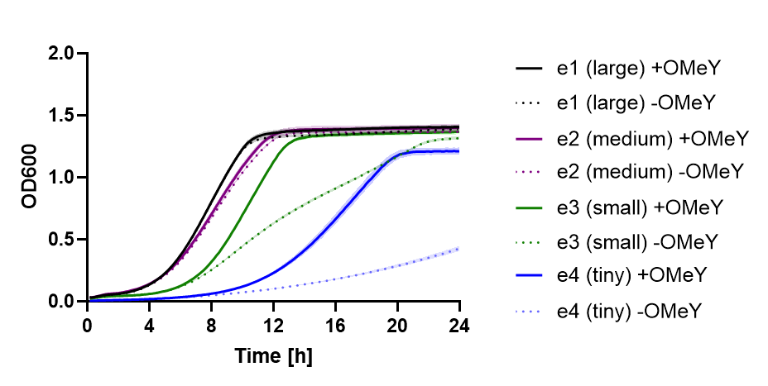
Supplementary Figure S3: Assaying OMeY dependence of escapees of PRP24 E184*. A plate reader growth assay for OMeY dependence was carried out with either no or 2 mM OMeY in the assay medium, with 10 replicates each. Shown are means with standard deviations of the biological replicates.

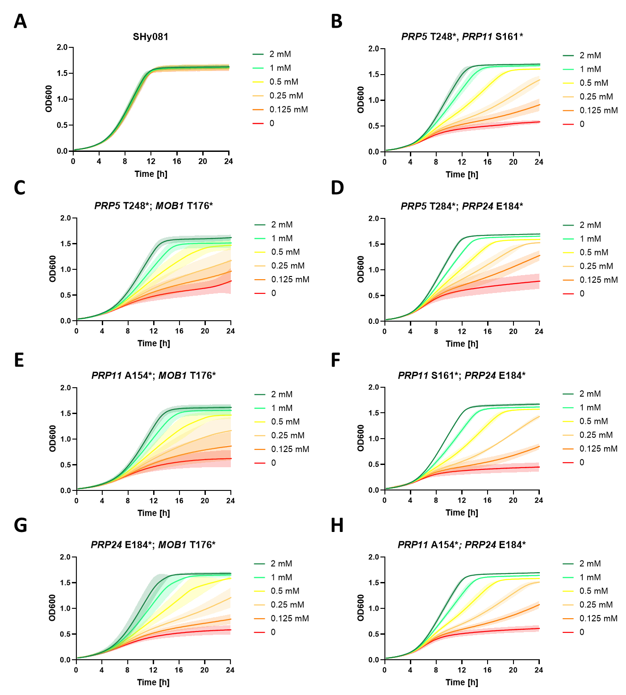
Supplementary Figure S4: Liquid growth assays to assay OMeY dependence in strains with TAG edits in two genes. A) shows the parental strain SHy081, which is the yeast laboratory strain BY4742 with the orthogonal translation system LeuOmeRS integrated at the ho locus. In the other panels strains with the following TAG edits are shown: B) PRP5 T248* and PRP11 S161*, C) PRP5 T284* and MOB1 T176*, D) PRP5 T284* and PRP24 E184*, E) PRP11 A154* and MOB1 T176*, F) PRP11 S161* and PRP24 E184*, G) PRP24 E184* and MOB1 T176*, H) PRP11 A154* and PRP24 E184*. All doubly TAG edited strains showed a clear dose-dependent growth response to OMeY. Shown are means with standard deviations from three independent experimental repeats.

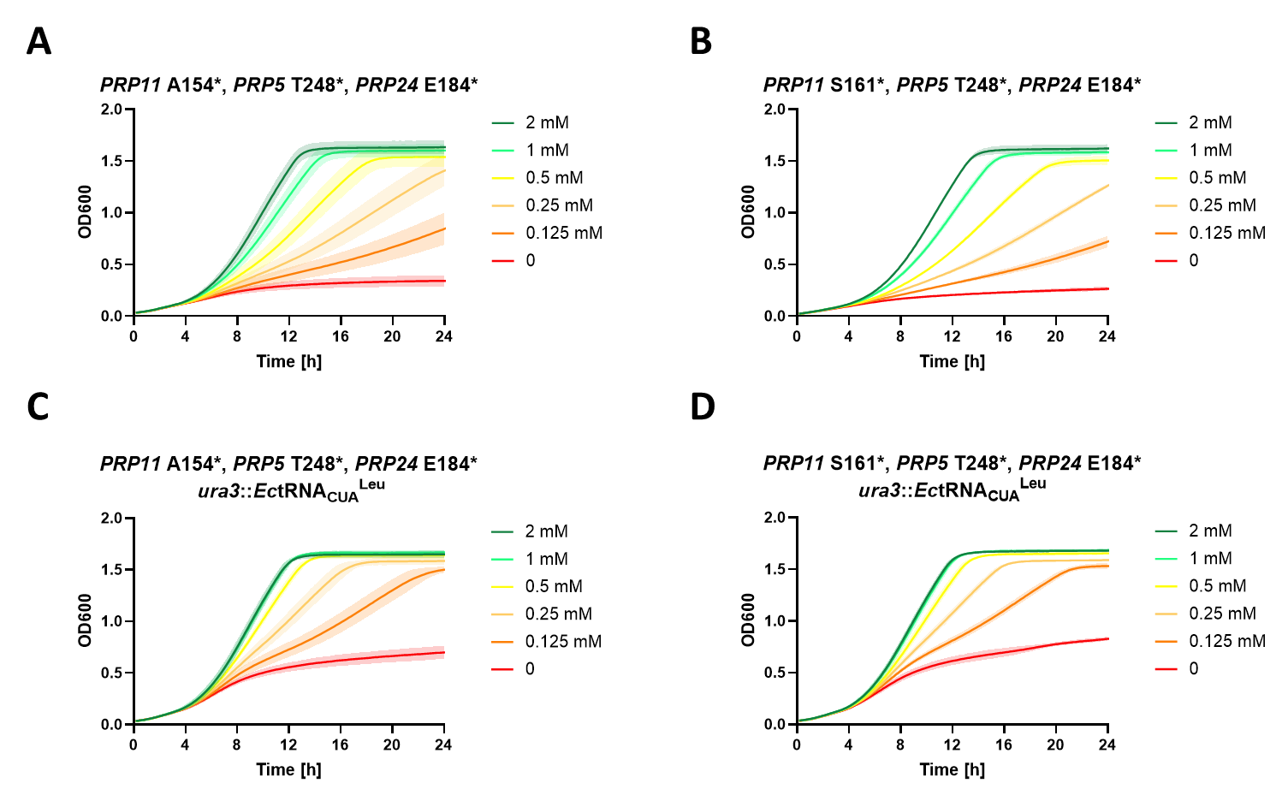
Supplementary Figure S5: Liquid growth assays to assay OMeY dependence in strains with TAG edits in three genes. Strains with three TAG edits in the base strain SHy081, shown in A) (PRP11 A154*; PRP5 T248*; PRP24 E184*) and B) (PRP11 S161*; PRP5 T248*; PRP24 E184*) had a stringent dependence on OMeY, but a slight growth defect at 2 mM OMeY. The combination of these three TAG edits with an additional genomic copy of the orthogonal tRNA in the ura3 locus alleviated the observed moderate growth defect, but rendered the strains less stringently dependent on OMeY. Shown are means with standard deviations from three independent experimental repeats.

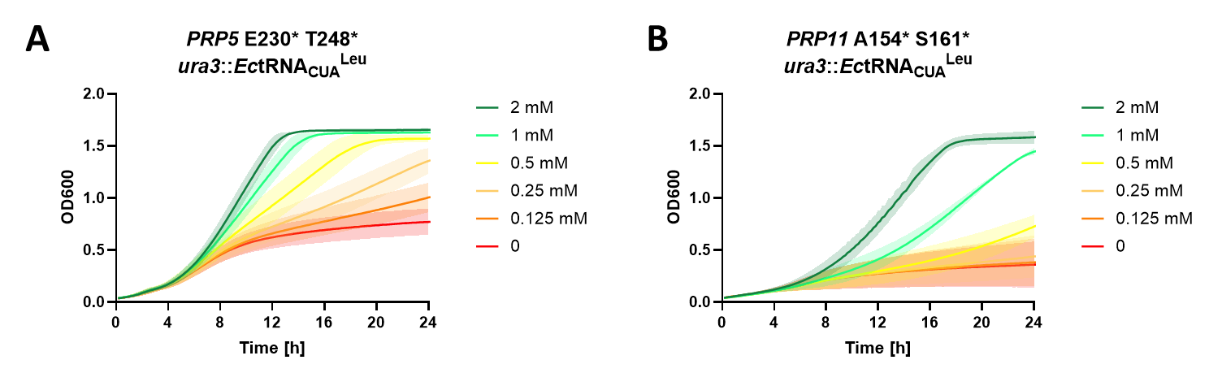
Supplementary Figure S6: Liquid growth assays to assay OMeY dependence in strains with two TAG edits in a single gene and an additional orthogonal tRNA in the ura3 locus. A) Combination of two TAG edits in PRP5. The resulting strain reached close to wild-type growth with 2 mM OMeY. B) Combination of two TAG edits in PRP11. The strain showed a strict dependence on OMeY, but a substantial fitness defect even at 2 mM OmeY. Shown are means with standard deviations from three independent experimental repeats.

Supplementary Table S1: Comparison of predicted substitution-tolerant residues in the Lac repressor (PDB 1LBI) to experimental assessment.
Residue | Clashes |  | Solvent assessable surface in Å² | Group†
Residue | With TRP | With ARG | Solvent assessable surface in Å² | Group†
ALA176 | 0 | 0 | 91.75 | I
ALA116 | 0 | 0 | 62.51 | XIV
GLY315 | 0 | 0 | 24.37 | II
ALA341 | 0 | 0 | 22.09 | N/A
ALA138 | 1 | 1 | 75.22 | I
GLY236 | 1 | 1 | 66.85 | II
GLY91 | 1 | 1 | 60.22 | I
GLY178 | 1 | 2 | 37.71 | I
ALA199 | 1 | 2 | 56.61 | I

† Group classification according to [19]. Group I – solvent exposed, mostly tolerant to substitutions. Group II – spacer regions, tolerant to substitutions. Group XIV – N-terminal domain of the core, near the center of the domain, substitutions result in weak I^{s} phenotype. N/A – position not assessed in the study

