Cross or bounce? Locational and video data reveal high road encounter and altered movement in a common ungulate
Stemle et al.
Supporting Information – Appendix S1
Methods
Data Cleaning and Processing
We removed all points from the first twenty-four hours of capture events, all duplicate and unsuccessful fixes. Next, we removed implausible movement speeds (3 km/hr) by using the flag_fast_steps() function in the package amt (Signer 2018). We utilized adehabitatLT (Calenge 2006) to make sure the distances and time stamps were logical.
Spatial Attributes and Covariates
We obtained road layers from the USGS National Transportation Dataset (https://nationalmap.gov/transport.html; USGS 2025). We grouped road types by OpenStreetMap classifications into three groups: large: primary, secondary, motorway; medium: tertiary, unclassified, residential; small: service, path (some small vehicles), track (OpenStreetMap 2024). For land cover types, we downloaded a National Land Cover Database (NLCD) layer from 2023 and used ArcGIS Pro to reclassify into more succinct land cover types (open water, wetlands, forest, development – open space, development – low to high intensity, crops/pastureland, scrub, grassland). We then used the road polyline to convert the pixels under the road to their own category, as not all roads were being displayed as a type of development.
We used the suncalc package to define diel periods (day, night, and twilight) to examine if time of day influenced road behavior (Thieurmel and Elmarhraoui 2025). Seasonal periods were defined based on phenological phases and behavioral ecology of white-tailed deer: pre-fawning (Jan–April), fawning (May–June), post-fawning (July–Sept), and rut (Oct–Dec).
Home Range Estimation
In order to look at road density withing the general home range of each individual, we estimated individual 95% kernel density (KD) home ranges with the package adehabitatHR (Calenge et al. 2011) with the reference bandwidth (href) for smoothing. We visually inspected KD outputs against point data to confirm it. To restrict analyses to focal areas, we delineated a spatial boundary around Lake Shelbyville using a combined 95% KD for all individuals (plus a 100 m buffer) and removed any points outside this extent. Road density was calculated within each individual home range as kilometers of road per square kilometer (km/km²).
Road Encounter Behavior – Barrier Behavior Analysis (BaBA)
We performed sensitivity analyses following Xu et al. (2021) to identify optimal parameters. Specifically, we determined the road buffer distance (d) by incrementally increasing it from 50–80 m in 10 m steps and identifying the point at which quick cross events plateaued (<2% increase). The optimal d was set at 50 m around the road polylines for all sites.
We defined t_{b} (max time for a short interaction) and t_{p} (max time for prolonged interaction) as 4 hours and 36 hours, respectively, and we used a 7 day (168 hours) for w to calculate average straightness. These parameters were based on biologist recommendations and examining the outputs (similar to Xu et al. 2021; Lee and Sanderson 2024 and Wilkinson et al. 2023). We set max_cross to 2 to account for GPS error (~10–12 m; T. Kishimoto, unpubl. data) and minor inaccuracies in the road polyline layers. Events exceeding this threshold were reclassified as unknown.
We then used BaBA to find and define encounters into seven categories: quick cross, average movement, bounce, trace, back-and-forth, trapped or unknown (Xu et al. 2021). Quick cross and bounce are short events, where bounce does not intersect with a road (the animal quickly moves away from the road) and quick cross does. Average movement, trace (moves along the side of the road), unknown, and back-and-forth (stays close to a road by going back and forth), are median events with various amounts of straightness of the encounter path and number of crossings. In average movement the animal does not change its movement pattern markedly. Trapped is a prolonged encounter event that stays near the road and might be constrained by it or be choosing to stay by it.
Video recordings
The camera data from 14 GPS collared deer (Lotek - InSight Video Camera Module) recorded 15 second videos, at various intervals – with increased frequency (every 10 minutes) during crepuscular times (dawn ~ 5-8 am and dusk ~ 5-9 pm).
Literature Cited
Calenge, C. (2006). The package adehabitat for the R software: a tool for the analysis of space and habitat use by animals. Ecological modelling, 197, 516–519.
Signer, J. (2018) amt: Animal Movement Tools. R package version 0.0.5.0. 1358 URL https://CRAN.R-project.org/package=amt
Thieurmel B, Elmarhraoui A. (2025). suncalc: Compute Sun Position, Sunlight Phases, Moon Position and Lunar Phase.
U.S. Geological Survey, National Geospatial Technical Operations Center, 20250115, USGS National Transportation Dataset (NTD) for Illinois (published 20250115) Shapefile: U.S. Geological Survey.

Supplemental Figures and Tables
Supplemental Figure 1. Predicted probability of a white-tailed deer crossing a road as a function of forest cover (a), agricultural cover (b) or development cover (c), based on predictions from the top model (a generalized linear mixed-effects model with a binomial error distribution and logit link). Predictions were generated from fixed effects only and illustrate the combined influence of linear and log-transformed standardized land cover while holding all other covariates at their mean values (continuous variables) or reference levels (categorical variables). Shaded ribbons represent 95% confidence intervals around model predictions. Reference levels were fawning, daytime and medium roads.
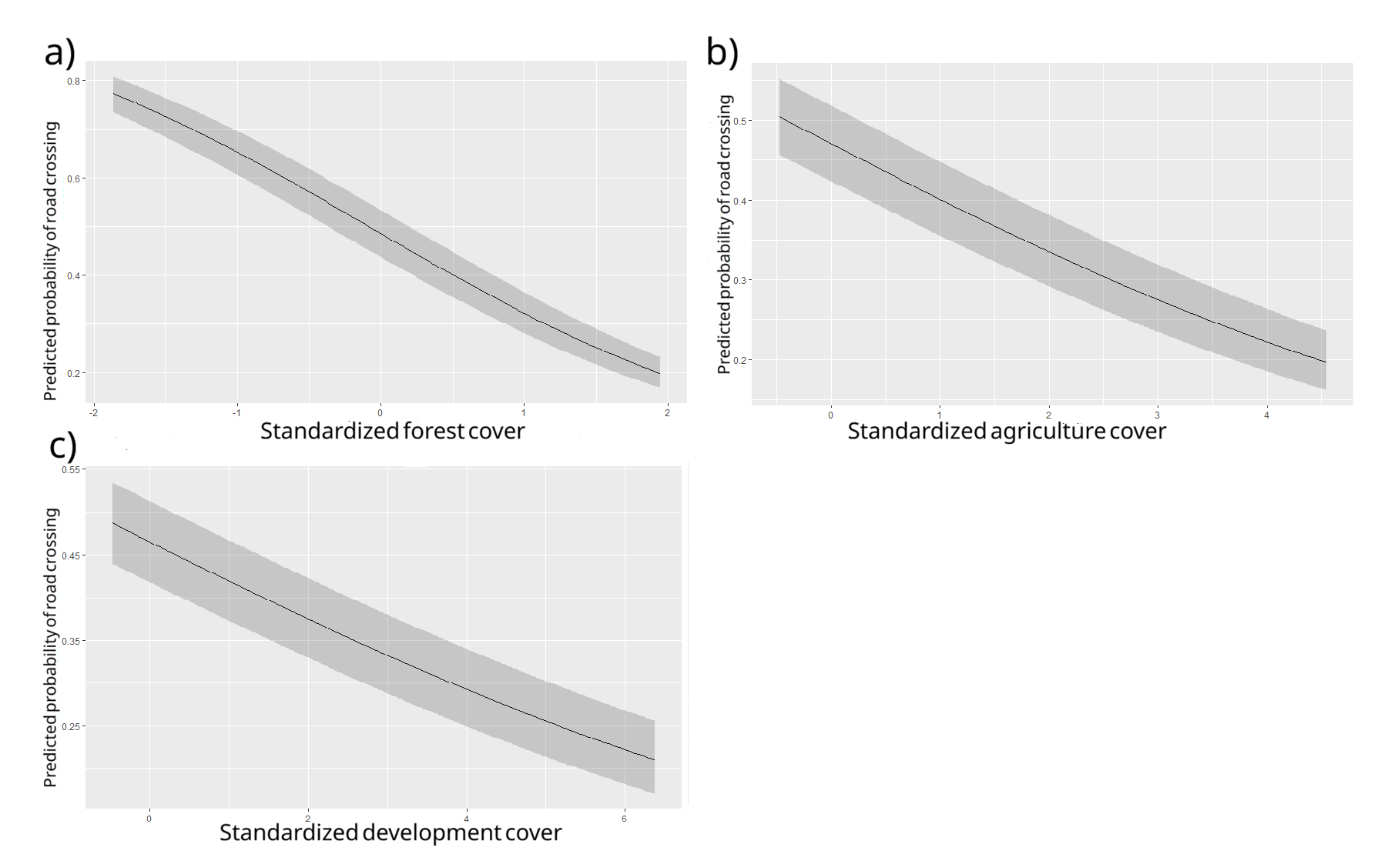
Supplemental Table 1. Main four models and all permutations for logistic regression of quick cross vs. bounce road encounter types for white tailed deer across in Illinois. The top model is bold.
Model | Structure (type: 1 = quick cross, 0 = bounce) | AIC | Delta AIC
Intercept only | type ~ (1 | site) + (1 | AnimalID) | 135793 | 3,473
Influence of deer related variables on bounce vs. quick cross | type ~ (1 | site) + (1 | AnimalID) + Age + Sex | 135796 | 3,476
Influence of deer related variables and season/time of day on bounce vs. quick cross | type ~ (1 |site) + (1|AnimalID) + Age + Sex + season + time.cat | 135011 | 2,691
Influence of deer related variables plus habitat related variables on bounce vs. quick cross | type ~ ln(forest) + ln(development) + ln(agriculture) + forest + agriculture + development + (1 | site) + (1 | AnimalID) + Age + sex | 132937 | 617
Influence of time/season and deer related variables plus habitat related variables on bounce vs. quick cross | type ~ ln(forest) + ln(development) + ln(agriculture) + forest + agriculture + development +(1 |site) + (1|AnimalID) + Age + Sex +season+time.cat | 132415 | 95
Influence of habitat related variables on bounce vs. quick cross | type ~ ln(forest) + ln(development) + ln(agriculture) + forest + agriculture + development + (1 | site) + (1 | AnimalID) | 132935 | 615
Influence of season and time of day on bounce vs. quick cross | type ~ (1 | site) + (1 | AnimalID) + time.cat + season | 135011 | 2,691
Influence of road related variables on bounce vs. quick cross | type ~ ln(road density) + road_category + (1 | site) + (1 | AnimalID) + road_category | 135753 | 3,433
Influence of time/season related variables plus habitat related variables on bounce vs. quick cross | type ~ ln(forest) + ln(development) + ln(agriculture) + forest + agriculture + development + (1 | site) + (1 | AnimalID) + season + time.cat | 132412 | 92
Influence of habitat related variables plus road related variables and deer related variables on bounce vs. quick cross | type ~ road density + ln(road density) + (1 | site) + (1 | AnimalID) + road_category + ln(forest) + ln(development) + ln(agriculture) + forest + agriculture + development + Age + Sex | 132839 | 519
Influence of deer related variables plus road related variables on bounce vs. quick cross | type ~ (1 |site) + (1|AnimalID) + Age + Sex + road density + ln(road density) + road_category | 135756 | 3,436
Influence of time/season related variables plus road related variables on bounce vs. quick cross | type ~ (1 |site) + (1|AnimalID) + season + time.cat + road density + ln(road density) + road_category | 134964 | 2,644
Influence of habitat related variables plus road related variables on bounce vs. quick cross | type ~ road density + ln(road density) + (1 | site) + (1 | AnimalID) + road_category + ln(forest) + ln(development) + ln(agriculture) + forest + agriculture + development | 132837 | 517
Influence of season/time of day related variables plus road related variables and deer related variables on bounce vs. quick cross | type ~ (1 | site) + (1 | AnimalID) + Age + Sex + season + time.cat + road density + ln(road density) + road_category | 134966 | 2,640
Influence of time/season and road related variables plus habitat related variables on bounce vs. quick cross | type ~ ln(forest) + ln(development) + ln(agriculture) + forest + agriculture + development + (1 |site) + (1|AnimalID) + season + time.cat  + road density + ln(road density) + road_category | 132320 | 0
Global model: all considered variables | type ~ road density + ln(road density) + ln(forest) + ln(development) + ln(agriculture) + forest + agriculture + development + (1 | site) + (1 | AnimalID) + Age + time.cat + Sex + road_category + season | 132322 | 2

Supplemental Table 2. Top glmmTMB model results. Variable abbreviation used in Fig. 4 is listed in parenthesis. Variables in bold are significant, significance codes: ‘***’ 0.0001 ‘**’ 0.001 ‘*’ 0.01.
Variable | Variable Category | Estimate | Std. Error | Z-value | P(>|z|)
Natural log of proportion forest with 100 m of road encounter (ln(forest)) | Land cover/habitat type | -0.073 | 0.021 | -3.41 | 0.0006 ***
Natural log of proportion of low medium high development with 100 m of road encounter (ln(development)) | Land cover/habitat type | 0.04 | 0.016 | 2.52 | 0.012 *
Natural log of proportion of agriculture with 100 m of road encounter  (ln(agriculture)) | Land cover/habitat type | -0.018 | 0.019 | -0.93 | 0.35
Proportion of forest with 100 m of road encounter (forest) | Land cover/habitat type | -0.62 | 0.018 | -34.46 | < 2e-16 ***
Proportion of agriculture with 100 m of road encounter (agriculture) | Land cover/habitat type | -0.27 | 0.022 | -12.17 | < 2e-16 ***
Proportion of low, medium, high development with 100 m of road encounter (development) | Land cover/habitat type | -0.21 | 0.01734 | -11.85 | < 2e-16 ***
Season during road encounter fawn vs. postfawn (fawn vs. postfawn) | Temporal | 0.17 | 0.020 | 8.43 | < 2e-16 ***
Season during road encounter – fawn vs. prefawn (fawn vs. prefawn) | Temporal | 0.08 | 0.019 | 3.97 | 7.14e-05 ***
Season during road encounter – fawn vs. rut (fawn vs. rut) | Temporal | 0.17 | 0.022 | 7.84 | 4.53e-15 ***
Time of day at the start of the road encounter – nighttime vs. daytime (day vs. nighttime) | Temporal | 0.03 | 0.016 | 2.17 | 0.03 *
Time of day at the start of the road encounter – twilight vs. daytime (day vs. twilight) | Temporal | 0.39 | 0.020 | 20.17 | < 2e-16 ***
Road density within the deer’s home range (road density) | Road variable | -0.03 | 0.076 | -0.39 | 0.70
Natural log of the road density within the deer’s home range (ln(road density)) | Road variable | 0.032 | 0.039 | 0.83 | 0.40
Road category – medium vs. large | Road variable | 0.56 | 0.075 | 7.51 | 6.05e-14 ***
Road category – small vs. large | Road variable | 0.41 | 0.075 | 5.44 | 5.33e-08 ***

Supplemental Table 3. Top glmmTMB model results with chi square value from ANOVA type III results, degrees of freedom and p-values. Variables in bold are significant.
Variable | Chi-square, p-value (df)
Natural log of proportion of forest with 100 m of road encounter | 11.65, < 0.0001 (1)
Natural log of proportion of low medium high development with 100 m of road encounter | 6.33, 0.012 (1)
Natural log of proportion of agriculture with 100 m of road encounter | 0.87, 0.35 (1)
Proportion of forest with 100 m of road encounter | 1187.49, < 0.0001 (1)
Proportion of agriculture with 100 m of road encounter | 148.19, < 0.0001 (1)
Proportion of low, medium, high development with 100 m of road encounter | 140.36, < 0.0001 (1)
Season during road encounter | 94.43, < 0.0001 (3)
Time of day at the start of the road encounter | 434.85, < 0.0001 (2)
Road density within the deer’s home range | 0.15, 0.695(1)
Natural log of the road density within the deer’s home range | 0.70, 0.403 (1)
Road category | 99.69, < 0.0001 (2)

