Supplementary Material

Phenolic Profile Characterization of Extra Virgin Olive Oils from the Omani Market Using a Salt-Assisted Extraction and LC-MS/MS Approach
Azza A.H. Al Shamli¹, Maryam Mousavizadegan¹, Haider A. J. Al Lawati¹*
ª Department of Chemistry, College of Science, Sultan Qaboos University, P.O. Box 36, Al Khoud 123, Muscat, Oman

*Corresponding author
Haider A. J. Al Lawati
Department of Chemistry
College of Science
Sultan Qaboos University
P.O. Box 36, Al Khoud 123
Muscat, Oman
Email: haiderl@squ.edu.om
Tel: +968 24141481

Table S1: LC gradient elution program (A, methanol; B, water).
Time (min) | A (%) | B (%)
1.00 | 2 | 98
6.00 | 55 | 45
18.00 | 80 | 20
19.00 | 100 | 0
19.30 | 2 | 98

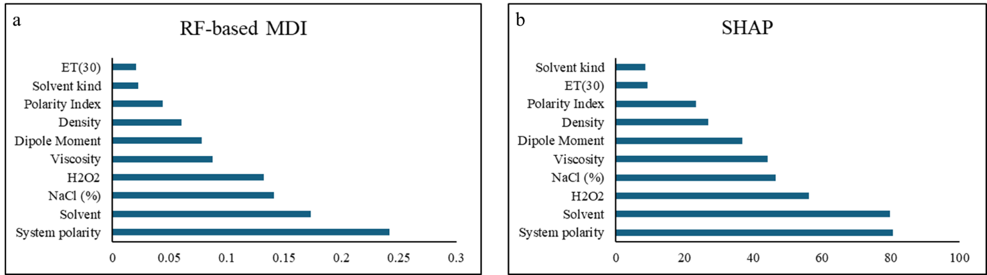
Figure S1: Feature importance through RF-based MDI and SHAP approach.

A.

B.

C.

D.

E.

F.

G.

H.
I.

J.

Figure S2: MS/MS spectra of A) p-coumaric acid, B) hydroxytyrosol, C) tyrosol, D) oleacein, E) pinoresinol, F) oleocanthal, G) luteolin, H) apigenin, I)diosmetin, J) oleuropein.

