Supplemental Material
Biological, chemical, and physical monitoring of a protected Hawaiian stream subject to water diversion, 2007-2021

Raikow^{1,2}, D. F. , A. C. Farahi² (0000-0001-7957-7889), A. L. McCutcheon² (0000-0001-6481-6920), and G. A. Puig-Santana³ (0000-0002-3366-0529)

Table S1. Descriptions of Geomorphic Channel Units for Habitat Characterization.
GCU | Code | Description
Pool (unspecified) | P | Still water, low velocity, smooth, glassy surface, usually deep compared to other parts of the stream.
Plunge Pool | PL | Pool at base of plunging cascade or falls.
Backwater Pool | BW | Pool separated from main flow off the side of the channel.
Eddy | ED | Water moving counter to the main flow usually due to obstruction such as a large boulder or roots along the bank. Water looks to be moving in a circular pattern resembling a whirlpool off of the main channel.
Glide | GL | Water moving slowly, with a smooth, unbroken surface. Low turbulence. Often the transition from pool to riffle.
Riffle | RF | Water moving, with small ripples, waves and eddies -- waves not breaking, surface tension not broken. Sound: "babbling", "gurgling".
Boulder Riffle | BR | A riffle over boulders rather than gravel, cobble or other substrate.
Run | RU | Moving water with low turbulence. Generally, shallower than a pool and deeper than a glide. Often the transition from a riffle to a pool.
Rapid | RD | Water movement rapid and turbulent, surface with intermittent whitewater with breaking waves. Sound: continuous rushing, but not as loud as cascade.
Chute or cutoff | CH | A new channel formed by erosion of the bank that shortens the course of the stream.
Cascade | CA | Water movement rapid and very turbulent over steep channel bottom. Most of the water surface is broken in short, irregular plunges, mostly whitewater. Sound: roaring.
Falls | FA | Free falling water over a vertical or near vertical drop into plunge, water turbulent and white over high falls. Sound: from splash to roar.
Abandoned/Dry Channel | AC | No water in the channel.

Table S2. Trend analysis of channel width by site in in Waikolu Stream Waikolu Stream, Kalaupapa National Historical Park, Moloka’i, Hawaii 2009-2021. Only fixed sites with statistically significant trends are displayed.
Site | term | Estimate | Std. Error | t value | p | Direction
FKALA02 | (Intercept) | -401.289 | 134.833 | -2.976 | *
 | Year | 0.202 | 0.067 | 3.024 | * | Increasing
FKALA03 | (Intercept) | -1,385.786 | 285.954 | -4.846 | **
 | Year | 0.693 | 0.142 | 4.885 | ** | Increasing
FKALA04 | (Intercept) | -820.313 | 219.367 | -3.739 | **
 | Year | 0.411 | 0.109 | 3.775 | ** | Increasing
* (p < 0.05), ** (p < 0.01)
Table S3. State of Hawaii specific inland water criteria for streams (State of Hawaii 2012).
Parameter | Unit | Season | Geometric mean not to exceed  the given value | Not to exceed the given value more than 10% of the time | Not to exceed the given value more than 2% of the time
Total Phosphorus | µgP ∙ L-1 | Wet1 | 50.0 | 100.0 | 150.0
Total Phosphorus | µgP ∙ L-1 | Dry 2 | 30.0 | 60.0 | 80.0
Total Nitrogen | mgN ∙ L-1 | Wet | 0.250 | 0.520 | 0.800
Total Nitrogen | mgN ∙ L-1 | Dry | 0.180 | 0.380 | 0.600
Nitrate + Nitrite | µgN ∙ L-1 | Wet | 70.0 | 180.0 | 300.0
Nitrate + Nitrite | µgN ∙ L-1 | Dry | 30.0 | 90.0 | 170.0
Total Suspended Solids | mg ∙ L-1 | Wet | 20.0 | 50.0 | 80.0
Total Suspended Solids | mg ∙ L-1 | Dry | 10.0 | 30.0 | 55.0
Turbidity | NTU | Wet | 5.0 | 15.0 | 25.0
Turbidity | NTU | Dry | 2.0 | 5.5 | 10.0
¹Wet season: November 1 - April 30.
²Dry season: May 1 - October 31.

Table S4. Geometric means of NO⁻₃ + NO⁻₂ and turbidity in Waikolu Stream by season, Kalaupapa National Historical Park, Moloka‘i, Hawaii.
Season | Year | NO-3 + NO-2  (n) | NO-3 + NO-2  (mg/L, Geometric mean) | Turbidity  (n) | Turbidity  (NTU, Geometric mean)
dry | 2008 | 8 | 0.117 | 7 | 0.11
dry | 2009 | 16 | 0.102 | 23 | 0.10
dry | 2010 | 9 | 0.113 | 17 | 0.16
dry | 2011 | 16 | 0.109 | 22 | 0.15
dry | 2012 | 15 | 0.086 | 14 | 0.14
dry | 2013 | 16 | 0.077 | 13 | 0.23
dry | 2014 | 16 | 0.104 | 8 | 0.10
dry | 2015 | 8 | 0.128 | 8 | 0.13
dry | 2016 | 16 | 0.123 | 16 | 0.14
dry | 2017 | 12 | 0.116 | 16 | 0.10
wet | 2007 | 7 | 0.093 | 1 | 1.30
wet | 2008 | 8 | 0.161 | 7 | 0.11
wet | 2009 | 8 | 0.126 | 8 | 0.18
wet | 2010 | 8 | 0.171 | 16 | 0.14
wet | 2011 | 16 | 0.139 | 14 | 0.14
wet | 2012 | 8 | 0.129 | 8 | 0.10
wet | 2013 | 16 | 0.125 | 7 | 0.11
wet | 2015 | 16 | 0.159 | 8 | 0.10
wet | 2016 | 16 | 0.161 | 16 | 0.10
wet | 2017 | 24 | 0.136 | 24 | 0.10

Table S5. Ranges of water quality parameters in Waikolu Stream, Kalaupapa National Historical Park, Moloka‘i, Hawaii 2007-2021.
Parameter | units | n | max | q3 | Arithmetic mean | Geometric mean | median | q1 | min
TDN | mg/l | 370 | 0.44 | 0.19 | 0.17 | 0.14 | 0.15 | 0.13 | 0.06
TDP | mg/l | 345 | 0.08 | 0.05 | 0.04 | 0.04 | 0.04 | 0.04 | 0.02
NO⁻₃ + NO⁻₂ | mg/l | 370 | 0.31 | 0.15 | 0.13 | 0.12 | 0.13 | 0.10 | 0.03
TN | mg/l | 40 | 0.30 | 0.15 | 0.17 | 0.17 | 0.17 | 0.13 | 0.09
TP | mg/l | 40 | 0.05 | 0.05 | 0.04 | 0.04 | 0.04 | 0.04 | 0.03
Chlorophyll | µg/l | 350 | 18.92 | 1.07 | 1.08 | 0.40 | 0.32 | 0.10 | 0.10
pH | None | 379 | 8.85 | 8.02 | 7.74 | 7.73 | 7.83 | 7.47 | 6.24
Sal | ppt | 405 | 0.16 | 0.06 | 0.06 | 0.05 | 0.05 | 0.05 | 0.02
Temp | °C | 412 | 23.09 | 20.70 | 20.03 | 20.00 | 19.92 | 19.29 | 16.79
Turbid+ | FNU | 370 | 47.52 | 0.14 | 0.64 | 0.17 | 0.10 | 0.10 | 0.10
ODOSat | % | 406 | 113.58 | 101.74 | 100.25 | 100.21 | 100.82 | 99.07 | 77.72
ODOConc | mg/l | 406 | 10.20 | 9.28 | 9.11 | 9.10 | 9.12 | 8.94 | 7.09
SpC | mS/cm | 405 | 0.34 | 0.12 | 0.12 | 0.00 | 0.11 | 0.10 | 0.00

Table S6. Summary of quarter and wet/dry seasonality tests showing p-values.
 | Quarter seasonality tests |  |  |  |  |  | Wet/Dry seasonality tests
Parameter | R² | Main | Time | Q1 | Q2 | Q3 | R² | Main | Time | Wet
TDN | 0.10 | 0.0000 | 0.0048 | 0.0004 | 0.0000 | 0.0000 | 0.07 | 0.0000 | 0.0066 | 0.0000
TDP | 0.07 | 0.0000 | 0.0001 | 0.5157 | 0.6183 | 0.0080 | 0.41 | 0.0003 | 0.0001 | 0.2317
NO⁻₃ + NO⁻₂ | 0.13 | 0.0000 | 0.0361 | 0.0051 | 0.0000 | 0.0000 | 0.12 | 0.0000 | 0.0868 | 0.0000
Chlorophyll | 0.03 | 0.0050 | 0.8582 | 0.0012 | 0.0010 | 0.0041 | 0.00 | 0.8723 | 0.8862 | 0.6167
pH | 0.00 | 0.2498 | 0.6911 | 0.3469 | 0.4295 | 0.1896 | 0.00 | 0.6595 | 0.7646 | 0.3857
ODOsat | 0.06 | 0.0000 | 0.0011 | 0.4633 | 0.0001 | 0.1213 | 0.04 | 0.0002 | 0.0008 | 0.0105
SpC | 0.02 | 0.0083 | 0.0065 | 0.5433 | 0.1929 | 0.2771 | 0.02 | 0.0168 | 0.0086 | 0.2573
Temperature | 0.18 | 0.0000 | 0.0039 | 0.0004 | 0.0027 | 0.0000 | 0.18 | 0.0000 | 0.0167 | 0.0000
Turbidity | 0.11 | 0.0000 | 0.0000 | 0.0000 | 0.4563 | 0.7907 | 0.06 | 0.0000 | 0.0000 | 0.0449

Table S7. Trend analysis of fish length in Waikolu Stream Waikolu Stream, Kalaupapa National Historical Park, Moloka’i, Hawaii 2009-2021.
Species | term | Estimate | Std. Error | df | t value | p | Direction
A. stamineus | (Intercept) | 163.365 | 38.213 | 71.913 | 4.275 | ****
 | Year | -0.080 | 0.019 | 71.907 | -4.204 | **** | Decreasing
E. sandwicensis | (Intercept) | 36.936 | 154.547 | 10.000 | 0.239 | 0.81
 | Year | -0.017 | 0.077 | 10.000 | -0.221 | 0.83
K. sandvicensis | (Intercept) | 35.350 | 44.371 | 9.563 | 0.797 | 0.45
 | Year | -0.016 | 0.022 | 9.573 | -0.738 | 0.48
L. concolor | (Intercept) | 32.877 | 9.974 | 118.303 | 3.296 | **
 | Year | -0.015 | 0.005 | 118.315 | -3.110 | ** | Decreasing
S. stimpsoni | (Intercept) | 38.497 | 17.265 | 99.102 | 2.230 | *
 | Year | -0.018 | 0.009 | 99.105 | -2.110 | * | Decreasing
S. hawaiiensis | (Intercept) | -146.706 | 219.199 | 1.000 | -0.669 | 0.62
 | Year | 0.074 | 0.109 | 1.000 | 0.680 | 0.62
* (p < 0.05), ** (p < 0.01), *** (p < 0.001), **** (p < 0.0001)

Table S8. Trend analysis of invertebrate abundance by site in Waikolu Stream Waikolu Stream, Kalaupapa National Historical Park, Moloka’i, Hawaii 2009-2021. Only fixed sites with statistically significant trends are displayed.
Species | Sites | term | Estimate | Std. Error | t value | p | Direction
A. bisulcata | FKALA03 | (Intercept) | 89.563 | 21.294 | 4.206 | ***
 | FKALA03 | Year | -0.044 | 0.011 | -4.194 | *** | Decreasing
A. bisulcata | FKALA04 | (Intercept) | 115.267 | 19.932 | 5.783 | ***
 | FKALA04 | Year | -0.057 | 0.010 | -5.745 | *** | Decreasing
M. lar | FKALA04 | (Intercept) | -147.228 | 27.996 | -5.259 | ***
 | FKALA04 | Year | 0.073 | 0.014 | 5.271 | *** | Increasing
A. bisulcata | FKALA07 | (Intercept) | 73.550 | 21.581 | 3.408 | **
 | FKALA07 | Year | -0.036 | 0.011 | -3.396 | ** | Decreasing
A. bisulcata | FKALA08 | (Intercept) | -113.473 | 20.483 | -5.540 | ***
 | FKALA08 | Year | 0.056 | 0.010 | 5.553 | *** | Increasing
N. granosa | FKALA01 | (Intercept) | 166.329 | 79.112 | 2.102 | *
 | FKALA01 | Year | -0.081 | 0.039 | -2.067 | * | Decreasing
N. granosa | FKALA02 | (Intercept) | 166.329 | 79.112 | 2.102 | **
 | FKALA02 | Year | -0.081 | 0.039 | -2.067 | ** | Decreasing
* (p < 0.05), ** (p < 0.01), *** (p < 0.001), **** (p < 0.0001)

Table S9. Trend analysis of invertebrate abundance by site in Waikolu Stream Waikolu Stream, Kalaupapa National Historical Park, Moloka’i, Hawaii 2009-2021. Only fixed sites with statistically significant trends are displayed.
Species | Sites | term | Estimate | Std. Error | t value | p | Direction
A. bisulcata | FKALA03 | (Intercept) | 89.563 | 21.294 | 4.206 | ***
 |  | Year | -0.044 | 0.011 | -4.194 | *** | Decreasing
A. bisulcata | FKALA04 | (Intercept) | 115.267 | 19.932 | 5.783 | ***
 |  | Year | -0.057 | 0.010 | -5.745 | *** | Decreasing
M. lar | FKALA04 | (Intercept) | -147.228 | 27.996 | -5.259 | ***
 |  | Year | 0.073 | 0.014 | 5.271 | *** | Increasing
A. bisulcata | FKALA07 | (Intercept) | 73.550 | 21.581 | 3.408 | **
 |  | Year | -0.036 | 0.011 | -3.396 | ** | Decreasing
A. bisulcata | FKALA08 | (Intercept) | -113.473 | 20.483 | -5.540 | ***
 |  | Year | 0.056 | 0.010 | 5.553 | *** | Increasing
N. granosa | FKALA01 | (Intercept) | 166.329 | 79.112 | 2.102 | *
 |  | Year | -0.081 | 0.039 | -2.067 | * | Decreasing
N. granosa | FKALA02 | (Intercept) | 166.329 | 79.112 | 2.102 | **
 |  | Year | -0.081 | 0.039 | -2.067 | ** | Decreasing
* (p < 0.05), ** (p < 0.01), *** (p < 0.001), **** (p < 0.0001)

Table S10. Trend analysis of Macrobrachium lar length in Waikolu Stream Waikolu Stream, Kalaupapa National Historical Park, Moloka’i, Hawaii 2009-2021.
Species | term | Estimate | Std. Error | df | t value | p | Direction
M. lar | (Intercept) | 126.524 | 52.521 | 65.572 | 2.409 | *
 | Year | -0.059 | 0.026 | 65.572 | -2.254 | * | Decreasing

Table S11. Repeated measures ANOVA comparing adult Neritona granosa abundance at FKALA01 and FKALA06.
 | Sum Sq | DF | F value | p
Intercept | 1190 | 1 | 0.2043 | 0.66
Site | 2771 | 1 | 0.4755 | 0.50
Year | 1135 | 1 | 0.1947 | 0.66
Site x Year | 2758 | 1 | 0.4733 | 0.50

Table S12. Correlations of selected water quality parameters between selected sites in Waikolu Stream, Kalaupapa National Historical Park, Moloka‘i, Hawaii, USA, 2007-2021.
Parameter | Fixed vs. Temporary |  | FKALA01 vs all others |  | FKALA02 vs all others |  | FKALA03 vs all others |  | FKALA04 vs all others |  | FKALA01 vs upper¹ |  | FKALA02 vs upper¹ |  | FKALA03 vs upper¹ |  | FKALA04 vs upper¹ |  | Upper¹ vs. all others
 | R | p | R | p | R | p | R | p | R | p | R | p | R | p | R | p | R | p | R | p
Chlorophyll | 0.86 | **** | 0.79 | **** | 0.66 | *** | 0.71 | **** | 0.77 | **** | 0.11 | 0.82 | 0.12 | 0.83 | 0.27 | 0.52 | 0.78 | * | 0.89 | *
NO⁻₃ + NO⁻₂ | 0.77 | **** | 0.85 | **** | 0.88 | **** | 0.89 | **** | 0.75 | **** | 0.47 | 0.35 | 0.25 | 0.64 | -0.11 | 0.83 | 0.46 | 0.36 | -0.04 | 0.94
ODOConc | 0.83 | **** | 0.83 | **** | 0.87 | **** | 0.84 | **** | 0.48 | ** | 0.50 | 0.25 | 0.37 | 0.41 | 0.60 | 0.16 | -0.02 | 0.96 | 0.64 | 0.12
ODOSat | 0.64 | **** | 0.70 | **** | 0.76 | **** | 0.59 | **** | 0.38 | * | 0.88 | ** | 0.93 | ** | 0.86 | * | 0.63 | 0.13 | 0.92 | **
pH | 0.96 | **** | 0.89 | **** | 0.96 | **** | 0.92 | **** | 0.89 | **** | 0.60 | 0.20 | 0.68 | 0.14 | 0.60 | 0.21 | 0.92 | * | 0.88 | *
Sal | 0.98 | **** | 0.94 | **** | 0.97 | **** | 0.93 | **** | 0.95 | **** | 0.17 | 0.72 | 0.17 | 0.72 | 0.12 | 0.79 | 0.91 | * | 0.57 | 0.18
SpC | 0.97 | **** | 0.94 | **** | 0.98 | **** | 0.94 | **** | 0.96 | **** | 0.25 | 0.59 | 0.31 | 0.51 | 0.05 | 0.91 | 0.80 | 0.03 | 0.57 | 0.18
TDN | 0.73 | **** | 0.58 | **** | 0.80 | **** | 0.88 | **** | 0.87 | **** | 0.68 | 0.14 | 0.92 | ** | 0.59 | 0.22 | 0.59 | 0.22 | 0.76 | 0.08
TDP | 0.82 | **** | 0.77 | **** | 0.65 | **** | 0.85 | **** | 0.42 | * | 0.91 | 0.27 | 1.00 | * | 0.99 | 0.10 | 0.59 | 0.60 | 1.00 | *
Temp | 0.88 | **** | 0.82 | **** | 0.86 | **** | 0.89 | **** | 0.74 | **** | 0.09 | 0.85 | 0.24 | 0.61 | -0.04 | 0.94 | 0.31 | 0.50 | 0.50 | 0.26
Mean² R | 0.85 |  | 0.83 |  | 0.87 |  | 0.89 |  | 0.76 |  | 0.49 |  | 0.34 |  | 0.43 |  | 0.61 |  | 0.70
Median² R | 0.84 |  | 0.81 |  | 0.84 |  | 0.84 |  | 0.72 |  | 0.47 |  | 0.50 |  | 0.42 |  | 0.60 |  | 0.68
* (p < 0.05), ** (p < 0.01), *** (p < 0.001), **** (p < 0.0001)
1. Data grouped from sites FKALA08, FKALA09, and FKALA10.
2. Using absolute value.

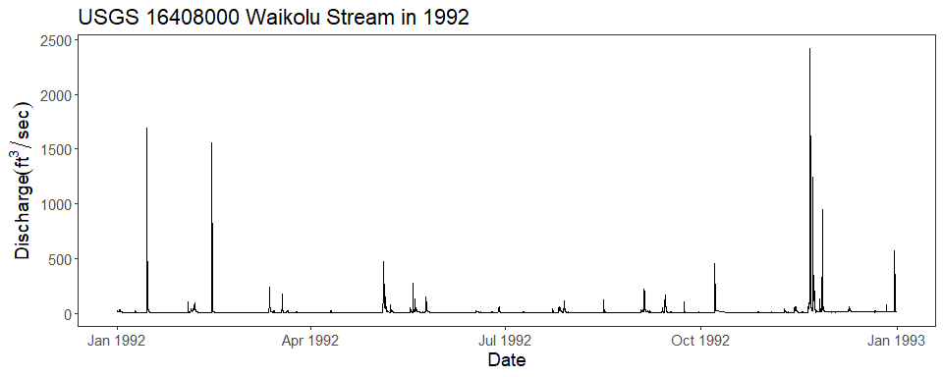

Figure. S1. Example of annual discharge (Q) regime in Waikolu Stream, Kalaupapa National Historical Park, Moloka‘i, HI, USA, (USGS monitoring location 16408000).

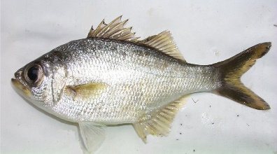  Kuhlia sandvicensis | 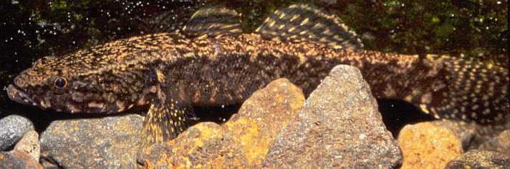  Eleotris sandwicensis
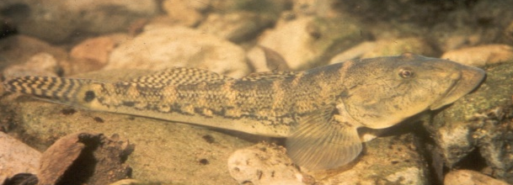  Awaous stamineus | 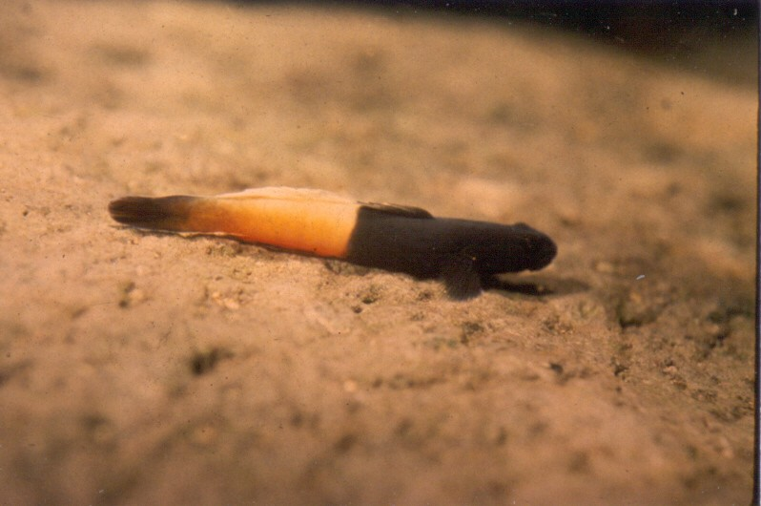  Lentipes concolor (male)
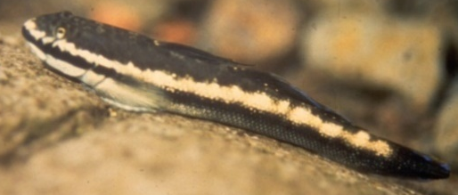  Sicyopterus stimpsoni | 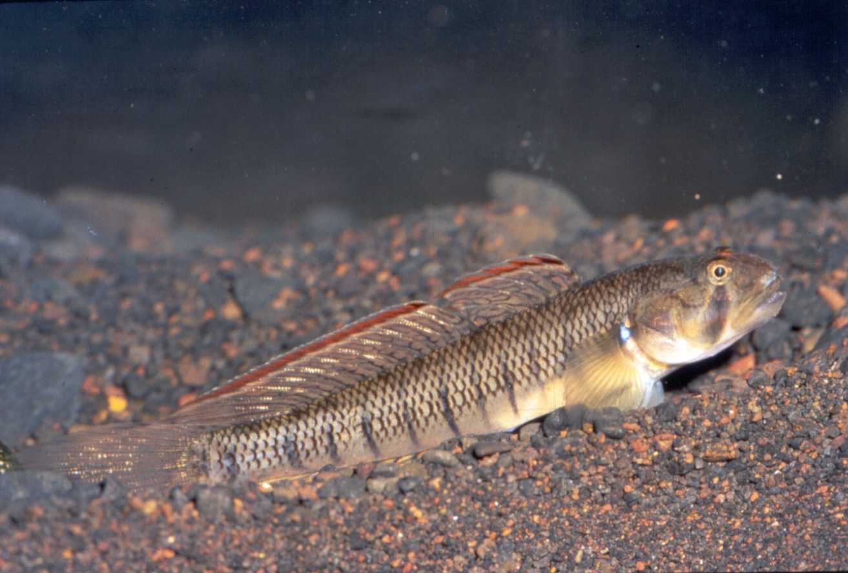  Stenogobius hawaiiensis
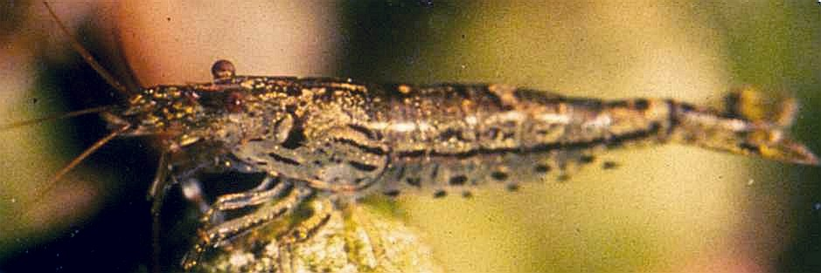  Atyoida bisulcata | 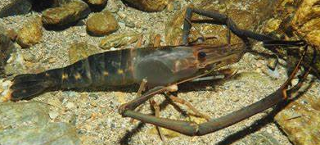  Macrobrachium lar
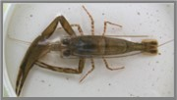  Macrobrachium grandimanus | 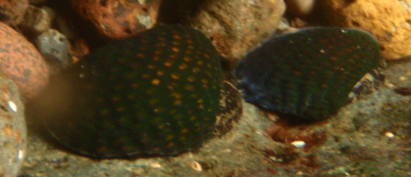  Neritona granosa

Figure. S2. Animals monitored in Waikolu Stream, Kalaupapa National Historical Park, Moloka‘i, HI, USA, 2009-2021.

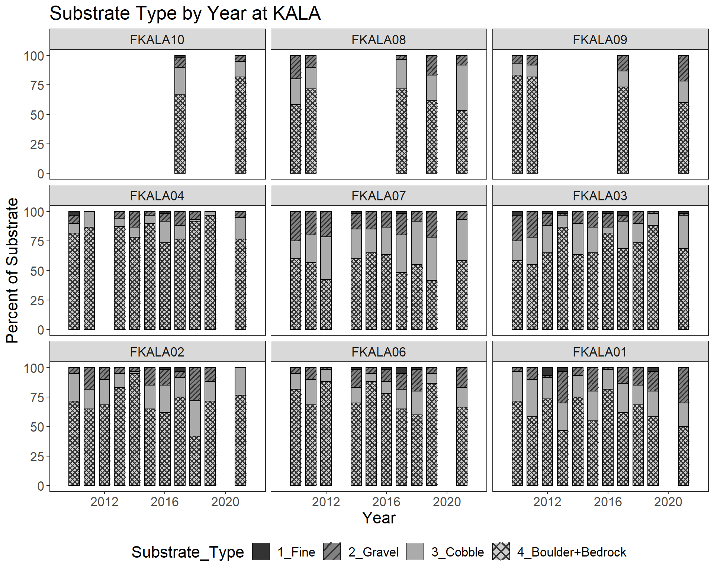

Figure S3. Relative abundance of substrate particles, as simplified substrate classes, arranged from upstream (top left, FKALA10) to downstream (bottom right, FKALA01) at fixed sites in Waikolu Stream, Kalaupapa National Historical Park, Moloka‘i, HI, 2009-2021.

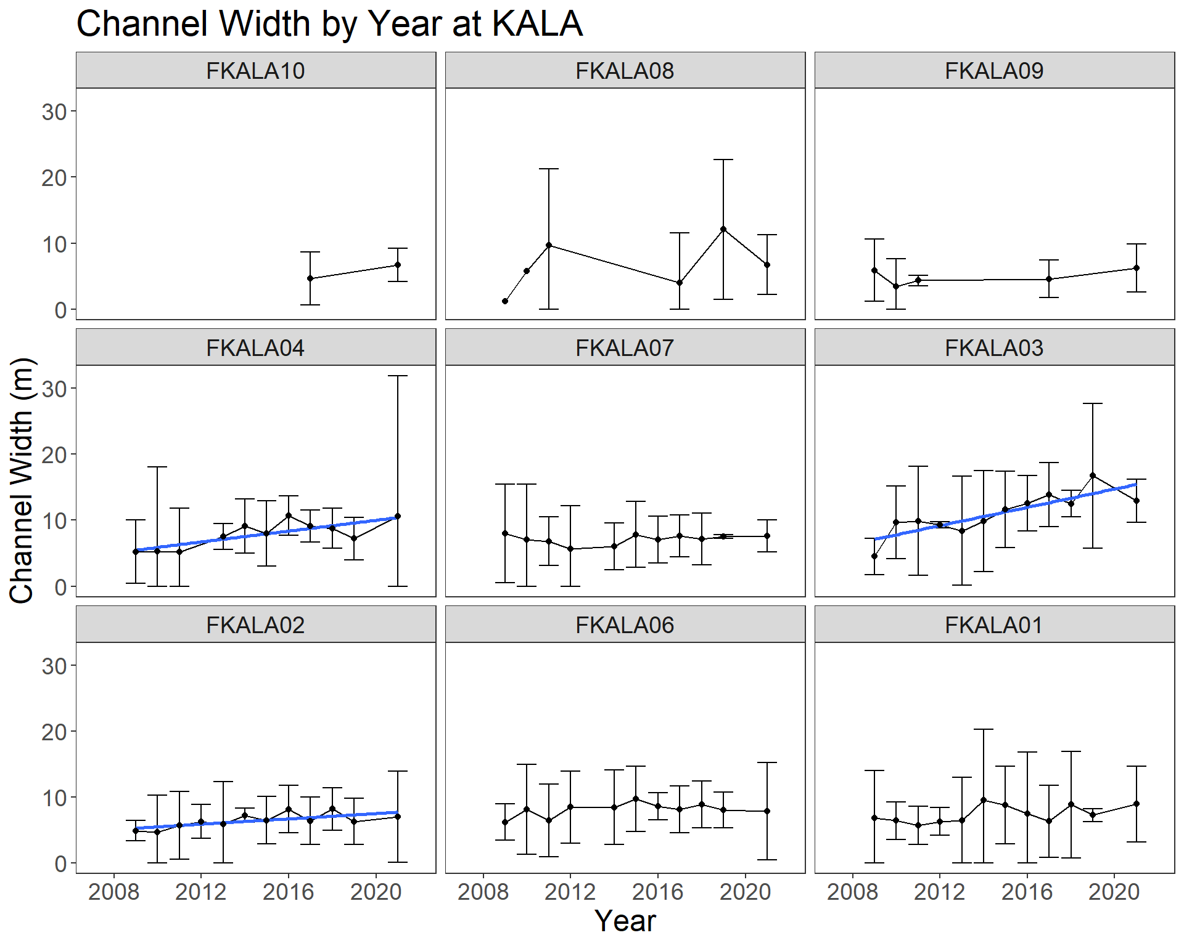
Figure S4. Channel width over time, by site, arranged from upstream (FKALA10), top left to bottom right, to downstream (FKALA01), at fixed sites in Waikolu Stream, Kalaupapa National Historical Park, Moloka‘i, HI, 2009-2021. Error bars are 95% confidence interval.
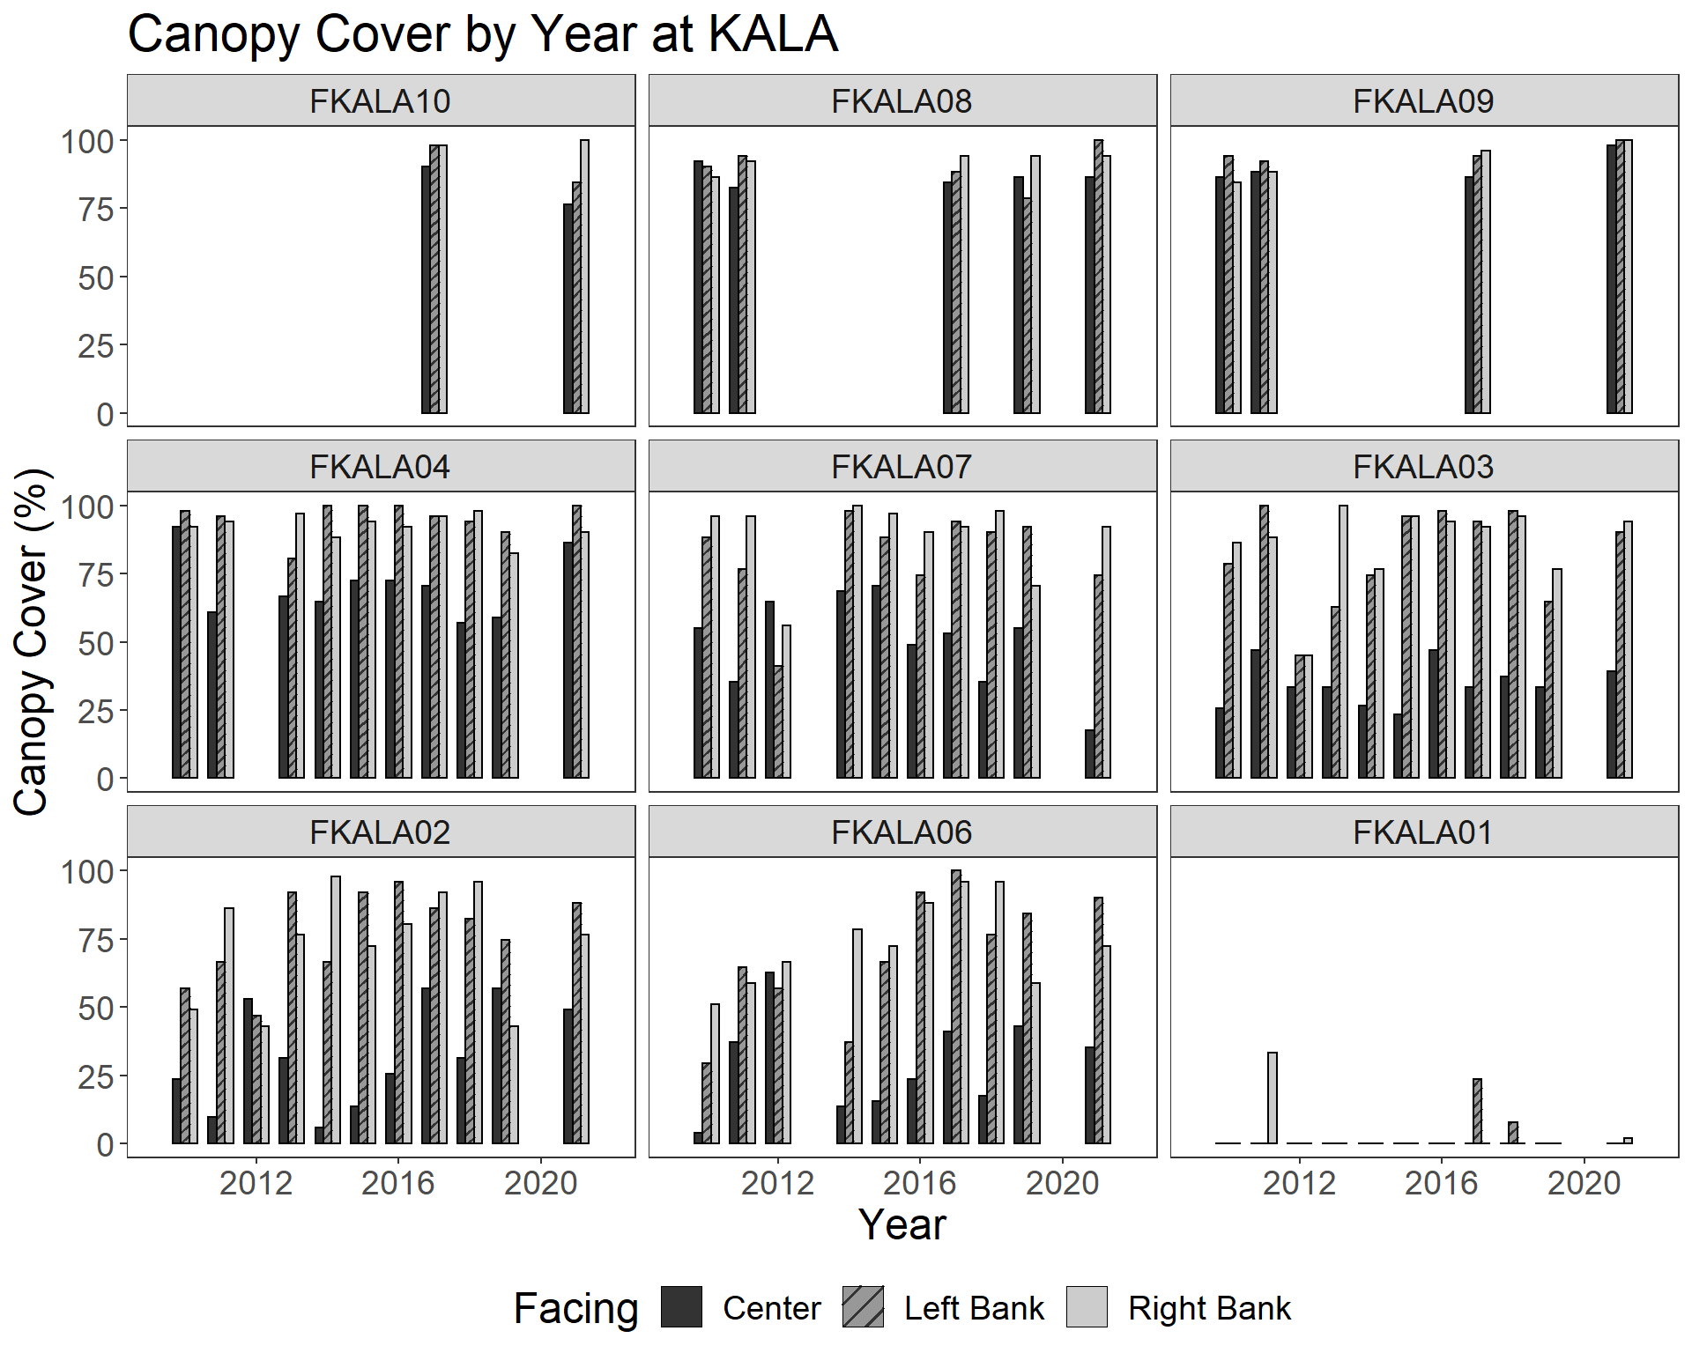
Figure S5. Canopy cover over time, by site, arranged from upstream (FKALA10), top left to bottom right, to downstream (FKALA01), at fixed sites in Waikolu Stream, Kalaupapa National Historical Park, Moloka‘i, HI, 2009-2021.

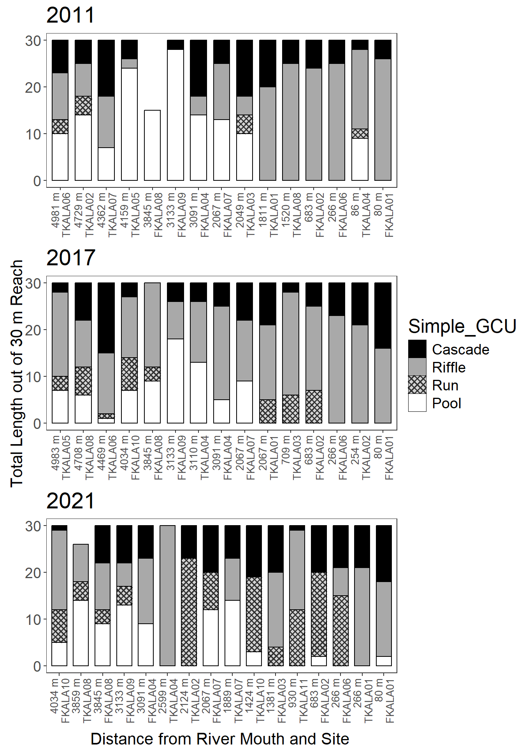

Figure S6. Simplified geomorphic channel units in Waikolu Stream, Kalaupapa National Historical Park, Moloka‘i, HI, USA in select years. Labels indicate distance from stream mouth and site name. Top: 2011, Middle: 2017, Bottom: 2021.

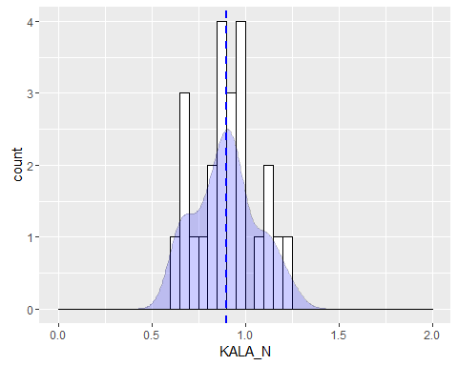
A)
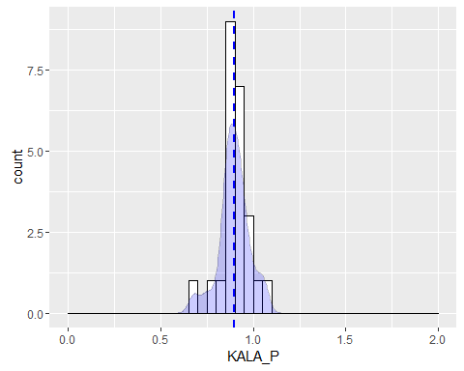
B)
Figure S7. Proportions of dissolved nitrogen (A) and phosphorus (B) in Waikolu Stream, Kalaupapa National Historical Park, Moloka‘i, Hawaii, USA.
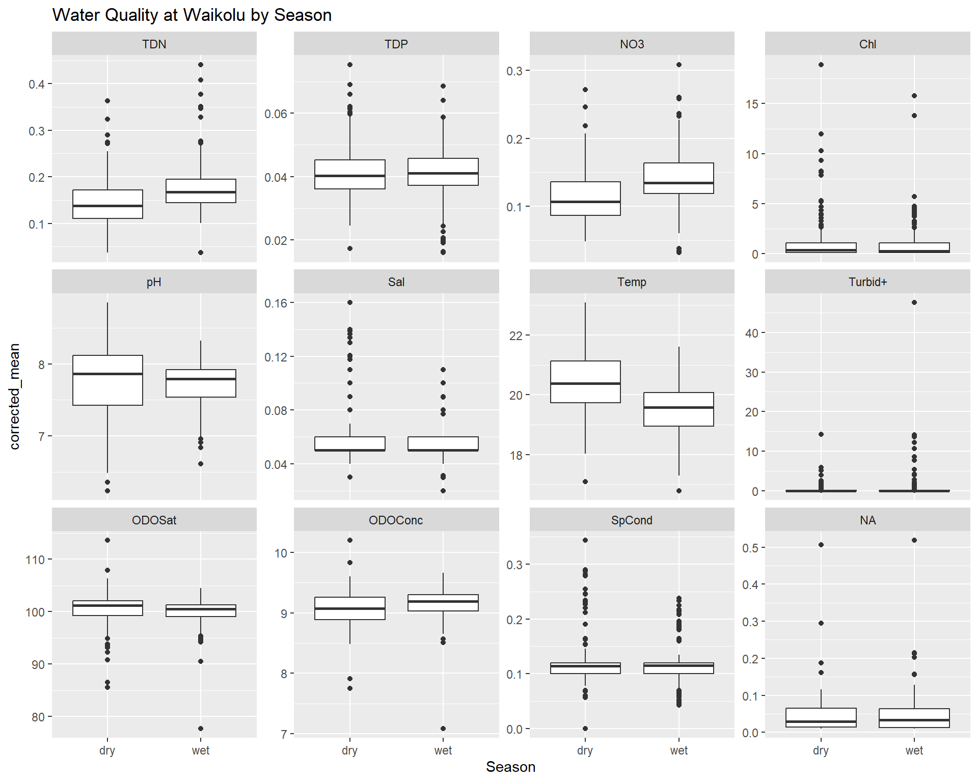
Mean
Figure S8. Distribution of water quality parameters by wet/dry season in Waikolu Stream, Waikolu Stream, Kalaupapa National Historical Park, Moloka‘i, Hawaii, USA.

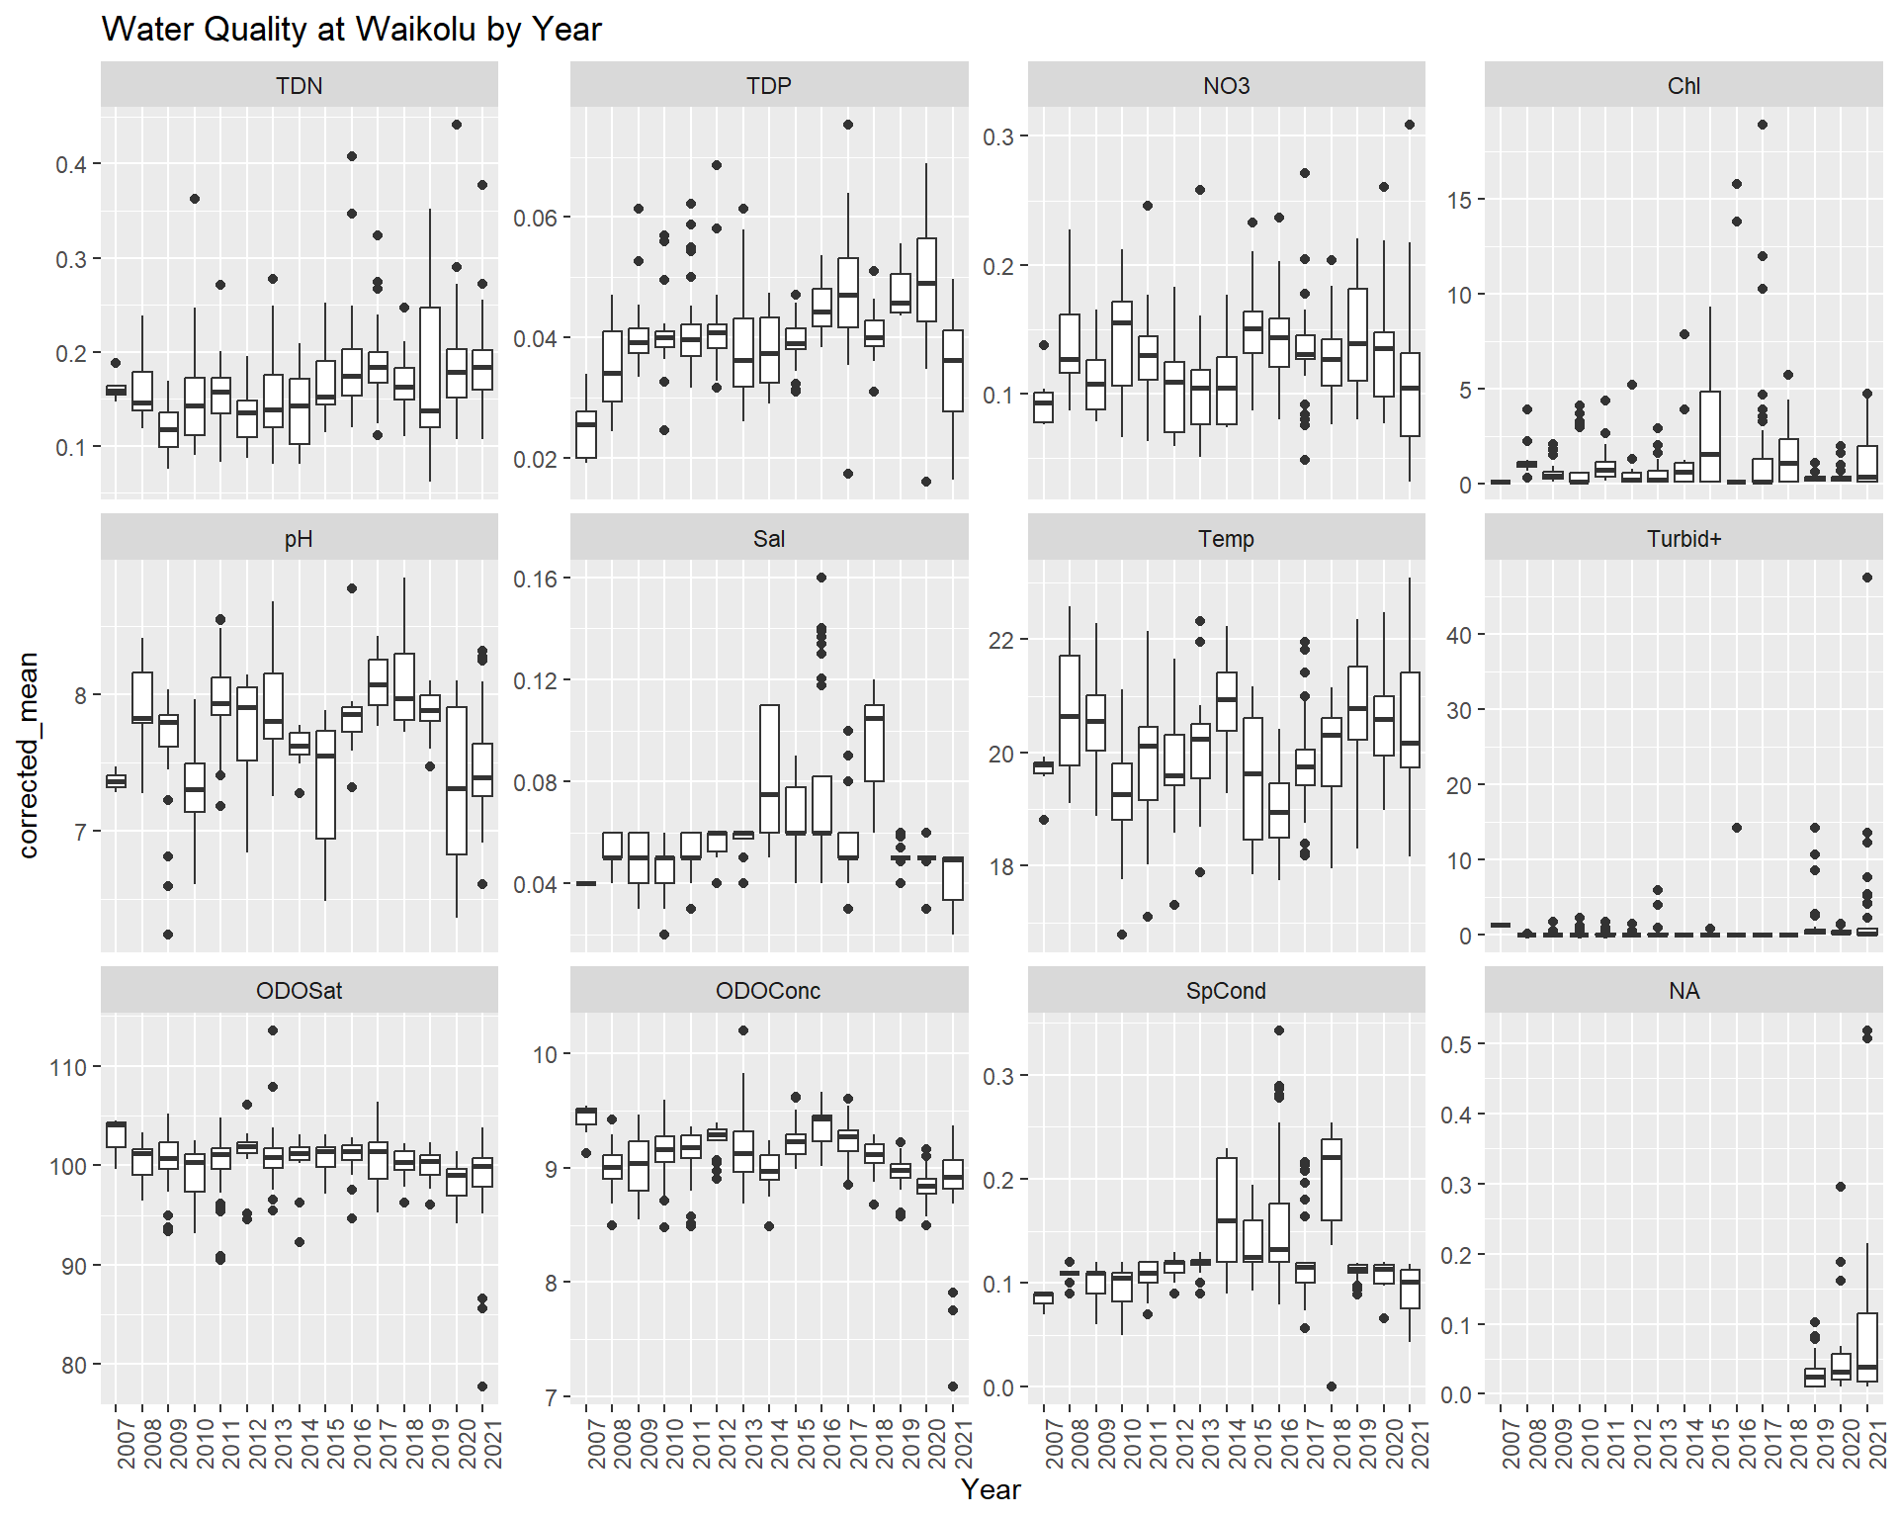
Mean
Figure S9. Distribution of water quality parameters by year in Waikolu Stream, Waikolu Stream, Kalaupapa National Historical Park, Moloka‘i, Hawaii, USA.

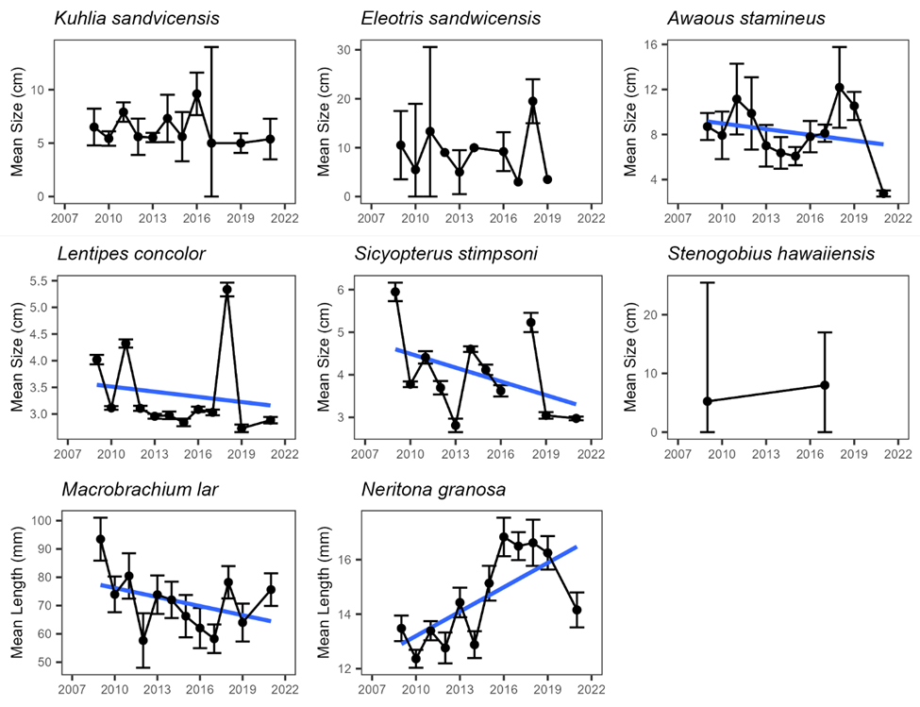
Figure S10. Animal size over time in in Waikolu Stream, Kalaupapa National Historical Park, Moloka‘i, HI, USA.

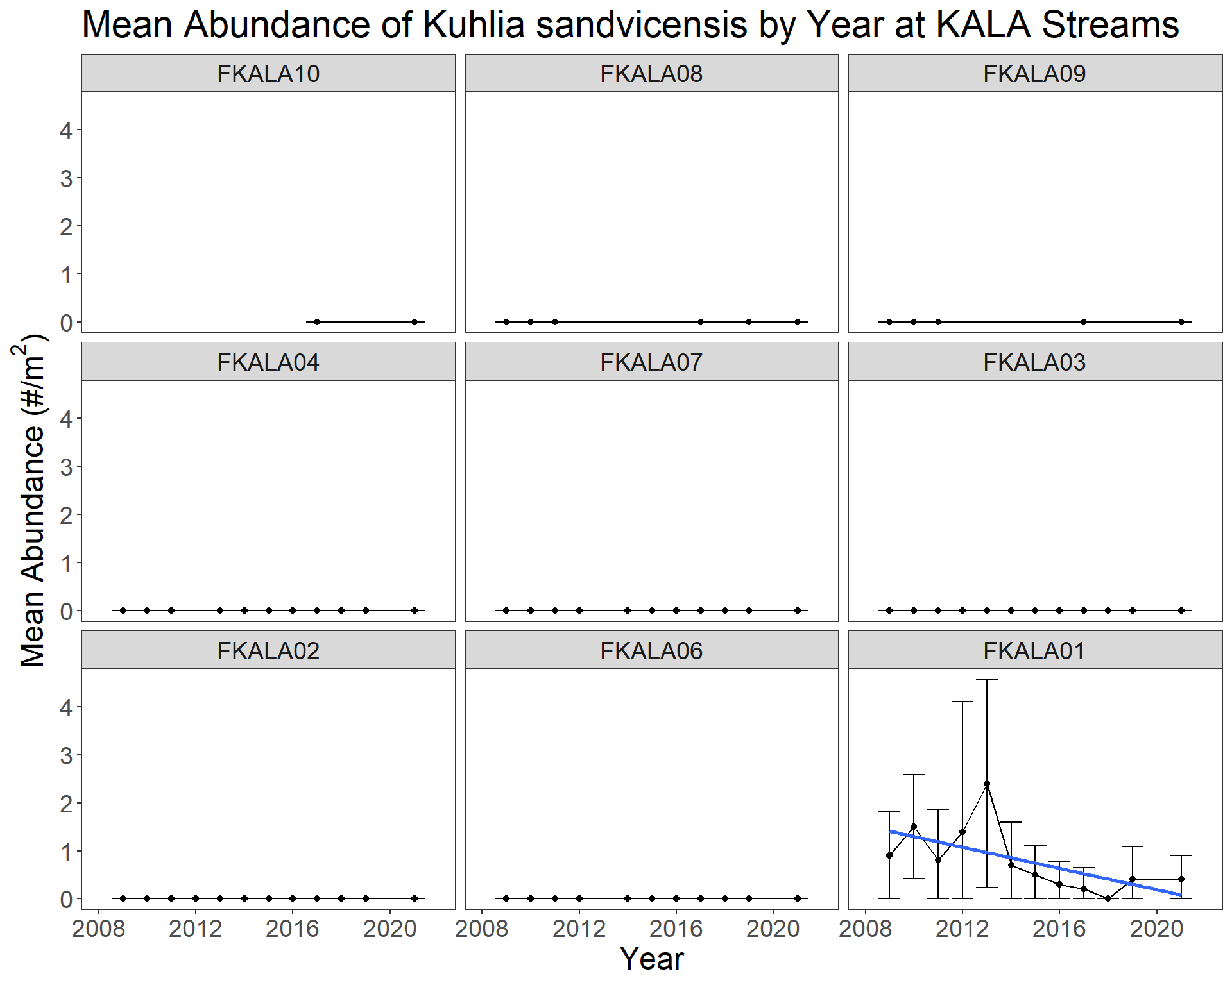
Figure S11. Abundance of K. sandwicensis, 2009-2021 by site. Panels are arranged upstream (top left) to downstream (bottom right).

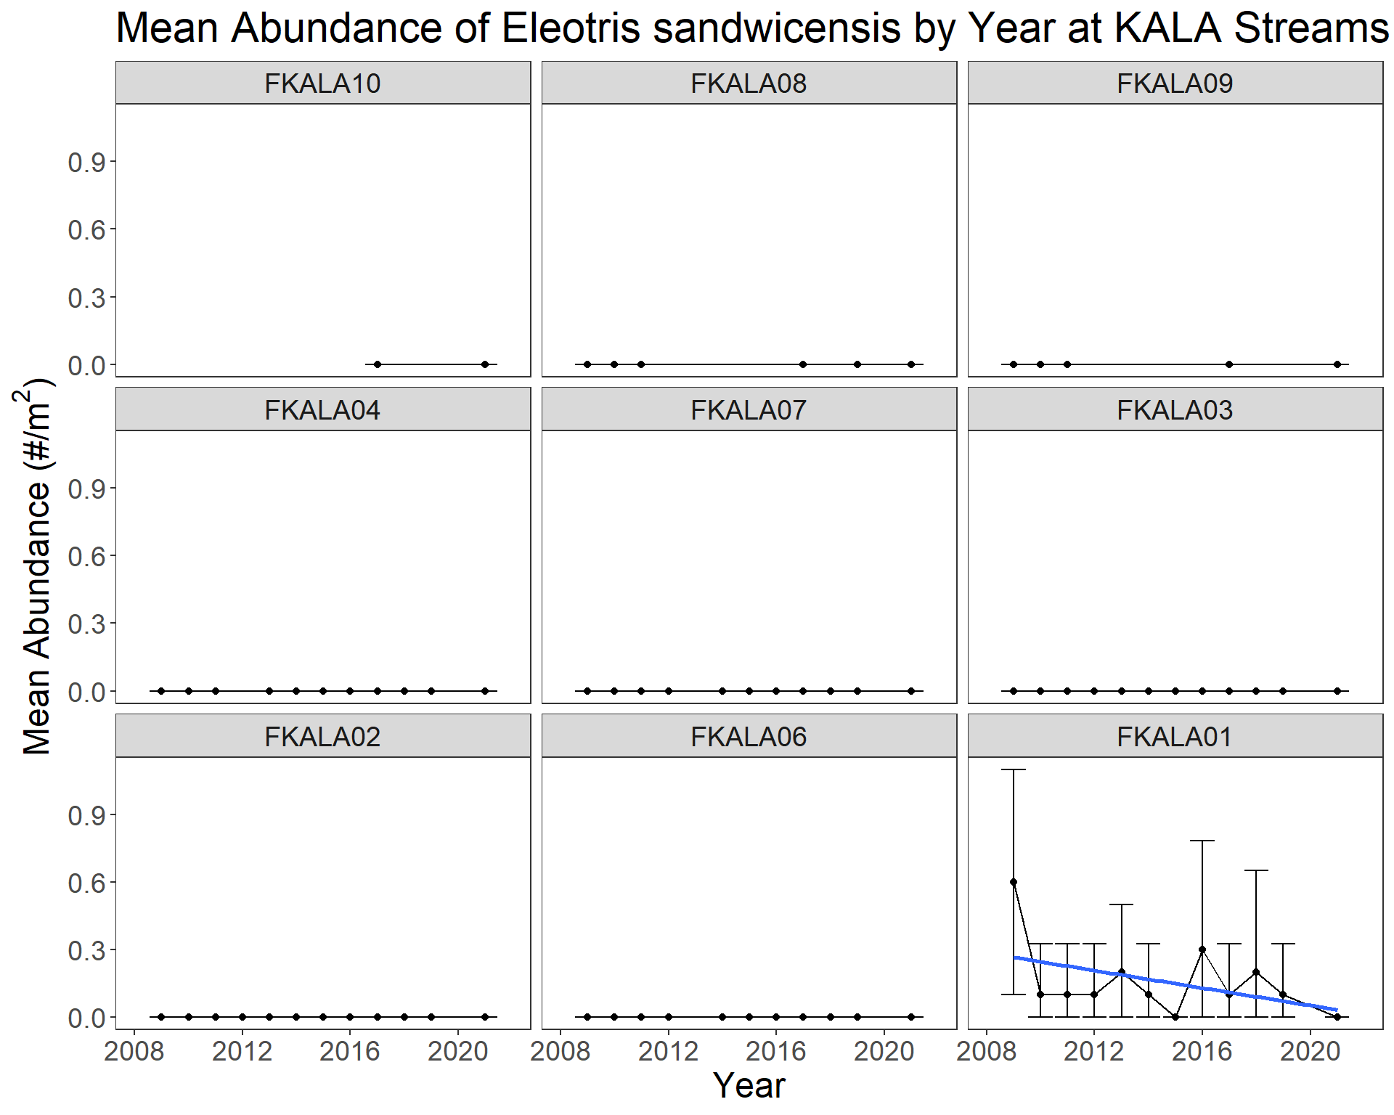
Figure S12. Abundance of E. sandwicensis, 2009-2021 by site. Panels are arranged upstream (top left) to downstream (bottom right).

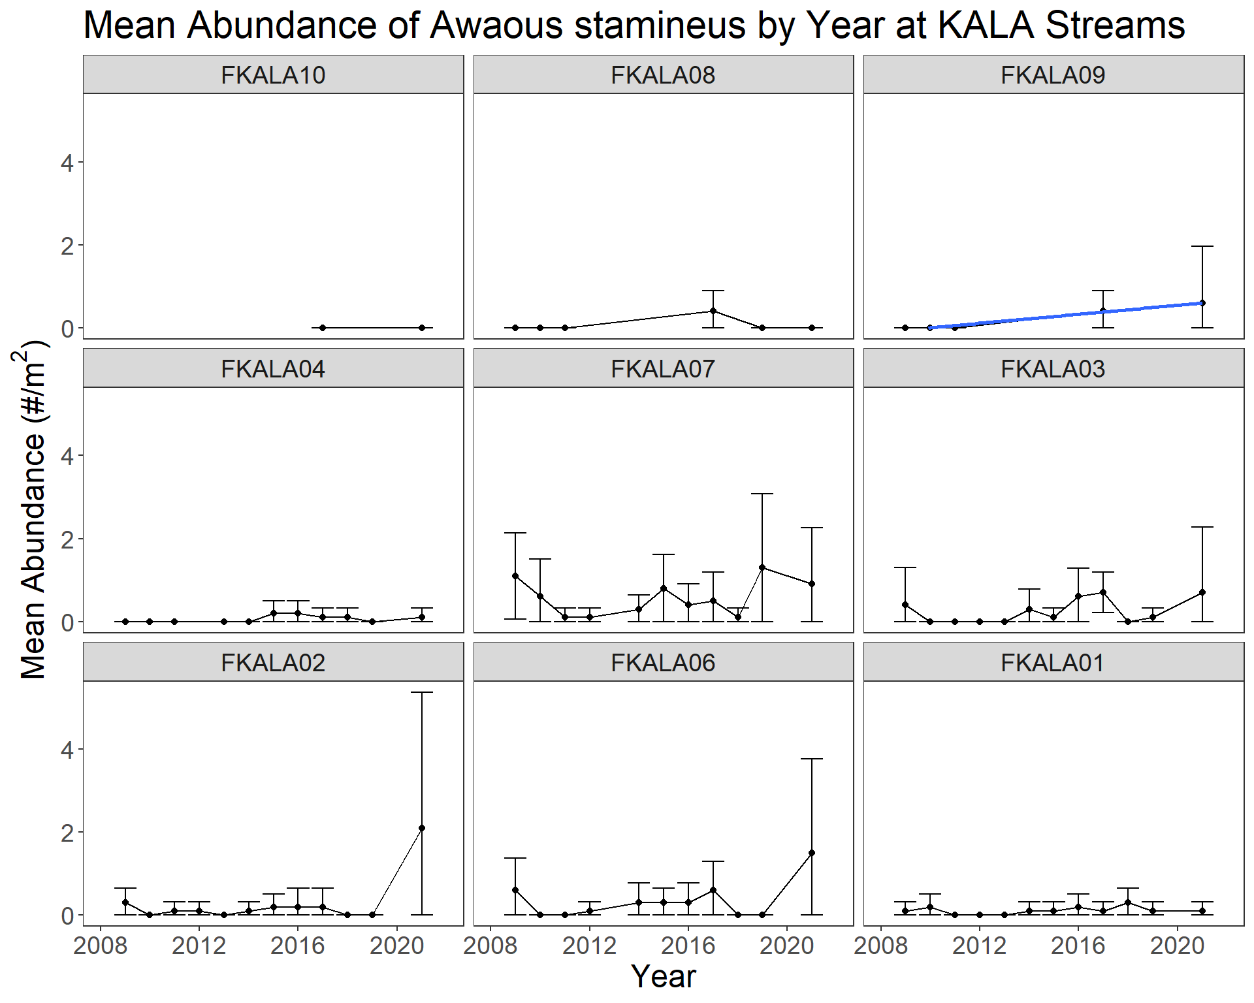
Figure S13. Abundance of A. stamineus, 2009-2021, by site. Panels are arranged upstream (top left) to downstream (bottom right).

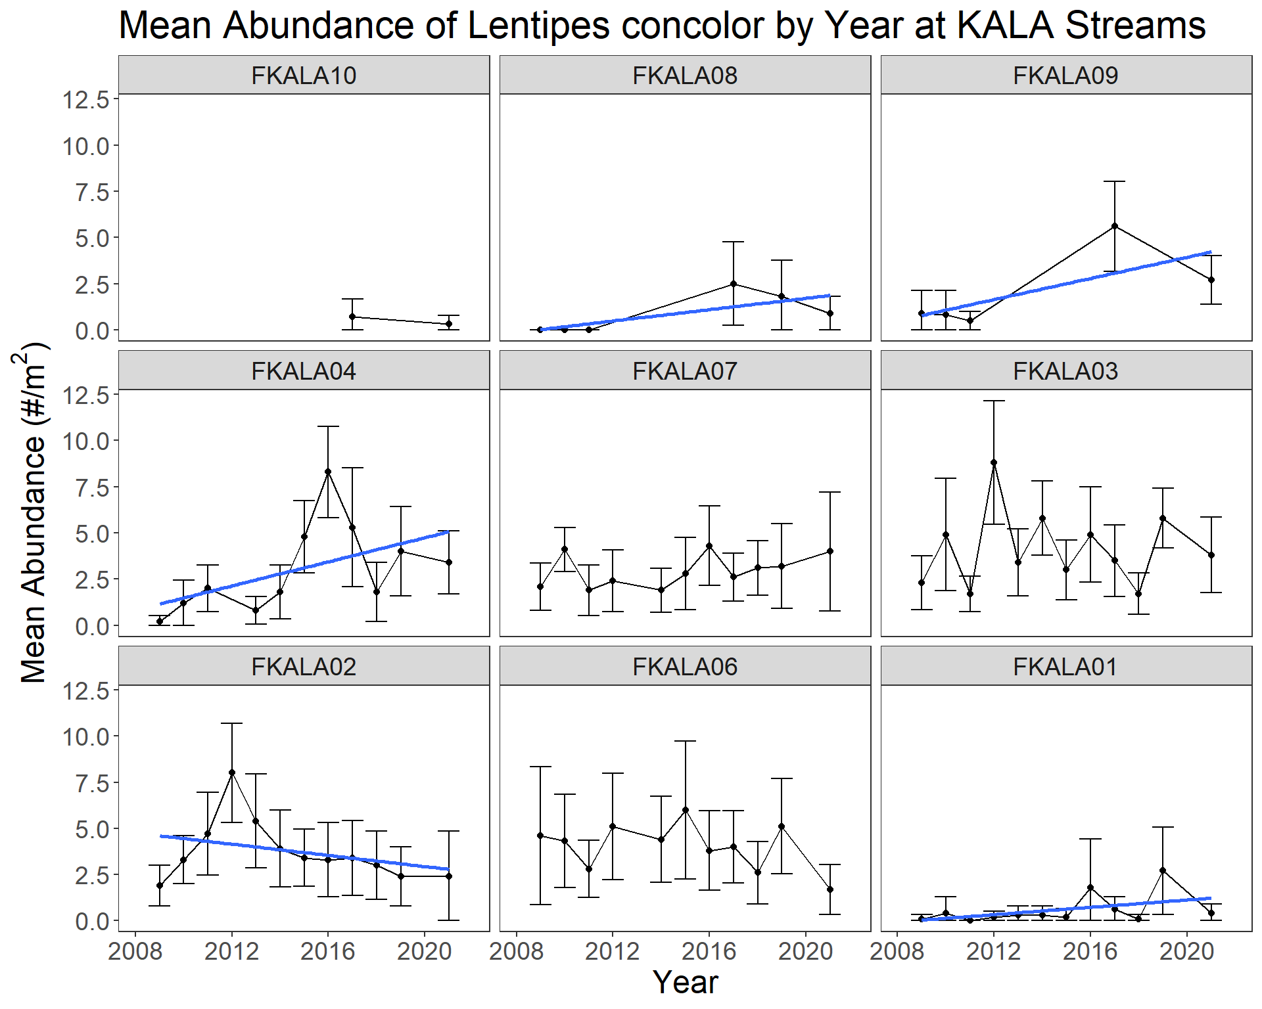
Figure S14. Abundance of L. concolor, 2009-2021 by site. Panels are arranged upstream (top left) to downstream (bottom right).

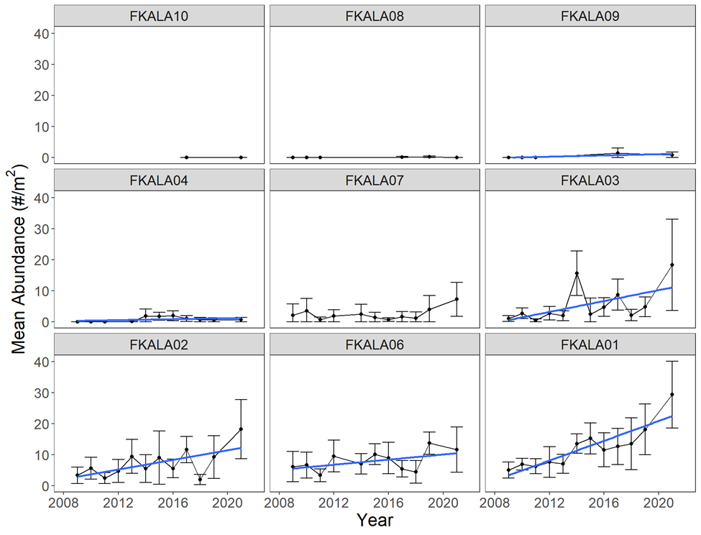
Figure S15. Abundance of S. stimpsoni, 2009-2021 by site. Panels are arranged upstream (top left) to downstream (bottom right).

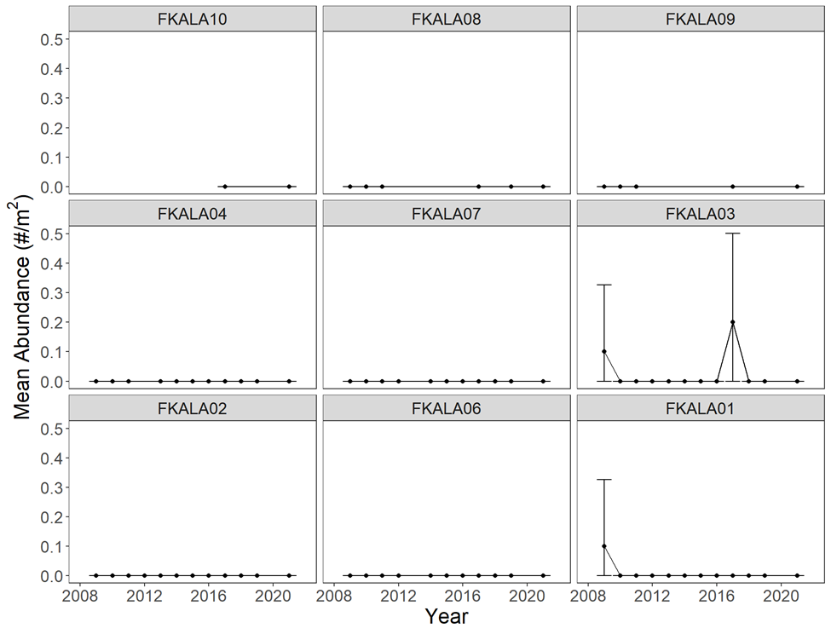
Figure S16. Abundance of S. hawaiiensis, 2009-2021 by site. Panels are arranged upstream (top left) to downstream (bottom right).

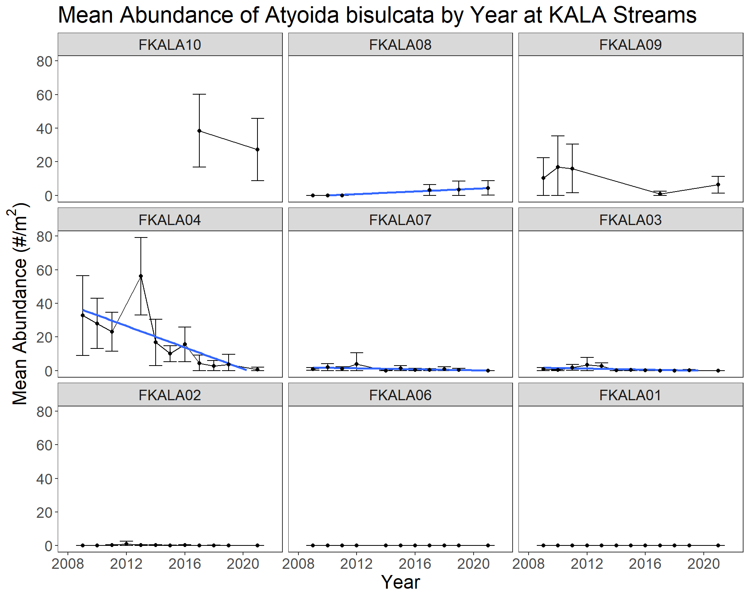Figure S17. Abundance of the shrimp Atyoida bisulcata, across time, by site, arranged from upstream (FKALA10) top left to bottom right, to downstream (FKALA01) in in Waikolu Stream, Kalaupapa National Historical Park, Moloka‘i, HI, 2009-2021. Error bars are 95% confidence intervals.

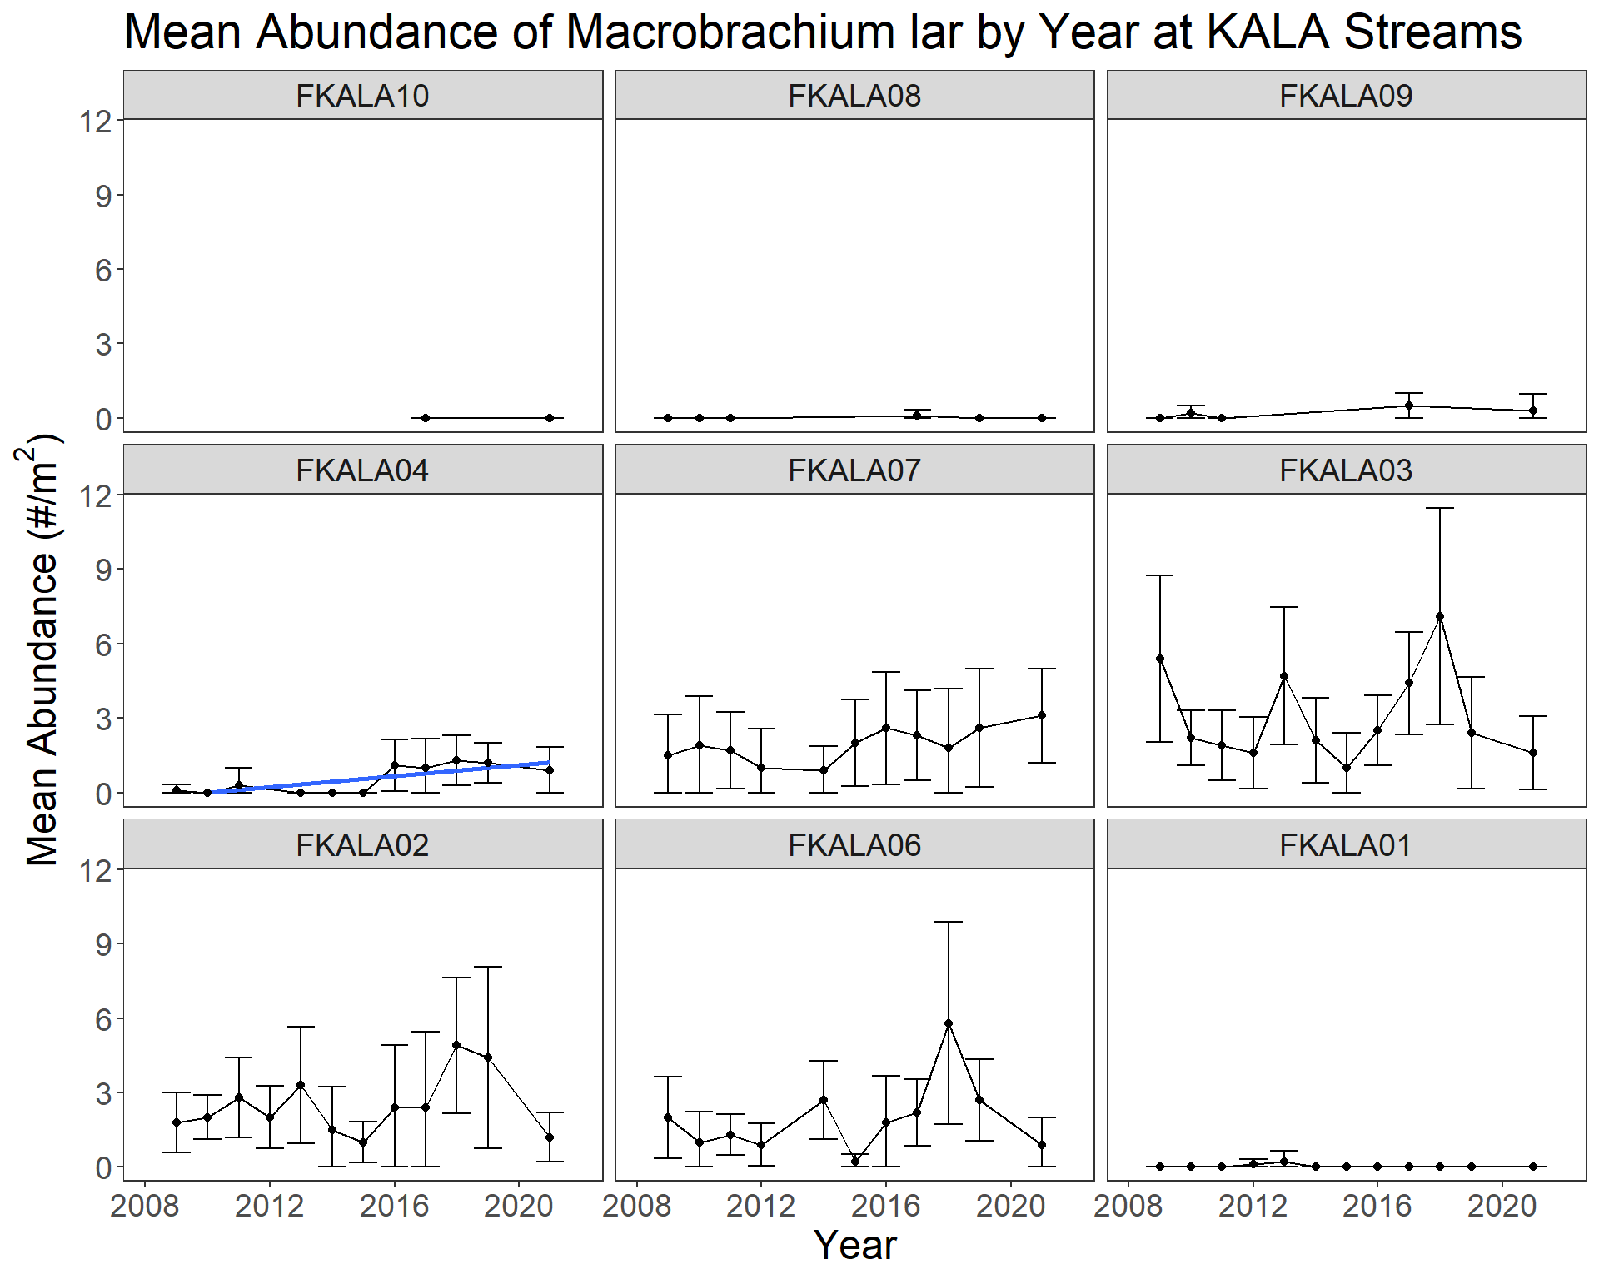Figure S18. Abundance of the shrimp Macrobrachium lar, across time, by site, arranged from upstream (FKALA10) top left to bottom right, to downstream (FKALA01) in Waikolu Stream, Kalaupapa National Historical Park, Moloka‘i, HI, USA 2009-2021. Error bars are 95% confidence intervals.

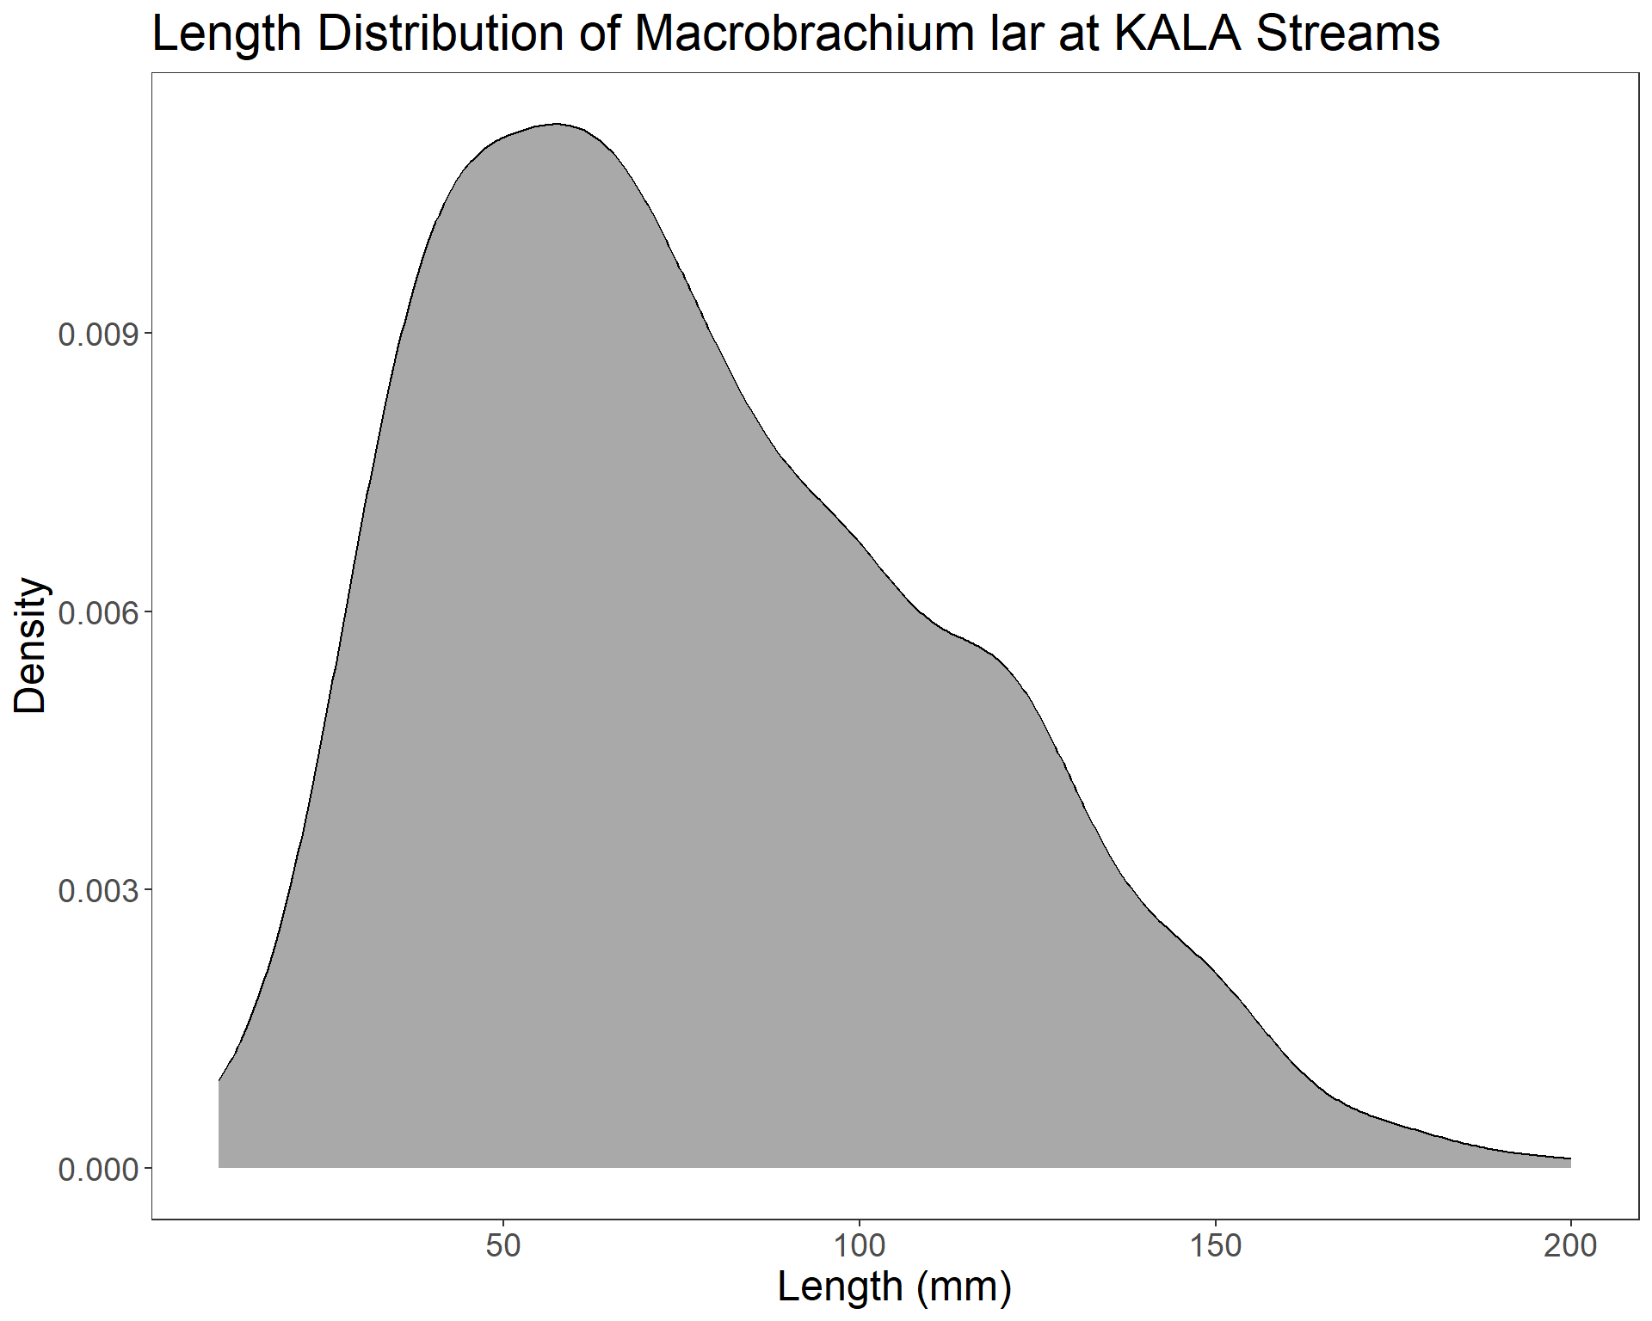
Figure S19. Distribution of Macrobrachium lar length across all sites and years in Waikolu Stream, Kalaupapa National Historical Park, Moloka‘i, HI, 2009-2021. Density is percentage of data at a length.

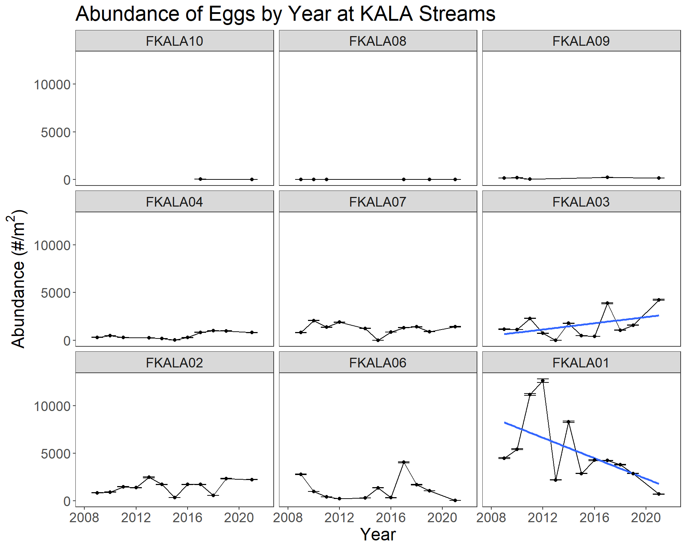
Figure S20. Abundance of Neritona granosa eggs, across time, by site, arranged from upstream (FKALA10) top right to bottom left, to downstream (FKALA01) in Waikolu Stream, Kalaupapa National Historical Park, Moloka‘i, HI, USA, 2009-2021. Error bars are 95% confidence intervals.
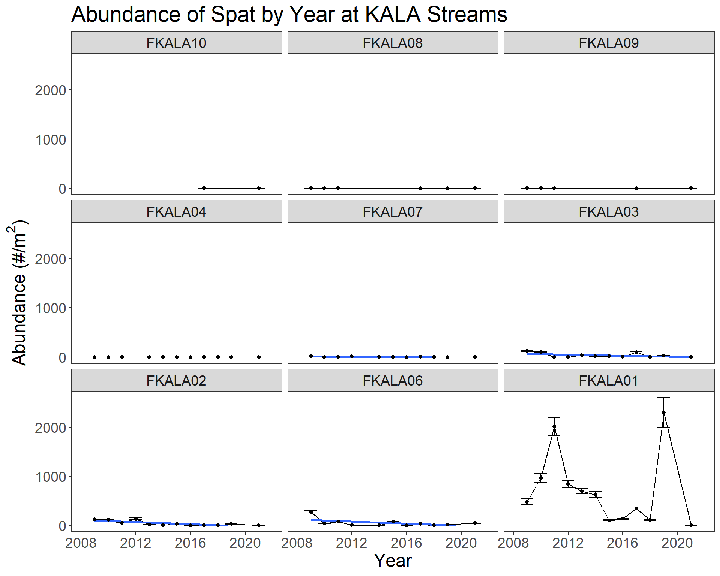
Figure S21. Abundance of Neritona granosa spat, across time, by site, arranged from upstream (FKALA10) top right to bottom left, to downstream (FKALA01) in Waikolu Stream, Kalaupapa National Historical Park, Moloka‘i, HI, 2009-2021. Error bars are 95% confidence intervals.
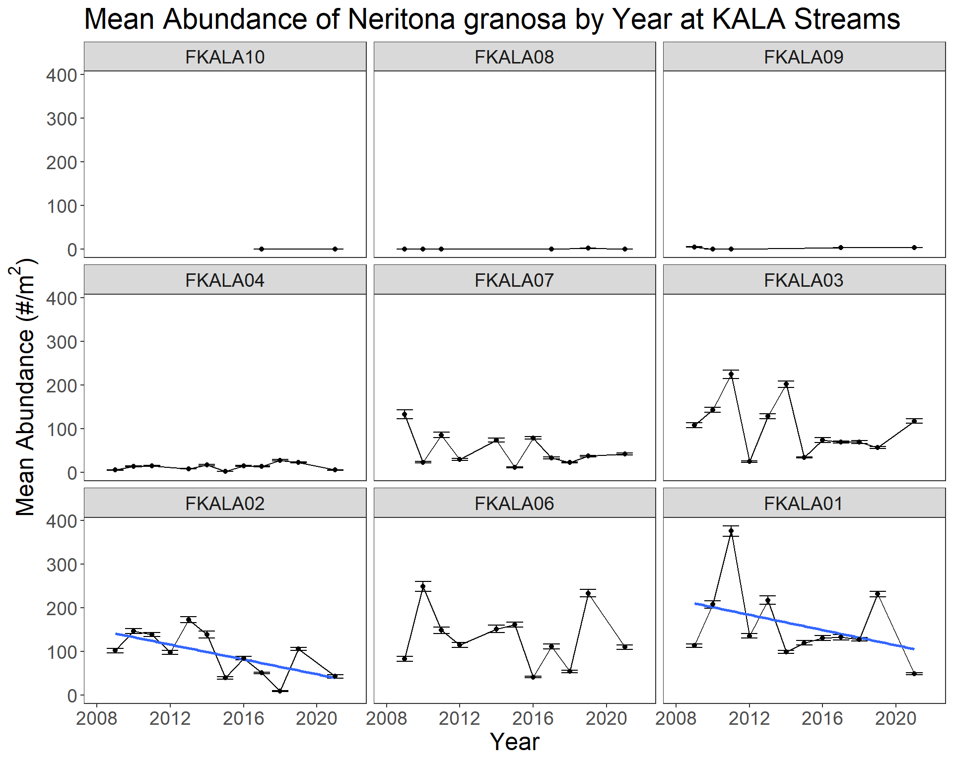
Figure S22. Abundance of Neritona granosa adults, across time, by site, arranged from upstream (FKALA10) top right to bottom left, to downstream (FKALA01) in Waikolu Stream, Kalaupapa National Historical Park, Moloka‘i, HI, 2009-2021. Error bars are 95% confidence intervals.
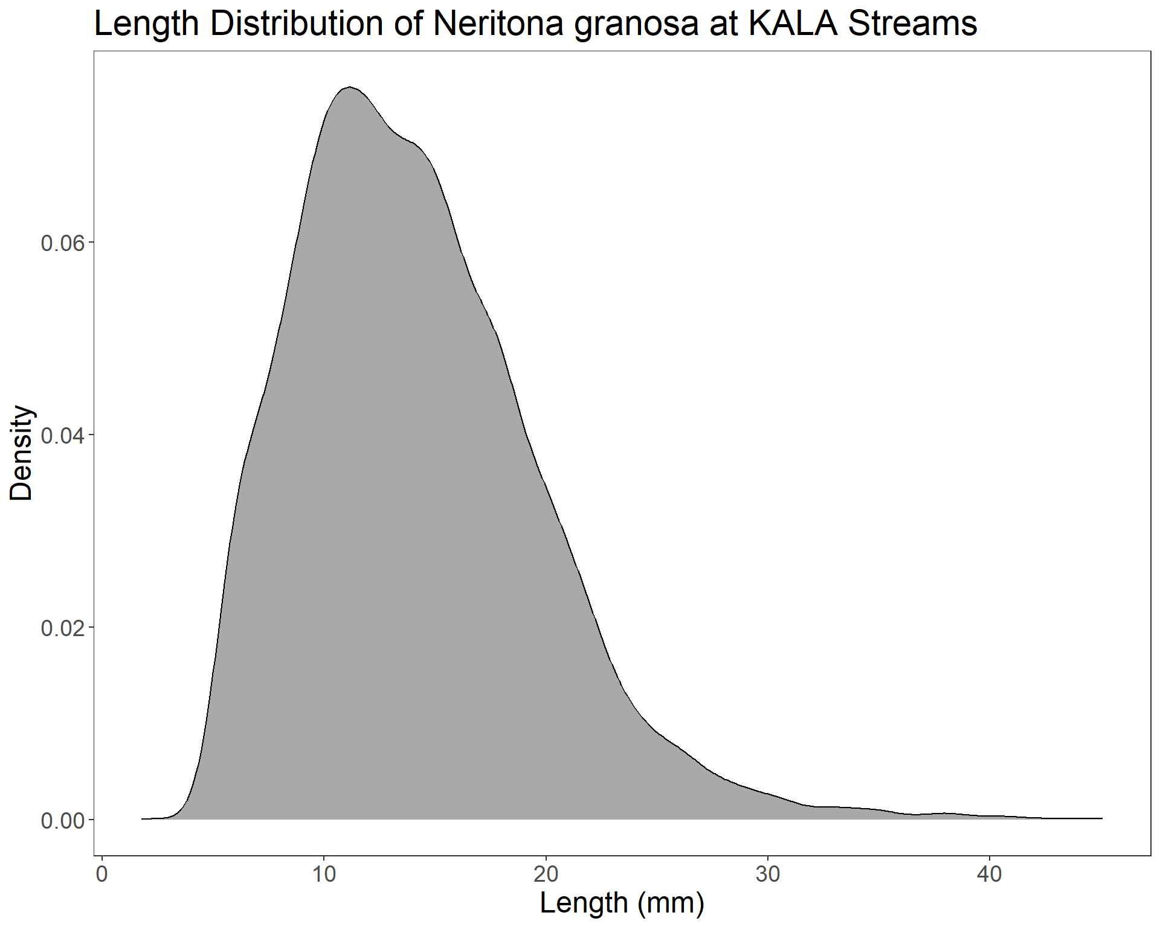
Figure S23. Distribution of adult Neritona granosa length (greater than 5mm) across all sites and years in Waikolu Stream, Kalaupapa National Historical Park, Moloka‘i, HI, USA, 2009-2021. Density is percentage of data at a length.

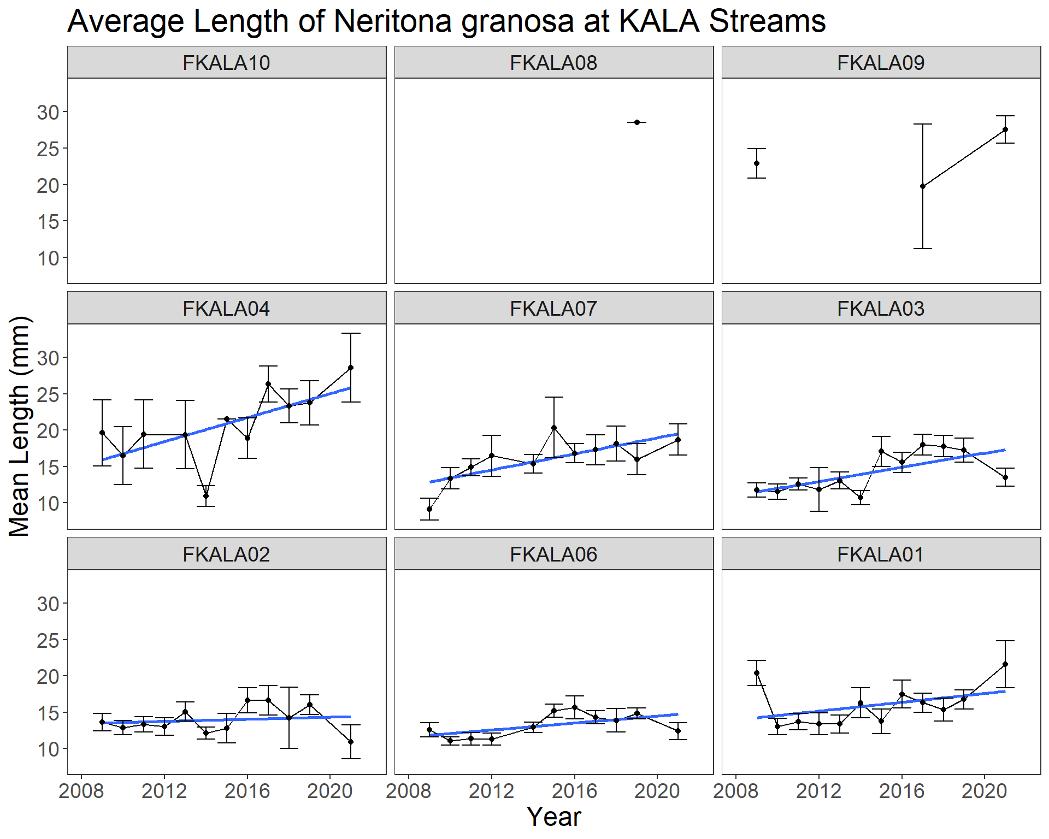
Figure S24. Mean length of adult Neritona granosa (greater than 5mm) at fixed sites in Waikolu Stream, Kalaupapa National Historical Park, Moloka‘i, HI, 2009-2021. Error bars are 95% confidence intervals.
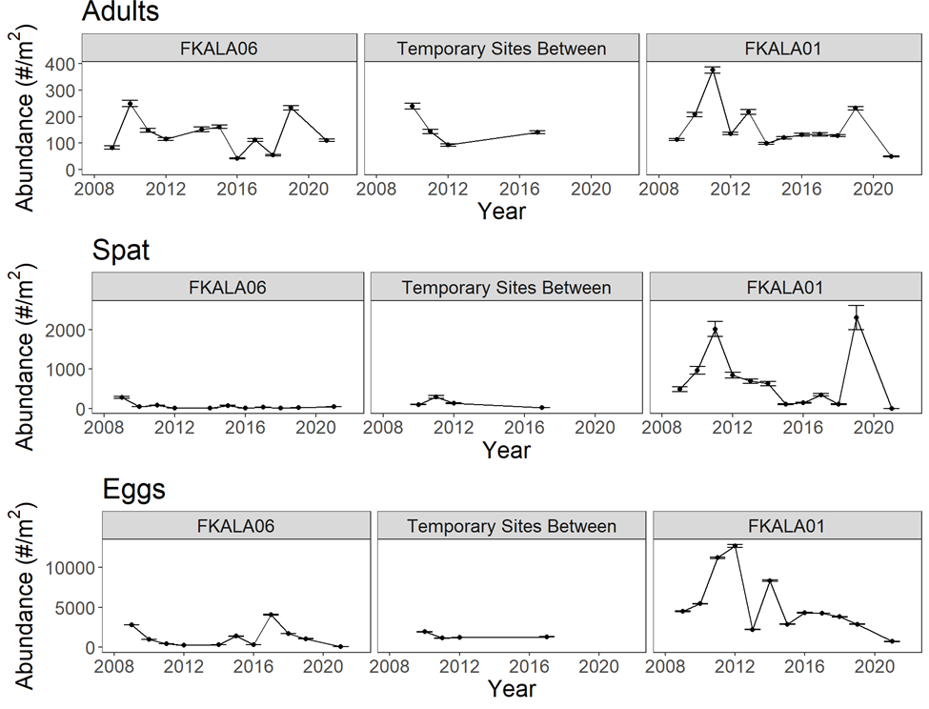
Figure S25. Abundance of Neritona granosa, across time, comparing sites FKALA06, FKALA01, and temporary sites in between in Waikolu Stream, Kalaupapa National Historical Park, Moloka‘i, HI, 2009-2021. Error bars are 95% confidence intervals.

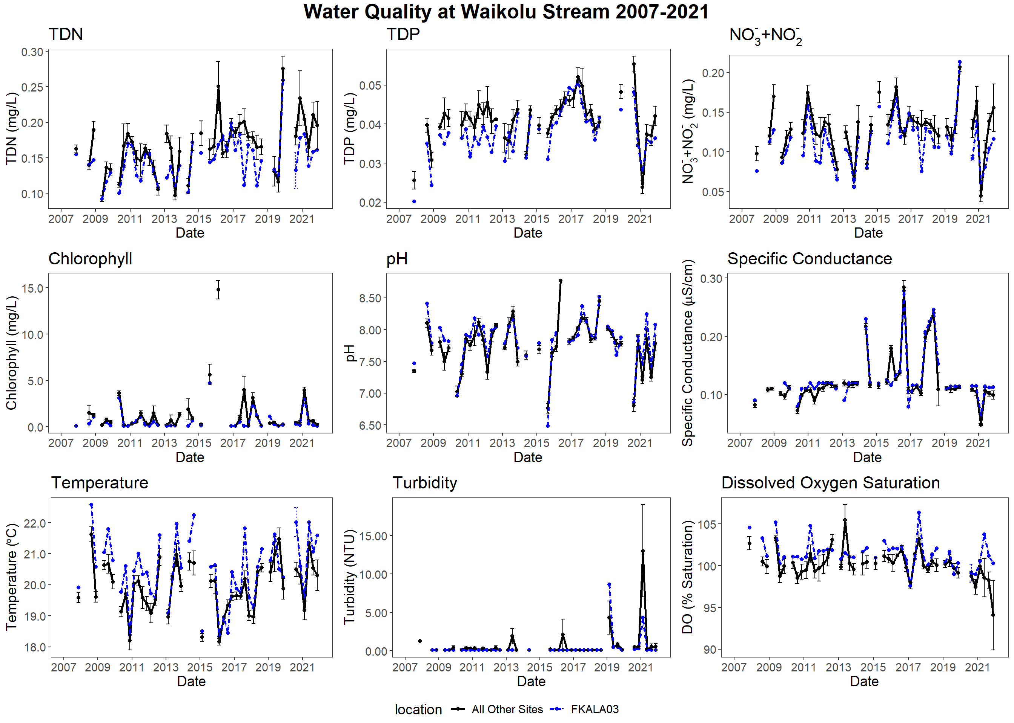
Figure S26. Temporal water quality parameter patterns comparing site FKALA03 with all other sites in Waikolu Stream, Kalaupapa National Historical Park, Moloka‘i, HI, 2009-2021.

