Supplementary Information The following supplementary materials are submitted separately alongside this manuscript:
Supplementary File 1: Appendix A (Survey Questionnaire - English translation and Chinese original)

Supplementary File 2: CHEERS 2022 Checklist

Supplementary Materials

Table S1. Model M3_Baseline Full Province Fixed Effects Coefficients

Province ID | M3_Baseline | Province ID | M3_Baseline
1.prov_id | 0.000 | 13.prov_id | 0.143
 | (.) |  | (0.138)
2.prov_id | 0.269** | 14.prov_id | 0.385***
 | (0.112) |  | (0.084)
3.prov_id | 0.027 | 15.prov_id | 0.180
 | (0.066) |  | (0.170)
4.prov_id | 0.213 | 16.prov_id | 0.269**
 | (0.135) |  | (0.117)
5.prov_id | 0.086 | 17.prov_id | 0.128*
 | (0.065) |  | (0.071)
6.prov_id | 0.639*** | 18.prov_id | 0.116
 | (0.035) |  | (0.108)
7.prov_id | 0.090 | 19.prov_id | 0.450***
 | (0.107) |  | (0.110)
8.prov_id | 0.344*** | 20.prov_id | 0.033
 | (0.102) |  | (0.109)
9.prov_id | 0.391*** | 21.prov_id | 0.268***
 | (0.107) |  | (0.100)
10.prov_id | 0.155* | 22.prov_id | 0.639***
 | (0.086) |  | (0.083)
11.prov_id | 0.103* | 23.prov_id | 0.455***
 | (0.061) |  | (0.106)
12.prov_id | 0.223* | 24.prov_id | 0.357***
 | (0.118) |  | (0.096)
 |  | _cons | 9.292***
 |  |  | (0.331)
N | 201
Standard errors in parentheses
="* p<0.1
Note: Standard errors in parentheses; * p < 0.10, ** p < 0.05, *** p < 0.01

---

Figure S1: Cost-Effectiveness Acceptability Curve (CEAC)

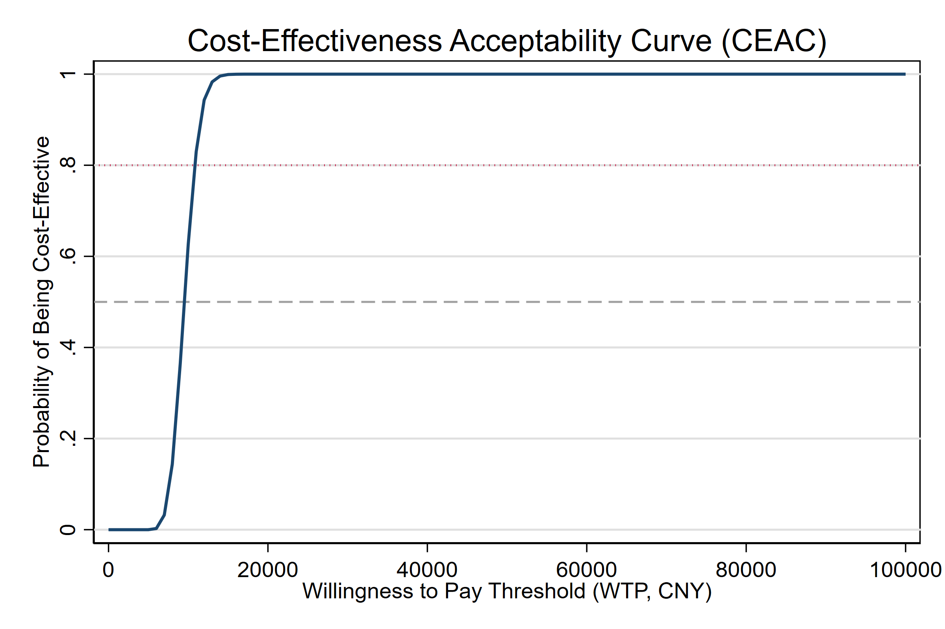

Figure S2: Tornado Diagram (One-Way Sensitivity Analysis)
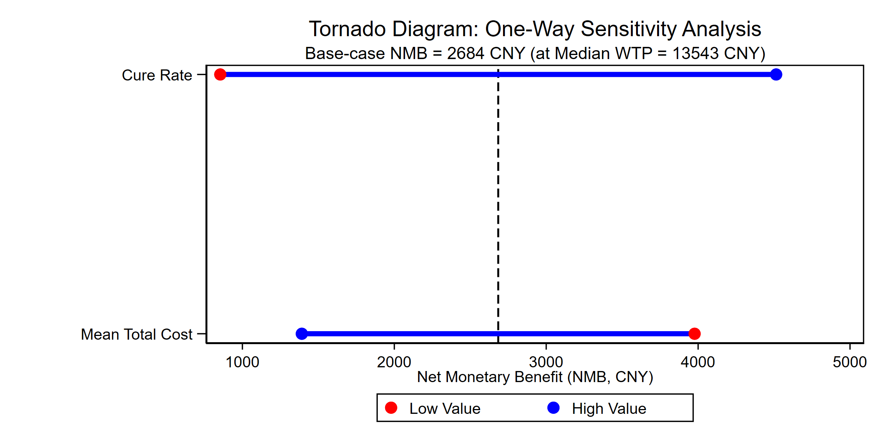

Figure S3: Cost-Effectiveness Scatter Plot
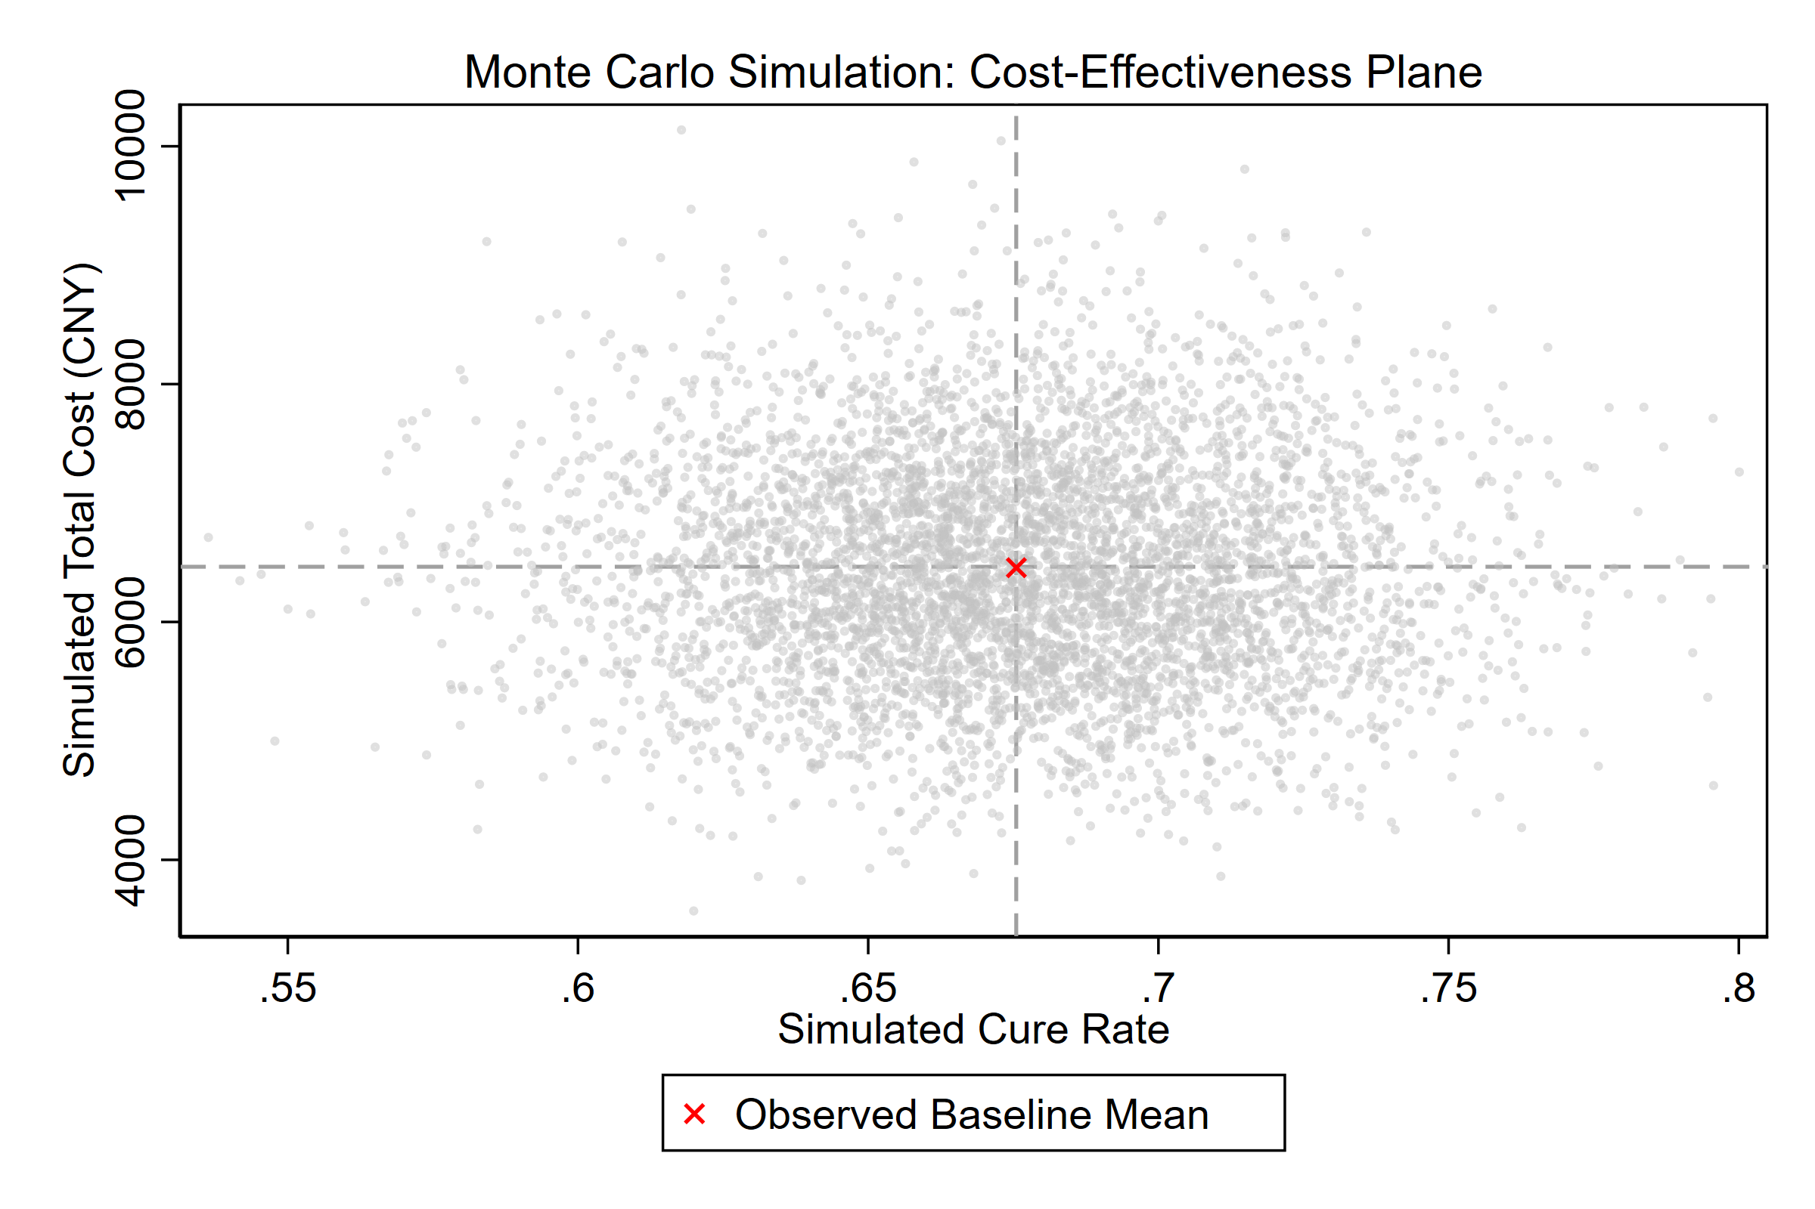

Corresponding Author: Wang Shijun, MPH
Email: u7667076@anu.edu.au
ORCID:
Wang Shijun: 0009-0004-1530-6165
Li Shoujin: 0009-0008-9297-7519

