Supplementary material:
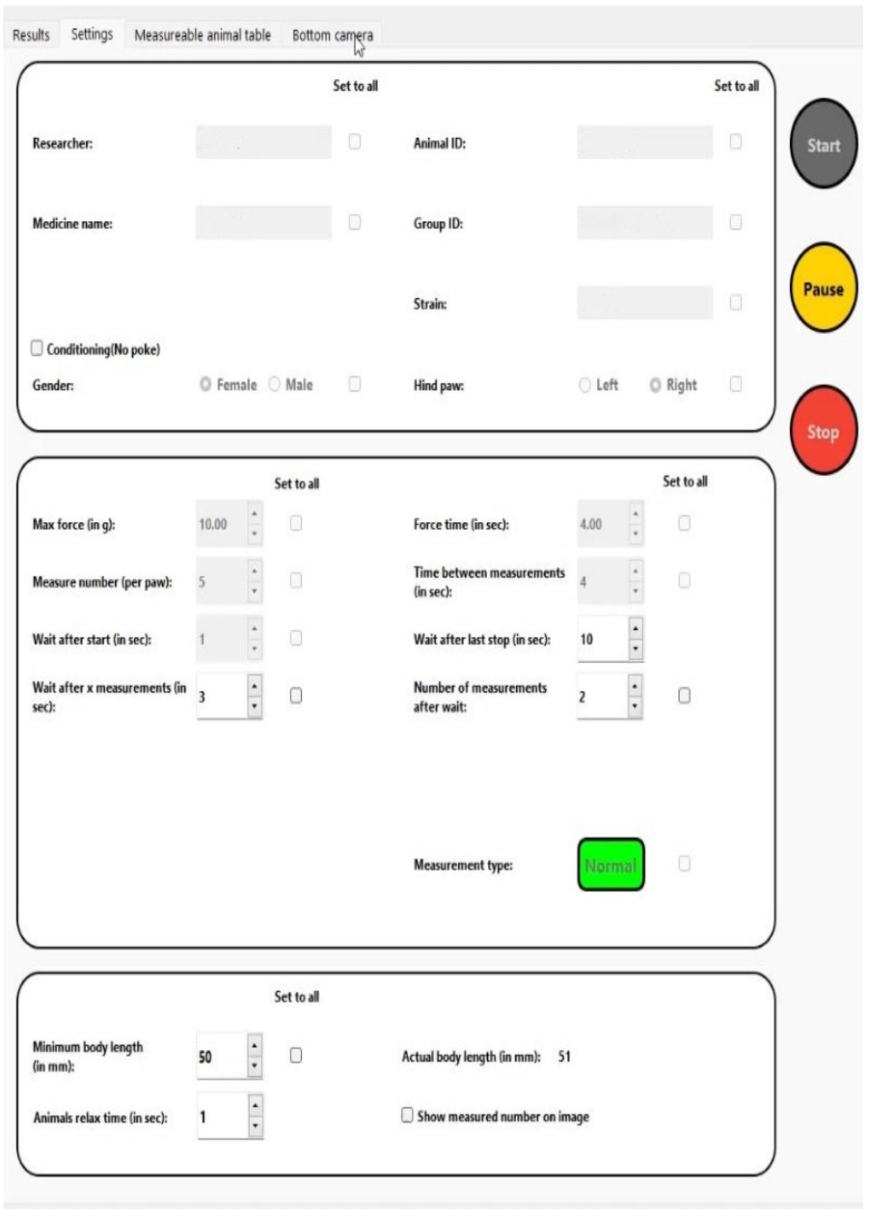
Suppl. Figure 1: Screenshot of the software interface that appears upon startup, showing input fields for animal details (species, ID, strain, number) and customizable settings such as needle conditioning, selected hind paw (left or right), applied force, and number of control measurements.

