SUPPLEMENTARY MATERIAL

Assessing the resilience of natural and anthropogenic vegetation to droughts in Argentina through remote sensing data

Table S1. Name and identification of vegetation units and their dominant natural and anthropogenic vegetation covers. Data include the total area (expressed in millions of hectares, Mha) and the national-scale representation (expressed in %) for each vegetation unit along with its corresponding dominant natural and anthropogenic vegetation covers. For units where multiple stable vegetation classes are co-dominant, more than one cover type is included for the analysis.
Vegetation unit ID and name | Total vegetation unit area (Mha and % of national territory) | Natural stable vegetation cover class (% of total vegetation unit area) | Anthropogenic stable vegetation cover class (% of total vegetation unit area)
1- Selva Montana y Bosque de Aliso y Pino del cerro | 2.8 Mha, 1% | 71.4% (Closed forests) | 4% (Temporary crops)
2- Selva de Transición | 2.2 Mha, 0.8% | 56% (Closed forests) | 18% (Temporary crops)
3- Selva Paranaense | 2.6 Mha, 0.9% | 59.2% (Closed forests) | 4.4% (Forest plantations)  3.4% (Perennial crops)
4- Valle del Paraná | 1.9 Mha, 0.7% | 28.6% (Flooded grasslands) | -
5- Delta del Paraná | 1.7 Mha, 0.6% | 69% (Flooded grasslands) | 2.5% (Forest plantations)
6- Prepuna | 1.3 Mha,.5% | 42.5% (Shrubs and herbaceous mosaic) | -
7- Chaco Serrano | 3.5 Mha, 1.3% | 18.4% (Closed forests) 8.52% (Grasslands) | 5% (Temporary crops)
8- Pastizales de Altura | 0.53 Mha, 0.2% | 50.8% (Grasslands) | -
9- Chaco Árido | 9.7 Mha, 3.5% | 13.9% (Closed forests) | -
10- Salinas Grandes | 1 Mha, 0.4% | Not studied | Not studied
11-Bañados de Mar Chiquita - Espartillares y zampales | 1.3 Mha, 0.5% | Not studied | Not studied
12- Chaco Semiárido | 23.6 Mha, 8.5% | 57.3% (Closed forests) | 6% (Temporary crops)
13- Chaco Subhúmedo | 8.8 Mha, 3.2% | 39.7% (Closed forests) | 13.9% (Temporary crops)
14- Chaco Húmedo con Bosques, Pajonales y Palmares de Caranday | 3.5 Mha, 1.2% | 32.5% (Closed forests) | -
15- Chaco Húmedo con Bosques y Cañadas | 6.7 Mha, 2.4% | 20.7% (Closed forests) 16.5% (Flooded grasslands) | 3.6% (Temporary crops)
16- Bajos Submeridionales; Espartillares | 3 Mha, 1.1% | 51.1% (Flooded grasslands) | 1.4% (Temporary crops)  0.23% (Pastures)
17- Pajonales y Palmares de Yatay | 2.2 Mha, 0.8% | 42.3% (Flooded grasslands) | -
18- Esteros del Iberá | 0.6 Mha, 0.2% | 87.1% (Flooded grasslands) | -
19- Ñandubayzal y Selva de Montiel | 5.9 Mha, 2.1% | 23.9% (Grasslands)  12.7% (Open forests) | 4.9% (Temporary crops)
20- Espinillar | 2.1 Mha, 0.8% | 17.8% (Flooded Grasslands) | 8.5% (Temporary crops)  8% (Pastures)
21- Algarrobal | 7.7 Mha, 2.8% | 1.9% (Grasslands) | 37.8% (Temporary crops)
22- Caldenal | 6.8 Mha, 2.4% | 18% (Open forests)  16.2% (Grasslands) | 9% (Temporary Crops)  1% (Pastures)
23- Monte de Sierras y Bolsones | 12.9 Mha, 4.6% | 29.8% (Open shrublands)  25% (Shrubs and herbaceous mosaic) | -
24- Bolsones Endorreicos | 4.6 Mha, 1.6% | 30.1% (Open shrublands) | -
25- Monte Austral | 24.5 Mha, 8.8% | 56.8% (Shrubs and herbaceous mosaic)  20.7% (Open shrublands) | -
26- Monte Oriental | 6.4 Mha, 2.3% | 16.6% (Shrubs and herbaceous mosaic)  5.53% (Open shrublands) | -
27- Campos y Urundayzales | 0.9 Mha, 0.3% | 17.5% (Grasslands) | 4.3% (Forest plantations)
28- Malezales | 1.7 Mha, 0.6% | 43.2% (Grasslands) | 0.5% (Forest plantations)
29- Pampa Mesopotámica | 2.9 Mha, 1% | 7.7% (Flooded grasslands)  6.2% (Grasslands) | 14% (Temporary crops)
30- Pampa Ondulada | 6.7 Mha, 2.4% | 10% (Grasslands) | 45% (Temporary crops)
31- Pampa Interior Plana | 8.4 Mha, 3% | 5.6% (Grasslands) | 33.3% (Temporary crops)
32- Pampa Interior Occidental | 8.9 Mha, 3.2% | 20.4% (Grasslands) | 26.5% (Temporary crops)
33- Pampa Deprimida | 9.5Mha, 3.4% | 48.7% (Grasslands) | 13% (Pastures)  7.2% (Temporary crops)
34- Pampa Austral | 7 Mha, 2.5% | 19.4% (Grasslands) | 30.8% (Temporary crops)
35- Puna | 12.9 Mha, 4.6% | 32.8% (Shrubs and Herbaceous Mosaic) | -
36- Provincia Altoandina | 13 Mha, 4.7% | Not Studied | Not Studied
37- Distrito de la Payunia | 3.1 Mha, 1,1% | 56.1% (Shrubs and herbaceous mosaic) | -
38- Distrito Subandino | 5.3 Mha, 1.9% | 32% (Shrubs and herbaceous mosaic) | -
39- Distrito Occidental | 12.4 Mha, 4.5% | 78% (Shrubs and herbaceous mosaic) | -
40- Estepa arbustiva de quilenbai | 4.5 Mha, 1.6% | 73.5% (Shrubs and herbaceous mosaic) | -
41- Estepa arbustiva serrana | 2 Mha, 0.7% | 78.9% (Shrubs and herbaceous mosaic) | -
42- Erial | 15.8 Mha, 5.7% | 69.1% (Shrubs and herbaceous mosaic) | -
43- Distrito del Golfo San Jorge | 2.9 Mha, 1% | 78.1% (Shrubs and herbaceous mosaic) | -
44- Distrito Central | 1.4 Mha, 0.5% | 62.6% (Shrubs and herbaceous mosaic) | -
45- Estepa arbustiva de mata negra | 2.1 Mha, 0.7% | 55% (Shrubs and herbaceous mosaic) | -
46- Estepa magallánica seca | 1.4 Mha, 0.5% | 76.1% (Shrubs and herbaceous mosaic) | -
47- Estepa magallánica húmeda | 1 Mha, 0.4% | 29.6% (Shrubs and herbaceous mosaic) | -
48- Ecotono Rionegrino | 2.5 Mha, 0.9% | 89.1% (Shrubs and herbaceous mosaic) | -
49- Ecotono de la Península de Valdés | 0.4 Mha, 0.1% | 86.6% (Shrubs and herbaceous mosaic) | -
50- Bosques Andino-Patagónicos | 3.1 Mha, 1.1% | 20.5% (Closed forests) | -

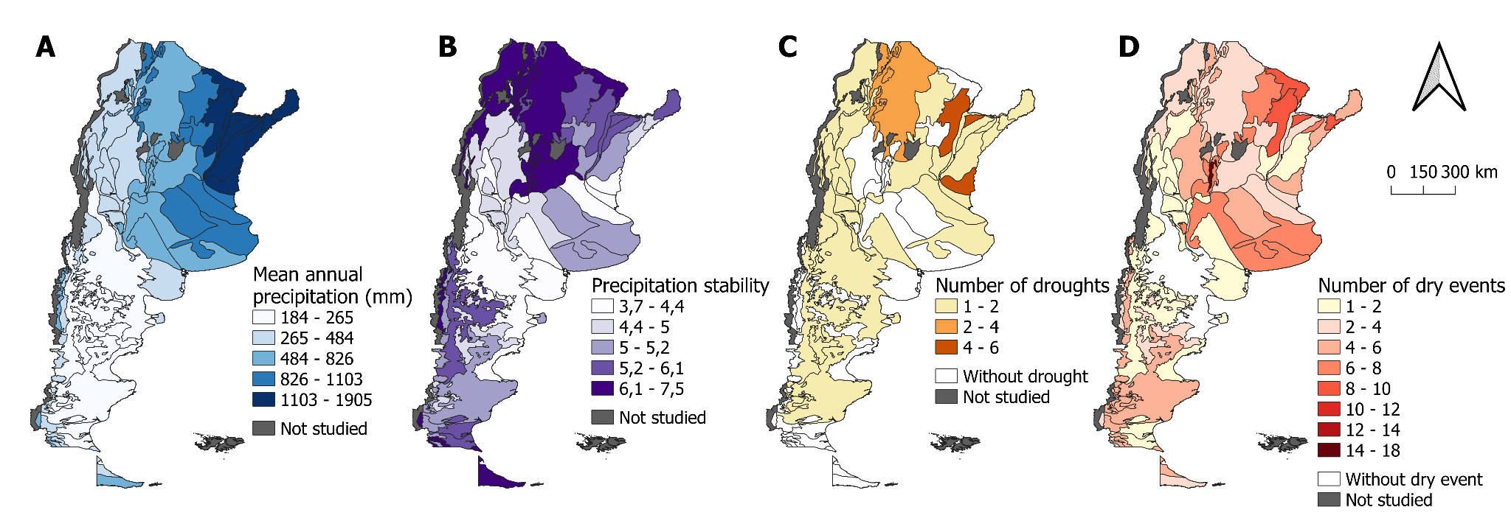
Figure S1. Mean annual precipitation, temporal stability of precipitation, and absolute frequency of droughts and dry events per vegetation unit. Spatial distribution maps are displayed: A. the mean annual precipitation values (mm/year) across; B. the calculated temporal stability values for the monitored period; C. the absolute number of droughts recorded; and D. the absolute frequency of dry events identified. All variables are represented by a color-coded scale according to the specific metric of each panel and are categorized per vegetation unit according to the classification of Oyarzabal et al. (2018).

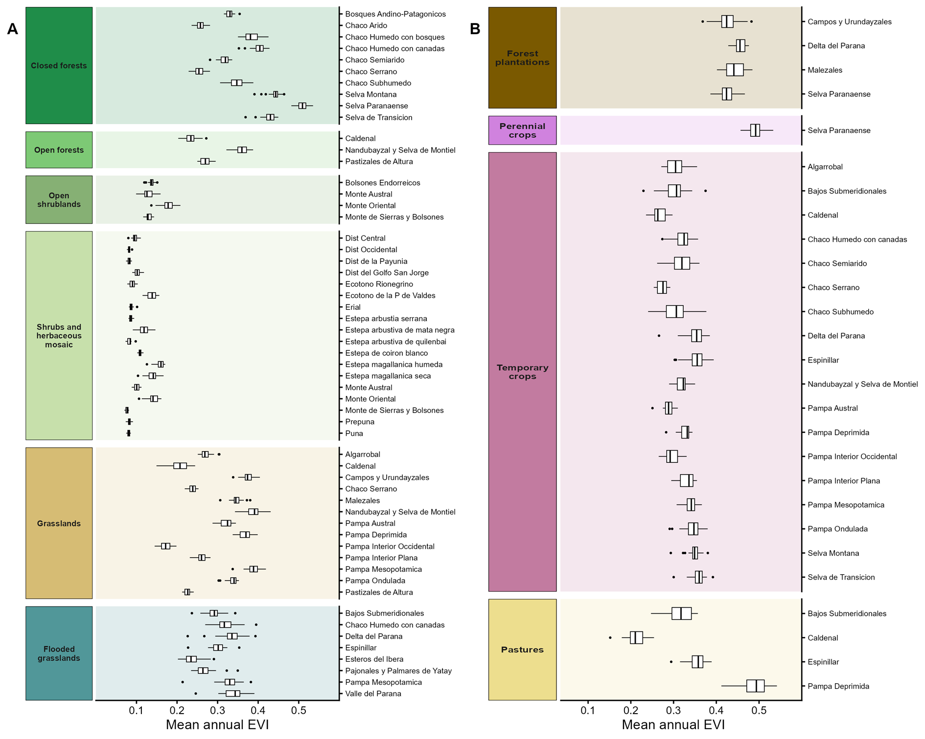
Figure S2. Mean inter-annual variation of EVI across dominant stable natural and anthropogenic vegetation covers. Boxplots display the distribution of EVI values for (A) natural vegetation covers and (B) anthropogenic covers. Each box represents the interquartile range (IQR), with the internal horizontal line indicating the median and whiskers extending to 1.5 times the IQR. Data are categorized according to the vegetation classes defined by the MapBiomas Argentina Collection 2 project; detailed characteristics for each vegetation unit are provided in Table 1S.

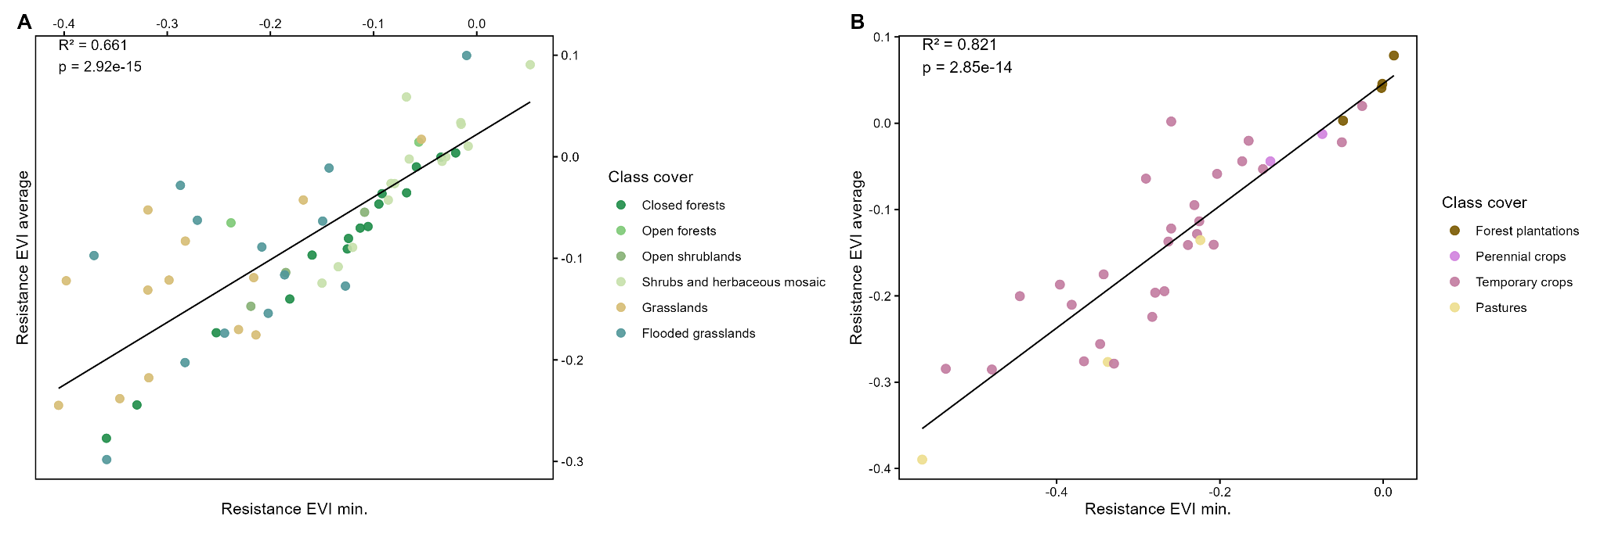
Figure S3. Resistance calculated as minimum EVI vs. average EVI during droughts for dominant stable natural and anthropogenic vegetation. Scatter plots illustrate the relationship between the two resistance metrics for A. natural covers and B. anthropogenic covers, per vegetation unit. The 1:1 dashed line represents the identity threshold; points distributed below this line indicate instances where the minimum EVI recorded during the drought period is lower than the corresponding drought-period average EVI. Vegetation classes are defined by the MapBiomas Argentina Collection 2 project.

