Appendix
Model | Company
Open-source
MedGemma 27B | Google DeepMind, London, UK
DeepSeek R1 70B | DeepSeek AI, Beijing, China
DeepSeek V2.5 | DeepSeek AI, Beijing, China
Llama 3.1 70B | Meta Platforms, Inc., Menlo Park, CA, USA
Llama 3.3 | Meta Platforms, Inc., Menlo Park, CA, USA
Llama 3.3 | Meta Platforms, Inc., Menlo Park, CA, USA
Llama 4 Maverick 262k | Meta Platforms, Inc., Menlo Park, CA, USA
Meditron 70B (Q5_1) | École Polytechnique Fédérale de Lausanne (EPFL), Lausanne, Switzerland
Qwen3 235B | Alibaba Cloud Intelligence, Hangzhou, China
Qwen3 30B | Alibaba Cloud Intelligence, Hangzhou, China
GPT-OSS | OpenAI, San Francisco, CA, USA
GPT-OSS 120B | OpenAI, San Francisco, CA, USA
Commercial
GPT-4.1 mini | OpenAI, San Francisco, CA, USA
GPT-4o | OpenAI, San Francisco, CA, USA
GPT-5 | OpenAI, San Francisco, CA, USA
Claude Opus 4.1 (2025-08-05) | Anthropic PBC, San Francisco, CA, USA
Claude Sonnet 4 (2025-05-14) | Anthropic PBC, San Francisco, CA, USA
Table A1: Comprehensive list of Large Language Models used in this study

Error Examples 1
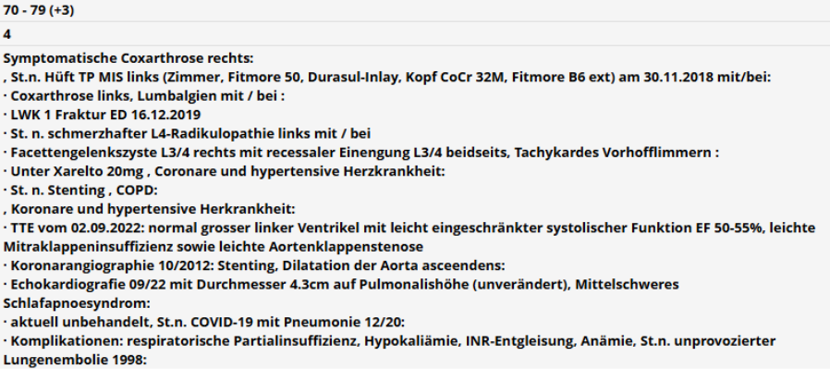Figure A1: Real-world clinical diagnoses documented for the patient
Human Consensus:
- Myocardial infarction (+1)
- Chronic pulmonary disease (+1)
- Age (+3)
- Total points = 5
GPT-5_without-guidelines:
{"Explanation":"Berechnung nach Charlson-Index (inkl. Alter):\n- Alter 70–79 Jahre: +3\n- Chronische Lungenerkrankung (COPD): +1\n- Keine Punkte für: KHK ohne dokumentierten Myokardinfarkt oder Herzinsuffizienz, Vorhofflimmern, Hypertonie, leichte Klappenvitien/Aortendilatation, Arthrose/Wirbelsäulenerkrankungen/Fraktur, Schlafapnoe, zurückliegende COVID-Pneumonie, frühere Lungenembolie.\nSumme: 4","CCI":4}
Error: Diagnosis list incomplete. Stent placement could be due to myocardial infarction or it could also be an elective procedure.
Error Examples 2
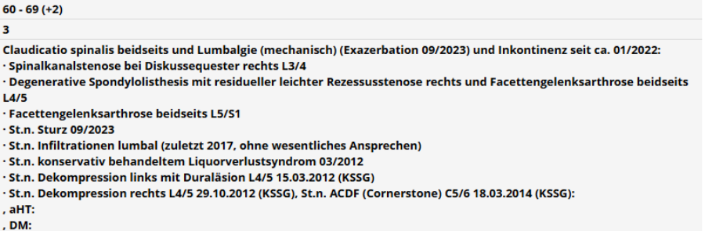Figure A2: Real-world clinical diagnoses documented for the patient
Human Consensus:
- Diabetes (without complications)
- Age (+2)
- Total points = 4
GPT-oss-120b_with-guidelines:
{\n "Explanation": "The patient is in the 60‑69 age group, which adds +2 points. None of the listed diagnoses (spinal conditions, incontinence, surgeries, hypertension, or unspecified diabetes) correspond to any of the Charlson comorbidity categories provided. Therefore, the total CCI is solely the age contribution.",\n "CCI": 2\n}
Error: The abbreviation DM was not recognized by LLM as diabetes mellitus.

Error example 3
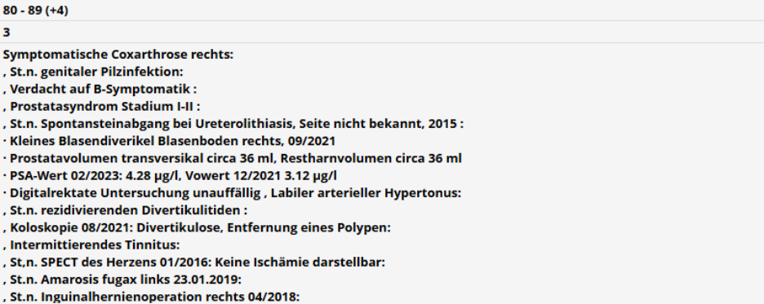Figure A3: Real-world clinical diagnoses documented for the patient
Human Consensus:
- Age (+4)
- Total points = 4
GPT-5_without-guidelines:
{"Explanation":"Alter 80–89 Jahre: +4. Zerebrovaskuläre Erkrankung: St.n. Amaurosis fugax (entspricht TIA) → +1. Keine weiteren anrechenbaren CCI-Diagnosen (keine KHK/MI, Herzinsuffizienz, COPD, Ulkus, Leber-/Niereninsuffizienz, Diabetes, Tumor/Metastasen, Demenz, PAVK, connective tissue disease, AIDS). Gesamt: 5.","CCI":5}
Error: Overlooking or misjudging a diagnosis by human raters

