Table S1:Logistic Regression Analysis of TPA and Circadian Syndrome risk
TPA | Crude model |  | Model 1 |  | Model 2 |  | Model 3
TPA | OR  (95% CI) | P-value | OR  (95% CI) | P-value | OR  (95% CI) | P-value | OR  (95% CI) | P-value
Q1 | — | — | — | — | — | — | — | —
Q2 | 0.66(0.49, 0.87) | 0.003** | 0.60(0.45, 0.81) | <0.001*** | 0.60(0.45, 0.80) | <0.001*** | 0.59(0.44, 0.80) | <0.001***
Q3 | 0.64(0.48, 0.85) | 0.003** | 0.65(0.48, 0.88) | 0.005** | 0.65(0.48, 0.88) | 0.005** | 0.63(0.46, 0.86) | 0.003**
Q4 | 0.39(0.29, 0.54) | <0.001*** | 0.44(0.32, 0.62) | <0.001*** | 0.46(0.33, 0.64) | <0.001*** | 0.45(0.32, 0.63) | <0.001***
Note: Model 1: age, gender, residential area, marital status and education level; Model 2: Model 1, current smoking status, current drinking status; Model 3: Model 2, Health insurance, Number of children.. OR, odds ratio; CI, confidence intervals; Total Physical Activity; TPA *p < 0.05, **p < 0.01*** p < 0.001.

Table S2:Logistic Regression Analysis of TPA and Circadian Syndrome risk excluding participants with cancer
TPA | Crude model |  | Model 1 |  | Model 2 |  | Model 3
TPA | OR  (95% CI) | P-value | OR  (95% CI) | P-value | OR  (95% CI) | P-value | OR  (95% CI) | P-value
Q1 | — | — | — | — | — | — | — | —
Q2 | 0.63(0.47, 0.83) | 0.001** | 0.57(0.43, 0.77) | <0.001*** | 0.57(0.43, 0.76) | <0.001*** | 0.56(0.42, 0.75) | <0.001***
Q3 | 0.62(0.47, 0.83) | 0.001** | 0.63(0.47, 0.85) | 0.003** | 0.63(0.46, 0.85) | 0.002** | 0.62(0.45, 0.83) | 0.002**
Q4 | 0.38(0.28, 0.52) | <0.001*** | 0.42(0.30, 0.59) | <0.001*** | 0.44(0.31, 0.62) | <0.001*** | 0.43(0.30, 0.60) | <0.001***
Note: Model 1: age, gender, residential area, marital status and education level; Model 2: Model 1, current smoking status, current drinking status; Model 3: Model 2, Health insurance, Number of children.. OR, odds ratio; CI, confidence intervals; Total Physical Activity; TPA *p < 0.05, **p < 0.01*** p < 0.001.
Table S3:Logistic Regression Analysis of TPA and Circadian Syndrome risk excluding participants with cardiac and renal diseases.
TPA | Crude model |  | Model 1 |  | Model 2 |  | Model 3
TPA | OR  (95% CI) | P-value | OR  (95% CI) | P-value | OR  (95% CI) | P-value | OR  (95% CI) | P-value
Q1 | — | — | — | — | — | — | — | —
Q2 | 0.66(0.47, 0.93) | 0.019* | 0.61(0.43, 0.87) | 0.007** | 0.60(0.41, 0.85) | 0.005** | 0.59(0.41, 0.84) | 0.004**
Q3 | 0.70(0.50, 0.99) | 0.047* | 0.70(0.49, 1.00) | 0.050* | 0.69(0.48, 0.99) | 0.043* | 0.67(0.46, 0.96) | 0.031*
Q4 | 0.40(0.27, 0.58) | <0.001*** | 0.42(0.28, 0.63) | <0.001*** | 0.45(0.30, 0.67) | <0.001*** | 0.43(0.28, 0.64) | <0.001***
Note: Model 1: age, gender, residential area, marital status and education level; Model 2: Model 1, current smoking status, current drinking status; Model 3: Model 2, Health insurance, Number of children.. OR, odds ratio; CI, confidence intervals; Total Physical Activity; TPA *p < 0.05, **p < 0.01*** p < 0.001.

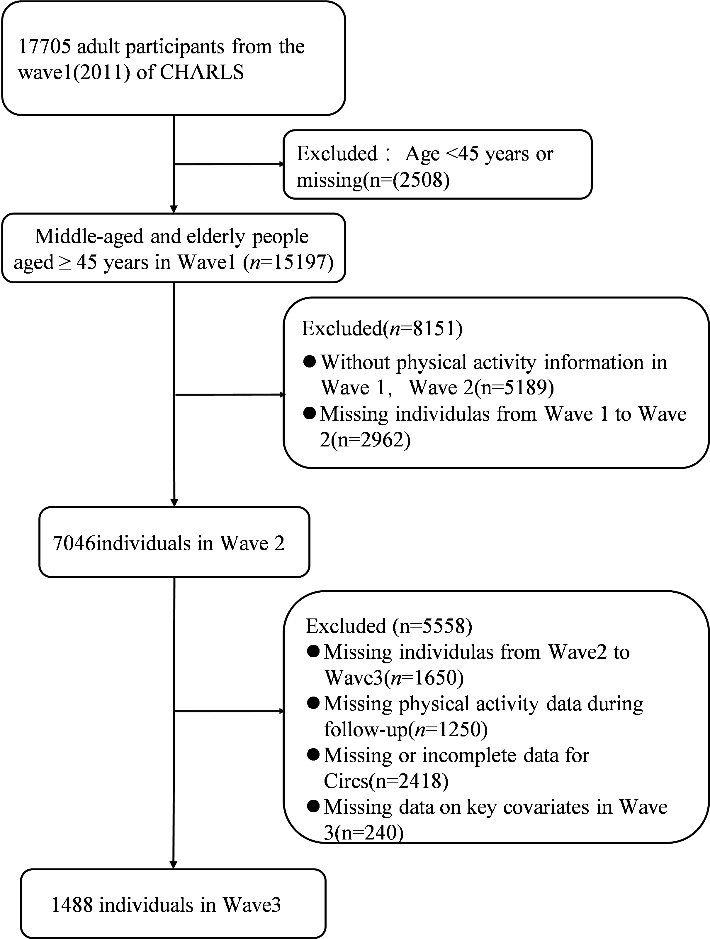
Figure s1. Flow of eligible participants selection.

model.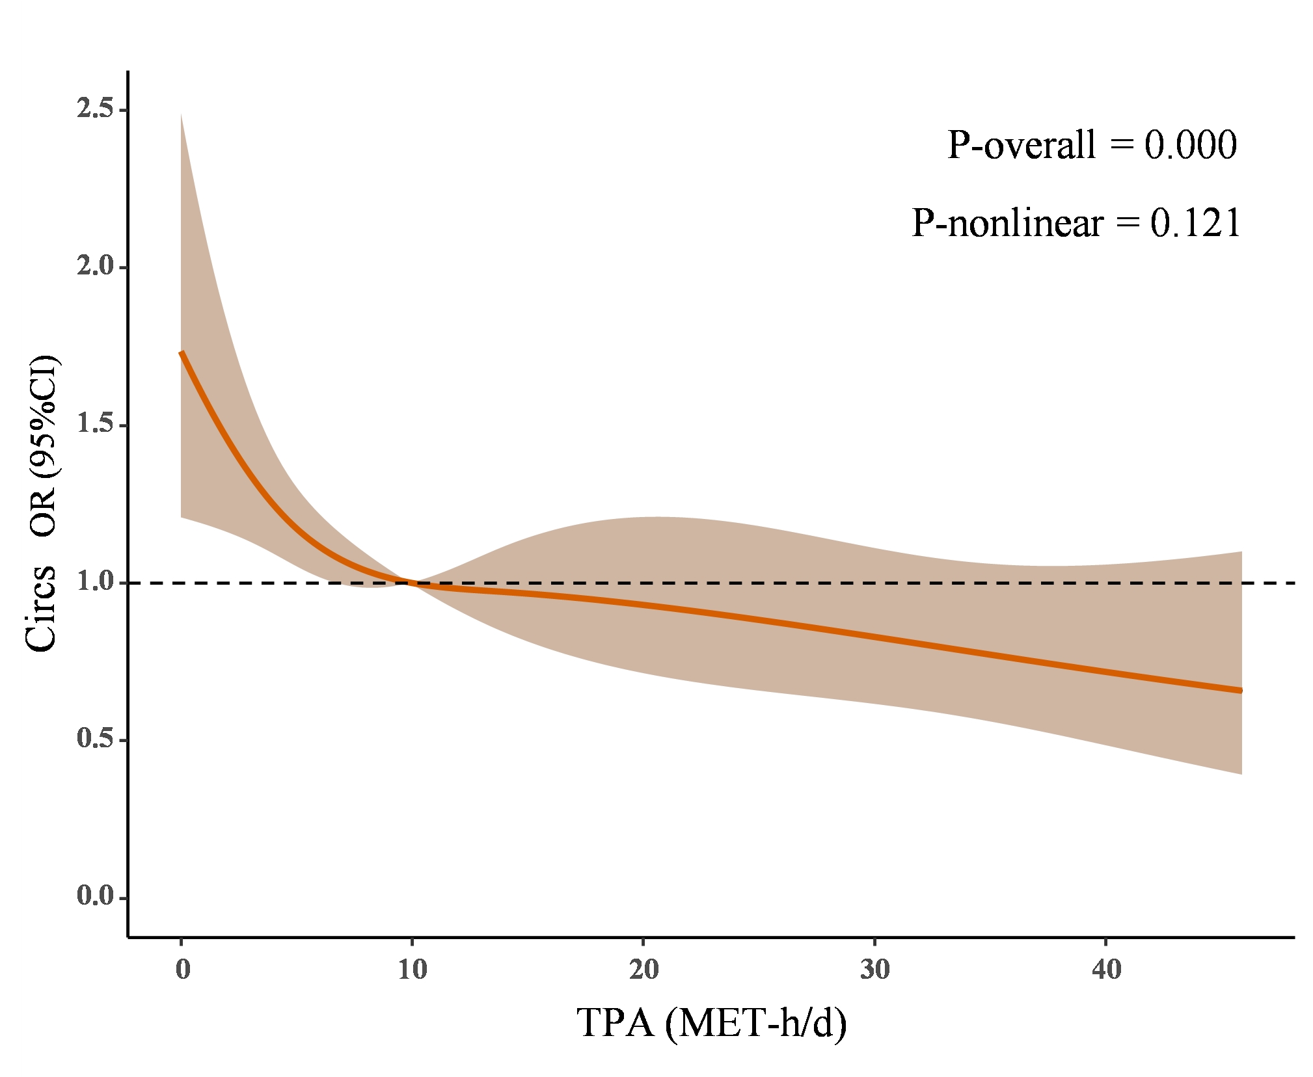
Figure S2 Dose-response relationship between TPA and Circadian Syndrome risk using an RCS model with four nodes (5th, 35th, 65th, and 95th percentiles). Solid lines and orange areas represent adjusted odds ratios (OR) and 95% confidence intervals (CI), respectively. The model adjusted for age, gender, residential area, marital status, education level, current smoking status, current drinking status, Health insurance, Number of children. OR: odds ratio; CI: confidence interval; TPA: total PA; MET: metabolic equivalent.
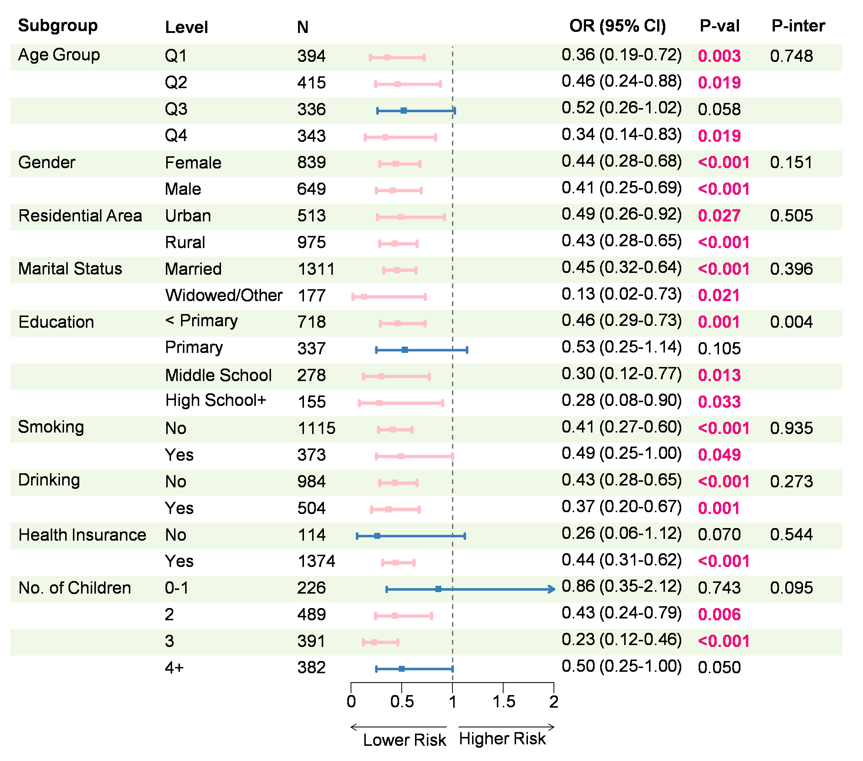
Figure S3 Subgroup analysis and interaction between TPA and Circadian Syndrome risk. The subgroup analysis, based on Model 3, adjusted for age, gender, residential area, marital status, education level, current smoking status, current drinking status, Health insurance, Number of children. OR, odds ratio; CI, confidence interval; TPA, total physical activity.

