Annex C. Cluster analysis – K value.
This Annex contains the analysis for selecting the number of clusters (k) in the Hierarchical Agglomerative Cluster (HAC). The application of HAC on the PCA-reduced dataset over a k range of 2-30 was analysed through the Silhouette Score (SS) and clustergram, plotting the distance of each cluster to the mean of the corresponding Principal Component Analysis. From the SS plot (Fig. C.1), it is clear that the values of the scores rapidly degrades, with the sole peaks being the first value and the k=8. While true that k=2 would be the absolute highest, we disregard this value as it would lead to few and uninteresting clusters and serves only as reference. Thus, k=8 is selected.
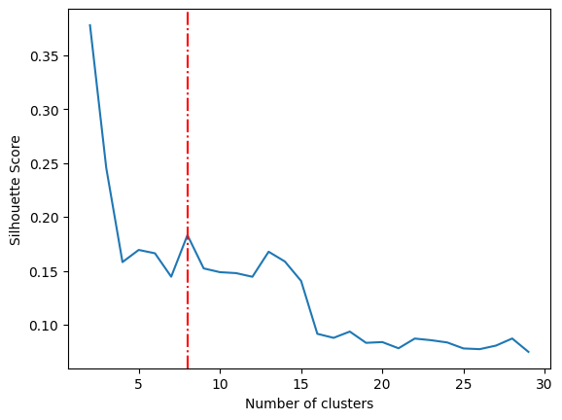
Fig. C.1. SS plot for HAC in the range k=2-30. The red dotted line highlights k=8.
Secondly, we can compare the selection of k=8 in the clustergram (Fig. C.2). The selected k=8 is far from any mayor splits (k=3 is an example), and thus can be considered a stable representation of the clusters. In higher k values, the split at k=8 is reduced without adding too much difference. Only at values of k>13 new splits appear with enough difference. Nevertheless, the splits are always contained in the bigger clusters that are from single cities and thus no additional knowledge for between cities comparison can be obtained. While by increasing k splits appears also in the sole cluster that is common in both cities (Cluster 8, from the main text), it is still a relatively small cluster.
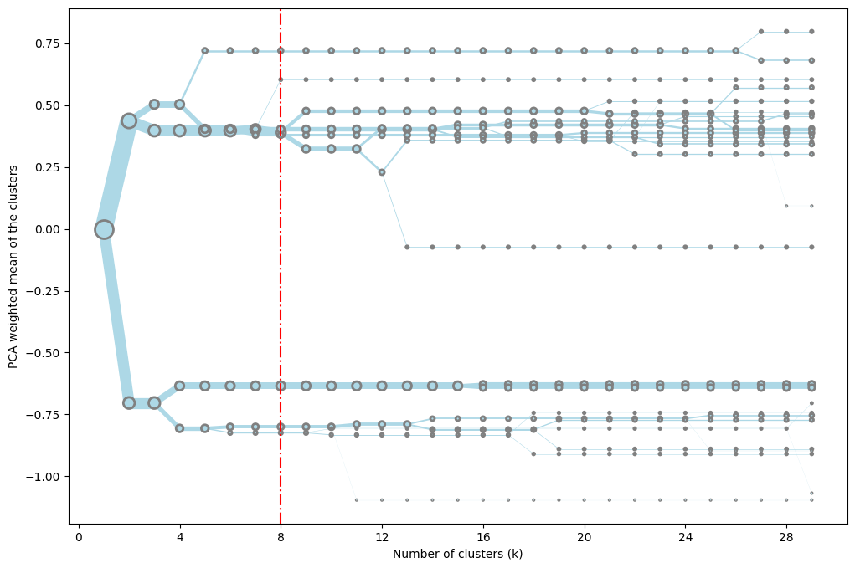
Fig. C.2. Clustergram obtained from HAC values in the range 2-30, highlighting the k=8.

