Supplementary Information
Manuscript ID: b87fe9d9-15a6-4cd3-b2bf-96a321577acd

This original image is provided as a supplementary file to fulfill the journal's requirement for the presentation of full, uncropped gels.

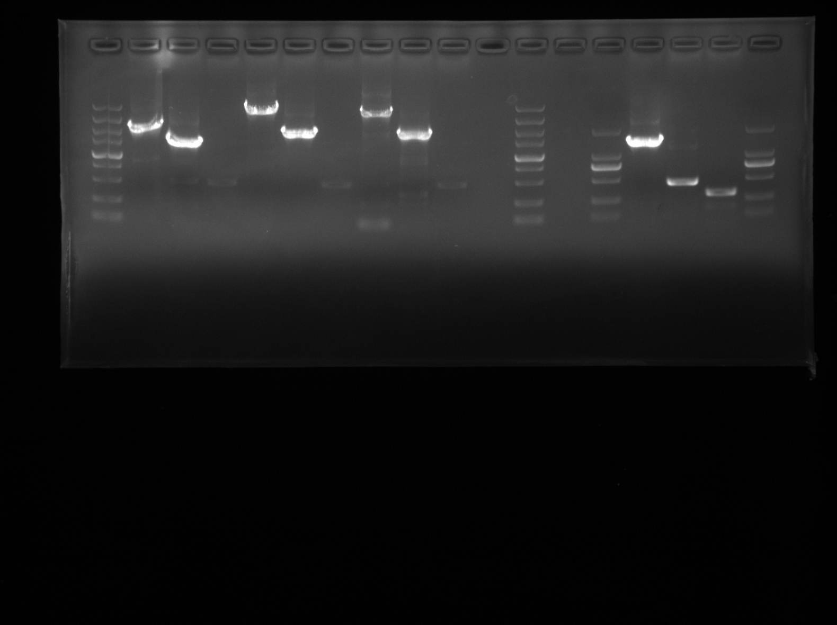
Note: This figure shows the full, uncropped agarose gel electrophoresis image to support the data integrity of the manuscript. Lanes 1–13: These lanes contain PCR products from other unrelated experiments and are not discussed in this study. Lane 14: DL 2000 DNA Marker. The visible bands (from top to bottom) correspond to 2000, 1000, 750, 500, 250, and 100 bp, which provide a size reference for the samples. Lane 15: PCR amplification product of the 16S ribosomal RNA gene from Bv. JN.Y2. Lanes 16–18: Other PCR products not relevant to the current manuscript.
Fig S1 Original uncropped gel image for the amplification of 16S ribosomal RNA gene.

