Electronic Supplementary Material

Article Title:
Whole-genome and Comparative Genomic Analysis Reveal the Biocontrol and Plant Growth-Promoting Potential of Bacillus velezensis JN.Y2 Against Oat Anthracnose

Journal Name:
Functional and Integrative Genomics

Author Names:
Wei Quan^{1†}, Ting Zhang², Chen-Lu Liu¹, Shao-xuan Shi¹, Xi-xi Zhang¹, Ke-han Liu¹, Chun-Yang Wang¹, Ming-min Zhao¹, Bao-Zhu Dong¹*, Hong-You Zhou¹*

Affiliation: College of Horticulture and Plant Protection, Inner Mongolia Agricultural University, Key Laboratory of Biopesticide Creation and Resource Utilization for Autonomous Region Higher Education Institutions, Hohhot, 010018, China

E-mail address of the corresponding authors:
Bao-Zhu Dong*, E-mail: dongbaozhu2020@imau.edu.cn;
Hong-You Zhou*, E-mail: zhouhongyou@imau.edu.cn.

Online Resource 1 Table S1 Primers used in this study
Primer name | Sequence (5'–3') | Target / Description | Source
16S rRNA-F | AGACTGGGATAACTCCGGGA | Amplifies 16S rRNA gene for molecular identification | This study
16S rRNA-R | ACCTTCCGATACGGCTACCT | - | -

Online Resource 1 Table S2 Predicted genes associated with growth-pormoting characters in Bv. JN.Y2 genome
Bv. JN.Y2-PGP activities detection | Gene name | Gene annotation | Chromosome location
Nitrogen fixation | nifH | 4Fe-4S iron sulfur cluster binding proteins | 99,969-101,021
 | yutI | Putative nitrogen fixation protein | 2,997,147-2,997,407
 | sufB | Fe-S cluster assemby protein SufB | 3,040,474-3,041,871
 | sufU | iron-sulfur cluster assembly scaffold protein SufU | 3,041,891-3,042,334
 | sufC | Fe-S cluster assembly ATP-binding protein | 3,044,875-3.945,660
 | sufD | Fe-S cluster assembly protein SufD | 3,043,544-3,044,857
 | nifU | nitrogen fixation protein NifU | 3,041,891-3,042,334
Phosphate metabolism | pstA | phosphate ABC transporter permease PstA | 2,400,060-2,400,944
 | pstB 1 | Phosphate import ATP-binding protein PstB 1 | 2,398,441-2,399,223
 | pstB 2 | Phosphate import ATP-binding protein PstB 2 | 2,399,235-2,400,041
 | pstC | phosphate ABC transporter permease subunit PstC | 2,400,944-2,401,873
 | pstS | Phosphate-binding protein PstS | 2,401,922-2,402,824
 | phoA | alkaline phosphatase | 871,002-872,381
 | bglA | 6-phospho-beta-glucosidase BglA | 2,011,029-2,012,471
Potassium metabolism | kdpD | K+-sensing histidine kinase KdpD | 2,483,683-2,484,981
 | ktrA | Ktr system potassium uptake protein A | 2,878,055-2,878,723
 | ktrC | K+ transport system regulatory component | 2,901,934-2,902,920
 | ktrD | Ktr system potassium uptake protein D | 1,243,901:1,245,253
Siderophore | fhuA | Ferrichrome transport ATP-binding protein | 344,017-344,775
 | fhuC | Ferrichrome transport ATP-binding protein fhuC | 3,089,244-3,090,470
 | fhuB | Iron(3+)-hydroxamate import system permease protein FhuB | 3,101,827-3,102,882
 | fhuD | Iron(3+)-hydroxamate-binding protein FhuD | 3,103,112-3,104,050
 | fhuG | Iron(3+)-hydroxamate import system permease protein FhuG | 3,638,109-3,639,122
 | feuC | Iron-uptake system permease protein feuC | 122,449-123,459
 | feuB | Iron-uptake system permease protein feuB | 3,101,827-3,102,882
 | dhbA | 2,3-dihydro-2,3-dihydroxybenzoate dehydrogenase | 2,973,767-2,974,552
 | entB | Bifunctional isochorismate lyase | 2,969,959-2,970,885
 | dhbC | isochorismate synthase | 2,972,547-2,973,743
 | dhbE | 2,3-dihydroxybenzoate-AMP ligase | 2,970,903-2,972,528
 | dhbF | nonribosomal peptide synthetase DhbF | 2,962,817-2,969,944
 | entC | Isochorismate EntC | 2,859,319-2,860,731
IAA production | trpA | tryptophan synthase alpha chain | 2,129,871-2,130,668
 | trpB | tryptophan synthase beta chain | 2,130,661-2,131,863
 | trpC | indole-3-glycerol phosphate synthase TrpC | 2,132,502-2,133,254
 | trpD | anthranilate phosphoribosyltransferase | 2,133,247-2,134,263
 | trpE | anthranilate synthase component I | 2,134,235-2,135,782
 | trpF | phosphoribosylanthranilate isomerase | 2,131,844-2,132,497

Online Resource 1 Table S3 Predicted genes associated with antagonistic characters in Bv. JN.Y2 genome
Bv. JN.Y2-antifungal activities detection | Gene name | Gene annotation | Chromosome location
Hydrolases-Amylase | amyA | alpha-amylase | 243,500-244,972
Hydrolases-Protease | arpE | subtilisin | 955,646-956,794
 | epr | Minor extracellular protease epr | 3,619,891-3,621,612
 | vpr | Minor extracellular protease vpr | 3,590,981-3,593,392
Hydrolases-Cellulase | celA | Cellulase/cellobiase CelA1 | 3,451,923-3,452,564
 | celB | cellobiose-specific IIC component | 3,618,371-3,619,684
 | celC | cellobiose-specific IIA component | 3,642,280-3,642,597
 | celF | 6-phospho-beta-glucosidase | 3,630,535-3,631,863
 | xynB | xylan 1,4-beta-xylosidase | 1,753,065-1,754,480
 | - | Endoglucanase | 1,819,859-1,821,160
Hydrolases-Pectinase | pel | pectate lyase | 674,931-676,241
 | pgdB | peptidoglycan deacetylase PgdB | 102,316-103,065
 | pgdA | peptidoglycan deacetylase PgdA | 728,066-728,830
 | secY | preprotein translocase subunit SecY | 86,990-88,261
 | tatA | twin-arginine translocase TatA | 208,054-208,251
Hydrolases-Chitinase | yxkH | polysaccharide deacetylase YxkH | 3,667,972-3,668,814
 | yheN | Putative polysaccharide deacetylase YheN | 892,672-893,520
B. velezensis JN.Y2 colonization-related chemotaxis | cheA | Chemotaxis protein CheA | 1,579,477-1,581,525
 | cheW | Chemotaxis signal transduction protein CheW | 1,298,231-1,299,115
 | cheY | Chemotaxis protein CheY | 1,570,552-1,570,914
 | mcpA | Methyl-accepting chemotaxis protein | 2,888,470-2,890,455
 | mcpB | Methyl-accepting chemotaxis protein McpB | 2,892,756-2,894,741
 | mcpC | Methyl-accepting chemotaxis protein McpC | 1,288,188-1,290,230
 | fliM | flagellar motor switch protein FliM | 1,568,383-1,569,381
 | fliN | flagellar motor switch protein FliN | 1,569,371-1,570,525
 | fliG | flagellar motor switch protein FliG | 1,560,934-1,561,950
Quorum sensing(QS) | comP | Sensor histidine kinase ComP | 1,247,688-1,248,653
 | comA | Competent response regulator ComA | 1,248,665-1,249,330
 | luxS | S-ribosylhomocysteine lyase | 2,848,296-2,848,769
 | phrA | phosphatase RapA inhibitor | 1,152,111-1,152,245
 | sinI | Anti-repressor SinI/antagonist of SinR | 3,606,795-3,606,956
 | sinR | HTH-type transcriptional regulator SinR | 2,377,824-2,378,192
Biofilm formation | tasA | Major biofilm matrix component | 2,378,240-2,379,025
 | bslA | Biofilm-surface layer protein A | 2,877,352-2,877,888
 | epsC | polysaccharide biosynthesis protein EpsC | 3,229,683-3,231,476
 | epsD | Glycosyltransferase EpsD | 3,228,528-3,229,667

Online Resource 1 Table S4 Detailed characteristics of predicted GIs in Bv. JN.Y2 genome
GI_id | Location | Start (bp) | End (bp) | Length (bp) | GC content (%)
GIs001 | Chr1 | 59, 092 | 94, 589 | 35, 498 | 44.06
GIs002 | Chr1 | 439, 846 | 476, 770 | 36, 925 | 37.50
GIs003 | Chr1 | 542, 413 | 550, 705 | 8, 293 | 41.93
GIs004 | Chr1 | 1, 091, 788 | 1, 096, 423 | 4, 636 | 38.65
GIs005 | Chr1 | 1, 530, 201 | 1, 539, 072 | 8, 872 | 46.45
GIs006 | Chr1 | 2, 034, 353 | 2, 047, 768 | 13, 416 | 36.40
GIs007 | Chr1 | 2, 066, 795 | 2, 071, 008 | 4, 214 | 44.49
GIs008 | Chr1 | 2, 474, 316 | 2, 491, 746 | 17, 431 | 38.82
GIs009 | Chr1 | 3, 145, 988 | 3, 150, 425 | 4, 438 | 35.08

Online Resource 1 Table S5 Characteristics of predicted prophage regions identified in Bv. JN.Y2 genome
Prophage_ID | Location | Start (bp) | End (bp) | Length (bp) | GC content (%)
Prophage_1 | Chr1 | 29, 352 | 103, 065 | 73, 714 | 46.00
Prophage_2 | Chr1 | 397, 726 | 462, 938 | 65, 213 | 42.13
Prophage_3 | Chr1 | 1, 086, 053 | 1, 098, 093 | 12, 041 | 42.40
Prophage_4 | Chr1 | 1, 149, 403 | 1, 182, 839 | 33, 437 | 46.89
Prophage_5 | Chr1 | 1, 496, 602 | 1, 618, 677 | 122, 076 | 46.82
Prophage_6 | Chr1 | 1, 729, 690 | 1, 804, 731 | 75, 042 | 41.94
Prophage_7 | Chr1 | 2, 031, 412 | 2, 118, 723 | 87, 312 | 44.05
Prophage_8 | Chr1 | 2, 159, 239 | 2, 215, 731 | 56, 493 | 46.67
Prophage_9 | Chr1 | 2, 340, 384 | 2, 385, 254 | 44, 871 | 46.41
Prophage_10 | Chr1 | 2, 418, 720 | 2, 502, 566 | 83, 847 | 43.90
Prophage_11 | Chr1 | 3, 315, 861 | 3, 341, 349 | 25, 489 | 44.67
Prophage_12 | Chr1 | 3, 406, 642 | 3, 442, 531 | 35, 890 | 46.43
Prophage_13 | Chr1 | 3, 449, 253 | 3, 458, 183 | 8, 931 | 45.47

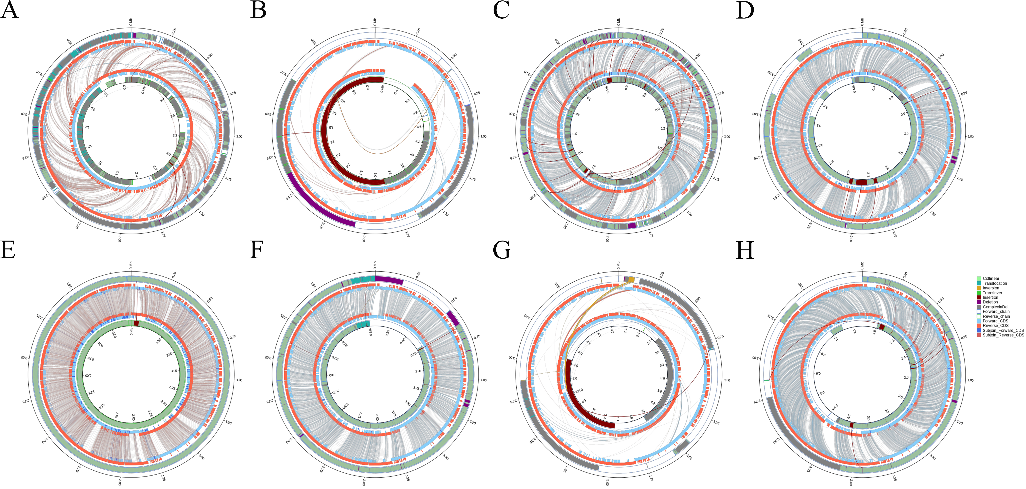
Note: (A-H) represents Structural variations between Bv. JN.Y2 and Bl.14580, Bm.BPN36.3, Bs.168, Bv.SQR9, Bv.CBMB205, Bv.FZB42, Bt.10792 and Ba.GKT04, respectively. The inner circle represents the query genome, while the outer circle represents the reference genome. Different colored bands connecting the two circles indicate various genomic rearrangements: Collinear (syntenic regions), Translocation (translocated regions), Inversion (inverted regions), and Tran+Inver (translocated and inverted regions). Insertion and Deletion refer to insertions and deletions of at least 50 bp, respectively. ComplexInDel indicates unaligned but spatially corresponding regions. The directional chains are defined as follows: Forward_chain for sequences on the forward strand with coordinates increasing clockwise, and Reverse_chain for sequences on the reverse strand with coordinates increasing counter-clockwise. Coding sequences (CDS) are further annotated: Forward_CDS and Reverse_CDS represent CDS on the forward and reverse strands, respectively. Subjoin_Forward_CDS and Subjoin_Forward_CDS denote additional CDS from the forward and reverse strands. In cases where the paired sequences of DeleteGene or InsertGene have 100% identity, they are annotated as supplementary CDS.
Online Resource 1 Figure S1 Structural variations between Bv. JN.Y2 and eight conparative Bacillus strains

