Supplementary Information

Development and Phytochemical Characterization of an Ocimum–Hibiscus Herbal Microemulsion with Antibacterial Activity and In Silico ADME Prediction

Santhoshraman B¹, K Jagajjanani Rao^{1*}, Tarangini Korumilli²

^{1*}Centre for Interfaces & Nanomaterials, Department of Biotechnology, Vel Tech Rangarajan Dr.Sagunthala R&D Institute of Science and Technology, Chennai-600062, India.

²Centre for Biomaterials & Environmental Biotechnology, Department of Biotechnology, Vel Tech Rangarajan Dr.Sagunthala R&D Institute of Science and Technology, Chennai-600062, India.

*Corresponding author E-mail: jeevan4u14@gmail.com; drjagajjananirao@veltech.edu.in

Fig. S1 Plant materials collected and identified as (a) Ocimum tenuiflorum and (b) Hibiscus rosa-sinensis.

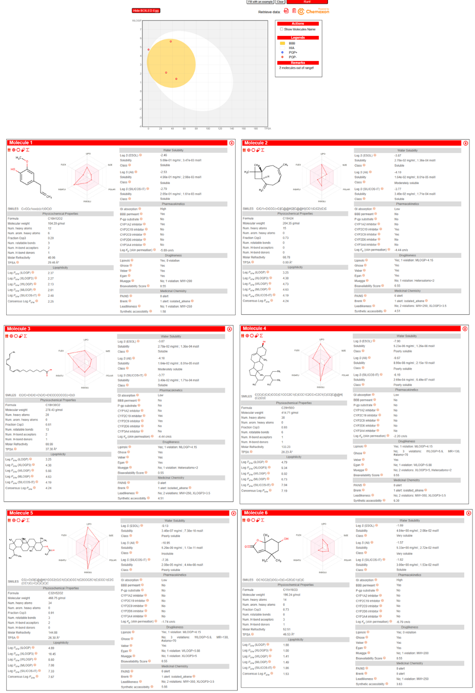
Fig. S2 In silico ADMET and drug-likeness profiling of selected molecules showing BOILED-Egg model prediction (top) and individual molecular property analyses including physicochemical parameters, bioavailability radar and toxicity indicators (bottom panels) for the selected compounds of Table 4.
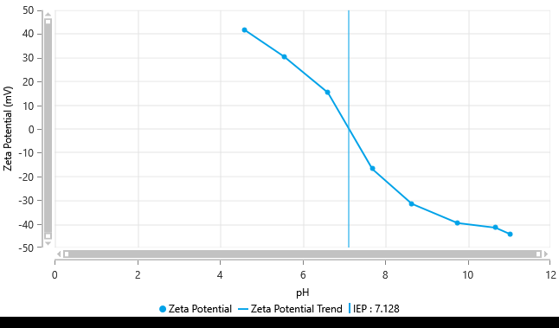
Measurement P^{H} | 4.5 | 5.5 | 6.6 | 7.6 | 8.6 | 9.7 | 10.6
Zeta (mV) | +41.79 | +30.39 | +15.25 | -16.78 | -31.39 | -39.5 | -41.48
Conductivity (ms/cm) | 0.2787 | 0.3092 | 0.3297 | 0.3501 | 0.3592 | 0.3838 | 0.5371

Fig. S3 Effect of pH on the zeta potential and electrical conductivity of CHME. Zeta potential was measured over pH 4.5–10.6; conductivity increased from 0.2787 to 0.5371 mS cm⁻¹ across the investigated pH range.

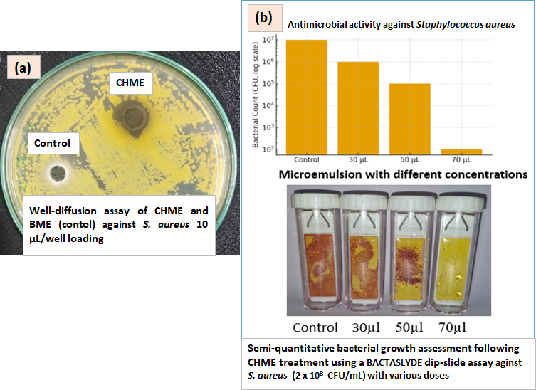

Fig. S4 Antibacterial activity of CHME against Staphylococcus aureus determined by (a) well-diffusion assay using an inoculum of 2 × 10⁸ CFU mL⁻¹ and (b) semiquantitative dip-slide assessment of bacterial growth following treatment with 30, 50, and 70 μL CHME. Untreated culture and BME served as controls.
Table S1 Phase behavior of coconut oil/Tween 20–glycerol/water system at a 1:1 Smix ratio.
Formulation | Coconut Oil (%) | Smix (%) | Water (%) | Coconut Oil (mL) | Smix (mL) | Water (mL) | Visual Appearance
F1 | 2 | 10 | 88 | 0.10 | 0.50 | 4.40 | Cloudy
F2 | 2 | 15 | 83 | 0.10 | 0.75 | 4.15 | Cloudy
F3 | 2 | 20 | 78 | 0.10 | 1.00 | 3.90 | Cloudy
F4 | 2 | 25 | 73 | 0.10 | 1.25 | 3.65 | Clear
F5 | 2 | 30 | 68 | 0.10 | 1.50 | 3.40 | Semiclear
F6 | 5 | 10 | 85 | 0.25 | 0.50 | 4.25 | Cloudy
F7 | 5 | 15 | 80 | 0.25 | 0.75 | 4.00 | Semiclear
F8 | 5 | 20 | 75 | 0.25 | 1.00 | 3.75 | Semiclear
F9 | 5 | 25 | 70 | 0.25 | 1.25 | 3.50 | Semiclear
F10 | 5 | 30 | 65 | 0.25 | 1.50 | 3.25 | Clear
F11 | 10 | 10 | 80 | 0.50 | 0.50 | 4.00 | Clear
F12 | 10 | 15 | 75 | 0.50 | 0.75 | 3.75 | Semiclear
F13 | 10 | 20 | 70 | 0.50 | 1.00 | 3.50 | Cloudy
F14 | 10 | 25 | 65 | 0.50 | 1.25 | 3.25 | Semiclear
F15 | 10 | 30 | 60 | 0.50 | 1.50 | 3.00 | Cloudy

Table S2 Phase behavior of coconut oil/Tween 20–glycerol/water system at a 2:1 Smix ratio.
Formulation | Coconut Oil (%) | Smix (%) | Water (%) | Coconut Oil (mL) | Smix (mL) | Water (mL) | Visual Appearance
F1 | 2 | 10 | 88 | 0.10 | 0.50 | 4.40 | Cloudy
F2 | 2 | 15 | 83 | 0.10 | 0.75 | 4.15 | Semiclear
F3 | 2 | 20 | 78 | 0.10 | 1.00 | 3.90 | Transparent
F4 | 2 | 25 | 73 | 0.10 | 1.25 | 3.65 | Cloudy
F5 | 2 | 30 | 68 | 0.10 | 1.50 | 3.40 | Cloudy
F6 | 5 | 10 | 85 | 0.25 | 0.50 | 4.25 | Cloudy
F7 | 5 | 15 | 80 | 0.25 | 0.75 | 4.00 | Semiclear
F8 | 5 | 20 | 75 | 0.25 | 1.00 | 3.75 | Semiclear
F9 | 5 | 25 | 70 | 0.25 | 1.25 | 3.50 | Clear
F10 | 5 | 30 | 65 | 0.25 | 1.50 | 3.25 | Clear
F11 | 10 | 10 | 80 | 0.50 | 0.50 | 4.00 | Clear
F12 | 10 | 15 | 75 | 0.50 | 0.75 | 3.75 | Semiclear
F13 | 10 | 20 | 70 | 0.50 | 1.00 | 3.50 | Semiclear
F14 | 10 | 25 | 65 | 0.50 | 1.25 | 3.25 | Semiclear
F15 | 10 | 30 | 60 | 0.50 | 1.50 | 3.00 | Semiclear

S1. Physicochemical Characterization and Stability Evaluation

Determination of Physicochemical Parameters
The pH, oxidation–reduction potential (ORP), dissolved oxygen (DO), and electrical conductivity (EC) of the herbal microemulsion formulations were measured using a calibrated multiparameter meter at room temperature. All measurements were performed in triplicate, and the results are expressed as mean ± standard deviation (SD).

Centrifugation Stability Test
The physical stability of the herbal microemulsion formulations and corresponding control formulations was evaluated by centrifugation. Samples were centrifuged at 5000 rpm for 30 min and subsequently examined visually for phase separation, creaming, sedimentation, and changes in appearance.

Heating–Cooling Cycle Stability Test
Heating–cooling stability was evaluated by alternately storing the samples at 4 ± 2 °C for 24 h and 45 ± 2 °C for 24 h. One complete cycle consisted of 48 h, and six consecutive cycles were performed. Following each cycle, the formulations were visually examined for changes in appearance, phase separation, precipitation, and creaming.

Freeze–Thaw Stability Test
Freeze–thaw stability was evaluated by subjecting the formulations to alternating storage at −20 ± 2 °C for 24 h and 25 ± 2 °C for 24 h. Six consecutive freeze–thaw cycles were performed. After completion of the cycles, the formulations were visually examined for changes in appearance, phase separation, precipitation and creaming.

Refractive Index
The refractive index (RI) of the herbal microemulsion and corresponding control formulations was determined using a digital refractometer (HI96800, Hanna Instruments). The instrument was calibrated with distilled water according to the manufacturer's instructions. Approximately 2–3 drops of each sample were placed on the prism surface, ensuring complete coverage and avoiding air bubbles. Measurements were performed in triplicate at 25 ± 2 °C, and the results are reported as mean ± SD.

Percentage Transmittance
The optical transparency of the herbal microemulsion formulations was evaluated by measuring percentage transmittance (%T) using a UV–visible spectrophotometer (MAR-2020 Fiber Optic, MARUTEK). Samples were diluted 1:100 (v/v) with distilled water, and %T was measured at 650 nm using distilled water as the blank. Measurements were performed in triplicate, and the results are expressed as mean ± SD.

Dilution Stability
Dilution stability was evaluated by diluting the herbal microemulsion formulations with distilled water at 1:10, 1:30, 1:50, and 1:100 (v/v). The diluted samples were gently mixed by inversion and incubated at 25 ± 2 °C for 24 h under static conditions. Samples were subsequently examined visually for phase separation, turbidity, creaming, precipitation, and changes in appearance.

Viscosity Measurement
The viscosity of the herbal microemulsion was determined using a BS4 viscosity cup at 25 ± 2 °C. Samples were gently mixed before measurement while avoiding air incorporation. The cup was filled carefully, and the efflux time was recorded using a stopwatch from the initiation of flow until the first interruption in the liquid stream. Viscosity was determined according to the manufacturer's calibration and expressed in centistokes (cSt). Measurements were performed in triplicate, and the results are reported as mean ± SD.

Storage Stability
The storage stability of the optimized combined herbal microemulsion (CHME) was evaluated at 4 ± 2 and 25 ± 2 °C for 60 days. Freshly prepared samples were transferred into separate glass containers and evaluated initially (day 0) and after 60 days of storage. Samples were visually examined for phase separation, creaming, precipitation, sedimentation, and changes in colour and odour. Particle size, polydispersity index (PDI), and zeta potential were subsequently measured in triplicate, and the results are expressed as mean ± SD.

Table S3 Centrifugation stability of blank and herbal microemulsion formulations after 5000 rpm for 30 min.

Centrifuge stability test
Samples | Phase separation | Creaming | Sedimentation | Appearance | Result
BME | No | No | NO | Clear | Pass
CME | No | No | NO | Clear | Pass
OTME | No | No | NO | Clear | Pass
HSME | No | No | NO | Clear | Pass
CHME | No | No | NO | Clear | Pass

Table S4 Heating–cooling stability of microemulsion formulations after six cycles between 4 ± 2 and 45 ± 2 °C.

Heating-cooling stability
Samples | Cycle  completed | Storage condition | Appearance | Phase separation | Remarks
BME | 6 | 4± 2°C ↔ 45± 2°C | Clear | No | Pass
CME | 6 | 4± 2°C ↔ 45± 2°C | Clear | No | Pass
OTME | 6 | 4± 2°C ↔ 45± 2°C | Clear | No | Pass
HSME | 6 | 4± 2°C ↔ 45± 2°C | Clear | No | Pass
CHME | 6 | 4± 2°C ↔ 45± 2°C | Clear | No | Pass

Table S5 Freeze–thaw stability of microemulsion formulations after six cycles between −20 ± 2 and 25 ± 2 °C.

Freeze-Thaw stability
Samples | Cycle  completed | Storage condition | Appearance | Phase separation | Remarks
BME | 6 | -20± 2°C ↔ 25± 2°C | Clear | No | Pass
CME | 6 | -20± 2°C ↔ 25± 2°C | Clear | No | Pass
OTME | 6 | -20± 2°C ↔ 25± 2°C | Clear | No | Pass
HSME | 6 | -20± 2°C ↔ 25± 2°C | Clear | No | Pass
CHME | 6 | -20± 2°C ↔ 25± 2°C | Clear | No | Pass

Table S6 Dilution stability of microemulsion formulations following 1:10, 1:30, 1:50, and 1:100 aqueous dilution.

Dilution stability
Sample | Dilution | Appearance | Phase separation | Turbidity | Creaming | Precipitation | Remarks
BME | 1:10 | Clear | No | No | No | No | Pass
BME | 1:30 | Clear | No | No | No | No | Pass
BME | 1:50 | Clear | No | No | No | No | Pass
BME | 1:100 | Clear | No | No | No | No | Pass
CME | 1:10 | Clear | No | No | No | No | Pass
CME | 1:30 | Clear | No | No | No | No | Pass
CME | 1:50 | Clear | No | No | No | No | Pass
CME | 1:100 | Clear | No | No | No | No | Pass
OTME | 1:10 | Clear | No | No | No | No | Pass
OTME | 1:30 | Clear | No | No | No | No | Pass
OTME | 1:50 | Clear | No | No | No | No | Pass
OTME | 1:100 | Clear | No | No | No | No | Pass
HSME | 1:10 | Clear | No | No | No | No | Pass
HSME | 1:30 | Clear | No | No | No | No | Pass
HSME | 1:50 | Clear | No | No | No | No | Pass
HSME | 1:100 | Clear | No | No | No | No | Pass
CHME | 1:10 | Clear | No | No | No | No | Pass
CHME | 1:30 | Clear | No | No | No | No | Pass
CHME | 1:50 | Clear | No | No | No | No | Pass
CHME | 1:100 | Clear | No | No | No | No | Pass

Table S7 60-Day storage stability of CHME at 4 ± 2 and 25 ± 2 °C based on particle size, polydispersity index, and zeta potential.
Days | Storage at 4±2°C |  |  | Storage at 25±2°C
Days | Particle size (nm) | Polydispersity index | Zeta (mV) | Particle size (nm) | Polydispersity index | Zeta (mV)
Initial | 155±  0.21 | 0.29±  0.14 | +32± 0.72 | 155±  0.21 | 0.29±  0.14 | +32±  0.72
60 | 159±  0.69 | 0.25±  0.23 | +36±  0.53 | 180±  0.32 | 0.26±  0.22 | +39±  0.04

