Supplementary Information for
Intraplate seismicity along inherited faults: insights from the 2020 earthquake sequence in SW Romania
PURE AND APPLIED GEOPHYSICS
Anica Otilia PLĂCINTĂ¹, Felix BORLEANU ², Eugen OROS ¹, Laura PETRESCU^{1,3}, Mircea RADULIAN^{1, 4,5}, Iren Adelina MOLDOVAN¹, Mihai ANGHEL⁶
¹ National Institute for Earth Physics, Department of Seismology and Lithosphere Structure, Măgurele, Romania.
² National Institute for Earth Physics, National Data Center Department, Măgurele, Romania.
³ Faculty of Physics, University of Bucharest, Măgurele, Romania
⁴ Romanian Academy, Bucharest, Romania.
⁵ Academy of Romanian Scientists, 54 Splaiul Independentei- 050094, Bucharest, Romania.
⁶ National Institute for Earth Physics, National Seismic Network Department, Măgurele, Romania.
Corresponding author: Plăcintă Anica Otilia, anca@infp.ro

The contents of this file: Tables S1, S2; Figures S1 and S2

Table S1 Earthquake parameters for the analyzed sequence. The main shock is marked in bold. Earthquakes were located using stations within a distance of up to two degrees. The magnitude is from ROMPLUS catalogue. The events marked with italic (1, 16 and 17) are not included in the catalogue

Nr. | Data  (yyyymmdd) | Time (hh:mm:ss) | Latitude (ºN) | Longitude  (ºE) | Depth (km) | Mw | No. of  stations | RMS  (s) | GAP  (º)
1. | 20200625 | 00:53:10.12 | 44.6736 | 22.2663 | 14.6 | 1.5 | 8 | 0.3 | 121
2. | 20200625 | 14:20:51.98 | 44.7187 | 22.3569 | 10.9 | 2.9 | 18 | 0.9 | 74
3. | 20200625 | 17:30:15.75 | 44.7182 | 22.3657 | 17.7 | 3.4 | 22 | 0.7 | 74
4. | 20200625 | 17:36:07.80 | 44.7355 | 22.3618 | 10.9 | 2.7 | 18 | 0.9 | 73
5. | 20200625 | 17:36:47.19 | 44.7260 | 22.3675 | 17.1 | 2.6 | 14 | 0.7 | 73
6. | 20200625 | 17:55:45.14 | 44.7454 | 22.4109 | 20.2 | 1.7 | 5 | 0.4 | 148
7. | 20200625 | 18:10:12.68 | 44.7336 | 22.4090 | 18.6 | 1.7 | 5 | 0.3 | 117
8. | 20200625 | 18:43:09.32 | 44.7299 | 22.4021 | 18.3 | 1.6 | 5 | 0.4 | 148
9. | 20200625 | 21:35:34.55 | 44.7365 | 22.3633 | 19.4 | 2.0 | 13 | 0.6 | 107
10. | 20200625 | 22:20:20.85 | 44.7590 | 22.3777 | 17.4 | 1.7 | 9 | 0.5 | 133
11. | 20200626 | 02:17:23.99 | 44.7353 | 22.3383 | 12.1 | 2.7 | 19 | 0.8 | 73
12. | 20200626 | 04:10:07.95 | 44.7418 | 22.3753 | 19.6 | 1.9 | 10 | 0.5 | 106
13. | 20200626 | 12:23:46.27 | 44.7346 | 22.4050 | 16.3 | 1.9 | 7 | 0.6 | 114
14. | 20200627 | 16:00:04.24 | 44.7470 | 22.3681 | 19.7 | 1.7 | 10 | 0.6 | 105
15 | 20200628 | 07:28:26.37 | 44.7417 | 22.4008 | 21.9 | 1.7 | 6 | 0.3 | 116
16. | 20200628 | 20:56:38.11 | 44.7088 | 22.2877 | 15.0 | 1.5 | 6 | 0.8 | 120
17. | 20200629 | 00:15:58.22 | 44.7384 | 22.4070 | 18.7 | 1.9 | 9 | 0.3 | 105
18. | 20200629 | 21:39:01.79 | 44.7483 | 22.3835 | 17.1 | 1.9 | 12 | 0.6 | 70
19. | 20200630 | 14:00:24.97 | 44.7446 | 22.3715 | 18.3 | 2.3 | 10 | 0.6 | 71
20. | 20200701 | 00:30:31.05 | 44.7397 | 22.4061 | 19.0 | 1.6 | 6 | 0.4 | 104
21. | 20200706 | 01:42:54.67 | 44.7398 | 22.3781 | 19.7 | 1.8 | 10 | 0.5 | 71

Table S2 Source parameters obtained from spectral ratios for the main shock and co-located earthquakes of the seismic sequence analyzed in this study. The main shock is marked in bold

Nr. | Data  yyyymmdd | Time  (hh:mm:ss) | Mo  (Nm) | Mw | ML Romplus | fc  (Hz) | Source radius (m) | Stress drop (MPa)
1. | 20200625 | 14:20:51.98 | (7.97±2.68)E⁺¹³ | 3.2±0.1 | 3.4±0.4 | 5.88±0.26 | 231.9±10.3 | 2.80±1.01
2. | 20200625 | 17:30:15.75 | (1.48±0.49)E⁺¹⁵ | 4.0±0.1 | 4.5±0.4 | 2.91±0.06 | 469.9±9.9 | 6.24±2.10
3. | 20200625 | 17:36:07.80 | (4.13±1.41)E⁺¹³ | 3.0±0.1 | 3.1±0.4 | 4.27±0.36 | 300.9±24.0 | 0.73±0.29
4. | 20200625 | 17:36:47.19 | (2.49±0.84)E⁺¹³ | 2.9±0.1 | 2.9±0.4 | 6.63±0.17 | 205.6±9.9 | 1.25±0.46
5. | 20200625 | 21:35:34.55 | (4.14±1.38)E⁺¹² | 2.3±0.1 | 1.7±0.4 | 12.16±0.75 | 112.0±6.9 | 1.29±0.49
6. | 20200626 | 02:17:23.99 | (2.73±0.91)E⁺¹³ | 2.9±0.1 | 3.0±0.3 | 7.57±0.16 | 180.1±3.8 | 2.04±0.69
7. | 20200626 | 04:10:07.95 | (2.12±0.71)E⁺¹² | 2.2±0.1 | 1.6±0.3 | 19.97±1.44 | 68.2±4.9 | 2.92±1.16
8. | 20200626 | 12:23:46.27 | (1.54±0.52)E⁺¹² | 2.1±0.1 | 1.6±0.3 | 11.080±0.55 | 123.0±6.1 | 0.36±0.13
9. | 20200630 | 14:00:24.97 | (8.80±3.08)E⁺¹² | 2.5±0.1 | 2.3±0.3 | 6.10±0.44 | 223.2±15.8 | 0.35±0.14

Fig. S1 Correlation matrix computed from cross‑correlation coefficients estimated within a 6‑s window around the S‑wave arrival on the vertical‑component recordings of station HERR (see Fig. 2), filtered with a Bandpass filter between 0.5 and 5 Hz
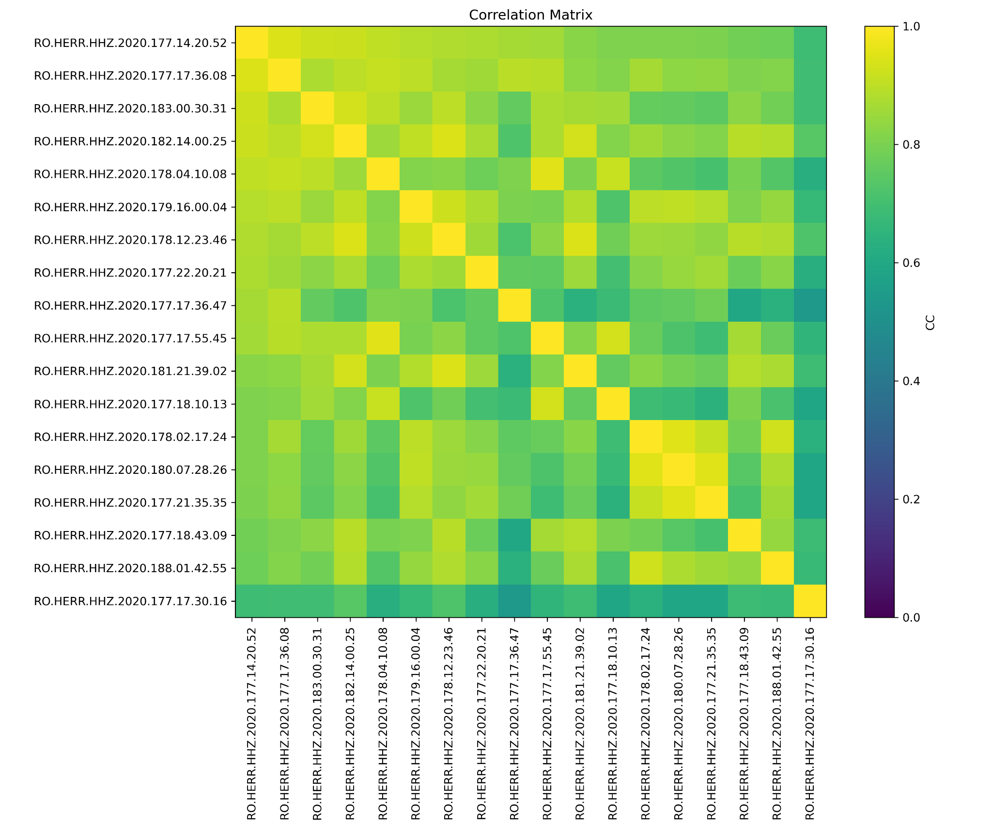

Fig. S2 Vertical‑component waveforms recorded at station HERR (HHZ), bandpass filtered between 0.5 and 5 Hz showing a high degree of similarity. The similarity is quantified by cross correlation coefficients estimated using a time window of 6 s around S-wave arrival. The cross correlation coefficients among the recordings (CC > 0.65) are indicated in blue.
