Table 1. Baseline demographic, clinical and laboratory characteristics
Variable | Value
Female sex | 56 (67.1%)
Mean age at onset (years) | 4.4
Onset <5 years | 57 (69%)
Mean diagnostic delay (months) | 9 (2–48)
Monoarticular onset | 29 (35%)
Knee involvement | 83%
ANA positive | 59 (71%)
Uveitis | 20 (24%)

Table 2. Therapeutic strategies and disease outcomes
Variable | Persistent (n=64) | Extended (n=18) | Total
Methotrexate use | 34 (53%) | 18 (100%) | 52 (63%)
Biologic therapy | 3 | 5 | 8
Extension within 2 years | - | 100% | -
Relapses | 8 | 3 | 11 (14%)
Ocular complications | 11 | 2 | 13
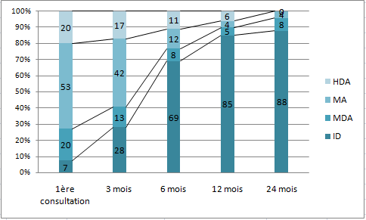
Figure 1. Evolution of disease activity according to JADAS-10 categories during the first 24 months of follow-up. The proportion of patients achieving inactive disease (ID) increased progressively, while moderate (MDA) and high disease activity (HDA) declined markedly. Most disease activity transitions occurred within the first year.

