Supplementary information for Optical Soliton in Quantum Dot Comb Laser
Xiangru Cui^{1,2}, Bo Yang^{1,2}, Artem Prokoshin³, Jingzhi Huang^{1,2}, Dong Han¹, Wenqi Wei⁴, Jiajian Chen⁴, Jiale Qin^{1,2}, Ning Liang^{1,2}, Dingyi Wu⁵, Jie Yan⁵, Zhiyong Jin⁶, Jianan Duan⁶, Zihao Wang^{1,2}, Xi Xiao⁵, Xinlun Cai⁷, Yating Wan³, Jianjun Zhang^{1,2,4,*}, Ting Wang^{1,2,8*}

¹Beijing National Laboratory for Condensed Matter Physics, Institute of Physics, Chinese Academy of Sciences, Beijing 100190, China
²Center of Materials Science and Optoelectronic Engineering, University of Chinese Academy of Science, Beijing 100049, China
³Integrated Photonics Lab (IPL), CEMSE, King Abdullah University of Science and Technology (KAUST), Thuwal 23955, Makkah Region, Saudi Arabia
⁴Songshan Lake Materials Laboratory, Dongguan, Guangdong 523808, China
⁵National Information Optoelectronics Innovation Center, China Information and Communication Technologies Group Corporation (CICT), Wuhan, Hubei 430074, China
⁶National Key Laboratory of Laser Spatial Information, Guangdong Provincial Key Laboratory of Integrated Photonic-Electronic Chip, Harbin Institute of Technology, Shenzhen 518055, China
⁷State Key Laboratory of Optoelectronic Materials and Technologies, School of Electronics and Information Technology, Sun Yat-sen University, Guangzhou 510275, China
⁸School of Electronic Information and Electrical Engineering, Shanghai Jiao Tong University, Shanghai 200240, China
*Corresponding authors: jjzhang@iphy.ac.cn, wangting@iphy.ac.cn

The numerical model is based on Maxwell's equations and a first-order propagation model governed by the generalized nonlinear Schrödinger equation (GNLSE), which describes the bidirectional evolution of optical fields within the laser cavity. The equation is then simplified by the scalar approximation and the slowly varying envelope approximation (SVEA) and can be written as:
$$\begin{matrix}\frac{1}{v_{g}}\frac{∂E_{±}}{∂t}±\frac{∂E_{±}}{∂z} & =\left[g_{0}\left(1+iα_{H}\right)−g_{0}({\left|E_{+}\right|}^{2}+{\left|E_{−}\right|}^{2})/I_{s}−α_{abs}−α_{SA}−\frac{g_{0}T_{2}^{2}}{1+α^{2}}\frac{∂^{2}}{∂t^{2}}\right]E_{±} \\ & +iD_{eff}\frac{∂^{2}E_{±}}{∂t^{2}}+iβ_{eff}\left({\left|E_{+}\right|}^{2}+{\left|E_{−}\right|}^{2}\right)E_{±}\end{matrix} (Eq. 1)$$
which including gain, resonant cavity loss, saturation absorption loss, gain spectrum bandwidth limitation, dispersion and nonlinearity effect. In equation Eq1, $E_{±}$ is electric field envelope for forward/backward propagation, $v_{g}$ is group velocity, $g_{0}$ is total gain, $α_{H}$ is linewidth enhancement factor, $α_{abs}$ and $α_{SA}$ are the cavity and saturable absorber loss respectively, and $I_{s}$ is the saturation intensity of the active region. The term $\frac{g_{0}T_{2}^{2}}{1+α^{2}}\frac{∂^{2}E_{±}}{∂t^{2}}$ describes the bandwidth limiting effect of gain spectrum, representing the filtering effect of finite gain bandwidth on high-frequency components. $D_{eff}$ is the effective group velocity dispersion coefficient, which represents the effect of dispersion on pulse broadening or compression, and can be written as:
$$D_{eff}=D−\frac{2α_{H}g_{0}T_{2}^{2}}{1+α_{H}^{2}} (Eq. 2)$$
where $T_{2}$ is the polarization relaxation time. The wider the gain spectrum, the smaller the $T_{2}$. $β_{eff}$ is the effective nonlinear coefficient, describing the Kerr-induced self-phase modulation (SPM) and cross-phase modulation (XPM) effect, and the intensity is proportional to the electric field strength. $β_{eff}$ can be written as:
$$β_{eff}=β−\frac{g_{0}α_{H}}{I_{s}} (Eq3)$$
where $I_{s}$ is the saturation strength of the gain medium. Both the $D_{eff}$ and $β_{eff}$ are proportional to the $g_{0}$ and thus scale with the injection current. Additionally, they are also affected by the non-zero $α_{H}$ factor, which results in the effective nonlinearity and dispersion being dependent on the laser injection current, which allows to tune the laser into the low-dispersion regime where soliton operation is observed.

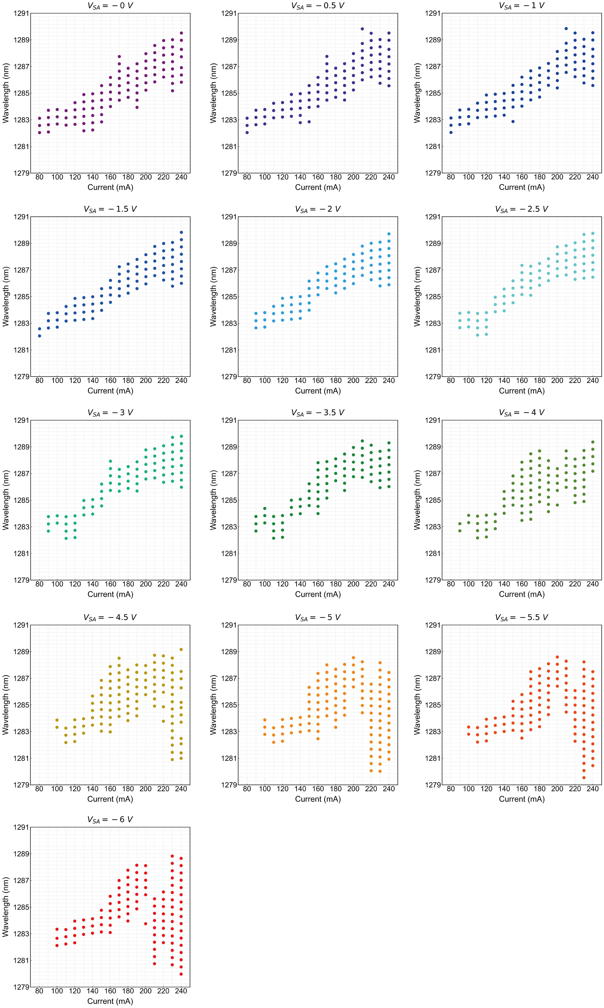
Fig. S1 Wavelengths of locked comb lines within 6 dB optical bandwidth (OBW) of CPM laser working at room temperature (23 ºC), I_{inj} from 80 mA to 240 mA with different V_{SA} (marked above the corresponding subgraph).
For demonstrating the influence of electric driving conditions on mode-locking stability of the CPM laser working under room temperature, the wavelength variations of comb lines within 6 dB OBW with I_{inj} from 80 mA to 240 mA and V_{SA} from 0 V to -6 V are shown in Fig. S1. The comb number change refers to the optical spectrum evolution from Gaussian type, sech² type to flat-top state. Obviously, increasing I_{inj} up to 200 mA results in red shift of locking wavelength. Further I_{inj} rise brings about the excitation of shorter wavelength modes amplified by another set of QDs, which may be due to weak electrical isolation.

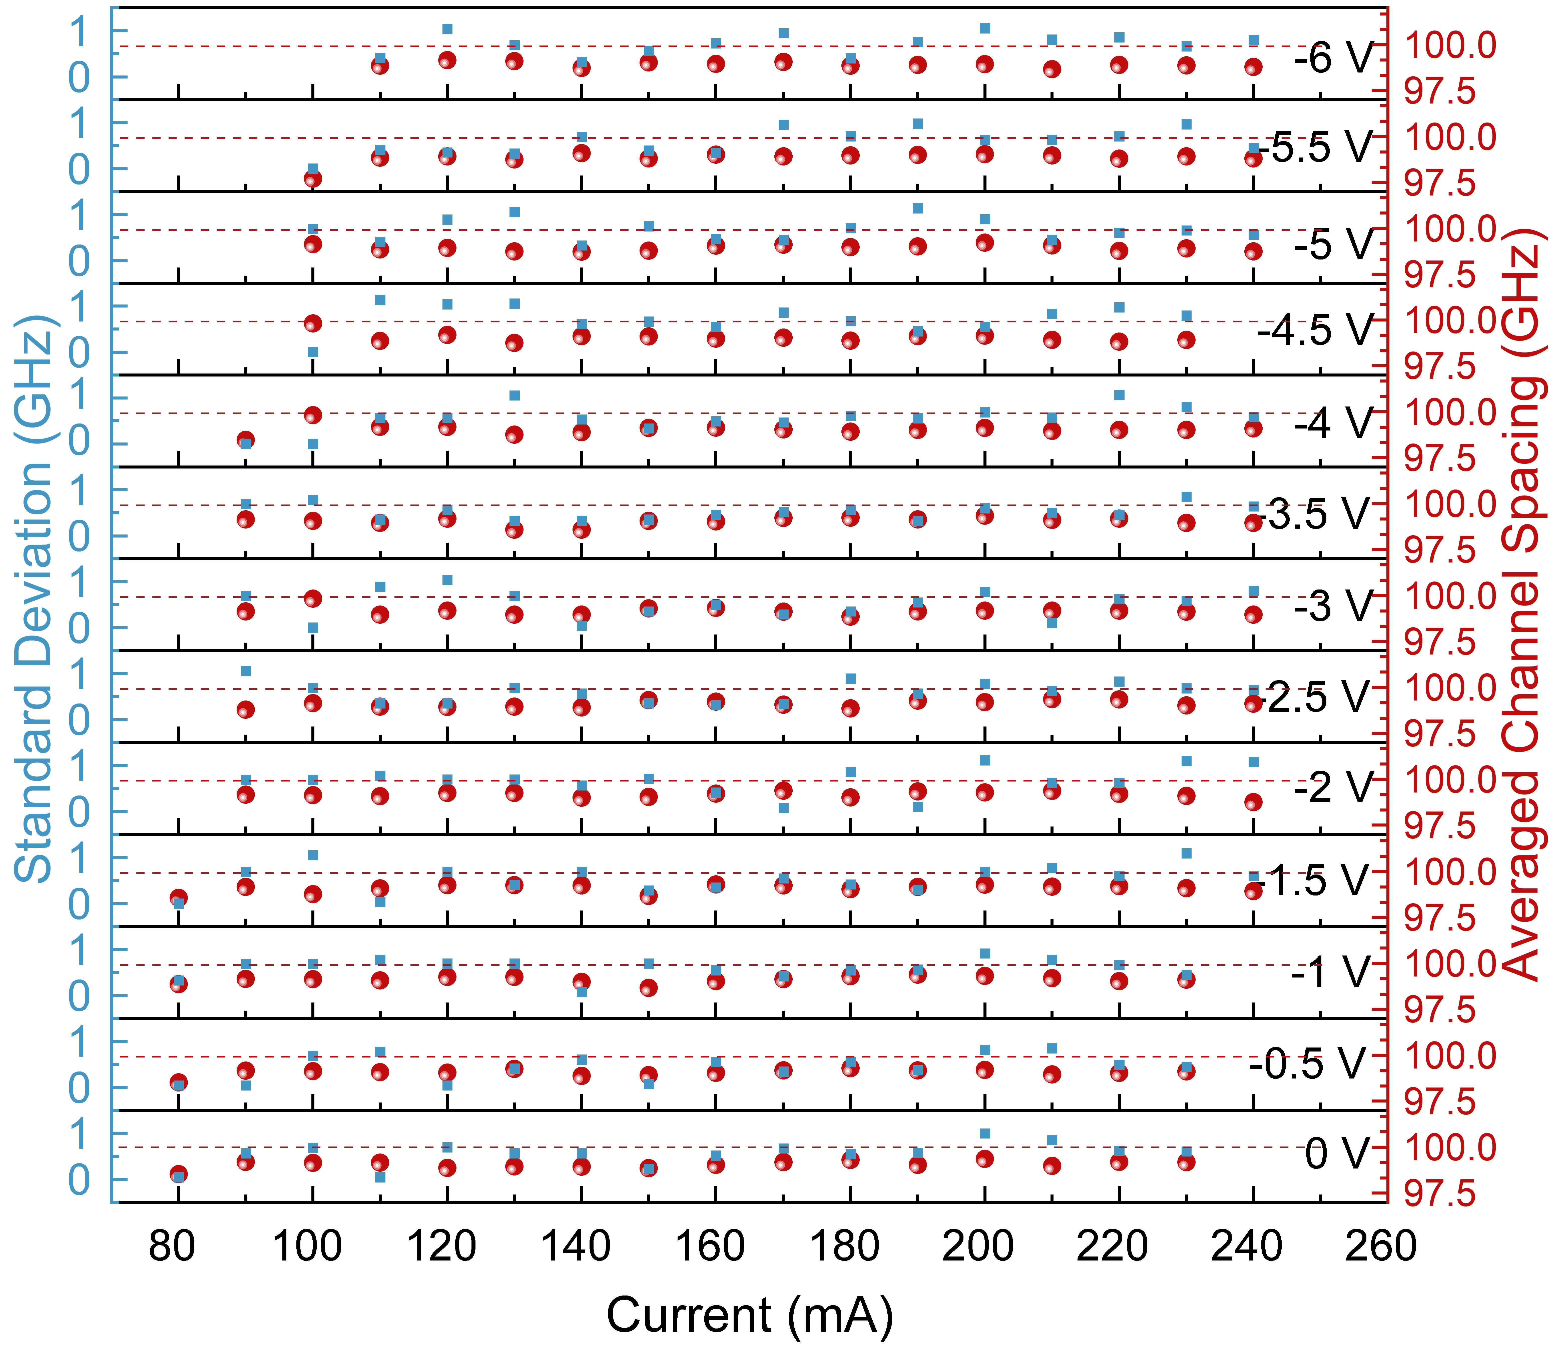
Fig. S2 Average channel spacing and standard deviation of comb lines within 6 dB OBW of laser working at room temperature (23 ºC), I_{inj} from 80 to 240 mA with different V_{SA} (marked in the right of the panel).
The channel stability evaluation is further carried out based on the locking wavelength shown in Fig. S1. The calculated average channel spacing and standard deviation are shown in Fig. S2. The average channel spacing is approximately 99 GHz, and the standard deviation is lower than 1.2 GHz, which shows good uniformity of this device under different mode-locked conditions.

Table. S1 Full width at half maximum (FWHM) of output optical spectra at different operating conditions
For the contour of mode-locked optical spectra that can be fitted by standard functions (e.g. Gaussian, Sech), the full width at half maximum (FWHM) is taken from the peak shape fitted by corresponding function of the outer contour. For those spectra without a standard fitting function, such as flat-topped spectrum, the FWHM is directly taken from the outer contour of locked peak.

Table. S2 FWHM of output pulse profile at different operating conditions
Similar to the spectral processing method, FWHMs of those stretched pulses is directly calculated from the test results.
Table. S3 The extinction ratio (ER) of autocorrelation (AC) trace at different operating conditions (Top). Bottom table are fine scan ER results. I_{inj} is swept from 95 mA to 130 mA with 5 mA step and V_{SA} from -4.5 V to -6 V with 0.5 V step.
Table. S4 The time bandwidth product (TBP) results at different operating conditions (Top). Bottom table are fine scan results. I_{inj} is swept from 95 mA to 130 mA with 5 mA step and V_{SA} from -4.5 V to -6 V with 0.5 V step.
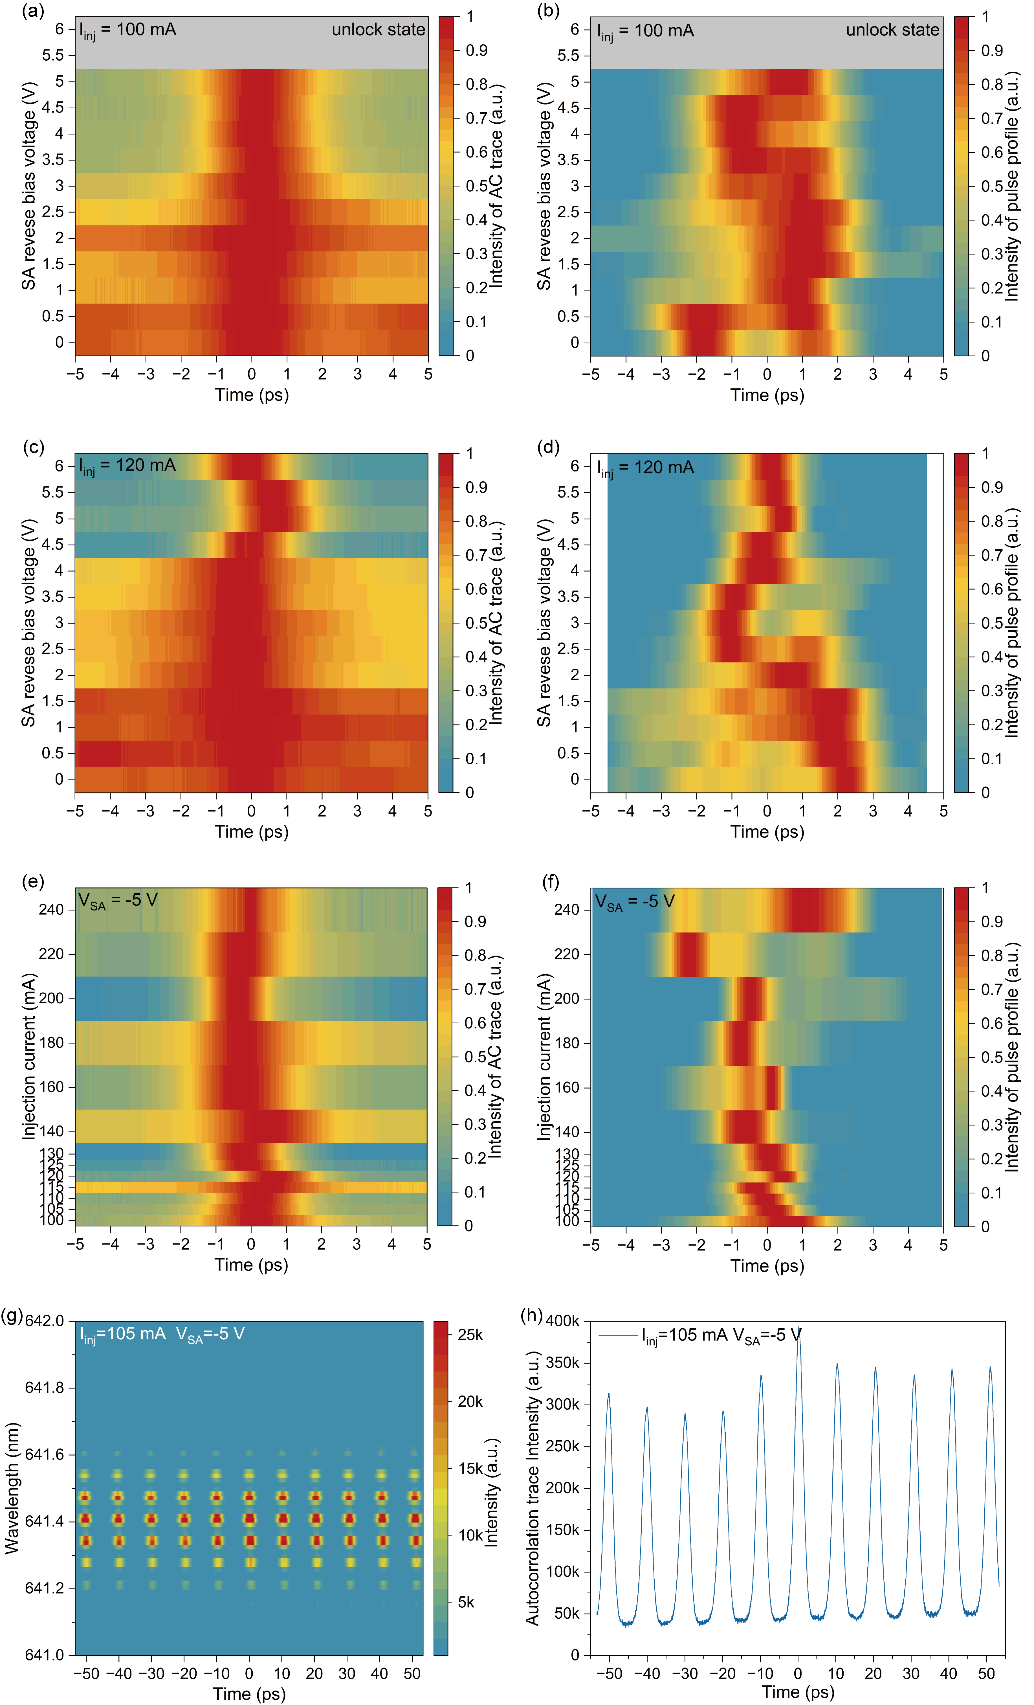
Fig. S3 Time domain mapping of Si-based 100 GHz QD CPM laser under fixed I_{inj} or V_{SA}. a ER of AC trace mapping and b pulse profile mapping at I_{inj} = 100 mA with V_{SA} swept from 0 V to -6 V. c ER of AC trace mapping and d pulse profile mapping at I_{inj} = 120 mA with V_{SA} swept from 0 V to -6 V. e ER of AC trace mapping and f pulse profile mapping at V_{SA} = -5 V with I_{inj} swept from 100 mA to 240 mA. g FROG tested signal in frequency domain and time domain and h pulse train of AC trace in 100 ps time scale of CPM laser operating at I_{inj} = 105 mA and V_{SA} = -5 V.
Fig. S3g and S3h confirms the AM soliton pulse train formed at I_{inj} = 105 mA and V_{SA} = -5 V. To further illustrate the time domain evolution with electric driving condition near soliton state, ER of AC trace and pulse profile intensity mappings are carried out. As shown in Fig. S3a and S3c, ER becomes higher at higher V_{SA}, corresponds to strong pulse output by strong AM effect of SAs with faster recovery ability. For the optical pulse, higher V_{SA}s bring less stretched pulses. However, the peak value appears at different time delay from 0 ps, and the reason needs further investigation. Besides, the optical pulse profiles at low V_{SA}s recovered by FROG algorithm have a certain degree of uncertainty, because AC traces with near zero ER are not ideal for algorithm principle. When V_{SA}= -5 V, the ER of AC trace remains quite high across different I_{inj} conditions (Fig. S3e), confirming the AM characteristic. At this fixed V_{SA}, the pulses become more stretched as I_{inj} increases, which can be attributed to the limited modulation capacity of SA, whose absorption effect becomes saturated with the increased number of cavity photons.

