Supplementary Material
Supplementary Methods. Participants, MRI Data Acquisition and Preprocessing, Latent Growth Curve Modeling, Partial Least Squares Correlation Analysis, Preprocessing of Allen Human Brain Atlas Data, Support Vector Machine Analysis
Fig. S1. Validation of Latent Variable 1 Using Partial Least Squares Correlation Analysis in rTMS Group
Fig. S2. Validation of Latent Variable 1 Using Partial Least Squares Correlation Analysis in tDCS Group
Fig. S3. Bootstrap Ratios for HAMD-17 Factor Scores in rTMS and tDCS Groups
Fig. S4. Gene Variance Explanation Ratios and Brain Loadings in rTMS and tDCS Groups
Table S1. Demographic characteristics and Clinical variables of the participants at baseline
Table S2. Clinical variables of the three groups at baseline (T0), after 10 sessions (T1) and after 20 sessions (T2)
Table S3. Latent Growth Curve Model Path Estimates of Symptom Trajectories for rTMS and tDCS Groups
Table S4. Distribution of Symptom-Related Connections Identified by Partial Least Squares Correlation Analysis in the rTMS and tDCS Groups
Table S5. rTMS and tDCS Genes Enriched Biological Processes and Pathways from Metascape
Table S6. The Top 15 Functional Connectivity Features Selected by LASSO Regression in the rTMS and tDCS Groups
Supplementary Method
Participants
All patients were recruited from the Early Intervention Unit, Affiliated Brain Hospital of Nanjing Medical University. Diagnoses were independently established by two trained psychiatrists, using the Structured Clinical Interview for DSM-IV Axis I Disorders (SCID) for participants aged ≥18 years and the Schedule for Affective Disorders and Schizophrenia for School-Age Children–Present and Lifetime Version (K-SADS-PL) for those <18 years. All participants had a 17-item Hamilton Depression Rating Scale (HAMD-17) score >17 at baseline. Exclusion criteria included: (1) contraindications to MRI; (2) history of head trauma and loss of consciousness for 5 minutes or more; (3) comorbidities with other axial I disorders.
The independent rTMS validation cohort consisted of 27 patients with major depressive disorder or bipolar disorder, recruited from the same clinical site under identical inclusion and exclusion criteria. Patients received 10-Hz rTMS targeting the left dorsolateral prefrontal cortex over 20 daily sessions, consistent with the primary rTMS cohort. This cohort was used to evaluate the generalizability of the predictive support vector machine (SVM) model trained on the original rTMS dataset.
The healthy control (HC) group comprised 40 age- and sex-matched individuals (aged 13–25 years) recruited via advertisements. All participants were fully informed about the study procedures and provided written informed consent (or parental consent for minors). None had a history of psychiatric or neurological disorders, as confirmed through structured clinical interviews. HC participants underwent the same rs-fMRI acquisition and preprocessing procedures as the patient cohorts, serving as a normative reference for functional connectivity (FC) analyses.

MRI Data Acquisition and Preprocess
The resting-state fMRI data were acquired using a MAGNETOM Prisma 3.0T superconductor MRI scanner (Siemens, Germany). The parameters were as follows: TR = 500 ms, TE = 30 ms, flip angle = 60, field of view = 224 × 224 mm², matrix = 64 × 64, voxel size = 3.5 × 3.5 × 3.5 mm³; interlayer spacing = 0.5 mm, and 35 axial slices per volume. A total of 960 volumes were collected over an 8-minute, 7-second scan session.
Image preprocessing was conducted using Statistical Parametric Mapping 8 (SPM8; https://www.fil.ion.ucl.ac.uk/spm) and the Data Processing Assistant for Resting-State fMRI (DPARSF; https://www.restfmri.net/forum/DPARSF). The first 10 time points were discarded to account for magnetic saturation effects. The remaining images underwent slice timing correction, followed by realignment to the first volume for head motion correction. Volumes with excessive motion (defined as > 3 mm displacement or >3° rotation) were excluded. Spatial normalization was performed using standard echo-planar imaging (EPI) templates in Montreal Neurological Institute (MNI) space, resampled to a 3 × 3 × 3 mm³ voxel size, and smoothed with a 6-mm full-width at half-maximum (FWHM) Gaussian kernel. To further reduce physiological noise and scanner-related artifacts, linear detrending was applied, and temporal bandpass filtering (0.01–0.08 Hz) was implemented.
Functional connectivity analyses were conducted using the Human Connectome Project (HCP) atlas, which parcellates the brain into 360 regions spanning Yeo’s 7 large-scale networks (1), including the default mode network (DMN), dorsal attention network (DAN), ventral attention network (VAN), limbic network (LIM), visual network (VIS), and frontoparietal network (FPN). Regional time series were extracted, and pairwise Pearson correlation coefficients were computed to quantify functional connectivity. Fisher’s r-to-z transformation was applied to normalize the correlation values for subsequent statistical analyses.

Partial Least Squares Correlation Analysis
Partial least squares correlation (PLSC) is a multivariate technique that identifies latent variable (LV) pairs capturing the maximal shared variance between two datasets. By maximizing covariance, PLSC provides an interpretable framework for characterizing distributed brain-behavior relationships (2, 3).
In this study, PLSC was employed to examine the association between functional connectivity alterations (X) and clinical symptom changes measured by HAMD-17 (Y). Prior to PLSC analysis, linear regression was applied to regress out potential confounders—including mean framewise displacement (motion) (4), age, sex, medication and duration —from both X and Y, ensuring that the extracted relationships were not driven by these nuisance variables. The residuals were then submitted to PLSC, which identified LVs representing significant patterns of covariance between connectivity and symptom changes. Each LV was defined as a weighted linear combination of input variables, with loadings quantifying the contribution of individual functional connections and clinical measures to the identified pattern.
Interpretation of contributing FC alterations depended on the directionality of original connectivity values. Positive loadings indicated greater symptom improvement with increased connectivity alterations, whereas negative loadings indicated better clinical response with smaller connectivity shifts. Functional connections contributing to the first LV (LV1), which explained the maximal covariance, were mapped onto Yeo’s 7-network parcellation for visualization.
To assess statistical significance, a permutation test (1,000 iterations) was performed on LV eigenvalues to generate a null distribution, with significance set at P < .05. Bootstrap resampling (1,000 iterations) was then used to estimate the stability of individual variable contributions. A bootstrap ratio (mean weight divided by its standard deviation) was computed, with a threshold of ±2 (corresponding to P < .05) indicating significant contributions.
Furthermore, to examine if a variable contributes significantly to an LV, we performed a bootstrap test to determine if its weight is significantly different from 0. This procedure was repeated 1000 times to examine the stability of these weights by simulating the sampling procedure and assuming that the sample best approximates the population of interest. The 1000 resampled weights of each variable, derived from each resampled PLSC analysis, provide a distribution and confidence intervals, which illustrate the stability of the observed value. A bootstrap ratio (i.e., mean divided by standard deviation of the distribution) was computed for each weight from this distribution to provide a Z-approximate that determines if the observed value is significantly different from 0; therefore, a value of 2 (corresponding to p of .05) was used as a threshold of weight stability. Lastly, 10-fold cross-validation was performed using the pls.cv function to evaluate the generalizability of results. In the cross-validation procedure, the dataset was divided into ten subsets. Nine subsets were used as a training set and the remaining subset as a test set. In the test sets, the LVs were predicted in turn by the corresponding training sets. This computed the predicted brain (LV_{X}) and clinical (LV_{Y}) scores by multiplying the test set with variable weights derived from the train set. Correlations between predicted and actual LV scores were assessed.

Preprocessing of Allen Human Brain Atlas Data
Transcriptional profiles were obtained from the Allen Human Brain Atlas (AHBA) website (https://human.brain-map.org/). The gene expression datasets were extracted from the post-mortem brain tissues of six donors. The donors were a 24-year-old (H0351.2001) and a 39-year-old (H0351.2002) African American male; a 57-year-old (H0351.1009), a 31-year-old (H0351.1012) and a 55-year-old (H0351.1016) European-ancestry male; as well as a 49-year-old Hispanic female (H0351.1015). Further details concerning the gene expression data are also provided at Allen Human Brain Atlas platform (http://www.brain-map.org). The profiles included 20,737 gene expressions measures represented by 58,692 probes. As right hemisphere samples were only available in two out of the six donors in the AHBA dataset, only tissue samples from the left hemisphere (n = all 6 donors) were included.
The expression data were preprocessed according to the 5 major steps: (i) verifying probe-to-gene annotations; (ii) filtering probes not exceeding background noise; (iii) selecting representative probes to index expression for each gene; (iv) assigning and mapping samples to the HCP atlas (https://humanconnectome.org/); (v) normalizing expression values to account for outlying values and inter-participant variances. The open-source code concerning the preprocessing procedure was used (https://github.com/BMHLab/AHBAprocessing). After preprocessing, each tissue sample had 10,027 probes (5). All brain tissue samples were then spatially coregistered to the HCP atlas, which consists of 360 cortical regions. The mean gene expression value of all brain tissue samples in each region was calculated, and the expression level of all genes in the left hemisphere regions was used for regression analysis.
To link treatment-responsive functional connectivity patterns (derived from PLSC) to transcriptional signatures, partial least squares regression (PLSR) was employed (5, 6). We first mapped the significant functional connections and their corresponding loadings obtained from the PLSC onto individual brain regions. Then the gene expression data were set as predictor variables, and the FC-loadings maps were response variables. We selected the first component in the PLS (PLS1), which was the linear combination of gene expression values that explained the most variance in associations with the FC-loadings maps, for further analyses. Gene weights from PLS1 were standardized (z-scored), and genes with absolute weights |Z| > 3 (indicating strong directional associations) and false discovery rate (FDR)-corrected p-values < 0.05 were prioritized as candidate mediators of neuroplasticity. This stringent threshold balanced sensitivity and specificity, isolating genes whose expression covaried robustly with connectivity features implicated in symptom improvement. Following gene selection, functional enrichment analysis was conducted using Metascape to identify biological processes overrepresented among the genes contributing to PLS1. Enrichment was corrected for multiple comparisons using the false discovery rate (FDR, p < 0.05). This approach allowed us to determine the molecular pathways potentially mediating the neurophysiological effects of brain stimulation, providing insights into the biological mechanisms underlying treatment-induced connectivity changes.

Support Vector Machine
To evaluate the predictive utility of baseline functional connectivity features in forecasting individualized treatment responses, a two-stage machine learning framework integrating feature selection and support vector machine (SVM) classification was implemented.
In the first stage, least absolute shrinkage and selection operator (LASSO) regression was applied to mitigate high dimensionality and multicollinearity in connectivity data . Covariate-adjusted connectivity values (residualized for age, sex, mean framewise displacement, medication and duration) were subjected to LASSO with 5-fold cross-validation in the training set (70% of data) to determine the optimal regularization parameter (λ) that minimized prediction error while enforcing sparsity. To ensure robustness, feature selection was repeated across 1,000 bootstrap iterations, retaining the 15 most frequently selected connections as input features. This approach prioritized connectivity edges consistently associated with clinical outcomes while reducing overfitting risk.
In the second stage, an SVM classifier with a radial basis function (RBF) kernel was trained on LASSO-selected features to capture nonlinear relationships between connectivity patterns and treatment response. Hyperparameters, including regularization strength (C) and kernel width (σ), were optimized via grid search (C: 10⁻³ to 10³; σ: 10⁻³ to 10³) within 10-fold cross-validation, maximizing the area under the receiver operating characteristic curve (AUC). To enhance generalizability, the entire pipeline—including LASSO feature selection, SVM training, and validation—was repeated 100 times using stratified random splits. Final performance metrics (accuracy, sensitivity, specificity, and AUC) were averaged across iterations.

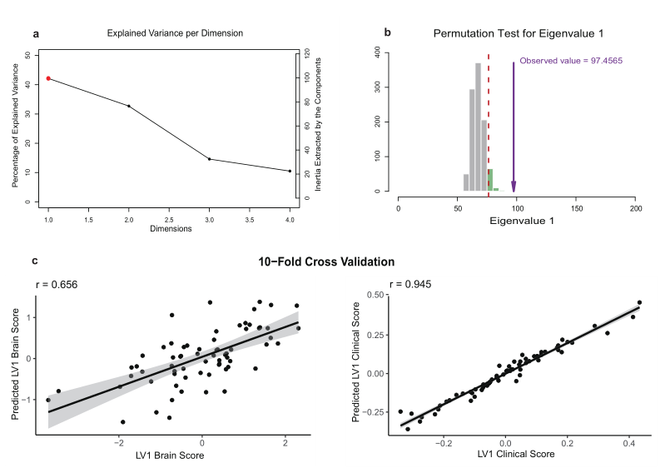
Fig. S1. Validation of Latent Variable 1 Using Partial Least Squares Correlation Analysis in rTMS Group.
(A) Explained variance per dimension in rTMS group using PLSC analysis, the first latent variable (LV1), highlighted in red, accounts for 41.27% of the variance. (B) Permutation test results for eigenvalue 1, the observed eigenvalue is significantly higher than the distribution generated by permutation. (C) Ten-fold cross-validation results for the predictive accuracy of LV1. The left scatter plot shows the correlation between predicted and actual brain scores, while the right scatter plot illustrates the correlation between predicted and actual clinical scores.

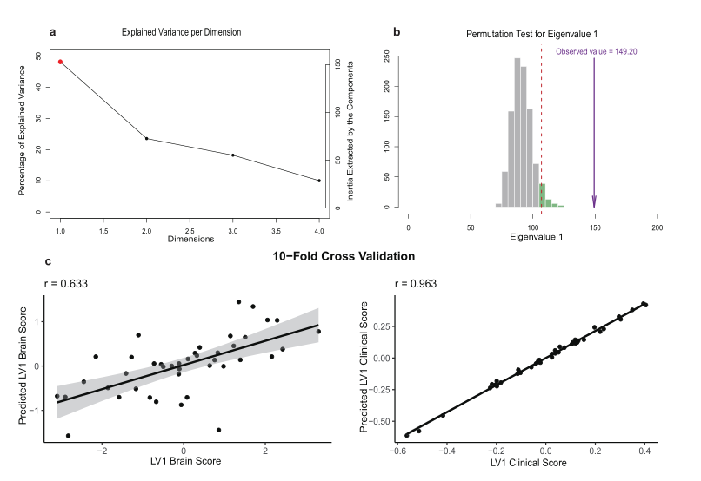
Fig. S2. Validation of Latent Variable 1 Using Partial Least Squares Correlation Analysis in tDCS Group.
(A) Explained variance per dimension in tDCS group using the PLSC analysis, the first latent variable (LV1), highlighted in red, accounts for 49.40% proportion of variance. (B) Permutation test results for eigenvalue 1, the observed eigenvalue is significantly higher than the distribution generated by permutation. (C) Ten-fold cross-validation results for the predictive accuracy of LV1. The left scatter plot shows the correlation between predicted and actual brain scores, while the right scatter plot illustrates the correlation between predicted and actual clinical scores.

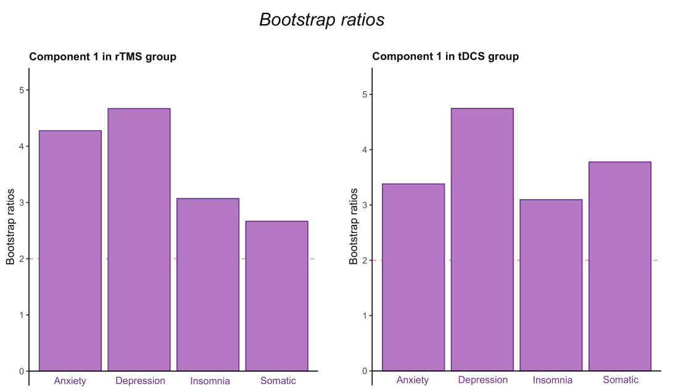
Fig. S3. Bootstrap Ratios for HAMD-17 Factor Scores in rTMS and tDCS Groups.
Bootstrap ratios for the four HAMD-17 factor scores in the rTMS (left) and tDCS (right) groups, derived from PLSC analysis. The four factors are based on the classification proposed by Shafer et al (7).

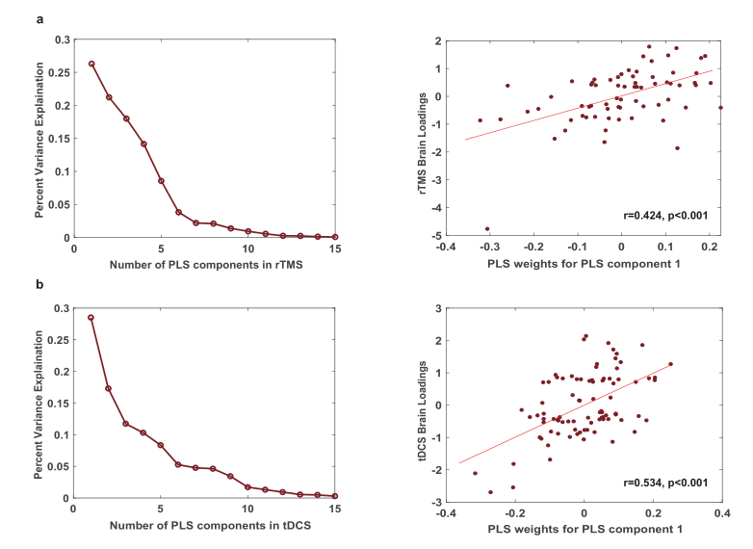
Fig. S4. Gene Variance Explanation Ratios and Brain Loadings in rTMS and tDCS Groups.
(A) The left panel shows explained variance per component in rTMS group using the PLS analysis, the first component (PLS1) accounts for 27.45% proportion of variance. The right panel shows the correlation between PLS1-derived weights and corresponding brain loadings. (B) The left panel shows explained variance per components in tDCS group using the PLS analysis, the first component (PLS1) accounts for 28.88% proportion of variance. The right panel shows the correlation between PLS1-derived weights and corresponding brain loadings.

Table S1. Demographic Characteristics and Clinical Variables of the Participants at Baseline
 | Mean (SD)
 | rTMS  (N = 67) | HD-tDCS  (N = 42) | rTMS Validation  (N = 27) | HC  (N = 40) | F/χ^{2 a} | P
Demographic
Age | 15.69 (2.14) | 15.21 (1.63) | 15.18 (2.19) | 16.05(2.47) | 1.42 | 0.24
Female, No. (%) | 53 (79.10) | 30 (71.43) | 22 (81.48) | 24 (60.00) | 5.77 | 0.12
Male, No. (%) | 14 (20.90) | 12 (28.57) | 5 (18.52) | 16 (40.00)
BD, No. (%) | 30 (44.78) | 23 (54.76) | 12 (44.44) | -- | 1.18 | 0.55
MDD, No. (%) | 37 (55.22) | 19 (45.24) | 15 (55.56) | --
Duration (months) | 28.46(25.41) | 25.05(18.49) | 31.48 (36.61) | -- | 0.51 | 0.60
Clinical variables
HAMD total scores | 26.04 (6.54) | 24.79 (6.00) | 27.30 (5.79) | -- | 1.02 | 0.36
Anxiety factor | 8.07 (2.40) | 8.07 (2.02) | 8.63 (2.06) | -- | 0.05 | 0.95
Depression factor | 11.06 (2.82) | 10.79 (2.97) | 11.78 (2.67) | -- | 1.10 | 0.34
Insomnia factor | 3.52 (1.68) | 2.95 (1.51) | 3.33 (1.68) | -- | 0.66 | 0.52
Somatic symptom factor | 3.39 (1.91) | 2.98 (1.60) | 3.56 (1.71) | -- | 0.40 | 0.67
HAMA total scores | 25.1 (8.60) | 23.55 (6.21) | 26.41 (6.57) | -- | 0.38 | 0.68
Somatic anxiety factor | 15.79 (4.39) | 16.00 (3.12) | 16.56 (3.27) | -- | 0.18 | 0.84
Psychic anxiety factor | 9.31 (5.34) | 7.55 (4.05) | 9.85 (4.30) | -- | 1.38 | 0.26
YMRS total scores | 9.58 (7.30) | 7.79 (5.83) | 11.81 (7.15) | -- | 1.85 | 0.11
BPRS total scores | 43.06(10.84) | 45.29(11.00) | 48.70 (8.31) | -- | 1.31 | 0.27
Anxiety-depression factor | 14.93 (3.48) | 16.38 (3.64) | 16.07 (2.28) | -- | 0.52 | 0.60
Withdrawal factor | 8.48 (3.27) | 8.57 (3.49) | 8.81 (3.13) | -- | 0.12 | 0.90
Thinking disorder factor | 5.76 (2.81) | 5.76 (3.21) | 7.48 (2.86) | -- | 1.05 | 0.35
Hostility-suspicion factor | 7.22 (2.86) | 6.95 (2.31) | 8.89 (2.28) | -- | 1.36 | 0.26
Activity factor | 6.67 (2.60) | 7.62 (2.64) | 7.44 (1.79) | -- | 0.50 | 0.63
History Medication
Antidepressant, No. (%) | 32 (47.76) | 19 (44.24) | 12 (44.44) | -- | 0.11 | 0.95
Mood stabilizer, No. (%) | 37 (55.22) | 22 (52.38) | 15 (55.56) | -- | 0.10 | 0.95
Benzodiazepine, No. (%) | 10 (14.93) | 8 (19.05) | 5 (18.52) | -- | 0.37 | 0.83
Current Medication
Antidepressant, No. (%) | 22 (32.84) | 14 (33.33) | 10 (37.03) | -- | 0.16 | 0.92
Sertraline, No. (%) | 10 (14.93) | 7 (16.67) | 6 (22.22) | -- | 0.73 | 0.69
Escitalopram, No. (%) | 3 (4.48) | 3 (7.14) | 2 (7.41) | -- | 0.47 | 0.79
Fluoxetine, No. (%) | 7 (10.45) | 2 (7.14) | 1 (3.70) | -- | 1.88 | 0.39
Fluvoxamine, No. (%) | 3 (4.48) | 2 (4.76) | 1 (3.70) | -- | 0.05 | 0.98
Duloxetine, No. (%) | 2 (2.99) | 1 (2.38) | 0 (0) | -- | 0.80 | 0.67
Venlafaxine, No. (%) | 2 (2.99) | 1 (2.38) | 0 (0) | -- | 0.80 | 0.67
Other, No. (%) | 3 (4.48) | 2 (4.76) | 2 (7.41) |  | 0.36 | 0.84
Mood stabilizer, No. (%) | 67 (100) | 42 (100) | 27 (100) | -- | -- | --
Lithium, No. (%) | 66 (98.51) | 40 (95.24) | 27 (100) | -- | 2.04 | 0.36
Quetiapine, No. (%) | 62 (92.54) | 40 (95.24) | 26 (96.30) | -- | 0.63 | 0.73
Lamotrigine, No. (%) | 35 (52.24) | 21 (50.00) | 15 (55.56) | -- | 0.20 | 0.90
Valproate, No. (%) | 13 (19.40) | 11 (26.19) | 6 (22.22) | -- | 0.69 | 0.71
Benzodiazepine, No. (%) | 44 (65.67) | 30 (71.43) | 19 (70.37) | -- | 0.66 | 0.72
a. The baseline group differences in age, duration and all scales were analyzed using ANOVA, while differences in gender, diagnosis and response rate were assessed using chi-square tests.
Abbreviations: rTMS, repetitive transcranial magnetic stimulation; tDCS, transcranial direct current stimulation; BD, bipolar disorder; MDD, major depressive disorder; HAMD-17, 17-item Hamilton Depression Scale; HAMA, Hamilton Anxiety Scale; YMRS, Young Mania Rating Scale; BPRS, Brief Psychiatric Rating Scale
Table S2. Clinical Variables of the Three Groups at Baseline (T0), after 10 Sessions (T1) and after 20 Sessions (T2).

 | rTMS (n=67) |  |  | HD-tDCS (n=42) |  |  | rTMS validation(N=27)
 | T0 | T1 | T2 | T0 | T1 | T2 | T0 | T1 | T2
HAMD total scores | 26.04 (6.54) | 18.78 (6.58) | 14.85 (6.10) | 24.79 (6.00) | 18.00 (7.11) | 12.67 (6.88) | 27.30 (5.79) | 20.74 (6.67) | 16.59 (6.70)
Anxiety factor | 8.07 (2.40) | 6.61 (2.39) | 5.67 (2.44) | 8.07 (2.02) | 6.55 (2.64) | 5.48 (2.63) | 8.63 (2.06) | 7.67 (2.31) | 6.11 (2.06)
Depression factor | 11.06 (2.82) | 7.67 (3.24) | 5.72 (2.77) | 10.79 (2.97) | 7.69 (3.39) | 5.31 (3.38) | 11.78 (2.67) | 7.74 (2.99) | 5.81 (3.24)
Insomnia factor | 3.52 (1.68) | 1.99 (1.53) | 1.63 (1.42) | 2.95 (1.51) | 1.69 (1.47) | 1.17 (1.32) | 3.33 (1.68) | 2.74 (1.60) | 2.26 (1.65)
Somatic symptom factor | 3.39 (1.91) | 2.51 (1.67) | 1.84 (1.48) | 2.98 (1.60) | 1.62 (1.27) | 1.17 (1.21) | 3.56 (1.71) | 2.59 (1.64) | 2.41 (1.66)
HAMA total scores | 25.1 (8.60) | 20.04 (8.37) | 16.12 (7.46) | 23.55 (6.21) | 18.86 (7.45) | 13.93 (7.28) | 27.89 (6.57) | 22.22 (6.73) | 17.74 (7.59)
Somatic anxiety factor | 15.79 (4.39) | 12.45 (3.80) | 9.79 (4.00) | 16.00 (3.12) | 13.02 (3.97) | 9.29 (4.06) | 16.56 (3.27) | 12.52 (3.46) | 10.04 (4.16)
Psychic anxiety factor | 9.31 (5.34) | 7.60 (5.43) | 6.33 (4.52) | 7.55 (4.05) | 5.83 (3.96) | 4.64 (3.55) | 12.85 (4.30) | 9.70 (4.28) | 7.70 (3.90)
YMRS total scores | 9.58 (7.30) | 10.30 (7.84) | 9.60 (6.42) | 7.79 (5.83) | 6.19 (5.31) | 4.50 (4.09) | 11.81 (7.15) | 10.22 (6.12) | 9.59 (6.18)
BPRS total scores | 43.06 (10.84) | 38.82 (9.77) | 35.43 (8.49) | 45.29 (11.00) | 38.05 (10.91) | 33.00 (8.50) | 48.70 (8.31) | 40.70 (8.28) | 36.89 (8.77)
Anxiety-depression factor | 14.93 (3.48) | 12.43 (3.64) | 10.42 (3.07) | 16.38 (3.64) | 12.90 (3.94) | 11.31 (3.71) | 16.07 (2.28) | 13.15 (3.47) | 10.78 (3.58)
Withdrawal factor | 8.48 (3.27) | 7.58 (2.71) | 7.40 (2.31) | 8.57 (3.49) | 7.36 (3.26) | 6.21 (2.61) | 8.81 (3.13) | 7.85 (2.61) | 7.22 (2.78)
Thinking disorder factor | 5.76 (2.81) | 5.55 (2.30) | 5.63 (2.57) | 5.76 (3.21) | 5.26 (2.21) | 4.55 (1.15) | 7.48 (2.86) | 6.41 (2.27) | 6.56 (2.51)
Hostility-suspicion factor | 7.22 (2.86) | 7.00 (2.53) | 6.48 (2.08) | 6.95 (2.31) | 6.43 (2.15) | 5.90 (1.86) | 8.89 (2.28) | 7.41 (1.83) | 6.59 (1.71)
Activity factor | 6.67 (2.60) | 6.25 (2.62) | 5.51 (2.24) | 7.62 (2.64) | 6.10 (2.39) | 5.02 (2.08) | 7.44 (1.79) | 5.89 (1.81) | 5.74 (1.97)
Abbreviations: rTMS, repetitive transcranial magnetic stimulation; HD-tDCS, high-definition transcranial direct current stimulation; HAMD-17, 17-item Hamilton Depression Scale; HAMA, Hamilton Anxiety Scale; YMRS, Young Mania Rating Scale; BPRS, Brief Psychiatric Rating Scale

Table S3. Latent Growth Curve Model Path Estimates of Symptom Trajectories for rTMS and tDCS Groups

 | Estimate | SE | 95% Confidence Intervals |  | p
Intercept
HAMD total scores | 0.829 | 1.192 | -1.508 | 3.166 | 0.487
Anxiety factor | -0.001 | 0.403 | -0.791 | 0.789 | 0.998
Depression factor | 0.201 | 0.551 | -0.879 | 1.280 | 0.716
Insomnia factor | 0.479 | 0.293 | -0.095 | 1.052 | 0.102
Somatic symptom factor | 0.449 | 0.324 | -0.187 | 1.084 | 0.166
HAMA total scores | 1.257 | 1.495 | -1.673 | 4.188 | 0.400
Somatic anxiety factor | -0.589 | 0.765 | -2.088 | 0.911 | 0.442
Psychic anxiety factor | 1.762 | 0.936 | -0.072 | 3.596 | 0.060
YMRS total scores | 2.278 | 1.318 | -0.304 | 4.860 | 0.084
BPRS total scores | -1.870 | 2.146 | -6.077 | 2.337 | 0.384
Anxiety-depression factor | -1.405 | 0.702 | -2.780 | -0.029 | 0.045
Withdrawal factor | -0.126 | 0.642 | -1.384 | 1.131 | 0.844
Thinking disorder factor | 0.001 | 0.561 | -1.101 | 1.100 | 0.999
Hostility-suspicion factor | 0.294 | 0.519 | -0.723 | 1.312 | 0.571
Activity factor | -0.739 | 0.499 | -1.717 | 0.238 | 0.138
Slope
HAMD total scores | 0.613 | 0.596 | -0.555 | 1.782 | 0.303
Anxiety factor | 0.118 | 0.255 | -0.382 | 0.618 | 0.645
Depression factor | 0.049 | 0.296 | -0.531 | 0.629 | 0.868
Insomnia factor | -0.033 | 0.184 | -0.393 | 0.327 | 0.857
Somatic symptom factor | 0.185 | 0.157 | -0.124 | 0.493 | 0.241
HAMA total scores | 0.428 | 0.730 | -1.002 | 1.859 | 0.557
Somatic anxiety factor | 0.428 | 0.450 | -0.454 | 1.311 | 0.341
Psychic anxiety factor | 0.001 | 0.456 | -0.894 | 0.895 | 0.999
YMRS total scores | 1.599 | 0.703 | 0.221 | 2.976 | 0.023
BPRS total scores | 2.119 | 0.878 | 0.398 | 3.840 | 0.016
Anxiety-depression factor | 0.271 | 0.326 | -0.367 | 0.909 | 0.405
Withdrawal factor | 0.544 | 0.283 | -0.010 | 1.099 | 0.054
Thinking disorder factor | 0.485 | 0.235 | 0.024 | 0.946 | 0.039
Hostility-suspicion factor | 0.090 | 0.271 | -0.441 | 0.622 | 0.739
Activity factor | 0.658 | 0.256 | 0.156 | 1.159 | 0.010
The intercept represents baseline symptom severity, and the slope reflects the change in symptoms over time. HAMD, 17-item Hamilton Depression Scale; HAMA, Hamilton Anxiety Scale; YMRS, Young Mania Rating Scale; BPRS, Brief Psychiatric Rating Scale

Table S4. Distribution of Symptom-Related Connections Identified by Partial Least Squares Correlation Analysis in the rTMS and tDCS Groups
 | rTMS |  |  | tDCS
 | Positive | Negative | Total | Positive | Negative | Total
DAN-DAN | 4 | 3 | 7 | 0 | 1 | 1
DAN-DMN | 7 | 3 | 10 | 1 | 2 | 3
DAN-FPN | 1 | 1 | 2 | 3 | 2 | 5
DAN-LIM | 5 | 0 | 5 | 1 | 0 | 1
DAN-SMN | 2 | 1 | 3 | 5 | 1 | 6
DAN-VAN | 4 | 1 | 5 | 4 | 2 | 6
DAN-VIS | 1 | 5 | 6 | 2 | 3 | 5
DMN-DMN | 4 | 5 | 9 | 1 | 13 | 14
DMN-FPN | 3 | 7 | 10 | 3 | 8 | 11
DMN-LIM | 1 | 2 | 3 | 1 | 7 | 8
DMN-SMN | 2 | 4 | 6 | 6 | 4 | 10
DMN-VAN | 0 | 11 | 11 | 9 | 4 | 13
DMN-VIS | 38 | 4 | 42 | 10 | 3 | 13
FPN-FPN | 2 | 1 | 3 | 2 | 8 | 10
FPN-LIM | 0 | 2 | 2 | 6 | 3 | 9
FPN-SMN | 2 | 0 | 2 | 9 | 0 | 9
FPN-VAN | 4 | 1 | 5 | 9 | 5 | 14
FPN-VIS | 4 | 4 | 8 | 6 | 9 | 15
LIM-LIM | 0 | 0 | 0 | 0 | 0 | 0
LIM-SMN | 2 | 0 | 2 | 1 | 0 | 1
LIM-VAN | 1 | 3 | 4 | 3 | 1 | 4
LIM-VIS | 2 | 6 | 8 | 2 | 1 | 3
SMN-SMN | 1 | 0 | 1 | 0 | 7 | 7
SMN-VAN | 1 | 18 | 19 | 4 | 2 | 6
SMN-VIS | 8 | 1 | 9 | 4 | 2 | 6
VAN-VAN | 1 | 3 | 4 | 0 | 6 | 6
VAN-VIS | 4 | 4 | 8 | 6 | 9 | 15
VIS-VIS | 5 | 4 | 9 | 0 | 4 | 4
Connections were assigned to large-scale networks according to the Yeo 7-network. Positive connections indicate functional connectivity associated with symptom improvement, while negative connections indicate associations with symptom worsening. DMN: default mode network, DAN: dorsal attention network, VAN: ventral attention network, LIM: limbic network, VIS: visual network, FPN: frontoparietal network, SMN: sensorimotor network

Table S5. rTMS and tDCS Genes Enriched Biological Processes and Pathways from Metascape
 | Description | -Log P | Count
rTMS
 | postsynapse | 12.142 | 49
 | glutamatergic synapse | 10.653 | 39
 | positive regulation of cell development | 9.554 | 32
 | regulation of trans-synaptic signaling | 9.124 | 34
 | modulation of chemical synaptic transmission | 9.103 | 34
 | neuron projection development | 8.565 | 40
 | phospholipid binding | 7.895 | 31
 | export from cell | 7.855 | 31
 | skeletal system development | 7.585 | 31
 | regulation of cytoskeleton organization | 7.579 | 32
 | neuron to neuron synapse | 7.312 | 27
 | regulation of monoatomic ion transport | 7.246 | 29
 | regulation of anatomical structure size | 7.097 | 30
 | dendritic tree | 6.908 | 34
 | dendrite | 6.940 | 34
tDCS
 | organophosphate biosynthetic process | 10.973 | 50
 | protein catabolic process | 10.290 | 59
 | myelin sheath | 10.043 | 14
 | stem cell differentiation | 9.332 | 25
 | perinuclear region of cytoplasm | 9.136 | 55
 | neuron projection development | 7.979 | 51
 | myelination | 7.970 | 19
 | ensheathment of neurons | 7.858 | 19
 | axon ensheathment | 7.858 | 19
 | negative regulation of cellular component organization | 7.726 | 51
 | protein domain specific binding | 7.443 | 46
 | brain development | 7.389 | 51
 | nucleoside monophosphate metabolic process | 7.336 | 14
 | head development | 7.257 | 53
 | nucleoside phosphate biosynthetic process | 7.116 | 28

Table S6. The Top 15 Functional Connectivity Features Selected by LASSO Regression in the rTMS and tDCS Groups

 | Region 1 | Network1 | Region 2 | Network2 | Weights
rTMS
 | Lateral_Belt_Comp_R | SMN | Para-Insular_Area_L | VAN | -0.435
 | Primary_Visual_Cortex_R | VIS | Posterior_InferTem_comp_R | VIS | -0.275
 | Fourth_Visual_Area_R | VIS | Area_47m_L | DMN | 0.385
 | Fourth_Visual_Area_R | VIS | Area_STSv_anterior_R | DMN | 0.618
 | Anterior_IntraParietal_Area_R | DAN | Ventral_Visual_Comp_L | VIS | 0.480
 | Area_44_R | FPN | ParaHip_Area_1_L | VIS | -0.505
 | Area_5m_ventral_R | VAN | Area_PFcm_R | VAN | 0.304
 | Fourth_Visual_Area_R | VIS | Area_STSd_anterior_L | DMN | 0.490
 | ParaHip_Area_2_R | VIS | Area_V3A_L | VIS | 0.410
 | VentroMedial_Visual_Area_1_R | VIS | Area_OP2-3-VS_L | SMN | 0.389
 | Area_IFSa_R | FPN | Auditory_5_Comp_R | SMN | 0.361
 | Frontal_Eye_Fields_R | DAN | Area_TE1_Middle_R | DMN | 0.331
 | Ventral_Visual_Comp_R | VIS | Area_IntraParietal_2_L | FPN | 0.361
 | Auditory_4_Comp_R | SMN | Area_PH_L | DAN | 0.432
 | Posterior_InferTem_comp_L | VIS | Area_Frontal_Opercular_5_L | VAN | 0.398
tDCS
 | Entorhinal_Cortex_R | LIM | Area_PGi_R | DMN | 0.537
 | Area_9_Middle_R | DMN | Area_TF_R | LIM | 0.555
 | Sup_and_Cingulate_Eye_Field_R | VAN | Area_TG_Ventral_L | LIM | 0.657
 | Eighth_Visual_Area_R | VIS | Area_13l_R | LIM | -0.546
 | Area_V3B_R | VIS | Area_6_anterior_L | DAN | 0.579
 | Posterior_OFC_Comp_R | LIM | Area_PFm_Comp_L | DMN | 0.418
 | Area_anterior_47r_R | FPN | Area_PF_Comp_R | VAN | -0.548
 | Anterior_24_prime_R | VAN | Area_11l_R | FPN | -0.410
 | VentroMedial_Visual_Area_2_R | VIS | Area_Posterior_24_prime_L | VAN | 0.598
 | Anterior_Agran_Insula_R | VAN | Para-Insular_Area_L | VAN | 0.549
 | Dorsal_area_6_L | SMN | Area_8Ad_L | DMN | -0.360
 | Area_31p_ventral_L | DMN | Lateral_Area_7P_L | DAN | 0.559
 | Area_8Ad_R | DMN | Area_PF_Comp_R | VAN | 0.489
 | VentroMedial_Visual_Area_1_R | VIS | Anterior_Agran_Insula_L | VAN | 0.580
 | Area_PHT_R | DAN | Area_posterior_47r_L | FPN | 0.429
Connections were assigned to large-scale networks according to the Yeo 7-network. DMN: default mode network, DAN: dorsal attention network, VAN: ventral attention network, LIM: limbic network, VIS: visual network, FPN: frontoparietal network

References:
1. Yeo BT, Krienen FM, Sepulcre J, Sabuncu MR, Lashkari D, Hollinshead M, et al. The organization of the human cerebral cortex estimated by intrinsic functional connectivity. J Neurophysiol. 2011;106(3):1125-65.
2. Gallucci J, Yu JC, Oliver LD, Nakua H, Zhukovsky P, Dickie EW, et al. Neural Circuitry and Therapeutic Targeting of Depressive Symptoms in Schizophrenia Spectrum Disorders. Am J Psychiatry. 2024;181(10):910-9.
3. Abdi H, Williams LJ. Partial least squares methods: partial least squares correlation and partial least square regression. Methods in molecular biology (Clifton, NJ). 2013;930:549-79.
4. Power JD, Mitra A, Laumann TO, Snyder AZ, Schlaggar BL, Petersen SE. Methods to detect, characterize, and remove motion artifact in resting state fMRI. Neuroimage. 2014;84:320-41.
5. Morgan SE, Seidlitz J, Whitaker KJ, Romero-Garcia R, Clifton NE, Scarpazza C, et al. Cortical patterning of abnormal morphometric similarity in psychosis is associated with brain expression of schizophrenia-related genes. Proceedings of the National Academy of Sciences of the United States of America. 2019;116(19):9604-9.
6. Li M, Santpere G, Imamura Kawasawa Y, Evgrafov OV, Gulden FO, Pochareddy S, et al. Integrative functional genomic analysis of human brain development and neuropsychiatric risks. Science. 2018;362(6420):eaat7615.
7. Shafer AB. Meta-analysis of the factor structures of four depression questionnaires: Beck, CES-D, Hamilton, and Zung. Journal of clinical psychology. 2006;62(1):123-46.

