Table S1. Normality Test Results for All Datasets.
Variable | Normality test | Test statistics (W) | P-value | Distribution
Body weight | Shapiro–Wilk | 0.9064 | 0.0635 | Normal
FBG | Shapiro–Wilk | 0.9751 | 0.7922 | Normal
FI | Shapiro–Wilk | 0.9346 | 0.2101 | Normal
HOMA2-IR | Shapiro–Wilk | 0.9682 | 0.8679 | Normal
OFT | Shapiro–Wilk | 0.8631 | 0.0534 | Normal
EPM | Shapiro–Wilk | 0.8910 | 0.1214 | Normal
RAWM | Shapiro–Wilk | 0.8887 | 0.1341 | Normal
Hippocampus markers | Shapiro–Wilk | 0.9488 | 0.6282 | Normal
Serum markers | Shapiro–Wilk | 0.9422 | 0.5462 | Normal
Normality was assessed using Shapiro–Wilk test, p value more than 0.05 indicate normal distribution.

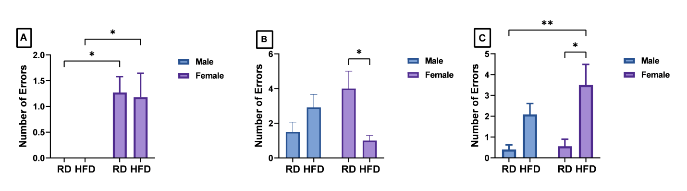
Figure S2. Sensitivity Analysis of RAWM Test.
Rat memory performance was assessed at (A) 30 min, (B) 5 h, and (C) 24 h post-training. Normality was assessed using the Shapiro–Wilk test and Q–Q plots. As all data were normally distributed, two-way ANOVA followed by Tukey’s multiple comparisons test was performed and revealed the following: (A) only sex (but not diet) has a significant effect (F _{(1, 39)} = 18.64, p = 0.0001). (B) Unlike male rat groups, HFDF rats made significantly lower errors than RDF rats (F _{(1, 39)} = 9.099, p = 0.0045). (C) HFD rats of both sexes committed significantly more errors than RD rats (F _{(1, 39)} = 12.38, p = 0.0011). RDM: regular diet male; RDF: regular diet female; HFDM: high-fat, high-fructose diet male; HFDF: high-fat, high-fructose diet female. Data represent mean ± SEM of N = 11–12 rats per group.

