Supplementary Information
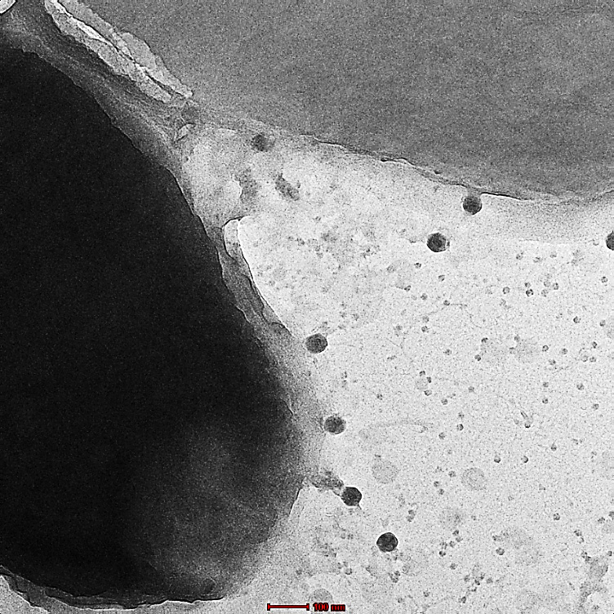
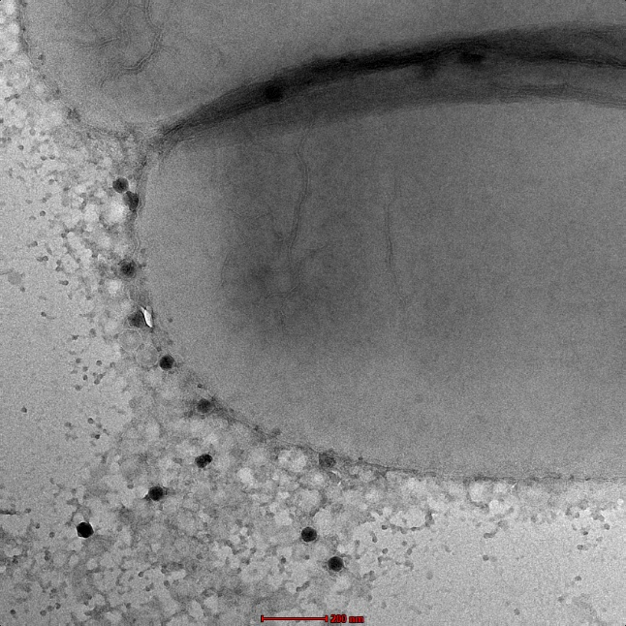
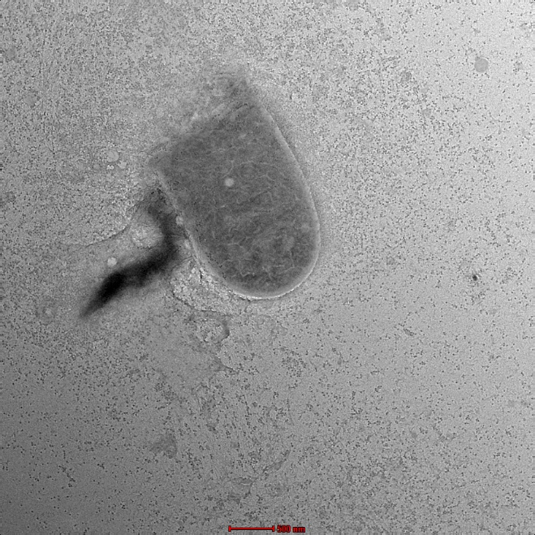
S1
S2
S3

Transmission electron microscopy of lysis event of phage SAKp26.2: S1 TEM image showing SAKp26.2 adsorption to the surface of host bacterial cells S2 and S3 TEM image showing SAKp26.2 infecting the host bacterial culture, followed by its lysis
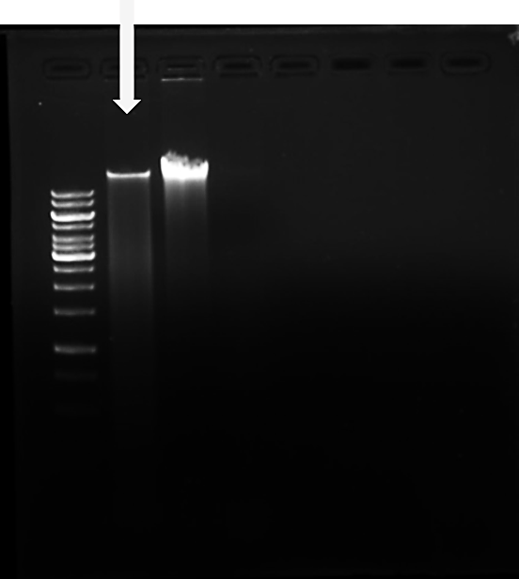
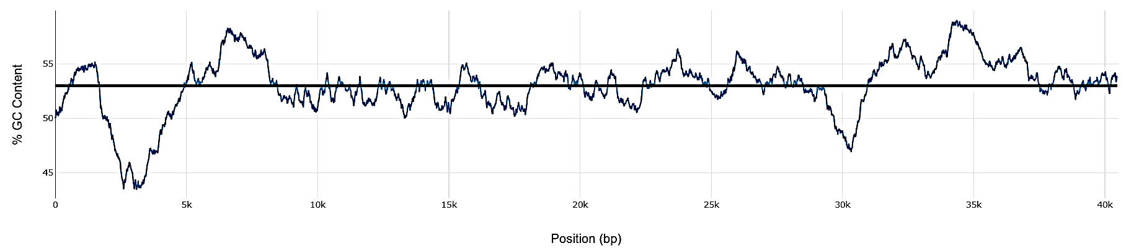
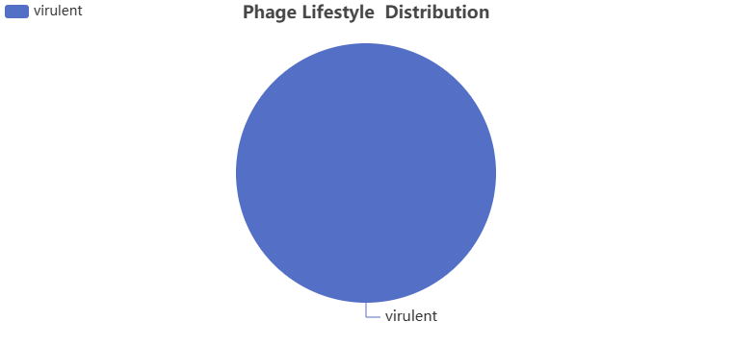
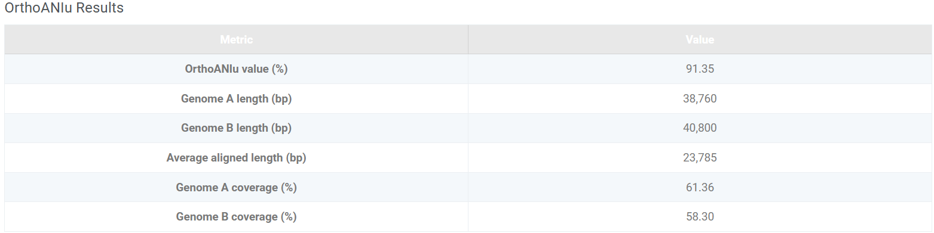
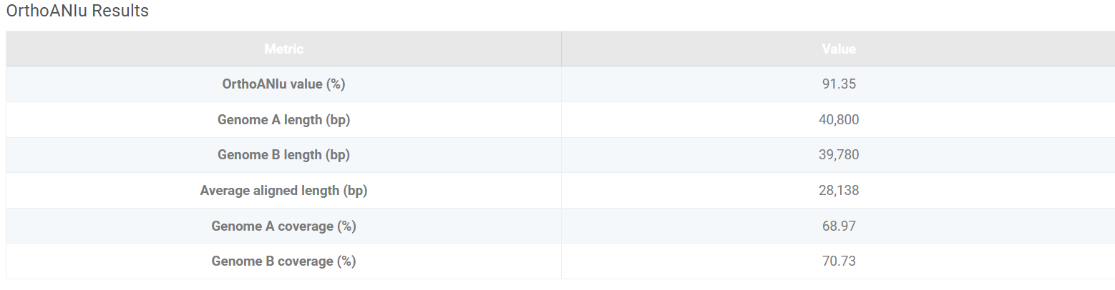
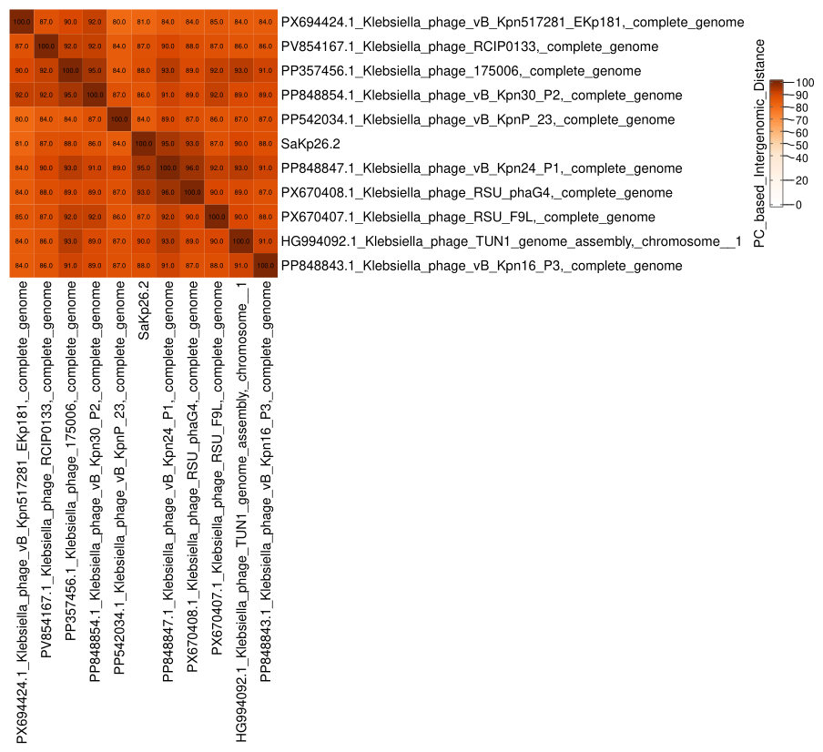
S4
S5
S6
S7
S8
S9

Genomic validation and comparative analyses of phage SAKp26.2. (S4) Agarose gel electrophoresis showing the isolated genomic DNA of phage SAKp26.2 appearing as a single high-molecular-weight band (~40 kb). (S5) GC content variation across the SAKp26.2 genome. (S6) Phage lifestyle prediction indicating a virulent (lytic) nature. (S7-S8) OrthoANIu analysis showing nucleotide identity between SAKp26.2 and closely related Klebsiella phages. (S9) Heatmap representing PC-based intergenomic distance among SAKp26.2 and related phages, supporting its classification as a novel member of the family Autographiviridae.
S11
S10
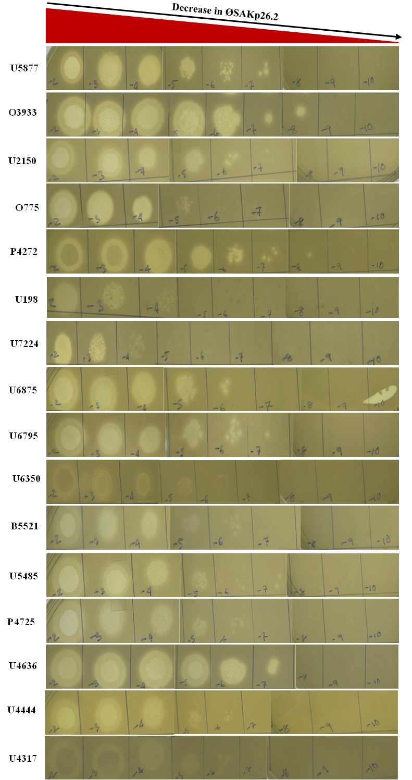

S12

S13

(S10) Spot assay of SAKp26.2 on the lawn of 16 clinical isolates of K. pneumoniae: Lytic activity of bacteriophage SAKp26.2 was observed at varying phage dilutions. Plaque formation was detected up to 10⁻⁷ dilution for U5877, U2150, U6795, U5485, and U4636; up to 10⁻⁸ for O3933, P4272, and U198; up to 10⁻⁶ for U6875, B5521, P4725, and U4444; up to 10⁻⁵ for O775; and up to 10⁻⁴ for U7224. Inefficient infection was observed in U6350 up to 10⁻⁵ dilution and in U4317 up to 10⁻⁷ dilution.
To determine the reference host; SAKp26.2 was amplified in three different bacterial strains. (S11) SAKp26.2 was amplified in O3933, and a small-drop plaque assay was performed using the purified phage on O3933, P4725, and U5877. (S12) SAKp26.2 was amplified in P4725, followed by a small-drop plaque assay with the purified phage on O3933, P4725, and U5877. (S13) SAKp26.2 was amplified in U5877, and the purified phage was subsequently tested by small-drop plaque assay on O3933, P4725, and U5877. Phage titers were calculated based on the number of plaques formed, and the corresponding graphs were plotted accordingly.

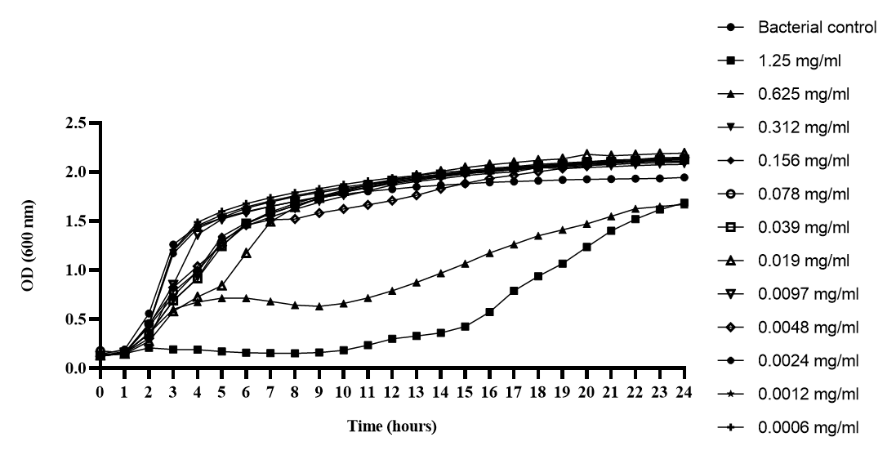
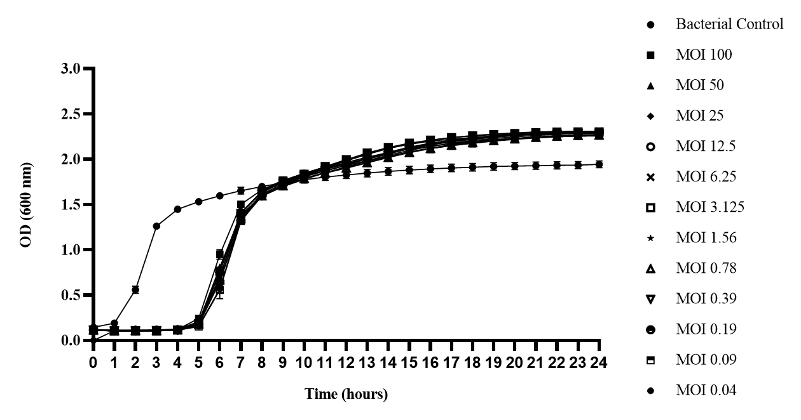
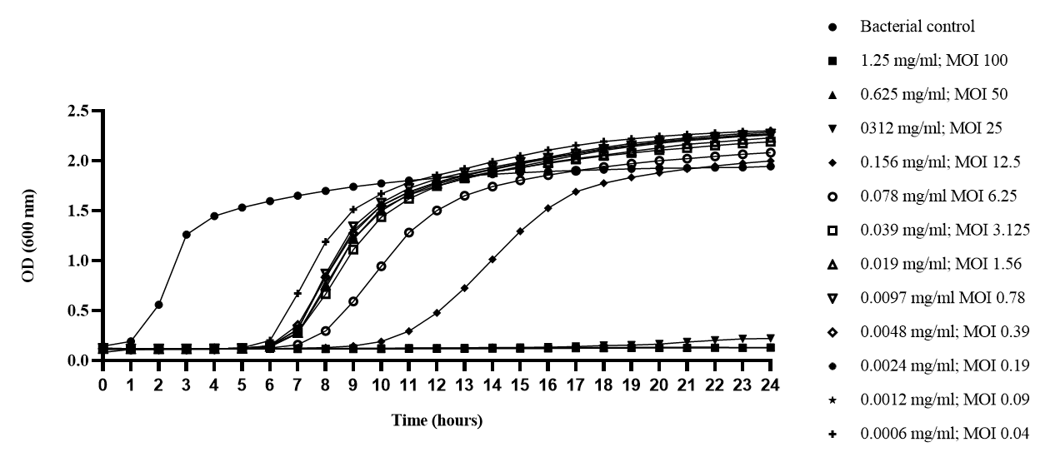
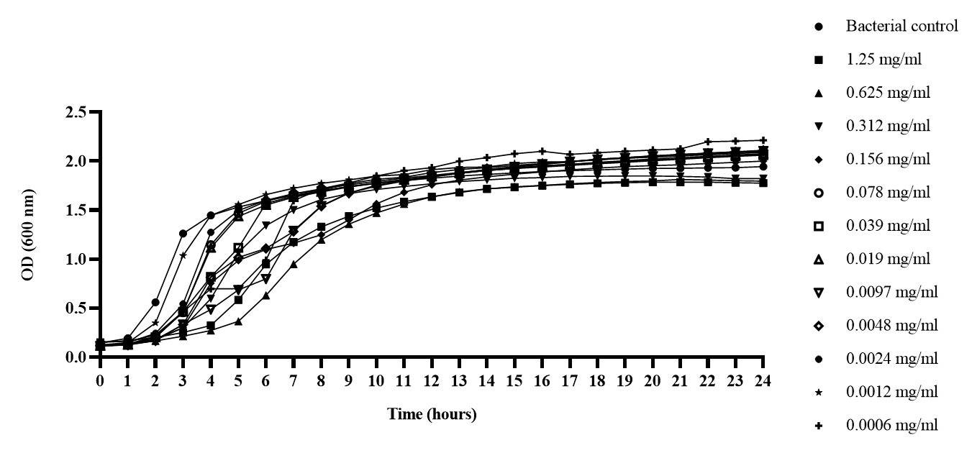
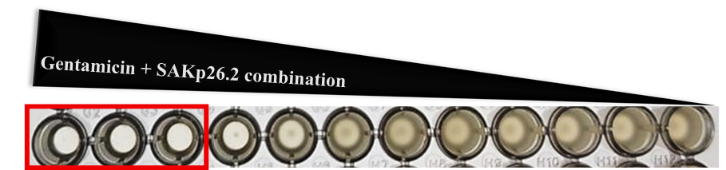
Ceftazidime
S14
Phage
S15
S18
Phage + Gentamicin
S17
Gentamicin
S19
S16
Phage +Ceftazidime

Phage antibiotic combination: (S14) Kill-kinetics curve of bacterial host upon ceftazidime treatment at different concentrations (S15) Kill-kinetics curve of bacterial host upon phage-only treatment at different MOIs (S15) Kill-kinetics curve of bacterial host upon ceftazidime-phage combination treatment (S16) Kill-kinetics curve of bacterial host upon gentamicin treatment (S17) Kill-kinetics curve of bacterial host upon gentamicin-phage combination treatment (S18) Visual representation of bacterial growth in the gentamicin-SAKp26.2 combination assay.

CDS | Start | Stop | Length | Strand | Protein
1 | 1 | 258 | 257 | + | Phage terminase small subunit
2 | 355 | 804 | 449 | + | Phage Rz-like lysis protein
3 | 797 | 2554 | 1757 | + | Phage terminase large subunit
4 | 4089 | 4556 | 467 | + | Phage S-adenosyl-L-methionine hydrolase
5 | 5129 | 6235 | 1106 | + | Phage serine/threonine kinase
6 | 6305 | 9025 | 2720 | + | Phage DNA-directed RNA polymerase
7 | 9309 | 9485 | 176 | + | hypothetical protein
8 | 9489 | 9605 | 116 | + | hypothetical protein
9 | 9586 | 9879 | 293 | + | hypothetical protein
10 | 10098 | 10211 | 113 | + | hypothetical protein
11 | 10312 | 11376 | 1064 | + | Phage-associated ATP-dependent DNA ligase
12 | 11576 | 11839 | 263 | + | hypothetical protein
13 | 11832 | 12257 | 425 | + | Phage nucleotide kinase
14 | 12250 | 12387 | 137 | + | hypothetical protein
15 | 12374 | 12499 | 125 | + | hypothetical protein
16 | 12465 | 12629 | 164 | + | hypothetical protein
17 | 12696 | 13394 | 698 | + | Phage single-stranded DNA-binding protein
18 | 13391 | 13834 | 443 | + | Phage HNH homing endonuclease
19 | 13807 | 14256 | 449 | + | Phage endonuclease I
20 | 14344 | 14805 | 461 | + | Phage endolysin
21 | 14954 | 15073 | 119 | + | hypothetical protein
22 | 15070 | 15435 | 365 | + | hypothetical protein
23 | 15410 | 17128 | 1718 | + | Phage primase/helicase protein
24 | 17200 | 17415 | 215 | + | hypothetical protein
25 | 17416 | 17595 | 179 | + | hypothetical protein
26 | 17608 | 17919 | 311 | + | hypothetical protein
27 | 17992 | 18378 | 386 | + | hypothetical protein
28 | 18395 | 20521 | 2126 | + | Phage DNA-directed DNA polymerase
29 | 20540 | 20827 | 287 | + | hypothetical protein
30 | 20824 | 21033 | 209 | + | hypothetical protein
31 | 21030 | 21314 | 284 | + | hypothetical protein
32 | 21307 | 22212 | 905 | + | Phage exonuclease
33 | 22194 | 22301 | 107 | + | hypothetical protein
34 | 22390 | 22635 | 245 | + | hypothetical protein
35 | 22638 | 22859 | 221 | + | Phage virion protein
36 | 22861 | 23121 | 260 | + | Phage virion assembly protein
37 | 23145 | 24752 | 1607 | + | Phage collar, head-to-tail connector protein
38 | 24856 | 25812 | 956 | + | Phage capsid assembly scaffolding protein
39 | 25954 | 26985 | 1031 | + | Phage major capsid protein
40 | 27042 | 27263 | 221 | + | hypothetical protein
41 | 27329 | 27907 | 578 | + | Phage non-contractile tail tubular protein
42 | 27930 | 30305 | 2375 | + | Phage non-contractile tail tubular protein
43 | 30378 | 30791 | 413 | + | Phage scaffold protein
44 | 30788 | 31174 | 386 | + | Putative integration and excision endonuclease VII
45 | 31179 | 31769 | 590 | + | Phage DNA ejectosome component, internal virion protein
46 | 31769 | 34024 | 2255 | + | Phage DNA ejectosome component, internal virion protein
47 | 34041 | 38006 | 3965 | + | Phage DNA ejectosome component, peptidoglycan lytic exotransglycosylase
48 | 38070 | 41123 | 3053 | + | tail fibers protein
49 | 41134 | 41292 | 158 | + | Phage holin, class II
50 | 41261 | 41434 | 173 | + | Phage holin, class II
Supplementary Table 1: Genome annotation of SAKp26.2

