Therapeutic Potential of a Novel Spirocyclic Molecule in a Murine Model of Peripheral Nerve Injury Mediated via Anti-inflammatory and Neuroprotective Properties

Soumya Ghosh^{1,4}, Papia Basuthakur^{1,4}, Vincy Vijay^{1,4}, Joachyutharayalu Oja^{2,4},Ramesh Samineni², Debiprasad Sinha^{1,4}, PratisthaWadnerkar³, Srihari Pabbaraja^{2,4}, Goverdhan Mehta⁵, Arvind Kumar³, Sumana Chakravarty^{1,4*}

¹AppliedBiology, CSIR-Indian Institute of Chemical Technology, Tarnaka, Uppal Road, Hyderabad 500007, India.
²Organic Synthesis & Process Chemistry, CSIR-Indian Institute of Chemical Technology, Tarnaka, Uppal Road, Hyderabad 500007, India.
³CSIR-Centre for Cellular and Molecular Biology, Habsiguda, Uppal Road, Hyderabad 500007, India.
⁴Academy of Scientific & Innovative Research (AcSIR), Ghaziabad, India
⁵School of Chemistry, University of Hyderabad, Hyderabad, India

* Corresponding Author:
Dr. Sumana Chakravarty
Applied Biology, CSIR- Indian Institute of Chemical Technology (IICT),
Tarnaka, Hyderabad- 500 007 (TG)
Email: sumanachak@csiriict.in; sumana98@gmail.com,
Phone: +91 040 27193155

Running Title: Therapeutic potential of IM-1725-RS-109a in PNI.

Key words: Sciatic nerve injury, Crush force model, Motor function, Gastrocnemius muscle, Dentate gyrus, Neurogenesis.

1. Reason for Strain Switch:
Self-mutilation or autotomy after nerve injury is well documented in rodent models, particularly in mice and rats. It is often considered a maladaptive behavioral expression of spontaneous neuropathic pain in a denervated limb, shaped by lesion pattern, peripheral and central sensitization, and genetic and immune factors. Neurological phenomena like neuropathic pain, anaesthesia dolorosa, and peripheral neuropathic and DRG mechanisms are often attributed to cause autotomy in rodents (1, 2).
Because our experiment focused on accidental injuries, we initially selected the CD1 mouse strain. However, these mice exhibited severe self-mutilation and complete limb autotomy after injury. Consequently, we switched to the C57Bl/6 strain, known for its high resistance to self-mutilation among inbred strains (3).
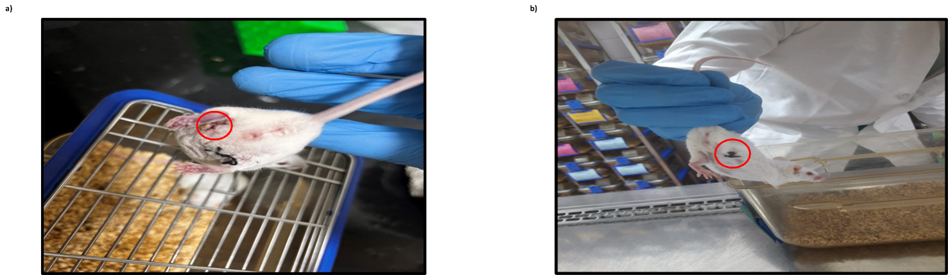
Supplementary Figure 1: The figure shows self-mutilation in the CD1 strain (a) and complete limb autotomy 4 days post injury (b).
2. Comparison of Half-Dose of Enantiopure with Racemate:
To further assess the efficacy of our enantiopure in treating peripheral nervous system injury, we have compared a half dose (2.5 mg/kg of B.W.) of our enantiopure (IM-1725-RS-109a) with the regular dose (5 mg/kg of B.W.) of our racemate (IM-1725-RS-109). We have implemented behavioral paradigms to assess the impact of our compound on motor coordination and motor activity. We have also used qRT-PCR to evaluate the neurogenic properties of our enantiopure at half the dose.
2.1 Experimental Design:
C57Bl/6 mouse was used for the experiment, and the animals were divided into three groups, namely (i) SNI, (ii) SNI+Peak A (2.5mg/kg), and (iii) SNI+RM (5mg/kg). The surgical procedure was performed as described in the manuscript (Materials and Methods section). The treatment was administered intraperitoneally (ip), and Phosphate-buffered saline (PBS) was used as the vehicle.

2.2 Behavioral Paradigms:
To assess the effectiveness of our compound in alleviating locomotory deficits, we have employed the Open Field Test (OFT) and the Rotarod Performance Test. We observed that subjects receiving the enantiopure (SNI+PeakA) at half-dose performed significantly better than the vehicle (SNI) group. Their performance was also comparable to that of mice that received the standard dose of the racemate (SNI+RM).

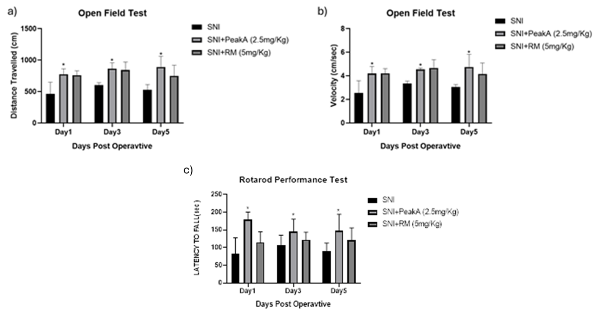

Supplementary Figure 2: This figure shows performance across all three groups in the open field test, distance travelled (a), velocity (b), and the rotarod performance test (c). Analysis was performed using one-way ANOVA, and a p-value < 0.05 was considered statistically significant.

2.3 Quantitative Real-Time PCR:
To assess the neurogenic capacity of our enantiopure, IM-1725-RS-109a, we used qRT-PCR to analyze the expression of neurogenic markers like SOX2 and DCX (doublecortin) in the dentate gyrus of the hippocampus (the neurogenic niche of the adult brain). We observed that the group receiving the enantiopure at half-dose (Peak A+SNI) showed significant upregulation of neurogenic markers compared with the vehicle group (SNI).

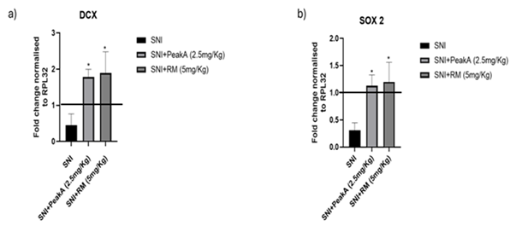
Supplementary Figure 3: This figure shows the assessment of neurogenic markers across all the groups. A line indicates the normalised upregulation value. Analysis was performed using one-way ANOVA, and a p-value < 0.05 was considered statistically significant.
3. References:
1. Minert A, Gabay E, Dominguez C, Wiesenfeld-Hallin Z, Devor M. Spontaneous pain following spinal nerve injury in mice. Experimental neurology. 2007 Aug 1;206(2):220-30.
2. Cao B, Xu Q, Shi Y, Zhao R, Li H, Zheng J, Liu F, Wan Y, Wei B. Pathology of pain and its implications for therapeutic interventions. Signal transduction and targeted therapy. 2024 Jun 8;9(1):155.
3. Rubinstein RE, Deem KC, Jensen J, MacKinnon SE, Tung TH. Strain differences in autotomy in mice after peripheral nerve transection or repair. Microsurgery. 2003;23(4):363-8.

4. Primers Utilised in qRT-PCR:
Primer | Forward | Reverse
RPL32 | ATCAGGCACCAGTCAGACCGAT | GTTGCTCCCATAACCGATGTTGG
SOX2 | AACGGCAGCTACAGCATGATGC | CGAGCTGGTCATGGAGTTGTAC
DCX | CTGACTCAGGTAACGACCAAGAC | TTCCAGGGCTTGTGGGTGTAGA
NESTIN | AGGAGAAGCAGGGTCTACAGAG | AGTTCTCAGCCTCCAGCAGAGT
BAX | AGGATGCGTCCACCAAGAAGCT | TCCGTGTCCACGTCAGCAATCA
BAD | GGGAGCAACATTCATCAGCAGG | CGTCCTCGAAAAGGGCTAAGCT

5: Uncropped Images of Blots Used in Representative Image of Western Blot:
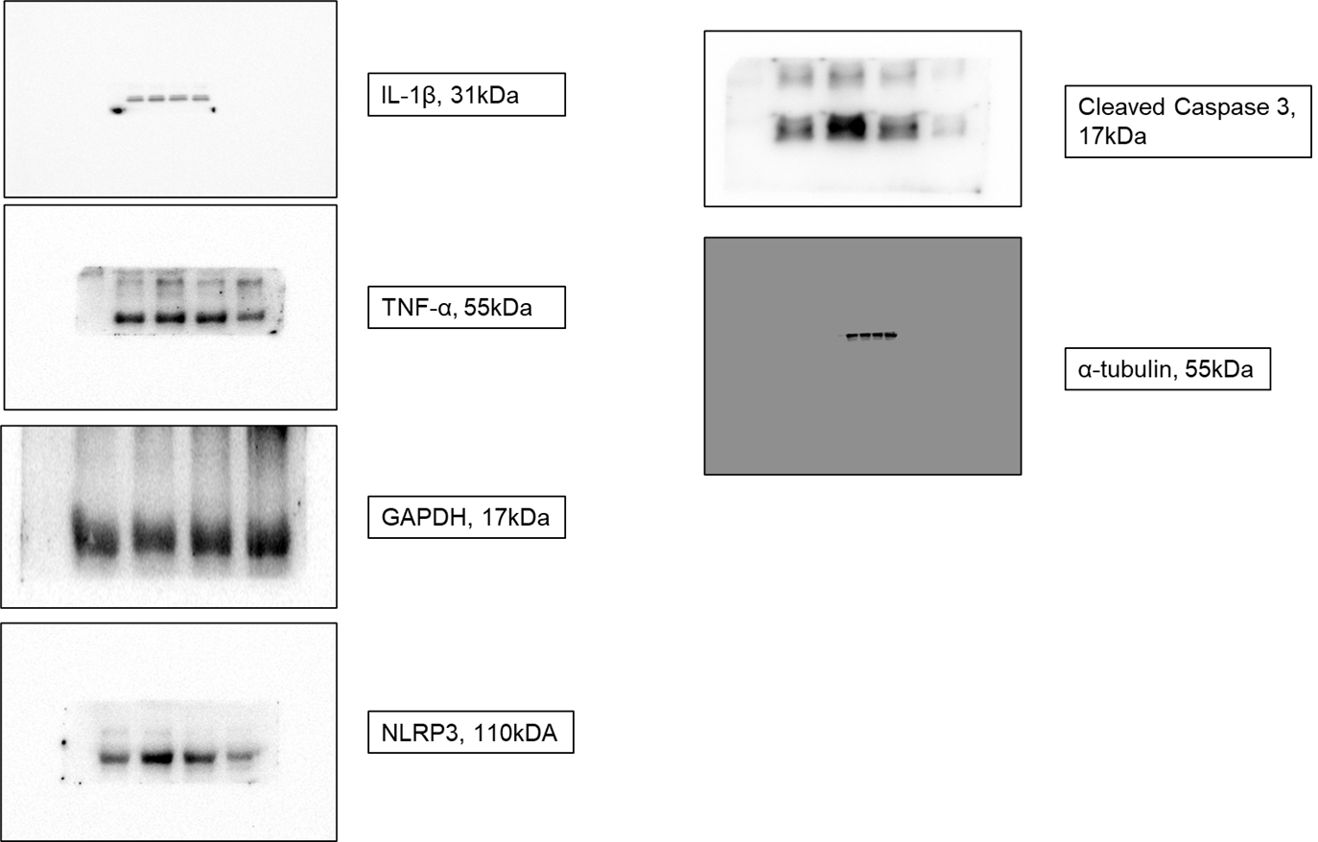
Supplementary Figure 4: This figure shows the uncropped version of the representative images used for immunoblotting under the section Results, Figure 9.

