Supplementary materials for:
Fagerholm N., Hällfors M., Heiskanen E., Kahilainen A., Heikkinen R.K., Aishwarya A., Christie M., Jaalama K., Khoirunisa R., Krohn C., Leikola, N. , Määttänen A.-M., Nielsen, J., Sobhani S., Vainio K.K., and Lechner A.M. Integrating ecological connectivity and place-based social values – towards multispecies valuation of urban green infrastructure.
Contents:
Tables 1–10
- Supplementary Table 1. Association of examined butterfly species in the produced butterfly archetypes.
- Supplementary Table 2. Differences between butterfly archetypes in various traits
- Supplementary Table 3. Differences between human groups in terms of sociodemographic variables and time spent in nature
- Supplementary Table 4. Relative share (%) of land use classes for each bivariate class combination and reference area.
- Supplementary Table 5. Resistance values for each butterfly archetype
- Supplementary Table 6. Parametrisation of habitat minimum patch size, maximum dispersal distance, and width of corridor applied in the connectivity models.
- Supplementary Table 7. Comparison of survey respondents to the population in the city of Tampere
- Supplementary Table 8. PPGIS survey statements for assessing respondents’ connection to nature
- Supplementary Table 9. PPGIS survey statements for assessing respondents perceived importance of nature’s diverse values
- Supplementary Table 10. Reclassification scheme for Urban Atlas data

Figures 1–12
- Supplementary Figure 1. Results of Gap statistic analysis
- Supplementary Figure 2. Bivariate spatial overlay
- Supplementary Figure 3. Analysis workflow for identifying ecological archetypes
- Supplementary Figure 4. Relationship between combined canopy metric and flying squirrel resistance values
- Supplementary Figure 5. Analysis workflow for identifying human groups
- Supplementary Figure 6. Results of the hierarchical clustering analysis
- Supplementary Figure 7. Results of the Silhouette analysis
- Supplementary Figure 8. Histogram of non-zero normalised values for each archetype connectivity layers
- Supplementary Figure 9. Histogram of non-zero normalised values for the five human groups
- Supplementary Figure 10. Spatial patterns for each archetype connectivity layer
- Supplementary Figure 11. Spatial patterns for each human group layer
- Supplementary Figure 12. Analysis workflow for bivariate spatial overlay

Texts 1–2
- Supplementary Text 1. Methodological consideration of the multispecies valuation of green infrastructure
- Supplementary Text 2. Construction of habitat data and parameter settings for Siberian flying squirrel connectivity analysis

Tables
Supplementary Table 1. Association of examined butterfly species in the produced butterfly archetypes.
 |  | Membership in different archetype clusters
Species | Author | DMB | MMB | FEB
Anthocharis cardamines | (Linnaeus, 1758) | x
Aphantopus hyperantus | (Linnaeus, 1758) | x
Araschnia levana | (Linnaeus, 1758) | x
Aricia artaxerxes | (Fabricius, 1793) | x
Aricia nicias | (Meigen, 1830) | x
Boloria selene | (Denis & Schiffermüller, 1775) | x
Brenthis ino | (Rottemburg, 1775) | x
Carterocephalus palaemon | (Pallas, 1771) | x
Carterocephalus silvicola | (Meigen, 1829) | x
Coenonympha glycerion | (Borkhausen, 1788) | x
Coenonympha pamphilus | (Linnaeus, 1758) | x
Cupido minimus | (Fuessly, 1775) | x
Cyaniris semiargus | (Rottemburg, 1775) | x |  | x
Eumedonia eumedon | (Esper, 1780) | x
Euphydryas aurinia | (Rottemburg, 1775) | x |  | x
Fabriciana adippe | (Denis & Schiffermüller, 1775) | x
Fabriciana niobe | (Linnaeus, 1758) | x
Glaucopsyche alexis | (Poda, 1761) | x
Hipparchia semele | (Linnaeus, 1758) | x
Issoria lathonia | (Linnaeus, 1758) | x
Lasiommata maera | (Linnaeus, 1758) | x |  | x
Leptidea sinapis | (Linnaeus, 1758) | x
Lycaena helle | (Denis & Schiffermüller, 1775) | x
Lycaena hippothoe | (Linnaeus, 1761) | x
Lycaena phlaeas | (Linnaeus, 1761) | x
Lycaena virgaureae | (Linnaeus, 1758) | x
Maniola jurtina | (Linnaeus, 1758) | x
Melitaea diamina | (Lang, 1789) | x
Ochlodes sylvanus | (Esper, 1777) | x
Pieris napi | (Linnaeus, 1758) | x
Polyommatus amandus | (Schneider, 1792) | x |  | x
Polyommatus icarus | (Rottemburg, 1775) | x |  | x
Pyrgus alveus | (Hübner, 1803) | x
Pyrgus malvae | (Linnaeus, 1758) | x
Scolitantides orion | (Pallas, 1771) | x
Speyeria aglaja | (Linnaeus, 1758) | x
Thymelicus lineola | (Ochsenheimer, 1808) | x
Aglais io | (Linnaeus, 1758) |  | x
Aglais urticae | (Linnaeus, 1758) |  | x
Apatura iris | (Linnaeus, 1758) |  | x | x
Argynnis paphia | (Linnaeus, 1758) |  | x
Celastrina argiolus | (Linnaeus, 1758) |  | x | x
Favonius quercus | (Linnaeus, 1758) |  | x
Gonepteryx rhamni | (Linnaeus, 1758) |  | x | x
Nymphalis antiopa | (Linnaeus, 1758) |  | x | x
Papilio machaon | Linnaeus, 1758 |  | x
Polygonia c-album | (Linnaeus, 1758) |  | x | x
Satyrium pruni | (Linnaeus, 1758) |  | x | x
Satyrium w-album | (Knoch, 1782) |  | x
Thecla betulae | (Linnaeus, 1758) |  | x | x
Aporia crataegi | (Linnaeus, 1758) |  |  | x
Boloria euphrosyne | (Linnaeus, 1758) |  |  | x
Callophrys rubi | (Linnaeus, 1758) |  |  | x
Euphydryas maturna | (Linnaeus, 1758) |  |  | x
Lasiommata petropolitana | (Fabricius, 1787) |  |  | x
Limenitis populi | (Linnaeus, 1758) |  |  | x
Lopinga achine | (Scopoli, 1763) |  |  | x
Pararge aegeria | (Linnaeus, 1758) |  |  | x
Plebejus argus | (Linnaeus, 1758) |  |  | x
Plebejus idas | (Linnaeus, 1761) |  |  | x

Supplementary Table 2. Trait difference across butterfly archetypes. Two-sided trait-level statistical significance was analysed using analysis of variance and statistical differences in representation of preferred environment types was analysed using a Pearson chi-square test of independence, followed up by chi-square or Fisher’s exact test (when expected counts were sparse) for each environment. All p-values are adjusted according to Benjamini–Hochberg procedure to control for false discovery rate, and statistically significant pairwise differences are indicated with asterisk (***=p<0.001, **= p<0.01, *=p<0.05, †=p<0.1). The direction of statistically significant pairwise differences are marked with + or – signs in braces.
 | Dispersal limited meadow butterflies, 51% (DMB; 37 sp.)   | Mobile meadow butterflies 18% (MMB; 13 sp.)   | Forest edge butterflies 31% (FEB; 22 sp.)  
Variables used in clustering
Moisture affinity  (F=3.286, df=2, p=0.065) | Mean=0.50, sd=0.70  Vs. MMB ns.  Vs. FEB ns. | Mean=0.46, sd=0.63  Vs. DMB ns.  Vs. FEB ns. | Mean=0.55, sd=0.49  Vs. DMB ns.  Vs. MMB ns.
Edge affinity  (F=1.009, df=2, p=0.403) | Mean=0.81, sd=0.43  Vs. MMB ns.  Vs. FEB ns. | Mean=0.61, sd=0.46  Vs. DMB ns.,  Vs. FEB ns. | Mean=0.72, sd=0.43  Vs. DMB ns.  Vs. MMB ns.
Host plant index, HSI  (F=1.498, df=2, p=0.277) | Mean=0.25, sd=0.18  Vs. MMB ns.  Vs. FEB ns. | Mean=0.21, sd=0.19  Vs. DMB ns.  Vs. FEB ns. | Mean=0.17, sd=0.15  Vs. DMB ns.  Vs. MMB ns.
Habitat breadth  (F=1.846, df=2, p=0.221) | Mean=1.78, sd=0.89  Vs. MMB ns.  Vs. FEB ns. | Mean=2.31, sd=0.85  Vs. DMB ns.  Vs. FEB ns. | Mean=1.82, sd=0.85  Vs. DMB ns.  Vs. MMB ns.
Mobility score  (F=3.286, df=2, p=0.065) | Mean=5.02, sd=1.60  Vs. MMB† (-)  Vs. FEB† (-) | Mean=6.23, sd=2.30  Vs. DMB† (+)  Vs. FEB ns. | Mean=5.95, sd=1.59  Vs. DMB† (+)  Vs. MMB ns.
Flight period (days)  (F=4.738, df=2, p=0.026) | Mean=28.48, sd=6.37  Vs. MMB** (-)  Vs. FEB ns. | Mean=54.01, sd=37.35  Vs. DMB** (+)  Vs. FEB ns. | Mean=37.78, sd=25.27  Vs. DMB ns.  Vs. MMB ns.
Affinity to canopy  (F=1.846, df=2, p=0.026) | Mean=-0.35, sd=0.26  Vs. MMB* (-)  Vs. FEB† (-) | Mean=-0.11, sd=0.30  Vs. DMB* (+)  Vs. FEB ns. | Mean=-0.20, sd=0.25  Vs. DMB† (+)  Vs. MMB ns.
Basking site height  (F=6.189, df=2, p=0.008) | Mean=0.74, sd=0.24  Vs. MMB** (-)  Vs. FEB ns. | Mean=1.13, sd=0.41  Vs. DMB** (+)  Vs. FEB** (+) | Mean=0.77, sd=0.47  Vs. DMB ns.  Vs. MMB** (-)
Wing Index, WIn  (F=7.326, df=2, p=0.004) | Mean=0.98, sd=0.03  Vs. MMB** (-)  Vs. FEB* (-) | Mean=1.04, sd=0.06  Vs. DMB** (+)  Vs. FEB ns. | Mean=1.01, sd=0.05  Vs. DMB* (+)  Vs. MMB ns.
Overwintering location height  (F=16.350, df=2, p<0.001) | Mean=2.08, sd=0.74  Vs. MMB*** (-)  Vs. FEB* (-) | Mean=4.00, sd=0.96  Vs. DMB*** (+)  Vs. FEB*** (+) | Mean=2.66, sd=1.45  Vs. DMB ns.  Vs. MMB** (-)
Egg laying vegetation height  (F=17.286, df=2, p<0.001) | Mean=0.79, sd=0.23  Vs. MMB*** (-)  Vs. FEB** (-) | Mean=1.39, sd=0.28  Vs. DMB*** (+)  Vs. FEB** (+) | Mean=1.04, sd=0.46  Vs. DMB* (+)  Vs. MMB** (-)
Larval vegetation height  (F=24.992, df=2, p<0.001) | Mean=0.55, sd=0.19  Vs. MMB*** (-)  Vs. FEB*** (-) | Mean=1.26, sd=0.41  Vs. DMB*** (+)  Vs. FEB* (+) | Mean=0.96, sd=0.46  Vs. DMB*** (+)  vs. MMB* (-)
Over-representation of environment types in the habitats of the species  [not used in clustering;  χ² (58) = 117.15, p<0.001] | Seminatural dry meadows***,  Seminatural mesic meadows** | Parks, yards and gardens*** | No statistically significant overrepresentation in any environment type

Supplementary Table 3. The relative shares (%) and statistically significant associations between human groups and socio-demographic variables and time spent in nature, as determined by cross-tabulation and the Chi-square test. The bolded values indicate results that remained significant after Bonferroni correction. NNC=Not nature-oriented car drivers, EIP=Elderly indoor people, ANF=Active nature-oriented females, NNM=Not nature-oriented men, and NOC=Nature-oriented cyclists.
 | Not nature-oriented car drivers (NNC)   | Elderly indoor people (EIP)   | Active nature-oriented females (ANF)   | Not nature-oriented men (NNM)   | Nature-oriented cyclists (NOC)  
Gender % (χ² (8) = 52.245,
p < 0.001, V = 0.146)
Female | *42.7% | 56.4% | ***64.7% | ***39.3% | 52.3%
Male | 52.4% | 42.8% | ***31.6% | ***59.6% | 46.6%
NA | *4.9% | 0.8% | **3.7% | 1.1% | 1.1%
Age group % (χ² (24) = 62.477,
p < 0.001, V = 0.113)
15–19 | 8.5% | 4.6% | 4.0% | 7.3% | 3.6%
20–29 | 12.2% | 20.5% | 16.1% | **27.9% | 18.8%
30–39 | 22.0% | 16.2% | 21.1% | 15.1% | 16.3%
40–49 | 15.9% | ***8.1% | 16.5% | 14.5% | *18.5%
50–59 | 14.6% | 15.7% | 11.8% | 11.7% | 15.6%
60–69 | 22.0% | 16.8% | 19.6% | 12.8% | 19.2%
>70 | *4.9% | ***18.1% | 10.9% | 10.6% | *8.0%
Education level (χ² (28) = 31.863,
p = 0.280, V = 0.080)
Compulsory school | 8.5% | 6.2% | 7.1% | 6.7% | 4.3%
High school | 13.4% | 13% | 11.5% | 17.3% | 14.8%
Community college | 6.1% | 8.4% | 9.9% | 7.3% | 5.4%
Vocational education | 19.5% | 14.6% | 16.1% | 12.3% | 13%
Lower academic degree | 22% | 28.9% | 29.4% | *20.7% | 27.1%
Higher academic degree | 20.7% | 23.8% | 22.6% | 26.8% | 29.2%
Doctoral degree | 6.1% | 3% | *1.9% | 6.1% | 4.3%
Other | 3.7% | 2.2% | 1.5% | 2.8% | 1.8%
Income level (χ² (24) = 30.013,
p = 0.184, V = 0.080)
Less than 1,500 Euros | 17.1% | 15.1% | 18.9% | 18.5% | *10.9%
1,500 – 1,999 Euros | 6.6% | 10.6% | 13.1% | 10.1% | 7.8%
2,000 – 3,999 Euros | 28.9% | 33.1% | 33% | 31.5% | 35.3%
4,000 – 5,999 Euros | 26.3% | 26.6% | 24.4% | 23.8% | 29.1%
6,000 – 7,999 Euros | 13.2% | 9.7% | 8.3% | 10.1% | 13.2%
8000-11,999 Euros | *7.9% | 3.4% | *1.3% | 4.8% | 2.7%
12,000 euros or more | 0% | 1.4% | 1% | 1.2% | 1.2%
Time spent in nature (χ² (16) = 104.123,
p = < 0.001, V = 0.146)
Less than 0.5 hours | ***24.4% | 5.8% | **3.4% | ***12.9% | ***1.5%
0.5-1 hour | 36.6% | **43.6% | 31% | 38.8% | 33.9%
1-2 hours | 28.0% | 34.2% | 39.8% | 31.5% | *42.7%
2-3 hours | **2.4% | 10.6% | 13.8% | 12.9% | 14.6%
More than 3 hours | 8.5% | 5.8% | ***11.9% | 3.9% | 7.3%
Post hoc test significance levels:
p<0.05 *. p<0.01 **. p<0.001 ***. based on adjusted residual values (>1.96. >2.58. >3.29).

Supplementary Table 4. Relative share (%) of land use classes for each bivariate class combination and reference area. The reference area represents the spatial union of all moderate and high social and ecological values.
Urban Atlas land use classes | Mod eco - Mod soc | Mod eco - High soc | High eco - Mod soc | High eco - High soc | Reference area
Forest | 24.0 % | 19.4 % | 66.3 % | 59.1 % | 31.6 %
Green urban areas | 36.7 % | 55.5 % | 18.1 % | 26.5 % | 14.3 %
Semi-natural areas | 0.6 % | 0.4 % | 0.6 % | 0.3 % | 0.5 %
Agricultural areas | 1.3 % | 0.6 % | 1.5 % | 0.4 % | 1.2 %
Water | 2.2 % | 2.9 % | 1.9 % | 3.8 % | 12.8 %
Sports and leisure facilities | 1.9 % | 1.7 % | 1.4 % | 1.5 % | 2.1 %
Housing areas | 22.4 % | 11.4 % | 5.9 % | 3.6 % | 23.1 %
Other artificial surfaces | 11.0 % | 8.1 % | 4.2 % | 4.7 % | 14.4 %

Supplementary Table 5. The resistance values used in the three resistance layers for the butterfly archetypes were developed separately for the two meadow butterfly and one forest edge butterfly archetypes, based on the overall land and water cover data layers merged from three sources of spatial data: RAMS-greenspace vector data for Tampere urban area (https://data.tampere.fi/data/en_GB/dataset/tampereen-asemakaavoitettujen-puistojen-ja-suojaviheralueiden-osat), 2-m resolution dataset on the land cover of the built environment in Finland (Built-up Land 2021, compiled by Syke; https://ckan.ymparisto.fi/dataset/%7B65547587-2DBA-4328-9A4E-0FAEBEA4990F%7D), and 20-m resolution Corine CLC2018 grid data (https://ckan.ymparisto.fi/dataset/%7B0B4B2FAC-ADF1-43A1-A829-70F02BF0C0E5%7D). The table shows both the RAMS classes considered as suitable key habitat for the archetypes, and the expert-opinion-based resistance values assigned to indicate the relative difficulty of species movements through different land and water cover types for each archetype. For the connectivity analysis, both the data layers including the key habitat patches for the butterfly archetypes as well as the different non-habitat land cover and water cover types in the matrix areas were resampled into a systematic 2 x 2 m grid. All the 2-m grid cells in the matrix area outside the habitat patch network were assigned a certain resistance value, following the grading of the unsuitable RAMS-greenspace classes, 22 land cover types in the built environment data, and the 48 CLC2018 land / water cover classes.
Land / water cover type | Resistance value for each archetype
Land / water cover type | Dispersal-limited meadow butterflies | Mobile meadow butterflies | Forest-edge butterflies
RAMS greenspace classes
Value meadow (A1) | Habitat | Habitat | 1
Recreational meadow (A2) | 1.5 | 1.5 | 1.5
Landscape meadow (A3) | Habitat | Habitat | 1
Open area (A4) | 1.5 | Habitat | 1
Landscape field (A5) | 1.5 | Habitat | 1.5
Value forest (M1) | 4 | 3 | 2*
Local forest (M2) | 3 | 2 | 2*
Outdoor and recreational forest (M3) | 5 | 5 | 2*
Protective forest (M4) | 3 | 2 | 1.5*
Commercial forest (M5) | 5 | 5 | 2.5*
High-class green area (R1) | 1.5 | 1,5 | 2.5
Functional green area (R2) | 1.5 | 3 | 4
Recreational green area (R3) | 3 | 2 | 2.5
Protective and transitional green area (R4) | 1 | 1 | 1.5
Built-up land 2021 data (SYKE)
Apartment building areas (class no 1) | 10 | 10 | 15
Detached / small house areas (2) | 3 | 2 | 2.5
Service building areas (3) | 4 | 4 | 5
Industrial building areas (4) | 10 | 10 | 15
Holiday housing areas (5) | 3 | 2 | 2.5
Sports and recreation building areas (6) | 5 | 5 | 5
Agricultural building areas (7) | 3 | 2 | 2.5
Other building areas (8) | 5 | 5 | 5
Transport areas (9) | 10 | 10 | 15
Port areas (10) | 10 | 10 | 15
Airport areas (11) | 1.5 | 1.5 | 2.5
Power line areas (12) | 1.5 | 1.5 | 2.5
Mineral extraction areas and landfills (13) | 5 | 5 | 15
Sports and recreation areas (14) | 3 | 2 | 2.5
Parks (15) | 1.5 | 2.5 | 1.5
Cemeteries (16) | 2.5 | 2.5 | 2.5
Allotment garden areas (17) | 1.5 | 1.5 | 1.5
Wind farm areas (18) | 5 | 5 | 5
Storage areas (19) | 7.5 | 7.5 | 10
Construction sites (20) | 10 | 10 | 15
Other open built-up areas in urban zones (21) | 5 | 5 | 10
Green areas near buildings in urban zones (22) | 2.5 | 2.5 | 4
Corine CLC2018 classes
Continuous urban fabric (CLC code 1.1.1) | 10 | 10 | 15
Discontinuous urban fabric (CLC 1.1.2) | 3 | 2 | 2.5
Commercial units (CLC 1.2.1.1) | 4 | 4 | 5
Industrial areas (CLC 1.2.1.2) | 10 | 10 | 15
Road and rail networks and associated land (CLC 1.2.2) | 10 | 10 | 15
Port areas (CLC 1.2.3) | 10 | 10 | 15
Airports (CLC 1.2.4) | 1.5 | 1.5 | 2.5
Mineral extraction sites (CLC 1.3.1.1) | 5 | 5 | 10
Open cast mines (CLC 1.3.1.2) | 10 | 10 | 20
Dump sites (CLC 1.3.2) | 10 | 10 | 15
Construction sites (CLC 1.3.3) | 3 | 2 | 15
Green urban areas (CLC 1.4.1) | 1.5 | 2.5 | 1.5
Summer cottages (CLC 1.4.2) | 3 | 2 | 2.5
Sport and leisure areas (CLC 1.4.2.2) | 3 | 2 | 2.5
Golf courses (CLC 1.4.2.3) | 3 | 3 | 4
Racecourses (CLC 1.4.2.4) | 3 | 3 | 4
Non-irrigated arable land (CLC 2.1.1) | 3 | 3 | 4
Fruit trees and berry plantations (CLC 2.2.2.1) | 2 | 1.5 | 1.5
Pastures (CLC 2.3.1.1) | 1.5 | 2 | 1.5
Natural pastures (CLC 2.3.1.2) | 1 | 1 | 1.5
Arable land outside farming subsidies (CLC 2.4.3.1) | 2.5 | 2.5 | 2.5
Agro-forestry areas (CLC 2.4.4.1) | 2.5 | 2.5 | 1.5
Broad-leaved forest on mineral soil (CLC 3.1.1.1) | 3 | 2 | 1*
Broad-leaved forest on peatland (CLC 3.1.1.2) | 5 | 5 | 2.5*
Coniferous forest on mineral soil (CLC 3.1.2.1) | 5 | 5 | 2.5*
Coniferous forest on peatland (CLC 3.1.2.2) | 7.5 | 7.5 | 4*
Coniferous forest on rocky soil (CLC 3.1.2.3) | 4 | 7.5 | 2.5*
Mixed forest on mineral soil (CLC 3.1.3.1) | 4 | 3 | 1*
Mixed forest on peatland (CLC 3.1.3.2) | 5 | 5 | 2.5*
Mixed forest on rocky soil (CLC 3.1.3.3) | 3 | 5 | 2.5*
Natural grassland (CLC 3.2.1.1 ) | 0.5 | 0.5 | 1
Moors and heathland (CLC 3.2.2.1) | 1.5 | 1.5 | 2.5
Transitional woodland/shrub cc <10% (CLC 3.2.4.1) | 2.5 | 2.5 | 1.5
Transitional woodland/shrub, cc 10-30%, on mineral soil (CLC 3.2.4.2) | 5 | 4 | 1.5
Transitional woodland/shrub, cc 10-30%, on peatland (CLC 3.2.4.3) | 7.5 | 7.5 | 2.5
Transitional woodland/shrub, cc 10-30%, on rocky soil (CLC 3.2.4.4) | 4 | 5 | 1.5
Transitional woodland/shrub under power lines (CLC 3.2.4.6) | 1.5 | 1.5 | 1.5
Beaches, dunes, and sand plains (CLC 3.3.1.1) | 1.5 | 2.5 | 2.5
Bare rock (CLC 3.3.2.1) | 1.5 | 2.5 | 2.5
Sparsely vegetated areas (CLC 3.3.3.1) | 2 | 2 | 2.5
Inland marshes, terrestrial (CLC 4.1.1.1) | 4 | 4 | 4
Inland marshes, aquatic (CLC 4.1.1.2) | 5 | 5 | 5
Peatbogs (CLC 4.1.2.1) | 2.5 | 2.5 | 2.5
Peat production sites (CLC 4.1.2.2) | 10 | 10 | 10
Salt marshes, terrestrial (CLC 4.2.1.1) | 2.5 | 2.5 | 2.5
Salt marshes, aquatic (CLC 4.2.1.2) | 5 | 5 | 5
Water courses (CLC 5.1.1.1) | 10 | 10 | 10
Water bodies (CLC 5.1.2.1) | 50 | 50 | 50
* The 10 m buffer established from the forest edge inwards to the interior forest area was included in the habitat layer, the other areas of this RAMS or CLC type into the resistance layer as ranked in the table
Supplementary Table 6. Parametrisation of habitat minimum patch size, maximum dispersal distance, and width of corridor applied in the connectivity models. Please note that a smaller minimum patch size was used for the Flying squirrel for known and highly likely breeding forests in the Tampere urban area (see Section 4.3.1.3).
Archetype | Minumum patch size | Dispersal distance | Corridor width
Dispersal-limited meadow butterflies | 0.2 | 1 km | 20 m
Mobile meadow butterflies | 0.2 | 5 km | 20 m
Forest edge butterflies | 0.2 | 2.5 km | 20 m
Flying squirrel | 4 ha | 2 km | 50 m

Supplementary Table 7. Comparison of survey respondents (n = 1,299) to the population in the city of Tampere (255,050 inhabitants). Bolded values indicate over-/under-representation (threshold of ±5%). Respondents aged 65–74 (+14.9% compared to population) and those with post-secondary non-tertiary (+7.0%) or tertiary education (+22.7%) are overrepresented. In contrast, respondents aged 15–24 (–6.4%) and 25–44 (–11.8%), and those whose highest degree was basic (–13.2%) or upper secondary education (–11.3%) are underrepresented.
Variables | Survey respondents | Tampere population^{a,b}
Gender % (n*=1295)
Female | 54.2 | 51.5
Male | 43.9 | 48.5
Other | 1.9 | NA
Total | 100 | 100
Age distribution % (n=1297)
15-24v | 14.7 | 21.1
25-44v | 35.1 | 46.8
45-64v | 28.5 | 29.4
65-74v | 16.3 | 1.4
>75v | 5.5 | 1.3
Total | 100 | 100
Educational level % (over 15-year-olds) (n=1299)
Only primary education completed | 6.7 | 19.9
Secondary education completed | 28.3 | 39.6
Post-secondary non-tertiary education completed | 7.9 | 0.9
Tertiary education completed | 55.1 | 32.4
Other | 2 | NA
Total | 100 | NA
Households % (n=1290)
Households of one person | 30.5 | 54.7
Households with children | 29.4 | 17.6
Households of four persons or more | 11.7 | 8.2
Average family size (persons) | 2 | 2.6
Employment % (n=1299)
Unemployed % | 5.7 | 6.3
Pensioners % | 23.8 | 21.1
Students % | 15.3 | 10.3

Supplementary Table 8. Eight Nature Relatedness Scale statements to measure connection to nature of PPGIS survey respondents. Statements were responded to on a five-point Likert scale (strongly disagree; disagree; neither agree nor disagree; agree; strongly agree).
Survey question: Your connection with nature. Choose how well the following statements describe you.
1. My ideal vacation spot would be a remote, wilderness area.
2. I always think about how my actions affect the environment.
3. My connection to nature and the environment is a part of my spirituality.
4. I take notice of wildlife wherever I am.
5. My relationship to nature is an important part of who I am.
6. I feel connected to all living things and the earth.
7. Other species should have fewer rights than humans.
8. I think a lot about the suffering of other species.

Supplementary Table 9. Statements to measure PPGIS survey respondents’ perceived importance of the diverse values of nature in relation to each mapped nature place. The research team formulated the statements based on the IPBES Value Assessment¹, which provides a framework to understand the diverse ways in which people value nature, including instrumental, relational, and intrinsic values. Statements were responded to on a five-point Likert scale (not at all important; slightly important; neutral, important; very important. There was also the option: I cannot answer). Responses to these statements were used as a basis to calculate, the social value, i.e., the perceived importance of the diverse values of nature for each mapped nature place,
Survey question: How IMPORTANT are the following characteristics to YOU personally in this place?
1. Here, I find mushrooms, berries or other things from nature.
2. This place holds personal memories or is an important part of me.
3. This place has a beautiful landscape.
4. This place allows me to relax.
5. Here, I can see and be with other species.
6. This place is home to animals, plants, and insects, which is valuable in itself.
7. Here, I feel connected to nature.
8. Here, I experience meaning or spirituality.

Supplementary Table 10. Reclassification scheme for urban atlas data. Using the latest version of Urban Atlas data from 2018 (https://doi.org/10.2909/fb4dffa1-6ceb-4cc0-8372-1ed354c285e6), we analysed the underlying land use for pairwise combinations through spatial overlay analysis using R packages terra and sf ^{2,3}. In this analysis, we only included pixels with at least two overlapping ecological archetype and human group pairs. This allowed comparison across the four bivariate classes and in relation to the reference study area, which was defined as the area covered by any record of moderate or high social or ecological value (i.e. spatial union of ecological and social values). The original 23 categories of the Urban Atlas were reclassified into eight categories: forest, green urban areas, semi-natural areas, agricultural areas, water, sports and leisure facilities, housing areas, and other artificial surfaces.
Reclassified categories | Urban atlas codes | Urban atlas names
Housing areas | 11100  11210  11230  11220  11240 | Continuous urban fabric  Discontinuous dense urban  Discontinuous low density urban fabric  Discontinuous medium density urban fabric  Discontinuous very low density urban fabric
Green urban areas | 14100 | Green urban areas
Other artificial surfaces | 12210  13300  12400  12100  11300  13100  12220  12230  13400 | Fast transit roads and associated land  Construction sites  Airports  Industrial, commercial, public, military, and private units  Isolated structures  Mineral extraction and dump sites  Other roads and associated land  Railways and associated land  Land without current use
Forests | 31000 | Forests
Agricultural areas | 21000  23000 | Arable land (annual crops)  Pastures
Sport and leisure facilities | 14200 | Sports and leisure facilities
Water | 50000 | Water
Semi-natural areas | 33000  32000  40000 | Open spaces with little or no vegetation  Herbaceous vegetation associations  Wetlands

Figures
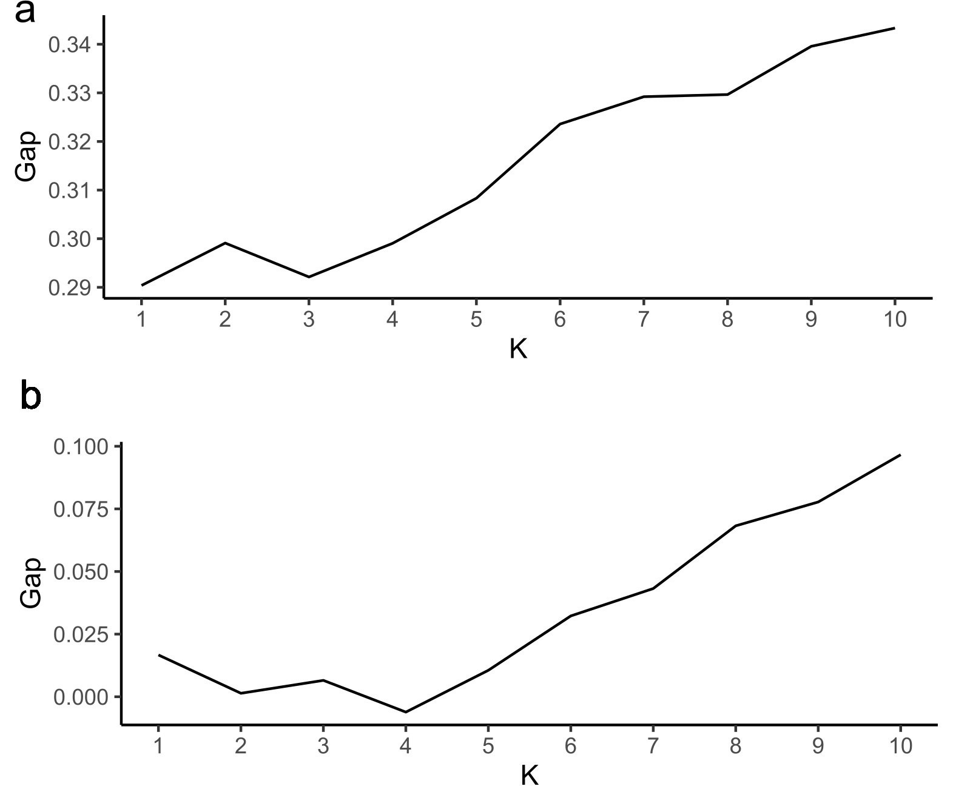
Supplementary Figure 1. Results of the Gap statistic analyses for selecting the optimal number of clusters for (a) meadow butterflies and (b) forest edge butterflies.

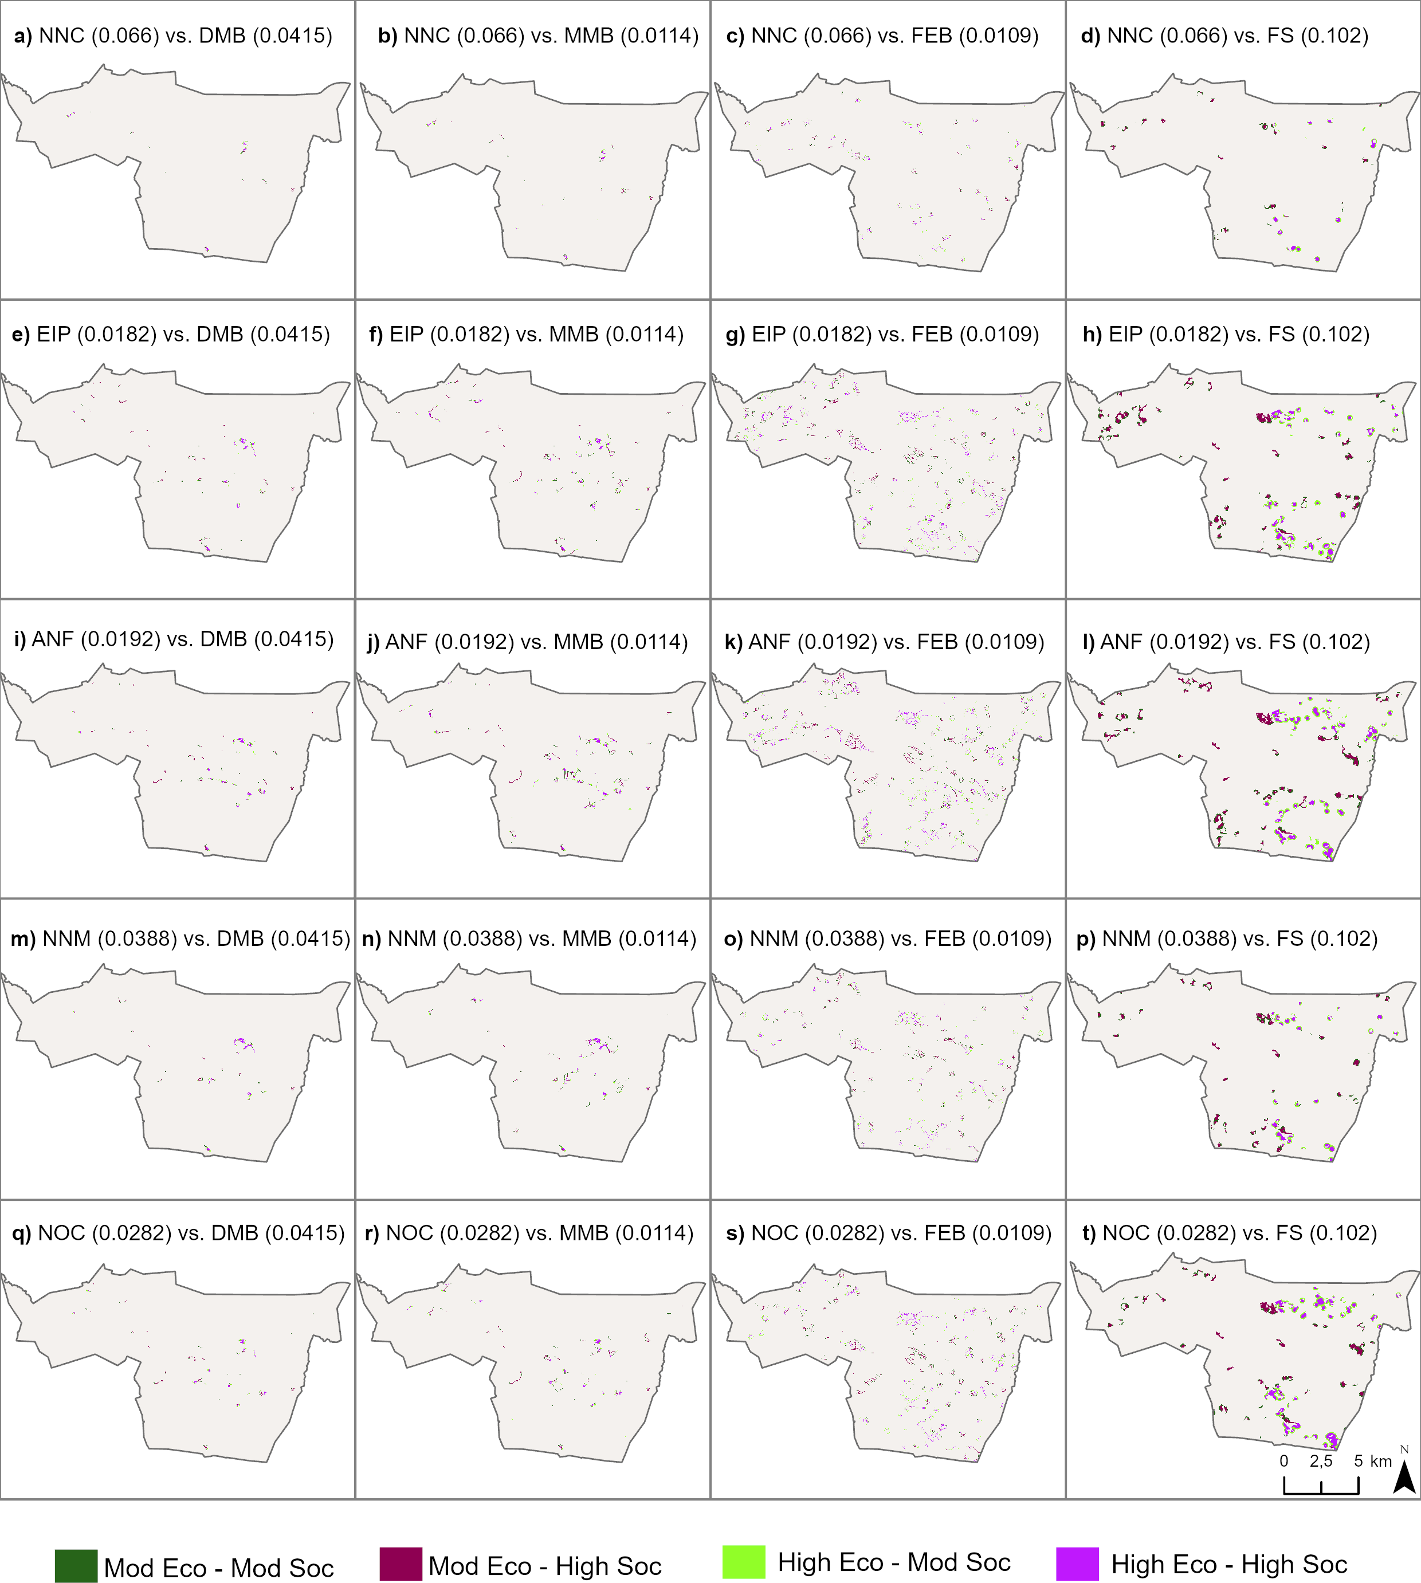
Supplementary Figure 2. Bivariate spatial overlay between each ecological and each social value layer, i.e. comparison of each of the five social archetypes with each of the four ecological archetypes. The numbers in brackets in the upper part of each panel denote the median (50th quantile) used as a threshold to distinguish moderate from high values. DMB=dispersal-limited meadow butterflies, MMB=mobile meadow butterflies, FEB=forest edge butterflies, NNC=Not nature-oriented car drivers, EIP=Elderly indoor people, ANF=Active nature-oriented females, NNM=Not nature-oriented men, and NOC=Nature-oriented cyclists. Mod = moderate; Eco = ecological value; Soc = social values.

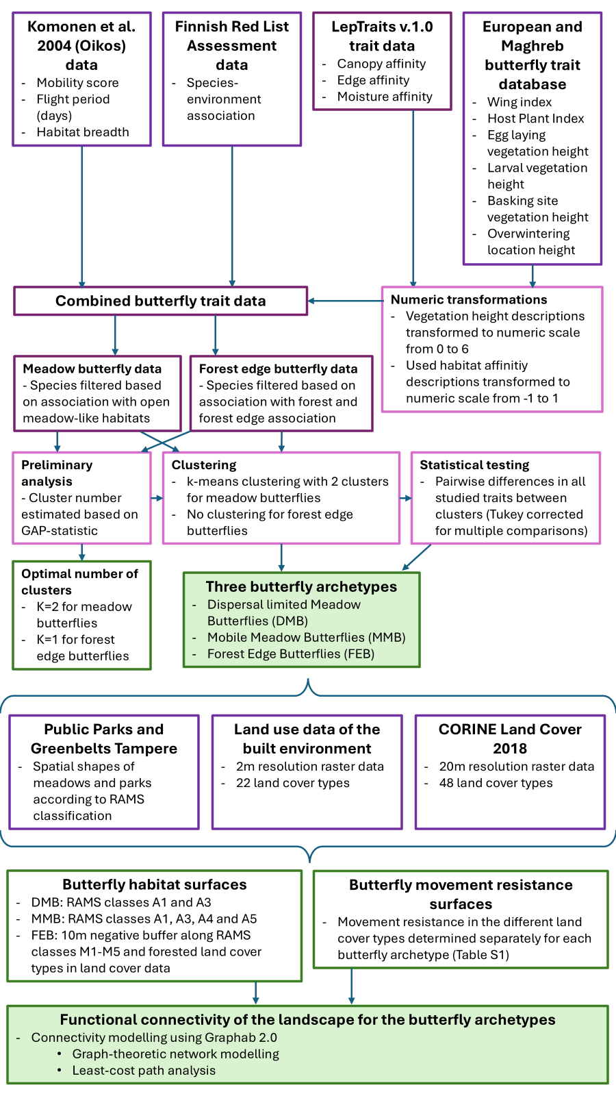
Supplementary Figure 3. Analysis workflow for identifying the three butterfly archetypes, followed by creation of spatial data and functional connectivity analyses. The workflow summarises the main steps of the analyses. Box outline colours represent the steps as follows: inputs (dark purple), methods (magenta), and outputs (green). Main results are highlighted with a green background. The analysis workflow for the Flying squirrel is described in Supplementary Text 2.

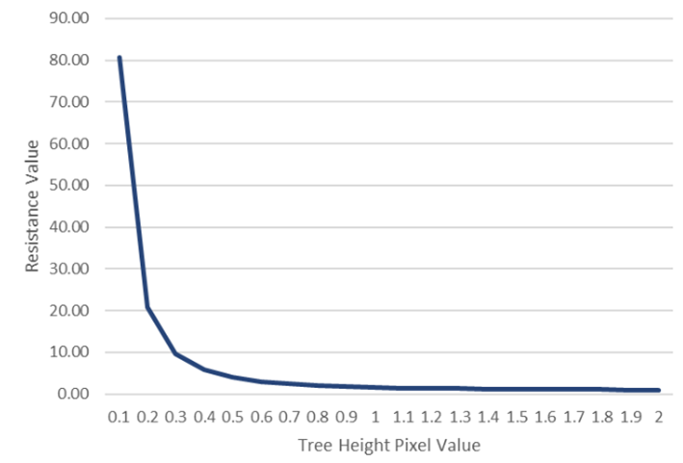
Supplementary Figure 4. Relationship between the combined canopy metric and the resulting resistance values for the flying squirrel. Resistance was computed using the formula 0.8 / (combined canopy value²) + 0.8. This produced high resistance in areas lacking tall trees and rapidly decreasing resistance as canopy cover and height increase.

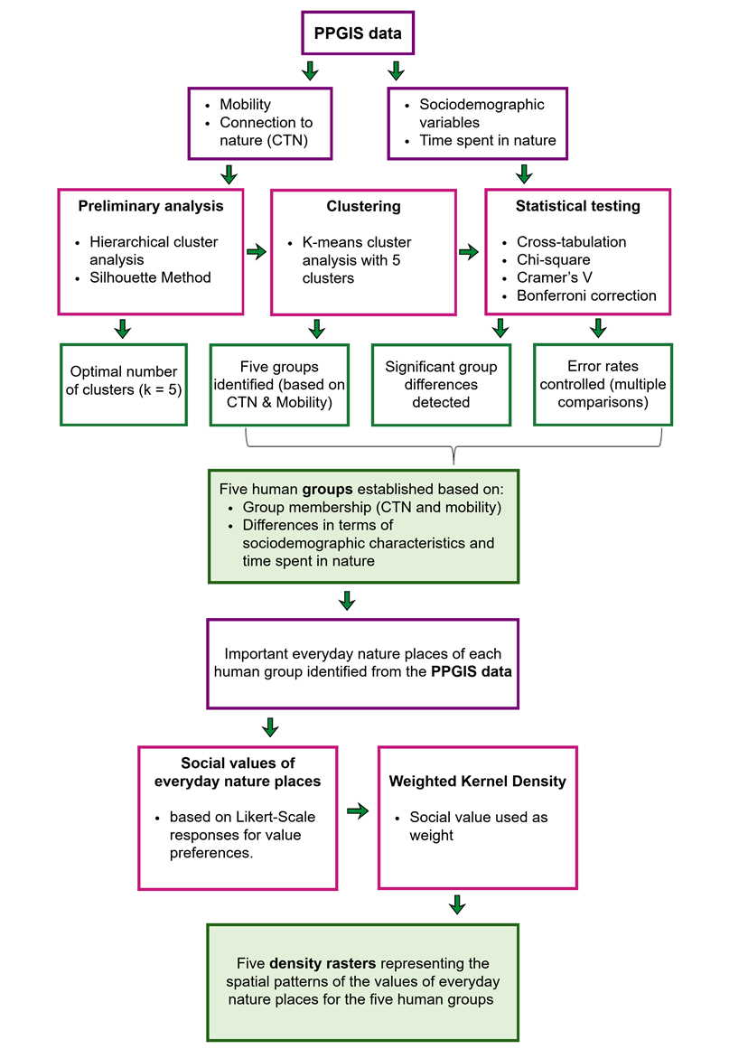
Supplementary Figure 5. Analysis workflow for identifying the five human groups based on connection to nature (CTN) and mobility choices, followed by spatial analysis. The workflow summarises the main steps of the analysis. Box outline colours represent the steps as follows: inputs (dark purple), methods (magenta), and outputs (green). Main results are highlighted with a green background.

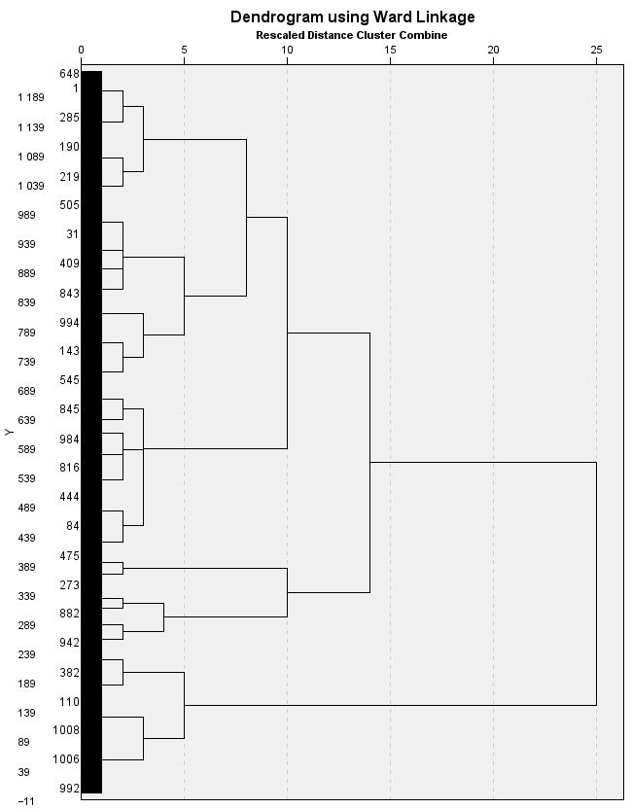
Supplementary Figure 6. Results of the hierarchical clustering analysis (HCA) for selecting the optimal number of clusters for human groups.

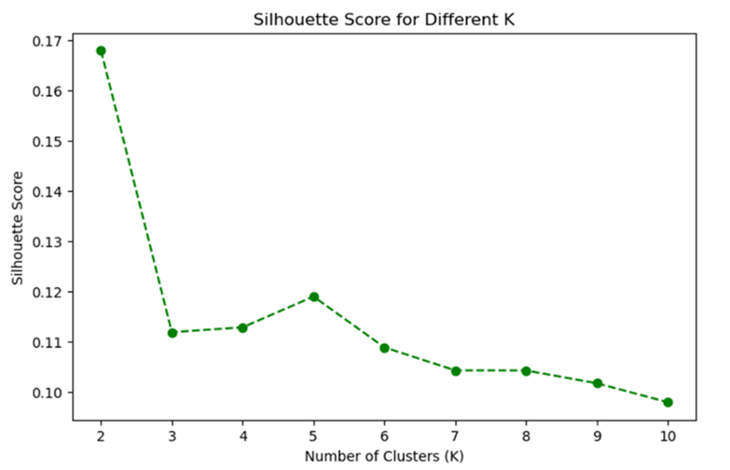
Supplementary Figure 7. Results of the Silhouette analysis for selecting the optimal number of clusters for human groups. Higher silhouette scores indicate more distinct and well-separated clusters, reflecting greater differentiation between clusters.

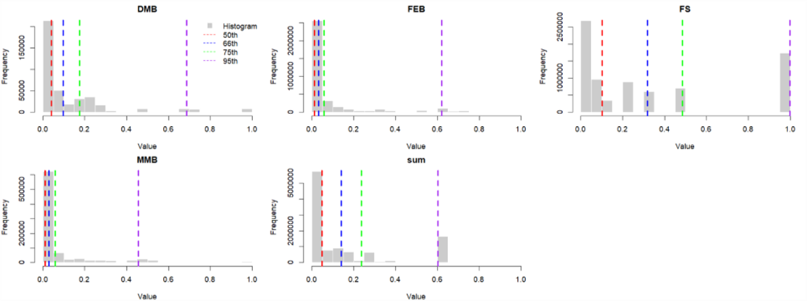Supplementary Figure 8. Histogram of non-zero normalised values for each connectivity layer of the ecological archetypes, with quantile lines at the 50th, 66th, 75th, and 95th percentiles. The median (50th quantile) was used as the threshold distinguishing moderate from high values.

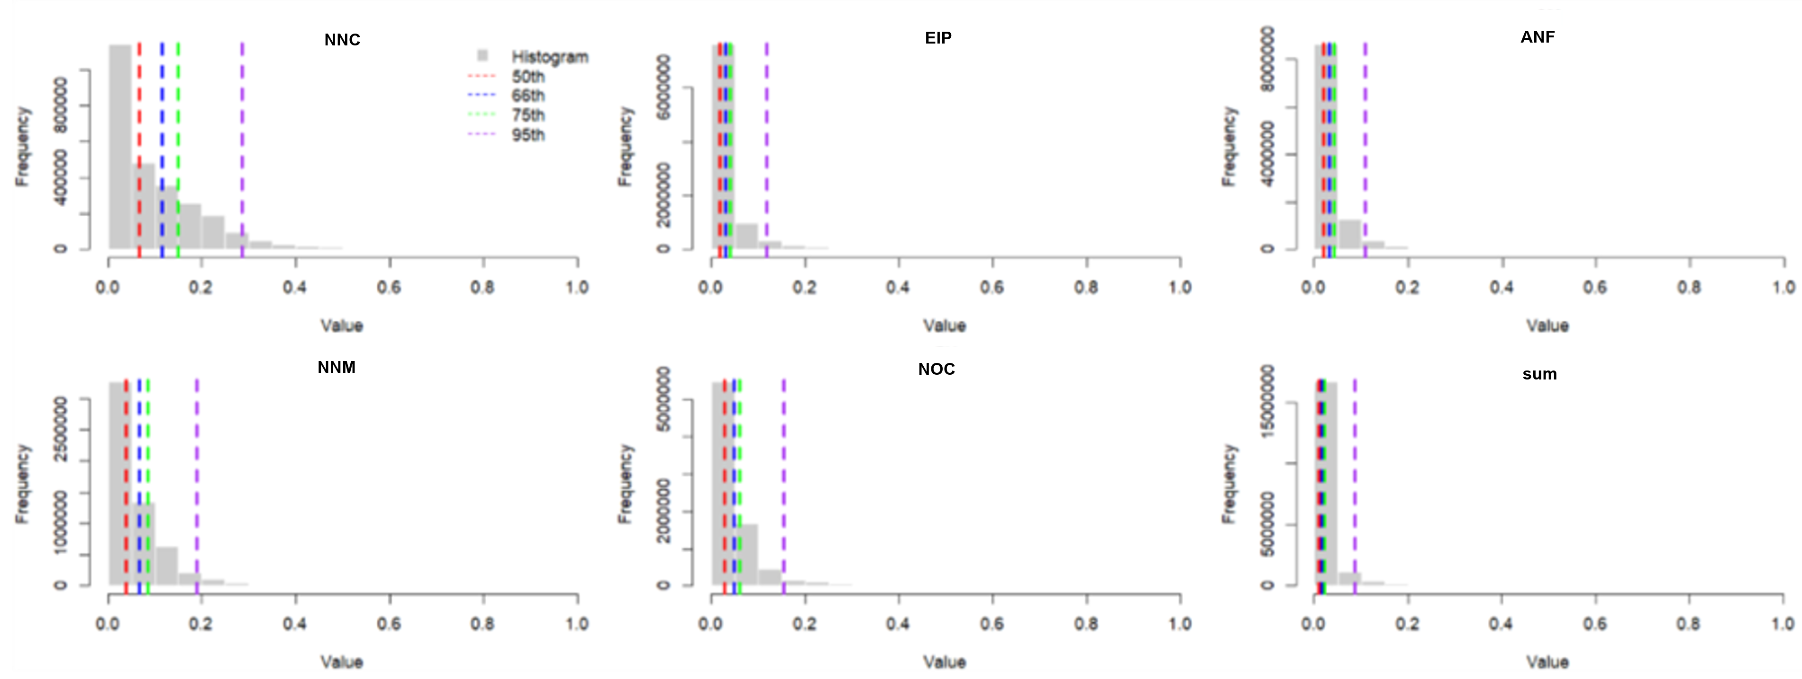Supplementary Figure 9. Histogram of non-zero normalised values for the five human groups, with quantile lines at the 50th, 66th, 75th, and 95th percentiles. The median (50th quantile) was used as the threshold distinguishing moderate from high values.

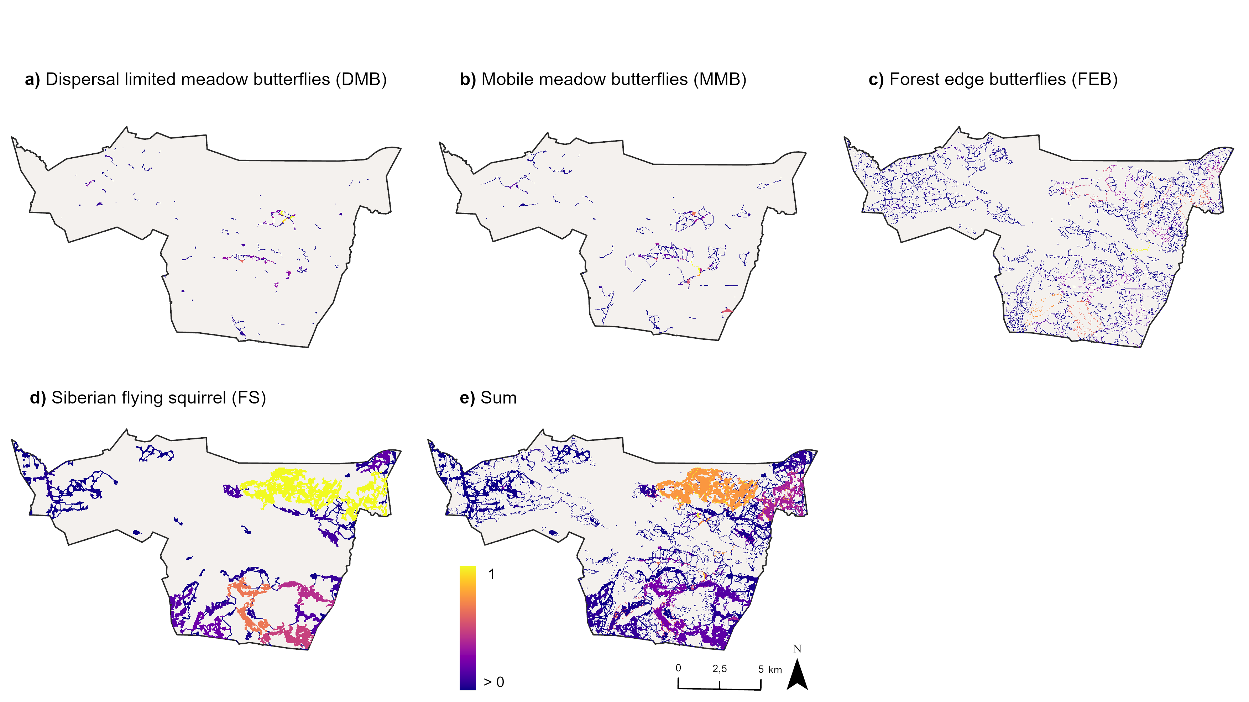Supplementary Figure 10. Spatial patterns for each connectivity layer of the ecological archetypes after normalisation from 0 to the layer’s maximum value. The final panel (sum) shows the summed connectivity surface obtained by aggregating all layers followed by normalisation.

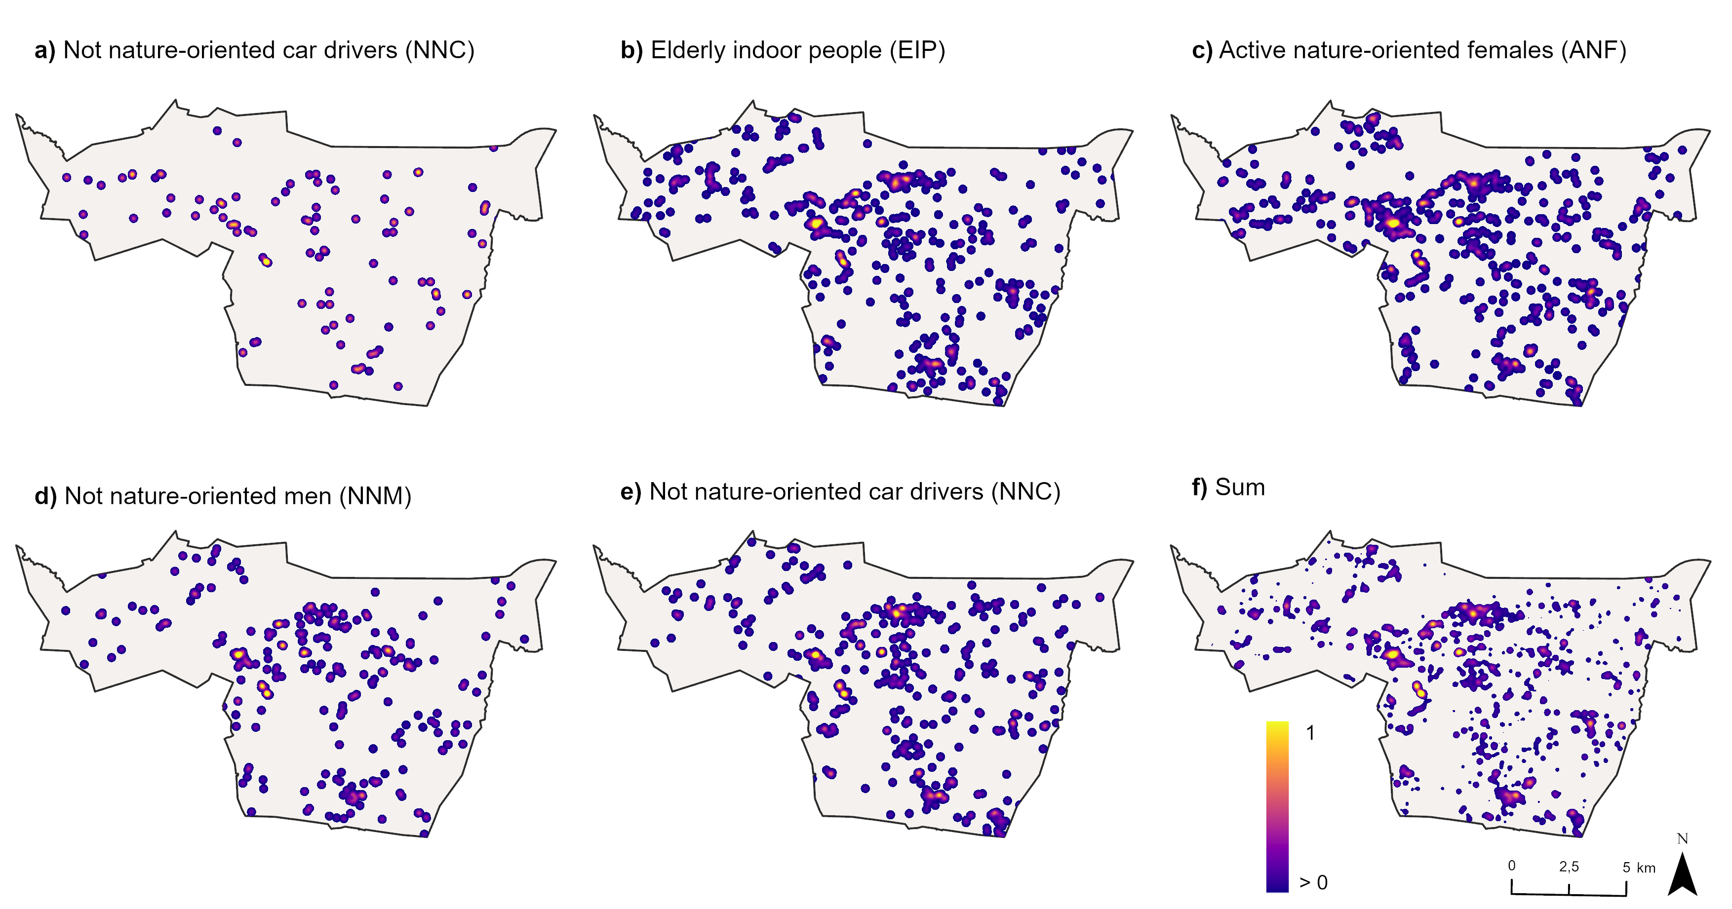Supplementary Figure 11. Spatial patterns for the five human groups after normalisation from 0 to the layer’s maximum value. The final panel (sum) shows the summed connectivity surface obtained by aggregating all layers followed by normalisation.

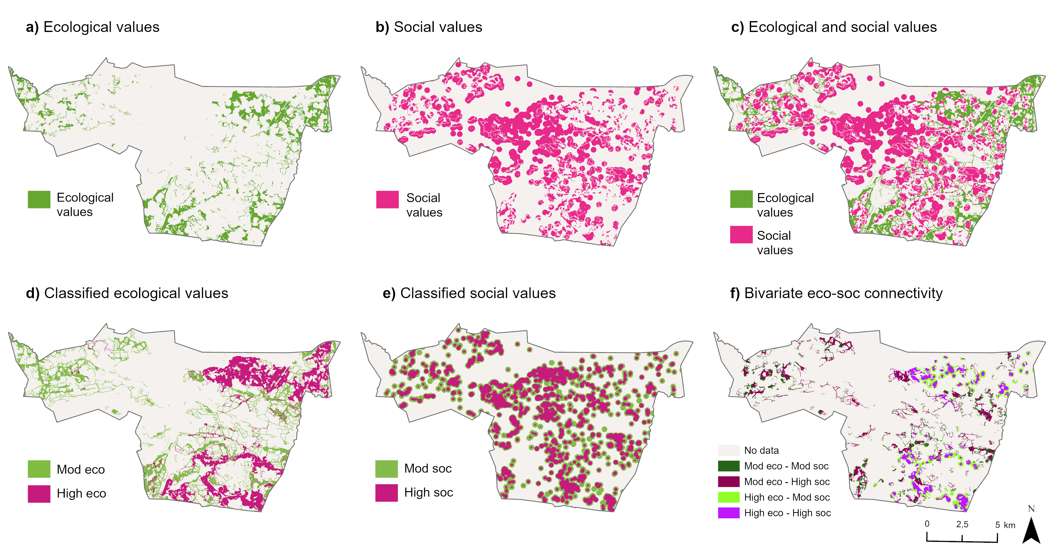Supplementary Figure 12. Analysis workflow for bivariate spatial overlay of ecological and social values. The summed bivariate approach, aggregates a) ecological values and b) social values separately and then c) compares them. d) For both datasets, the median (50th quantile) was used as a threshold, 0.0475 for ecological and 0.00854 for social, distinguishing moderate from high values (Supplementary Figs. 8 and 9). We then visualised locations where only ecological or social values were found (Supplementary Fig. 12 a-b). Based on this, we made e) an initial bivariate comparison between the two summed ecological and social value layers to generate f) a layer describing the four bivariate classes moderate–moderate, moderate–high, high–moderate, and high–high. Mod = moderate; Eco = ecological value; Soc = social values.

Texts
Supplementary Text 1. Methodological consideration of the multispecies valuation of green infrastructure
We acknowledge that, strictly speaking, our approach does not represent humans and other species evenly, and this connects to both practical limitations and ethical considerations. While grouping species into functional archetypes provides a scalable framework for land use planning, it encompasses several challenges. Multispecies justice acknowledges that both humans and other species interact with nature in diverse ways. From the ecological perspective, different species have varying needs for natural space, with some requiring large areas of undisturbed habitat of a certain type, while others can tolerate or even thrive in more human-modified environments. Similarly, within human communities, preferences for natural areas vary across needs, preferences, and attitudes. The role of a specific area in ecological (and functional) connectivity is, however, fundamentally and conceptually different to the role of a green space for providing values to humans. While humans mostly live in buildings, spend most of their time in other areas than green spaces, and although connection to nature and green areas are important for human health^{4,5}, human individuals can survive without green infrastructure of a specific type, quality, and connectedness. However, for other species, the requirements of habitats and connectivity are crucial for not only individual survival but also for population and species viability. This requirement by other species for life sustenance, nevertheless, tightly connects back to humans and their prerequisites for existence, since all human life and our societies are dependent on biodiversity and the services that ecosystems provide. As urban settlements have often been developed in highly biodiverse areas^{6,7}, cover 2% of terrestrial land⁸, but at the same time play an important role for forming the habitat matrix that biodiversity in and around urban areas depends on^{6,9}, it could be argued that the quality and extent of green area and nature-based solutions in urban settings will indirectly also form important prerequisites for human survival.
Furthermore, the taxonomic resolution that is feasible to cover in an analysis like ours can arguably be contested. While Homo sapiens is one species among millions, in our analysis we give it equal and even more weight compared to any single other species. This means that we compare this one species, human, divided into several groups that represent behavioural and attitudinal differences, while attempting to make the diversity of other species operationalizable through grouping several species into a few archetypes based on traits and habitat requirements. In addition, the trait-based ecological archetype grouping that we use here can address only species that we have enough data on concerning their likely dispersal abilities, habitat requirements, etc. Future focus in this line of research should be on stabilising this balance, for example by increasing the number of taxa included in trait based ecological archetypes (mammals, birds, and plants), and improving the representation taxonomical groups such as fungi, other insects, and bacteria to the analysis, e.g., by using species agnostic approaches such as constructing virtual species or using geodiversity metrics as a proxy for diverse niche space¹⁰.
Similarly to the poor overall representation of biodiversity, our human data does not capture people who do not use green spaces and likely did not respond to our survey. It also misses marginalised groups of people, such as immigrants or people with disabilities, which is a common challenge of PPGIS^{11,12} and survey methods in general. Hence, developing the human data representativeness is an important future research need. Additionally, the question on what nature is from a human perspective is worthy of more discussion. Here, we consider nature to be a subjective interpretation that encompasses anything from a microscale single tree or a roadside green patch used for dog walking to macro scale urban parks and forests. Hence, it is not possible to understand the human values for urban green infrastructure simply by using mapped green infrastructure data produced by authorities. Therefore, instead of using officially produced data, we applied PPGIS data collection as it enables collecting respondents’ subjective place-based experiences and produce spatial data that can be applied in spatial analysis.
Furthermore, our study also highlights how the understanding of distribution of benefits and harms among species and human groups could be highly dependent on the underlying data and methodological choices. Even though we only used a limited number of groups in this study, the results demonstrate that the methodological choices for the ecological connectivity analyses (e.g., taxonomic and data choices, and parameterisation) as well as the for the human groups (e.g., data used for clustering, weights for importance) are strongly linked to agency. This aspect should not be underestimated but instead be used as a basis for further examination within the specific context of its application to form part of the transparency advocated for in MSJ. This also includes accounting for the chosen threshold values when integrating the group-specific outputs and using those for assessing the distribution of harms and benefits.

Supplementary Text 2. Construction process of habitat data and parameter setting for the connectivity analysis for the Siberian flying squirrel.
We extracted data from four complementary sources to determine the key forest habitat patches for the Siberian flying squirrel: (i and ii) The Finnish Forest Centre’s polygon and raster data on privately owned forest areas, including various types of quantitative information on tree stands (Paikkatietoaineistot | Metsäkeskus; (iii) the SAKTI database governed by Parks & Wildlife Finland, including data on tree stands and forestry operations both on state-owned and in privately owned conservation areas; and (iv) data from the Multi-source national forest inventory data of Finland (MSNFI), governed by Natural Resources Institute Finland, including data on tree stands at the resolution of 16 x 16 meter (https://etsin.fairdata.fi/dataset/6ffb8be2-405a-4936-a99f-5fc4db0683c5). All these four forest data sets were integrated into a lattice system covering the whole Finland at a 16 x 16 m resolution (the MSNFI lattice system).
We used the parameters from the Habitat suitability index (HSI) developed for the Siberian flying squirrel by¹³ (Appendix 2 therein) to delimit suitable key forest patches for the species. In essence, the HSI for the species includes three criteria: (i) the volume of spruce is > 175 m3/ha; (ii) the proportion of spruce of total timber volume is >60%; and (iii) the volume of deciduous trees is > 15 m3/ha. All the 16 x 16 m pixels in the study area that fulfilled these three criteria in at least one of the four types of source forest data were considered potential key habitat.
Next, we evaluated whether the 16-m pixels considered suitable key habitat had been subject to recent forest clear-cuts or other notable changes in land use. This was done by identifying the pixels which overlapped with the areas included both in the following two forest data layers: (i) clear-cuts defined for the study area in the Global Forest Change Forest Loss layer data conducted between 2001 and 2022¹⁴, and (ii) The Finnish Forest Centre's announcement system for forest cuttings (Metsään.fi service; https://www.metsakeskus.fi/fi/palvelut/metsankayttoilmoitus ), where forest owners submit notifications of their forest use (here we considered the class ‘cutting purpose = regeneration felling’ and the notifications for altered land use). All the managed 16-m pixels were excluded from the potential key habitat area.
The breeding areas of the Siberian flying squirrel constitute larger forest areas that may include both optimal forest habitat and intervening patches of pine forest and younger forests, forming a mosaic entity¹⁵. To take this into account, we applied a moving window procedure to dissect the 16-m pixels which had at minimum five 16-m pixels in their adjacent surroundings that fulfilled the HSI criteria from those pixels that had less than five HSI pixels. In our moving window, we considered the focal centre 16-m pixel and the two rows of adjacent pixels as a larger combination of 25 16-m pixels. In these combinations of 25 pixels, the centre 16-m pixel was deemed as suitable optimal habitat if there were ≥5 HSI pixels around it among the 25 pixels. The centre pixel was considered suitable even if it did not fulfil the HSI criteria itself, i.e., this decision was made at the level of whole combination of 25 16-m pixels and how many HSI pixels it contained. This moving window procedure enabled us both to (i) exclude suitable solitary 16-m HSI pixels from the data and (ii) merge small-sized open and less vegetated patches into the larger forest areas providing suitable breeding habitat for the species. Next, all the physically adjacent 16-m pixels fulfilling the moving window criteria were merged to delimit larger areas of contiguous key habitat. The last step in the delimitation of HSI based key habitats was excluding those contiguous HSI forest areas that were less than 4 hectares in size.
We acknowledge that the home ranges of the Siberian flying squirrel are in forested landscapes larger than the 4 hectares cut-off value used in our study (on average 8 ha for females and 60 ha for males¹⁶. However, recent studies have shown that the species can successfully breed also in smaller-sized mixed forest patches in urban and semi-urban areas, provided that there are mature trees with sufficient cavities or twigs for nesting, and in some cases also in nest boxes or holes in buildings^{15,17} (see also https://www.espoo.fi/en/news/2025/10/flying-squirrel-life-project-concluded-espoo-will-continue-reconcile-urban-development-and). Thus, to complement the key forest patch data for FS in the Tampere city area, we supplemented the HSI based ≥4 ha key habitat data with observed breeding records and data on forests that have been scored as highly potential for breeding. This supplementary information has been collected in field surveys coordinated by the Tampere city Nature conservation unit. The supplementary habitat data was merged with the HSI-based habitat data, and the combined final key habitat data layer was resampled to a uniform 20 x 20 m lattice system matching the national Corine CLC 2018 data system.
Radio-tracking studies^{17–19} suggest that movement distances of FS can be longer in areas containing ample amounts of suitable forest habitat, but the species can also utilise woodland strips for inter‐patch movements and even solitary trees when crossing inhospitable gaps. Moreover, the citizen-science records also suggest that the species may use corridors of trees and small woodland patches when moving around the Tampere urban area. Thus, instead of using land cover-based resistance values¹⁵ we developed a resistance layer for the species movements using fine-resolution data on the occurrence of trees higher than 10 meters (cf.¹⁷). For this, we extracted fine-resolution data on tree height for our study area from The Finnish Forest Centre’s Canopy height model (CHM; 'Latvusmalli', see https://www.metsakeskus.fi/fi/avoin-metsa-ja-luontotieto/aineistot-paikkatieto-ohjelmille/paikkatietoaineistot). This CHM data set provides information on the height of trees at the resolution of 1x1 m based on laser scanning assessments with a point density of ≥0.5 points per m². To filter out potential misclassifications of high buildings as trees in the CHM data we used the data on the occurrence of buildings in our study area, as derived from National Land Survey of Finland (NLS; https://www.maanmittauslaitos.fi/en).
Using ArcGIS Python scripts, we removed all pixels with trees lower than 10 m in height in the CHM tree height data by reclassifying them to zero values. For the remaining pixels with trees ≥10 m, we developed two separate measurements. In both measurements, a moving window with a 10 m circular radius (20 m diameter) was used. Firstly, the 10 m moving window was used to calculate the relative cover of the 1x1 m pixels with 10m or taller trees within the window, with resulting values ranging from 0 to 1 and. The second moving window was used to define the maximum canopy height value among the pixels falling within the 10 m circular window (the canopy height values varying here between 10 and 45 m, the maximum tree height in our dataset). The resulting maximum canopy height layer was then rescaled so that the values also range from 0 to 1, like the first moving window, before the two measures were combined.
Next, we combined the two moving-window layers using the raster calculator to sum up the first layer and the rescaled the second layer. The resulting values ranged from 0 to 2, and the resistance layer was then calculated from this combined layer using the formula:
resistance = 0.8 / (TPV^2) + 0.8;
TPV= Tree Pixel Value
After this, we multiplied the resistance value by 2 since we processed all the subsequent connectivity analysis at the 2-meter resolution and resampled the three data into this 2-m raster grid. Moreover, also the key habitat data for the Siberian flying squirrel were resampled to the same 2 m raster before running the connectivity model. The pixels that included key habitat data were coded with value 2 and the pixels in the surrounding matrix were scored using the formula above.
The final step in launching the connectivity runs was defining interpatch dispersal distances. We defined 2 km as the maximal movement distance for the Siberian flying squirrel. This represents the average natal dispersal distance of the species^{15,20}. The species has been recorded to make long-distance relocations across ca. 9km¹⁹ and citizen-science records of the species in Tampere are partly further than 2km from the larger key habitat areas. However, here we deliberately focused on the shorter-distance (≤2km) movements which are very likely constituting most of the dispersal events of the species¹⁹. This enabled us to dissect the more important corridor areas for the species from the more resource-consuming sporadic longer movements across the more inhospitable urban matrix (cf.¹⁷). These key connectivity areas derived from the connectivity models thus provide useful key comparative areas of mature forest biota in the multispecies assessments.

References
1. Pascual, U. et al. Diverse values of nature for sustainability. Nature 620, 813–823 (2023).
2. Pebesma E. Simple Features for R: Standardized Support for Spatial Vector Data. 10, 439–446 (2018).
3. Hijmans R, Brown A, Barbosa M. terra: Spatial Data Analysis.
4. White, M. P. et al. Spending at least 120 minutes a week in nature is associated with good health and wellbeing. Sci. Rep. 9, 7730 (2019).
5. Bowler, D. E., Buyung-Ali, L. M., Knight, T. M. & Pullin, A. S. A systematic review of evidence for the added benefits to health of exposure to natural environments. BMC Public Health 10, 456 (2010).
6. Ives, C. D. et al. Cities are hotspots for threatened species. Glob. Ecol. Biogeogr. 25, 117–126 (2016).
7. Li, G. et al. Global impacts of future urban expansion on terrestrial vertebrate diversity. Nat. Commun. 13, 1628 (2022).
8. Ritchie, H. How urban is the world? Our World Data https://archive.ourworldindata.org/how-urban-is-the-world (2018).
9. Spotswood, E. N. et al. The Biological Deserts Fallacy: Cities in Their Landscapes Contribute More than We Think to Regional Biodiversity. BioScience 71, 148–160 (2021).
10. Määttänen, A.-M., Hällfors, M. & Kemppinen, J. Geodiversity is an inseparable but underutilized aspect of ecological connectivity assessments under climate change. Ecography n/a, e07768.
11. Rall, E., Hansen, R. & Pauleit, S. The added value of public participation GIS (PPGIS)for urban green infrastructure planning. Urban For. Urban Green. 40, 264–274 (2019).
12. Fagerholm, N. et al. Analysis of pandemic outdoor recreation and green infrastructure in Nordic cities to enhance urban resilience. Npj Urban Sustain. 2, 1–14 (2022).
13. Mönkkönen, M. et al. Spatially dynamic forest management to sustain biodiversity and economic returns. J. Environ. Manage. 134, 80–89 (2014).
14. Hansen, M. C. et al. High-Resolution Global Maps of 21st-Century Forest Cover Change. Science 342, 850–853 (2013).
15. Kosma, M., Laita, A. & Duflot, R. No net loss of connectivity: Conserving habitat networks in the context of urban expansion. Landsc. Urban Plan. 239, 104847 (2023).
16. Hanski, I. K., Stevens, P. C., Ihalempiä, P. & Selonen, V. Home-Range Size, Movements, and Nest-Site Use in the Siberian Flying Squirrel, Pteromys Volans. J. Mammal. 81, 798–809 (2000).
17. Mäkeläinen, S., de Knegt, H. J., Ovaskainen, O. & Hanski, I. K. Home-range use patterns and movements of the Siberian flying squirrel in urban forests: Effects of habitat composition and connectivity. Mov. Ecol. 4, 5 (2016).
18. Selonen, V. & Hanski, I. K. Movements of the flying squirrel Pteromys volans in corridors and in matrix habitat. Ecography 26, 641–651 (2003).
19. Selonen, V. & Hanski, I. K. Young flying squirrels (Pteromys volans) dispersing in fragmented forests. Behav. Ecol. 15, 564–571 (2004).
20. Selonen, V. & Mäkeläinen, S. Ecology and protection of a flagship species, the Siberian flying squirrel. Hystrix Ital. J. Mammal. 28, 134–146 (2017).

