Supplementary Appendix
- Advanced search strategy
- Methods for reconstructing survival curves and extracting individual patient data
- Summary of included trials
- Supplementary references

- Advanced search strategy

MEDLINE (Ovid) = 820
1. exp Lung Neoplasms/
2. exp Non-Small-Cell Lung Carcinoma/
3. Carcinoma, Non-Small-Cell Lung/
4. NSCLC.tw,kf.
5. lung adenocarcinoma.tw.
6. squamous cell lung carcinoma.tw.
7. squamous lung cancer.tw.
8. or/1-7
9. (advanced or metastatic or stage IV or stage 4 or unresectable).tw.
10. (early-stage or stage I or stage II or stage III or localized or resectable or surgery).tw.
11. 9 not 10
12. exp Immune Checkpoint Inhibitors/
13. exp Immunotherapy/
14. exp Programmed Cell Death 1 Receptor/
15. exp Programmed Cell Death 1 Ligand 1 Protein/
16. exp Cytotoxic T-Lymphocyte-Associated Protein 4/
17. (PD-1 or PD1 or PD-L1 or PDL1 or CTLA4 or CTLA-4).tw.
18. (immune checkpoint inhibitor* or checkpoint blockade or anti-PD-1 or anti-PD-L1 or anti-CTLA-4).tw.
19. (immunotherapy or immuno-oncology).tw.
20. (durvalumab or pembrolizumab or nivolumab or atezolizumab or ipilimumab or tremelimumab or cemiplimab or tislelizumab).tw.
21. or/12-20
22. ("first line" or "front line" or "treatment naive" or "previously untreated" or "initial therapy" or "de novo").tw.
23. randomized controlled trial.pt.
24. controlled clinical trial.pt.
25. clinical trial, phase ii.pt.
26. clinical trial, phase iii.pt.
27. (phase II or phase III or phase 2 or phase 3).tw.
28. random*.tw.
29. trial.tw.
30. placebo.tw.
31. or/23-30
32. exp animals/ not humans.sh.
33. (clinical trial, phase i or phase 1).pt.
34. (phase I or phase 1).tw,kf.
35. 31 not (32 or 33 or 34)
36. and/8, 11, 21,22, 35
37. limit 36 to yr="2000 - 2025"

Cochrane CENTRAL = 561
#1 ("non small cell lung cancer" OR NSCLC OR "lung adenocarcinoma" OR "squamous cell lung carcinoma" OR "squamous lung cancer" OR "non-small-cell lung carcinoma"):ti,ab,kw
#2 (advanced OR metastatic OR "stage IV" OR "stage 4" OR unresectable):ti,ab,kw
#3 (early-stage OR "stage I" OR "stage II" OR "stage III" OR localized OR resectable OR surgery):ti,ab,kw
#4 #2 NOT #3
#5 ("immune checkpoint inhibitor" OR "checkpoint blockade" OR "immunotherapy" OR "immuno-oncology" OR "anti-PD-1" OR "anti-PD-L1" OR "anti-CTLA-4"):ti,ab,kw
#6 (PD-1 OR PD1 OR PD-L1 OR PDL1 OR CTLA4 OR CTLA-4 OR durvalumab OR pembrolizumab OR nivolumab OR atezolizumab OR ipilimumab OR tremelimumab OR cemiplimab OR tislelizumab):ti,ab,kw
#7 #5 OR #6
#8 ("phase II" OR "phase III" OR "phase 2" OR "phase 3"):ti,ab,kw
#9 ("phase I" OR "phase 1"):ti,ab,kw
#10 #8 NOT #9
#11 1 AND #4 AND #7 AND #10
#12 Publication Year from 2000 to 2025

Embase = 304
1. 'non small cell lung cancer'/exp
2. 'lung adenocarcinoma'/exp
3. 'squamous cell lung carcinoma'/exp
4. (NSCLC or "non-small cell lung carcinoma" or "non-small cell lung cancer"
or "lung adenocarcinoma" or "squamous cell lung carcinoma"
or "squamous lung cancer").ti,ab,kw.
5. 1 or 2 or 3 or 4
6. (advanced or metastatic or "stage IV" or "stage 4" or unresectable).ti,ab,kw.
7. (early-stage or "stage I" or "stage II" or "stage III"
or localized or resectable or surgery).ti,ab,kw.
8. 6 not 7
9. 'immune checkpoint inhibitor'/exp
10. 'immunotherapy'/exp
11. 'programmed cell death 1 receptor'/exp
12. 'programmed cell death ligand 1'/exp
13. 'cytotoxic T lymphocyte antigen 4'/exp
14. (PD-1 or PD1 or PD-L1 or PDL1 or CTLA4 or CTLA-4).ti,ab,kw.
15. (durvalumab or pembrolizumab or nivolumab or atezolizumab or ipilimumab or tremelimumab or cemiplimab or tislelizumab).ti,ab,kw.
16. (immune checkpoint inhibitor* or checkpoint blockade or anti-PD-1 or anti-PD-L1 or anti-CTLA-4 or immunotherapy or immuno-oncology).ti,ab,kw.
17. 9 or 10 or 11 or 12 or 13 or 14 or 15 or 16
18. ('first line' or 'front line' or 'treatment naive' or 'previously untreated' or 'initial therapy' or 'de novo').ti,ab,kw.
19. 'phase 2 clinical trial'/exp
20. 'phase 3 clinical trial'/exp
21. ('phase II' or 'phase III' or 'phase 2' or 'phase 3').ti,ab,kw.
22. 19 or 20 or 21
23. 'phase 1 clinical trial'/exp
24. ('phase I' or 'phase 1').ti,ab,kw.
25. 22 not (23 or 24)
26. ('melanoma' or 'renal' or 'kidney' or 'urothelial' or 'bladder' or 'gastric' or 'head and neck' or 'colorectal' or 'esophageal' or 'breast' or 'prostate' or 'hepatocellular' or 'liver' or 'mesothelioma' or 'glioblastoma' or 'ovarian' or 'pancreatic' or 'endometrial' or 'cervical' or 'sarcoma' or 'multiple tumor types' or 'solid tumors').ti,ab,kw.
27. 5 and 8 and 17 and 18 and 25
28. 27 not 26
29. limit 28 to (full text and human and yr="2000 - 2025")
PubMed = 293
("Lung Neoplasms"[Mesh] OR "Carcinoma, Non-Small-Cell Lung"[Mesh]
OR "Adenocarcinoma of Lung"[Mesh] OR "Squamous Cell Lung Carcinoma"[Mesh]
OR NSCLC[tiab] OR "non-small cell lung cancer"[tiab]
OR "non-small cell lung carcinoma"[tiab]
OR "lung adenocarcinoma"[tiab] OR "squamous lung cancer"[tiab])
AND
(advanced[tiab] OR metastatic[tiab] OR "stage IV"[tiab] OR "stage 4"[tiab] OR unresectable[tiab])
NOT
(early-stage[tiab] OR "stage I"[tiab] OR "stage II"[tiab] OR "stage III"[tiab]
OR localized[tiab] OR resectable[tiab] OR surgery[tiab])
AND
"Immune Checkpoint Inhibitors"[Mesh] OR "Immunotherapy"[Mesh]
OR "Programmed Cell Death 1 Receptor"[Mesh]
OR "Programmed Cell Death 1 Ligand 1 Protein"[Mesh]
OR "Cytotoxic T-Lymphocyte-Associated Protein 4"[Mesh]
OR (PD-1[tiab] OR PD1[tiab] OR PD-L1[tiab] OR PDL1[tiab] OR CTLA4[tiab] OR CTLA-4[tiab])
OR (durvalumab[tiab] OR pembrolizumab[tiab] OR nivolumab[tiab] OR atezolizumab[tiab]
OR ipilimumab[tiab] OR tremelimumab[tiab] OR cemiplimab[tiab] OR tislelizumab[tiab])
OR ("immune checkpoint inhibitor*"[tiab] OR "checkpoint blockade"[tiab]
OR "anti-PD-1"[tiab] OR "anti-PD-L1"[tiab] OR "anti-CTLA-4"[tiab]
OR immunotherapy[tiab] OR immuno-oncology[tiab])
AND
("first line"[tiab] OR "front line"[tiab] OR "treatment naive"[tiab]
OR "previously untreated"[tiab] OR "initial therapy"[tiab] OR "de novo"[tiab])
AND
("Clinical Trial, Phase II"[Publication Type] OR "Clinical Trial, Phase III"[Publication Type]
OR ("phase II"[tiab] OR "phase III"[tiab] OR "phase 2"[tiab] OR "phase 3"[tiab]))
NOT
("Clinical Trial, Phase I"[Publication Type] OR ("phase I"[tiab] OR "phase 1"[tiab]))
NOT
melanoma[tiab] OR renal[tiab] OR kidney[tiab] OR urothelial[tiab] OR bladder[tiab]
OR gastric[tiab] OR "head and neck"[tiab] OR colorectal[tiab] OR esophageal[tiab]
OR breast[tiab] OR prostate[tiab] OR hepatocellular[tiab] OR liver[tiab]
OR mesothelioma[tiab] OR glioblastoma[tiab] OR ovarian[tiab] OR pancreatic[tiab]
OR endometrial[tiab] OR cervical[tiab] OR sarcoma[tiab]
OR "multiple tumor types"[tiab] OR "solid tumors"[tiab]
AND
("2000/01/01"[Date - Publication] : "2025/01/31"[Date - Publication])

- Methods for reconstructing published survival curves and extracting individual patient data

The IPDfromKMWebtool by MD Anderson Cancer Centre was used to digitize Kaplan-Meier Survival Curves and reconstruct individual patient data. The inbuilt IPDfromKM Shiny app adapts the R package IPDfromKM to reconstruct IPD from published Kaplan-Meier (K-M) survival curves. The coordinates from curves are extracted directly (Figure S1), and additional parameters are then added (Figure S2) to reconstruct curves.
The reconstructed curves were used to calculate survival at landmark timepoints: 6 month, 1 year, 2 year, 3 year, 4 year and 5 year survival; and survival probabilities at key percentiles: 90th, 75th, 50th (median), 25th and 10th.

A worked example for the CheckMate 9LA study and the accompanying outputs are shown below.

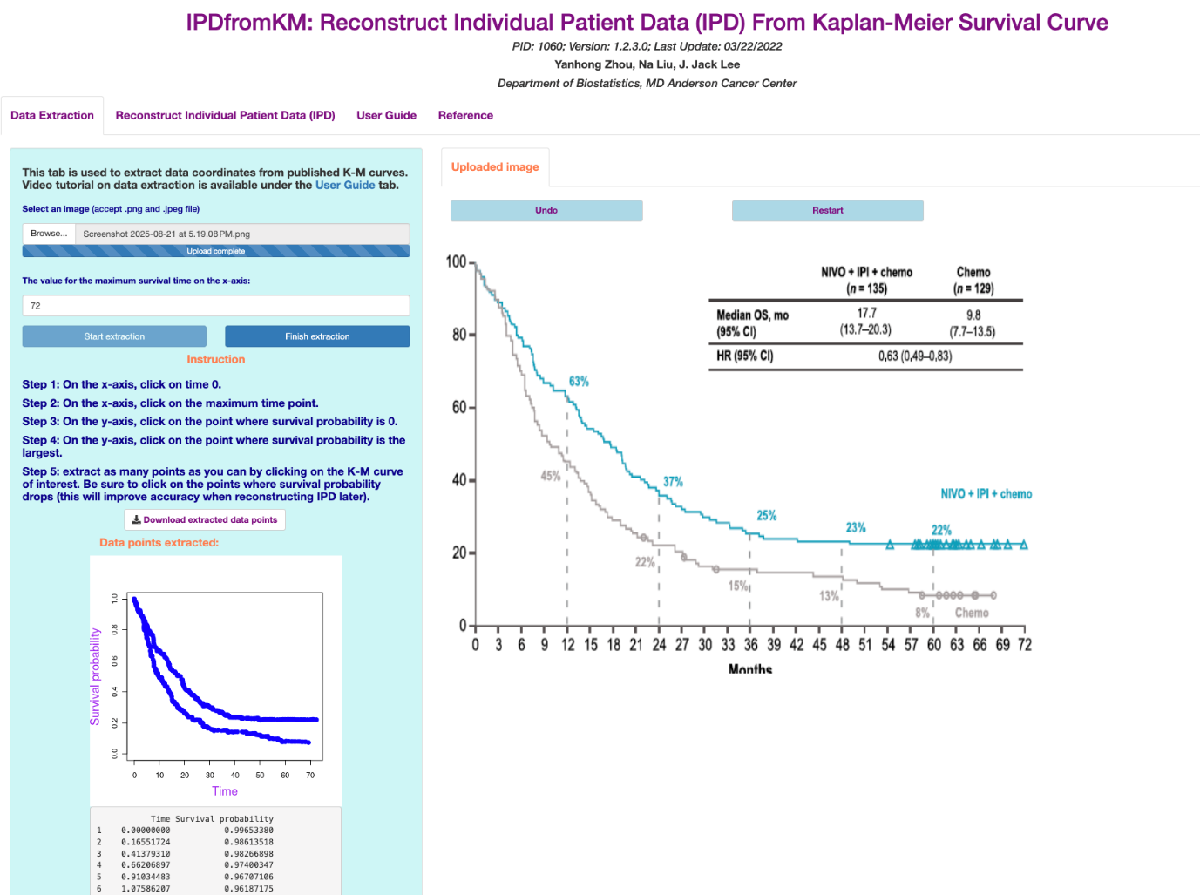

Figure S1 Data extraction process using the IPDfromKM Shiny app
Coordinates from published Kaplan-Meier survival curves were digitised using the ‘Data extraction’ tab, forming the basis for reconstructing individual patient data.
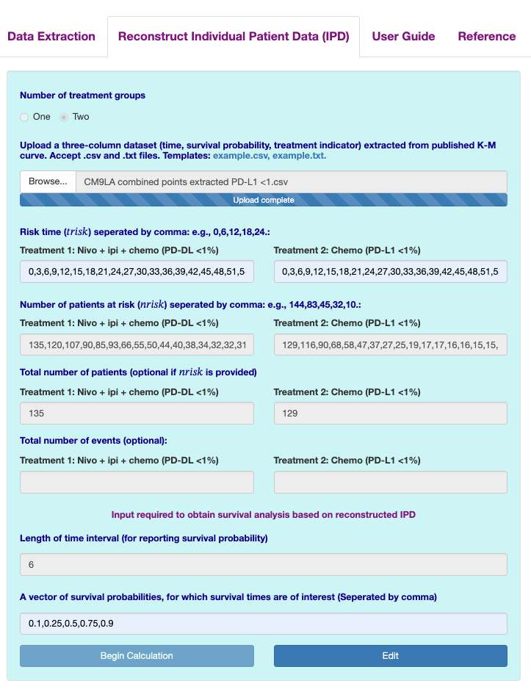

Figure S2 Additional parameters for reconstruction of Kaplan-Meier survival curves
Parameters such as treatment groups, risk time, number of patients at risk, and number of events were added to reconstruct survival curves.

Table S1 shows the first six reconstructed IPD.
Table S1 Example of reconstructed IPD
Survival time | Status | Treatment group
0.17 | 1 | Nivo + ipi + chemo
0.17 | 1 | Nivo + ipi + chemo
0.66 | 1 | Nivo + ipi + chemo
0.66 | 1 | Nivo + ipi + chemo
1.08 | 1 | Nivo + ipi + chemo
1.08 | 1 | Nivo + ipi + chemo

Evaluation of the Accuracy of Reconstructed Curves
New survival curves were reconstructed from the IPD and compared with read-in coordinates (Figure S3 and S4).

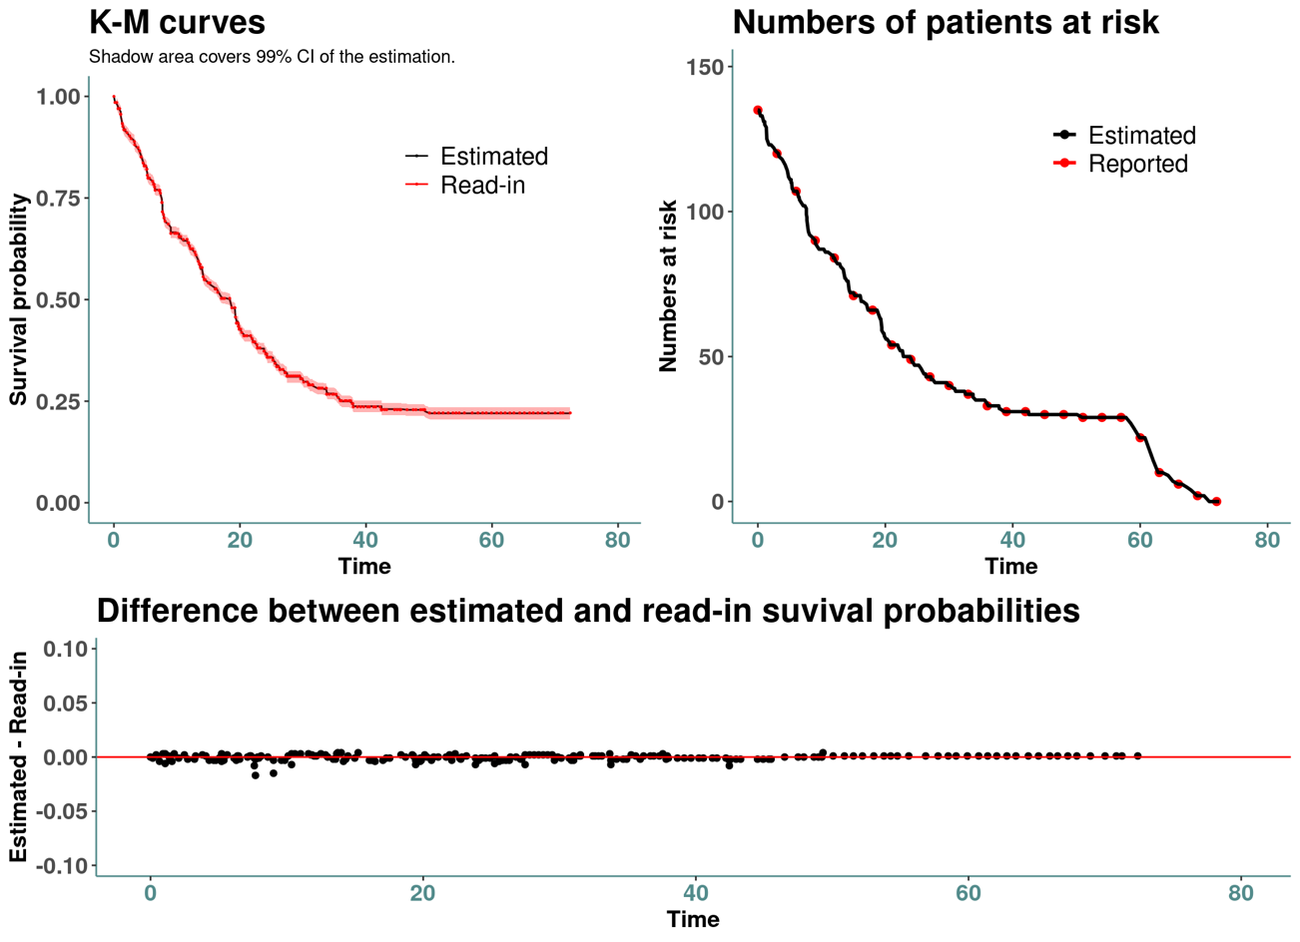

Figure S3 Survival probability for treatment 1 (Nivo + ipi + chemo)

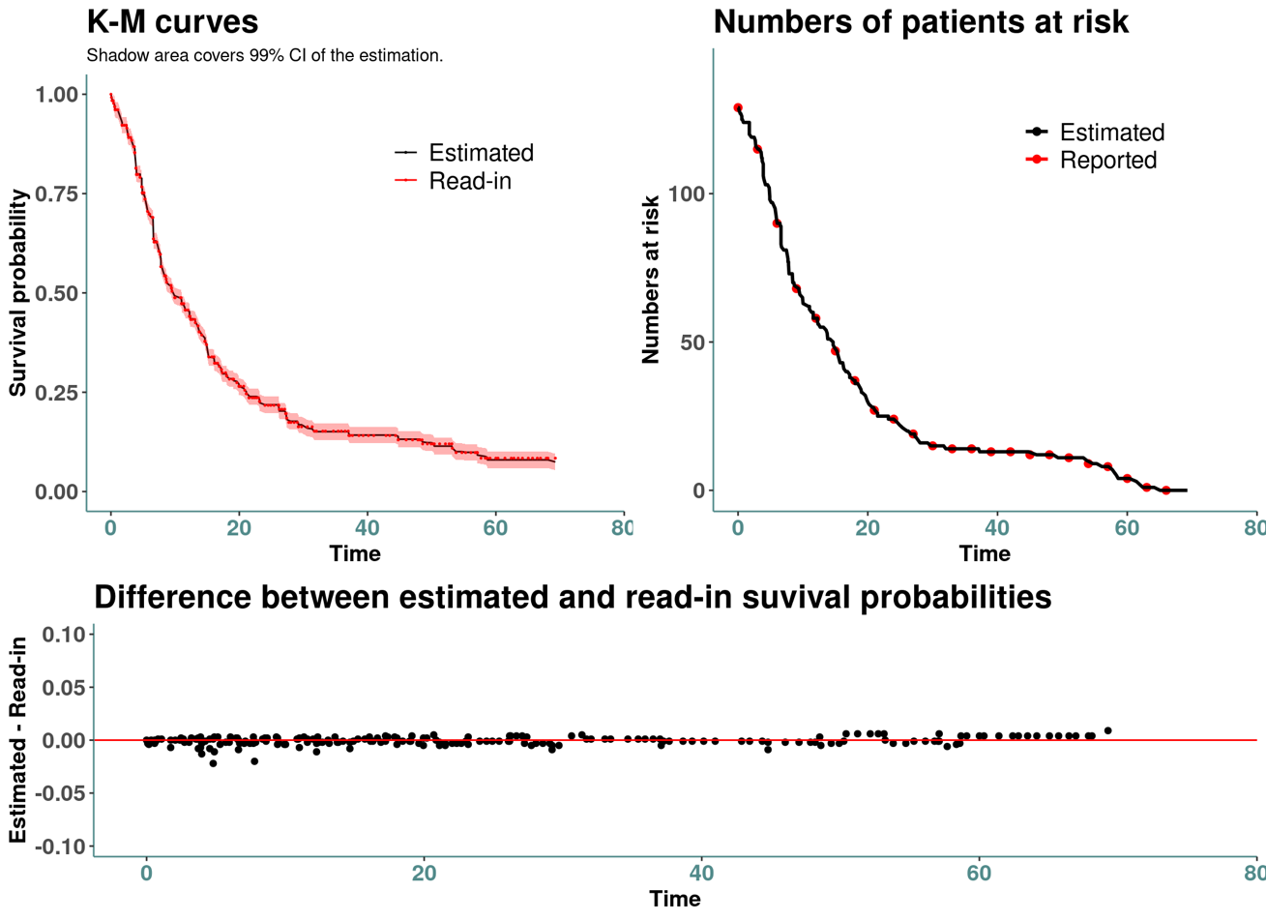
Figure S4 Survival probability for treatment 2 (chemo)

Table S2 shows the summary statistics that are used to evaluate the accuracy of the IPD reconstruction for the two groups.
Table S2 Summary statistics of accuracy assessment
Summary statistics | Treatment 1  Nivo + ipi + chemo | Treatment 2  Chemo
Root mean square error (RMSE) | 0.003 | 0.004
Mean absolute error | 0.002 | 0.003
Max absolute error | 0.004 | 0.009
Kolmogorov-Smirnov test statistics (p-value) | 0.14(0.027) | 0.08(0.5538)

Secondary analysis on the reconstructed IPD
A standard survival analysis is performed on the reconstructed IPD. Figure S5 shows the K-M curve and cumulative risk.
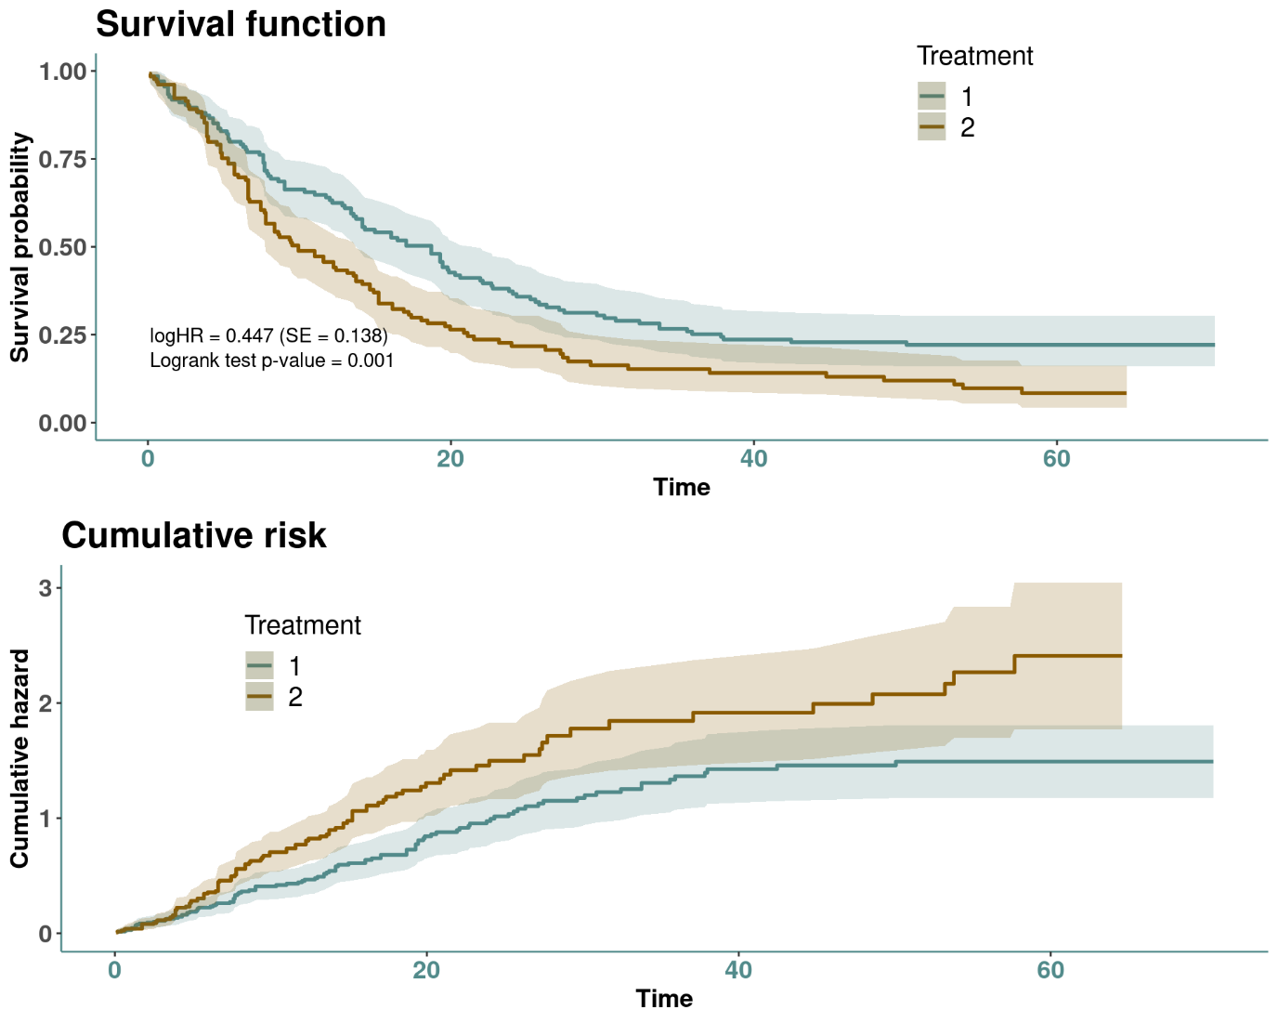
Figure S5 K-M curve and cumulative risk

Table S3 shows the landmark survival probabilities, standard error (SE), and 95% confidence intervals (CIs), given specified survival times, while Table S4 shows the reported survival times and corresponding 95% CI given specified survival probabilities (key percentiles).

Table S3 Survival probabilities, standard error (SE), and 95% CIs
Time | Survival probability | SE | 95% lower CI | 95% upper CI
Treatment 1 (Nivo + ipi + chemo)
6 | 0.7989 | 0.0346 | 0.7339 | 0.8697
12 | 0.6325 | 0.0418 | 0.5556 | 0.72
18 | 0.5029 | 0.0435 | 0.4245 | 0.5958
24 | 0.3734 | 0.0421 | 0.2993 | 0.4658
30 | 0.3048 | 0.0401 | 0.2355 | 0.3945
36 | 0.2515 | 0.0378 | 0.1873 | 0.3377
42 | 0.2362 | 0.037 | 0.1737 | 0.3212
48 | 0.2286 | 0.0366 | 0.167 | 0.3129
54 | 0.221 | 0.0362 | 0.1603 | 0.3046
60 | 0.221 | 0.0362 | 0.1603 | 0.3046
66 | 0.221 | 0.0362 | 0.1603 | 0.3046
Treatment 2 (Chemo)
6 | 0.6977 | 0.0404 | 0.6228 | 0.7816
12 | 0.4569 | 0.0439 | 0.3784 | 0.5515
18 | 0.2987 | 0.0405 | 0.229 | 0.3897
24 | 0.2174 | 0.0376 | 0.1549 | 0.305
30 | 0.163 | 0.0352 | 0.1068 | 0.2488
36 | 0.1522 | 0.0345 | 0.0976 | 0.2372
42 | 0.1413 | 0.0337 | 0.0886 | 0.2254
48 | 0.1304 | 0.0328 | 0.0797 | 0.2135
54 | 0.0978 | 0.0295 | 0.0542 | 0.1767
60 | 0.0838 | 0.0284 | 0.0432 | 0.1629

Table S4 Survival times and 95% CIs
Survival probability | Survival time | 95% lower CI | 95% upper CI
Treatment 1 (Nivo + ipi + chemo)
0.9 | 2.731 | 1.3241 | 4.8
0.75 | 7.6138 | 5.2966 | 9.0207
0.5 | 18.7034 | 14.1517 | 21.931
0.25 | 37.8207 | 27.1448 | NA
0.1 | NA | NA | NA
Treatment 2 (Chemo)
0.9 | 2.6483 | 1.7379 | 3.8897
0.75 | 5.2966 | 3.8897 | 6.6207
0.5 | 9.931 | 7.7793 | 13.7379
0.25 | 21.1034 | 16.8828 | 29.2138
0.1 | 53.7931 | 31.6966 | NA

- Summary of included trials

Table S5 Randomized trials of first-line immune checkpoint inhibitor for advanced NSCLC
Study | Year | Sample size | Intervention | n | Control | n | Median OS  HR (95% CI) | PD-L1 selected | References
ICI-alone
CHECKMATE 026 | 2017 | 541 | Nivolumab 3 mg/kg q2w | 271 | Platinum-doublet chemotherapy | 270 | 14.4 vs 13.2  1.02 (0.80-1.30) | Yes  >5 | ¹
IMpower110 | 2021 | 554 | Atezolizumab 1200 mg q3w | 277 | Platinum-doublet chemotherapy | 277 | 18.9 vs 14.7  0.85 (0.69-1.04) | No | ^{2,3}
KEYNOTE 024 | 2021 | 305 | Pembrolizumab 200 mg q3w up to 35 cycles | 154 | Platinum-doublet chemotherapy | 151 | 26.3 vs 13.4  0.62 (0.48-0.81) | Yes  ≥50 | ^{4,5}
Keynote 042 | 2022 | 1274 | Pembrolizumab 200 mg q3w up to 35 cycles | 637 | Platinum-doublet chemotherapy | 637 | 20.0 vs 12.2  0.68 (0.57-0.81) | Yes  ≥1 | ^{6,7}
Mystic | 2020 | 1118 | Durvalumab 20 mg/kg q4w | 369 | Platinum-doublet chemotherapy | 352 | 16.3 vs 12.9  0.76 (0.55-1.04) | Y  ≥25 | ⁸
Mystic | 2020 | 1118 | Durvalumab 20 mg/kg qw4 + tremelimumab 1 mg/kg q4w (induction then maintenance) | 371 | Platinum-doublet chemotherapy | 352 | 11.9 vs 12.9  0.85 (0.61-1.17) | Y  ≥25 | ⁸
CHECKMATE 227 | 2023 | 1,739 | Nivolumab 3 mg/kg q3w + ipilimumab 1 mg/kg q3w | 583 | Carboplatin AUC 6 or cisplatin 75 mg/m2 + pemetrexed 500 mg/m2 q3w | 583 | 17.1 vs 14.9  0.77 (0.66-0.91) | Y  ≥1 | ⁹⁻¹¹
CHECKMATE 227 | 2023 | 1,739 | Nivolumab 240 mg q3w | 396 | Carboplatin AUC 6 or cisplatin 75 mg/m2 + pemetrexed 500 mg/m2 q3w |  | 18.8 vs 15.6  0.86 (0.69-1.08) | Y  ≥1 | ⁹⁻¹¹
EMPOWER-Lung 1 | 2023 | 712 | Cemiplimab 350 mg q3w up to 108 weeks | 357 | Platinum-doublet chemotherapy | 355 | 26.1 vs 13.3  0.57 (0.46-0.71) | Y  ≥50 | ^{12,13}
ICI-chemo
BMS Study 104 | 2017 | 956 | Ipilimumab 10mg/kg q3w + chemotherapy | 388 | Platinum-doublet chemotherapy | 361 | 13.4 vs 12.4  0.91 (0.77-1.07) | No | ¹⁴
Checkmate 9LA | 2024 | 719 | Nivolumab 350 mg q3w + Ipilimumab 1mg/kg q6w + chemotherapy | 361 | Carboplatin AUC 6 or cisplatin 75 mg/m2 + pemetrexed 500 mg/m2 q3w | 358 | 15.8 vs 11.0  0.73 (0.62-0.85) | No | ^{15,16}
IMpower130 | 2019 | 724 | Atezolizumab 1200 mg q3w + Carboplatin q3w + nab-paclitaxel (induction then maintenance) | 483 | Platinum-doublet chemotherapy | 240 | 18.6 vs 13.9  0.79 (0.64-0.98) | No | ¹⁷
IMPower131 | 2020 | 1021 | Atezolizumab 1200 mg q3w + chemotherapy | 681 | Carboplatin AUC 6 + nab-paclitaxel or paclitaxel | 340 | 14.2 vs 13.5  0.88 (0.73-1.05) | No | ¹⁸
IMPower132 | 2021 | 578 | Atezolizumab 1200 mg q3w + chemotherapy | 292 | Carboplatin AUC 6 or cisplatin 75 mg/m2 + pemetrexed 500 mg/m2 q3w | 286 | 17.5 vs 13.6  0.86 (0.71-1.06) | No | ¹⁹
IMpower150 | 2021 | 1202 | Atezolizumab 1200mg q3w + bevacizumab 15mg/kg q3w + chemotherapy | 400 | Bevacizumab 15 mg/kg q3w + chemotherapy (carboplatin AUC 6 + paclitaxel 200 mg/m2 q3w) | 400 | 19.5 vs 14.7  0.80 (0.67-0.95) | No | ^{20,21}
IMpower150 | 2021 | 1202 | Atezolizumab 1200mg q3w + chemotherapy | 402 | Bevacizumab 15 mg/kg q3w + chemotherapy (carboplatin AUC 6 + paclitaxel 200 mg/m2 q3w) |  | 19.0 vs 14.7  0.84 (0.71-1.00) | No | ^{20,21}
Keynote 189 | 2023 | 616 | Pembrolizumab 200 mg + Platinum-based chemotherapy + Pemetrexed q3w (induction then maintenance) | 410 | Platinum-doublet chemotherapy | 206 | 22.0 vs 10.6  0.60 (0.50-0.72) | No | ^{22,23}
Keynote 407 | 2023 | 559 | Pembrolizumab 200 mg + Carboplatin + Paclitaxel/nab-paclitaxel (induction then maintenance) | 278 | Platinum-doublet chemotherapy | 281 | 17.2 vs 11.6  0.71 (0.59-0.85) | No | ²⁴
RATIONALE 304 | 2024 | 334 | Tislelizumab 200 mg q3W + chemotherapy | 223 | Carboplatin AUC 6 or cisplatin 75 mg/m2 + pemetrexed 500 mg/m2 q3w | 111 | 21.4 vs 14.9  0.71 (0.47-1.07) | No | ^{25,26}
TASUKI 52 | 2025 | 550 | Nivolumab 360 mg q3w + bevacizumab 15 mg/kg q3w + chemotherapy | 275 | Bevacizumab 15 mg/kg q3w + chemotherapy (carboplatin AUC 6 + paclitaxel 200 mg/m2 q3w) | 275 | 31.6 vs 24.7  0.71 (0.57-0.88) | No | ^{27,28}
POSEIDON | 2025 | 1013 | Durvalumab 1500 mg + tremelimumab 75 mg + platinum-based chemotherapy q3w, followed by durvalumab q4w | 338 | Platinum-doublet chemotherapy | 337 | 14.0 vs 11.6  0.76 (0.64-0.89) | No | ^{29,30}
POSEIDON | 2025 | 1013 | Durvalumab 1500 mg + platinum-based chemotherapy q3w x 4 cycles, followed by durvalumab q4w | 338 | Platinum-doublet chemotherapy |  | 13.3 vs 11.6  0.84 (0.72-1.00) | No | ^{29,30}
CI, confidence interval; ICI, immune checkpoint inhibitor; OS, overall survival; HR, hazard ratio

Supplementary References

1. Carbone DP, Reck M, Paz-Ares L, et al. First-Line Nivolumab in Stage IV or Recurrent Non–Small-Cell Lung Cancer. New England Journal of Medicine. 2017;376(25):2415-2426. doi:doi:10.1056/NEJMoa1613493
2. Herbst RS, Giaccone G, Marinis Fd, et al. Atezolizumab for First-Line Treatment of PD-L1–Selected Patients with NSCLC. New England Journal of Medicine. 2020;383(14):1328-1339. doi:doi:10.1056/NEJMoa1917346
3. Jassem J, de Marinis F, Giaccone G, et al. Updated Overall Survival Analysis From IMpower110: Atezolizumab Versus Platinum-Based Chemotherapy in Treatment-Naive Programmed Death-Ligand 1&#x2013;Selected NSCLC. Journal of Thoracic Oncology. 2021;16(11):1872-1882. doi:10.1016/j.jtho.2021.06.019
4. Reck M, Rodríguez-Abreu D, Robinson AG, et al. Pembrolizumab versus Chemotherapy for PD-L1–Positive Non–Small-Cell Lung Cancer. New England Journal of Medicine. 2016;375(19):1823-1833. doi:doi:10.1056/NEJMoa1606774
5. Reck M, Rodríguez-Abreu D, Robinson AG, et al. Five-Year Outcomes With Pembrolizumab Versus Chemotherapy for Metastatic Non–Small-Cell Lung Cancer With PD-L1 Tumor Proportion Score ≥ 50%. Journal of Clinical Oncology. 2021;39(21):2339-2349. doi:10.1200/jco.21.00174
6. Castro Gd, Kudaba I, Wu Y-L, et al. Five-Year Outcomes With Pembrolizumab Versus Chemotherapy as First-Line Therapy in Patients With Non–Small-Cell Lung Cancer and Programmed Death Ligand-1 Tumor Proportion Score ≥ 1% in the KEYNOTE-042 Study. Journal of Clinical Oncology. 2023;41(11):1986-1991. doi:10.1200/jco.21.02885
7. Mok TSK, Wu Y-L, Kudaba I, et al. Pembrolizumab versus chemotherapy for previously untreated, PD-L1-expressing, locally advanced or metastatic non-small-cell lung cancer (KEYNOTE-042): a randomised, open-label, controlled, phase 3 trial. The Lancet. 2019;393(10183):1819-1830. doi:10.1016/S0140-6736(18)32409-7
8. Rizvi NA, Cho BC, Reinmuth N, et al. Durvalumab With or Without Tremelimumab vs Standard Chemotherapy in First-line Treatment of Metastatic Non–Small Cell Lung Cancer: The MYSTIC Phase 3 Randomized Clinical Trial. JAMA Oncology. 2020;6(5):661-674. doi:10.1001/jamaoncol.2020.0237
9. Hellmann MD, Paz-Ares L, Caro RB, et al. Nivolumab plus Ipilimumab in Advanced Non–Small-Cell Lung Cancer. New England Journal of Medicine. 2019;381(21):2020-2031. doi:doi:10.1056/NEJMoa1910231
10. Brahmer JR, Lee J-S, Ciuleanu T-E, et al. Five-Year Survival Outcomes With Nivolumab Plus Ipilimumab Versus Chemotherapy as First-Line Treatment for Metastatic Non–Small-Cell Lung Cancer in CheckMate 227. Journal of Clinical Oncology. 2023;41(6):1200-1212. doi:10.1200/jco.22.01503
11. Borghaei H, O’Byrne KJ, Paz-Ares L, et al. Nivolumab plus chemotherapy in first-line metastatic non-small-cell lung cancer: results of the phase III CheckMate 227 Part 2 trial. ESMO Open. 2023;8(6)doi:10.1016/j.esmoop.2023.102065
12. Sezer A, Kilickap S, Gümüş M, et al. Cemiplimab monotherapy for first-line treatment of advanced non-small-cell lung cancer with PD-L1 of at least 50%: a multicentre, open-label, global, phase 3, randomised, controlled trial. The Lancet. 2021;397(10274):592-604. doi:10.1016/S0140-6736(21)00228-2
13. Özgüroğlu M, Kilickap S, Sezer A, et al. First-line cemiplimab monotherapy and continued cemiplimab beyond progression plus chemotherapy for advanced non-small-cell lung cancer with PD-L1 50% or more (EMPOWER-Lung 1): 35-month follow-up from a mutlicentre, open-label, randomised, phase 3 trial. The Lancet Oncology. 2023;24(9):989-1001. doi:10.1016/S1470-2045(23)00329-7
14. Govindan R, Szczesna A, Ahn M-J, et al. Phase III Trial of Ipilimumab Combined With Paclitaxel and Carboplatin in Advanced Squamous Non–Small-Cell Lung Cancer. Journal of Clinical Oncology. 2017;35(30):3449-3457. doi:10.1200/jco.2016.71.7629
15. Reck M, Ciuleanu TE, Schenker M, et al. Five-year outcomes with first-line nivolumab plus ipilimumab with 2 cycles of chemotherapy versus 4 cycles of chemotherapy alone in patients with metastatic non-small cell lung cancer in the randomized CheckMate 9LA trial. Eur J Cancer. Nov 2024;211:114296. doi:10.1016/j.ejca.2024.114296
16. Paz-Ares L, Ciuleanu TE, Cobo M, et al. First-line nivolumab plus ipilimumab combined with two cycles of chemotherapy in patients with non-small-cell lung cancer (CheckMate 9LA): an international, randomised, open-label, phase 3 trial. Lancet Oncol. Feb 2021;22(2):198-211. doi:10.1016/s1470-2045(20)30641-0
17. West H, McCleod M, Hussein M, et al. Atezolizumab in combination with carboplatin plus nab-paclitaxel chemotherapy compared with chemotherapy alone as first-line treatment for metastatic non-squamous non-small-cell lung cancer (IMpower130): a multicentre, randomised, open-label, phase 3 trial. The Lancet Oncology. 2019/07/01/ 2019;20(7):924-937. doi:https://doi.org/10.1016/S1470-2045(19)30167-6
18. Jotte R, Cappuzzo F, Vynnychenko I, et al. Atezolizumab in Combination With Carboplatin and Nab-Paclitaxel in Advanced Squamous NSCLC (IMpower131): Results From a Randomized Phase&#xa0;III Trial. Journal of Thoracic Oncology. 2020;15(8):1351-1360. doi:10.1016/j.jtho.2020.03.028
19. Nishio M, Barlesi F, West H, et al. Atezolizumab Plus Chemotherapy for First-Line Treatment of Nonsquamous NSCLC: Results From the Randomized Phase 3 IMpower132 Trial. Journal of Thoracic Oncology. 2021;16(4):653-664. doi:10.1016/j.jtho.2020.11.025
20. Socinski MA, Nishio M, Jotte RM, et al. IMpower150 Final Overall Survival Analyses for Atezolizumab Plus Bevacizumab and Chemotherapy in First-Line Metastatic Nonsquamous NSCLC. Journal of Thoracic Oncology. 2021;16(11):1909-1924. doi:10.1016/j.jtho.2021.07.009
21. Socinski MA, Jotte RM, Cappuzzo F, et al. Atezolizumab for First-Line Treatment of Metastatic Nonsquamous NSCLC. New England Journal of Medicine. 2018;378(24):2288-2301. doi:doi:10.1056/NEJMoa1716948
22. Gandhi L, Rodríguez-Abreu D, Gadgeel S, et al. Pembrolizumab plus Chemotherapy in Metastatic Non–Small-Cell Lung Cancer. New England Journal of Medicine. 2018;378(22):2078-2092. doi:doi:10.1056/NEJMoa1801005
23. Garassino MC, Gadgeel S, Speranza G, et al. Pembrolizumab Plus Pemetrexed and Platinum in Nonsquamous Non–Small-Cell Lung Cancer: 5-Year Outcomes From the Phase 3 KEYNOTE-189 Study. Journal of Clinical Oncology. 2023;41(11):1992-1998. doi:10.1200/jco.22.01989
24. Novello S, Kowalski DM, Luft A, et al. Pembrolizumab Plus Chemotherapy in Squamous Non–Small-Cell Lung Cancer: 5-Year Update of the Phase III KEYNOTE-407 Study. Journal of Clinical Oncology. 2023;41(11):1999-2006. doi:10.1200/jco.22.01990
25. Lu S, Wang J, Yu Y, et al. Tislelizumab plus chemotherapy as first-line treatment of locally advanced or metastatic nonsquamous non-small-cell lung cancer (final analysis of RATIONALE-304: a randomized phase III trial). ESMO Open. 2024;9(10)doi:10.1016/j.esmoop.2024.103728
26. Lu S, Wang J, Yu Y, et al. Tislelizumab Plus Chemotherapy as First-Line Treatment for Locally Advanced or Metastatic Nonsquamous NSCLC (RATIONALE 304): A Randomized Phase 3 Trial. J Thorac Oncol. Sep 2021;16(9):1512-1522. doi:10.1016/j.jtho.2021.05.005
27. Lee KH, Lee J-S, Sugawara S, et al. First-line nivolumab plus platinum chemotherapy and bevacizumab for advanced nonsquamous non-small cell lung cancer: A 3-year follow-up of the phase 3 randomized TASUKI-52 trial. Lung Cancer. 2025/03/01/ 2025;201:108109. doi:https://doi.org/10.1016/j.lungcan.2025.108109
28. Sugawara S, Lee JS, Kang JH, et al. Nivolumab with carboplatin, paclitaxel, and bevacizumab for first-line treatment of advanced nonsquamous non-small-cell lung cancer. Ann Oncol. Sep 2021;32(9):1137-1147. doi:10.1016/j.annonc.2021.06.004
29. Peters S, Cho BC, Luft AV, et al. Durvalumab With or Without Tremelimumab in Combination With Chemotherapy in First-Line Metastatic NSCLC: Five-Year Overall Survival Outcomes From the Phase 3 POSEIDON Trial. Journal of Thoracic Oncology. 2025;20(1):76-93. doi:10.1016/j.jtho.2024.09.1381
30. Johnson ML, Cho BC, Luft A, et al. Durvalumab With or Without Tremelimumab in Combination With Chemotherapy as First-Line Therapy for Metastatic Non-Small-Cell Lung Cancer: The Phase III POSEIDON Study. J Clin Oncol. Feb 20 2023;41(6):1213-1227. doi:10.1200/jco.22.00975

