Supplement of
Unlocking credible space-based methane sensing through a year-long single-blind test

Correspondence to: Adam R. Brandt (abrandt@stanford.edu)

S1. Study timeline

The year-long study was divided into quarterly phases during calendar year 2025, spanning January 1, 2025 to December 31, 2025 (Table S1). After each quarterly phase, participants could report results during a 30-day reporting period after the final release of the phase. After the end of the reporting period, ground-truth data for that phase were unblinded. Teams that did not submit during the 30-day reporting period forfeited participation in that phase but remained eligible for subsequent phases.

Prior the formal start of blind testing in January 2025, a period of cooperative, non-blind releases (“Phase 0”) occurred. These releases were performed between August and December 2024. Phase 0 primarily served as a debugging period for new satellite entrants to test instrument tasking, refine retrieval algorithms, and validate analysis pipelines. Concurrently, the Stanford/University of Michigan experiment team performed equipment upgrades to test and debug remote connection capability and remote control of flow and heating systems. Phase 0 releases were conducted in Evanston, Wyoming (Aug–Oct) and Casa Grande, Arizona (Oct–Dec). In Phase 0, satellite teams received advance notice of release times and, in some cases, consulted on target rates. Ground-metered emissions were shared within one week to enable rapid comparison with satellite-based estimates. The Phase 0 dataset has been archived in the Stanford Digital Repository ¹. Phase 0 data should not be compared to the main study results, due to the lack of a blind protocol.


Table S1. Experiment schedule, with phase unblinding dates starred
 | Aug-Dec ‘24 | Jan ‘25 | Feb ‘25 | Mar ‘25 | Apr  ‘25 | May ‘25 | Jun  ‘25 | Jul  ‘25 | Aug  ‘25 | Sep ‘25 | Oct ‘25 | Nov  ‘25 | Dec ‘25 | Jan ‘25
Phase 0 releases (non-blind)
Phase 1 releases (blind)
Phase 1 sub-missions due

Phase 2
releases
Phase 2 sub-missions due
Phase 3
releases
(blind)
Phase 3 sub-missions due
Phase 4 releases
(blind)
Phase 4 sub-missions due

S2. Participating satellites and analyst teams

Table S2. Matrix of participating satellites (columns) and analyzing organizations (rows). Dark grey cells indicate no single blind results available for that satellite-team pairing. Light grey cells indicate that satellite/team participated in one phase. White cells indicate that satellite-team pairing participated in two, three or four phases of testing. These markings indicate team-satellite pairings for this study; teams may analyze additional instruments in other contexts.
 | TG1 | GHGSat | GHOSt | EMIT | EnMAP | PRISMA | WV3 | GF5 | ZY1 | LS | S2 | MS
Carbon Mapper | X
GHGSat |  | X
NASA-JPL |  |  |  | X
UPV |  |  |  | X | X | X
IMEO |  |  |  | X | X | X |  |  |  | X | X
Google |  |  |  | X
NJU |  |  |  | X | X | X |  | X | X | X | X
Kayrros |  |  |  | X | X | X |  |  |  | X | X
SRON |  |  |  | X | X | X
Orbio Earth |  |  |  | X |  |  |  |  |  | X | X
ARKA |  |  |  |  | X | X |  |  |  |  | X
IUB |  |  |  | X | X | X
Orbital Sidekick |  |  | X
Momentick | X |  |  | X | X | X | X |  |  | X | X
Geolabe |  |  |  |  |  |  |  |  |  |  | X
MethaneSAT |  |  |  |  |  |  |  |  |  |  |  | X

S2.1 Participating satellites
Twelve satellite systems collected at least one measurement during the study period. Table 1 in the main text summarizes key technical characteristics of each instrument. We have broadly grouped participating satellites into three groups: Group A comprises instruments that were purpose built for methane detection, which includes GHGSat and Tanager-1 (Carbon Mapper); Group B comprises multi-purpose scientific and commercial instruments with hyperspectral and/or tasking capabilities that have been repurposed toward methane monitoring, including EnMAP, Gaofen 5, PRISMA, EMIT, Worldview-3, Ziyuan 1; Group C comprises multi-purpose multispectral global scanning satellites Sentinel-2 and Landsat 8/9. Each observing system is described briefly below.

MethaneSat, a project of the Environmental Defense Fund launched in 2024, was designed to make high fidelity methane concentration measurements at regional scale. Unfortunately, the MethaneSat instrument failed in June 2025. No results were submitted for the 12 MethaneSat releases that were performed during Phase 1 and 2. Reasons for lack of result submission were not made clear to researchers.

The TROPOMI instrument aboard the Sentinel-5P satellite was excluded from this study because its expected detection threshold exceeds the maximum emission rates achievable by the controlled release system used here.

Group A satellites:

GHGSat
The GHGSat network is a constellation of targeted greenhouse gas-monitoring satellites operated by GHGSat Inc., a private Canadian company. Since the launch of GHGSat-D precursor satellite in 2016, the constellation has grown to sixteen satellites. Additional satellites are scheduled to launch in the coming years. The payload is a Wide-Angle Fabry-Perot imaging spectrometer, operating in the Shortwave Infrared (SWIR) region to resolve methane and CO₂ absorption features with 0.3 nm spectral resolution. The satellites typically image specific industrial sites of approximately 12x12 km with a spatial resolution of 25 m. The expanded GHGSat constellation size resulted in a frequent revisit rate to the experiment site of approximately 1-2 days, with some days having multiple overpasses. Data from the GHGSat constellation is available commercially through subscription-based services as well as through select scientific partnerships ².

Tanager-1 (Carbon Mapper)
Tanager-1 (TG1) is the first satellite in the planned Carbon Mapper constellation, launched in early 2024. The mission is a public-private partnership between the non-profit Carbon Mapper Coalition and Planet Labs, which built and operates the satellite. Tanager-1 is a targeted hyperspectral imaging spectrometer with 5 nm spectral sampling, a spatial resolution of 30 m and a swath width of approximately 20 km at target altitude of 406 km. Tanager-1 underwent orbit lowering during various study phases (e.g. 480 km to 430 km in Phase 1), resulting in some changes in spatial resolution over the course of the experiment.

Each Tanager satellite is capable of imaging up to 250,000 km² per day. Tanager-1 had a release site revisit rate of approximately 1 week. Tanager-1 can be operated in multiple modes; for this study, Carbon Mapper used mostly maximum sensitivity mode where the site is imaged 4 times in rapid succession. This system is designed to detect, quantify, and attribute point source emissions of both methane and carbon dioxide. Data from the Carbon Mapper constellation is made publicly available through its online data portal with data latency of 30 days. The constellation is expanding, with the next three Tanager satellites currently in assembly ^{3,4}.

Group B satellites:

EMIT
The Earth Surface Mineral Dust Source Investigation (EMIT) is a NASA mission developed by the Jet Propulsion Laboratory (JPL). Its primary objective is to map the mineral composition of Earth's arid dust source regions to better understand their role in climate ⁵. The instrument is a hyperspectral imaging spectrometer mounted on the International Space Station (ISS). Due to the ISS's non-sun-synchronous orbit, its overpass schedule over any given location is irregular and less predictable than traditional polar-orbiting satellites. Also, the ISS orbit is less deterministically predictable than other satellites, and observations were not frequent during the study period. EMIT provides hyperspectral data with a spectral sampling of approximately 7.4 nm, a spatial resolution of 60 m, and a swath width of 75 km.

EnMAP
The Environmental Mapping and Analysis Program (EnMAP) satellite is a German hyperspectral satellite mission managed by the German Aerospace Center (DLR) ⁶. Launched in April 2022, the mission's primary goal is to monitor and characterize the Earth's environment on a global scale. The satellite carries a hyperspectral imaging spectrometer with spectral bands from 420-2,450 nm at 10 nm resolution, spatial resolution of 30 m, and a swath width of 30 km. EnMAP has a maximum revisit frequency of 4 days. Tasking acquisitions are prioritized based on approved user proposals submitted via the EnMAP portal.

Gaofen 5
The Gaofen-5 (GF5) satellite series is operated by the China National Space Administration (CNSA). This study included the Gaofen 5-02 instrument, launched in September 2021. The satellite is equipped with an Advanced Hyperspectral Imager that provides data with a spatial resolution of 30 m over a 60 km swath ⁷. While prior experiments suggested a potential revisit capability of approximately 7 days, tasking opportunities over the test site for this study were sparse; the experiment team was only informed of a handful of overpasses in advance. Data from GF5 is available upon request from the relevant Chinese government agencies.

GHOSt
The GHOSt (Global Hyperspectral Observation Satellite) constellation is commercially operated by the U.S.-based company Orbital Sidekick. The constellation consists of four pushbroom imaging spectrometers designed to provide high-resolution hyperspectral imagery. The instruments feature a high spatial resolution of 8 m over a 4 km swath ⁸. Based on the observation opportunities provided during this study, the constellation demonstrated an effective revisit capability of approximately 2-3 days. Data from the GHOSt constellation is proprietary and available commercially.

PRISMA
PRISMA (PRecursore IperSpettrale della Missione Applicativa) is a hyperspectral satellite mission of the Italian Space Agency (ASI), launched in March 2019 ⁹. Its primary mission objectives are imaging of natural resources and atmospheric characteristics. The instrument includes 173 bands in the NIR/SWIR range of 920-2505 nm at about 10-12 nm resolution. Its spatial resolution is 30 m over a 30 km swath and has a maximum revisit frequency of 7 days. Acquisitions can be tasked upon request, and the mission's data can be requested from ASI’s catalogues.

WorldView-3
WorldView-3 (WV3) is a high-resolution commercial Earth observation satellite operated by Maxar Technologies, launched in August 2014. The instrument can be tasked to specific targets with a maximum 1-day revisit capability, although site revisit in this study occurred approximately every 7 days. WorldView-3 is a multispectral sensor with eight SWIR bands at 50nm resolution, providing imagery over a 13 km swath at 3.7 m spatial resolution. As a commercial mission, new acquisitions can be tasked upon request; data is available for purchase through Maxar and its resellers.

Worldview-3 is somewhat unique in this study due to its very high spatial resolution, about 1 order of magnitude finer spatial resolution than the majority of other instruments.

Ziyuan-1
The Ziyuan-1 (ZY-1) series of satellites is operated by the China National Space Administration. This study included the ZY1-02D (launched 2019) and ZY1-02E (launched 2021) satellites. Each satellite is equipped with an Advanced Hyperspectral Imager providing data with a spatial resolution of 30 m and a swath width of 60 km. Relevant methane observing wavelength ranges include 90 SWIR bands between 1005–2501 nm and a spectral resolution of 20 nm ¹⁰. Prior controlled release studies suggested a revisit capability of 1-2 days ¹¹. However, observation opportunities over the test site in this study were sparse, and the experiment team was only informed of a small number of overpasses in advance.

Group C satellites:

Sentinel-2
The Sentinel-2 mission of the European Union's Copernicus Earth observation program is designed for global land monitoring. The constellation comprises Sentinel-2A (launched 2015), Sentinel-2B (launched 2017), and the recently added Sentinel-2C (launched 2024). The satellites carry multispectral instruments and provide broad global coverage with a wide 290 km swath. For methane detection, key spectral information typically comes from two bands in the SWIR region: Band 11 (1610 nm) and Band 12 (2190 nm), both with a spatial resolution of 20 m. Data from the Sentinel-2 mission is openly available through several platforms, including the Copernicus Open Access Hub and cloud-based providers like Google Earth Engine.

Landsat 8/9
The Landsat program is the world's longest-running civilian Earth observation mission, jointly managed by NASA and the U.S. Geological Survey ¹². This study utilizes data from the two currently operational satellites, Landsat 8 (launched 2013) and Landsat 9 (launched 2021), which fly in an 8-day offset orbit. Both satellites provide data at a 185 km swath width across several spectral bands. Methane retrievals typically rely on Band 6 (1610 nm) and Band 7 (2200 nm), both delivered at a spatial resolution of 30 m. The Landsat data archive is publicly available through the USGS EarthExplorer data portal and various cloud platforms.

S2.2 Participating analyst teams
Fifteen analysis teams participated in at least one phase of the single-blind study. Each team analyzed data from between one and seven satellites. We invited all teams that were known by the Stanford/UM researchers to estimate methane emissions from the participating satellites. The GEISAT satellite (Spain) operated by Satlantis, and the analysis team at Satelytics were contacted but declined participation in the study. Dr. Daniel Varon at Massachusetts Institute of Technology, previously of Harvard University, who participated in previous single blind testing (Sherwin et al., 2023), was invited but declined to participate in this round of testing due to limited time availability.

Below, we briefly describe each participating organization, alphabetically. Further details on each team and methods can be found in the Performer Info spreadsheets in the data and code repository.

ARKA
ARKA Group, L.P. is a privately owned aerospace and defense company that acquired Maxar’s Radar and Sensor Technology division in 2024. The ARKA team analyzed data from Sentinel-2, EnMAP, and PRISMA in this study, submitting results exclusively for Phase 1 of the blind test. The group was also a participant in the Sherwin et al. (2024) controlled release study.

ARKA's workflow includes a proprietary Methane Mapper algorithm to retrieve methane concentration enhancements from the satellite imagery. Plumes are identified and delineated via manual analyst inspection of the methane enhancement image. Mass flow rate is calculated using the Integrated Methane Enhancement (IME) method. Wind speed and direction data were sourced from the ERDDAP 7 reanalysis product and interpolated to the release stack's location and satellite overpass time.

Carbon Mapper
Carbon Mapper is a non-profit organization based in Pasadena, California, USA. The Carbon Mapper team participated in all four study phases, processing Tanager-1 data with an in-house software package (cmpro).

Methane enhancement retrieval is performed using a matched filter algorithm, with the full methodology described in their public Algorithm Theoretical Basis Document (https://assets.carbonmapper.org/documents/L2B%20Algorithm%20Theoretical%20Basis%20Document_formatted_10-24-25.pdf). Plume segmentation is performed via an automated process involving calculating a dynamic noise background for each scene and then identifying plumes based on a set of rules including pixel clumping, connected components, and proximity to the potential source location. The emission rate is quantified using the IME method. Wind speed data are derived from the High-Resolution Rapid Refresh (HRRR) reanalysis product, and no effective wind speed modulation is applied.

Geolabe
Geolabe LLC is from Los Alamos, New Mexico, USA. Geolabe specializes in developing artificial intelligence (AI) approaches for multispectral and radar satellite imagery. In this study, Geolabe analyzed data from Sentinel-2, participating only in Phase 2. Their methodology uses a deep learning model designed for plume detection in Sentinel-2 imagery (plumenet v63.2). The model was trained on a large dataset of synthetic Gaussian plumes, which were embedded into real Sentinel-2 imagery to create a realistic training set. A full description of this method is available in Rouet-Leduc et al. (2024). For quantification, wind data was sourced from NASA's GEOS reanalysis product and local weather stations near the test site (specifically KAZCASAG250, KAZCASAG158, and KAZCASAG216).

GHGSat
GHGSat Inc. is a Canadian company that operates a commercial methane-monitoring constellation. The team participated in all four phases of the study, analyzing data exclusively from their own satellites. Overpass opportunities were scheduled and coordinated directly with the GHGSat team. The data analyzed in this study were collected using satellites running firmware version 10.29.4 and a specific observation script (N5138CC1.GSB).

GHGSat’s source rate retrieval algorithm is described in Jervis et al.¹³. Two methods were used for plume masking. The primary method uses a floodfill algorithm, initiated from the emission source location. For smaller plumes (e.g., the release on March 29), analysts performed manual pixel selection to define the mask. Wind data for quantification were sourced from the OpenWeatherMap API.

Google
The Google team participated in Phases 2 and 4 of the study, analyzing data from the EMIT instrument. Their approach uses a machine learning (ML) model designed to retrieve methane concentrations directly from satellite imagery. The model is trained on a synthetic plume dataset. Plumes are generated using a wind and plume dispersion model and are then embedded into real EMIT imagery. Model details are expected in a forthcoming publication in 2026 (email correspondence V. Batchu).

The ML model's inputs include Level 1B radiance data and with associated observing metadata. Once the model predicts a methane enhancement map, a plume mask is generated via simple thresholding (in Phase 2). A later version of their model used in Phase 4 also predicted plume instance masks (instead of simple thresholding). The final emission rate is calculated using IME. Wind data is sourced from the ERA5 reanalysis product ¹⁴.

International Methane Emissions Observatory (IMEO)
IMEO participated through its Methane Alert and Response System (MARS) initiative. IMEO analyzed data from EMIT, Sentinel-2, Landsat, EnMAP, and PRISMA across all four phases of testing. The IMEO methodology is built around the MARSML (v1.24) module, which integrates methane enhancement retrieval, AI-based plume detection, and IME-based flux rate quantification.

The retrieval approach is sensor-dependent: for hyperspectral data (EMIT, EnMAP, PRISMA), a matched filter based on Roger et al. (2023) is used, while a double-ratio multiband multi-pass method is used for multispectral data ¹⁵. Following the retrieval and an initial AI-based detection, MARS generates alerts that are passed to Plume Viewer (v1.27), a web-based application designed for analyst review and editing. Any modification prompts MARSML to re-calculate the flux rate. For quantification, 10 m wind speed data are sourced from multiple reanalysis products (primarily ERA5) and adjusted to an effective wind speed following linear relationships described in the literature ^{16,17}.

IMEO informed the experiment team that they updated coefficients for EMIT effective windspeed in Phase 4. IMEO’s quantified estimates from Phase 2 shown are the results at the time of submission and thus reflect the prior method. A revision of Phase 2 estimates using the new coefficients leads to a downward revision and a reduction in fitted slope. See IMEO technical documentation at https://wedocs.unep.org/items/c77a439f-9689-4164-874d-d49045e6d097.

Institute of Environmental Physics (IUP), University of Bremen
The Institute of Environmental Physics (IUP) at the University of Bremen, Germany, analyzed data from EMIT, EnMAP, and PRISMA, participating in all four phases of the study.

Their methodology pairs a matched filter retrieval using High Resolution Fit (HiFi) software with a Cross-Sectional Flux (CSF) method for quantification (CSF v1.6). The CSF algorithm does not require a discrete plume detection and masking step. Instead, it operates by defining a series of cross-sections orthogonal to the wind direction over the target location. The final emission rate (Q) is the average of these individual cross-sectional fluxes, and a 1-sigma uncertainty for Q is also calculated. IUP uses the 10 m wind speed from the ERA5 reanalysis product; no correction factor is applied (U_eff = U₁₀).

The IUP workflow includes a quality flagging system that flags results based on conditions such as low wind speed (≤ 1 m/s), insufficient data coverage (< 90% valid pixels), or too few independent cross-sections. For the analysis in this paper, all submitted IUP results were included regardless of their quality flag status; however, the flags are provided for reference in the supplementary data files.

Jet Propulsion Laboratory
The NASA Jet Propulsion Laboratory (JPL) team analyzed data from the EMIT instrument, participating in Phases 2 and 4 of the study. Their methodology involves examination of the Level 2A methane enhancement data in the vicinity of the known release site for visible enhancements. Plume masks are generated using image thresholding. Quantification is performed using IME. Wind data are sourced from the HRRR 10 m product, with values linearly interpolated in space and time to the plume location. The final emission rate uncertainty is calculated by propagating uncertainties from: 1) the concentration-length uncertainty and 2) the wind speed uncertainty, which is defined as the standard deviation of the nine nearest HRRR grid points surrounding the source location.

Kayrros
Kayrros is a French company specializing in satellite-based global environmental monitoring. They analyzed EMIT, EnMAP, PRISMA, Sentinel-2, and Landsat during all four phases of testing.

For hyperspectral sensors, their algorithm is based on the matched filter formulation described in Guanter et al. ¹⁶. For multispectral sensors, the method leverages the correlation between two methane-relevant bands and background removal to enhance the methane signal. Plume delineation is performed manually. Every confirmed detection is subsequently quantified using IME method ¹⁷. Wind estimates were derived from the European Centre for Medium-Range Weather (ECMWF) ERA5 reanalysis product. The 10 m wind speed is converted to an effective wind speed (Ueff) using the formula Ueff = 0.34 * U10 + 0.44, described in Guanter et al. (2021).

MethaneSAT
MethaneSAT, a subsidiary of the Environmental Defense Fund (EDF), coordinated and executed targeted overpasses of the release site during Phases 1 and 2. Unfortunately, the MethaneSAT mission ended prematurely in June 2025. The MethaneSAT team did not submit results for single-blind evaluation.

Momentick
Momentick is an Israel-based company specializing in Earth observation for emissions monitoring. Momentick analyzed data from WorldView-3, PRISMA, EnMAP, EMIT, Landsat, and Sentinel-2 during all four phases. They also analyzed Tanager-1 data in Phase 4. Their detection and quantification workflows are based on proprietary deep learning models. Wind data are sourced from the ECMWF ERA5 reanalysis product.

Nanjing University
The team from Nanjing University (NJU) analyzed EMIT, PRISMA, EnMAP, Gaofen-5, Ziyuan-1, Landsat, and Sentinel-2 in Phases 1-4. NJU uses a matched filter for methane concentration retrieval. Plume masks are generated semi-automatically using a watershed segmentation technique applied to a denoised methane enhancement map.

To derive the wind speed for quantification, an effective wind speed (Ueff) is calculated from the 10 m wind speed (U₁₀) sourced from the GEOS-FP reanalysis product. The calculation uses the formula: Ueff = 0.34 * U₁₀ + 0.44. The final emission rate is calculated using IME.

Orbio Earth
Orbio Earth is a Germany-based company founded in 2021 focused on monitoring global methane emissions from the oil and gas industry using satellite imagery. The team participated in three out of four phases of testing, analyzing data from EMIT, Landsat, and Sentinel-2.

Their methodology is centered on an open-source codebase that applies computer vision (CV) models to each sensor. For multispectral imagery, the CV model generates 1) a binary classification map indicating the probability of each pixel belonging to a methane plume, and 2) a regression layer that predicts the fractional reduction in the ratio of the two SWIR bands. This fractional reduction is then converted into a physical concentration retrieval (in mol/m²). For EMIT, the CV model is trained to predict both the binary classification map and the final concentration retrieval map. For all sensors, once the retrieval is complete, plume segmentation is performed using a watershed algorithm applied to the binary probability mask. Wind data are sourced from the ERA5 reanalysis product, and the final emission rate is quantified using IME method. More details can be found at: https://orbio-earth.github.io/Project-Eucalyptus/.

Orbital Sidekick
Orbital Sidekick (OSK) is a U.S.-based company that operates the GHOSt constellation and provides commercial monitoring services for sustainability and security objectives. In this study, OSK analyzed data from its own GHOSt satellite constellation in Phases 1-4. Their data processing workflow is proprietary but includes steps based on matched filtering for methane retrieval and the IME method for quantification. Wind data is sourced from the High-Resolution Rapid Refresh (HRRR) weather model.

SRON
SRON, Space Research Organization Netherlands, analyzed EnMAP, PRISMA, and EMIT in all four rounds of the study. Their data processing is performed using the HyperGas v0.2 software package, which is based on the methodology detailed in their preprint (doi.org/10.5194/egusphere-2025-6127), with additional improvements noted in their submission files.

The workflow uses a matched filter retrieval which incorporates water masks. Following retrieval and denoising of the methane enhancement map, plume detection is performed manually. The team also made a point to note instances where a faint enhancement was visible at the source location but would not have been confidently reported in an operational "in the wild" scenario. Once a plume is confirmed, a mask is generated using a watershedding technique. The source location is defined as the most upwind high-enhancement pixel within the mask.

Quantification is performed using the IME method. Wind data is sourced from the ERA-5 10 m reanalysis product. Sensor-specific calibrations are used to determine the effective wind speed (U_eff). For EMIT, the U_eff is calculated as 0.35 × U₁₀ + 0.43. For EnMAP, the formula used is U_eff = 0.32 × U₁₀ + 0.45, and for PRISMA, it is U_eff = 0.31 × U₁₀ + 0.43.

Universitat Politècnica de València (UPV)
The team from the Universitat Politècnica de València (UPV), Spain participated in all four study phases, analyzing data from PRISMA and EnMAP. UPV’s methodology for detection is a combo-matched filter ¹⁸. Enhancements are visually inspected, and plumes are manually delineated. For quantification, a different retrieval algorithm is used, based on two lognormal matched filters that leverage different unit methane absorption spectra ¹⁹. The final emission rate is calculated using the IME method, which combines the quantification retrieval, the manual delineation, and wind data. Wind information is sourced from the GEOS-FP reanalysis 10 m wind speed (U₁₀) product. For EnMAP and PRISMA, the formula is U_eff = 0.34 * U₁₀ + 0.44 ^{16,18}; the formula for EMIT is: U_eff = 0.31 * U₁₀ + 0.40 ²⁰.

Table S3. Participating teams’ wind data source and use of effective windspeed (U_eff)
Team | Wind reanalysis product | Modulates with U_eff
Arka | ERDDAP 7 (NOAA) | No
Carbon Mapper | HRRR (NOAA) | No
Geolabe | GEOS-FP (NASA) | unknown
GHGSat | OpenWeatherMap | Yes
Google | ERA5 (ECMWF) | No
IMEO | ERA5 (ECMWF) | Yes
IUP | ERA5 (ECMWF) | No
JPL | HRRR (NOAA) | No
Kayrros | ERA5 (ECMWF) | Yes
Momentick | ERA5 (ECMWF) | unknown
NJU | GEOS-FP (NASA) | Yes
Orbio Earth | ERA5 (ECMWF) | No
Orbital Sidekick | HRRR (NOAA) | Yes
SRON | ERA5 (ECMWF) | Yes
UPV | GEOS-FP (NASA) | Yes

S3. Supplementary results

S3.1 Submission dates

During Phase 1, 12 teams submitted results: ARKA, Carbon Mapper, GHGSat, IMEO, IUP-UB, Kayrros, Momentick, NJU, Orbio Earth, Orbital Sidekick, SRON, and UPV. In Phase 2, 14 teams submitted results: the same 12 teams as Phase 1 minus ARKA plus Google, Geolabe, and JPL. In Phase 3, 11 teams submitted results: the same 12 teams as Phase 1 minus ARKA. And in Phase 4, 12 teams submitted results: the same 12 teams as Phase 1 minus ARKA plus Google and JPL. Teams were permitted to submit results at any time during the 30-day window following the final release of the phase (i.e., throughout April 2025 for Phase 1, throughout July 2025 for Phase 2, throughout October 2025 for Phase 3, and throughout January 2026 for Phase 4). The date of each team’s initial submission is provided in the table below.

The experiment team reviewed submissions for completeness and followed up with teams in cases where materials were missing or needed clarification. This prompted some teams to submit revised versions, which are also noted in the table. In some cases, minor revisions were submitted after the 30-day window as the experiment team was processing and checking submissions. Slightly late responses were accepted if the ground truth results had not yet been unblinded. In Phase 1, Geolabe attempted to submit results after some data had been unblinded, and their data were therefore not accepted. Similarly, NJU submitted three additional data points for PRISMA on May 11, after unblinding had occurred; these were also excluded from analysis.

Table S4. Results submission dates for each team by phase, listed alphabetically
Analysis team | Phase 1  (Date of first submission,  Date of last accepted edits) | Phase 2  (Date of first submission,  Date of last accepted edits) | Phase 3  (Date of first submission,  Date of last accepted edits) | Phase 4  (Date of first submission,  Date of last accepted edits)
ARKA (ARK) | 4/9/2025, 4/28/2025 | n/a | n/a | n/a
Carbon Mapper (CM) | 4/29/2025 | 7/25/2025 | 10/30/2025 | 1/27/2026
Geolabe (GEO) | n/a | 8/1/2025, 8/4/2025 | n/a | n/a
Google (GOO) | n/a | 7/30/2025, 7/31/2025 | n/a | 2/1/2026  2/3/2026
GHGSat (GHG) | 4/30/2025 | 7/30/2025, 8/5/2025 | 10/31/2025 | 1/30/2026
IMEO | 4/18/2025, 4/24/2025 | 7/17/2025, 7/18/2025 | 10/6/2025, 10/9/2025 | 1/22/2026, 1/29/2026, 2/4/2026
IUP-UB | 4/16/2025, 4/23/2025 | 7/9/2025, 7/14/2025 | 10/9/2025, n/a | 1/12/2026, 1/15/2026
JPL | n/a | 7/25/2025, n/a | n/a | 1/29/2026
Kayrros (KAY) | 4/30/2025, n/a | 7/30/2025,  n/a | 10/31/2025, 11/3/2025 | 1/30/2026
MethaneSAT (MS) | n/a | n/a | n/a | n/a
Momentick (MO) | 4/29/2025 | 7/31/2025, 8/1/2025 | 10/30/2025, 11/2/2025 | 1/28/2026
NJU | 5/1/2025, 5/2/2025 | 8/1/2025, n/a | 10/31/2025, 11/3/2025 | 1/29/2026
Orbio Earth (OE) | 4/30/2025, n/a | 7/25/2025, 7/31/2025 | 10/28/2025, 10/31/2025 | n/a
Orbital Sidekick  (OSK) | 4/30/2025, n/a | 7/29/2025, n/a | 10/31/2025 | 1/31/2026
SRON | 4/30/2025, n/a | 7/29/2025, n/a | 10/31/2025 | 1/29/2026
UPV | 4/20/2025, 4/24/2025 | 7/17/2025, n/a | 10/9/2025, n/a | 1/27/2026

S3.2 Exclusion criteria

The Stanford/University of Michigan experiment team (henceforth, the experiment team,) excluded release events or intentional non-release events from consideration in results if:

1. A release was severely mis-timed. For example, if it began much later than the intended start time. Releases were designed to last 8-12 minutes on average to provide sufficient time for plume buildup. Occasionally, delays were caused by issues with remotely accessing the heater or flow control equipment.

2. The experiment team learned about overpasses during the results submission period and a release had been occurring within or near the overpass window for another instrument or continuous monitor.

3. The metered flow standard deviation, accounting for all sources of variability and uncertainty, exceeded 5% of the mean flow. This occurred for one Landsat release on September 8, 2025. These points were still considered for detection but removed from quantification.

Note on unforeseen overpasses: In several instances, the experiment team was not aware of a satellite overpass prior to becoming aware of it during the reporting period. This happened with Sentinel-2A during Phase 1 of the experiment when Sentinel-2C was phased in and made the Sentinel-2A overpass schedule unpredictable. It also occurred occasionally with taskable commercial instruments like GHOSt where a new observation opportunity was not communicated in advance. In these cases, we adopted a “data centric” approach—if an analyst team processed the satellite data while remaining fully blind to the ground-truth conditions, their results were included in the final analysis, provided the event did not violate the three exclusion criteria listed above.

Analyst teams were allowed to exclude measurements for any reason. The submission sheet provided a space to specify reason for exclusion (see reporting template below). The most common reason was cloud cover.

In a handful of instances, a team submitted multiple responses corresponding to a single release event, typically when multiple images were captured in rapid succession during a single satellite pass. For detection analysis, these submissions were consolidated into a single outcome. In all such cases, the duplicate detection outcomes were identical (e.g. both were True Positives). If multiple quantified estimates were provided for a release, these are treated as separate points on the parity charts.

S3.3 Release and non-release event outcomes

3.3.1 Detection summary

Table S5. Detection results by satellite, team, and phase. Satellites GH: GHGSat, GO: GHOSt, TG: Tanager, EN: EnMAP, ET: EMIT, PR: PRISMA, GF: Gaofen5, WV: WorldView, ZY: Ziyuan, LS: Landsat, S2: Sentinel-2. NT denotes not tasked/no imagery, AT denotes analysis team (acronyms above), and ET denotes experiment team. Any differences between total counts and those reported in Fig 2 of the main text are missing responses.
Sat | AT | True positive (TP)  P1 P2 P3 P4 |  |  |  | False negative (FN)  P1 P2 P3 P4 |  |  |  | True negative (TN)  P1 P2 P3 P4 |  |  |  | False positive (FP)  P1 P2 P3 P4 |  |  |  | NT | Cloudy  P1 P2 P3 P4 |  |  |  | ET fil-tered | AT filtered  P1 P2 P3 P4 |  |  |  | To-tal
TG | CM  MO | 6  - | 10  - | 9  - | 6  6 | 0  - | 0  - | 0  - | 0  0 | 1  - | 0  - | 2  - | 2  1 | 0  - | 0  - | 0  - | 0  0 | 4  4 | 1  0 | 1  0 | 2  0 | 1  2 | 0  0 | 0  0 | 0  0 | 0  0 | 0  0 | 45  13
GH | GHG | 11 | 15 | 9 | 12 | 2 | 1 | 0 | 1 | 1 | 2 | 1 | 4 | 1 | 0 | 0 | 0 | 5 | 9 | 9 | 13 | 11 | 0 | 0 | 0 | 0 | 0 | 107
EN | ARK  IMEO  IUP  KAY  MO  NJU  SRON  UPV | 9  9  9  9  9  9  9  9 | -  6  7  7  7  7  7  7 | -  7  9  6  7  9  8  5 | -  7  10  7  9  8  7  7 | 0  2  0  0  1  0  0  0 | -  0  1  0  0  0  0  0 | -  1  2  2  2  0  2  3 | -  4  1  4  2  3  4  4 | 2  2  0  2  2  2  2  2 | -  1  0  1  0  1  1  1 | -  1  2  1  1  1  1  1 | -  0  0  0  0  0  0  0 | 0  0  2  0  0  0  0  0 | -  0  1  0  1  0  0  0 | -  0  0  0  0  0  0  0 | -  0  1  0  0  0  0  0 | 18  18  18  18  18  18  18  18 | 2  0  2  2  1  2  2  2 | -  1  0  1  1  1  1  1 | -  3  0  4  3  3  2  4 | -  1  1  2  2  2  2  2 | 0  0  0  0  0  0  0  0 | 0  0  0  0  0  0  0  0 | -  1  0  0  0  0  0  0 | -  1  0  0  0  0  0  0 | -  1  0  0  0  0  0  0 | 31  66  66  66  66  66  66  66
ET | GOO  IMEO  IUP  JPL  KAY  MO  NJU  OE  SRON  UPV | -  -  -  -  0  0  -  0  0  - | 3  5  5  3  3  4  4  3  4  3 | -  0  0  -  0  0  0  0  0  0 | 2  2  2  2  2  2  2  -  2  2 | -  -  -  -  0  0  -  0  0  - | 2  0  0  2  2  1  1  2  1  1 | -  0  0  -  0  0  0  0  0  0 | 0  0  0  0  0  0  0  -  0  0 | -  -  -  -  0  0  -  0  0  - | 0  0  0  0  0  0  0  0  0  0 | -  2  2  -  2  1  2  1  2  1 | 0  0  0  0  0  0  0  -  0  0 | -  -  -  -  0  0  -  0  0  - | 0  0  0  0  0  0  0  0  0  0 | -  0  0  -  0  1  0  1  0  0 | 0  0  0  0  0  0  0  -  0  0 | 3  3  3  3  3  3  3  3  3  3 | -  -  -  -  -  -  -  -  -  - | 0  0  0  0  0  0  0  0  0  1 | -  0  0  -  0  0  0  0  0  1 | 0  0  0  0  0  0  0  -  0  0 | 0  0  0  0  0  0  0  0  0  0 | -  -  -  -  -  -  -  -  -  - | 0  0  0  0  0  0  0  0  0  0 | -  0  0  -  0  0  0  0  0  0 | 0  0  0  0  0  0  0  -  0  0 | 10  12  12  10  12  12  12  10  12  12
PR | ARK  IMEO  IUP  KAY  MO  NJU  SRON  UPV | 7  7  6  6  6  3  6  6 | -  4  6  6  6  5  6  5 | -  5  7  4  5  4  4  4 | -  3  4  2  2  2  2  2 | 0  0  1  1  1  1  1  1 | -  1  1  0  0  1  0  1 | -  1  0  2  1  2  2  2 | -  2  1  3  3  3  3  3 | 1  1  0  1  1  1  1  1 | -  1  0  1  1  1  1  1 | -  1  0  1  1  1  1  1 | -  1  1  1  1  1  1  1 | 0  0  1  0  0  0  0  0 | -  0  1  0  0  0  0  0 | -  0  1  0  0  0  0  0 | -  0  0  0  0  0  0  0 | 15  15  15  15  15  15  15  15 | 0  0  0  0  0  0  0  0 | -  1  0  1  1  1  1  1 | -  1  0  1  1  1  1  1 | -  0  0  0  0  0  0  0 | 0  0  0  0  0  0  0  0 | 0  0  0  0  0  0  0  0 | -  1  0  0  0  0  0  0 | -  0  0  0  0  0  0  0 | -  0  0  0  0  0  0  0 | 23  45  45  45  45  41  45  45
GF | NJU | 1 | - | - | - | 0 | - | - | - | 0 | - | - | - | 0 | - | - | - | 0 | 0 | - | - | - | 0 | 0 | - | - | - | 1
GO | OSK | 5 | 6 | 7 | 0 | 3 | 5 | 1 | 2 | 7 | 15 | 5 | 2 | 1 | 0 | 1 | 0 | 70 | 1 | 8 | 7 | 5 | 2 | 0 | 0 | 2 | 2 | 157
WV | MO | 3 | 4 | 5 | 3 | 1 | 0 | 0 | 1 | 2 | 0 | 1 | 0 | 0 | 1 | 0 | 1 | 2 | 1 | 0 | 2 | 1 | 0 | 0 | 0 | 0 | 0 | 28
ZY | NJU | 1 | - | - | - | 0 | - | - | - | 0 | - | - | - | 0 | - | - | - | 1 | 1 | - | - | - | 0 | 0 | - | - | - | 3
LS | IMEO  KAY  MO  NJU  OE | 1  2  4  0  7 | 0  3  6  0  6 | 0  1  8  0  7 | 2  1  6  0  - | 6  7  3  6  1 | 8  5  2  8  2 | 8  8  1  11  2 | 3  6  1  5  - | 7  9  5  9  4 | 11  12  10  12  6 | 7  9  9  11  4 | 8  10  8  7  - | 0  0  1  0  3 | 0  0  2  0  4 | 0  0  1  0  3 | 0  0  3  0  - | 1  1  1  1  1 | 8  4  9  7  7 | 2  1  1  1  2 | 7  4  3  0  5 | 6  3  5  11  - | 3  3  3  3  3 | 0  0  0  0  0 | 0  0  0  0  1 | 0  0  0  0  1 | 4  3  0  0  - | 92  92  92  92  69
S2 | ARK  GEO  IMEO  KAY  MO  NJU  OE | 4  -  0  4  8  0  7 | -  8  0  5  12  0  15 | -  -  0  1  11  0  16 | -  -  1  2  6  0  - | 10  -  13  10  6  13  5 | -  5  19  14  7  18  3 | -  -  20  20  10  23  4 | -  -  10  13  9  13  - | 11  -  14  13  11  13  8 | -  12  17  17  17  17  5 | -  -  11  13  10  17  6 | -  -  17  19  13  16  - | 3  -  0  0  3  0  5 | -  1  0  0  1  0  11 | -  -  0  0  3  0  7 | -  -  0  0  5  0  - | 1  1  1  1  1  1  1 | 10  -  11  12  9  12  9 | -  10  9  9  8  10  8 | -  -  13  12  12  6  12 | -  -  7  11  11  16  - | 0  0  1  1  1  1  0 | 0  -  0  0  0  0  4 | -  9  0  0  0  0  3 | -  -  2  0  0  0  1 | -  -  10  0  1  0  - | 39  46  176  176  175  176  130
3.3.2 Detection outcome by release size

Figure S1 is alternative version of Figure 1 that appears in the main text that adopts a stricter definition of non-detection. Here, non-detections include missed releases for any reason, including instances of failed tasking and analyst-filtered datapoints due to clouds. As expected, true positive rates are consistently lower.

Figure S2 breaks out detection performance by team and satellite, binned by release rate. Some teams participated in different study phases and filtered different releases, leading to different counts for the same satellite. Figure S3 aggregates these results by satellite.

In a handful of events, a team submitted two detection outcomes corresponding to a single release or non-release event. This occurred when multiple images were captured in rapid succession during a single satellite pass. For the detection analysis (e.g., calculating True Positive Rates), these submissions were consolidated to ensure a one-to-one correspondence between a unique observing event and its outcome. In all such cases, the two submitted outcomes were identical (e.g., both were True Positives, or both were filtered for clouds), making the consolidation straightforward. Each satellite-team-event combination is therefore represented by only a single data point in the detection statistics. For quantification analysis, if a team submitted multiple quantified estimates, each estimate was treated as an individual data point. These are represented as separate points on the parity charts and no averaging was performed.

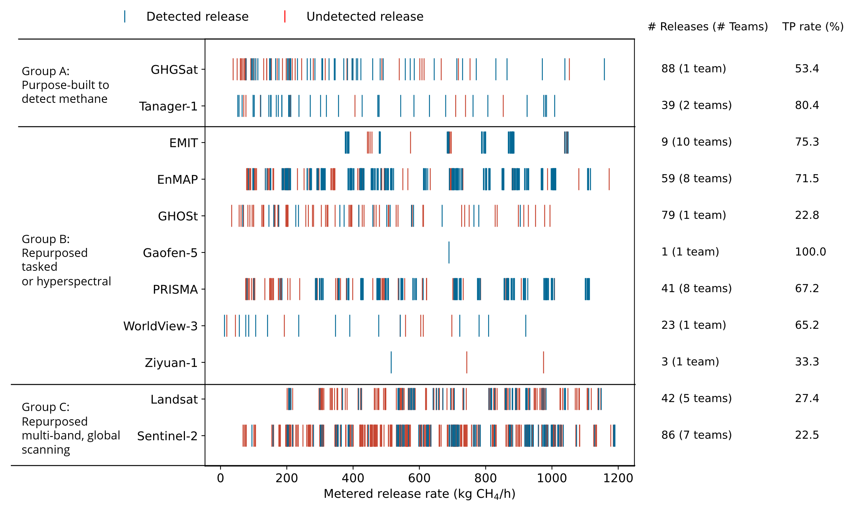
Figure S1. Detection outcomes over the distribution of metered release rates, by satellite and instrument grouping, including releases that were undetected for any reason. This chart differs from Figure 1 in the main text because it includes releases wherein the team did not detect for any reason (e.g., clouds).
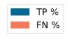
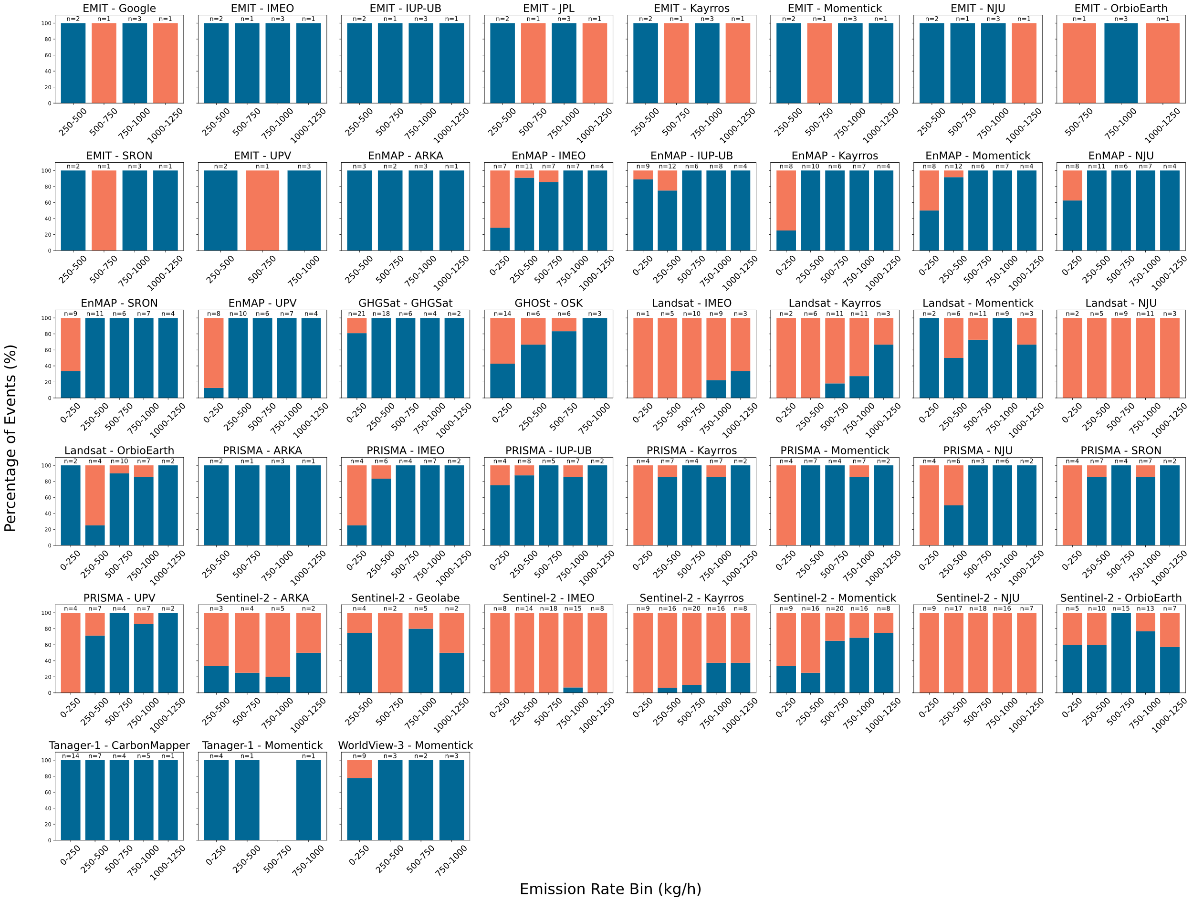

Figure S2. Detection performance binned by release rate. Some teams participated in different study phases and filtered different releases, leading to different counts for the same satellite.
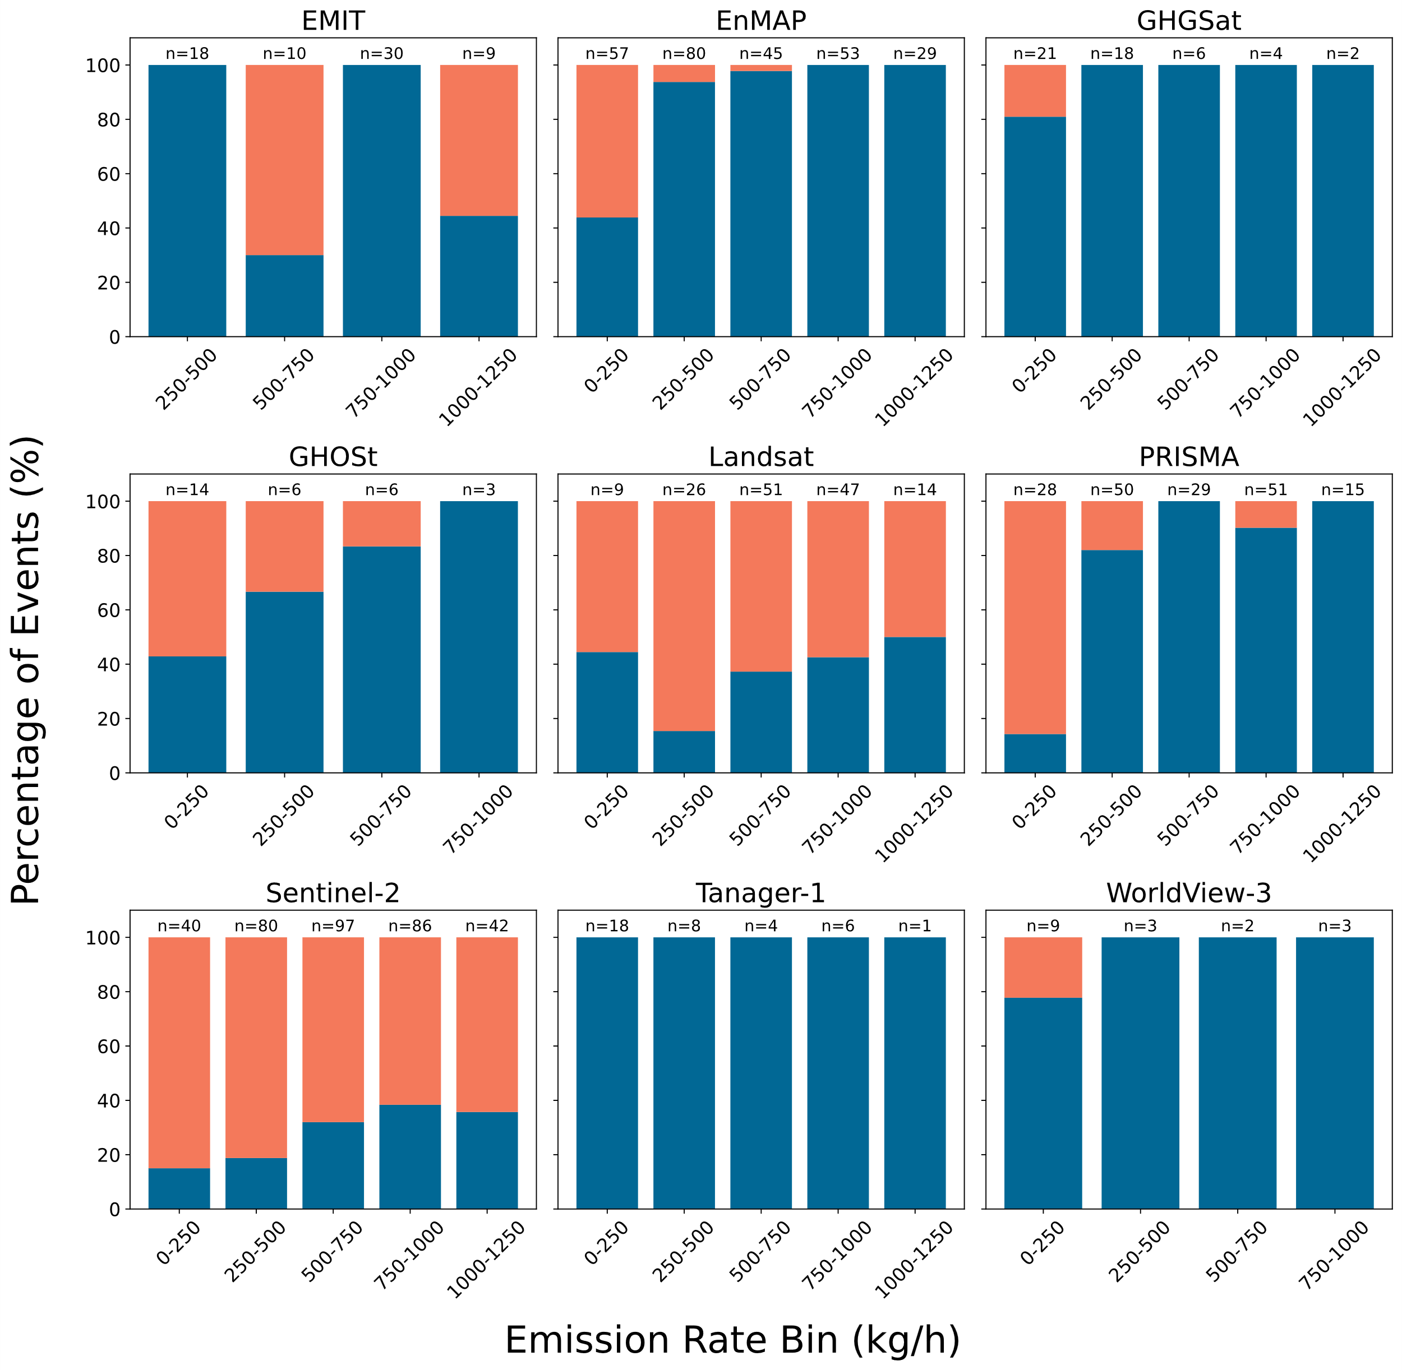

Figure S3. Detection outcomes for release events by satellite, binned by release rate. Counts represent number of releases and analyzing teams (e.g. 2 releases x 9 teams analyzing = 18).

S3.4 Classification performance by team and satellite

The following metrics were calculated for each team-satellite pairing to evaluate their classification performance (Table S6). The calculations are based on the four possible outcomes for an unfiltered release or non-release event: TN, TP, FN, FP.

- Observed accuracy: the overall proportion of correct classifications out of all classifications made.
  - (TP + TN) / (TP + FP + TN + FN)
- Baseline accuracy (prevalence): the accuracy a naive model would achieve by always guessing the most prevalent class. In this experiment, the most prevalent class is most often “True” since more events were releases than non-releases. It represents the benchmark to beat, and methods that improve upon baseline accuracy may be evidencing detection skill.
- p_value: the probability of a team achieving their Observed Accuracy or better, under the null hypothesis where no detection skill exists. That null world is created through permutation analysis: their labels were assigned randomly with a 10,000-fold permutation test. By permuting their reported results, this accounts for the team's specific guess rate (i.e., how often they guessed "True" vs. "False"). A small P-value suggests that the team's performance is statistically significant and unlikely to be the result of random chance. The lowest possible P-value is 0.00001 due to the use of 10,000 simulations.
- Sensitivity (recall): measures the ability of the team to find all the actual "True" cases.
  - TP / (TP + FN)
- Specificity: measures the ability of the team to find all the actual “False” cases.
  - TN / (TN + FP)
- Precision: measures the accuracy of the positive predictions
  - TP / (TP + FP)
- F1 score: the harmonic mean of Precision and Sensitivity
- Balanced accuracy: the average of Sensitivity and Specificity. This metric provides a more representative measure of overall performance than Observed Accuracy when the actual number of "True" and "False" cases is unequal (as it is in our case, where we performed about 2/3 “True” releases and 1/3 “False” non-release controls).

We present significance P-value thresholds of 0.05 and 0.01. Some teams with high accuracy are non-significant statistically. This tends to occur where baseline accuracy is high and overall sample sizes are small. No correction for multiple comparison is performed, so significant results near thresholds could represent random chance. For cases with very low P-values, any correction for multiple comparisons would have trivial impacts.

Table S6. Metrics of classification performance by satellite and team. p_value * <0.05, ** <0.01

Satellite | Team | Observed accuracy | Baseline accuracy | p_value | Sensitivity  (recall) | Specificity | Precision | F1 | Balanced accuracy
Tanager | CM | 1 | 0.861 | 9.999E-05  ** | 1 | 1 | 1 | 1 | 1
Tanager | MO | 1 | 0.857 | 0.143 | 1 | 1 | 1 | 1 | 1
GHGSat | GHG | 0.916 | 0.85 | 9.999E-05  ** | 0.923 | 0.889 | 0.97917 | 0.945 | 0.905
EMIT | GOO | 0.714 | 1 | 1 | 0.714 | n/a | 1 | 0.833 | n/a
EMIT | IMEO | 1 | 0.778 | 0.029 * | 1 | 1 | 1 | 1 | 1
EMIT | IUP | 1 | 0.778 | 0.029 * | 1 | 1 | 1 | 1 | 1
EMIT | JPL | 0.714 | 1 | 1 | 0.714 | n/a | 1 | 0.833 | n/a
EMIT | KAY | 0.778 | 0.778 | 0.167 | 0.714 | 1 | 1 | 0.833 | 0.857
EMIT | MO | 0.778 | 0.778 | 0.413 | 0.857 | 0.5 | 0.85714 | 0.857 | 0.679
EMIT | NJU | 0.889 | 0.778 | 0.084 | 0.857 | 1 | 1 | 0.923 | 0.929
EMIT | OE | 0.571 | 0.714 | 0.711 | 0.6 | 0.5 | 0.75 | 0.667 | 0.55
EMIT | SRON | 0.889 | 0.778 | 0.084 | 0.857 | 1 | 1 | 0.923 | 0.929
EMIT | UPV | 0.889 | 0.778 | 0.086 | 0.857 | 1 | 1 | 0.923 | 0.929
EnMAP | ARKA | 1 | 0.818 | 0.016 * | 1 | 1 | 1 | 1 | 1
EnMAP | IMEO | 0.825 | 0.9 | 0.004 ** | 0.806 | 1 | 1 | 0. 892 | 0.903
EnMAP | IUP | 0.822 | 0.867 | 0.174 | 0.897 | 0.333 | 0.897 | 0.897 | 0.615
EnMAP | KAY | 0.846 | 0.897 | 0.003 ** | 0.829 | 1 | 1 | 0.906 | 0.914
EnMAP | MO | 0.854 | 0.902 | 0.018 * | 0.865 | 0.75 | 0.970 | 0.914 | 0.807
EnMAP | NJU | 0.925 | 0.9 | 0.0004 ** | 0.917 | 1 | 1 | 0.957 | 0.958
EnMAP | SRON | 0.854 | 0.902 | 0.002 ** | 0.838 | 1 | 1 | 0.912 | 0.919
EnMAP | UPV | 0.821 | 0.897 | 0.005 ** | 0.8 | 1 | 1 | 0.889 | 0.9
GHOSt | OSK | 0.783 | 0.517 | 9.999E-05 ** | 0.621 | 0.935 | 0.9 | 0.735 | 0.778
Gaofen5 | NJU | 1 | 1 | 1 | 1 | n/a | 1 | 1 | n/a
PRISMA | ARKA | 1 | 0.875 | 0.125 | 1 | 1 | 1 | 1 | 1
PRISMA | IMEO | 0.852 | 0.852 | 0.005 ** | 0.826 | 1 | 1 | 0.905 | 0.913
PRISMA | IUP | 0.8 | 0.867 | 0.453 | 0.885 | 0.25 | 0.885 | 0.885 | 0.567
PRISMA | KAY | 0.786 | 0.857 | 0.010 * | 0.75 | 1 | 1 | 0.857 | 0.875
PRISMA | MO | 0.821 | 0.857 | 0.005 ** | 0.792 | 1 | 1 | 0.884 | 0.896
PRISMA | NJU | 0.72 | 0.84 | 0.025 * | 0.667 | 1 | 1 | 0.8 | 0.833
PRISMA | SRON | 0.786 | 0.857 | 0.010 * | 0.75 | 1 | 1 | 0.857 | 0.875
PRISMA | UPV | 0.75 | 0.857 | 0.016 * | 0.708 | 1 | 1 | 0.829 | 0.854
WV3 | MO | 0.818 | 0.773 | 0.055 | 0.882 | 0.6 | 0.882 | 0.882 | 0.741
ZY1 | NJU | 1 | 1 | 1 | 1 | n/a | 1 | 1 | n/a
Landsat | IMEO | 0.590 | 0.541 | 0.090 | 0.107 | 1 | 1 | 0.194 | 0.554
Landsat | KAY | 0.644 | 0.548 | 0.002 ** | 0.212 | 1 | 1 | 0.35 | 0.606
Landsat | MO | 0.8 | 0.557 | 9.999E-05 ** | 0.774 | 0.821 | 0.774 | 0.774 | 0.797
Landsat | NJU | 0.565 | 0.565 | 1 | 0 | 1 |  |  | 0.5
Landsat | OE | 0.694 | 0.510 | 0.005 ** | 0.8 | 0.583 | 0.667 | 0.727 | 0.692
Sentinel-2 | ARKA | 0.536 | 0.5 | 0.498 | 0.286 | 0.786 | 0.571 | 0.381 | 0.536
Sentinel-2 | GEO | 0.769 | 0.5 | 0.005 ** | 0.615 | 0.923 | 0.889 | 0.727 | 0.769
Sentinel-2 | IMEO | 0.492 | 0.516 | 0.516 | 0.016 | 1 | 1 | 0.031 | 0.508
Sentinel-2 | KAY | 0.565 | 0.527 | 0.001 ** | 0.174 | 1 | 1 | 0.296 | 0.587
Sentinel-2 | MO | 0.667 | 0.523 | 9.999E-05 ** | 0.536 | 0.80952 | 0.755 | 0.627 | 0.673
Sentinel-2 | NJU | 0.485 | 0.515 | 1 | 0 | 1 | n/a | n/a | 0.5
Sentinel-2 | OE | 0.620 | 0.543 | 0.026 * | 0.76 | 0.452 | 0.623 | 0.685 | 0.606

S3.5 Statistical analysis of false positive rates

To evaluate if AI-based methods were significantly more likely to produce false positives (FPs), we run a bootstrap analysis. In our dataset, AI-based methods produced 58 FPs across 302 blank scenes (False Positive Rate [FPR] = 19.2%), while non-AI methods produced 13 FPs across 317 blank scenes (FPR = 4.1%). We perform 100,000 bootstrap iterations. In each iteration, the FPRs for the AI and non-AI groups are simulated by resampling their respective true negative and false positive outcomes with replacement. The difference between the simulated AI and non-AI FPRs is recorded.

This procedure yields a 95% confidence interval for the difference in FPRs (AI FPR - Non-AI FPR) of [0.1018, 0.2004]. The probability of observing a difference less than or equal to zero under this model was negligible (p < 0.00001). Since the confidence interval does not contain zero, this provides strong statistical evidence that AI-based methods have a higher FPR.

We repeat the analysis with subsets 1) Group A and B satellites only and 2) Group C satellites only. The higher FPRs for AI-based methods remains statistically significant for the Group C subset. There was no statistically significant difference in the FPRs between AI and non-AI methods for Group A and B satellites.

S3.6 Real-world plume observations with Tanager-1

To contextualize the performance observed in the experiment, we analyzed a set of real-world Tanager-1 plume detections. We downloaded all publicly available (as of February 18, 2026) Tanager-1 plumes from the Permian Basin, a desert region with numerous emission sources and an environment relatively similar to the test site.

Figure S4 shows the distribution of the 762 quantified emission rates (plumes >1500 kg/h not shown). The count of plumes in the 200-300 kg/h bin is comparable to the 300-400 kg/h bin, and both are substantially larger than the count in the 100-20 kg/h bin. Given expected power-law behavior of emission source populations in the Permian down to at least 100 kg/h, the drop-off in detections below 200-400 kg/h suggests that Tanager-1 is operating within its partial detection range.

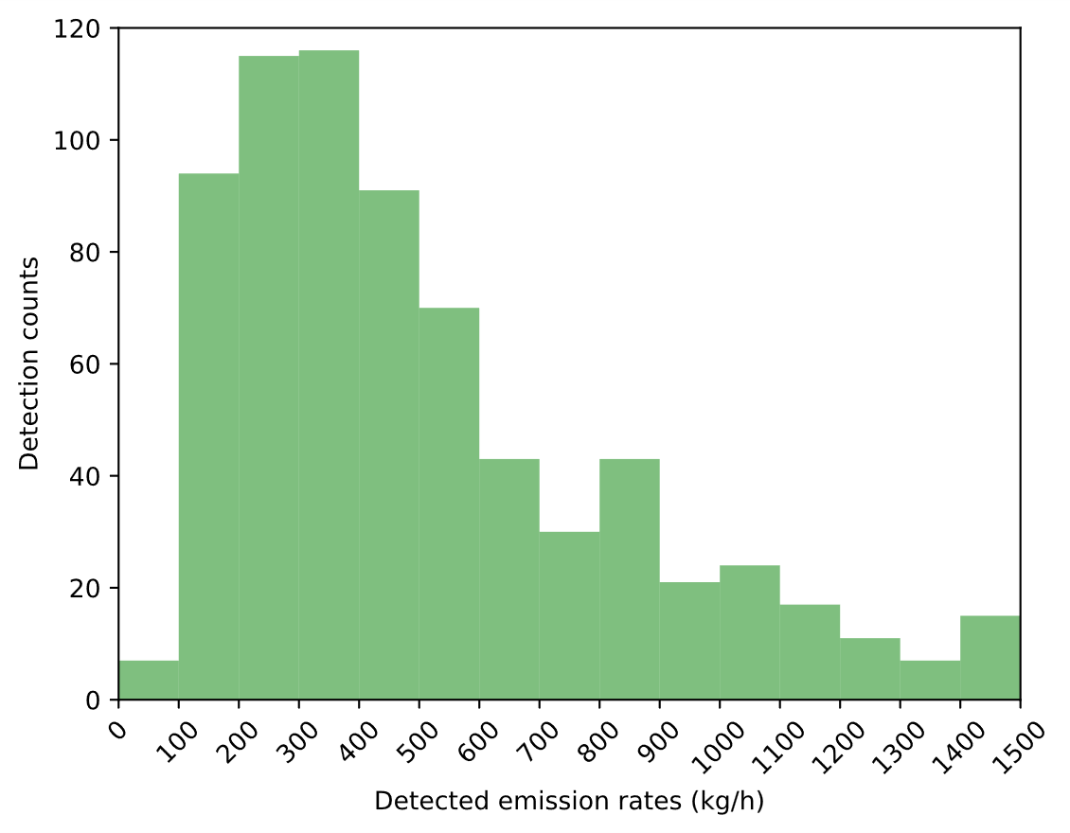
Figure S4. Tanager-1 plume detections in the Permian basin
S3.7 Detection and meteorology effects

Figure S5 illustrates the proportion of accurate detection outcomes (the sum of True Positives and True Negatives divided by total attempts) for each satellite typology, binned by 10 m wind speed. Uncertainty bands are generated using the Wilson score interval (https://www.mwsug.org/proceedings/2008/pharma/MWSUG-2008-P08.pdf).

The purpose-built Group A satellites demonstrated a high proportion of accurate detections (>0.9) across a broad range of wind speeds (0–6 m/s). A slight reduction in accuracy was observed in the highest wind bin (>6 m/s); however, high wind speed samples were limited.

Of the three groups, the repurposed hyperspectral instruments (Group B) showed the most sensitivity to wind speed, with observed accuracy declining for winds exceeding 3 m/s. This suggests that in some cases stronger winds more quickly dilute plumes and push methane enhancements below detectable limits. A deeper examination of wind effects and statistical significance is reserved for future investigation.

The multispectral scanners (Group C) exhibited a consistent but more modest proportion of accurate detections (~0.6) that was largely independent of wind speed across the tested range.

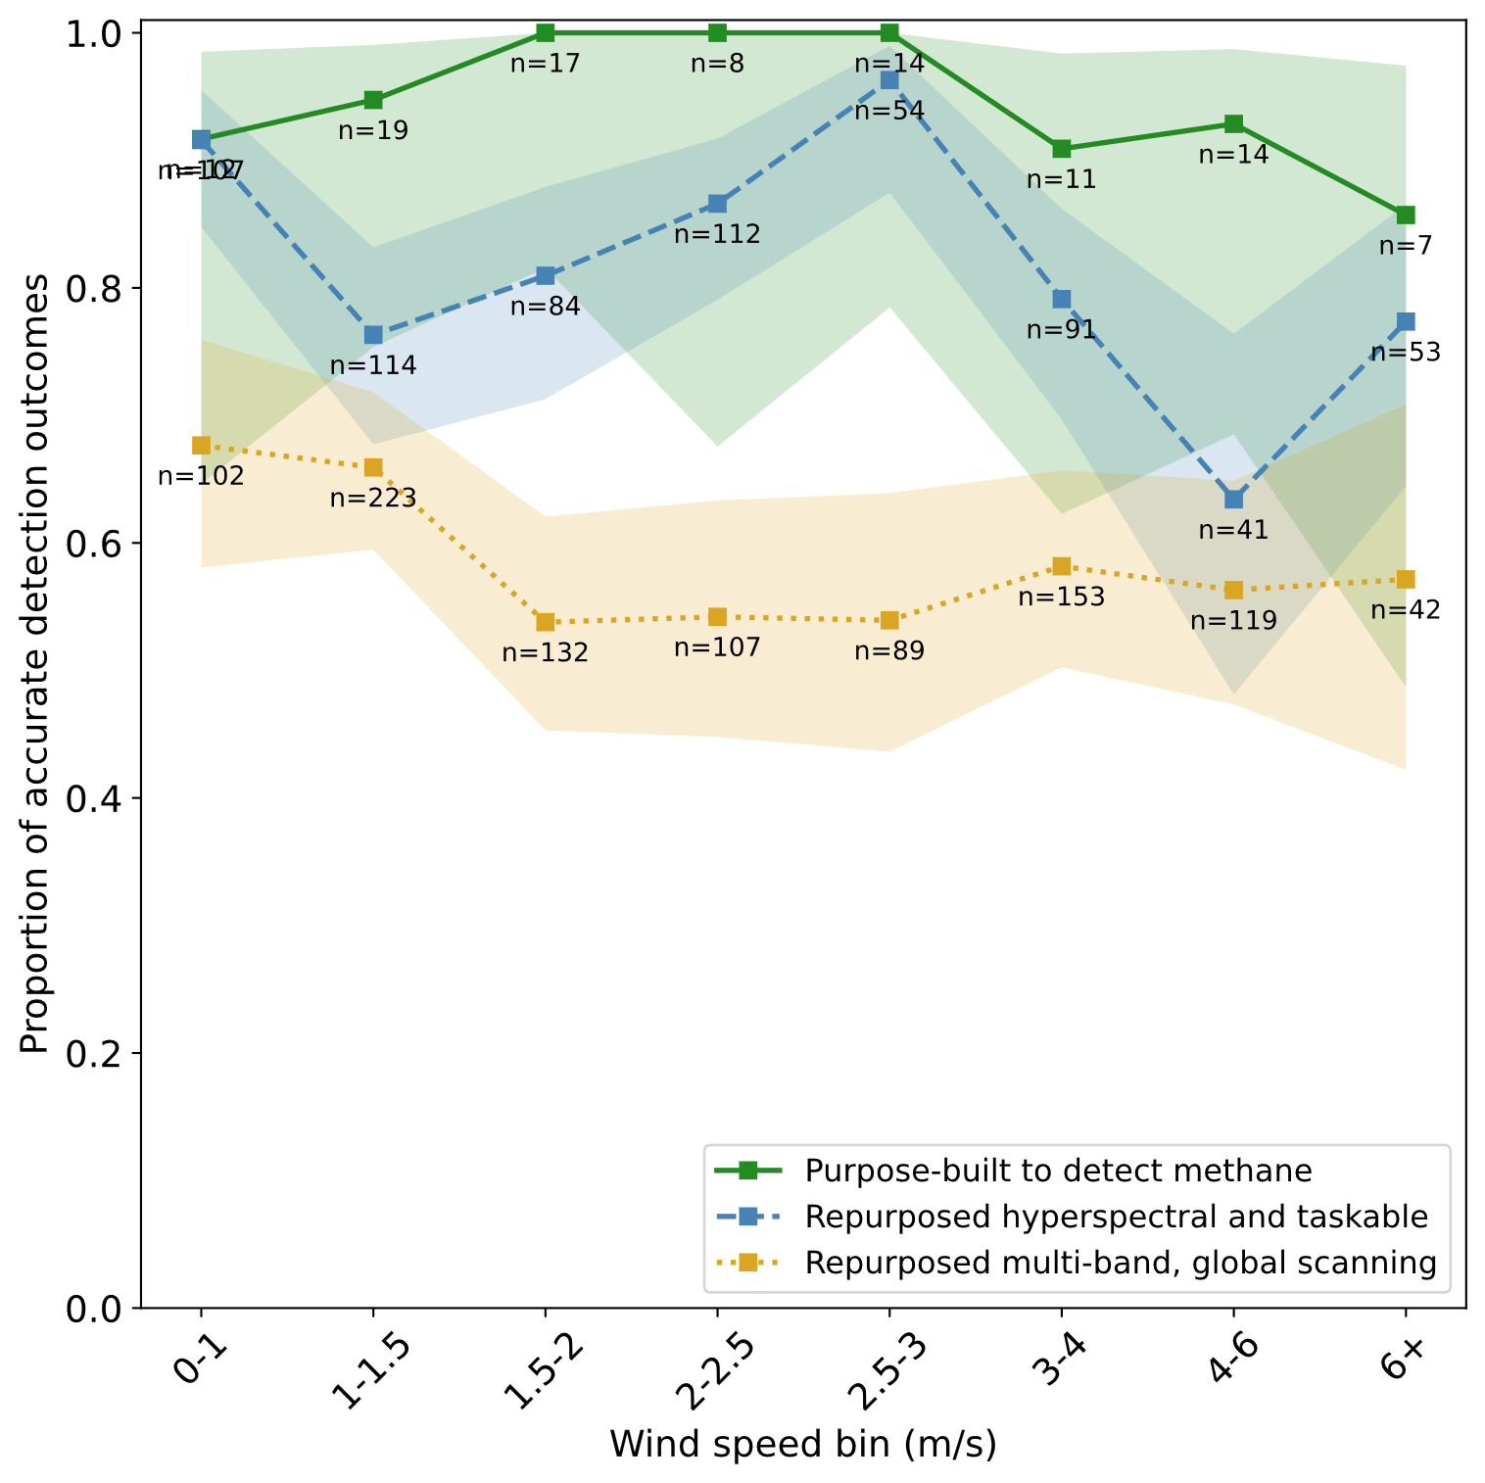
Figure S5. Detection accuracy across satellite typologies, binned by wind speed. Samples per bin listed on chart

Figure S6 presents the distribution of all attempted release rates alongside the distribution of successfully detected rates, both binned by 10 m wind speed. The distribution of release rates attempted during the experiment (grey bars), including the mean and interquartile range, remains relatively consistent across all wind speed bins. In contrast, the distribution of successfully detected release rates (green bars) shows dependence on wind speed. As expected, the mean detected emission rate increases with increasing wind speed, indicating teams were less able to detect smaller releases during windier conditions. At the highest wind speed bin, only the largest of releases are able to be detected. Although not broken out here, all three satellite groupings (A, B, C) are represented in the highest windspeed bin. A deeper examination of how windspeed affects detection capabilities is warranted for future study.

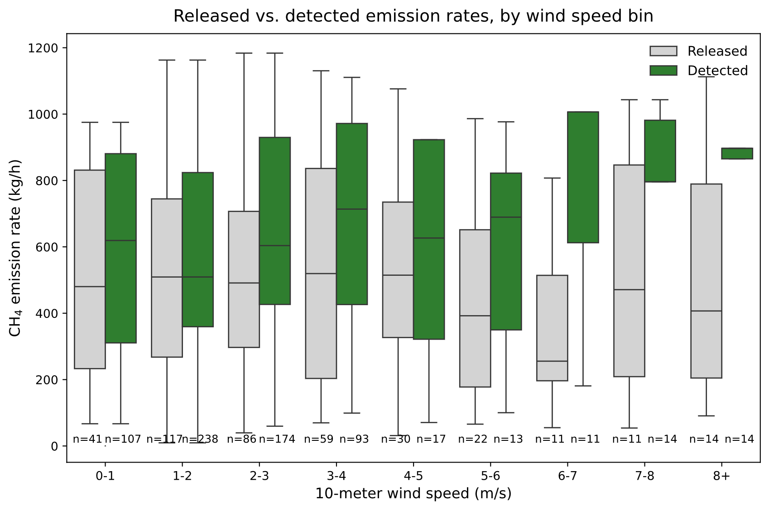
Figure S6. Distribution of release rates and detected release rates, binned by wind speed.

Figure S7 presents a comparison of the 10 m wind speeds used by analysis against the ground-truth measurements recorded on-site, averaged over a five-minute period prior to each overpass. The scatter plot reveals only weak to moderate agreement.

As detailed in the individual team descriptions, teams sourced wind information from several different reanalysis products, including ERA5, HRRR, GEOS-FP, and OpenWeatherMap. Each team may apply has its own spatial and temporal interpolation techniques to estimate the wind conditions at the location and time of the overpass. Also, each team may convert the resulting wind speed to an “effective” wind speed that is used in the IME or IME-like method. While not explored in depth here, how these meteorological discrepancies affect final quantification results merits future study.

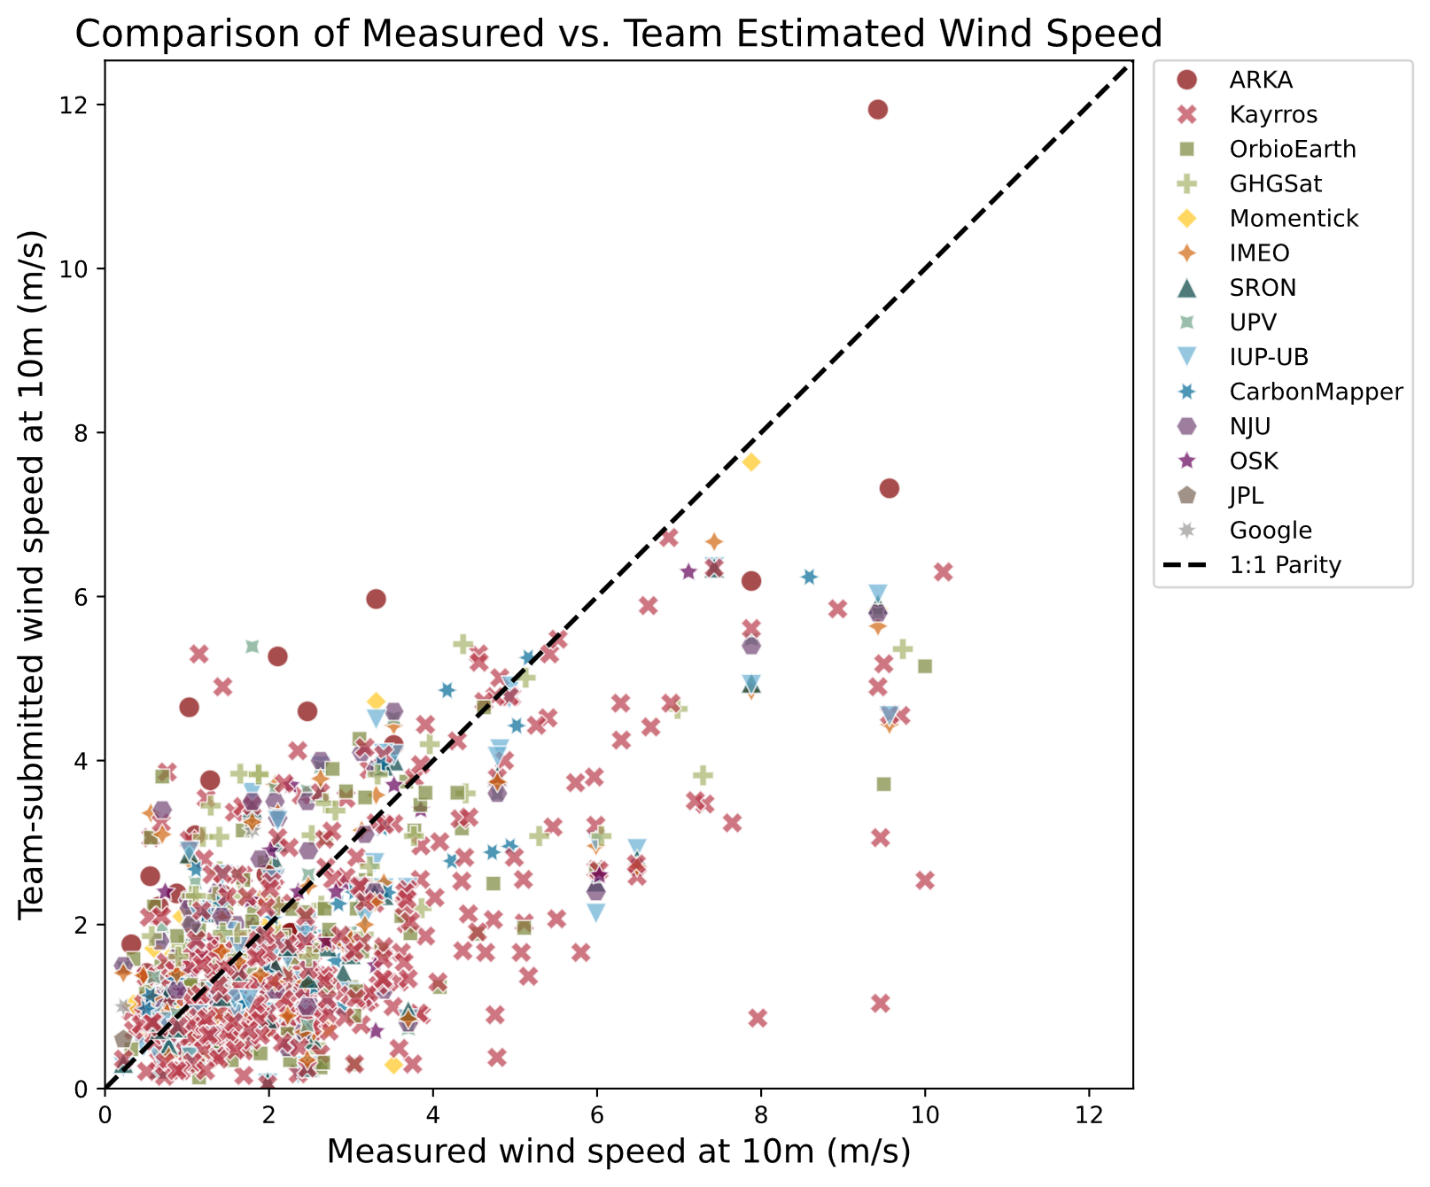
Figure S7. Scatter plot of 5-minute averaged windspeeds at 10 m measured onsite, compared to team-submitted windspeeds at 10 m. Analysing teams source wind information from different reanalysis products. Geolabe did not report 10 m windspeeds.

S3.8 Enhancements and plume masks

Figures S8 through S52 show an enhancement and plume mask (if applicable) for each satellite-team pairing. Each figure shows a wind rose of the 10-min average of 10 m wind speed prior to the satellite overpass. Image selection was random, with priority given to choosing events from days that featured multiple satellite overpasses.

Figure S8.
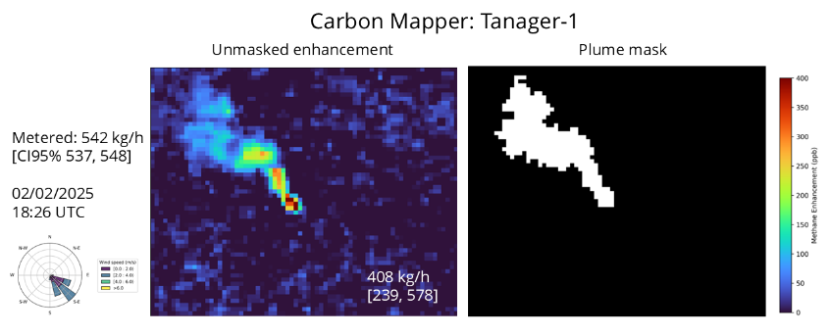

Figure S9.
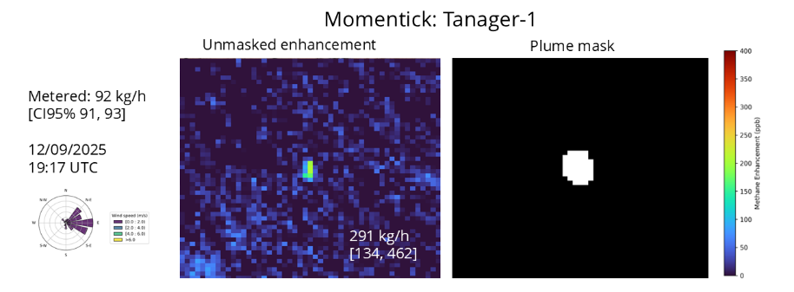

Figure S10.
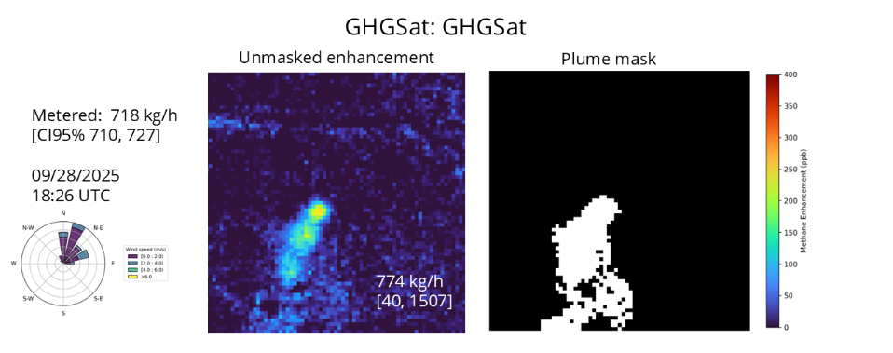

Figure S11.
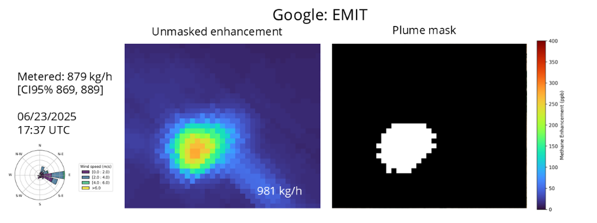

Figure S12.
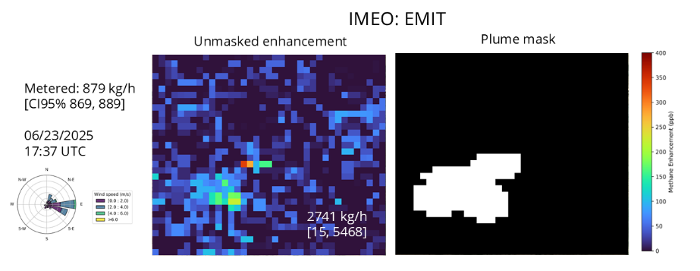

Figure S13.
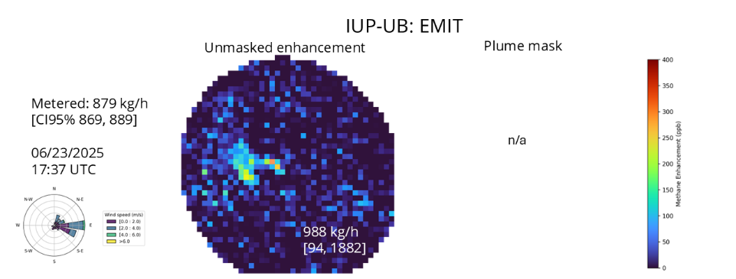

Figure S14.
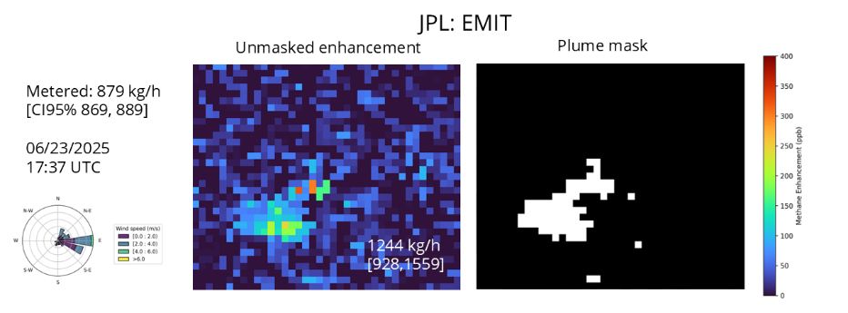

Figure S15.
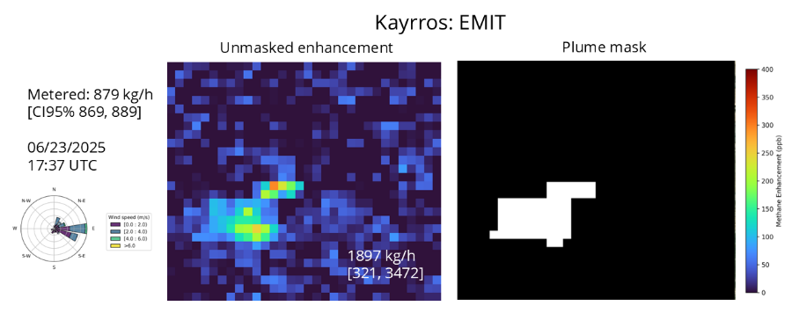

Figure S16.
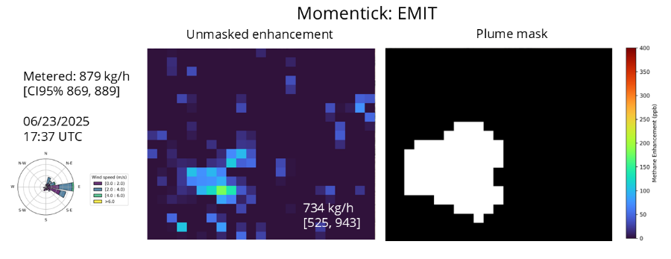

Figure S17.
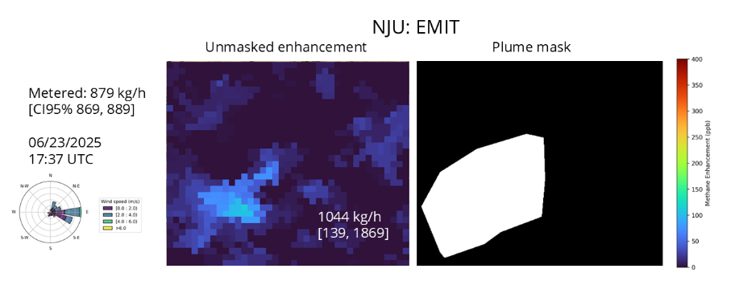
Figure S18.
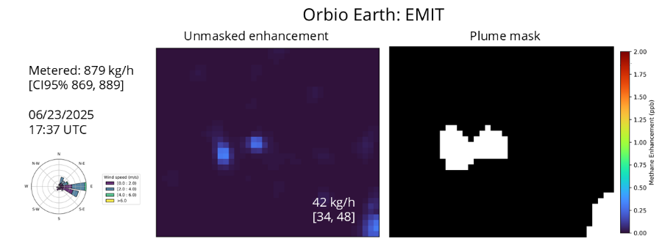
Note: Change in color scale on this image to show very small enhancement.

Figure S19.
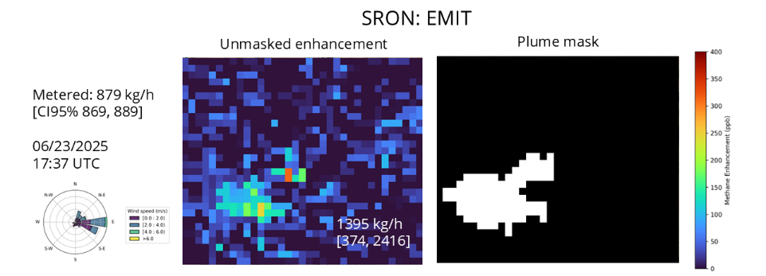

Figure S20.
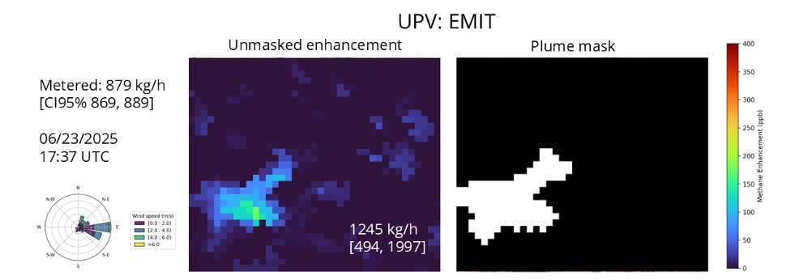

Figure S21.
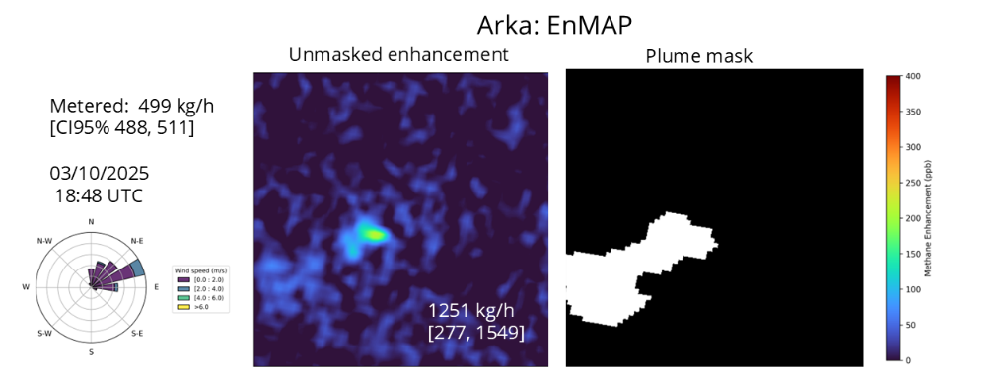

Figure S22.
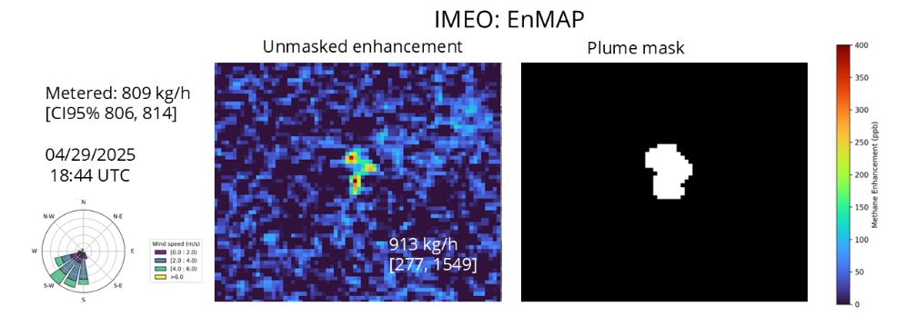

Figure S23.
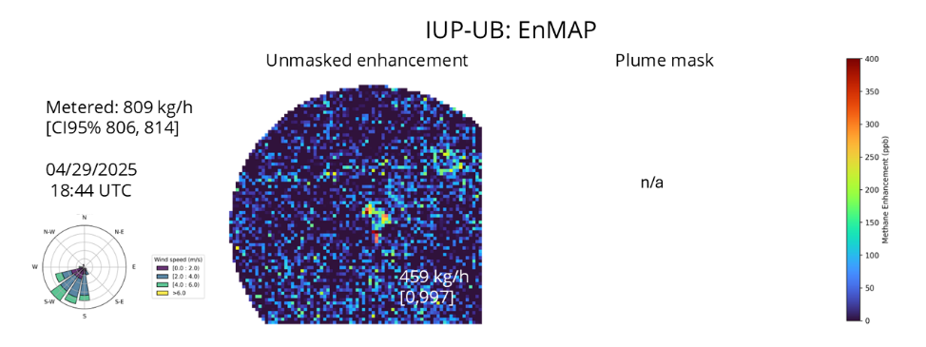
Figure S24.
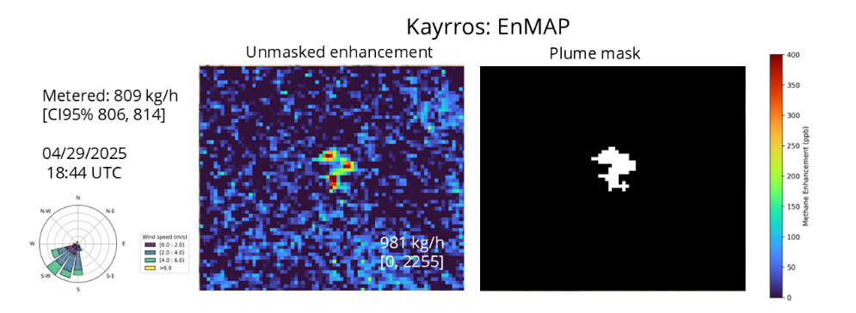

Figure S25.
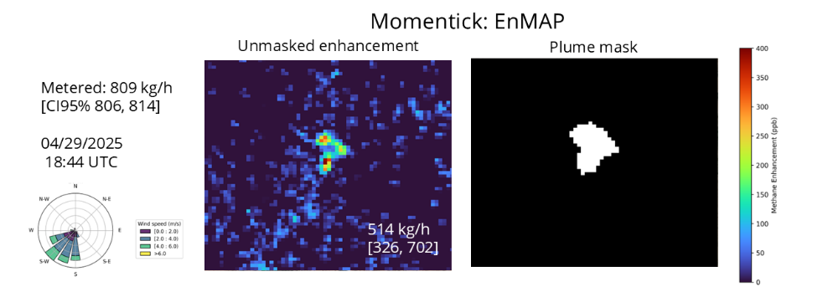

Figure S26.
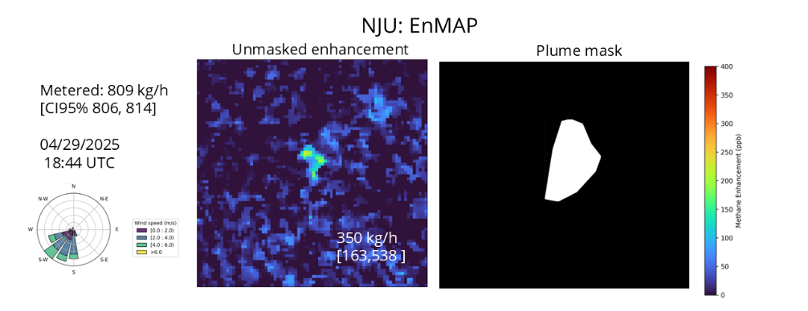
Note: No CRS was provided for the enhancement; Mask location is approximated to the enhancement.

Figure S27.
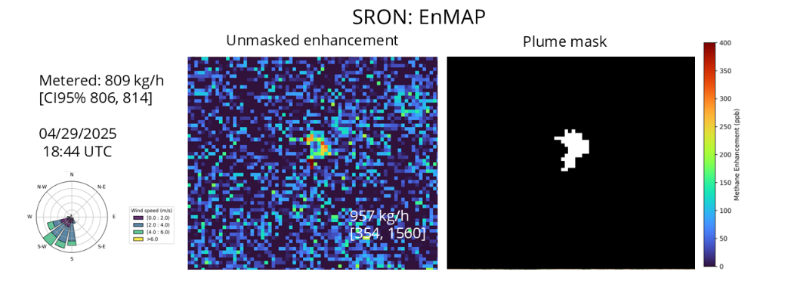
Figure S28.
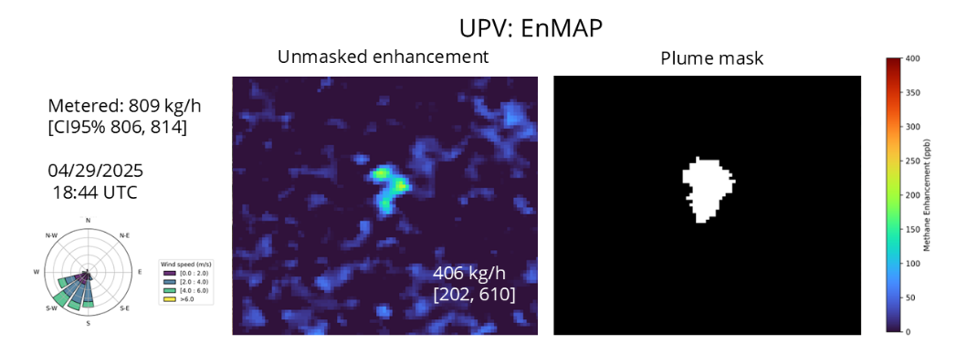
Figure S29.
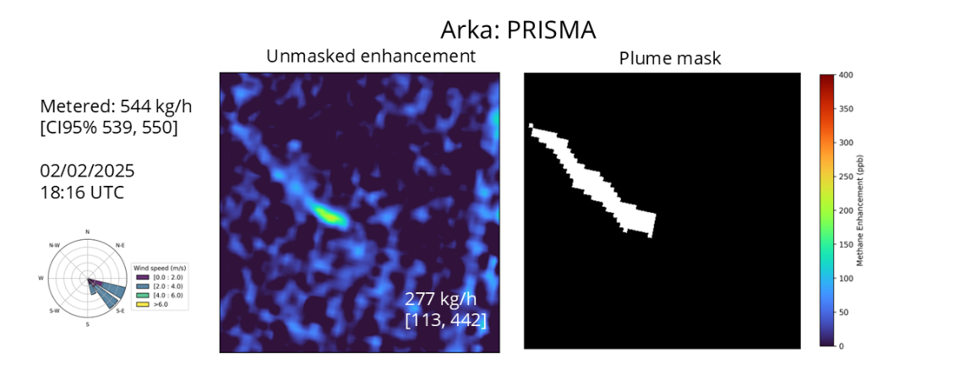

Figure S30.
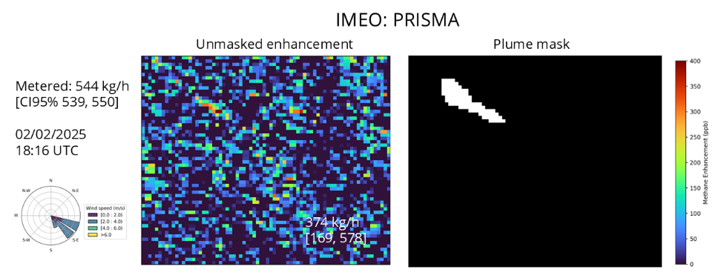

Figure S31.
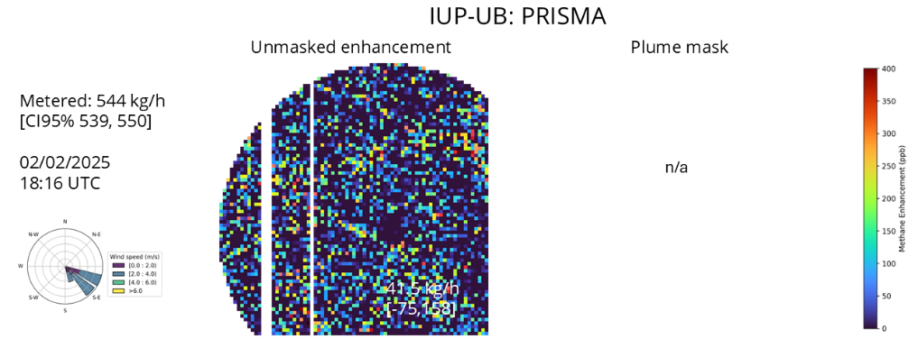
Figure S32.
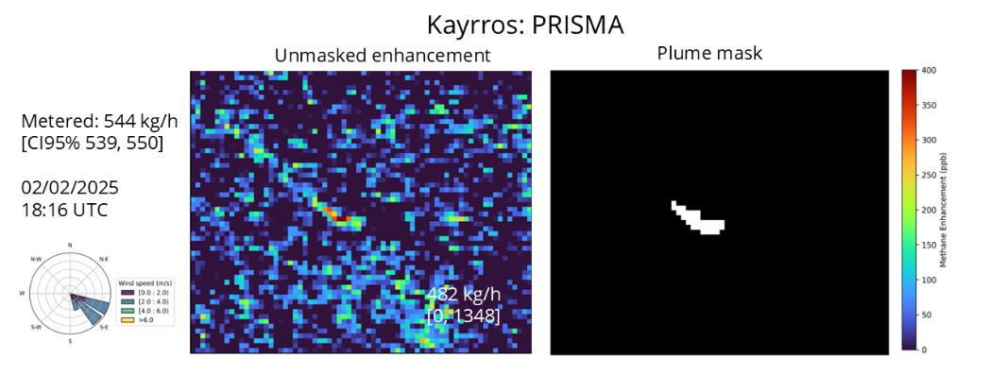
Figure S33.
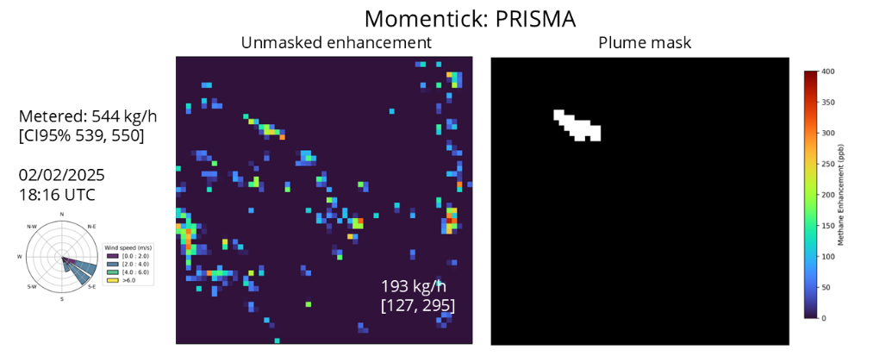

Figure S34.
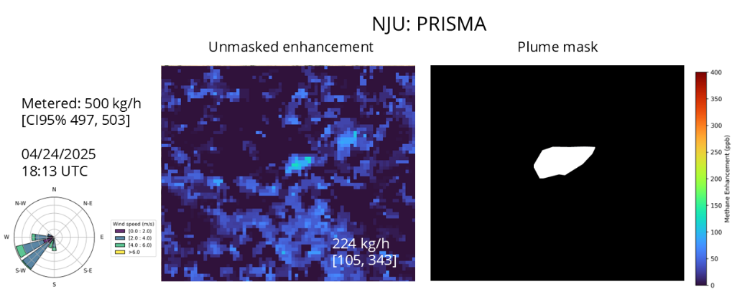
Figure S35.
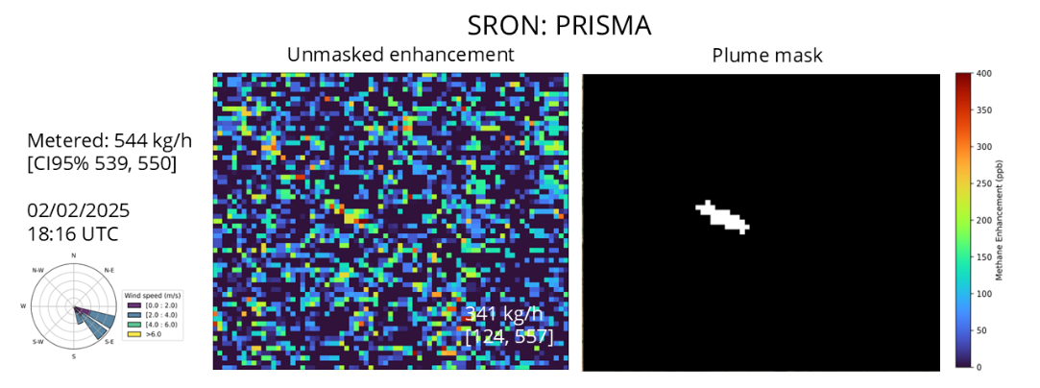
Figure S36.
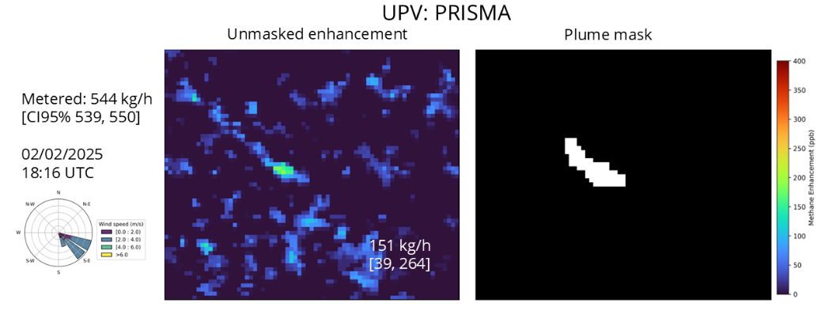

Figure S37.
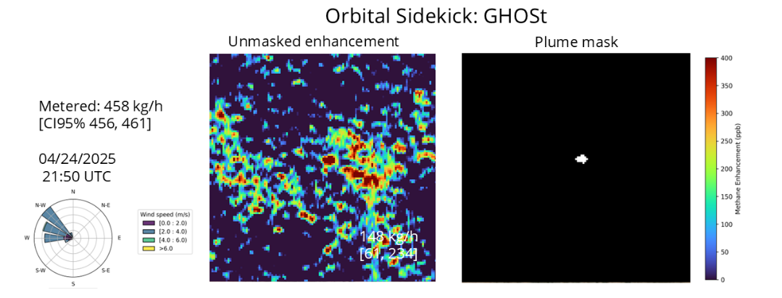
Figure S38.
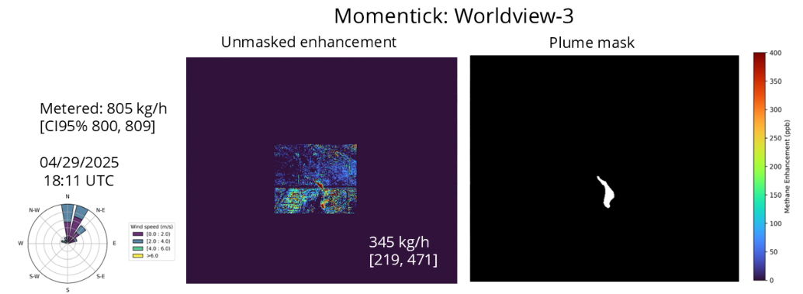
Figure S39.
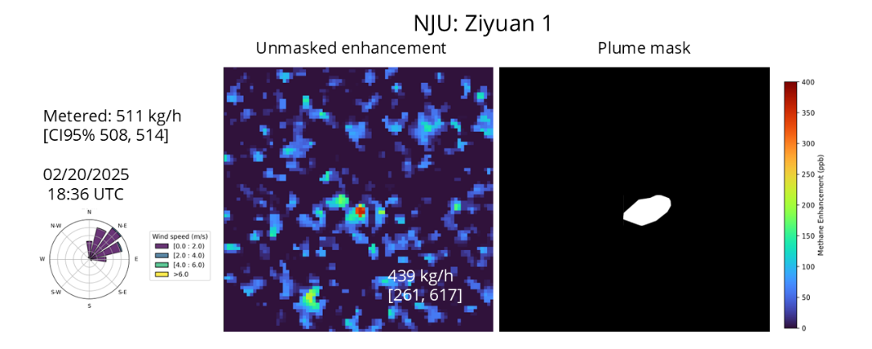
Note: No CRS was provided for the enhancement; Mask location is approximated to the enhancement.

Figure S40.
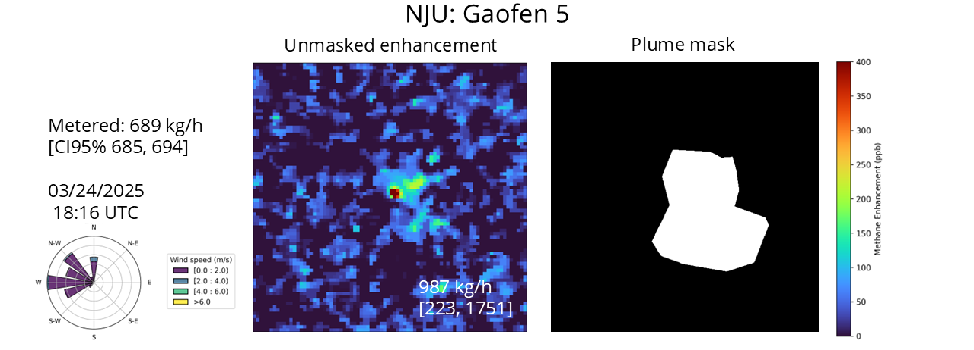
Note: No CRS was provided for the enhancement; mask location is approximated to the enhancement.

Figure S41.
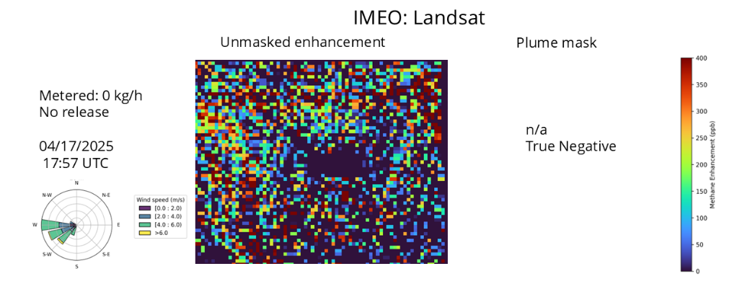
Figure S42.
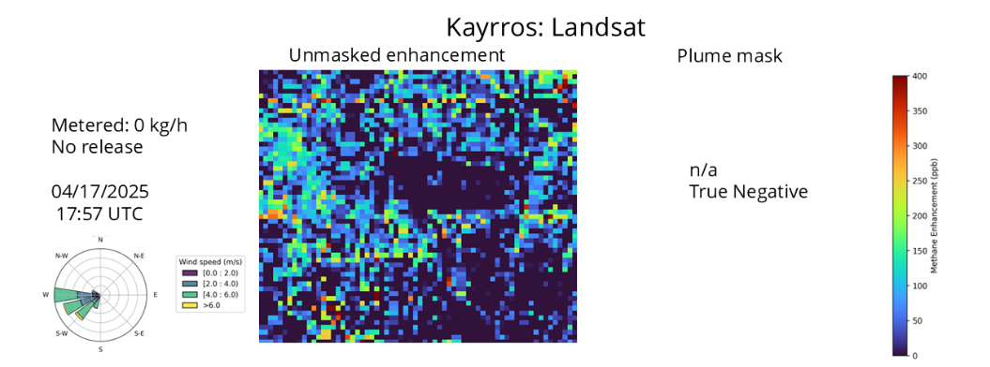

Figure S43.
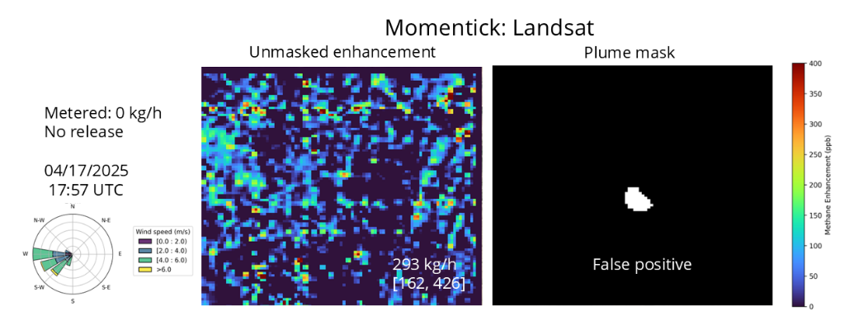
Figure S44.
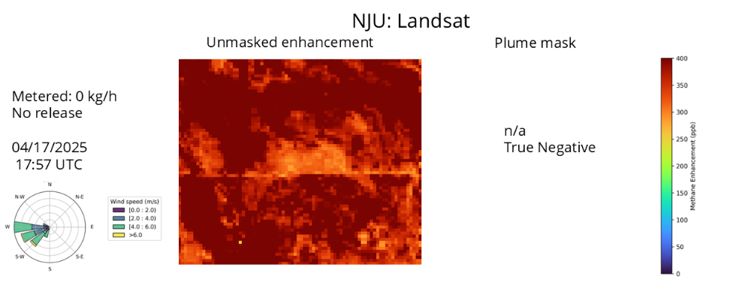
Figure S45.
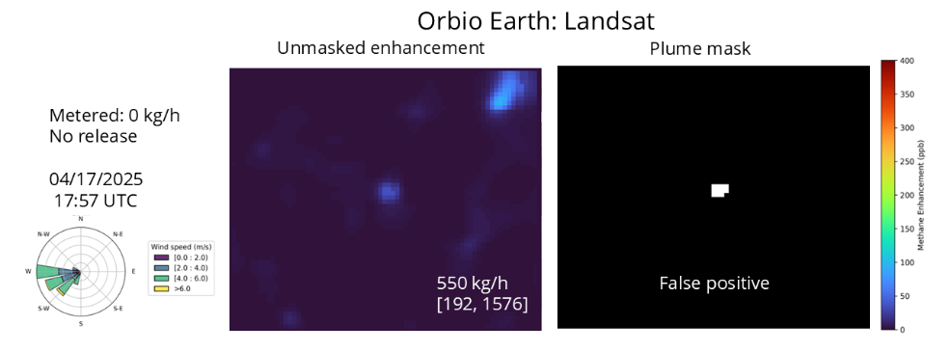

Figure S46.
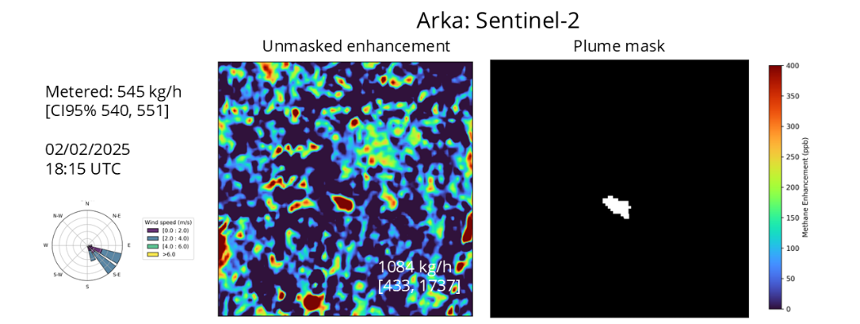

Figure S47.
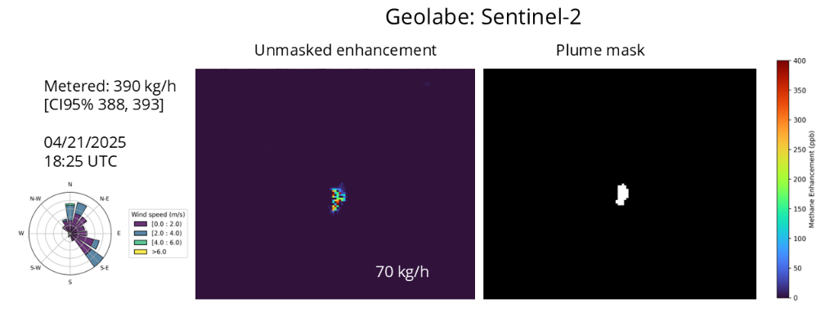
Figure S48.
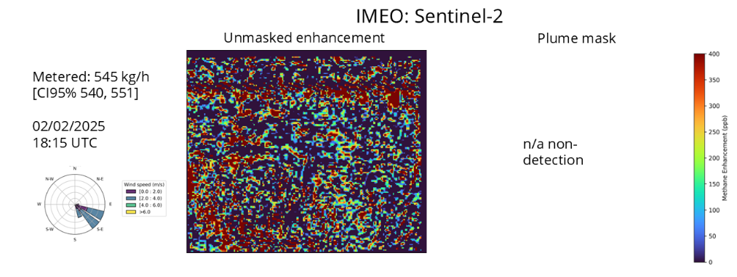
Figure S49.
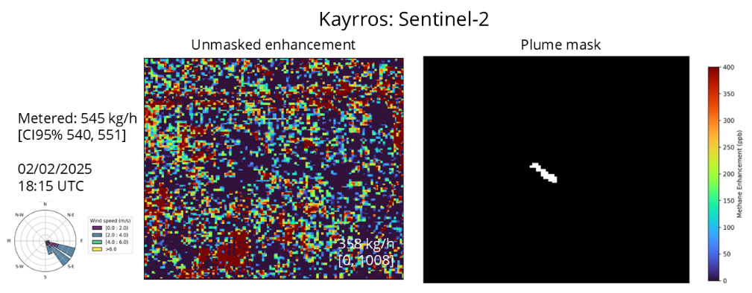

Figure S50.
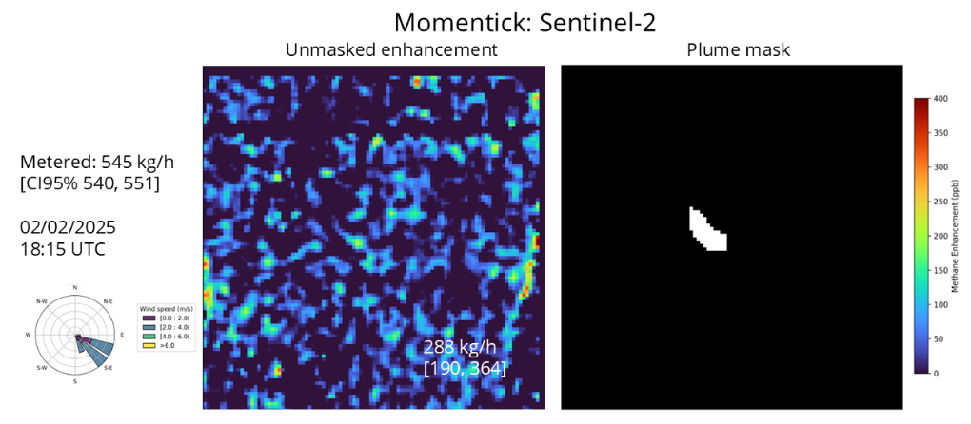

Figure S51.
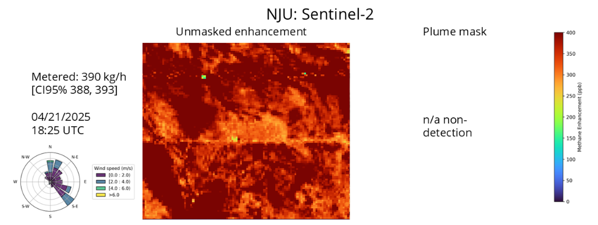

Figure S52.
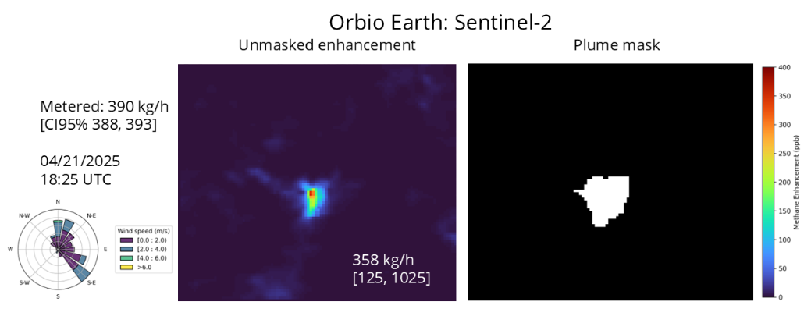

S3.9 Quantification results

S3.9.1 Methodology for Quantification Fits and Simulation Study

To characterize the quantification performance of each satellite-team pairing, we required a minimum of five true positive (TP) detections to fit an Ordinary Least Squares (OLS) regression. Most pairings met this threshold since, in most cases, dozens of release opportunities occurred over the year-long study. Exceptions included the NJU team analyzing GF5 and ZY1, which had fewer than five overpasses each. Some teams had fewer than five detections with Sentinel-2 and Landsat.

For each satellite-team pairing we applied two regression models:
- 2-Parameter ("2P") Model: A regression with a free slope and intercept, fit only to TP estimates.
- 2-Parameter ("2P") Model: A regression with a free slope and intercept, fit to both TP and false positive (FP) estimates.

This approach differs from prior work that exclusively used a forced-zero-intercept model^{11,21}. The decision to use both models was informed by a simulation study, detailed below. Alternative regressions to OLS, including York and standardized major axis, are available and useful for accounting for error in x values, when relevant. However, in this case, x-direction errors with a mean 95% confidence interval of +/- 1.1% (max +/- 8.0%) are small compared to y-direction errors. Sherwin et al. (2023) also shows these alternatives can introduce undesirable upward bias in the slopes.

Simulation Design for Quantification Fit

The primary goal of the simulation was to answer the question: Which regression model, when fit to controlled release data, provides the most useful correction factor for measurements of real-world sources of unknown rates? That is, if we use our regression results to later correct real-world measurements for instrument bias and noise, which fit is likely to produce corrected results that are most aligned with the actual volumes?

To determine the optimal fitting strategy, we designed a simulation to mimic the process of calibration and application. Simulation steps were:

- Generate a synthetic calibration dataset
- A synthetic emission rates dataset was generated to mimic 100 test releases, with rates drawn from a uniform random distribution between 0 and 1250 kg/h, in line with the operational range of our release equipment

- Simulate sensor performance for hypothetical sensors
- A hypothetical sensor's performance was simulated by systematically varying key parameters; parameter values were altered by sweeping over pre-defined value ranges. This artificial performance simulation allowed us to determine which fitting method would give the best representation of the real-world observations across a range of sensor performance settings.
- Sensor performance parameters were:
    - Probability of detection (POD) curves characterized by variable sigmoid width scales (sweep range: 10 to 150 kg/h) and midpoint (50%) parameters (sweep range 0 to 500 kg/h) were applied to the synthetic emission rates
    - Quantification Bias: Both additive bias (sweep range: -100 to 100 kg/h) and multiplicative scaling bias (multiplier range: 0.6 to 1.4) were applied to the measured emission rates of detected plumes
    - Noise: Random noise was added to bias multiplier (sweep range: 0.15 to 0.3) and the quantified estimates (gaussian noise sigma sweep range: 10 to 300 kg/h)
    - False Positives: FPs were introduced at varying rates (0% to 15%), with estimated emission rates either simulated randomly or drawn from a half-normal distribution based on the quantification noise level

- Calibrate models
- For each simulated dataset generated, five regression models were fit to each sensor’s observed emission rates:
  - 1-Parameter fit (forced zero intercept) using all points (TPs and false negatives)
  - 1-Parameter fit using only TPs
  - 2-Parameter fit (free intercept) using all points
  - 2-Parameter fit using only TPs
  - 2-Parameter fit using TPs and FPs
- Note: in scenarios with no FPs, Fit D and E are the same.
- Figure S53 shows an example of the Fits C, D and E for one simulation. Note that the inclusion of FPs in the fit results in larger y-intercepts and flatter slopes

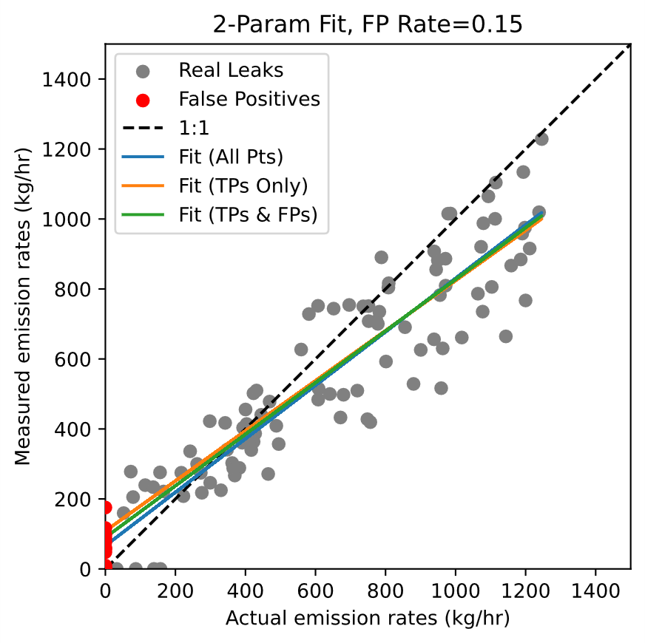
Figure S53. Example 2-parameter simulated fits

- Generate a synthetic validation dataset
- A separate "real-world" validation dataset of 100 emission rates was generated, with rates drawn from a log-normal distribution to represent typical “in-the-wild” emission profiles
- The same sensor performance characteristics (e.g. POD, bias, noise) from Step 2 were applied in each case.

- Evaluate model performance
- Each of the five calibration models A-E derived in Step 3 was used to "correct" the quantified estimates in the synthetic validation dataset. For example, if a 1P fit was derived to have a slope of 1.5, measurements would be corrected by dividing by 1.5 to estimate true emission rate.
- The performance of each model was then evaluated by calculating the ratio of the total corrected mass of detected emissions to the total true mass of those same detected emissions. Because we know the true mass of the synthetic validation dataset, we can exactly determine the impact of each correction. A ratio of 1.0 indicates a perfect correction.

Figures S54-S58 chart the distribution of the ratio of corrected emissions to true emissions for each calibration method when FPs were present. A mean ratio of 1.0 indicates a perfect correction. In scenarios with non-negligible FPs, the 2P model fit to both TPs and FPs (Fit E) consistently provided the most accurate correction, with a mean ratio closest to 1.0. Calibration models that did not incorporate the FPs in their fit were shown to overestimate total emissions when applied to the validation set. Meanwhile, in scenarios with no FPs, the 1P model fit only to TPs (Fit B) provides the best correction, while Fit E also performs well. Because we cannot determine the real-world FP rate, and because the 2-parameter fit to all data also works well in cases without false positives, we use the 2P fit to both TPs and FPs as the default result.

While it might be useful in some cases, we do not recommend using the 2P fit to only the TP data (Fit D). In some sense, this could be considered the “best” correction to the true results, in that it only includes TP data in making the correction. However, in a real-world case where corrections are to be applied to observations in real images, one does not know if any given measurement is a TP or FP measurement. Therefore, a fit only to TP data might underestimate the upward bias caused by the existence of FP measurements. The recommended fit for each satellite-team pairing in this study is denoted in Table S7.

Note on the exclusion of True Negatives

True Negatives (TNs) were intentionally excluded from the regression models based on the practicalities of operational monitoring. In any real-world monitoring scenario, the number of TNs is effectively unbounded; it depends on the total area and time surveyed and will always vastly outnumber the quantity of true detections. Including a potentially immense number of (0,0) data points would overwhelmingly anchor any regression to the origin. This could obscure the true performance characteristics of the system, such as a non-zero bias, when a plume is actually present. Furthermore, in a non-experimental scenario, a "non-detection" cannot be definitively confirmed as a TN without ground-truth knowledge, making the inclusion of such points in a generalizable calibration methodology more difficult.

Limitations of this approach

While the derivation of calibration factors is a primary goal, we caution that factors developed under these specific test conditions may not be directly applicable to measurements made under varying global scenarios. The favorable conditions of this experiment (e.g., constrained source location, generally high sunlight, high and spatially uniform albedo) will differ significantly from some of those encountered in operational plumes monitoring in diverse locations (e.g., cloudy regions, complex terrain). Further study is required to determine the global applicability of these findings.

This approach is expected to behave well for instruments tested well beyond the partial detection range. However, there are statistical challenges when testing in an instrument’s partial detection range (i.e., Sentinel-2 and Landsat). In this regime, quantification becomes convolved with Y/N detection—signals that are diminished by noise will be undetected, and signals boosted by noise will be over-quantified—this effect will tend to flatten a linear fit.

Figure S54-S58. Histograms of ratio of corrected emissions to true emissions, using Fits A-E, when false positives are present.

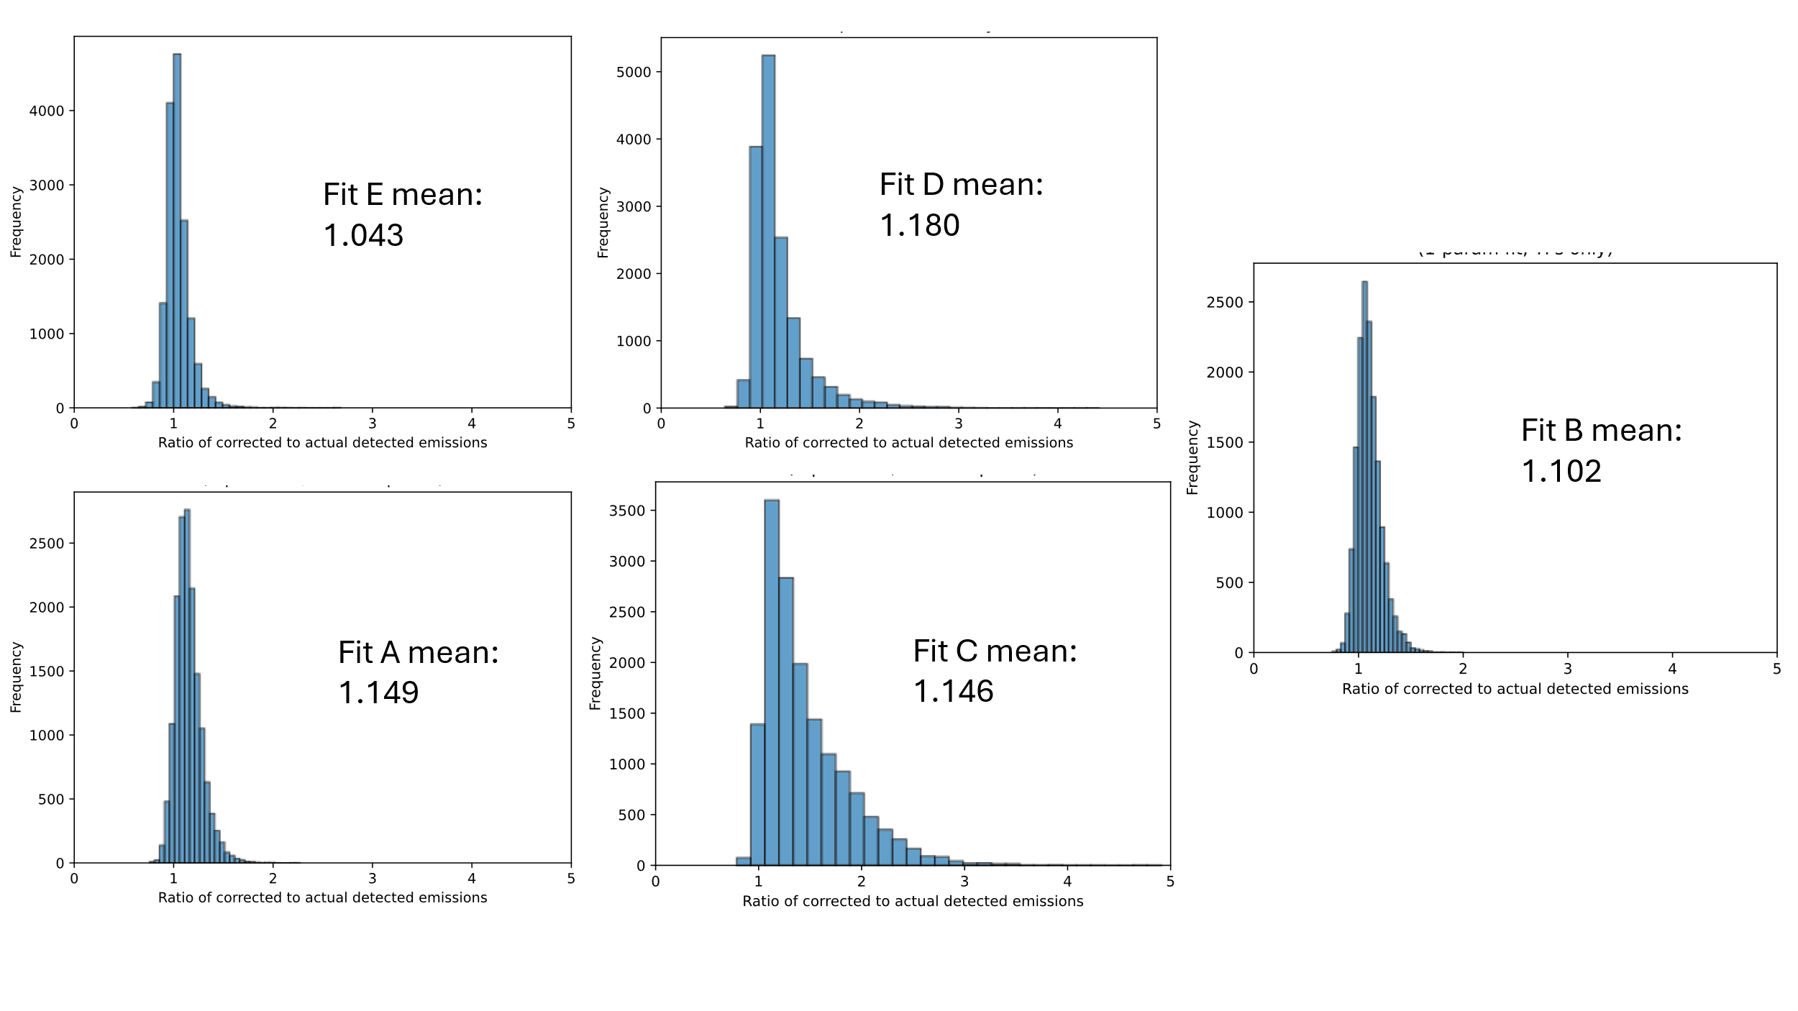

S3.9.2 Quantification results by team

Applying the conclusions of the above simulation, the recommended fit for each satellite-team pairing is Fit E; these are the fits plotted in Figure 5 of the main text. For well-behaved systems with negligible FPs, there is little difference between Fit D and Fit E.

Table S7. OLS fits, corresponding to Figure 5 in main text. Fit E is a 2-parameter model with a free slope and intercept fit to both True Positive and False Positive estimates. Fit D is a 2-parameter model fit only to True Positive estimates.
Instrument | Team | OLS Fit E (recommended)  (slope [CI], R², intercept [CI]) | OLS Fit D  (slope, R², intercept)
GHGSat | GHGSat | 0.83 [0.66, 1.00], 0.69, 38.5 [-41.1, 118.0] | 0.84, 0.69, 35.7
Tanager-1 | Carbon Mapper  Momentick | 0.94 [0.65, 1.24], 0.64, 84.9 [-56.0, 225.8]  1.05 [0.26, 1.86], 0.77, 125.1 [-243.0, 493.2] | 0.95, 0.64, 84.9  1.06, 0.77, 125.1
EMIT | Google  IMEO  IUP-UB  JPL  Kayrros  Momentick  Orbio Earth  NJU  SRON  UPV | 0.99 [-0.45, 2.42] 0.61,  -50.3 [-1077.7, 977.2]  2.99 [-0.33, 6.31], 0.52,  -268.4 [-2813.6, 2276.7]  1.57 [0.22, 2.91], 0.64,  -687.3[-1718.4, 343.7]  1.00 [-1.17, 3.17], 0.42,  -51.8 [-1600.1, 1496.5]  1.60 [-1.10, 4.30], 0.54, 6.0 [-1920.0, 1931.9]  0.26 [-0.43, 0.94], 0.21, 324.4 [-211.3, 860.1]  Not enough quantified points  0.57 [-1.25, 2.40], 0.16, 492.7 [-806.7, 1792.2]  0.53 [-0.96, 2.02], 0.20, 425.4 [-736.3, 1587.2]  1.22 [-1.24, 3.69], 0.45,  -115.9 [-1873.7, 1641.8] | 0.99, 0.61, -50.3  2.99, 0.52, -268.4  1.57, 0.64, -687.3  1.00, 0.42, -51.8  1.60, 0.54, 6.0  0.26, 0.21, 324.4  0.57, 0.16, 492.7  0.53, 0.20, 425.4  1.22, 0.45, -115.9
EnMAP | ARKA  IMEO  IUP-UB  Kayrros  Momentick  NJU  SRON  UPV | 0.81 [-0.30, 1.91], 0.30, 417.4 [-384.3, 1219.1]  0.65 [0.24, 1.06], 0.28, 316.3 [30.4, 602.1]  0.71 [0.37, 1.04], 0.33, 50.8 [-154.9, 256.6]  0.95 [0.53, 1.36], 0.45, 342.2 [54.2, 630.3]  0.76 [0.45, 1.07], 0.44, 94.0 [-110.3, 298.2]  0.39 [0.19, 0.60], 0.33, 255.7 [121.9, 389.5]  0.73 [0.30, 1.16], 0.30, 232.2 [-61.0, 525.4]  0.57 [0.20, 0.95], 0.28, 168.7 [-93.9, 431.3] | 0.81, 0.30, 417.4  0.65, 0.28, 316.3  0.72, 0.28, 42.3  0.95, 0.45, 342.2  0.77, 0.42, 84.5  0.39, 0.33, 255.7  0.73, 0.30, 232.2  0.57, 0.28, 168.7
GHOSt | Orbital Sidekick | 0.85 [0.49, 1.20], 0.58, 18.1 [-149.6, 185.8] | 0.99, 0.62, -64.2
PRISMA | ARKA  IMEO  IUP-UB  Kayrros  Momentick  NJU  SRON  UPV | 1.19 [-1.84, 4.22], 0.17, 289.6 [-2029.3, 2608.5]  0.77 [0.21, 1.33], 0.33, 232.3[-183.2, 647.7]  0.65 [0.32, 0.97], 0.42, 30.5 [-174.7, 235.8]  1.07 [0.40, 1.74], 0.42, 234.2 [-258.9, 727.4]  0.55 [0.14, 0.96], 0.32, 44.4 [-250.5, 339.2]  1.28 [0.28, 2.29], 0.39,  -259.7 [-1065.5, 546.1]  0.70 [0.10, 1.3], 0.27, 255.7 [-189.8, 701.1]  1.33 [0.66, 1.99], 0.55,  -207.0 [-707.8, 293.9] | 1.19, 0.17, 289.6  0.77, 0.33, 232.3  0.71, 0.38, -20.8  1.07, 0.42, 234.2  0.55, 0.32, 44.4  1.28, 0.39, -259.7  0.70, 0.27, 255.7  1.33, 0.55, -207.0
WorldView-3 | Momentick | 0.60 [0.40, 0.81] , 0.70, 75.9 [-19.0, 170.8] | 0.59, 0.65, 90.4
Landsat | IMEO  Kayrros  Momentick  NJU  Orbio Earth | Not enough quantified points  -0.75 [-3.16, 1.67], 0.11, 1470.7 [-649.7, 3591.1]  0.45 [0.16, 0.74], 0.27, 327.5 [138.4, 516.6]  Not enough quantified points  0.44 [0.09, 0.79], 0.19, 410.6 [193.2, 628.1] | -0.75, 0.11, 1470.7  0.50, 0.14, 288.6  0.57, 0.10, 303.6
Sentinel-2 | ARKA  Geolabe  IMEO  Kayrros  Momentick  NJU  Orbio Earth | 0.12 [-1.93, 2.17], .00, 1313.1 [133.3, 2492.9]  0.68 [-0.42, 1.79], 0.23, 186.4 [-649.3, 1022.0]  Not enough quantified points  0.71 [-0.33, 1.74], 0.19, 196.4 [-700.1, 1092.9]  0.32 [0.14, 0.50], 0.23, 422.3 [305.9, 538.6]  Not enough quantified points  -0.21 [-0.69, 0.28], 0.01, 1151.7 [875.1, 1428.4] | Not enough quantified points  0.99, 0.30, -77.8  0.71, 0.19, 196.4  0.51, 0.27, 266.5  0.55, 0.06, 566.0

Figure S59 presents the quantification results gridded by analysis team, offering a different assessment from Figure 5 in the main text, which is gridded by satellite. This allows for visual assessment of whether performance characteristics are consistent for a given team's methodology when applied to different satellite data streams. For example, SRON's results show consistent performance for EnMAP and PRISMA. IUP-UB's analyses of EnMAP and PRISMA are also consistent, exhibiting a modest low bias. Momentick's results tend to be biased somewhat low across different instruments, while both ARKA and Kayrros show a tendency toward a high bias.
For consistency across panels, Fit E is displayed for every satellite-team pairing.

Figure S59. Parity plots by team comparing reported emission rates to metered values. The solid black lines denote exact 1:1 agreement. Each point is color-coded by satellite. All plots display ordinary least squares (OLS) regression fits with a free intercept (2P fit described above). For most teams, 95% CIs were calculated as 1.96 times the submitted 1-sigma uncertainty. Momentick submitted only minimum and maximum estimates, so their error bars reflect this range rather than a 95% confidence interval. Orbio Earth submitted a 2-sigma uncertainty statistic that was not always symmetric about the mean; we used the reported values as provided.

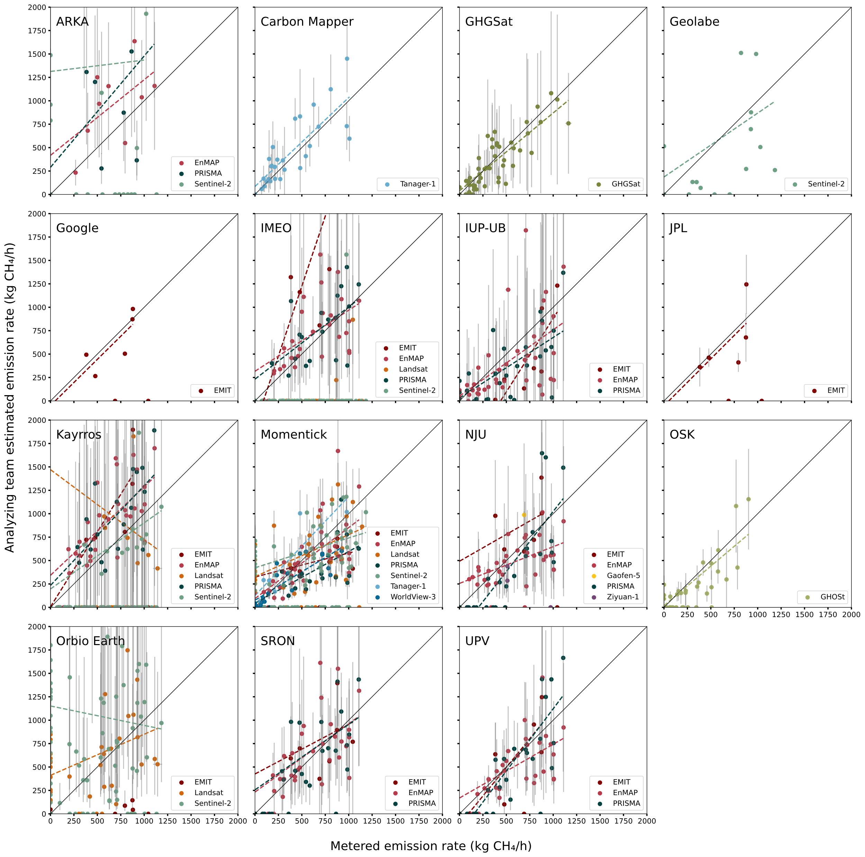

S3.9.3 Satellite- and team-specific parity charts
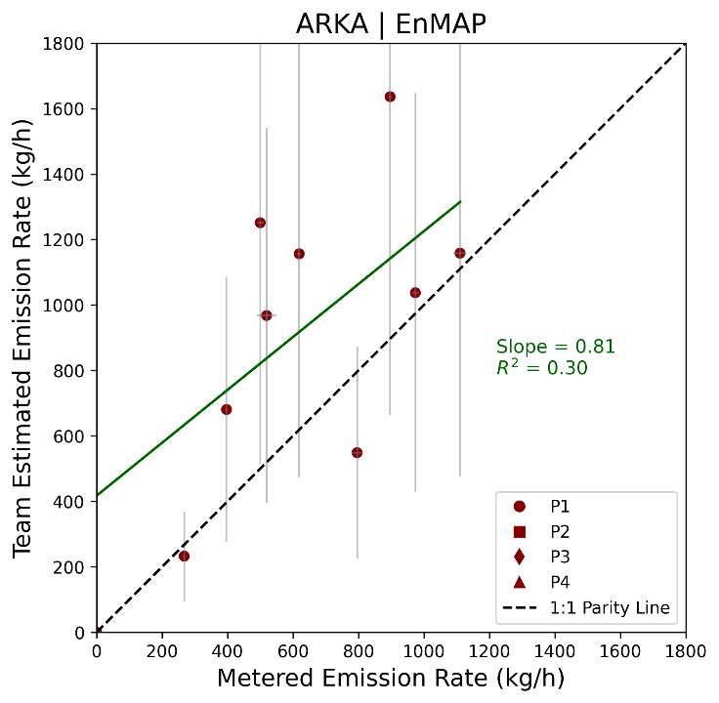
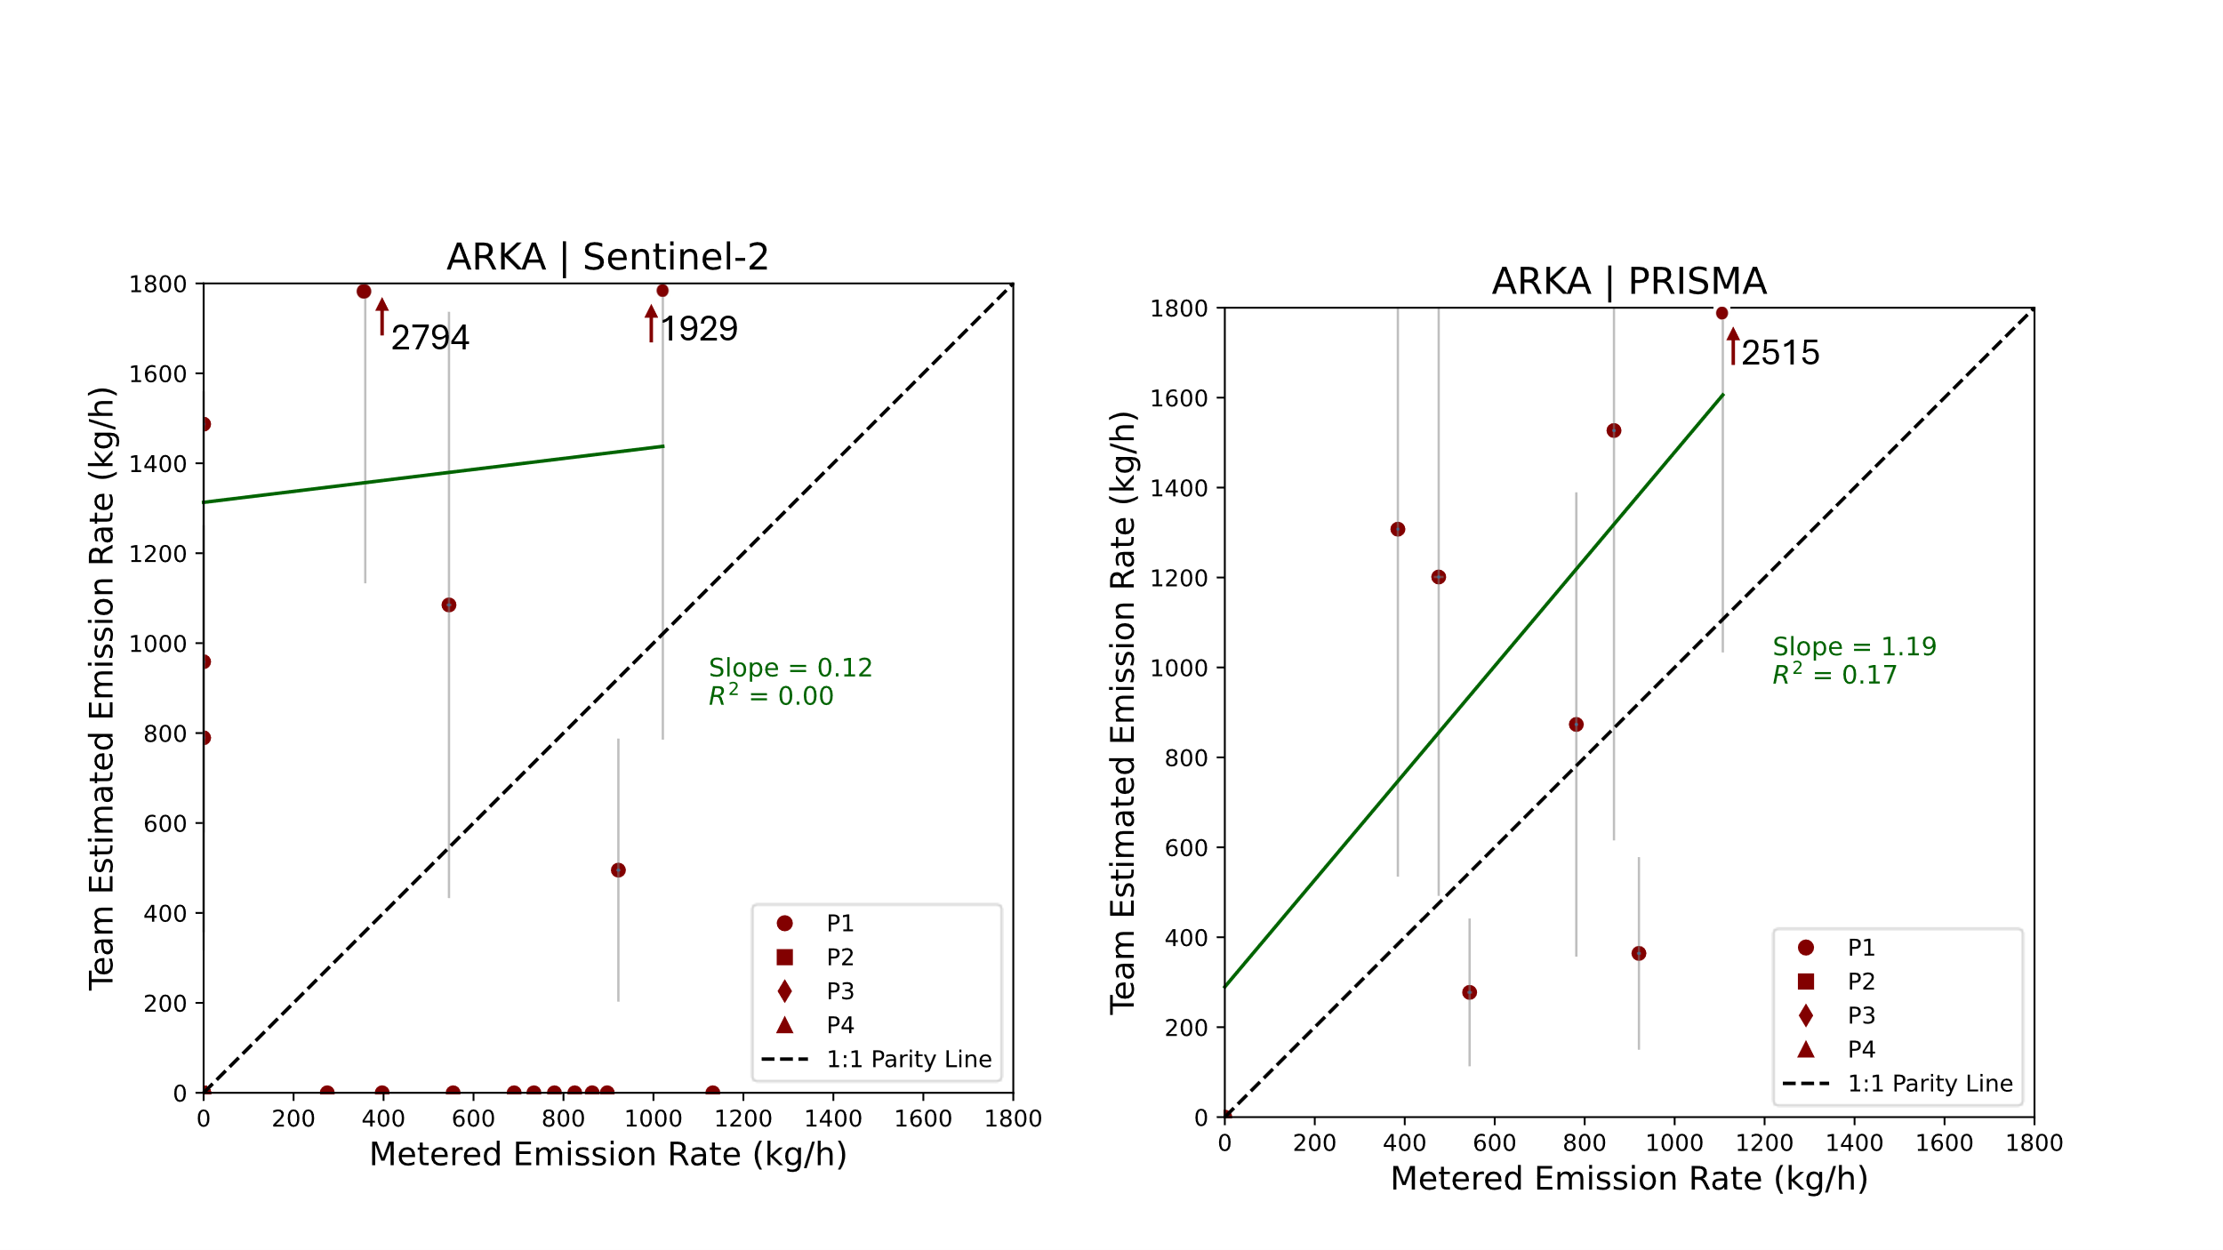

Figure S60. Quantification performance for ARKA for each analyzed satellite, with 95% X and Y confidence intervals. The black dashed line denotes 1:1 agreement. Fitted slope and R² shown for ordinary least squares fit to quantified points (green line).

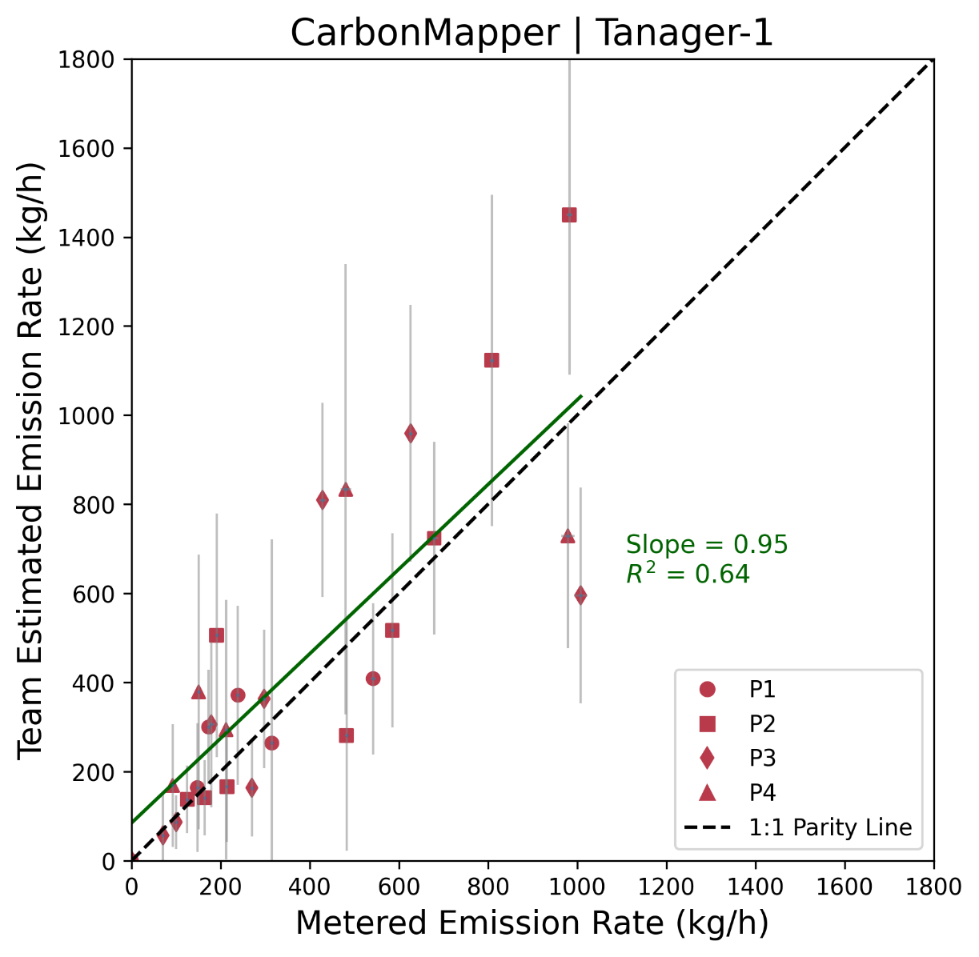

Figure S61. Quantification performance for Carbon Mapper, with 95% X and Y confidence intervals. The black dashed line denotes 1:1 agreement. Fitted slope and R² shown for ordinary least squares fit to quantified points (green line).
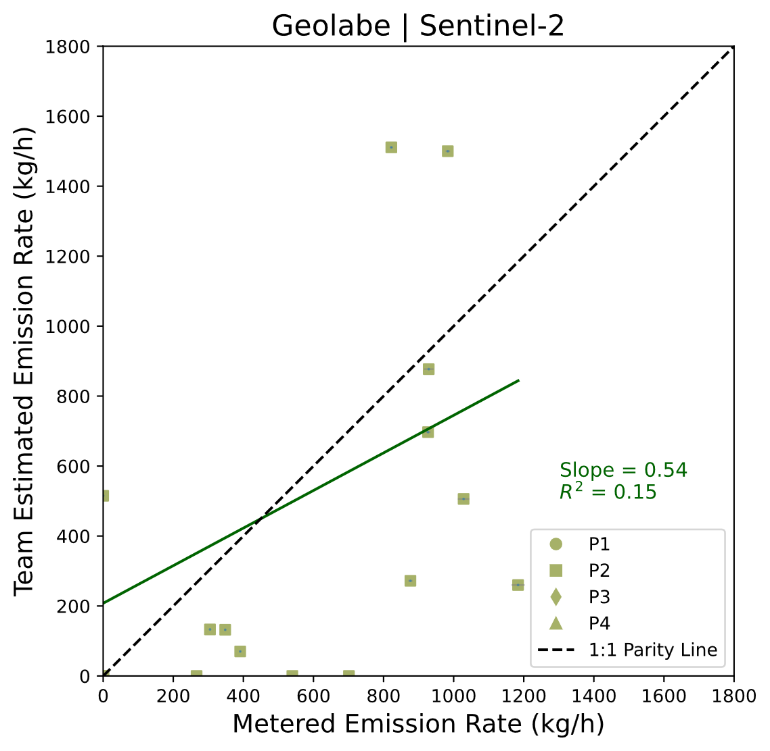

Figure S62. Quantification performance for Geolabe, with 95% X confidence intervals. Geolabe did not submit emission rate uncertainty intervals. The black dashed line denotes 1:1 agreement. Fitted slope and R² shown for ordinary least squares fit to quantified points (green line).

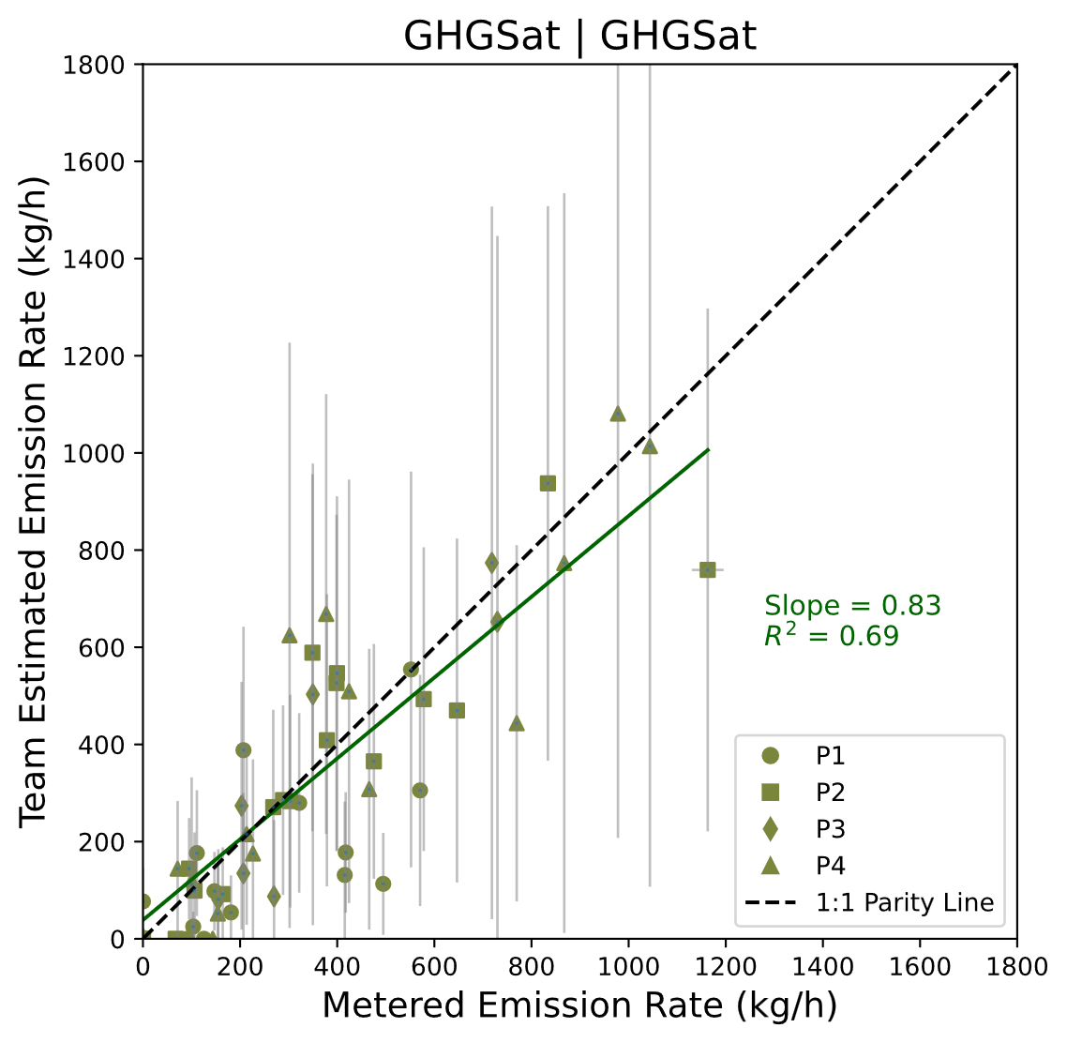

Figure S63. Quantification performance for GHGSat, with 95% X and Y confidence intervals. The black dashed line denotes 1:1 agreement. Fitted slope and R² shown for ordinary least squares fit to quantified points (green line).

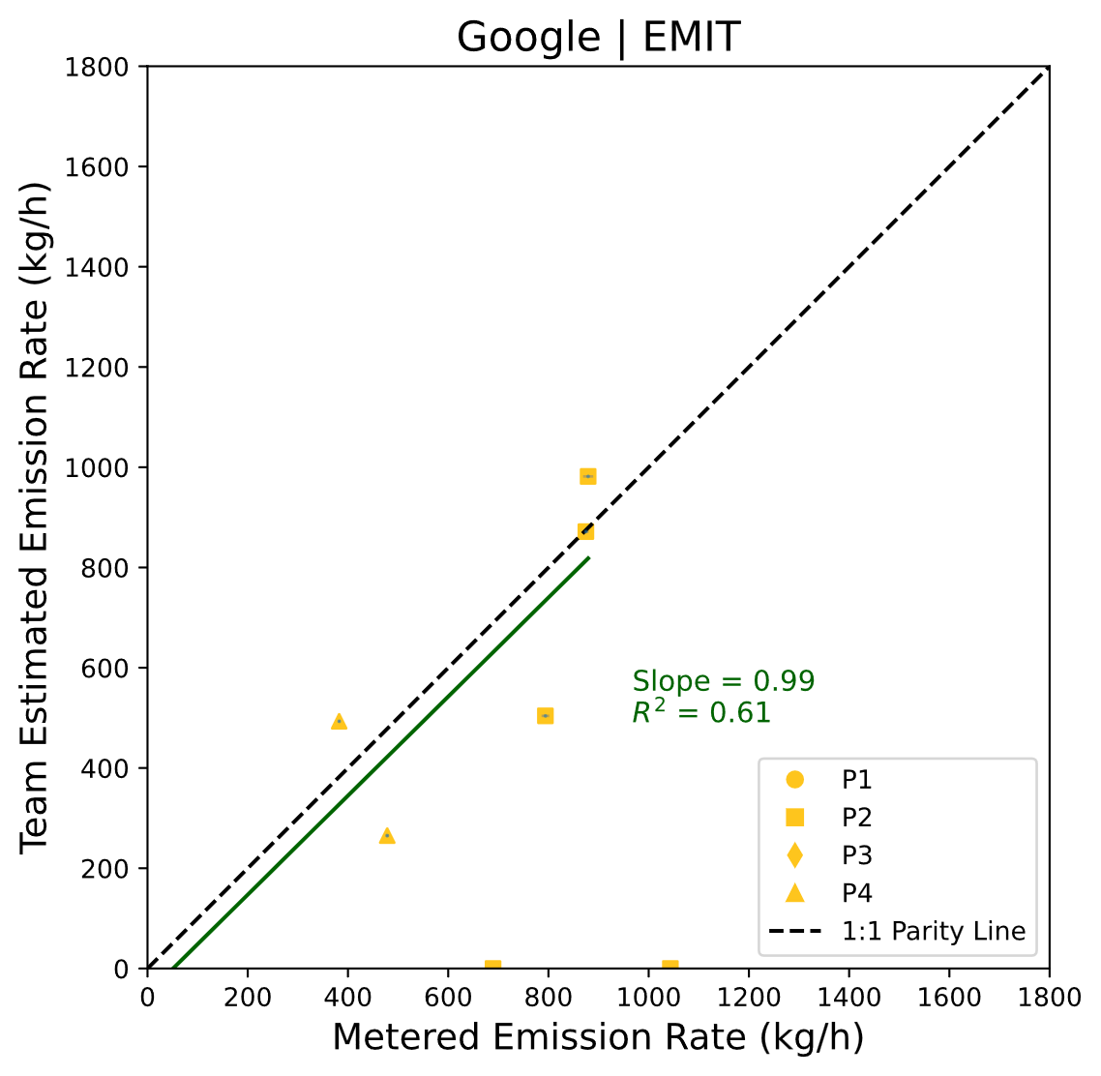
Figure S64. Quantification performance for Google, with 95% X confidence intervals. Google did not submit emission rate uncertainty intervals. The black dashed line denotes 1:1 agreement. Fitted slope and R² shown for ordinary least squares fit to quantified points (green line).
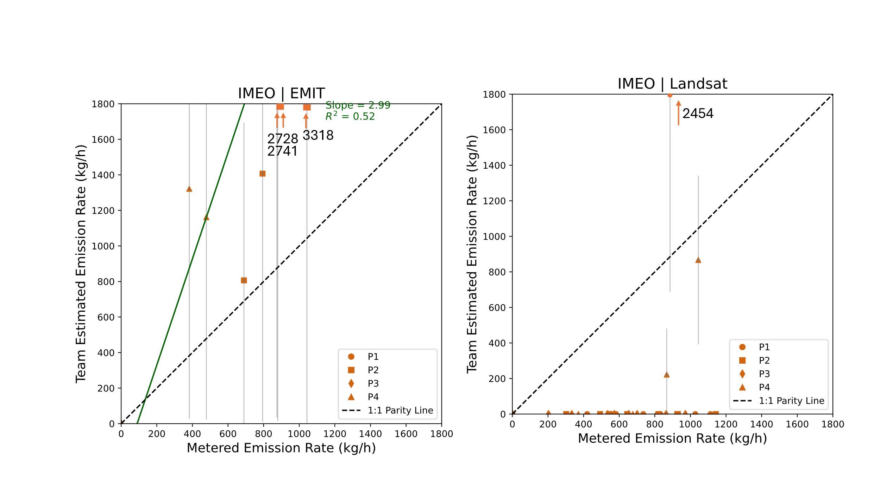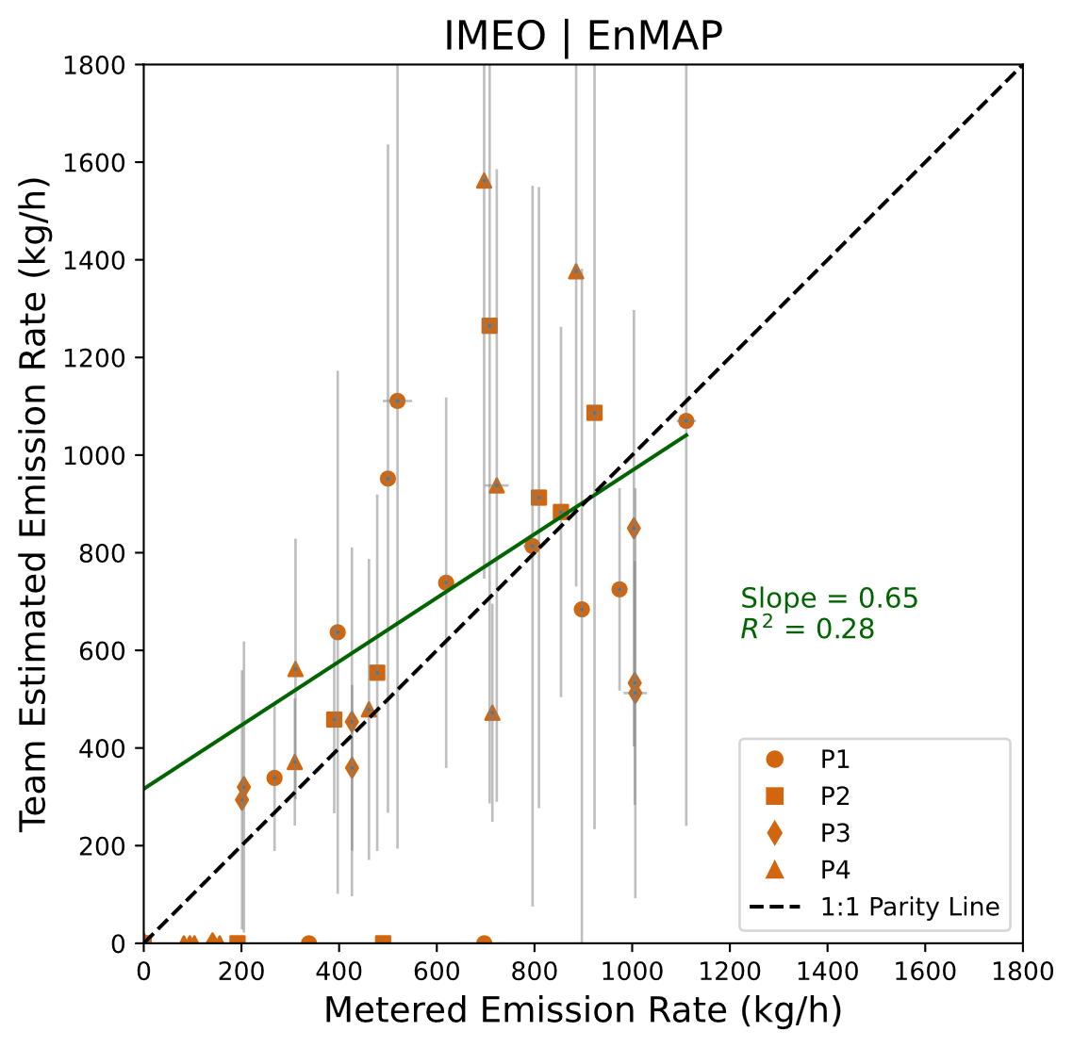
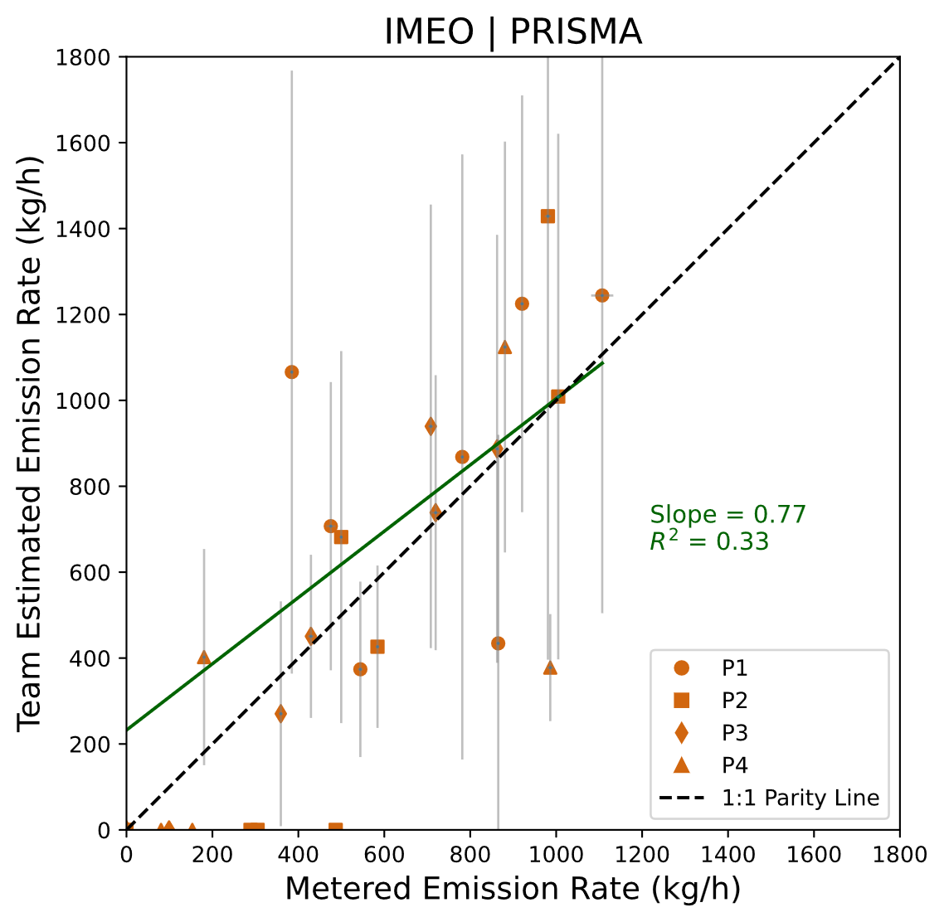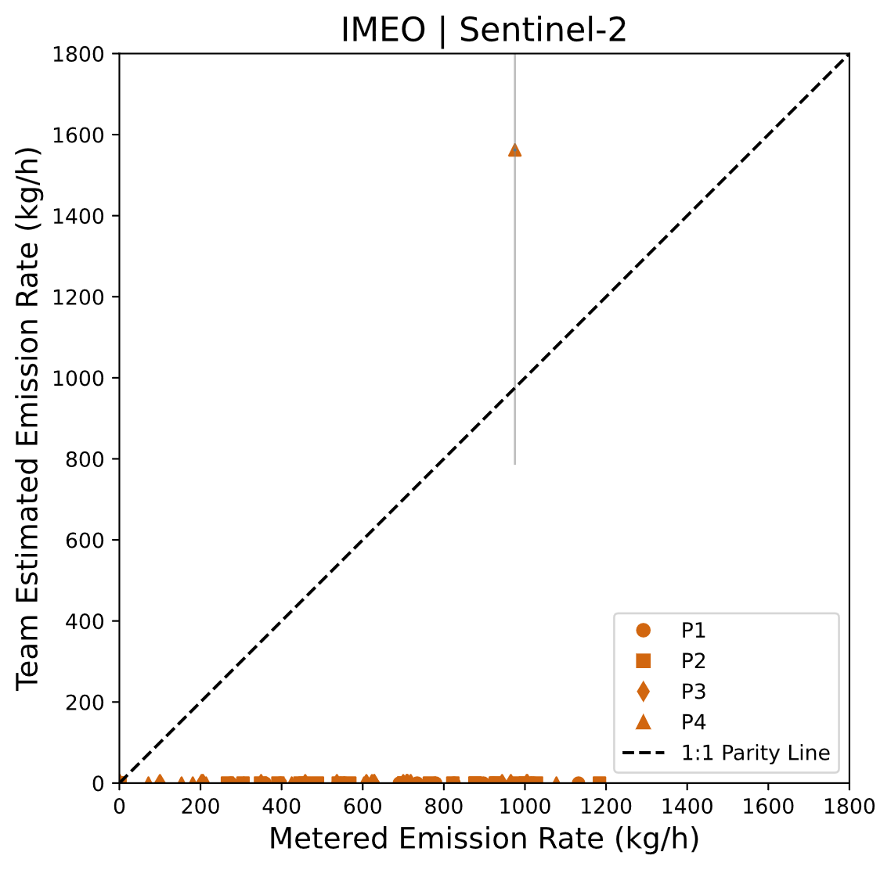
Figure S65. Quantification performance for IMEO, with 95% X and Y confidence intervals. The black dashed line denotes 1:1 agreement. Fitted slope and R² shown for ordinary least squares fit to quantified points (green line). IMEO’s quantification methodology for EMIT changed between Phases 2 and 4 (see S2.2).
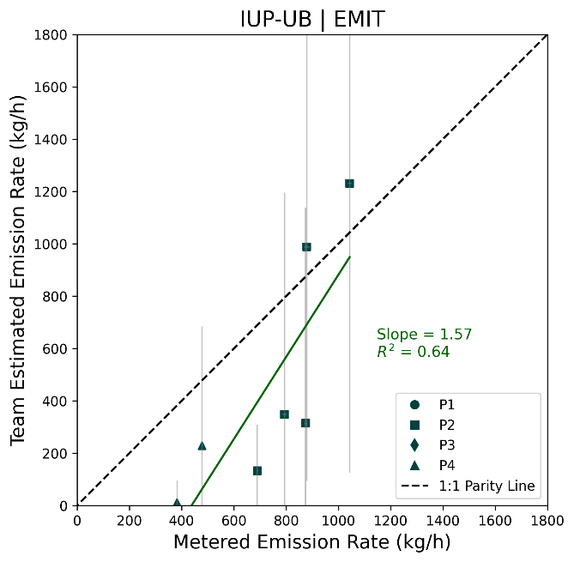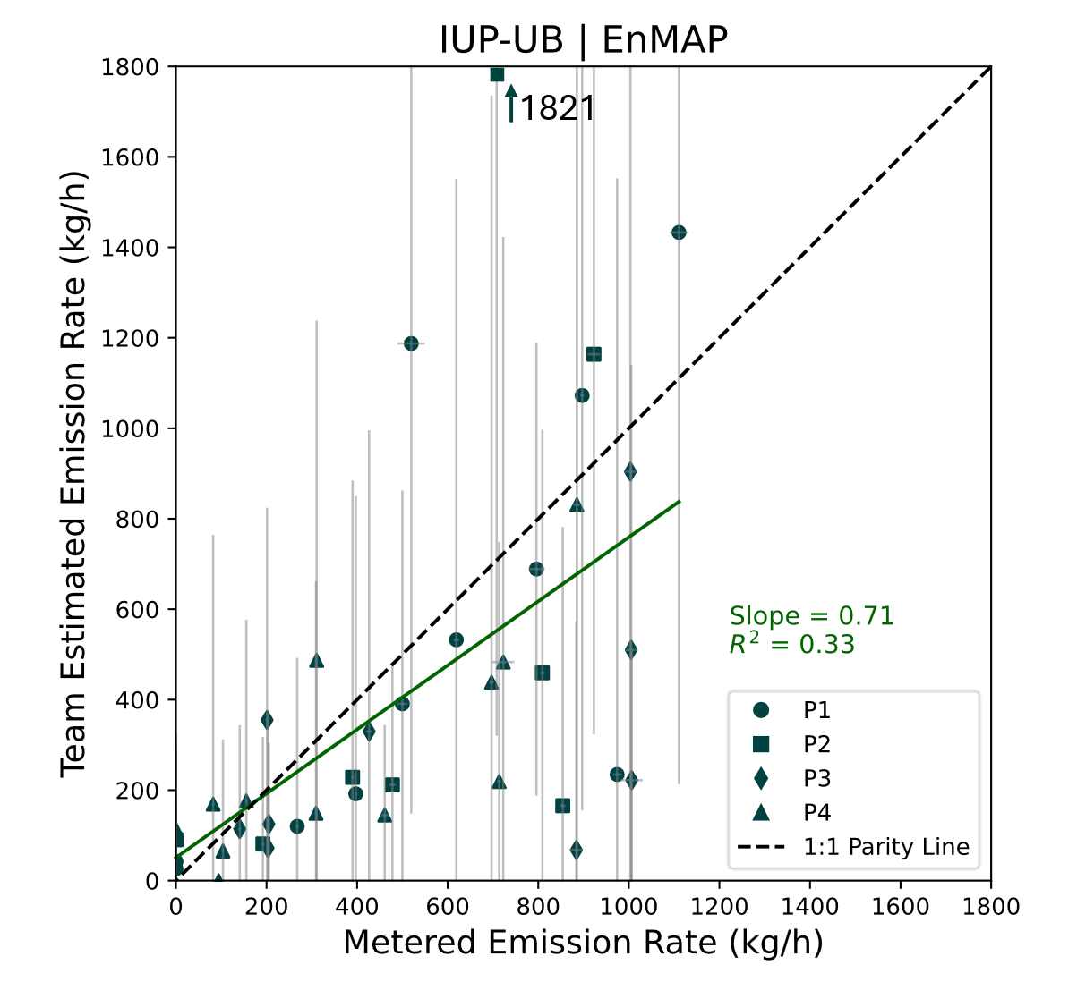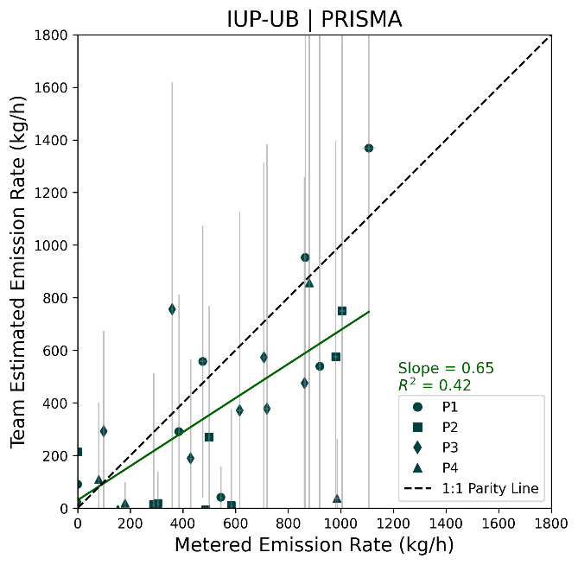
Figure S66. Quantification performance for IUP-UB, with 95% X and Y confidence intervals. The black dashed line denotes 1:1 agreement. Fitted slope and R² shown for ordinary least squares fit to quantified points (green line).

Note: Interpreting FP detections by IUP-UB with the EnMAP and PRISMA instruments requires consideration of their analytical method. Their cross-sectional flux method does not include a plume detection step and instead directly estimates an emission rate (Q). As agreed upon with the analyst team, any final Q > 0 was classified as a detection for this study even if the 1-sigma uncertainty interval included zero. If a more conservative threshold were applied that considers estimates close to zero as non-detections, these FPs would be eliminated and the number of reported TPs reduced.

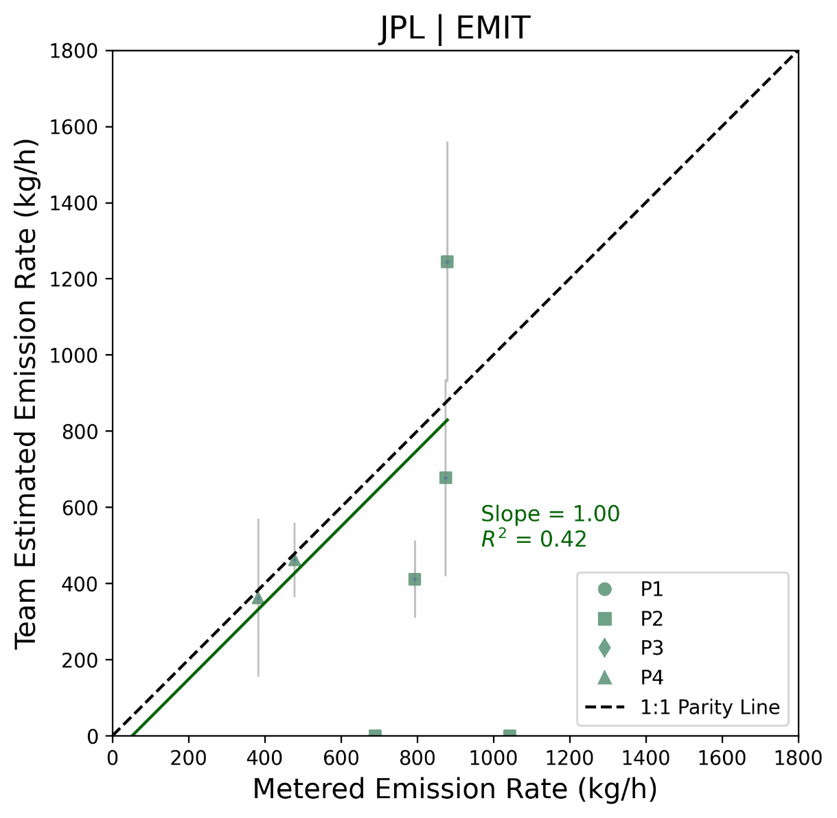

Figure S67. Quantification performance for JPL, with 95% X and Y confidence intervals. The black dashed line denotes 1:1 agreement. Fitted slope and R² shown for ordinary least squares fit to quantified points (green line).

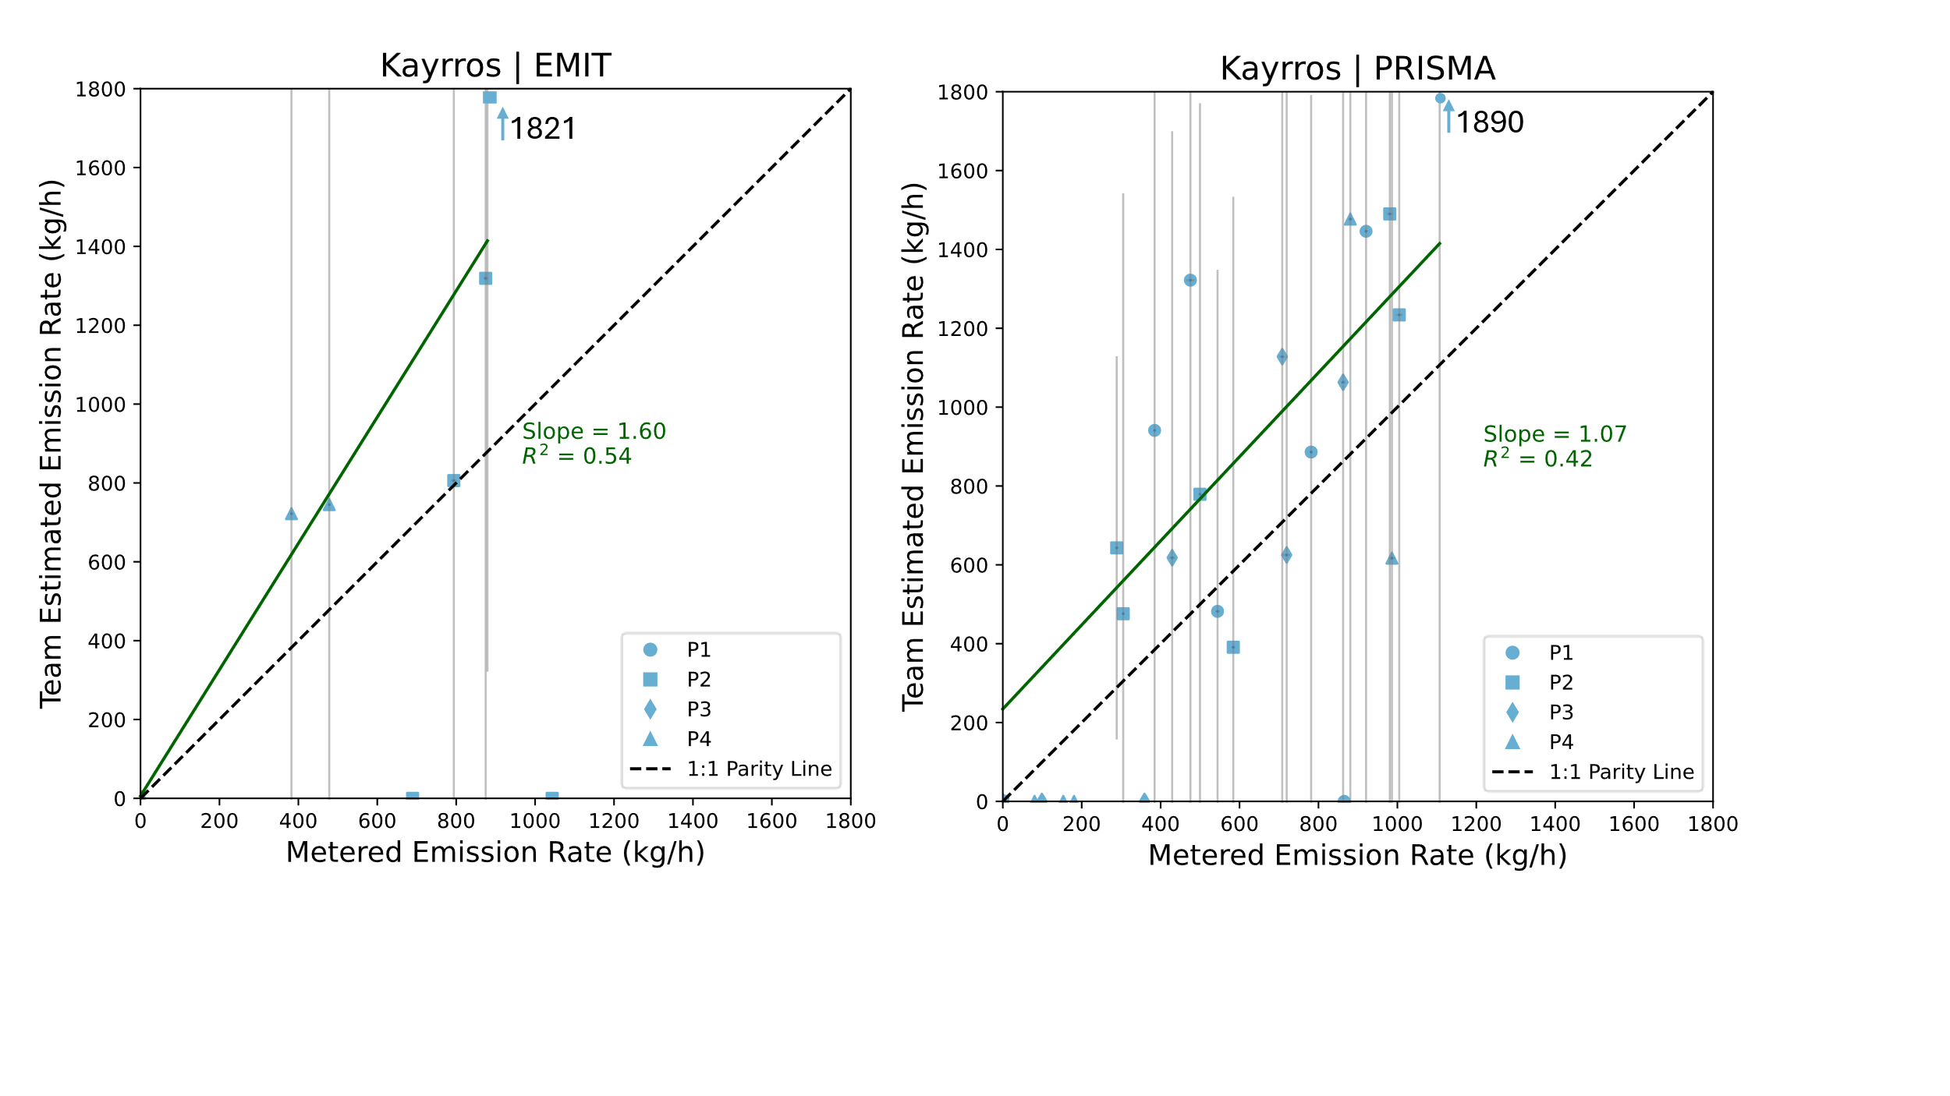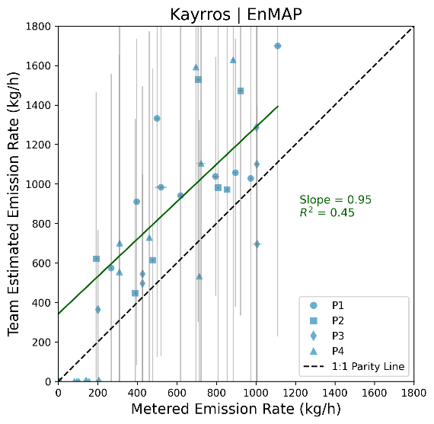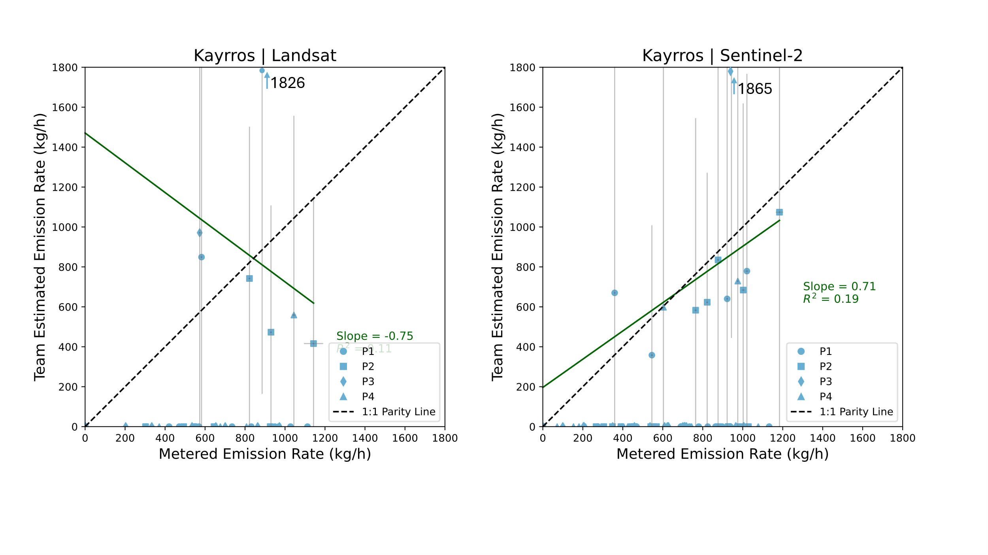
Figure S68. Quantification performance for Kayrros, with 95% X and Y confidence intervals. The black dashed line denotes 1:1 agreement. Fitted slope and R² shown for ordinary least squares fit to quantified points (green line).
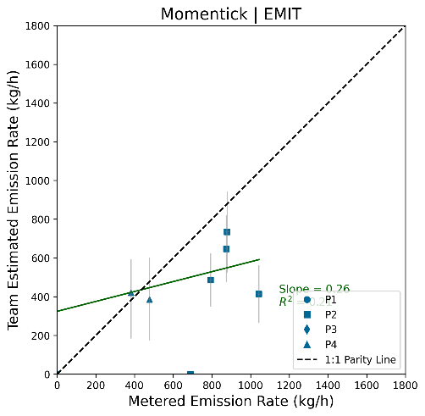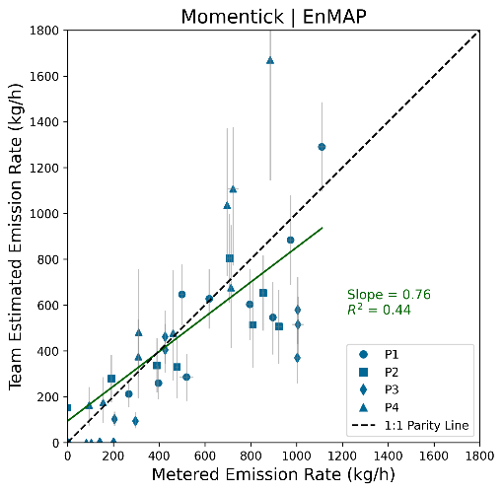
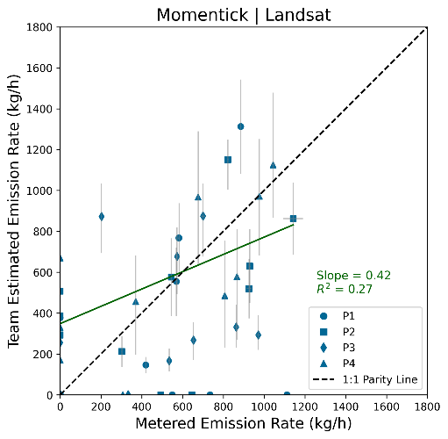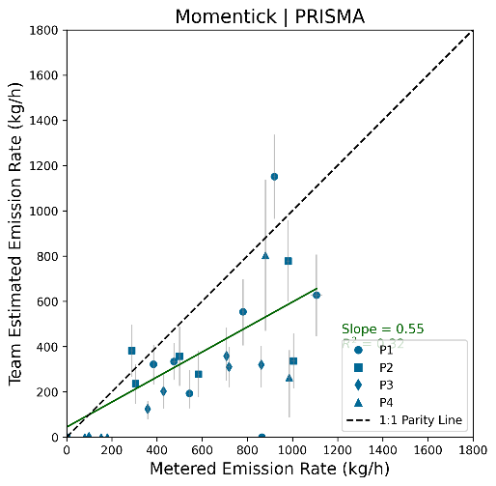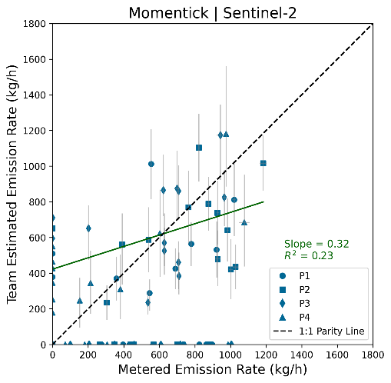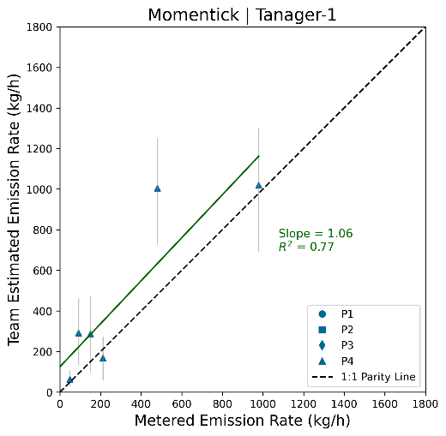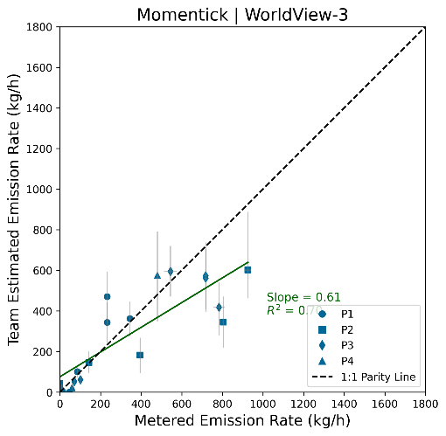
Figure S69. Quantification performance for Momentick, with 95% X confidence intervals. Momentick submitted minimum and maximum estimates, so their error bars reflect this range rather than a 95% confidence interval. The black dashed line denotes 1:1 agreement. Fitted slope and R² shown for ordinary least squares fit to quantified points (green line).

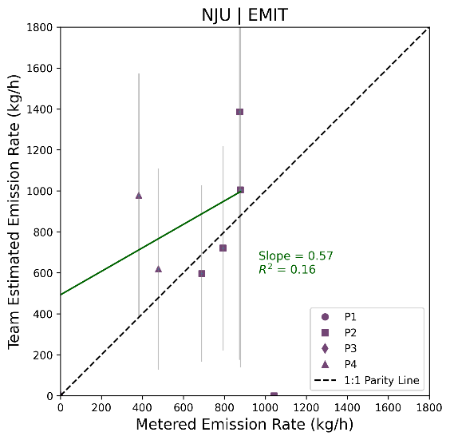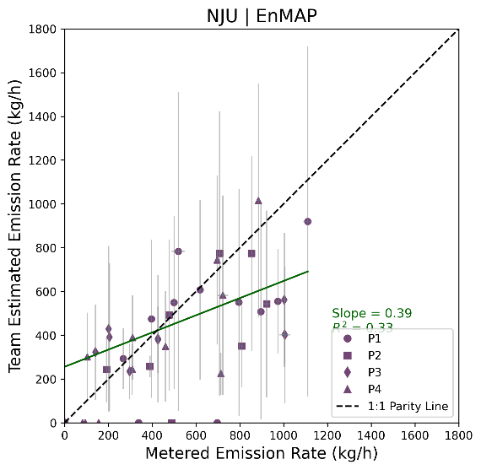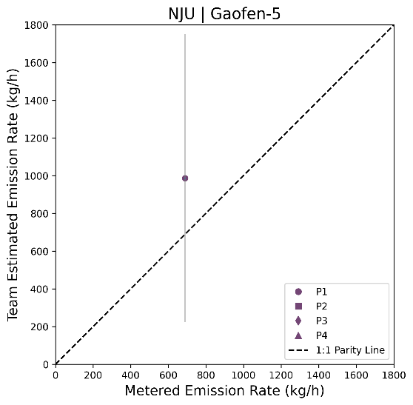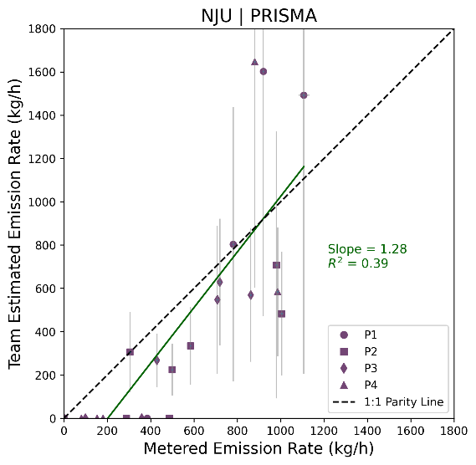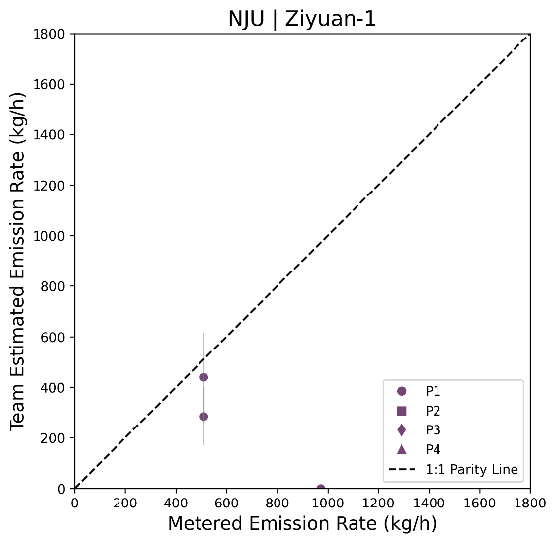
Figure S70. Quantification performance for NJU, with 95% X and Y confidence intervals. The black dashed line denotes 1:1 agreement. Fitted slope and R² shown for ordinary least squares fit to quantified points (green line).

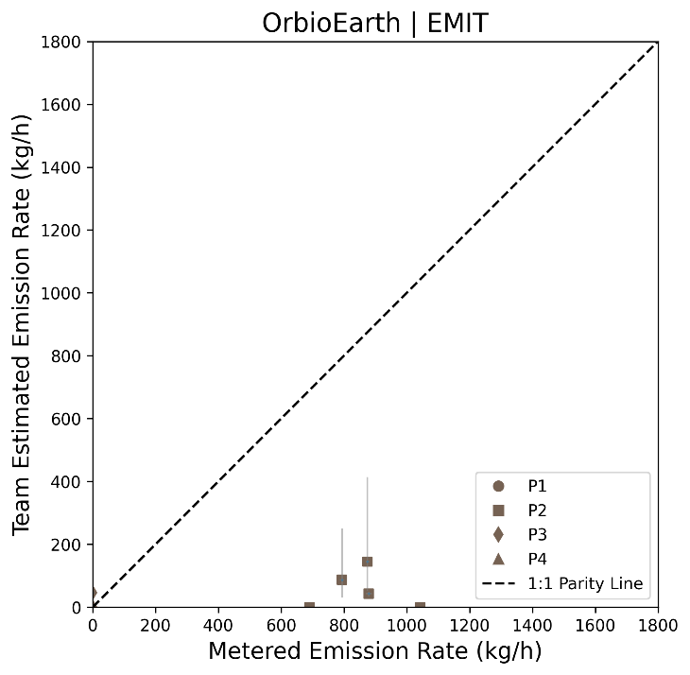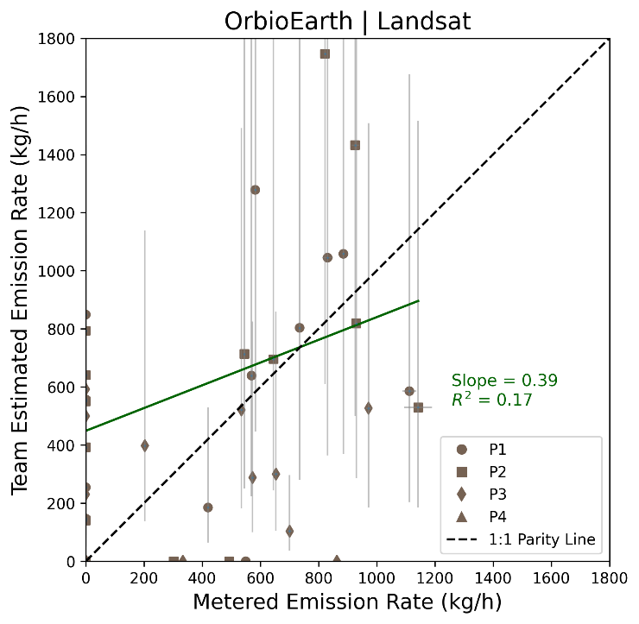
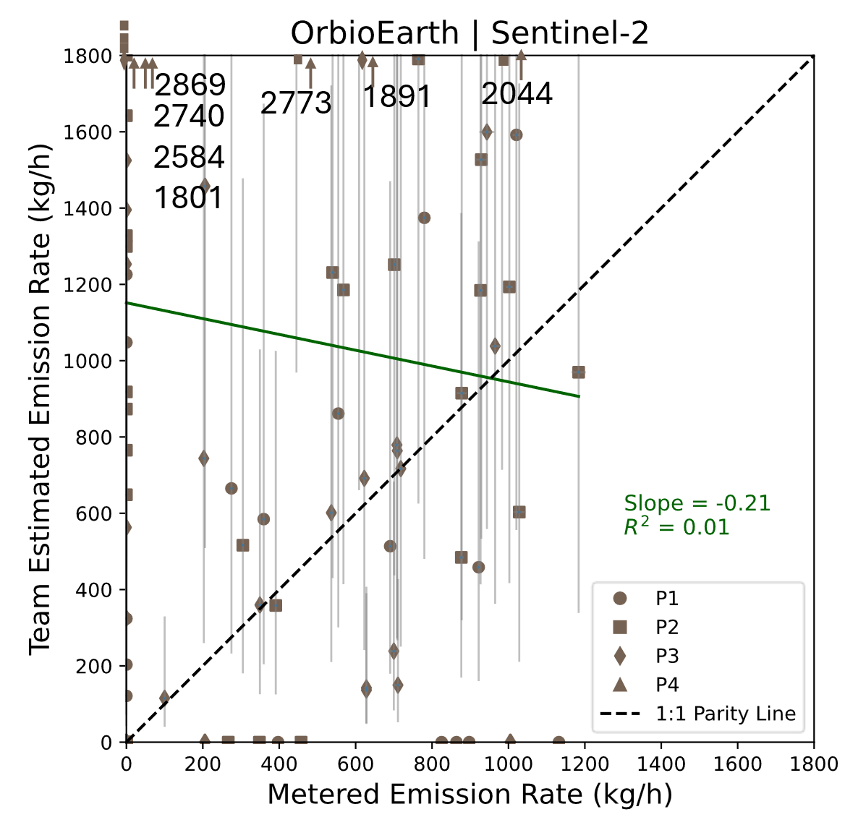
Figure S71. Quantification performance for Orbio Earth, with 95% X confidence intervals. Orbio Earth submitted a 2-sigma uncertainty statistic that was not always symmetric about the mean; rather than adjust these intervals, we used the reported values as provided. The black dashed line denotes 1:1 agreement. Fitted slope and R² shown for ordinary least squares fit to quantified points (green line).

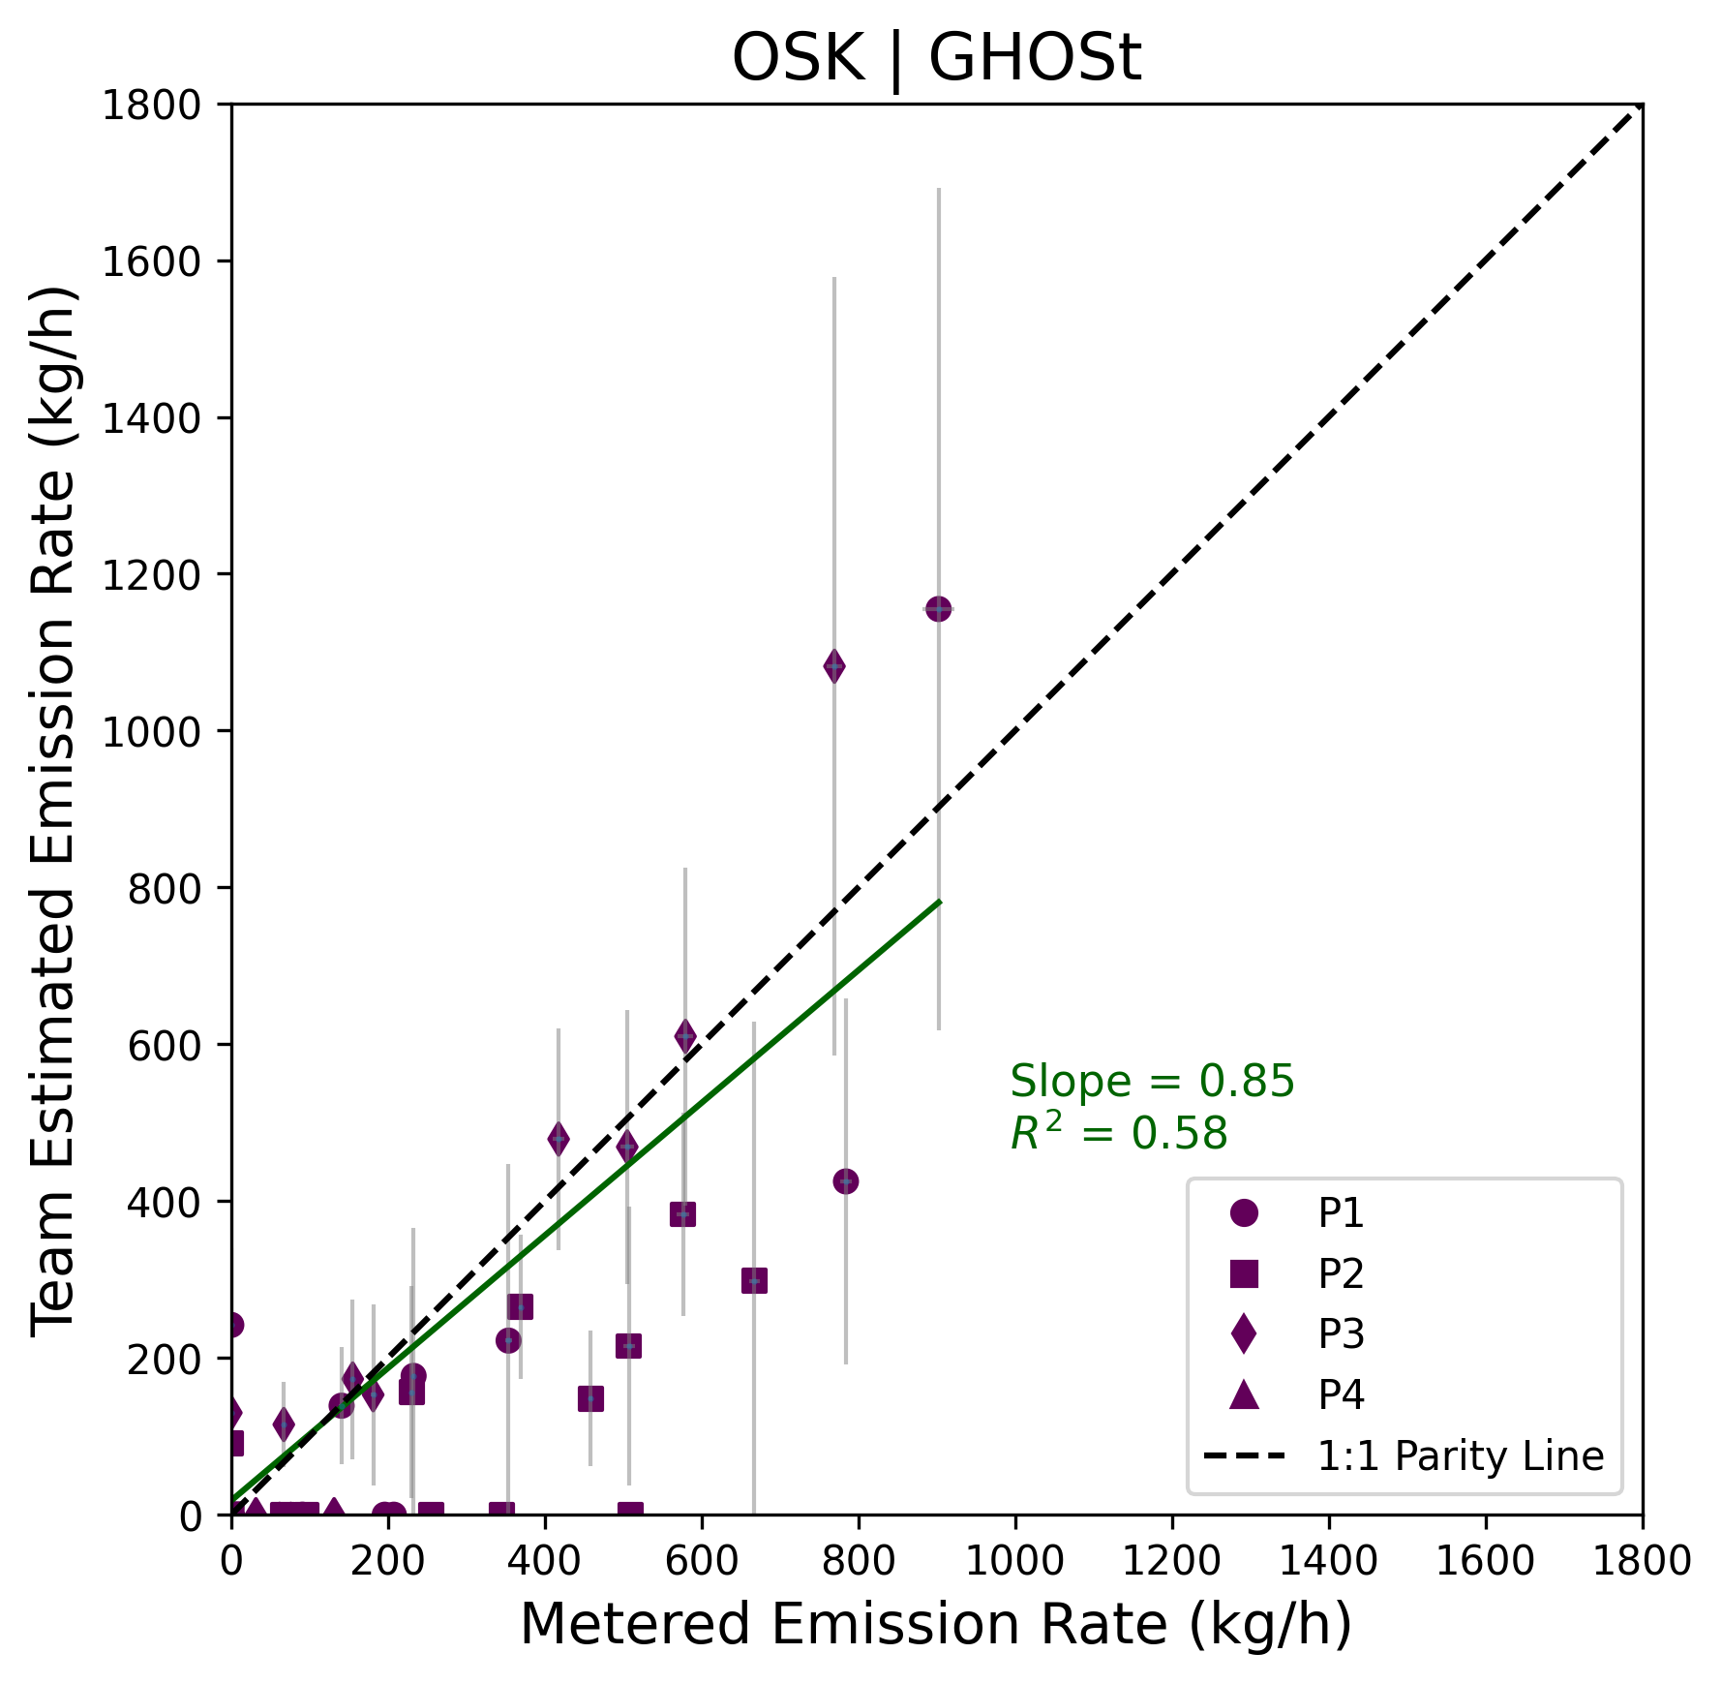
Figure S72. Quantification performance for Orbital Sidekick, with 95% X and Y confidence intervals. The black dashed line denotes 1:1 agreement. Fitted slope and R² shown for ordinary least squares fit to quantified points (green line).

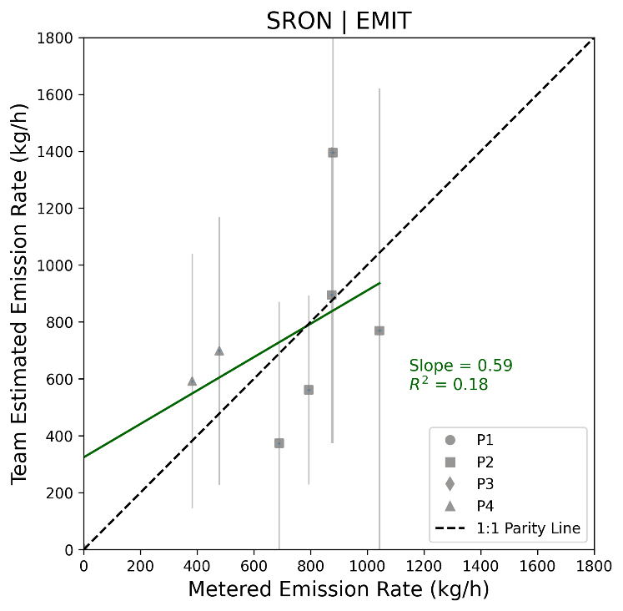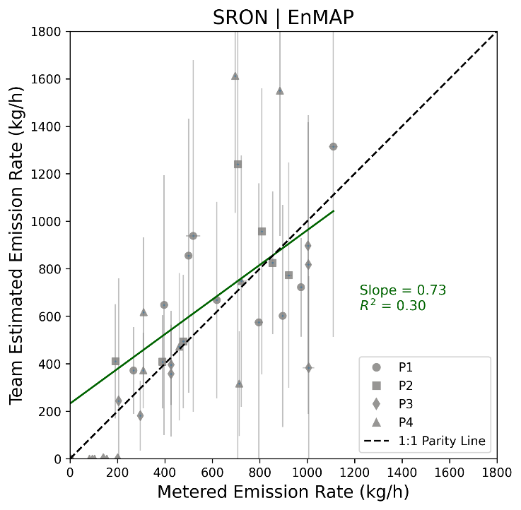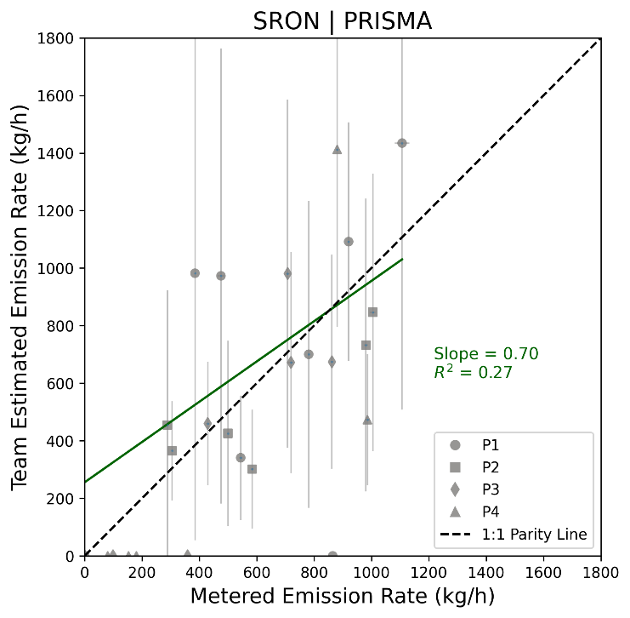
Figure S73. Quantification performance for SRON, with 95% X and Y confidence intervals. The black dashed line denotes 1:1 agreement. Fitted slope and R² shown for ordinary least squares fit to quantified points (green line). Note: in one instance on Apr 6, 2025, SRON quantified an EMIT plume although they did not categorize it as a confident detection. In the main text, this is considered a False Negative point and not included in quantification fits. However, their emission rate estimate is included in the fit here. See Notes column in submitted data sheets.

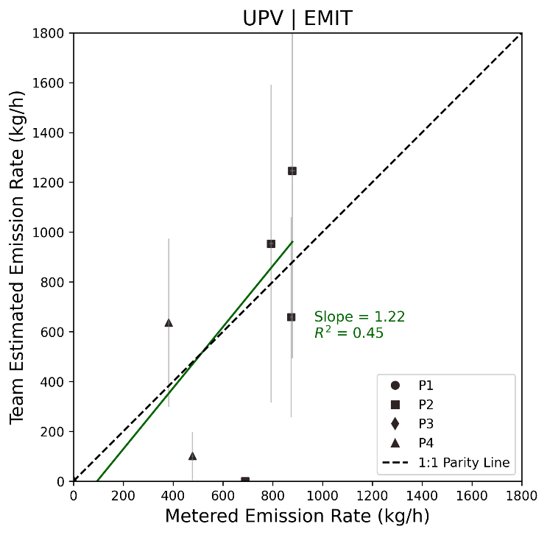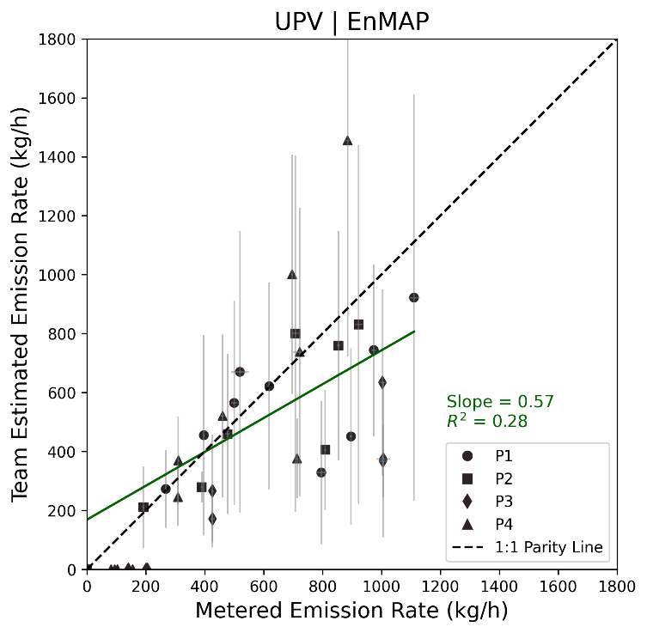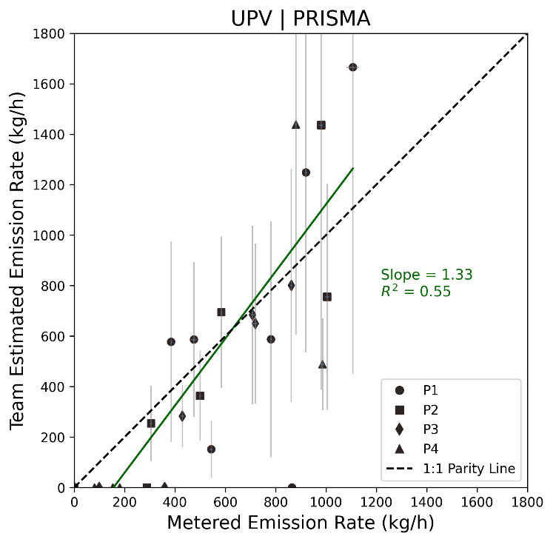
Figure S74. Quantification performance for UPV, with 95% X and Y confidence intervals. The black dashed line denotes 1:1 agreement. Fitted slope and R² shown for ordinary least squares fit to quantified points (green line).

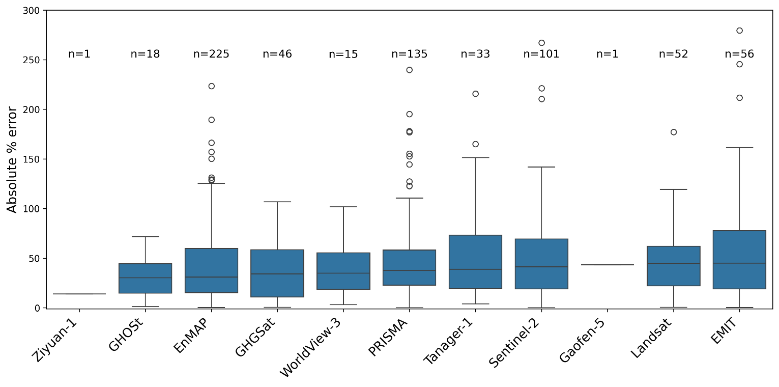
Figure S75. Absolute value of percent error for quantified estimates by satellite, ordered by median.

We present satellite-team rankings of five performance metrics in Table S8 with the following columns:
- Balanced Accuracy rank. Ranked from highest (best) to lowest. Balanced Accuracy the average of Sensitivity and Specificity (see Table S6). Balanced Accuracy rankings are not provided for pairings where either the Sensitivity or Specificity metric could not be calculated.
- (2) p_value rank. Ranked from the lowest p-value (highest statistical significance of skill) to the highest. p_value is the probability of a team achieving their Observed Accuracy (see Table S6) or better, under the null hypothesis where no detection skill exists.
- (3) Slope deviation rank. Ranked from smallest deviation (best) to largest. We calculated the absolute difference between the fitted slope and an ideal value of 1.0. Rankings are only provided for pairings with sufficient data (>5 datapoints, see Table S7).
- (4) Mean absolute percent error rank. Ranked from lowest percent error (best) to highest. Mean absolute percent error is calculated as the average distance of quantified estimates from the metered rate, relative to metered rate size, on quantified True Positive detections only.
- (5) Mean absolute error rank. Ranked from lowest (best) to highest. Mean absolute error is calculated as the average distance of quantified estimates from the metered rate on True Positive detections only.

Multiple metrics related to both detection and quantification were intentionally chosen to avoid over-reliance on any single performance indicator. Each metric emphasizes different things. For example, p_value is aided by larger sample sizes. Rankings by absolute error may favor systems that observed smaller releases and rankings by percent error may favor those that observed larger ones.

The rankings for each metric are independent. They are based on numerical value only and do not imply that the difference between any two ranks is statistically significant.

Table entries are colored by satellite category (Group A, B, C). This facilitates visual inspection of overall trends, allowing for a quick assessment of where teams may have over performed in a given instrument grouping.

Table S8. Performance metric rankings by satellite and team. Groupings are colored (Group A purple, Group B yellow, Group C green).
Balanced accuracy rank | p_value rank | Slope rank | Absolute % error rank | Absolute error rank
(tie) | (tie) | (1) EMIT - JPL | (1) EMIT - JPL | (1) GHGSat - GHGSat
(1) Tanager-1 – Carbon Mapper | (1) Tanager-1 - CarbonMapper | (1) EMIT - JPL | (1) EMIT - JPL | (2) WorldView-3 - Momentick
(1) Tanager-1 - Momentick | (1) GHGSat - GHGSat | (2) EMIT - Google | (2) EMIT - Google | (3) EMIT - Google
(1) EnMAP - ARKA | (1) Landsat - Momentick | (3) Tanager-1 - CarbonMapper | (3) EMIT - Momentick | (4) GHOSt - OSK
(1) PRISMA - ARKA | (1) GHOSt - OSK | (4) EnMAP - Kayrros | (4) EnMAP - UPV | (5) Tanager-1 - Momentick
(1) EMIT - IMEO | (5) Sentinel-2 - Momentick | (5) Tanager-1 - Momentick | (5) GHOSt - OSK | (6) Tanager-1 - CarbonMapper
(1) EMIT - IUP-UB | (6) Sentinel-2 - Kayrros | (6) PRISMA - Kayrros | (6) Sentinel-2 - Kayrros | (7) EMIT - JPL
(7) EnMAP - NJU | (7) EnMAP - NJU | (7) GHOSt - OSK | (7) PRISMA - UPV | (8) EnMAP - NJU
(tie) | (8) Landsat - Kayrros | (8) GHGSat - GHGSat | (8) EnMAP - Momentick | (9) EnMAP - Momentick
(8) EMIT - SRON | (8) Landsat - Kayrros | (8) GHGSat - GHGSat | (8) EnMAP - Momentick | (10) EnMAP - UPV
(8) EMIT - NJU | (9) EnMAP - SRON | (9) PRISMA - ARKA | (9) Sentinel-2 - Momentick | (11) PRISMA - IMEO
(10) EnMAP - SRON | (10) EnMAP - Kayrros | (10) EnMAP - ARKA | (10) GHGSat - GHGSat | (12) EnMAP - IMEO
(11) EMIT - UPV | (11) PRISMA - IMEO | (11) EMIT - UPV | (11) PRISMA - NJU | (13) EnMAP - SRON
(12) EnMAP - Kayrros | (12) EnMAP - UPV | (12) PRISMA - IMEO | (12) EMIT - SRON | (14) EMIT - Momentick
(13) PRISMA - IMEO | (13) EnMAP - IMEO | (13) EnMAP - Momentick | (13) EnMAP - IMEO | (15) PRISMA - UPV
(14) GHGSat - GHGSat | (14) PRISMA - Momentick | (14) EnMAP - SRON | (14) EnMAP - SRON | (16) PRISMA - SRON
(15) EnMAP - IMEO | (15) Sentinel-2 - Geolabe | (15) PRISMA - NJU | (15) PRISMA - IMEO | (17) Sentinel-2 - Kayrros
(16) EnMAP - UPV | (16) Landsat - OrbioEarth | (16) EnMAP - IUP-UB | (16) EnMAP - NJU | (18) EMIT - SRON
(17) PRISMA - Momentick | (17) PRISMA - SRON | (17) Sentinel-2 - Kayrros | (17) WorldView-3 - Momentick | (19) EMIT - NJU
(tie) | (18) PRISMA - Kayrros | (18) PRISMA - SRON | (18) PRISMA - SRON | (20) EnMAP - IUP-UB
(18) PRISMA - SRON | (18) PRISMA - Kayrros | (18) PRISMA - SRON | (18) PRISMA - SRON | (21) PRISMA - IUP-UB
(18) PRISMA - Kayrros | (19) PRISMA - UPV | (19) Sentinel-2 - Geolabe | (19) PRISMA - Momentick | (22) EMIT - UPV
(20) EMIT - Kayrros | (20) EnMAP - ARKA | (20) PRISMA - UPV | (20) EMIT - UPV | (23) Sentinel-2 - Momentick
(21) PRISMA - UPV | (21) EnMAP - Momentick | (21) EnMAP - IMEO | (21) Tanager-1 –CarbonMapper | (24) Landsat - Momentick
(22) PRISMA - NJU | (22) PRISMA - NJU | (22) PRISMA - IUP-UB | (22) EMIT - NJU | (25) PRISMA - Momentick
(23) EnMAP - Momentick | (23) EMIT - IMEO | (23) WorldView-3 - Momentick | (23) Landsat - OrbioEarth | (26) PRISMA - NJU
(24) Landsat - Momentick | (24) EMIT - IUP-UB | (24) EnMAP - UPV | (24) Landsat - Momentick | (27) EnMAP - Kayrros
(25) GHOSt - OSK | (25) Sentinel-2 - OrbioEarth | (25) EMIT - NJU | (25) EnMAP - IUP-UB | (28) EnMAP - ARKA
(26) Sentinel-2 - Geolabe | (26) WorldView-3 - Momentick | (26) PRISMA - Momentick | (26) EMIT - IUP-UB | (29) EMIT - IUP-UB
(27) WorldView-3 - Momentick | (27) EMIT - SRON | (27) EMIT - SRON | (27) Landsat - Kayrros | (30) PRISMA - Kayrros
(28) Landsat - OrbioEarth | (28) Landsat - IMEO | (28) Landsat - Momentick | (28) Sentinel-2 - Geolabe | (31) Landsat - OrbioEarth
(29) EMIT - Momentick | (29) EMIT - NJU | (29) Landsat - OrbioEarth | (29) PRISMA - IUP-UB | (32) EMIT - Kayrros
(30) Sentinel-2 - Momentick | (30) PRISMA - ARKA | (30) EMIT - IUP-UB | (30) PRISMA - Kayrros | (33) Sentinel-2 - Geolabe
(31) EnMAP - IUP-UB | (31) Tanager-1 - Momentick | (31) EMIT - Kayrros | (31) EnMAP - ARKA | (34) Landsat - Kayrros
(32) Sentinel-2 - OrbioEarth | (32) EMIT - Kayrros | (32) EnMAP - NJU | (32) EMIT - Kayrros | (35) PRISMA - ARKA
(33) Landsat - Kayrros | (33) EnMAP - IUP-UB | (33) Sentinel-2 - Momentick | (33) EnMAP - Kayrros | (36) Sentinel-2 - OrbioEarth
(34) Sentinel-2 - Kayrros | (34) EMIT - UPV | (34) EMIT - Momentick | (34) Tanager-1 - Momentick | (37) Sentinel-2 - ARKA
(35) PRISMA - IUP-UB | (35) EMIT - Momentick | (35) Sentinel-2 - ARKA | (35) Sentinel-2 - OrbioEarth | (38) EMIT - IMEO
(36) Landsat - IMEO | (36) PRISMA - IUP-UB | (36) Sentinel-2 - OrbioEarth | (36) PRISMA - ARKA
(37) EMIT - OrbioEarth | (37) Sentinel-2 - ARKA | (37) Landsat - Kayrros | (37) EMIT - IMEO
(38) Sentinel-2 - ARKA | (38) Sentinel-2 - IMEO | (38) EMIT - IMEO
(39) Sentinel-2 - IMEO | (39) EMIT - OrbioEarth
(tie) | (tie)
(40) Landsat - NJU | (40) Landsat - NJU
(40) Sentinel-2 - NJU | (40) Sentinel-2 - NJU
 | (40) EMIT - Google
 | (40) EMIT - JPL
 | (40) Gaofen-5 - NJU
 | (40) Ziyuan-1 - NJU
S4. Supplementary methods

Figure S76. Annotated Google Earth imagery of the Casa Grande release site
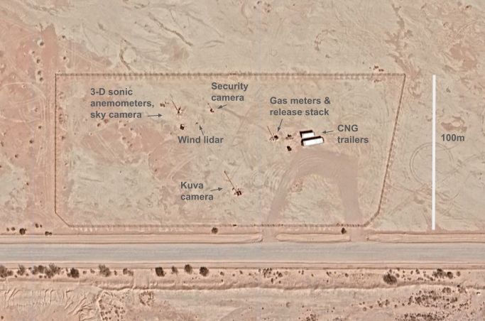

Figure S77. Photograph of the release stacks, pressure regulation unit, and CNG trailer
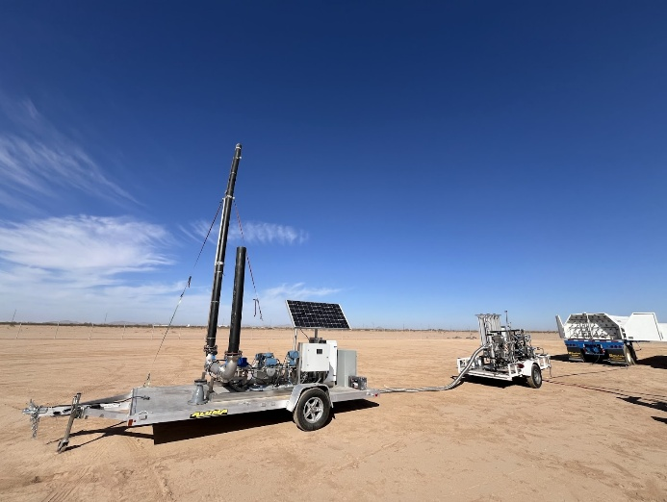

S4.1 Coriolis meter calibration
The Emerson Micro Motion Coriolis flow meters used in this study were calibrated by the manufacturer according to the schedules described in El Abbadi et al. (2024)²². These meters are known for their durability, with minimal drift expected under typical field conditions. To avoid potential risks from uninstalling, shipping, and reinstalling the meters for laboratory recalibration, the research team developed a field-based verification method.

An Apollo High Capacity Balance (model GX-102000LS) was used to validate meter performance. The scale has a 102 kilogram capacity, repeatability of 1 gram, and accuracy of ±10 grams, and includes a built-in function for calculating flow rates. Inert gas (N₂) from 50-pound cylinders flowed through the small (CMFS015H, 0.166 inch) and medium (CMF050M, 0.5 inch) Coriolis meters, while CNG was disconnected. Flow was tested at 5, 10, 15, and 20 kg/h on the small meter, and at 50 and 75 kg/h on the medium meter. Each test run lasted a minimum of five minutes, and average flow rate values were calculated over that time window. A wind shield was used to minimize cylinder rocking and associated weight fluctuations on the scale. Table S9 summarizes the five-minute averaged flow rates as recorded by both the scale and the Coriolis meters, along with the intended flow setpoints. Figure S79 shows time series for the 50 kg/h test case. The two readings show good agreement: five-minute average flow measured by the scale was 54.63 kg/h, while the Coriolis meter reported 54.85 kg/h (0.4% difference).

The high-flow meter, used for all releases greater than 300 kg/h, could not be calibrated using the same methods as the small and medium meters. Instead, we used a mass-balance analysis over the year-long experiment. This method reconciles the total mass of purchased gas against the sum of all known metered and unmetered outputs from the system.

Twenty CNG trailer refills were conducted, corresponding to a total purchased gas mass of 50,053 kg of natural gas, accounting for the gas composition specific to each purchase event. We use gas composition as reported by the pipeline operator and averaged over 5 days before the refill, as in the main text. Fill volumes are reported as SCF, and we use the GPSA-recommended conversion value of 1.1953 moles per SCF to convert to moles then to mass.

Mass balance terms:
- 20 fill events, excluding a fill on afternoon of January 1st 2025. This fill was not included as this was before the first release of the study.
- Difference between initial and final mass loading of the trailers. An initial pressure before the first release of the study was noted to be 2280 psig in experimental notes (F. Reuland). This resulted in initial gas storage of 3693 kg. Final gas mass in storage on December 31st was 803 kg, derived from 603 psig reading.
- The sum of all metered releases conducted for satellite, aircraft, and continuous monitoring tests, after January 1st 2025. Time series of 1 Hz mass flow rates summed over the year account for 91% of filled trailer mass.
- Heater system consumption is estimated using the time to flow plus 15 minutes to pre-heat the heaters before flow begins. A total of 8 CATCO catalytic heaters are installed on the RT-20 regulation skids. These are 1500 W heaters with consumption rates of 11.8 scf/h.
- Trailer fitting leaks: two leaks on trailer fittings occurred in June and July 2025. Mass emissions rates were estimated based on the time required to notice the issue and procure repair equipment (approx. 20 days), and we assume a leak rate of 0.1 kg/h for each event; these were small events that were not noticeable from far away by refill technician, but were noticeable upon approaching the rear of the trailer to disconnect the pressure hose.
- Pressure release value (PRV) leak: a persistent small leak from a pressure release valve on the RT-20 pressure regulation trailer was observed by multiple ground sensors (Konica on June 11; QLM continuously). Based on these observations, we assume an ongoing leak rate of approximately 0.25 kg/h throughout the experiment.
- Stack vent: a small seep from the stack vent was first noted by a Kuva camera on August 1 and was estimated to have a rate of approximately 1 kg/h.
- Heater system leaks: small fugitive leaks from the system's CATCO heaters and associated piping were noticed by the KonicaMinolta team, and occasionally by odorant by experiment team onsite. KonicaMinolta quantification estimate was a combined rate of approximately 0.25 kg/h.

Summing these terms accounts for ~98.5-100% of the total purchased gas mass, depending on various duration assumptions for the small leaks noted above. This mass balance closure, combined with the demonstrated accuracy of the identically calibrated small and medium meters, provides strong confidence in the accuracy of the high-flow meter. It is reasonable to assume that any residual error in this meter is small compared to the much larger uncertainties in satellite-based source rate quantification.

Figure S78. Field site Coriolis meter calibration with gas cylinder on scale.
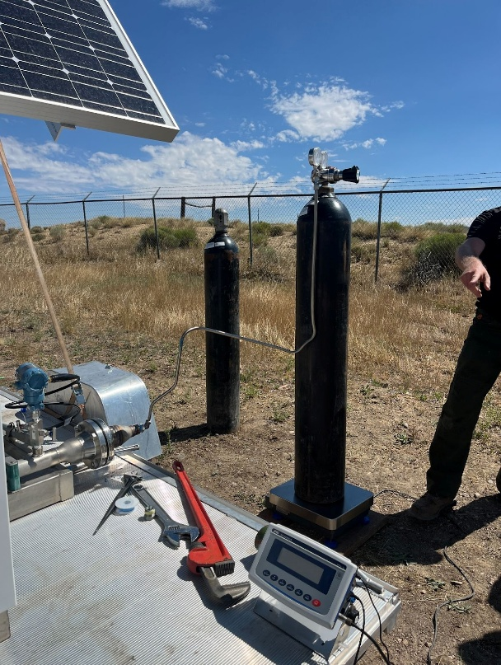

Table S9. Coriolis meter calibration results of scale-derived flow rates compared to meter-reported flow rates
Test set point (kg/h) | Scale-measured 5-min flow rate average | Meter-reported 5-min flow rate average
5 | 5.508 | 5.097
10 | 10.056 | 9.886
15 | 15.773 | 15.21
20 | 19.20 | 19.23
50 | 54.63 | 54.848
75 | 71.789 | 72.363

Figure S79. Coriolis meter calibration time series gas flow for the 50 kg/h test case
Note: A small increase in meter rate (red) around the 15:20:50 UTC mark corresponds to a manual adjustment of the upstream pressure valve.
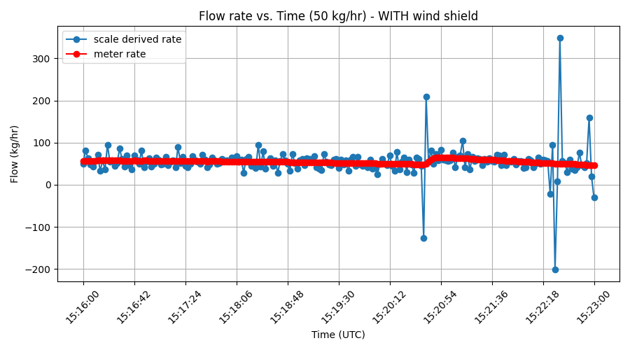

S4.2 Meteorological equipment
Power for the 2-, 5-, and 10-meter sensors, CR1000X Datalogger, sky camera, and soil probes was provided by a PV system with four 100 Watt (W) monocrystalline SunShare panels. The panels were connected in parallel via a 4-to-1 pigtail configuration and fed into a Tracer3210AN maximum power point tracking (MPPT) solar charge controller, rated for a maximum current of 30 Amps (A). Energy storage was supplied by two Li Time 100 Amp-hour (Ah), 12.8 Volt (V) lithium iron phosphate (LiFePO₄) batteries wired in parallel, providing reliable overnight and low-sunlight power for continuous operation. The ZX 300 LIDAR had a dedicated PV system with two 410 W Jinko panels and MidNite Solar MNPV3 combiner. Power was regulated through Morningstar Tristar solar charge controllers and supplemented by a Meanwell PB-600-24 three-stage switching-mode battery charger. The battery system consists of ten 99 Ah gel batteries (2-s 5-p) housed in an insulated enclosure. Power was delivered to the LIDAR via 6 AWG armored cabling.

Table S10. Meteorological equipment install and reinstall dates and recorded data outages
Equipment | Install date | Outages
Sky camera | Install Feb 18, 2025 (Phase 1) | February 21 and 22, 2025 before 18:20:00 UTC  March 11, 2025  April 8, 10-12, 2025  June 20, 2025  July 4-11, 17, 31, 2025  August 21-28, 31 2025  September 2-16, 25-30, 2025  October 1, 6, 8, 30 2025
2m wind sensor | Before start of Phase 1 | Oct 8, 2024 – Oct 16, 2024 (Phase 0)  April 10-12, 2025
5m ultrasonic anemometer | Apr 9, 2025 (Phase 2) | April 10-12, 2025
10m ultrasonic anemometer | Before start of Phase 1 | Oct 8, 2024 – Oct 16, 2024 (Phase 0)  April 8, 10-12, 2025
Soil moisture sensor 1 | Before start of Phase 1 | Oct 8, 2024 – Oct 16, 2024 (Phase 0)  April 8, 11-12
Soil moisture sensor 2 | Before start of Phase 1 | Oct 8, 2024 – Oct 16, 2024 (Phase 0)  April 8, 11-12
ZX Lidar wind data | Jan 13, 2025 (Phase 1) | Periodic gaps overnight to mid-morning due to power loss on: January 29, 30, 31, February 1, 2, 4, 9, 11, 12, 13, 15, 16, 17,  April 8, 10  May 7, May 8, May 10, May 17, May 25, May 31, 2025, June 27, July 9

Figure S80A-C. A. Wematics sky camera and Metsens500 wind sensor mounted on tripod. B. Campbell Scientific 3-D ultrasonic anemometer mounted at 10 m height. C. ZX Lidar Unit

A) 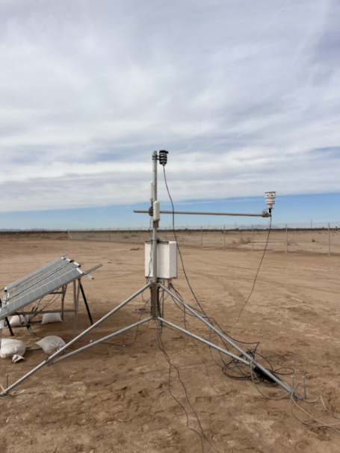 B) 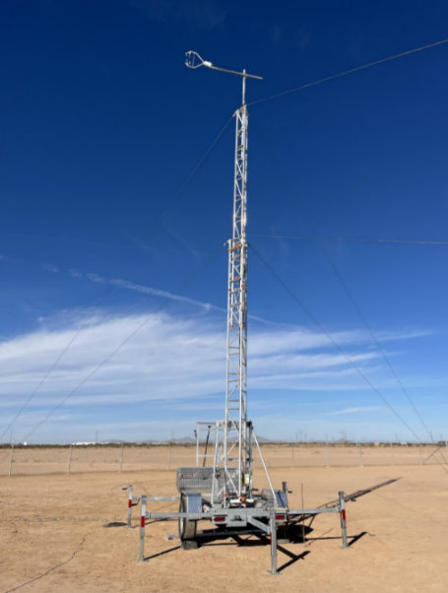 C) 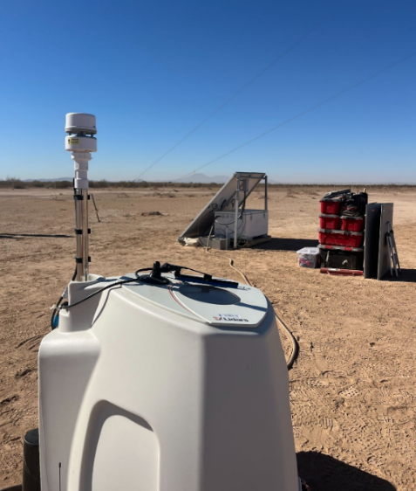

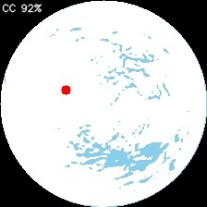
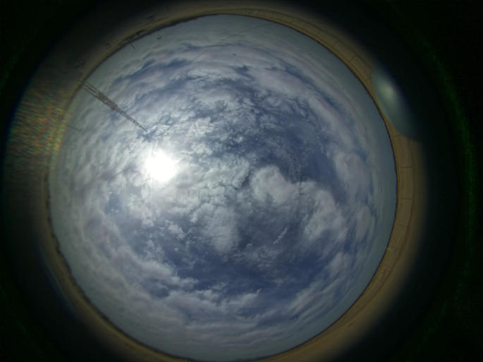
Figure S81. Sky camera HDR images and cloud masks on two days in March 2025
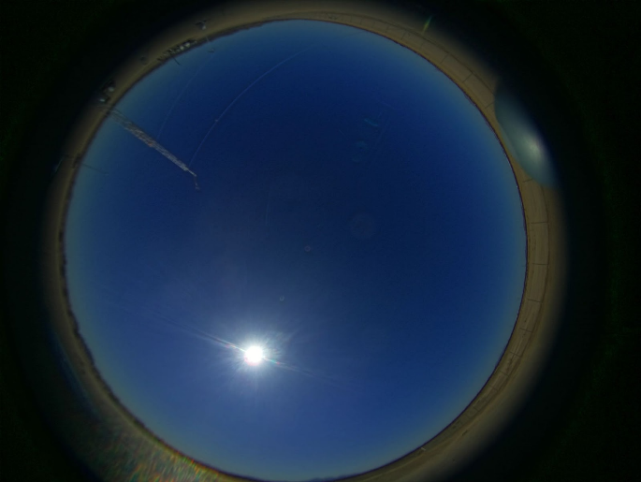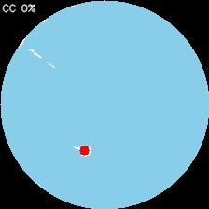

S4.3 Site meteorology during each study phase

This section details the meteorological conditions at the release site during the study period. The histograms presented below (Figures S82-S87) display key variables, time-averaged over the 5-minute window preceding each satellite overpass. These satellite observations primarily occurred between 11:00 and 15:00 local time due to the nature of the polar-orbiting satellite orbits common among these observing systems.

The study spanned one calendar year and distinct seasonal profiles are visible. Across Phase 1, 2, and 3, the predominant wind direction was from the southwest. In Phase 4 the wind direction shifted to be more variable with more winds from the southeast. Phase 1 was characterized by the coolest temperatures, with midday averages around 20°C, and had a higher frequency of low wind speeds (< 2 m/s) compared to the other phases. Phase 2 represented the driest period of the study and, correspondingly, experienced the highest solar irradiances. Phase 3 was the hottest and most humid, with temperatures regularly surpassing 35°C, which aligns with the region's late summer monsoon season.

Overall cloud cover remained extremely low year-round. This is one reason the site is considered to have idealized conditions. Note that a small number of solar irradiance measurements below 200 W/m² are present in the dataset. These values are abnormally low for midday, clear-sky conditions and likely correspond to sensor interference (e.g., from dust storms or temporary dust accumulation) or transient sensor failure rather than true atmospheric conditions. For future analyses using this public dataset, we recommend filtering out these specific data points.

Figure S82. Polar histogram of 10 m wind direction during overpasses, by phase

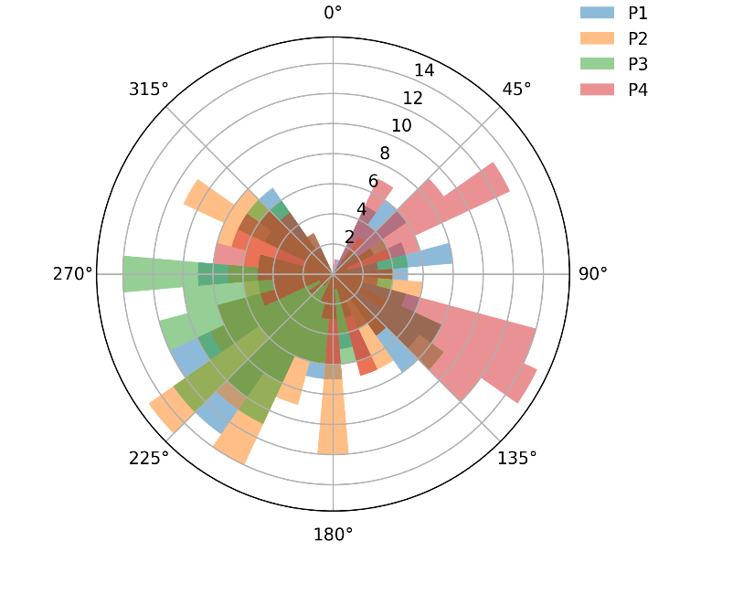

Figure S83. Histogram of 10 m wind speed during overpasses, by phase

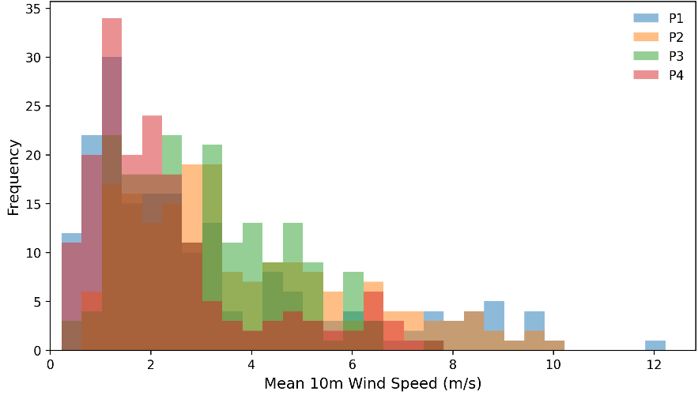

Figure S84. Histogram of relative humidity by phase

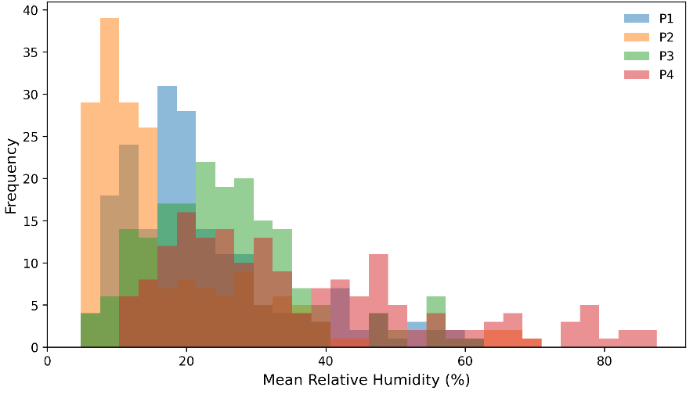

Figure S85. Histogram of air temperature during overpasses, by phase
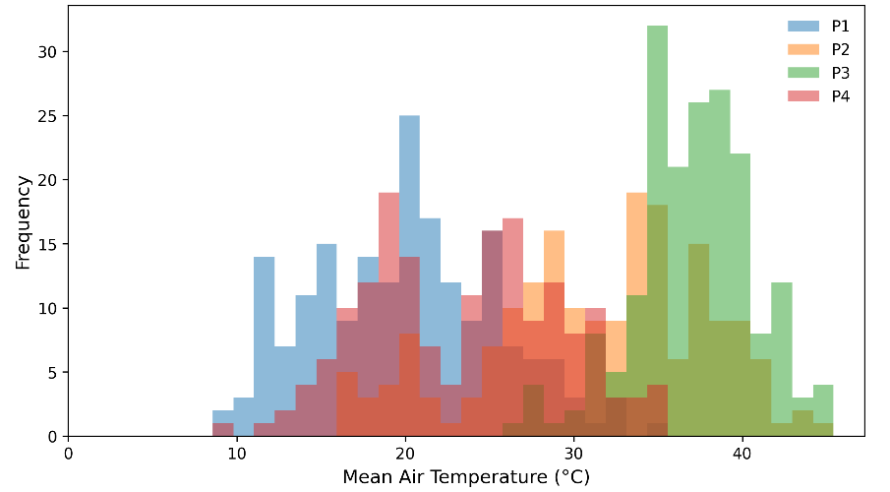

Figure S86. Histogram of cloud cover % during overpasses, by phase
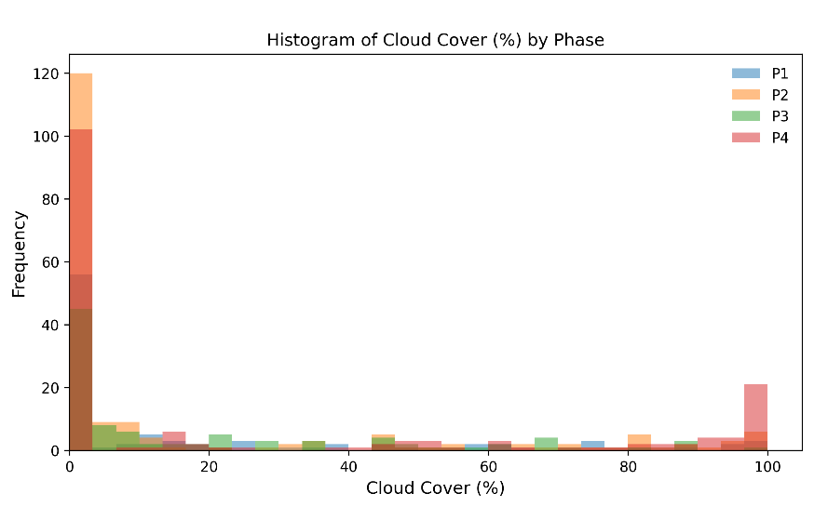

Figure S87. Histogram of irradiances (W/m2) during overpasses, by phase

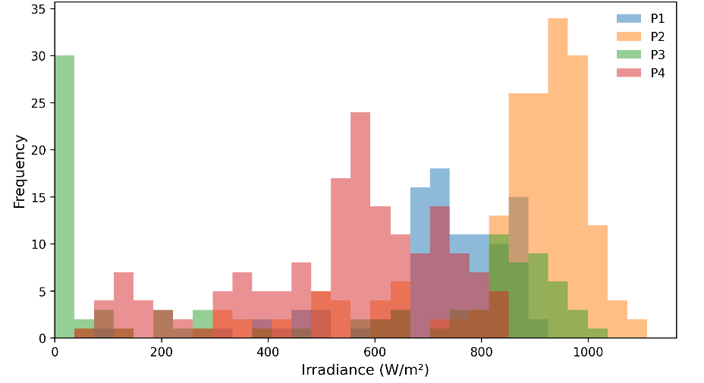

S4.4 Gas composition
Gas composition data were obtained from the two nearest gas composition measurement stations located upstream of the CNG fill point in Casa Grande, AZ. We obtained datafiles for gas composition provided by the gas pipeline supplier that serves the CNG station. Trailer refills were performed by trained and licensed staff from Armadillo Trucking. Stanford researchers maintained detailed logs of trailer fill dates and usage. These records allowed us to associate each gas release event with the correct trailer fill and corresponding gas composition. Batch numbers start at 12 because 11 refills took place prior the start of blind testing during the five-month testing period occurring in Evanston, WY and Casa Grande, AZ.

Table S11. Fill dates and methane composition for each gas batch at Casa Grande
Batch number | Fill date | CH₄ content (avg %, std dev %)
12 | 1/1/2025 | 93.4, 0.149
13 | 1/27/2025 | 92.7, 0.448
14 | 2/16/2025 | 93.1, 0.189
15 | 3/6/2025 | 94.2, 1.09
16 | 3/20/2025 | 95.0, 0.291
17 | 4/18/2025 | 96.5, 0.215
18 | 5/11/2025 | 95.5, 0.694
19 | 5/23/2025 | 95.6, 0.443
20 | 6/9/2025 | 95.1, 0.224
21 | 6/25/2025 | 96.1, 0.267
22 | 7/3/2025 | 95.4, .0278
23 | 7/22/2025 | 94.5, 0.408
24 | 8/8/2025 | 94.9, 0.609
25 | 8/25/2025 | 95.0, .0791
26 | 9/16/2025 | 95.9, 0.575
27 | 10/10/2025 | 95.5, 0.221
28 | 10/30/2025 | 95.0, 0.142
29 | 11/23/2025 | 95.8, 0.226
30 | 12/16/2025 | 96.5, 0.314

S4.5 Advancing Development of Emissions Detection Protocol

Some of this section has been reproduced from Sherwin et al. 2024 with permission.

The single-blind controlled methane release testing in this study followed the Advancing Development of Emissions Detection (ADED) protocol, developed at the Methane Emissions Technology Evaluation Center (METEC) in Colorado ²³

We followed protocols from Section 10, “Aerial Survey Emission Detection And Quantification,” which was designed to apply to remote sensing technologies in general, including satellites.

Documentation of the system under test is included both within this paper as well as in the “Performer Info” tab of the data spreadsheets submitted by each team, which are available in the data and code repository. Submitted emission estimates used a standard template spreadsheet modified based on the Aerial Survey Emission Detection and Quantification version of the ADED protocol. See Table S12 and S13 for the quantitative and qualitative reporting fields.

Following Section 10.4.1 of the ADED protocol, the test location was at least 1 km away from all potential confounding methane sources, e.g. the local landfill, and from all nearby water features.

Table S12. Single-blind quantitative reporting template sheet columns and descriptions
Column | Description | Unit | Type
InstrumentName | Name of satellite instrument or platform |  | Drop down
DateAnalysis | Date the analysis form is completed, format MM/DD/YYYY | MM/DD/YYYY | User entered
DateObs | Date of satellite observation attempt, format MM/DD/YYYY | MM/DD/YYYY | User entered
ObsTimestamp | Time of overpass, UTC | UTC | User entered
StartTime | If applicable, start time for overpass/acquisition, UTC | UTC | User entered
EndTime | If applicable, end time for overpass/acquisition, UTC | UTC | User entered
ImagingMode | If applicable, specify imaging mode for this observation, e.g. pushbroom, specific target mode, glint, etc. |  | User entered
OffNadirAngle | Off-nadir sensor viewing angle, in degrees | degrees | User entered
ViewingAzimuth | Viewing azimuth angle, in degrees clockwise from 0 as North | degrees | User entered
SolarZenith | Solar Zenith Angle at time of satellite observation, in degrees | degrees | User entered
SolarAzimuth | Solar Azimuth Angle at time of satellite observation, in degrees clockwise from 0 N | degrees | User entered
DetectionAttempt | Indicate whether plume detection attempt is FEASIBLE or INFEASIBLE. Note, DetectionAttempt may be feasible while Detection is FALSE. If infeasible, please select reason or use Notes Column to indicate. |  | Drop down
Detection | Indicate whether an emissions plume is detected (TRUE) or not (FALSE). Leave blank if DetectionAttempt (col L) was indicated to be infeasible. Detection may be TRUE even if quantification attempt is not made. |  | Binary (True/False)
QuantAttempt | Indicate whether an emissions rate quantification attempt is made. If emissions rate estimate is not made, please select reason or use Notes Column to indicate. |  | Drop down
Gas | Gas species measured |  | Drop down
PlumeOriginLat | Latitude coordinate of estimated origin for controlled release plume | decimal degrees | User entered
PlumeOriginLon | Longitude coordinate of estimated origin for controlled release plume | decimal degrees | User entered
PlumeLength | Plume length included in quantification, in meters | meters | User entered
IME | Integrated mass enhancement, in kg | kilograms | User entered
EmissionRate | Enter the mass emission rate in kg/hr. Enter 0 to signify no emissions are detected in a successful observation. Enter N/A if emission rate estimate is not attempted. Use drop down or notes to indicate reason. | kilograms/hour | User entered
EmissionRateUpper | Enter the upper bound estimate of mass emission rate in kg/hr | kilograms/hour | User entered
EmissionRateLower | Enter the lower bound estimate of mass emission rate in kg/hr | kilograms/hour | User entered
EmissionRateUncertaintyType | The form of uncertainty presented (e.g. min/max, 95% confidence interval, standard deviation) for EmissionRate. |  | User entered
U10WindSpeed | If applicable, report here the 10-meter altitude wind speed estimate used in quantifying emission rate, in meters per second. | meters/sec | User entered
UeffWindSpeed | If applicable, report the Ueff windspeed parameter used in quantification, in meters per second. | meters/sec | User entered
WindSpeedUpper | If applicable, enter the upper uncertainty estimate of Ueff wind speed in m/s. | meters/sec | User entered
WindSpeedLower | Enter the lower uncertainty estimate of Ueff wind speed in m/s. | meters/sec | User entered
WindSpeedUncertaintyType | The form of uncertainty presented for WindSpeed (e.g. min/max, 95% confidence interval, standard deviation). |  | User entered
WindDirection | In degrees measured clockwise relative to 0 as geographic North. Here, the angle corresponds to the direction FROM where the wind comes. For example, 180 degree wind comes from the South. | degrees | User entered
Notes | Leave any other notes in this cell |  | User entered

Table S13 Single-blind methods description reporting sheet
Question
(1) Company/Organization name
(2) Please provide a detailed description of system configuration and primary components including the sensor(s) and satellite platform(s). If any auxiliary equipment (such as ground meteorological stations) is used please specify.
(3) Please record the software revision installed on the components in (2), including performer-specific software components, revisions, or customizations, where relevant.
(4) Please record the revision number of any data processing software used in analysis. For example: retrieval software version or source rate estimation tools. If multiple software versions are used throughout this study, please specify what software versions apply to which dates.
(5) If your equipment is capable of multiple imaging modes, please describe what they are and which imaging mode(s) is used in this study.
(6) Please provide a detailed description of the methodology used during emission detection and quantification surveys.

*If multiple distinct methodologies are used, please use the Notes column in the Overpass Summary tab to specify which method applies on which dates.
(7) Please describe your method for obtaining methane concentration retrieval.
(8) Please describe your method of plume delineation/segmentation (e.g., plume mask generation).
(9) Please describe how plume length is determined for quantification, if applicable.
(10) If wind speed is used in computing total emission rate, please describe how the wind estimate is obtained, including the precise instrument or wind reanalysis product used and if/how Ueff is generated.
(11) Please record the number of personnel participating in the surveys and their roles. Names of individual personnel are not required.
(12) Did any major changes or discontinuities occur during the study that are relevant to the main analysis (i.e. change in satellite orbit altitude, major change to data processing methodology)? If so, please describe what the change was and when it occurred.

Supplement references
1. Reuland, F., Adams, T., Galvin, K., Kort, E. A. & Brandt, A. R. Large-Scale Controlled Methane Releases for Satellite-Based Detection and Emission Quantification of Point-Sources. Preprint at https://doi.org/10.25740/QH001QT3946 (2025).
2. GHGSat. Emission Sensing Technology - GHGSat. https://www.ghgsat.com/en/technology/ (2025).
3. Carbon Mapper. Carbon Mapper Coalition’s First Methane-Sensing Satellite to Launch August 16th. https://carbonmapper.org/articles/carbon-mapper-coalitions-first-methane-sensing-satellite-to-launch (2024).
4. Duren, R. et al. The Carbon Mapper emissions monitoring system. EGUsphere 1–41 (2025) doi:10.5194/egusphere-2025-2275.
5. Green, R. O. et al. The Earth Surface Mineral Dust Source Investigation: An Earth Science Imaging Spectroscopy Mission. in 2020 IEEE Aerospace Conference 1–15 (IEEE, Big Sky, MT, USA, 2020). doi:10.1109/AERO47225.2020.9172731.
6. Earth Observation Center of DLR. Mission - EnMAP. https://www.enmap.org/mission/ (2023).
7. Liu, Y.-N. et al. The Advanced Hyperspectral Imager: Aboard China’s GaoFen-5 Satellite. IEEE Geosci. Remote Sens. Mag. 7, 23–32 (2019).
8. eoPortal. GHOSt (Global Hyperspectral Observation Satellite) - eoPortal. https://www.eoportal.org/satellite-missions/ghost#eop-quick-facts-section (2024).
9. OHB Italia. Satellites & Missions: PRISMA. PRISMA https://www.ohb-italia.it/satellites-missions/ (2022).
10. Chen, L. et al. Mapping Alteration Minerals Using ZY-1 02D Hyperspectral Remote Sensing Data in Coalbed Methane Enrichment Areas. Remote Sens. 15, 3590 (2023).
11. Sherwin, E. D. et al. Single-blind test of nine methane-sensing satellite systems from three continents. Atmospheric Meas. Tech. 17, 765–782 (2024).
12. USGS. Landsat 8 | U.S. Geological Survey. https://www.usgs.gov/landsat-missions/landsat-8 (2023).
13. Jervis, D. et al. The GHGSat-D imaging spectrometer. Atmospheric Meas. Tech. 14, 2127–2140 (2021).
14. Setchell, H. ECMWF Reanalysis v5. (2020).
15. Irakulis-Loitxate, I., Gorroño, J., Zavala-Araiza, D. & Guanter, L. Satellites Detect a Methane Ultra-emission Event from an Offshore Platform in the Gulf of Mexico. Environ. Sci. Technol. Lett. 9, 520–525 (2022).
16. Guanter, L. et al. Mapping methane point emissions with the PRISMA spaceborne imaging spectrometer. Remote Sens. Environ. 265, 112671 (2021).
17. Varon, D. J. et al. Quantifying methane point sources from fine-scale satellite observations of atmospheric methane plumes. Atmospheric Meas. Tech. 11, 5673–5686 (2018).
18. Roger, J., Guanter, L., Gorroño, J. & Irakulis-Loitxate, I. Exploiting the entire near-infrared spectral range to improve the detection of methane plumes with high-resolution imaging spectrometers. Atmospheric Meas. Tech. 17, 1333–1346 (2024).
19. Pei, Z. et al. Improving quantification of methane point source emissions from imaging spectroscopy. Remote Sens. Environ. 295, 113652 (2023).
20. Guanter, L. et al. Multisatellite Data Depicts a Record-Breaking Methane Leak from a Well Blowout. Environ. Sci. Technol. Lett. https://doi.org/10.1021/acs.estlett.4c00399 (2024) doi:10.1021/acs.estlett.4c00399.
21. Sherwin, E. D. et al. Single-blind validation of space-based point-source detection and quantification of onshore methane emissions. Sci. Rep. 13, 3836 (2023).
22. El Abbadi, S. H. et al. Technological Maturity of Aircraft-Based Methane Sensing for Greenhouse Gas Mitigation. Environ. Sci. Technol. 58, 9591–9600 (2024).
23. Bell, C. & Zimmerle, D. METEC controlled test protocol: survey emission detection and quantification. Preprint at https://doi.org/10.25675/10217/235363 (2022).

