Supporting Information
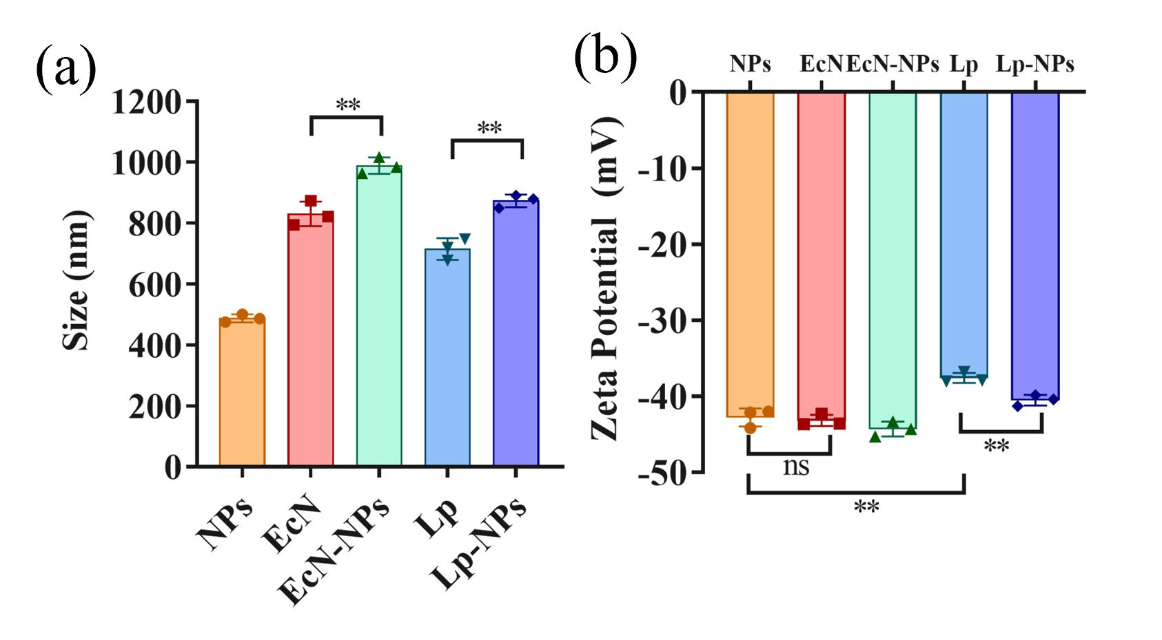
Figure S1. a) Average hydrodynamic diameters and b) Zeta potentials of nanoparticles, naked bacteria, and assembled bacteria. *p < 0.05, **p < 0.01, ***p < 0.001.
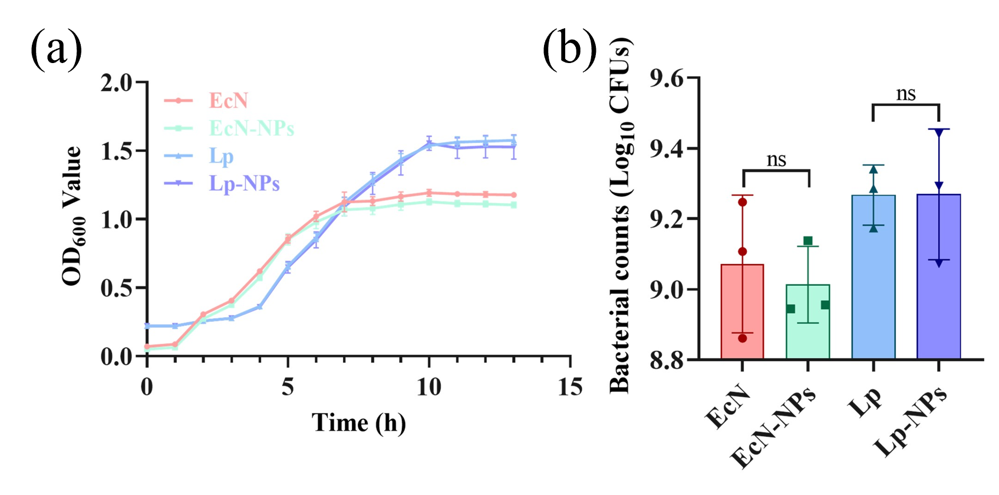
Figure S2. Influence of nanoparticle assembly on the viability and growth curves.
Figure S3. Live/dead staining of naked and assembled EcN under CLSM after continuous treatment with SGF for 2 h and SIF for 2 h. Scale bar: 10 μm.

Figure S4. Live/dead staining of naked and armed Lp under CLSM after continuous treatment with SGF for 2 h and SIF for 2 h. Scale bar: 10 μm.
Figure S5. Comparison between ordinary EcN and EcN-Mcherry transformed with the pBBR1MCS2-Tac-mCherry plasmid. The latter can express red fluorescence under CLSM. Scale bar: 10 μm.
Figure S6. Plate coating of the contents in the stomach, small intestine, colon, and cecum of the mouse gastrointestinal tract 4 hours after oral gavage of naked bacteria and assembled bacteria.
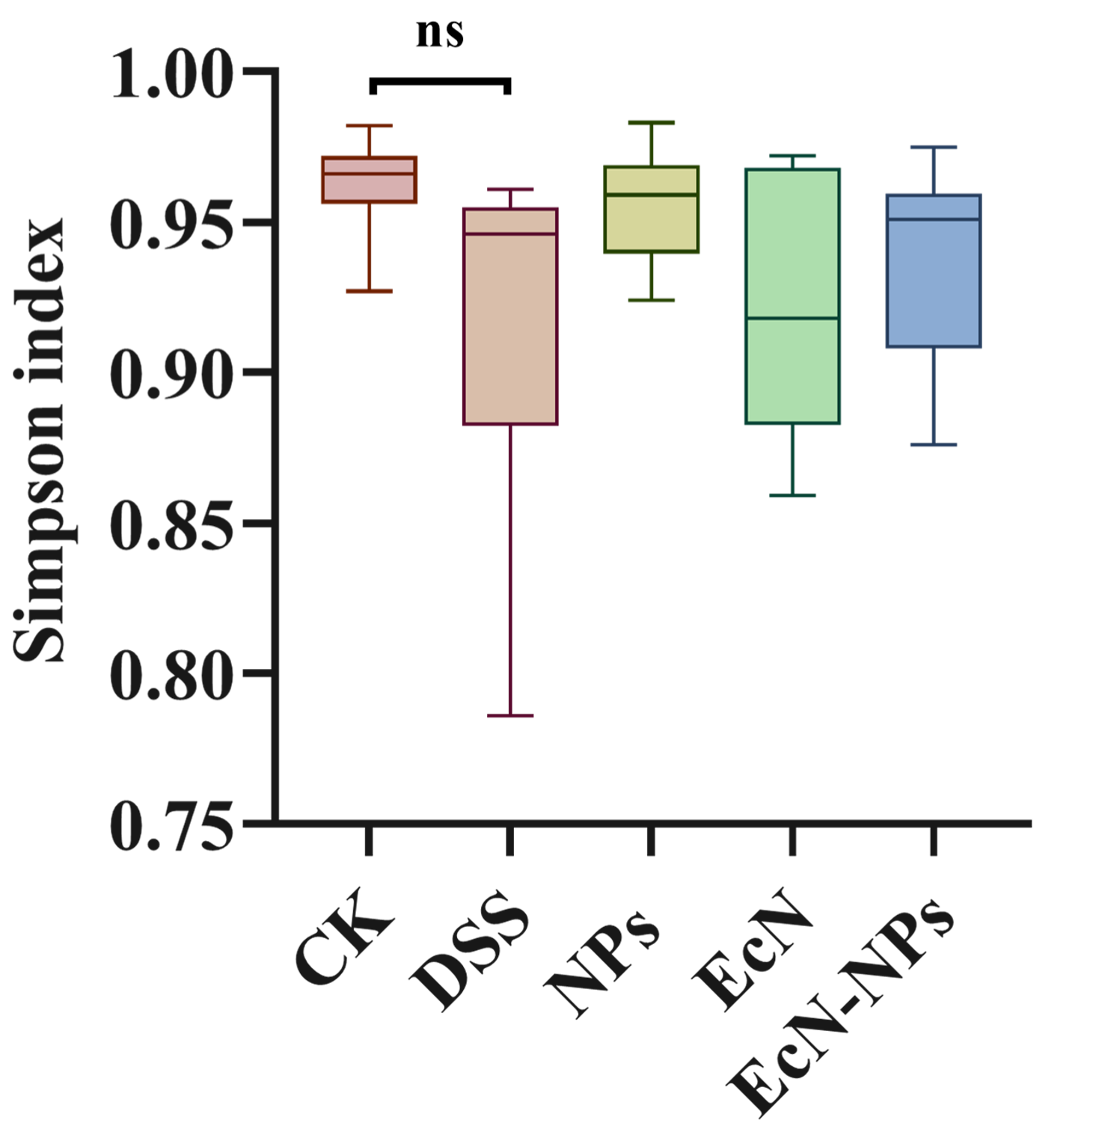
Figure S7. Simpson diversity index of the intestinal microbiota in mice of each group.
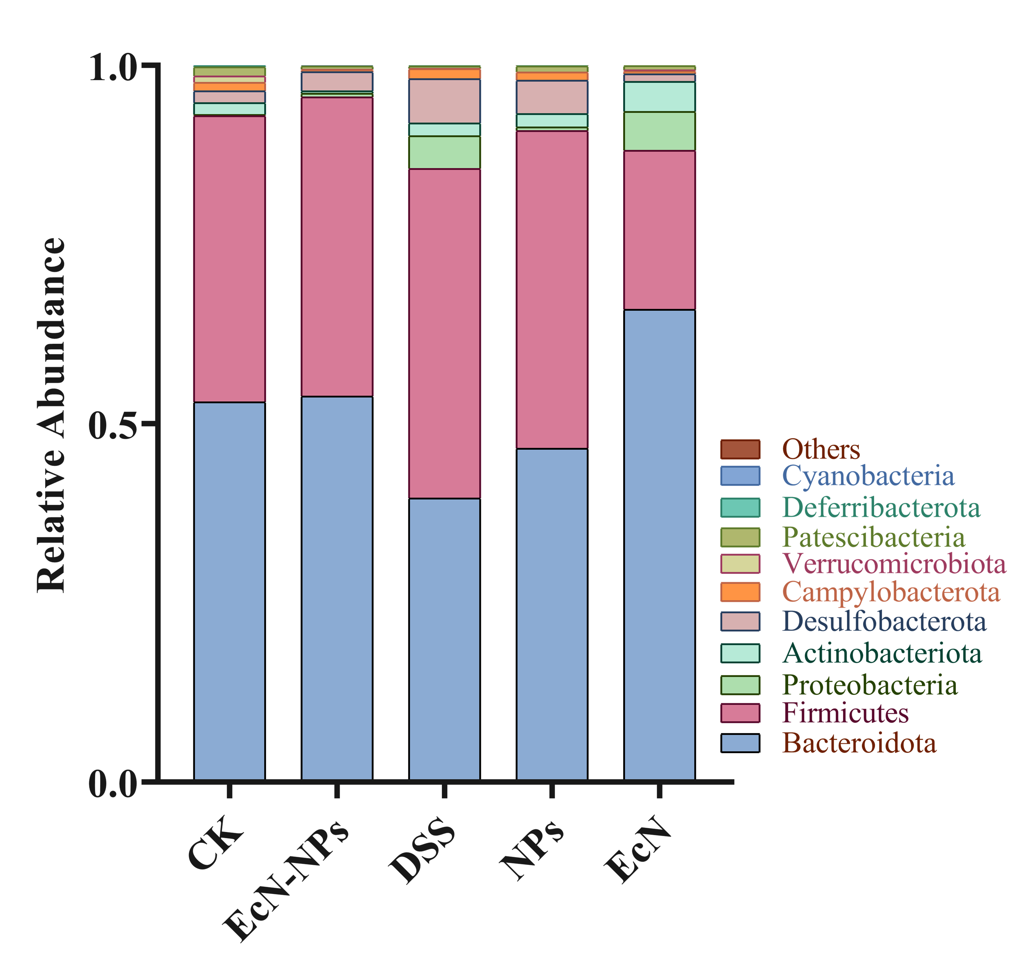
Figure S8. Relative abundance of Phyla in the mouse gut microbiota.

