Legends of supplementary material
Figure S1. Flowchart of participant inclusion and exclusion
Figure S2. Evaluation of IPW for the Analysis of MetS and UTI Association
Figure S3. Comparison of Standardized Mean Differences Before and After IPW Weighting (MetS as Treatment)
Figure S4. IPW Weight Boxplot by nMetS Subgroup (1%-99% Trimmed)
Figure S5. IPW Weight Distribution Histogram by nMetS Subgroup (1%-99% Trimmed)
Figure S6. Association Between nMetS and UTI Risk: A Comprehensive Visual Analysis with Stabilized IPW
Figure S7. Cumulative risk of UTI with and without MetS (stabilized IPW weights)
Figure S8. Cumulative risk of UTI with and without MetS (Model 3 adjusted)
Figure S9. Cumulative risk of UTI with and without MetS, stratified by UTI subtypes (UUTI, LUTI and UTI, NOS) (stabilized IPW weights)
Figure S10. Cumulative risk of UTI with and without MetS, stratified by UTI subtypes (UUTI, LUTI and UTI, NOS) (Model 3 adjusted)
Figure S11. Cumulative risk of UTI by nMetS (0–5) (Model 3 adjusted)
Figure S12. Association between MetS and UTI Risk by Follow-up Period (stabilized IPW weights and Model 3 adjusted)
Figure S13. Association between nMetS and UTI risk (stabilized IPW weights and Model 3 adjusted)
Figure S14. Association between nMetS and UTI Risk stratified by UTI subtypes (UUTI, LUTI and UTI, NOS) (stabilized IPW weights)
Figure S15. Association between nMetS and UTI Risk stratified by UTI subtypes (UUTI, LUTI and UTI, NOS) (Model 3 adjusted)
Figure S16. Association of Metabolic, Anthropometric, and Biochemical Parameters with UTI Risk: Per-Unit Increment Analyses (Model 3 adjusted)
Figure S17. Association of Metabolic, Anthropometric, and Biochemical Parameters with UTI Risk: Restricted Cubic Spline Analyses (Model 3 adjusted)
Figure S18. Subgroup Analysis of UTI Risk Stratified by Demographic and Lifestyle Factors: Interaction Tests Based on IPW-Adjusted HR
Figure S19. Subgroup Analysis of UTI Risk Stratified by Demographic and Lifestyle Factors: Interaction Tests Based on Model 3-Adjusted HR
Figure S20. Mediation Analyses of MetS Associated Metabolic and Biochemical Parameters with UTI Risk: Model 3 Adjusted HR

Table S1. Classification of UTI subtypes and corresponding ICD‑10 codes
Table S2. Baseline Covariates, Categorization Criteria, and Corresponding UK Biobank Field IDs
Table S3. Baseline characteristics of the study population (unweighted).
Table S4. Baseline characteristics of the study population by UTI subtype (IPW-weighted percentages and P-values).
Table S5. Baseline characteristics of the study population by MetS status (IPW-weighted percentages and P-values).
Table S6. Baseline characteristics of the study population by nMetS (IPW-weighted percentages and P-values).
Table S7. Association between nMetS and UTI Risk (Model 1, 2, 3 adjusted)
Table S8. Association between nMetS and UTI Risk stratified by UTI subtypes (UUTI, LUTI and UTI, NOS) (Model 1, 2, 3 adjusted)
Table S9. Sensitivity analysis of hazard ratios (95% CI) for the risk of UTI associated with metabolic, anthropometric, and biochemical parameters (stabilized IPW weights)
Table S10. Sensitivity analysis of hazard ratios (95% Cl) for the risk of UTI associated with nMetS (stabilized IPW weights)
Table S11. Sensitivity analysis of multivariable-adjusted hazard ratios (95% Cl) for the risk of UTI associated with Metabolic, Anthropometric, and Biochemical Parameters (Model 3 adjusted)
Table S12. Sensitivity analysis of multivariable-adjusted hazard ratios (95% Cl) for the risk of UTI associated with nMetS (Model 3 adjusted)

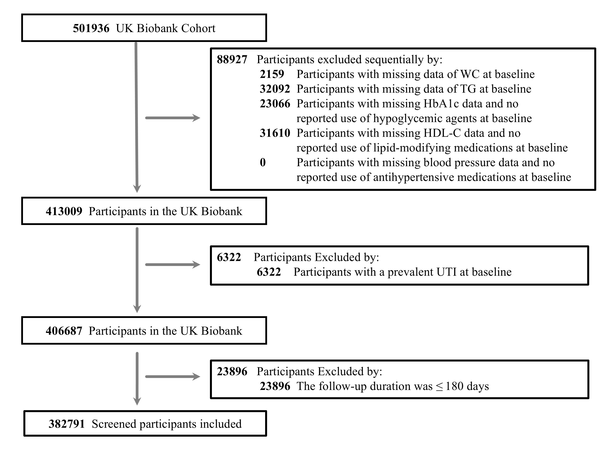
Figure S1. Flowchart of participant inclusion and exclusion
WC, Waist circumference; TG, Triglyceride; HbA1c, Glycosylated Hemoglobin A1c; HDL, high-density lipoprotein.
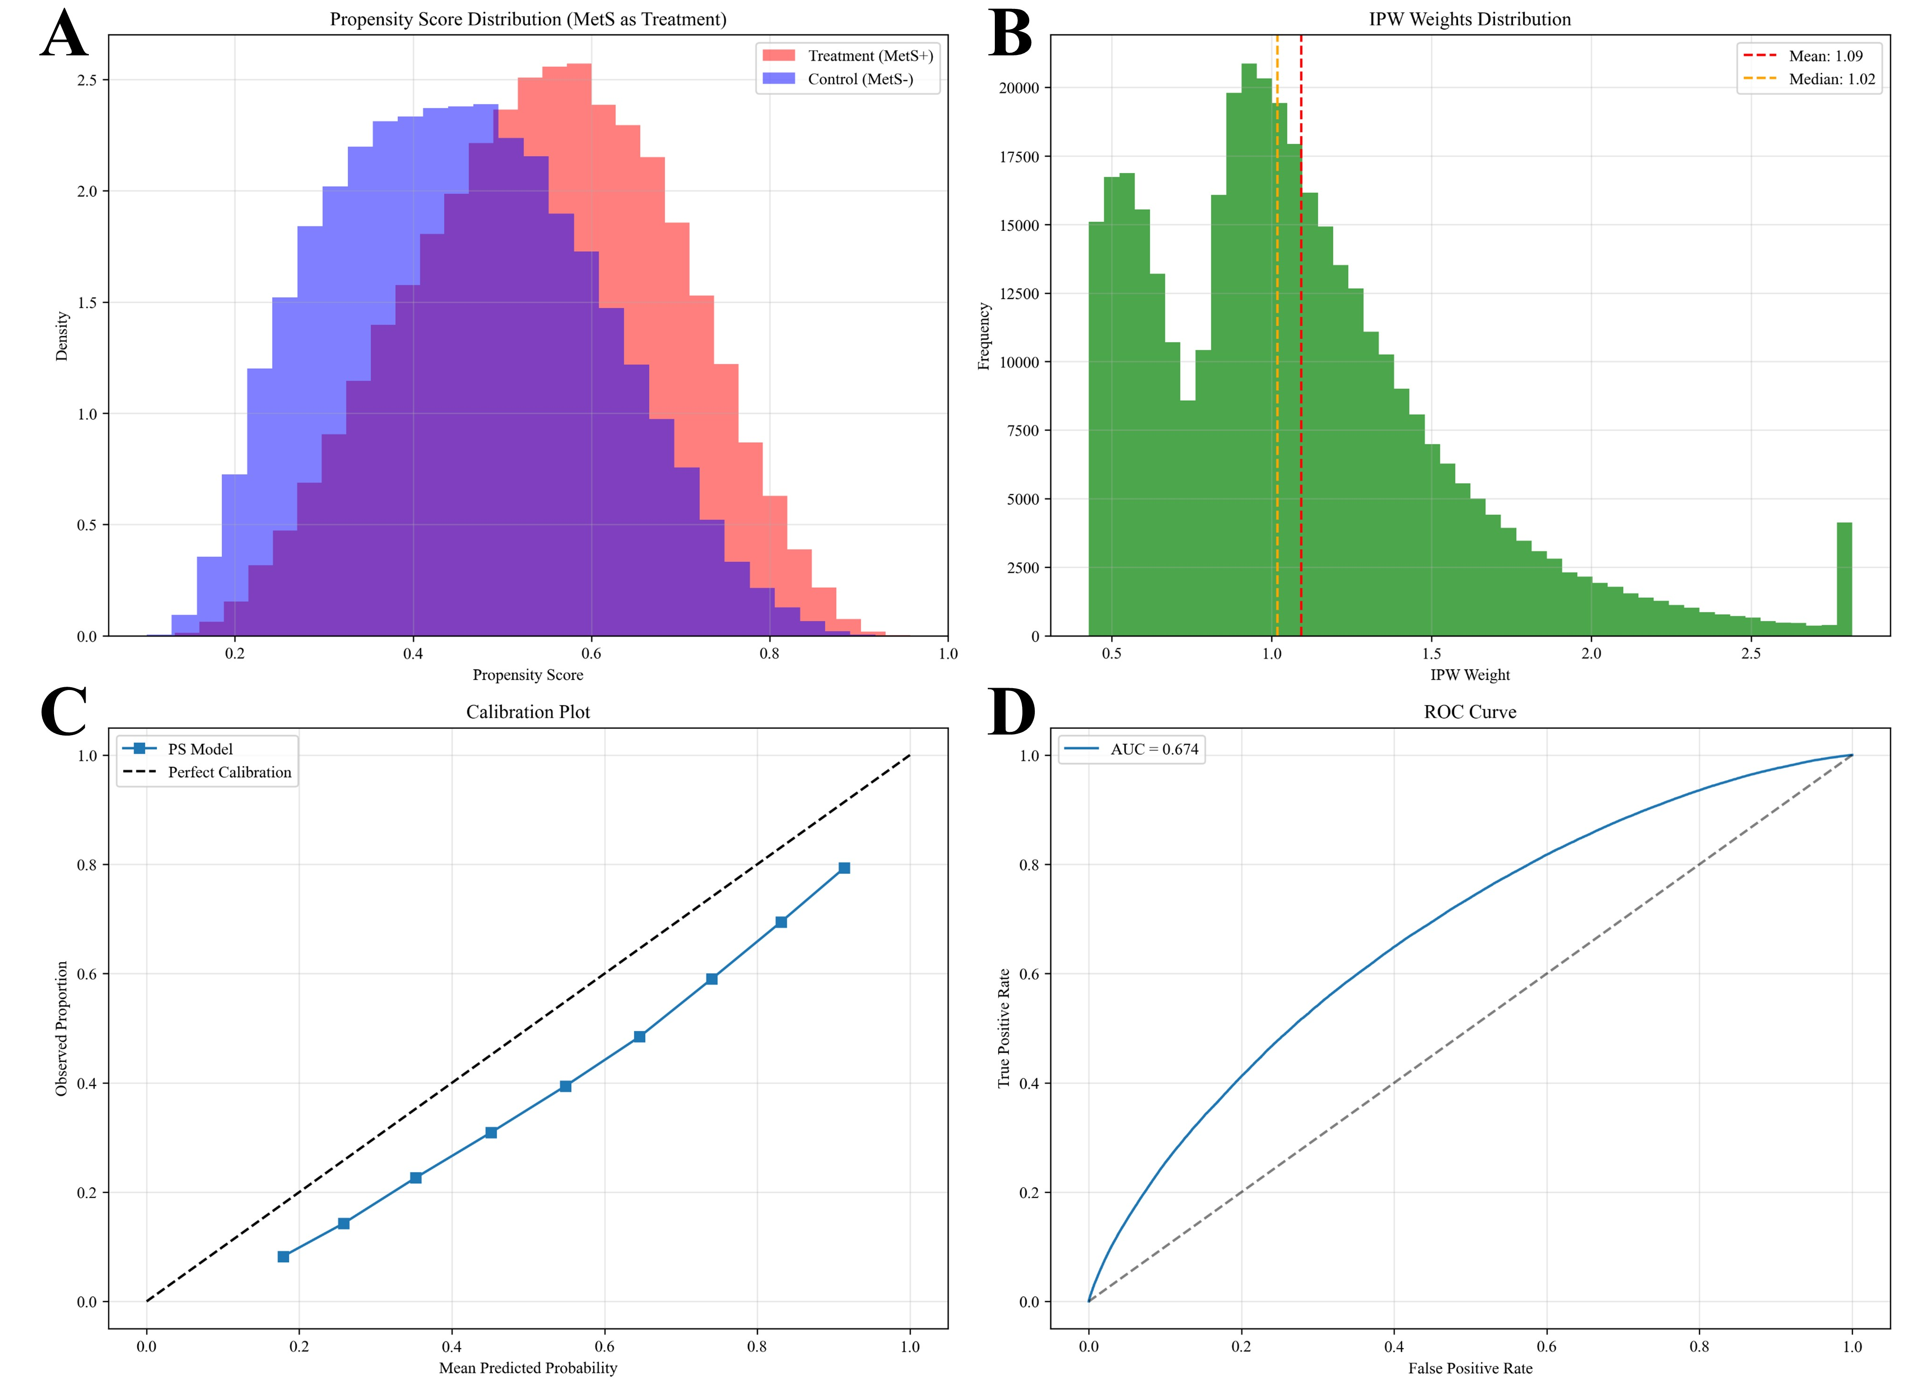
Figure S2. Evaluation of IPW for the Analysis of MetS and UTI Association
(A) Propensity Score Distribution (MetS as Treatment); (B) Distribution of IPW Weights; (C) Calibration Plot of the Propensity Score Model; (D) ROC Curve of the Propensity Score Model (AUC = 0.674)

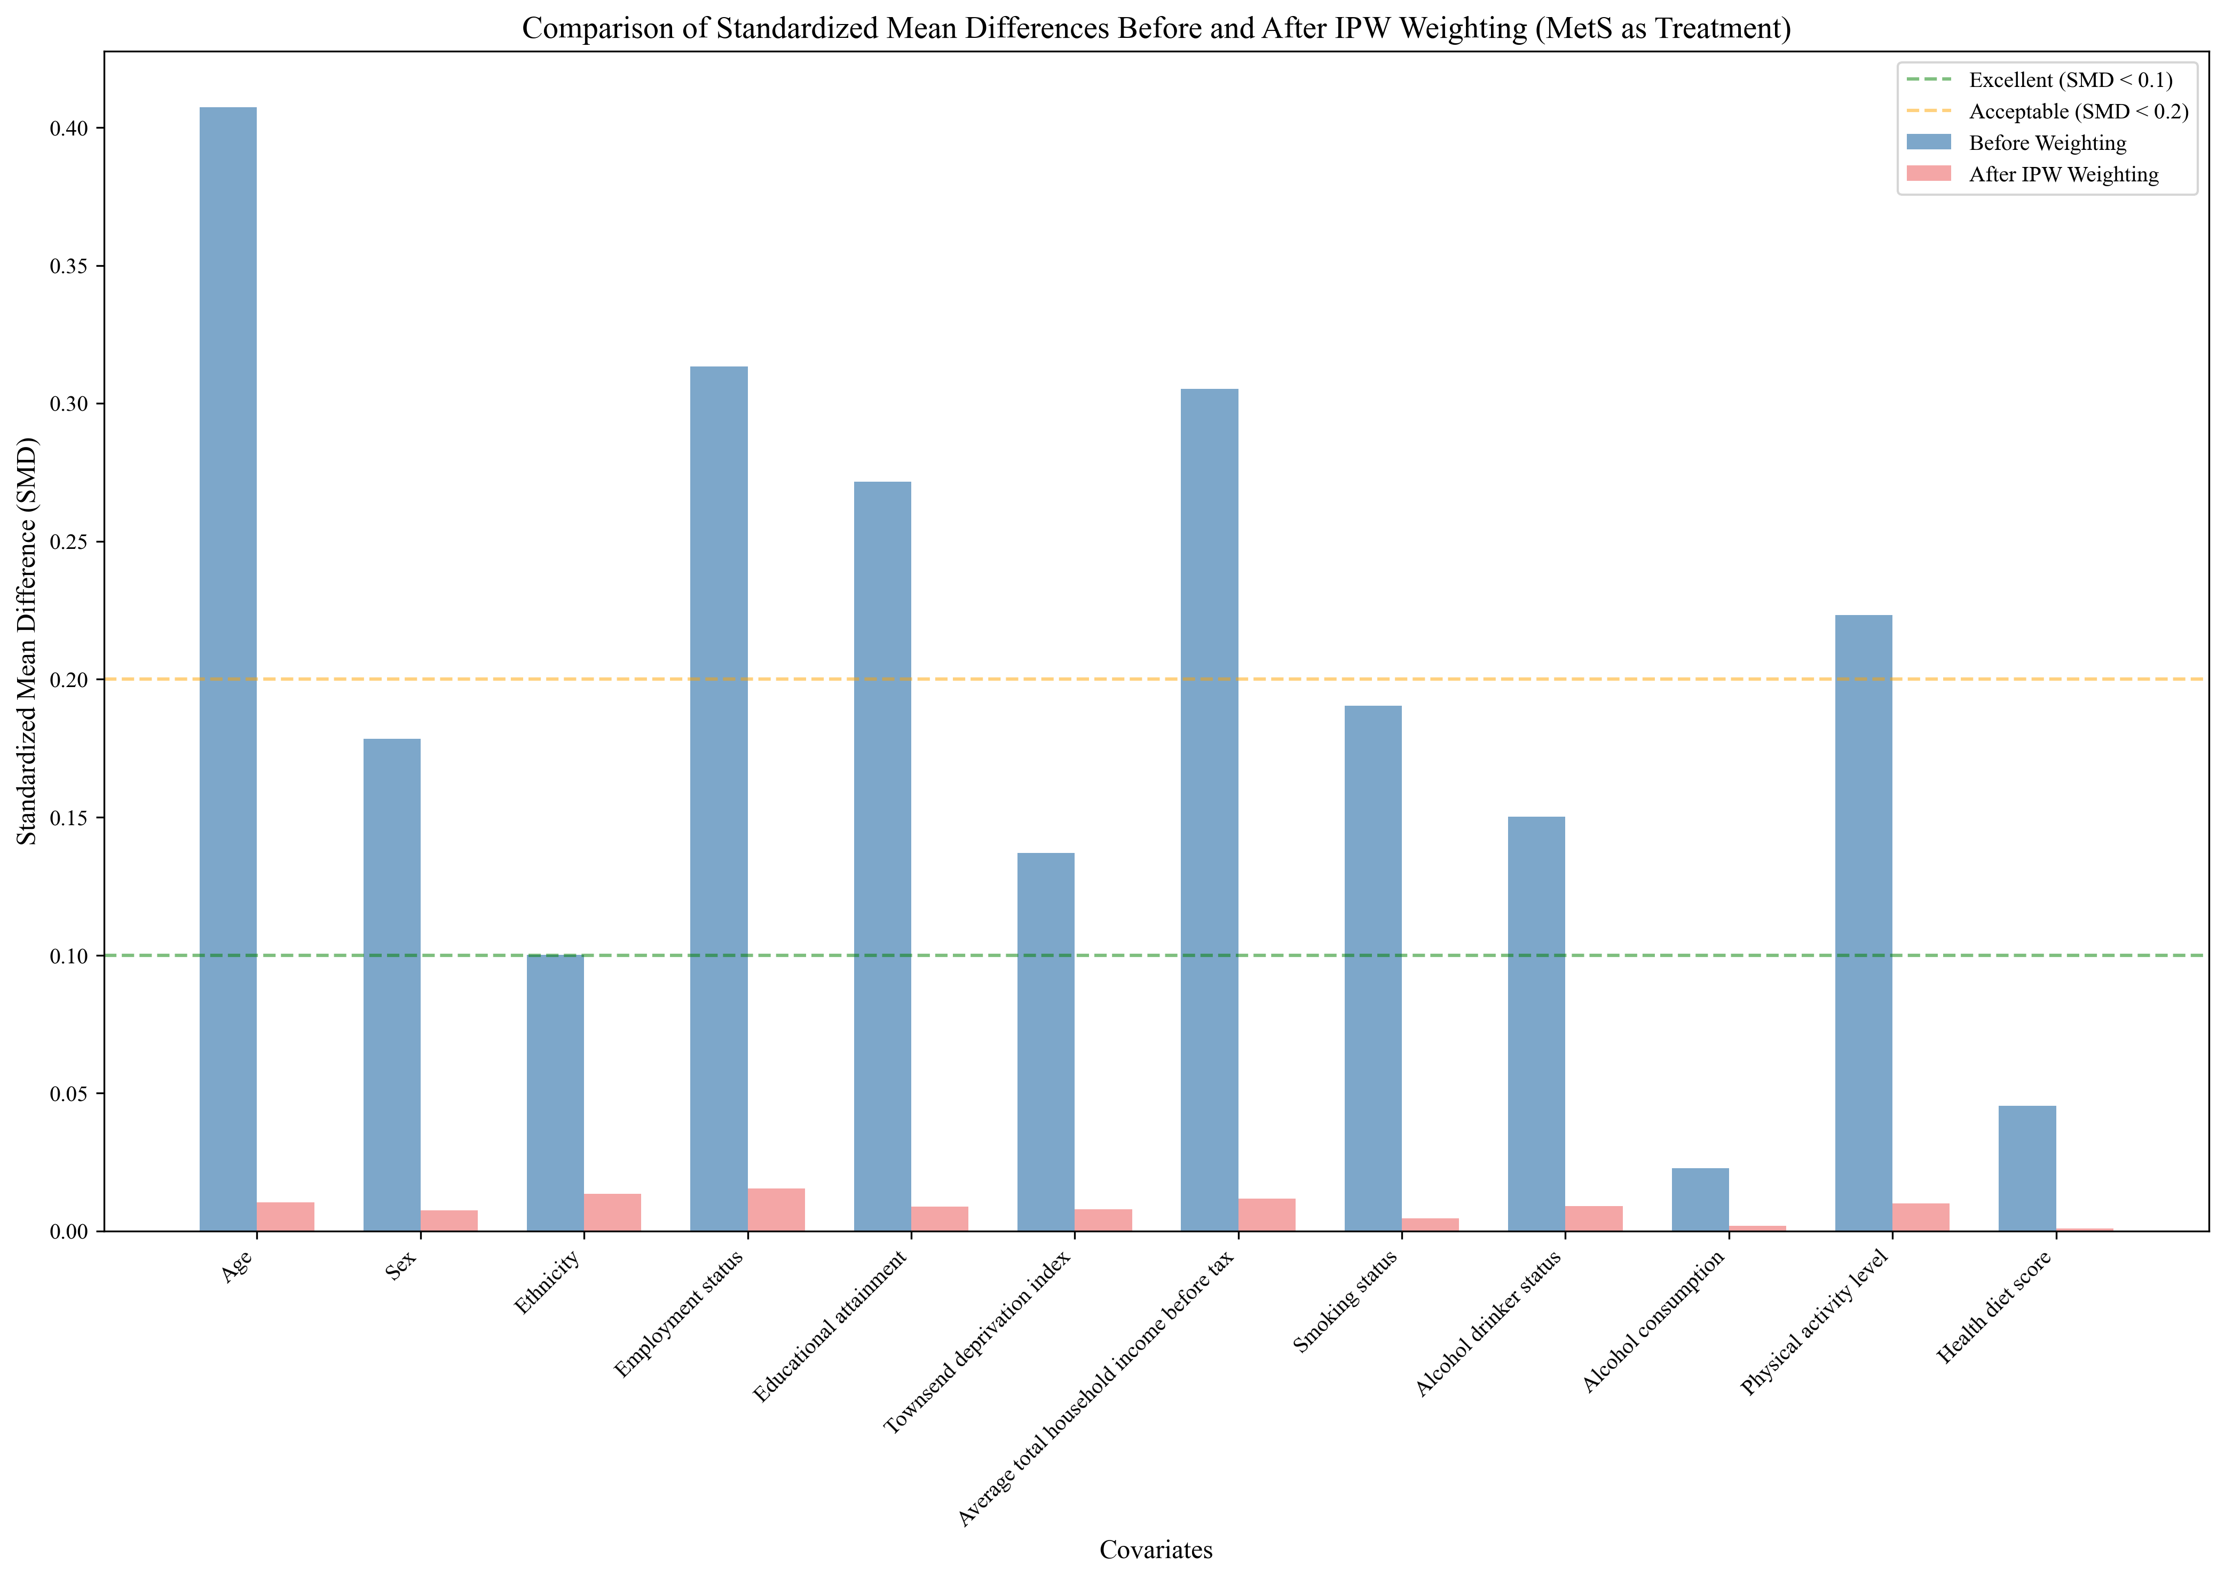
Figure S3. Comparison of Standardized Mean Differences Before and After IPW Weighting (MetS as Treatment)
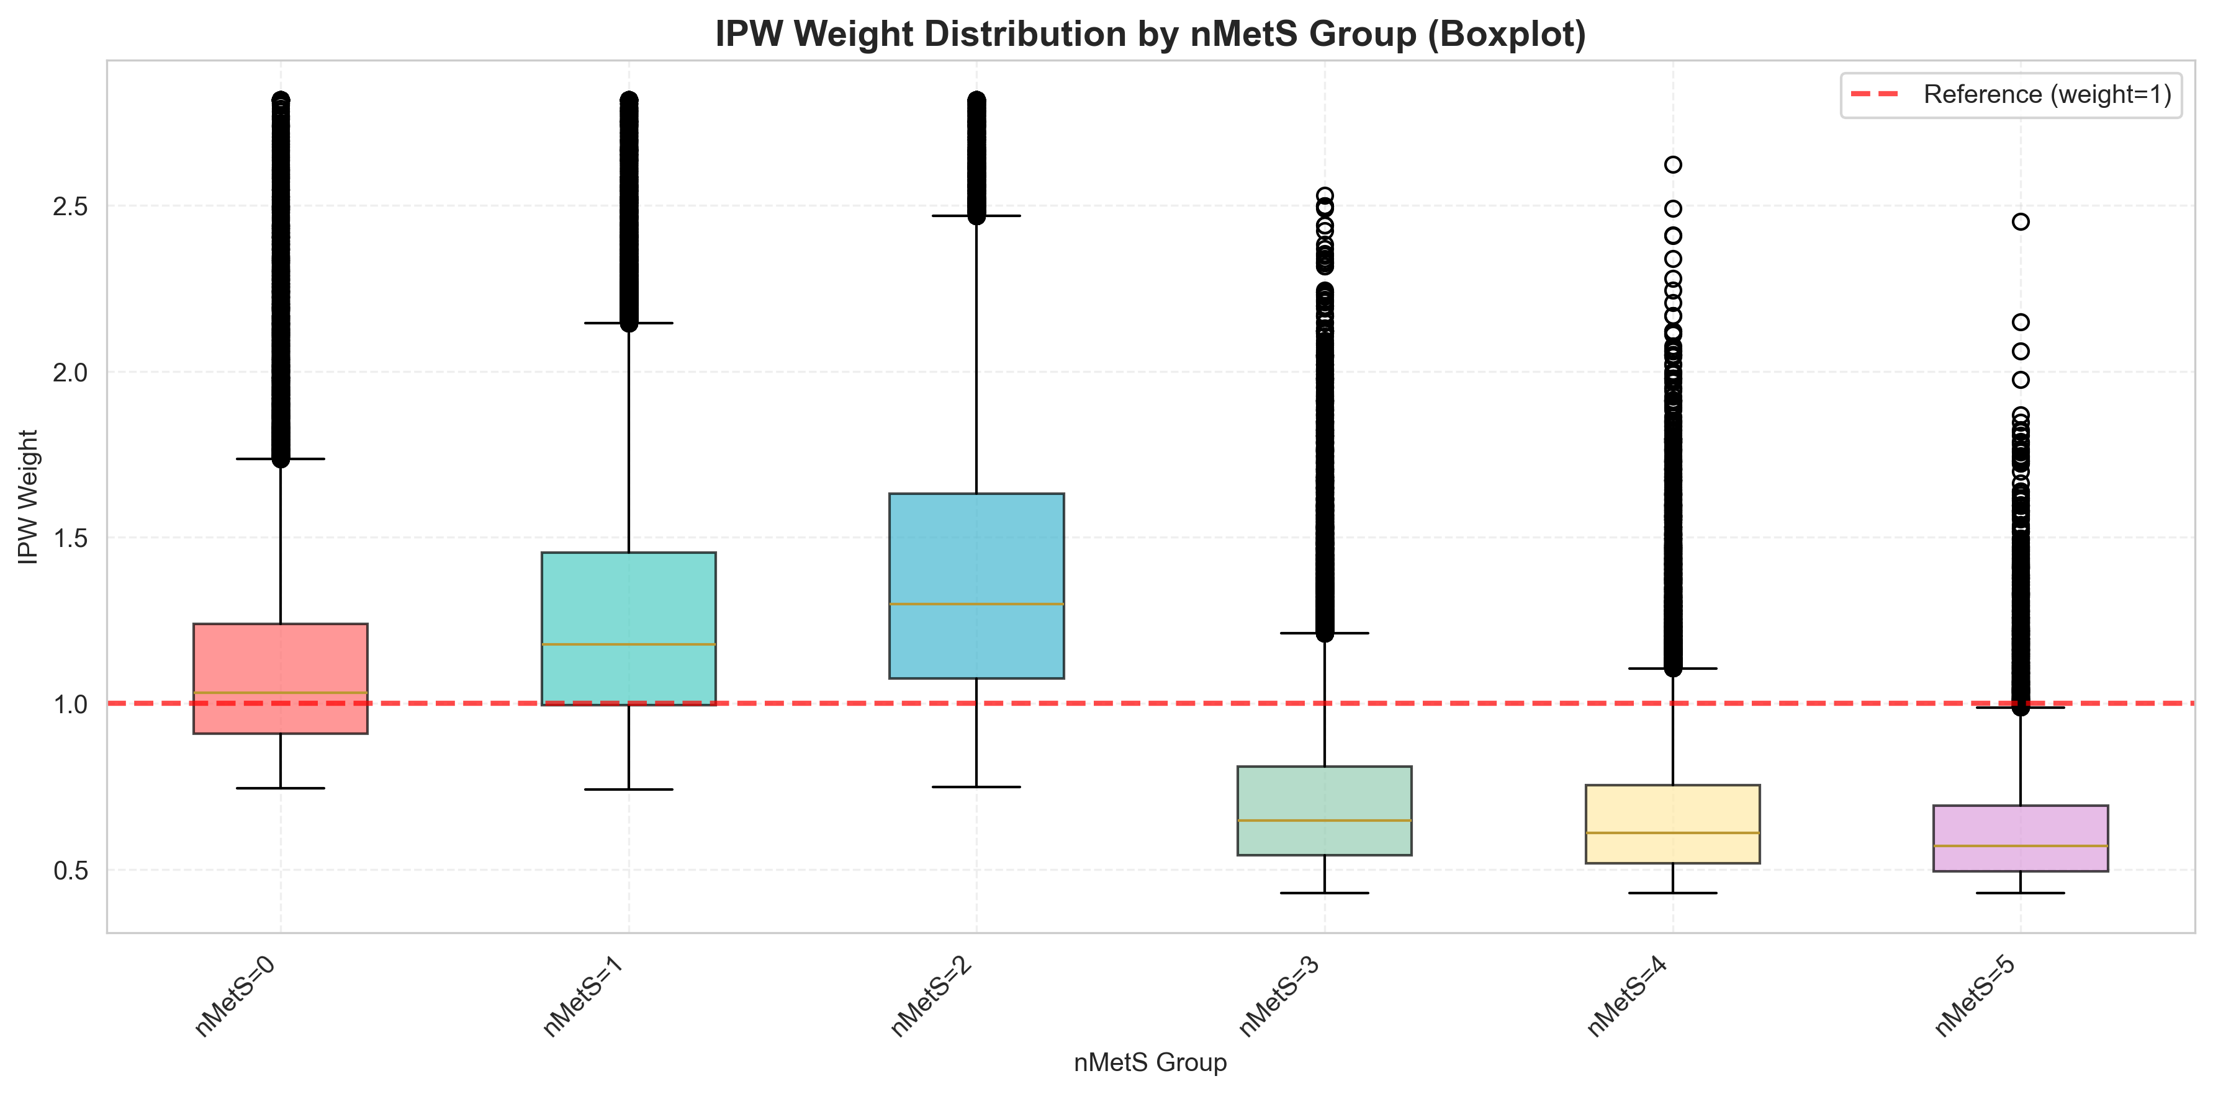

Figure S4. IPW Weight Boxplot by nMetS Subgroup (1%-99% Trimmed)

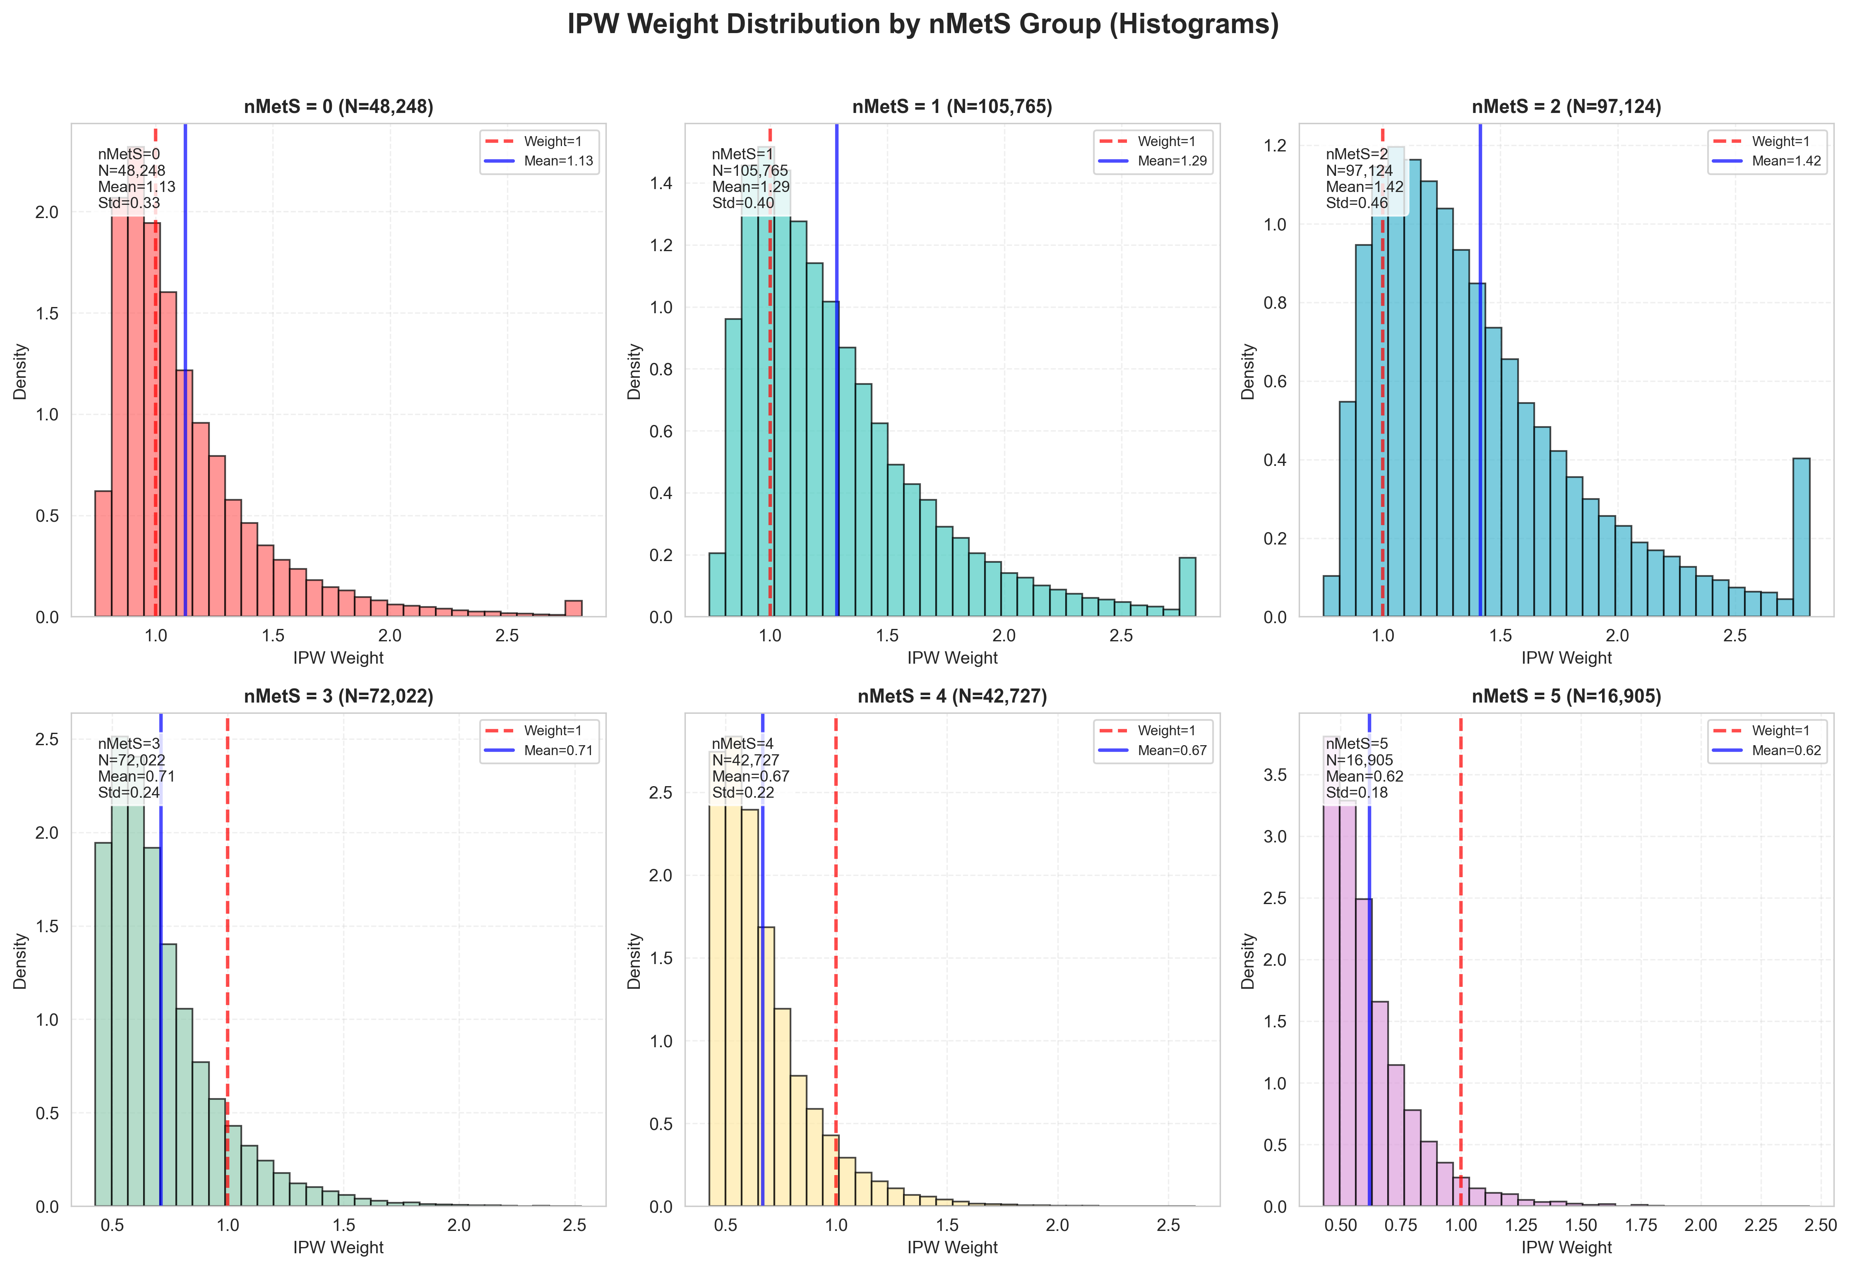
Figure S5. IPW Weight Distribution Histogram by nMetS Subgroup (1%-99% Trimmed)
Figure S6. Association Between nMetS and UTI Risk: A Comprehensive Visual Analysis with Stabilized IPW
(A) Dose-Response Relationship Between nMetS and UTI Risk; (B) Subgroup Analysis of the Association Between nMetS and UTI Risk; (C) Time-Dependent Effect of nMetS on UTI Risk During Follow-Up; (D) Piecewise Hazard Ratio Analysis of nMetS and UTI Risk by Follow-Up Period; (E) Population Attributable Risk (PAR) of UTI Associated With nMetS; (F) Number Needed to Treat (NNT) Analysis for UTI Prevention in High-Risk MetS Groups; (G) Sensitivity Analysis: Impact of IPW Weight Standardization on Effect Estimates; (H) Landmark Analysis of nMetS and UTI Risk at Different Follow-Up Time Points; (I) Dynamic Cumulative Incidence of UTI by nMetS

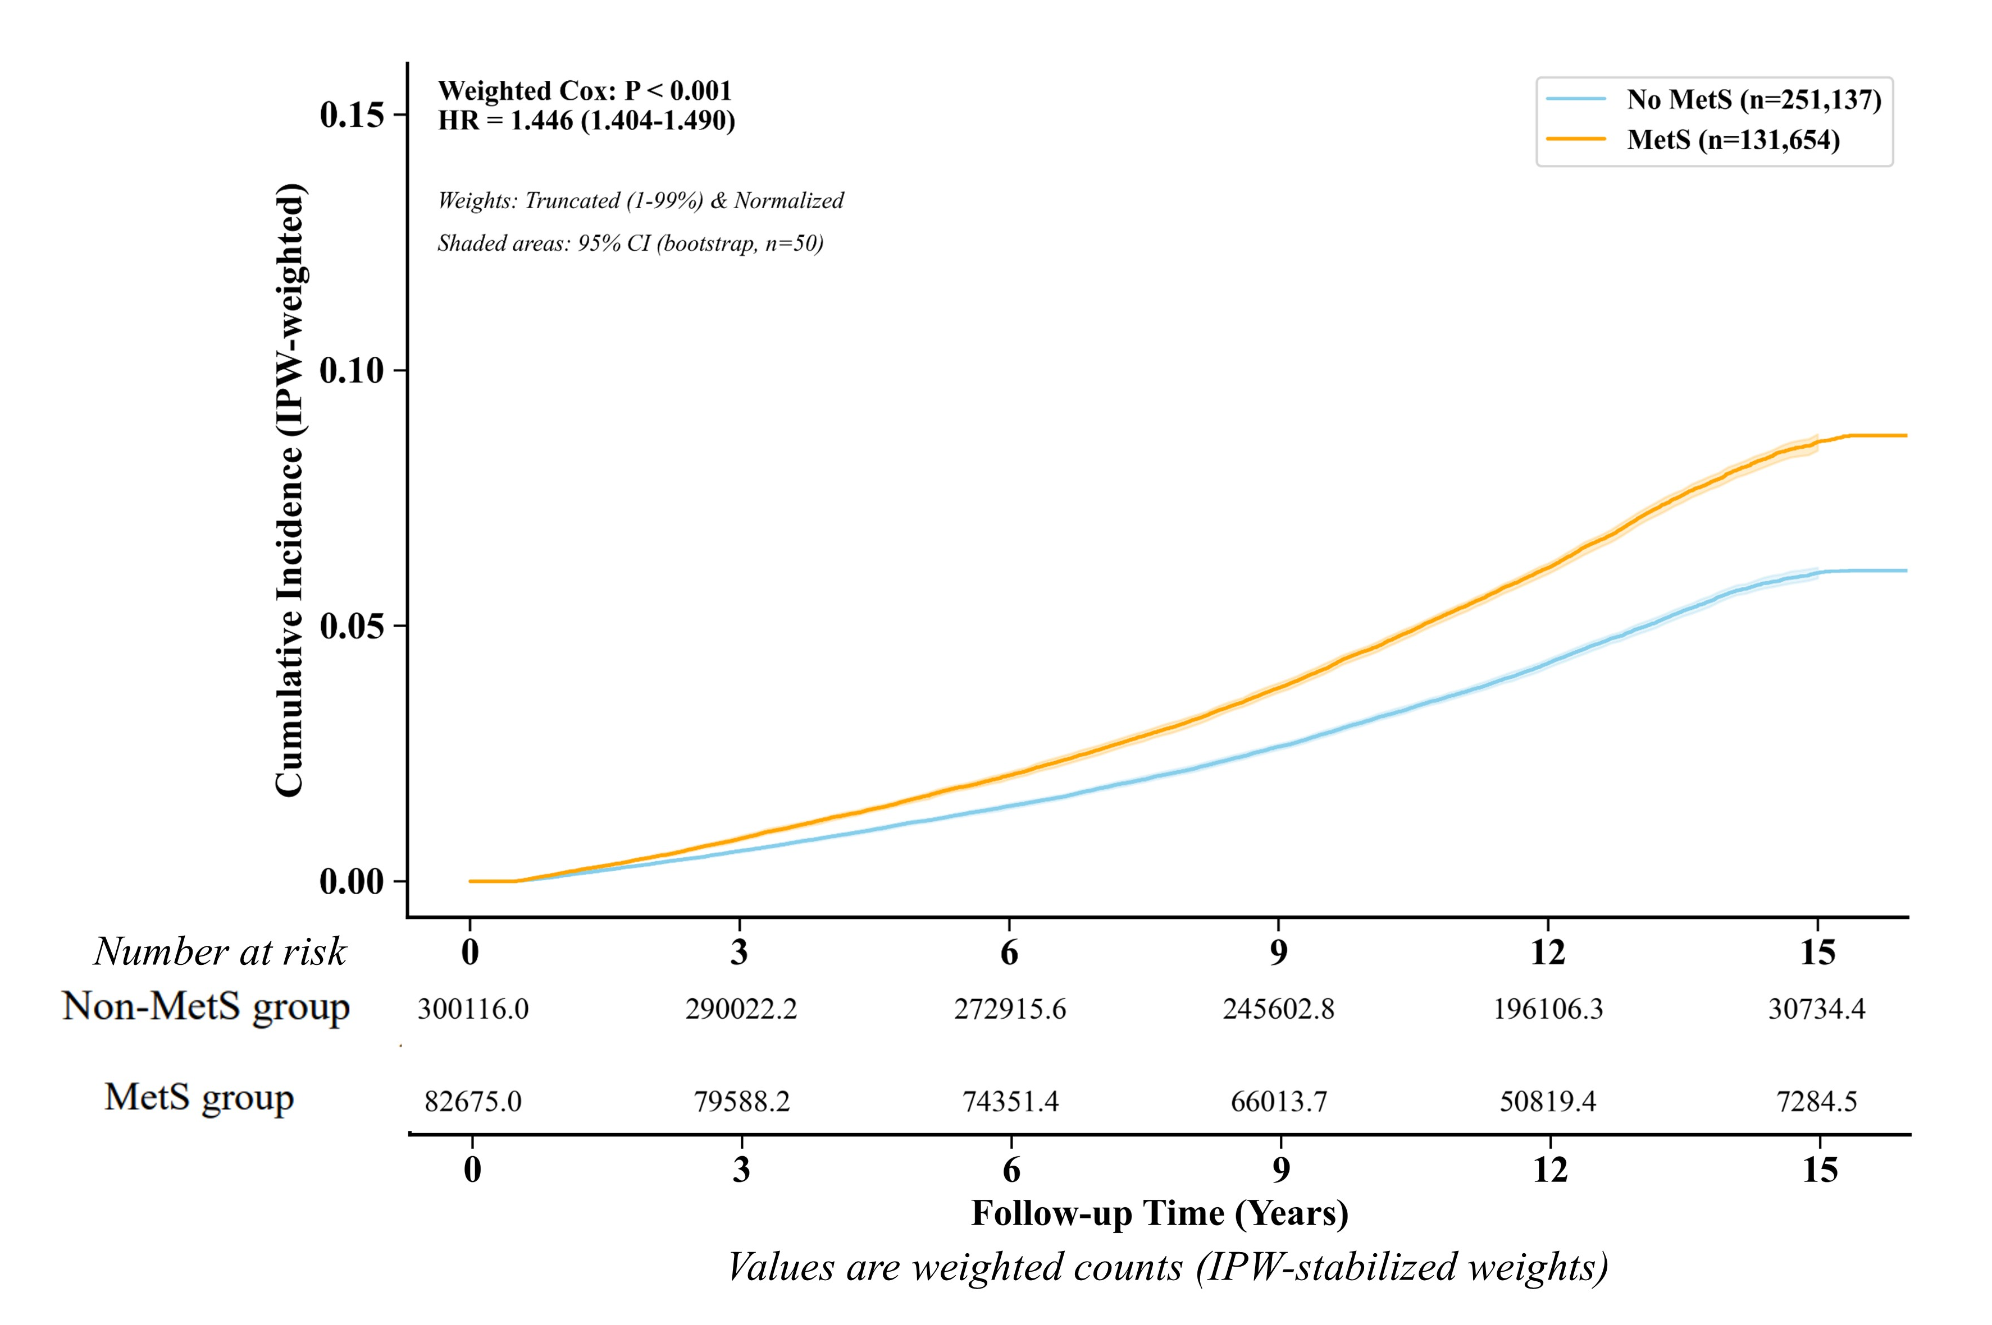

Figure S7. Cumulative risk of UTI with and without MetS (stabilized IPW weights)

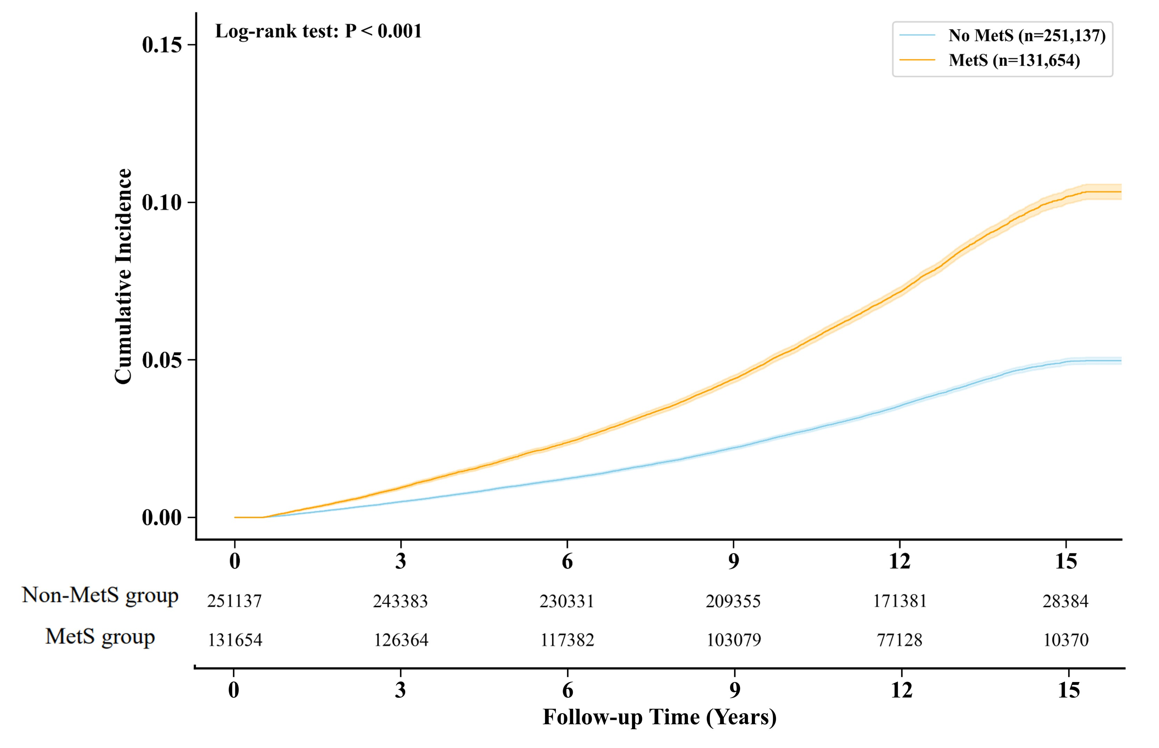
Figure S8. Cumulative risk of UTI with and without MetS (Model 3 adjusted)

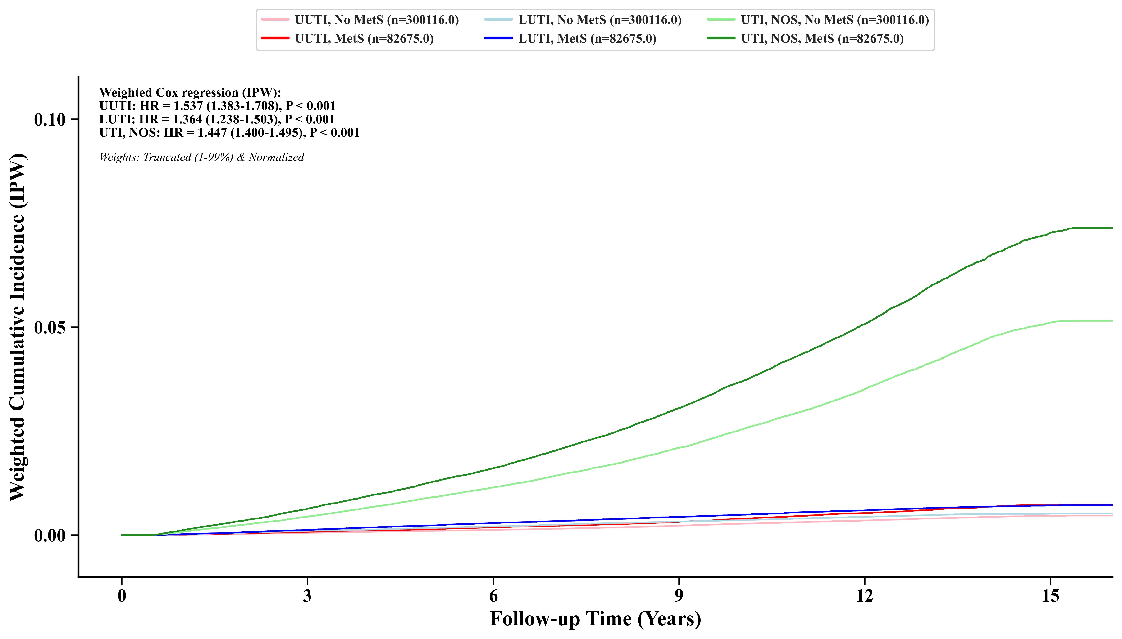
Figure S9. Cumulative risk of UTI with and without MetS, stratified by UTI subtypes (UUTI, LUTI and UTI, NOS) (stabilized IPW weights)
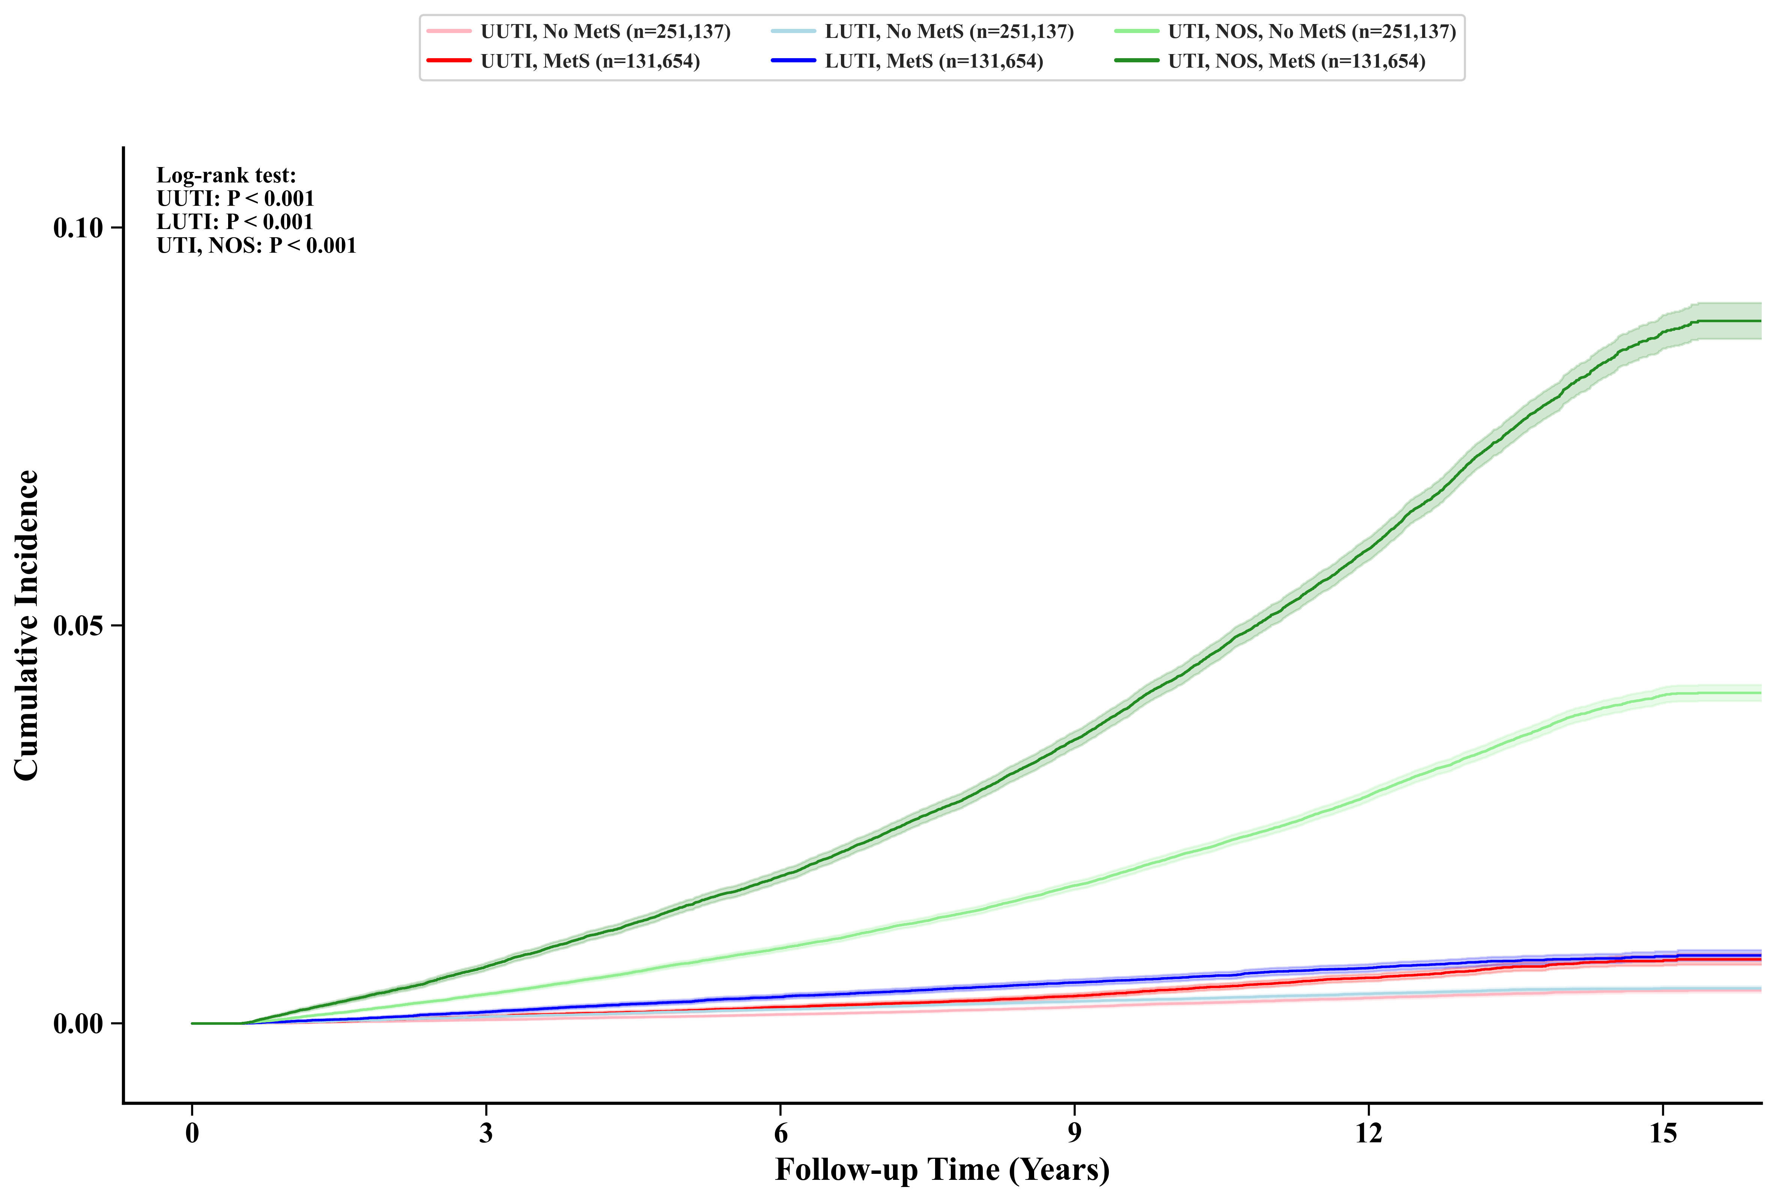
Figure S10. Cumulative risk of UTI with and without MetS, stratified by UTI subtypes (UUTI, LUTI and UTI, NOS) (Model 3 adjusted)

Figure S11. Cumulative risk of UTI by nMetS (0–5) (Model 3 adjusted)

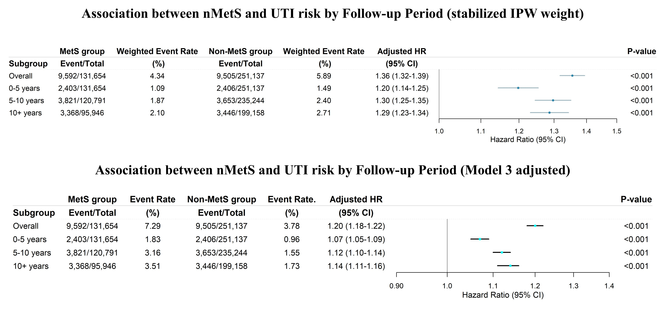
Figure 12. Association between MetS and UTI Risk by Follow-up Period (stabilized IPW weights and Model 3 adjusted)

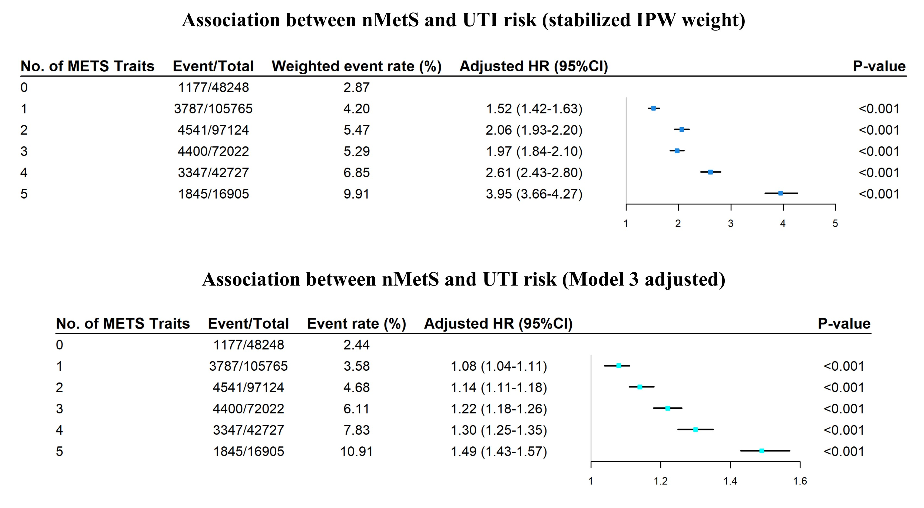
Figure S13. Association between nMetS and UTI risk (stabilized IPW weights and Model 3 adjusted)

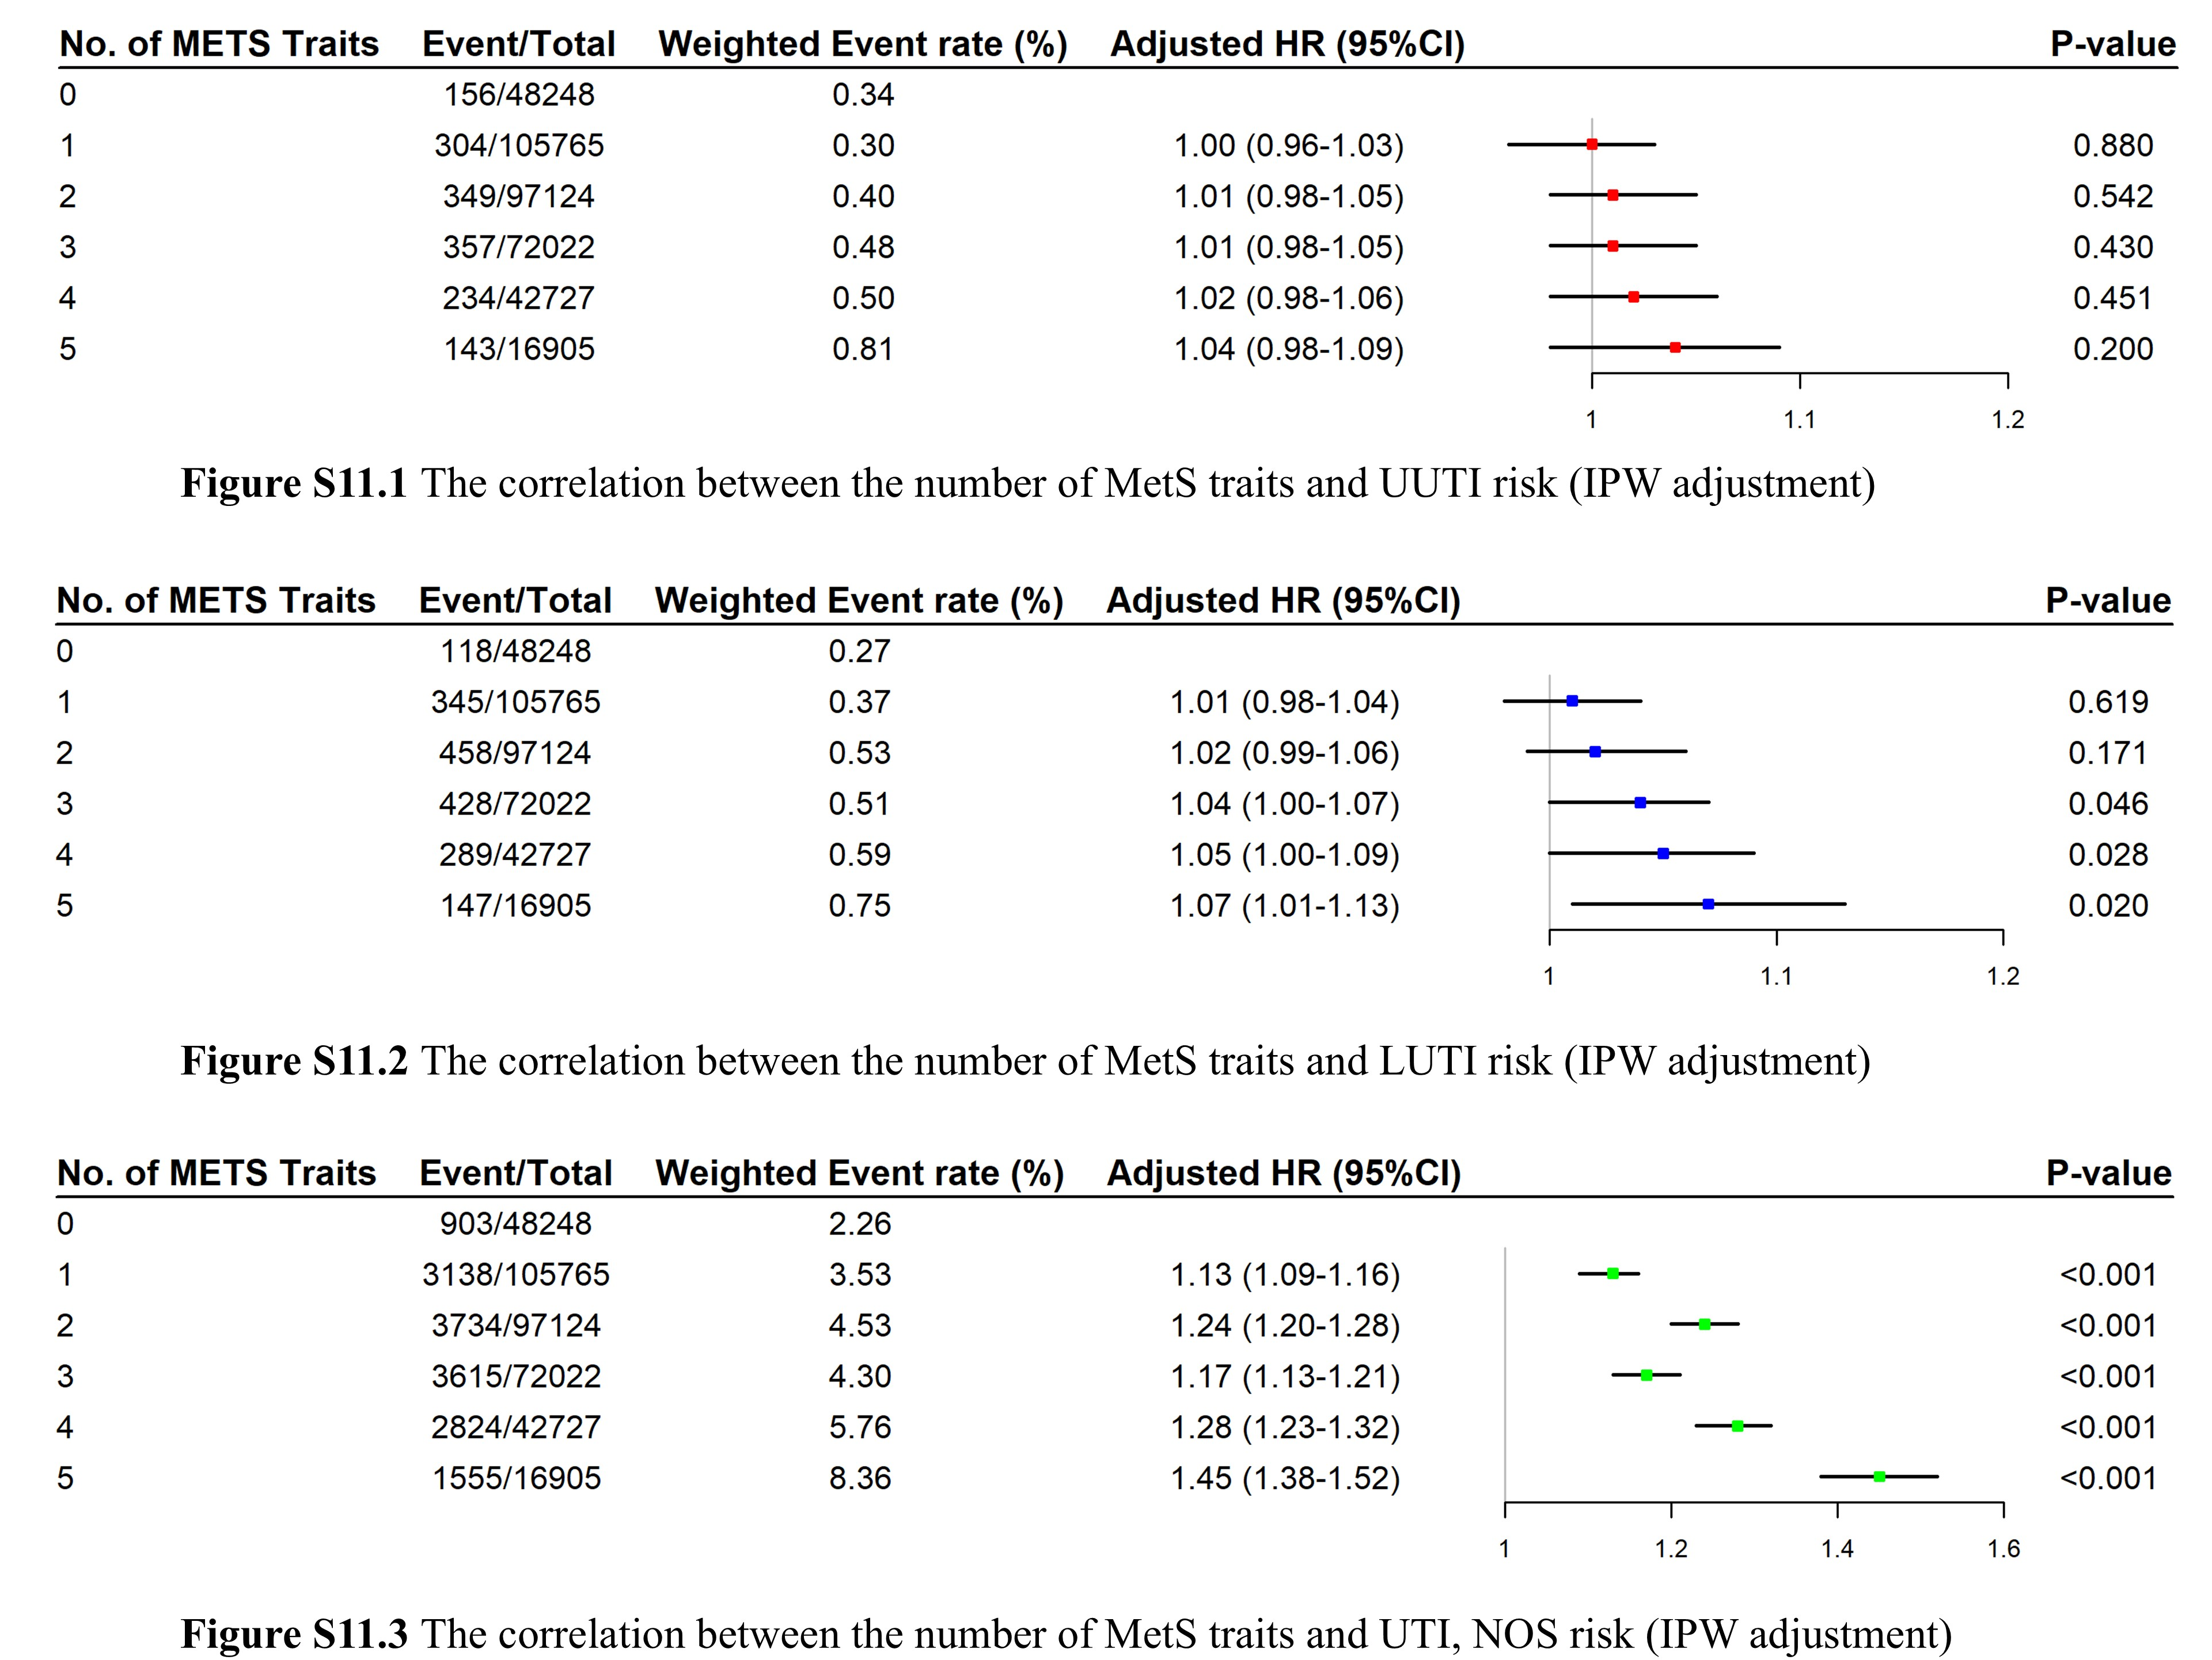
Figure S14. Association between nMetS and UTI Risk stratified by UTI subtypes (UUTI, LUTI and UTI, NOS) (stabilized IPW weights)

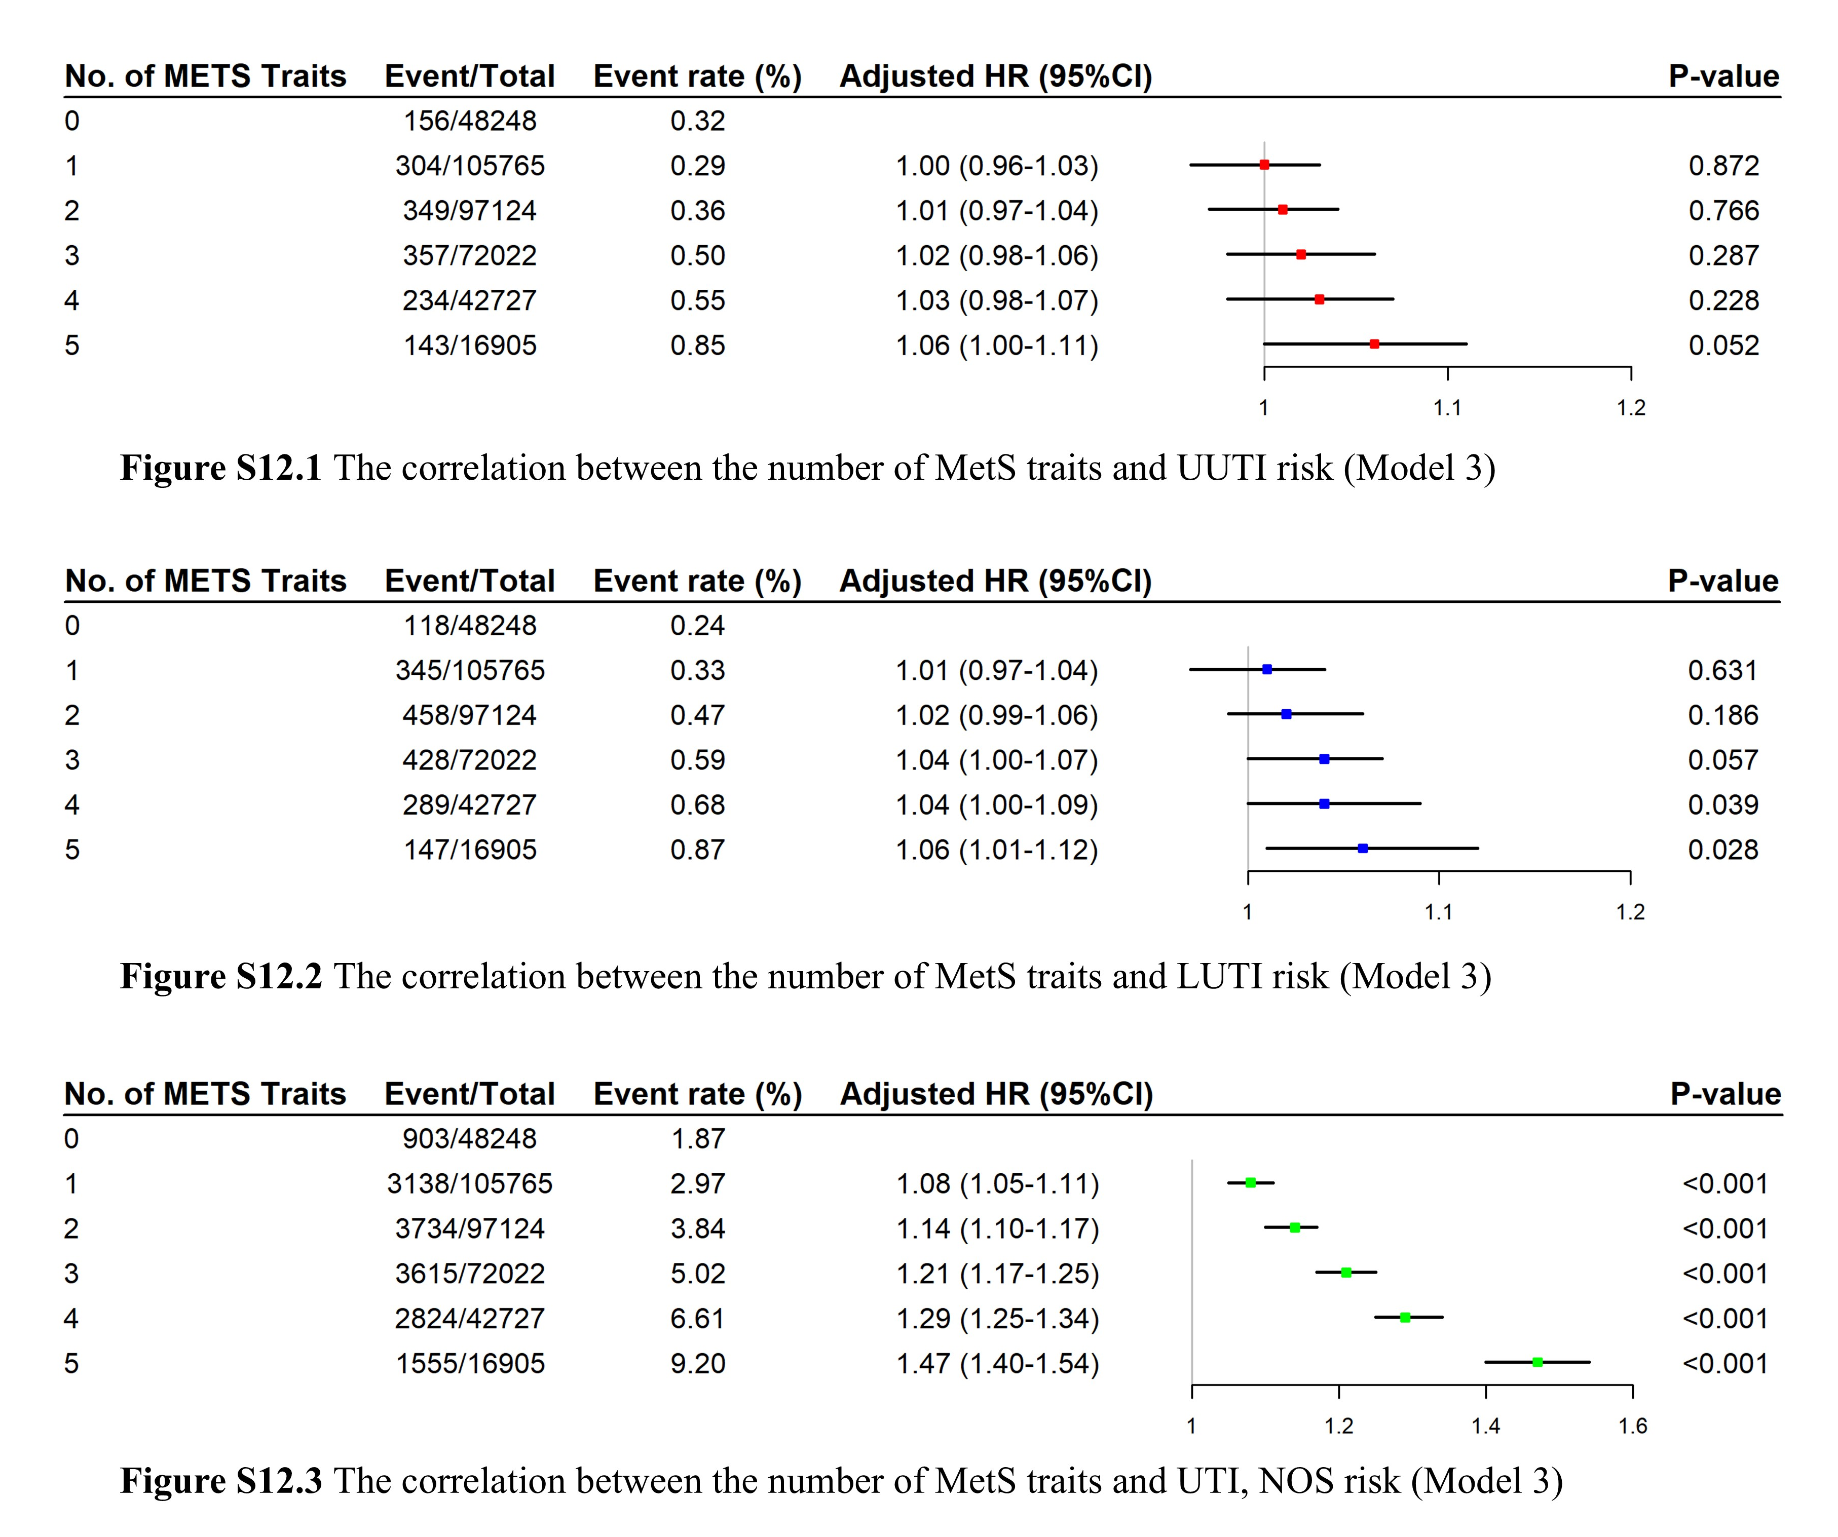
Figure S15. Association between nMetS and UTI Risk stratified by UTI subtypes (UUTI, LUTI and UTI, NOS) (Model 3 adjusted)
Figure S16. Association of Metabolic, Anthropometric, and Biochemical Parameters with UTI Risk: Per-Unit Increment Analyses (Model 3 adjusted)
Figure S17. Association of Metabolic, Anthropometric, and Biochemical Parameters with UTI Risk: Restricted Cubic Spline Analyses (Model 3 adjusted)
BMI, body mass index; BFP, body fat percentage; WC, waist circumference; HDL, high-density lipoprotein; LDL, low-density lipoprotein.
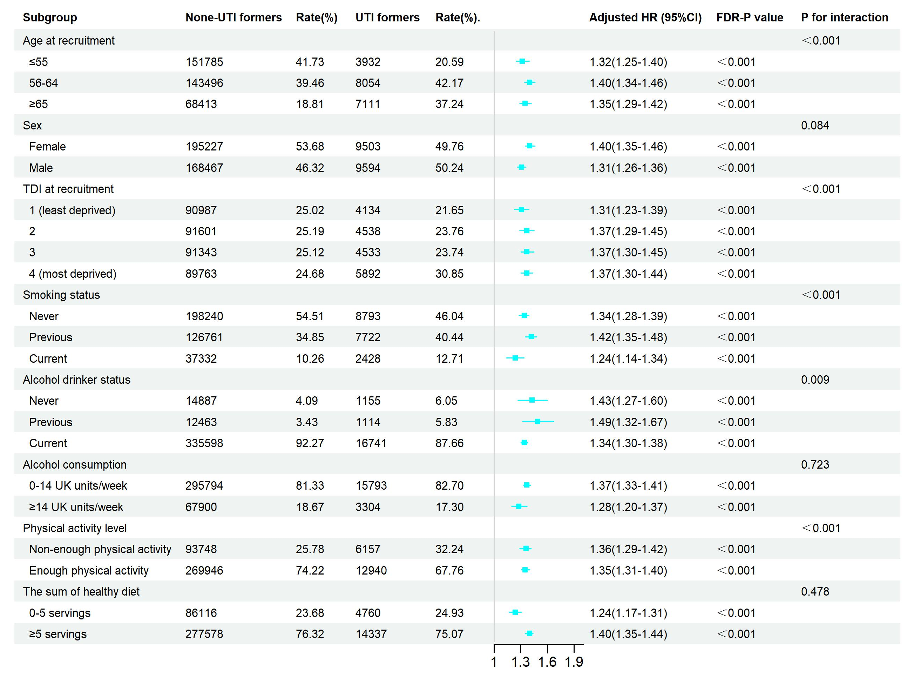
Figure S18. Subgroup Analysis of UTI Risk Stratified by Demographic and Lifestyle Factors: Interaction Tests Based on IPW-Adjusted HR
TDI at recruitment, Townsend deprivation index at recruitment

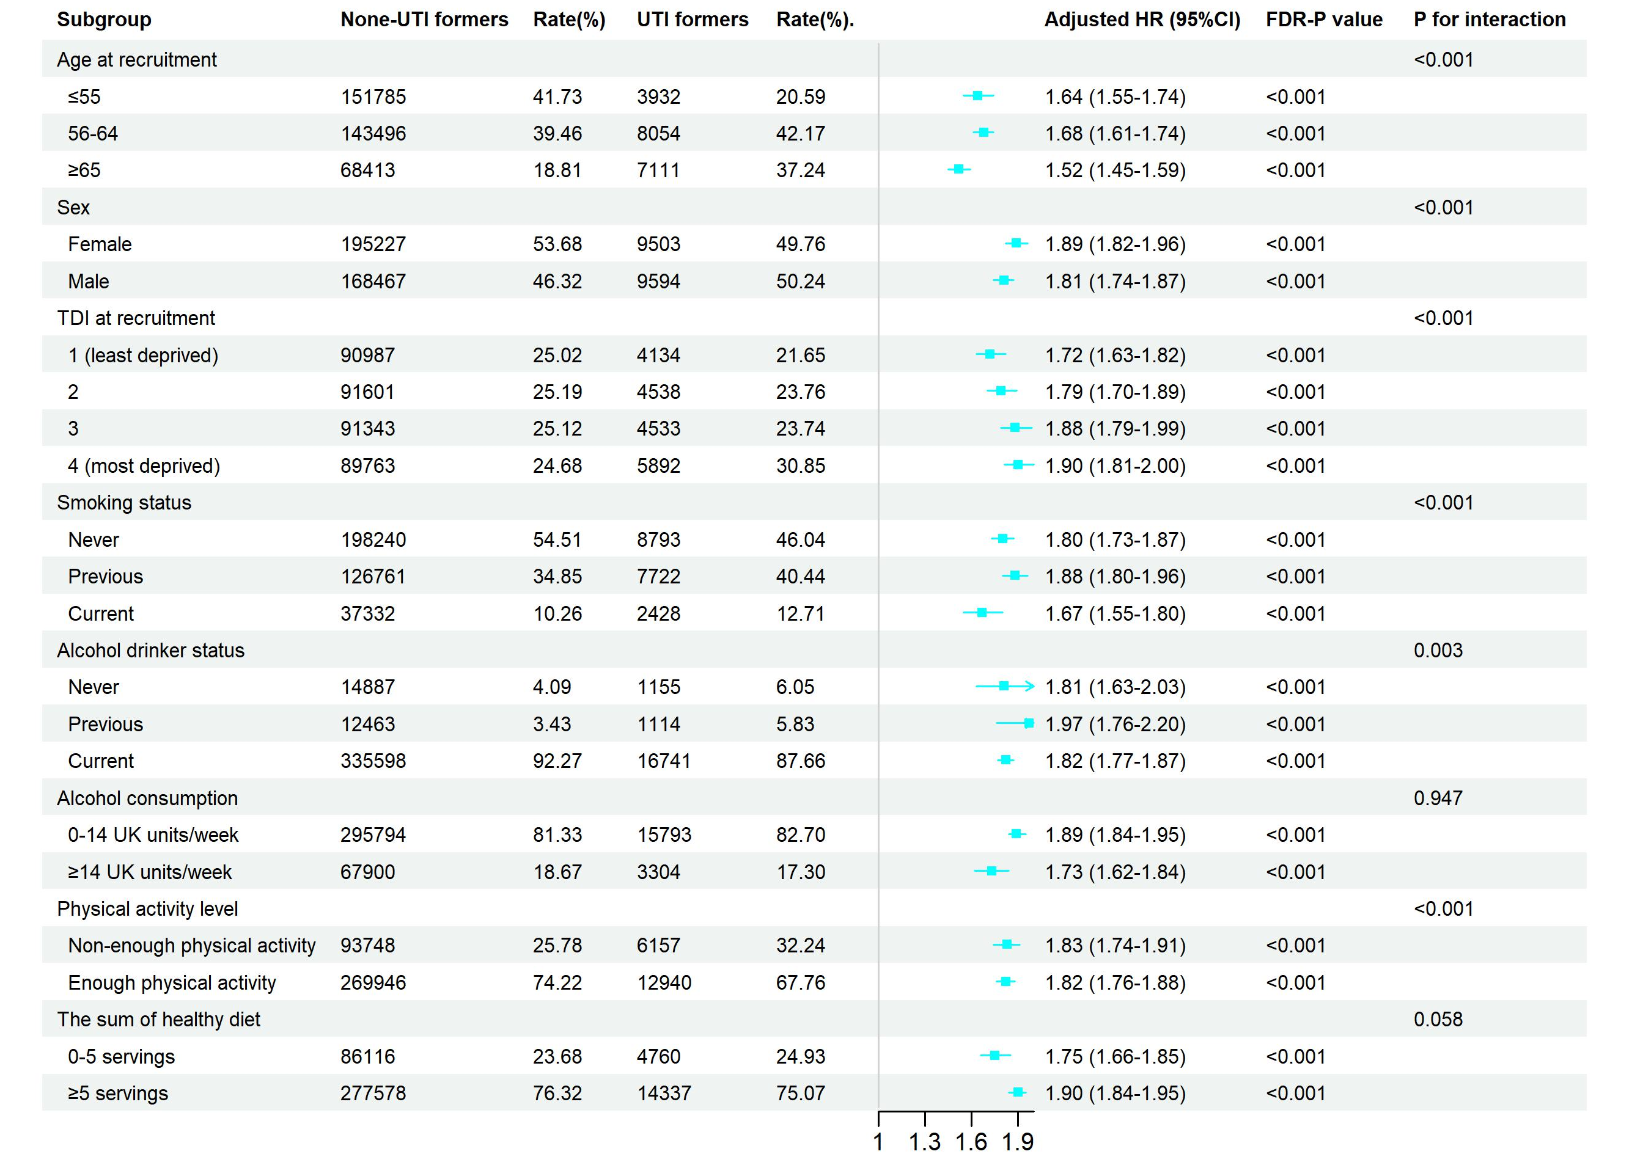
Figure S19. Subgroup Analysis of UTI Risk Stratified by Demographic and Lifestyle Factors: Interaction Tests Based on Model 3-Adjusted HR
TDI at recruitment, Townsend deprivation index at recruitment.
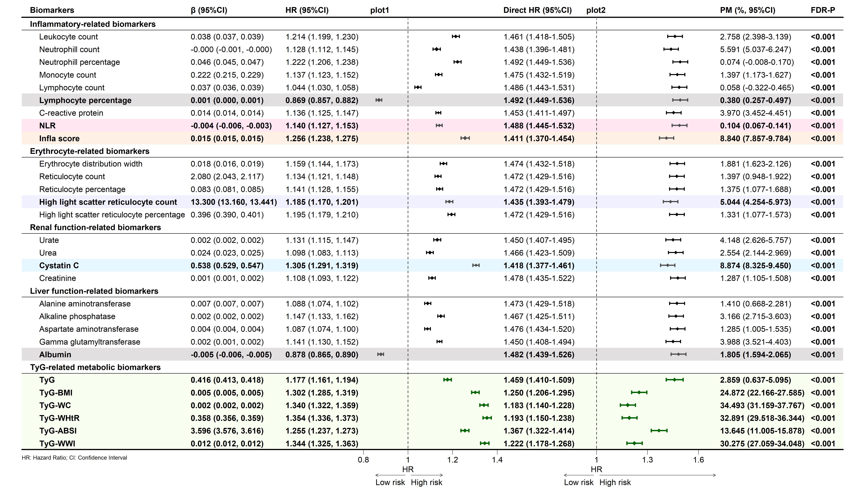
Figure S20. Mediation Analyses of MetS-Associated Metabolic and Biochemical Parameters with UTI Risk: Model 3-Adjusted HR
NLR, neutrophil-to-lymphocyte ratio; PLR, platelet-to-lymphocyte ratio; TyG, triglyceride-glucose index; TyG-BMI, triglyceride glucose-body mass index; TyG-WC, triglyceride glucose-waist circumference; TyG-WHtR, triglyceride glucose-waist to height ratio; TyG-ABSI, triglyceride glucose-a body shape index; TyG-WWI, triglyceride glucose-waist to weight ratio.

UTI subtype | ICD-10 codes | Corresponding diagnosis in UK Biobank
Upper UTI (UUTI) | N10, N12 | Acute pyelonephritis, Chronic pyelonephritis
Lower UTI (LUTI) | N30.0, N30.9 | Acute cystitis, Cystitis unspecified
UTI, not otherwise specified (UTI, NOS) | N39.0 | Urinary tract infection unspecified
Table S1. Classification of UTI subtypes and corresponding ICD‑10 codes
Classification standards: 1. Participants were classified according to the earliest recorded UTI subtype.
2. For those with simultaneous codes for UUTI, LUTI, and UTI, NOS, classification prioritized UUTI first, followed by LUTI, this principle based on the greater clinical severity of UUTI.

Covariate | Category/Definition | UK Biobank Field IDs
Sex | "Male", "Female" | 22001
Age at recruitment | Continuous | 21022
Ethnicity | "White", "Mixed", "Asian or Asian British", "Black or Black British", "Chinese", "Other/Unknown" | 21000
Educational attainment | "A-level or equivalent", "Degree", "No qualification/Unknown", "O-level/GCSE/CSE", "Vocational/Professional" | 6138
Average total household income before tax | "< £18,000", "£18,000 to £30,999", "£31,000 to £51,999", "£52,000 to £100,000", "> £100,000" | 738
Employment status | "Other/Unknown", "Employed", "Retired", "Homemaker", "Sick/Disabled", "Unemployed", "Unpaid or voluntary work", "Full or part-time student" | 6142
Townsend Deprivation Index at recruitment | Categorized into quartiles (1=lowest to 4=highest deprivation) [1] | 189
Smoking status | "Never", "Previous", "Current" | 20116
Alcohol drinker status | "Never", "Previous", "Current" | 20117
Alcohol consumption | categorized as ≤14 vs. >14 UK units/week[2, 3] | 1558, 1568, 1578, 1588,  1598, 1608, 5364, 4407,  4418, 4440, 4451, 4429
Physical activity | weekly metabolic equivalent of task (MET)-minutes,  categorized as ≤600 vs. >600 MET-min/week[2, 3] | 864, 874, 884,  894, 904, 914
Dietary intake | daily servings of fruits and vegetables,  categorized as ≤5 vs. >5 servings/day[2, 3] | 1289, 1299, 1309
Table S2. Baseline Covariates, Categorization Criteria, and Corresponding UK Biobank Field IDs
1 Ye J, Wen Y, Sun X, Chu X, Li P, Cheng B, Cheng S, Liu L, Zhang L, Ma M, Qi X, Liang C, Kafle OP, Jia Y, Wu C, Wang S, Wang X, Ning Y, Sun S, Zhang F. Socioeconomic Deprivation Index Is Associated With Psychiatric Disorders: An Observational and Genome-wide Gene-by-Environment Interaction Analysis in the UK Biobank Cohort. Biol Psychiatry. 2021;89(9):888-95.
2 Foster HME, Ho FK, Mair FS, Jani BD, Sattar N, Katikireddi SV, Pell JP, Niedzwiedz CL, Hastie CE, Anderson JJ, Nicholl BI, Gill JMR, Celis-Morales C, O'Donnell CA. The association between a lifestyle score, socioeconomic status, and COVID-19 outcomes within the UK Biobank cohort. BMC Infect Dis. 2022;22(1):273.
3 Ding D, Rogers K, van der Ploeg H, Stamatakis E, Bauman AE. Traditional and Emerging Lifestyle Risk Behaviors and All-Cause Mortality in Middle-Aged and Older Adults: Evidence from a Large Population-Based Australian Cohort. PLoS Med. 2015;12(12):e1001917.

Variables | Overall  (n = 382791) | No UTI  (n = 363694) | UTI  (n = 19097) | P
Sex, n(%) |  |  |  | <0.001
Female | 204730 (53.48) | 195227 (53.68) | 9503 (48.42)
Male | 178061 (46.52) | 168467 (46.32) | 9594 (51.58)
Age at recruitment, Mean ± SD | 56.78 ± 8.03 | 56.56 ± 8.03 | 61.00 ± 6.97 | <0.001
BMI, Mean ± SD | 27.46 ± 4.80 | 27.39 ± 4.75 | 27.60 ± 4.98 | <0.001
Whole body fat mass, Mean ± SD | 24.73 ± 9.59 | 24.61 ± 9.51 | 24.73 ± 10.11 | <0.001
Body fat percentage, Mean ± SD | 31.18 ± 8.69 | 31.11 ± 8.67 | 31.00 ± 9.11 | <0.001
Waist-to-Hip Ratio, Mean ± SD | 0.87 ± 0.09 | 0.87 ± 0.09 | 0.89 ± 0.09 | <0.001
Townsend deprivation index at recruitment, n(%) |  |  |  | <0.001
1 (least deprived) | 95121 (24.85) | 90987 (25.02) | 4134 (21.58)
2 | 96139 (25.12) | 91601 (25.19) | 4538 (23.68)
3 | 95876 (25.05) | 91343 (25.12) | 4533 (23.55)
4 (most deprived) | 95655 (24.99) | 89763 (24.68) | 5892 (31.19)
Educational attainment, n(%) |  |  |  | <0.001
Degree | 125082 (32.68) | 120556 (33.15) | 4526 (22.97)
A-level or equivalent | 42842 (11.19) | 41200 (11.33) | 1642 (8.36)
O-level/GCSE/CSE | 100607 (26.28) | 95977 (26.39) | 4630 (24.07)
Vocational/Professional | 45198 (11.81) | 42642 (11.72) | 2556 (13.40)
No qualification/Unknown | 69062 (18.04) | 63319 (17.41) | 5743 (31.19)
Ethnic background, n(%) |  |  |  | 0.013
White | 365082 (95.37) | 346848 (95.37) | 18234 (95.47)
Mixed | 2094 (0.55) | 2009 (0.55) | 85 (0.45)
Asian or Asian British | 6826 (1.78) | 6479 (1.78) | 347 (1.78)
Black or Black British | 4713 (1.23) | 4471 (1.23) | 242 (1.27)
Chinese | 1068 (0.28) | 1037 (0.29) | 31 (0.15)
Other/Unknown | 3008 (0.79) | 2850 (0.78) | 158 (0.88)
Average total household income before tax, n(%) |  |  |  | <0.001
Less than 18,000 | 97872 (25.57) | 89809 (24.69) | 8063 (43.23)
18,000 to 30,999 | 96790 (25.29) | 91654 (25.20) | 5136 (27.04)
31,000 to 51,999 | 99764 (26.06) | 96180 (26.45) | 3584 (18.29)
52,000 to 100,000 | 70445 (18.40) | 68561 (18.85) | 1884 (9.41)
Greater than 100,000 | 17920 (4.68) | 17490 (4.81) | 430 (2.03)
Employment Status, n(%) |  |  |  | <0.001
Other/Unknown | 3775 (0.99) | 3552 (0.98) | 223 (1.13)
Employed | 208507 (54.47) | 202106 (55.57) | 6401 (32.31)
Retired | 136762 (35.73) | 126599 (34.81) | 10163 (54.13)
Homemaker | 9515 (2.49) | 9206 (2.53) | 309 (1.56)
Sick/Disabled | 14721 (3.85) | 13164 (3.62) | 1557 (8.43)
Unemployed | 6860 (1.79) | 6519 (1.79) | 341 (1.94)
Unpaid or voluntary work | 1716 (0.45) | 1639 (0.45) | 77 (0.39)
Full or part-time student | 935 (0.24) | 909 (0.25) | 26 (0.12)
Smoking status, n(%) |  |  |  | <0.001
Never | 207033 (54.09) | 198240 (54.51) | 8793 (45.70)
Previous | 134483 (35.13) | 126761 (34.85) | 7722 (40.06)
Current | 39760 (10.39) | 37332 (10.26) | 2428 (13.43)
Alcohol drinker status, n(%) |  |  |  | <0.001
Never | 16042 (4.19) | 14887 (4.09) | 1155 (6.08)
Previous | 13577 (3.55) | 12463 (3.43) | 1114 (5.80)
Current | 352339 (92.04) | 335598 (92.27) | 16741 (87.57)
Physical activity level, n(%) |  |  |  | <0.001
Non-enough physical activity | 99905 (26.10) | 93748 (25.78) | 6157 (32.70)
Enough physical activity | 282886 (73.90) | 269946 (74.22) | 12940 (67.30)
Alcohol consumption, n(%) |  |  |  | <0.001
0-14 UK units/week | 311587 (81.40) | 295794 (81.33) | 15793 (82.32)
≥14 UK units/week | 71204 (18.60) | 67900 (18.67) | 3304 (17.68)
The sum of healthy diet, n(%) |  |  |  | <0.001
0-5 servings | 90876 (23.74) | 86116 (23.68) | 4760 (25.87)
≥5 servings | 291915 (76.26) | 277578 (76.32) | 14337 (74.13)
Sleep duration, n(%) |  |  |  | <0.001
≤6 or ≥9 hour/d | 123475 (32.26) | 116161 (31.94) | 7314 (37.89)
7-8 hour/d | 259316 (67.74) | 247533 (68.06) | 11783 (62.11)
Chronotype, n(%) |  |  |  | 0.417
Tend to be a "morning person" | 253028 (66.10) | 240457 (66.12) | 12571 (66.38)
Tend to be a "evening person" | 129763 (33.90) | 123237 (33.88) | 6526 (33.62)
Insomnia, n(%) |  |  |  | <0.001
Low-Freq (Never, rarely, sometimes) | 274109 (71.61) | 261544 (71.91) | 12565 (66.48)
High-Freq (Usually) | 108682 (28.39) | 102150 (28.09) | 6532 (33.52)
Snoring, n(%) |  |  |  | <0.001
No | 137962 (36.04) | 130861 (35.98) | 7101 (34.95)
Yes | 244829 (63.96) | 232833 (64.02) | 11996 (65.05)
Daytime dozing, n(%) |  |  |  | <0.001
Low-Freq (Never, rarely, sometimes) | 372132 (97.22) | 353957 (97.32) | 18175 (95.47)
High-Freq (Often, all the time) | 10659 (2.78) | 9737 (2.68) | 922 (4.53)
LDL Cholesterol, Mean ± SD | 1.74 ± 0.34 | 1.74 ± 0.34 | 1.71 ± 0.36 | <0.001
Total Cholesterol, Mean ± SD | 4.62 ± 0.71 | 4.62 ± 0.71 | 4.57 ± 0.75 | <0.001
Elevated WC, n(%) | 129930 (33.94) | 121121 (33.30) | 8809 (46.13) | <0.001
Elevated TG, n(%) | 154495 (40.36) | 145607 (40.04) | 8888 (46.54) | <0.001
Elevated BP or blood pressure medication, n (%) | 286032 (74.72) | 269983 (74.23) | 16049 (84.04) | <0.001
Elevated HbA1c or insulin use, n(%) | 73639 (19.24) | 67662 (18.60) | 5977 (31.30) | <0.001
Reduced HDL or cholesterol lowering medication, n(%) | 127416 (33.29) | 118457 (32.57) | 8959 (46.91) | <0.001

Table S3. Baseline characteristics of the study population (unweighted).
1. Continuous data are presented as mean ± standard deviation (Mean ± SD), and categorical data as n (%).
2. P-values were calculated as follows:
(1) For continuous variables: the Mann-Whitney U test (Wilcoxon rank-sum test) was used for two-group comparisons.
(2) For categorical variables: the Pearson chi-squared test was used.
All P-values are reported to 3 decimal places.

Variables | Total  (n = 382791) | No UTI  (n = 363694) | UUTI  (n = 1543) | LUTI  (n = 1785) | UTI, NOS  (n = 15769) | P
Sex, n(%) |  |  |  |  |  | <0.001
Female | 204730 (51.75) | 195227 (51.92) | 957 (61.36) | 898 (48.92) | 7648 (47.13)
Male | 178061 (48.25) | 168467 (48.08) | 586 (38.64) | 887 (51.08) | 8121 (52.87)
Age at recruitment, Mean ± SD | 57.27 ± 7.97 | 57.07 ± 7.97 | 58.13 ± 7.88 | 61.21 ± 6.68 | 61.25 ± 6.84 | <0.001
BMI, Mean ± SD | 26.91 ± 4.49 | 26.87 ± 4.46 | 27.71 ± 5.34 | 27.39 ± 4.74 | 27.61 ± 4.96 | <0.001
Whole body fat mass, Mean ± SD | 23.62 ± 9.13 | 23.56 ± 9.08 | 25.66 ± 10.52 | 24.68 ± 9.78 | 24.64 ± 10.10 | <0.001
Body fat percentage, Mean ± SD | 30.40 ± 8.68 | 30.37 ± 8.66 | 32.52 ± 8.99 | 31.06 ± 8.85 | 30.85 ± 9.14 | <0.001
Waist-to-Hip Ratio, Mean ± SD
Townsend deprivation index at recruitment, n(%) |  |  |  |  |  | <0.001
1 (least deprived) | 95121 (24.36) | 90987 (24.50) | 317 (20.06) | 427 (23.96) | 3390 (21.46)
2 | 96139 (24.88) | 91601 (24.94) | 348 (22.59) | 452 (25.44) | 3738 (23.59)
3 | 95876 (25.06) | 91343 (25.14) | 369 (23.74) | 390 (21.22) | 3774 (23.79)
4 (most deprived) | 95655 (25.70) | 89763 (25.42) | 509 (33.62) | 516 (29.39) | 4867 (31.16)
Educational attainment, n(%) |  |  |  |  |  | <0.001
Degree | 125082 (30.88) | 120556 (31.29) | 379 (23.53) | 438 (23.60) | 3709 (22.85)
A-level or equivalent | 42842 (10.93) | 41200 (11.06) | 150 (9.46) | 136 (7.40) | 1356 (8.36)
O-level/GCSE/CSE | 100607 (26.35) | 95977 (26.47) | 414 (26.23) | 459 (25.21) | 3757 (23.74)
Vocational/Professional | 45198 (12.28) | 42642 (12.22) | 199 (12.82) | 233 (13.19) | 2124 (13.48)
No qualification/Unknown | 69062 (19.56) | 63319 (18.96) | 401 (27.97) | 519 (30.59) | 4823 (31.57)
Ethnic background, n(%) |  |  |  |  |  | <0.001
White | 365082 (95.21) | 346848 (95.19) | 1439 (93.91) | 1724 (96.85) | 15071 (95.47)
Mixed | 2094 (0.53) | 2009 (0.53) | 16 (1.00) | 7 (0.34) | 62 (0.41)
Asian or Asian British | 6826 (1.89) | 6479 (1.90) | 45 (2.56) | 25 (1.39) | 277 (1.75)
Black or Black British | 4713 (1.30) | 4471 (1.30) | 25 (1.47) | 16 (0.80) | 201 (1.30)
Chinese | 1068 (0.27) | 1037 (0.27) | 1 (0.03) | 1 (0.06) | 29 (0.17)
Other/Unknown | 3008 (0.81) | 2850 (0.81) | 17 (1.04) | 12 (0.56) | 129 (0.89)
Average total household income before tax, n(%) |  |  |  |  |  | <0.001
Less than 18,000 | 97872 (27.47) | 89809 (26.66) | 591 (39.33) | 698 (39.48) | 6774 (44.02)
18,000 to 30,999 | 96790 (25.85) | 91654 (25.79) | 375 (24.36) | 477 (27.27) | 4284 (27.27)
31,000 to 51,999 | 99764 (25.42) | 96180 (25.79) | 337 (21.42) | 354 (19.46) | 2893 (17.86)
52,000 to 100,000 | 70445 (17.08) | 68561 (17.48) | 191 (11.96) | 198 (10.71) | 1495 (9.02)
Greater than 100,000 | 17920 (4.17) | 17490 (4.28) | 49 (2.92) | 58 (3.08) | 323 (1.83)
Employment Status, n(%) |  |  |  |  |  | <0.001
Other/Unknown | 3775 (1.00) | 3552 (0.99) | 21 (1.14) | 17 (0.86) | 185 (1.16)
Employed | 208507 (52.25) | 202106 (53.28) | 692 (42.90) | 629 (34.51) | 5080 (31.06)
Retired | 136762 (37.67) | 126599 (36.82) | 610 (40.81) | 969 (56.13) | 8584 (55.17)
Homemaker | 9515 (2.31) | 9206 (2.35) | 33 (2.47) | 31 (1.58) | 245 (1.47)
Sick/Disabled | 14721 (4.24) | 13164 (4.02) | 134 (9.28) | 115 (5.47) | 1308 (8.68)
Unemployed | 6860 (1.87) | 6519 (1.87) | 40 (2.69) | 18 (1.13) | 283 (1.96)
Unpaid or voluntary work | 1716 (0.43) | 1639 (0.43) | 10 (0.56) | 5 (0.27) | 62 (0.38)
Full or part-time student | 935 (0.23) | 909 (0.23) | 3 (0.16) | 1 (0.05) | 22 (0.12)
Smoking status, n(%) |  |  |  |  |  | <0.001
Never | 207033 (52.84) | 198240 (53.21) | 753 (46.92) | 825 (46.32) | 7215 (45.52)
Previous | 134483 (35.88) | 126761 (35.67) | 581 (37.83) | 739 (41.18) | 6402 (40.15)
Current | 39760 (10.86) | 37332 (10.73) | 188 (13.84) | 210 (12.08) | 2030 (13.54)
Alcohol drinker status, n(%) |  |  |  |  |  | <0.001
Never | 16042 (4.47) | 14887 (4.38) | 112 (7.38) | 105 (5.51) | 938 (6.02)
Previous | 13577 (3.80) | 12463 (3.70) | 95 (6.33) | 72 (3.88) | 947 (5.97)
Current | 352339 (91.49) | 335598 (91.69) | 1326 (85.60) | 1605 (90.46) | 13810 (87.44)
Physical activity level, n(%) |  |  |  |  |  | <0.001
Non-enough physical activity | 99905 (27.47) | 93748 (27.20) | 485 (31.83) | 574 (31.46) | 5098 (32.93)
Enough physical activity | 282886 (72.53) | 269946 (72.80) | 1058 (68.17) | 1211 (68.54) | 10671 (67.07)
Alcohol consumption, n(%) |  |  |  |  |  | <0.001
0-14 UK units/week | 311587 (81.43) | 295794 (81.38) | 1309 (85.09) | 1478 (82.46) | 13006 (82.05)
≥14 UK units/week | 71204 (18.57) | 67900 (18.62) | 234 (14.91) | 307 (17.54) | 2763 (17.95)
The sum of healthy diet, n(%) |  |  |  |  |  | <0.001
0-5 servings | 90876 (24.25) | 86116 (24.16) | 387 (26.78) | 464 (26.69) | 3909 (25.69)
≥5 servings | 291915 (75.75) | 277578 (75.84) | 1156 (73.22) | 1321 (73.31) | 11860 (74.31)
Sleep duration, n(%) |  |  |  |  |  | <.0001
≤6 or ≥9 hour/d | 123475 (32.31) | 116161 (32.03) | 602 (37.91) | 643 (35.07) | 6069 (38.20)
7-8 hour/d | 259316 (67.69) | 247533 (67.97) | 941 (62.09) | 1142 (64.93) | 9700 (61.80)
Chronotype, n(%) |  |  |  |  |  | 0.870
Tend to be a "morning person" | 253028 (66.46) | 240457 (66.46) | 1002 (65.79) | 1166 (65.81) | 10403 (66.51)
Tend to be a "evening person" | 129763 (33.54) | 123237 (33.54) | 541 (34.21) | 619 (34.19) | 5366 (33.49)
Insomnia, n(%) |  |  |  |  |  | <0.001
Low-Freq (Never, rarely, sometimes) | 274109 (71.71) | 261544 (71.98) | 980 (64.53) | 1170 (65.80) | 10415 (66.75)
High-Freq (Usually) | 108682 (28.29) | 102150 (28.02) | 563 (35.47) | 615 (34.20) | 5354 (33.25)
Snoring, n(%) |  |  |  |  |  | 0.655
No | 137962 (34.87) | 130861 (34.86) | 568 (34.66) | 698 (36.24) | 5835 (34.83)
Yes | 244829 (65.13) | 232833 (65.14) | 975 (65.34) | 1087 (63.76) | 9934 (65.17)
Daytime dozing, n(%) |  |  |  |  |  | <0.001
Low-Freq (Never, rarely, sometimes) | 372132 (97.28) | 353957 (97.37) | 1477 (95.85) | 1711 (96.14) | 14987 (95.36)
High-Freq (Often, all the time) | 10659 (2.72) | 9737 (2.63) | 66 (4.15) | 74 (3.86) | 782 (4.64) | <0.001
LDL Cholesterol, Mean ± SD | 1.75 ± 0.34 | 1.75 ± 0.34 | 1.74 ± 0.37 | 1.71 ± 0.34 | 1.71 ± 0.36 | <0.001
Total Cholesterol, Mean ± SD | 4.65 ± 0.70 | 4.65 ± 0.70 | 4.64 ± 0.75 | 4.56 ± 0.73 | 4.56 ± 0.76 | <0.001
Elevated WC, n(%) | 129930 (26.96) | 121121 (26.63) | 687 (33.88) | 763 (30.12) | 7359 (33.68) | <0.001
Elevated TG, n(%) | 154495 (34.26) | 145607 (34.19) | 713 (37.16) | 879 (38.76) | 7296 (35.20) | <0.001
Elevated BP or blood pressure medication, n (%) | 286032 (73.07) | 269983 (72.70) | 1188 (73.67) | 1494 (80.99) | 13367 (81.00) | <0.001
Elevated HbA1c or insulin use, n(%) | 73639 (14.04) | 67662 (13.71) | 454 (21.35) | 486 (18.10) | 5037 (20.72) | <0.001
Reduced HDL or cholesterol lowering medication, n(%) | 127416 (26.59) | 118457 (26.18) | 682 (34.24) | 814 (33.69) | 7463 (34.54) | <0.001
Table S4. Baseline characteristics of the study population by UTI subtype (IPW-weighted percentages and P-values).

1. Continuous data are presented as mean ± standard deviation (Mean ± SD), and categorical data as n (%).
2. P-values were calculated as follows:
(1) For continuous variables: weighted one-way analysis of variance (ANOVA) was used for comparisons of the four groups.
(2) For categorical variables: the weighted Pearson chi-squared test was used.
All P-values are reported to 3 decimal places.

Variables | Overall  (n = 382791) | No Mets  (n = 251137) | Mets  (n = 131654) | P
Sex, n(%) |  |  |  | 0.007
Female | 204730 (51.75) | 141984 (51.83) | 62746 (51.49)
Male | 178061 (48.25) | 109153 (48.17) | 68908 (48.51)
Age at recruitment, Mean ± SD | 57.27 ± 7.97 | 57.25 ± 8.00 | 57.33 ± 7.87 | 0.002
BMI, Mean ± SD | 26.91 ± 4.49 | 25.83 ± 3.69 | 30.84 ± 4.92 | <0.001
Whole body fat mass, Mean ± SD | 23.62 ± 9.13 | 21.60 ± 7.67 | 30.96 ± 10.21 | <0.001
Body fat percentage, Mean ± SD | 30.40 ± 8.68 | 29.15 ± 8.31 | 34.94 ± 8.51 | <0.001
Waist-to-Hip Ratio, Mean ± SD | 0.87 ± 0.09 | 0.85 ± 0.08 | 0.92 ± 0.08
UTI Diagnosis, n(%) | 190097 (4.90) | 9505 (4.51) | 9592 (6.32) | <0.001
Townsend deprivation index at recruitment, n(%) |  |  |  | 0.228
1 (least deprived) | 95121 (24.36) | 65884 (24.39) | 29237 (24.23)
2 | 96139 (24.88) | 64855 (24.91) | 31284 (24.78)
3 | 95876 (25.06) | 62816 (25.07) | 33060 (25.02)
4 (most deprived) | 95655 (25.70) | 57582 (25.63) | 38073 (25.97)
Educational attainment, n(%) |  |  |  | 0.099
Degree | 125082 (30.88) | 92235 (30.95) | 32847 (30.63)
A-level or equivalent | 42842 (10.93) | 29751 (10.94) | 13091 (10.89)
O-level/GCSE/CSE | 100607 (26.35) | 65901 (26.35) | 34706 (26.34)
Vocational/Professional | 45198 (12.28) | 27191 (12.28) | 18007 (12.30)
No qualification/Unknown | 69062 (19.56) | 36059 (19.47) | 33003 (19.85)
Ethnic background, n(%) |  |  |  | 0.073
White | 365082 (95.21) | 241032 (95.24) | 124050 (95.10)
Mixed | 2094 (0.53) | 1434 (0.53) | 660 (0.53)
Asian or Asian British | 6826 (1.89) | 3269 (1.86) | 3557 (2.02)
Black or Black British | 4713 (1.30) | 2778 (1.30) | 1935 (1.30)
Chinese | 1068 (0.27) | 788 (0.27) | 280 (0.27)
Other/Unknown | 3008 (0.81) | 1836 (0.81) | 1172 (0.80)
Average total household income before tax, n(%) |  |  |  | 0.040
Less than 18,000 | 97872 (27.47) | 52553 (27.37) | 45319 (27.83)
18,000 to 30,999 | 96790 (25.85) | 61386 (25.85) | 35404 (25.84)
31,000 to 51,999 | 99764 (25.42) | 69576 (25.44) | 30188 (25.35)
52,000 to 100,000 | 70445 (17.08) | 53302 (17.14) | 17143 (16.88)
Greater than 100,000 | 17920 (4.17) | 14320 (4.19) | 3600 (4.10)
Employment Status, n(%) |  |  |  | <0.001
Other/Unknown | 3775 (1.00) | 2388 (1.00) | 1387 (1.01)
Employed | 208507 (52.25) | 150154 (52.35) | 58353 (51.91)
Retired | 136762 (37.67) | 78792 (37.62) | 57970 (37.86)
Homemaker | 9515 (2.31) | 7078 (2.33) | 2437 (2.24)
Sick/Disabled | 14721 (4.24) | 6552 (4.17) | 8169 (4.49)
Unemployed | 6860 (1.87) | 4221 (1.88) | 2639 (1.86)
Unpaid or voluntary work | 1716 (0.43) | 1222 (0.44) | 494 (0.41)
Full or part-time student | 935 (0.23) | 730 (0.23) | 205 (0.23)
Smoking status, n(%) |  |  |  | 0.495
Never | 207033 (52.84) | 144000 (52.88) | 63033 (52.67)
Previous | 134483 (35.88) | 82136 (35.84) | 52347 (36.04)
Current | 39760 (10.86) | 24197 (10.86) | 15563 (10.85)
Alcohol drinker status, n(%) |  |  |  | 0.039
Never | 16042 (4.47) | 8557 (4.43) | 7485 (4.59)
Previous | 13577 (3.80) | 7356 (3.78) | 6221 (3.88)
Current | 352339 (91.49) | 234786 (91.54) | 117553 (91.30)
Physical activity level, n(%) |  |  |  | 0.006
Non-enough physical activity | 99905 (27.47) | 56975 (27.37) | 42930 (27.83)
Enough physical activity | 282886 (72.53) | 194162 (72.63) | 88724 (72.17)
Alcohol consumption, n(%) |  |  |  | 0.649
0-14 UK units/week | 311587 (81.43) | 203657 (81.41) | 107930 (81.48)
≥14 UK units/week | 71204 (18.57) | 47480 (18.59) | 23724 (18.52)
The sum of healthy diet, n(%) |  |  |  | 0.963
0-5 servings | 90876 (24.25) | 57947 (24.25) | 32929 (24.25)
≥5 servings | 291915 (75.75) | 193190 (75.75) | 98725 (75.75)
Sleep duration, n(%) |  |  |  | <0.001
≤6 or ≥9 hour/d | 123475 (32.31) | 75332 (31.53) | 48143 (35.18)
7-8 hour/d | 259316 (67.69) | 175805 (68.47) | 83511 (64.82)
Chronotype, n(%) |  |  |  | <0.001
Tend to be a "morning person" | 253028 (66.46) | 166986 (66.96) | 86042 (64.66)
Tend to be a "evening person" | 129763 (33.54) | 84151 (33.04) | 45612 (35.34)
Insomnia, n(%) |  |  |  | <0.001
Low-Freq (Never, rarely, sometimes) | 274109 (71.71) | 184372 (72.38) | 89737 (69.27)
High-Freq (Usually) | 108682 (28.29) | 66765 (27.62) | 41917 (30.73)
Snoring, n(%) |  |  |  | <0.001
No | 137962 (34.87) | 77465 (31.79) | 60497 (46.05)
Yes | 244829 (65.13) | 173672 (68.21) | 71157 (53.95)
Daytime dozing, n(%) |  |  |  | <0.001
Low-Freq (Never, rarely, sometimes) | 372132 (97.28) | 245554 (97.47) | 126578 (96.60)
High-Freq (Often, all the time) | 10659 (2.72) | 5583 (2.53) | 5076 (3.40)
LDL Cholesterol, Mean ± SD | 1.75 ± 0.34 | 1.75 ± 0.33 | 1.74 ± 0.36 | 0.007
Total Cholesterol, Mean ± SD | 4.65 ± 0.70 | 4.69 ± 0.68 | 4.50 ± 0.76 | <0.001
Table S5. Baseline characteristics of the study population by MetS status (IPW-weighted percentages and P-values).

1. Continuous data are presented as mean ± standard deviation (Mean ± SD), and categorical data as n (%).
2. P-values were calculated as follows:
(1) For continuous variables: the weighted t-test was used for two-group comparisons.
(2) For categorical variables: the weighted Pearson chi-squared test was used.
All P-values are reported to 3 decimal places.

Variables | Total  (n = 382791) | nMetS=0  (n = 48248) | nMetS=1  (n = 105765) | nMetS=2  (n = 97124) | nMetS=3  (n = 72022) | nMetS=4  (n = 42727) | nMetS=5  (n = 16905) | P
Sex, n(%) |  |  |  |  |  |  |  | <0.001
Female | 204730 (51.75) | 34701 (68.00) | 60805 (53.26) | 46478 (44.01) | 33540 (50.43) | 20822 (52.71) | 8384 (53.35)
Male | 178061 (48.25) | 13547 (32.00) | 44960 (46.74) | 50646 (55.99) | 38482 (49.57) | 21905 (47.29) | 8521 (46.65)
Age at recruitment, Mean ± SD | 57.27 ± 7.97 | 53.26 ± 7.87 | 57.27 ± 7.90 | 58.80 ± 7.59 | 56.73 ± 8.04 | 57.76 ± 7.72 | 59.12 ± 7.07 | <0.001
BMI, Mean ± SD | 26.91 ± 4.49 | 23.79 ± 2.73 | 25.12 ± 3.06 | 27.33 ± 3.97 | 29.67 ± 4.55 | 31.85 ± 4.82 | 33.82 ± 5.11 | <0.001
Whole body fat mass, Mean ± SD | 23.62 ± 9.13 | 18.67 ± 5.93 | 20.30 ± 6.58 | 24.04 ± 8.51 | 28.80 ± 9.65 | 32.89 ± 10.01 | 36.22 ± 10.42 | <0.001
Body fat percentage, Mean ± SD | 30.40 ± 8.68 | 27.78 ± 7.76 | 28.37 ± 8.09 | 30.47 ± 8.53 | 33.69 ± 8.59 | 36.15 ± 8.18 | 37.80 ± 7.76 | <0.001
Waist-to-Hip Ratio, Mean ± SD | 0.87 ± 0.09 | 0.81 ± 0.07 | 0.84 ± 0.08 | 0.89 ± 0.08 | 0.91 ± 0.08 | 0.93 ± 0.08 | 0.96 ± 0.08 | <0.001
UTI Diagnosis, n(%) | 19097 (4.90) | 1177 (2.87) | 3787 (4.20) | 4541 (5.47) | 4400 (5.29) | 3347 (6.85) | 1845 (9.91) | <0.001
Townsend deprivation index at recruitment, n(%) |  |  |  |  |  |  |  | <0.001
1 (least deprived) | 95121 (24.36) | 12431 (24.30) | 28670 (25.29) | 24783 (23.53) | 17005 (25.59) | 9035 (23.06) | 3197 (20.82)
2 | 96139 (24.88) | 12187 (24.46) | 27453 (25.12) | 25215 (24.88) | 17788 (25.52) | 9982 (24.41) | 3514 (22.15)
3 | 95876 (25.06) | 12168 (25.30) | 26504 (25.20) | 24144 (24.85) | 18043 (24.90) | 10805 (25.36) | 4212 (24.71)
4 (most deprived) | 95655 (25.70) | 11462 (25.94) | 23138 (24.39) | 22982 (26.74) | 19186 (24.00) | 12905 (27.17) | 5982 (32.32)
Educational attainment, n(%) |  |  |  |  |  |  |  | <0.001
Degree | 125082 (30.88) | 21661 (39.98) | 39729 (32.04) | 30845 (26.30) | 19452 (32.84) | 10025 (28.85) | 3370 (24.63)
A-level or equivalent | 42842 (10.93) | 6470 (12.93) | 12672 (11.18) | 10609 (9.93) | 7533 (11.36) | 4068 (10.50) | 1490 (9.66)
O-level/GCSE/CSE | 100607 (26.35) | 12405 (26.64) | 27666 (26.38) | 25830 (26.22) | 19227 (26.43) | 11267 (26.53) | 4212 (25.35)
Vocational/Professional | 45198 (12.28) | 3915 (9.40) | 11195 (11.97) | 12081 (13.71) | 9677 (11.92) | 5877 (12.50) | 2453 (13.62)
No qualification/Unknown | 69062 (19.56) | 3797 (11.05) | 14503 (18.43) | 17759 (23.83) | 16133 (17.45) | 11490 (21.63) | 5380 (26.74)
Ethnic background, n(%) |  |  |  |  |  |  |  | <0.001
White | 365082 (95.21) | 46218 (95.11) | 101954 (95.78) | 92860 (94.75) | 68120 (95.42) | 40012 (94.58) | 15918 (94.91)
Mixed | 2094 (0.53) | 374 (0.73) | 579 (0.52) | 481 (0.46) | 342 (0.51) | 236 (0.57) | 82 (0.50)
Asian or Asian British | 6826 (1.89) | 546 (1.58) | 1184 (1.58) | 1539 (2.24) | 1720 (1.76) | 1295 (2.29) | 542 (2.55)
Black or Black British | 4713 (1.30) | 480 (1.20) | 1104 (1.20) | 1194 (1.43) | 1066 (1.28) | 701 (1.46) | 168 (0.95)
Chinese | 1068 (0.27) | 203 (0.37) | 314 (0.26) | 271 (0.23) | 162 (0.28) | 92 (0.27) | 26 (0.19)
Other/Unknown | 3008 (0.81) | 427 (1.00) | 630 (0.66) | 779 (0.89) | 612 (0.76) | 391 (0.83) | 169 (0.90)
Average total household income before tax, n(%) |  |  |  |  |  |  |  | <0.001
Less than 18,000 | 97872 (27.47) | 7027 (19.06) | 20934 (25.75) | 24592 (32.26) | 21990 (24.27) | 15737 (30.30) | 7592 (38.57)
18,000 to 30,999 | 96790 (25.85) | 9793 (22.04) | 26062 (26.14) | 25531 (27.08) | 19500 (25.59) | 11437 (25.99) | 4467 (26.68)
31,000 to 51,999 | 99764 (25.42) | 14365 (28.79) | 29796 (26.12) | 25415 (23.45) | 17718 (26.74) | 9415 (24.59) | 3055 (20.61)
52,000 to 100,000 | 70445 (17.08) | 12912 (23.20) | 22891 (17.70) | 17499 (14.19) | 10490 (18.60) | 5141 (15.69) | 1512 (11.73)
Greater than 100,000 | 17920 (4.17) | 4151 (6.91) | 6082 (4.29) | 4087 (3.02) | 2324 (4.81) | 997 (3.43) | 279 (2.41)
Employment Status, n(%) |  |  |  |  |  |  |  | <0.001
Other/Unknown | 3775 (1.00) | 433 (0.97) | 956 (0.95) | 999 (1.06) | 713 (0.95) | 474 (1.07) | 200 (1.17)
Employed | 208507 (52.25) | 35321 (67.79) | 63515 (53.14) | 51318 (45.46) | 34394 (55.33) | 18081 (49.70) | 5878 (41.17)
Retired | 136762 (37.67) | 8192 (21.46) | 33427 (37.54) | 37173 (44.09) | 30379 (35.67) | 19309 (39.35) | 8282 (44.47)
Homemaker | 9515 (2.31) | 2064 (3.73) | 3025 (2.39) | 1989 (1.70) | 1332 (2.27) | 780 (2.16) | 325 (2.28)
Sick/Disabled | 14721 (4.24) | 948 (3.22) | 2358 (3.55) | 3246 (5.16) | 3486 (3.44) | 2956 (5.12) | 1727 (7.91)
Unemployed | 6860 (1.87) | 780 (1.87) | 1660 (1.75) | 1781 (2.00) | 1332 (1.69) | 904 (1.99) | 403 (2.34)
Unpaid or voluntary work | 1716 (0.43) | 290 (0.57) | 527 (0.45) | 405 (0.37) | 263 (0.39) | 168 (0.43) | 63 (0.42)
Full or part-time student | 935 (0.23) | 220 (0.38) | 297 (0.22) | 213 (0.17) | 123 (0.25) | 55 (0.17) | 27 (0.24)
Smoking status, n(%) |  |  |  |  |  |  |  | <0.001
Never | 207033 (52.84) | 29643 (57.95) | 61916 (54.38) | 52441 (49.40) | 35991 (54.65) | 19976 (51.51) | 7066 (46.18)
Previous | 134483 (35.88) | 14094 (31.30) | 33923 (35.00) | 34119 (38.46) | 27610 (34.68) | 17340 (36.88) | 7397 (40.43)
Current | 39760 (10.86) | 4390 (10.43) | 9601 (10.22) | 10206 (11.66) | 8066 (10.28) | 5166 (11.16) | 2331 (12.84)
Alcohol drinker status, n(%) |  |  |  |  |  |  |  | <0.001
Never | 16042 (4.47) | 1477 (3.91) | 3384 (4.14) | 3696 (4.93) | 3512 (3.91) | 2646 (5.04) | 1327 (6.64)
Previous | 13577 (3.80) | 1352 (3.61) | 2953 (3.60) | 3051 (4.02) | 2843 (3.24) | 2171 (4.24) | 1207 (6.08)
Current | 352339 (91.49) | 45354 (92.29) | 99258 (92.03) | 90174 (90.77) | 65476 (92.65) | 37766 (90.46) | 14311 (86.99)
Physical activity level, n(%) |  |  |  |  |  |  |  | <0.001
Enough physical activity | 99905 (27.47) | 9827 (24.29) | 22511 (25.60) | 24637 (30.35) | 21185 (24.94) | 14901 (30.22) | 6844 (35.45)
Non-enough physical activity | 282886 (72.53) | 38421 (75.71) | 83254 (74.40) | 72487 (69.65) | 50837 (75.06) | 27826 (69.78) | 10061 (64.55)
Alcohol consumption, n(%) |  |  |  |  |  |  |  | <0.001
0-14 UK units/week | 311587 (81.43) | 41497 (86.29) | 85365 (81.08) | 76795 (79.81) | 57765 (79.71) | 35617 (83.10) | 14548 (85.71)
≥14 UK units/week | 71204 (18.57) | 6751 (13.71) | 20400 (18.92) | 20329 (20.19) | 14257 (20.29) | 7110 (16.90) | 2357 (14.29)
The sum of healthy diet, n(%) |  |  |  |  |  |  |  | <0.001
0-5 servings | 90876 (24.25) | 10759 (23.35) | 23441 (23.22) | 23747 (25.61) | 17964 (24.21) | 10738 (24.34) | 4227 (24.22)
≥5 servings | 291915 (75.75) | 37489 (76.65) | 82324 (76.78) | 73377 (74.39) | 54058 (75.79) | 31989 (75.66) | 12678 (75.78)
Sleep duration, n(%) |  |  |  |  |  |  |  | <.0001
≤6 or ≥9 hour/d | 123475 (32.31) | 13051 (28.55) | 31057 (30.76) | 31224 (33.46) | 25002 (33.47) | 16078 (36.28) | 7063 (40.49)
7-8 hour/d | 259316 (67.69) | 35197 (71.45) | 74708 (69.24) | 65900 (66.54) | 47020 (66.53) | 26649 (63.72) | 9842 (59.51)
Chronotype, n(%) |  |  |  |  |  |  |  | 0.870
Tend to be a "morning person" | 253028 (66.46) | 31670 (65.77) | 70665 (67.27) | 64651 (67.12) | 47330 (64.94) | 27920 (64.66) | 10792 (63.33)
Tend to be a "evening person" | 129763 (33.54) | 16578 (34.23) | 35100 (32.73) | 32473 (32.88) | 24692 (35.06) | 14807 (35.34) | 6113 (36.67)
Insomnia, n(%) |  |  |  |  |  |  |  | <0.001
Low-Freq (Never, rarely, sometimes) | 274109 (71.71) | 36253 (73.93) | 77885 (72.74) | 70234 (71.41) | 50568 (71.13) | 28671 (68.15) | 10498 (63.19)
High-Freq (Usually) | 108682 (28.29) | 11995 (26.07) | 27880 (27.26) | 26890 (28.59) | 21454 (28.87) | 14056 (31.85) | 6407 (36.81)
Snoring, n(%) |  |  |  |  |  |  |  | 0.655
No | 137962 (34.87) | 10677 (23.09) | 30642 (29.72) | 36146 (37.27) | 31572 (43.91) | 20364 (48.06) | 8561 (50.99)
Yes | 244829 (65.13) | 37571 (76.91) | 75123 (70.28) | 60978 (62.73) | 40450 (56.09) | 22363 (51.94) | 8344 (49.01)
Daytime dozing, n(%) |  |  |  |  |  |  |  | <0.001
Low-Freq (Never, rarely, sometimes) | 372132 (97.28) | 47254 (97.62) | 103584 (97.67) | 94716 (97.21) | 69794 (97.26) | 40935 (96.26) | 15849 (94.35)
High-Freq (Often, all the time) | 10659 (2.72) | 994 (2.38) | 2181 (2.33) | 2408 (2.79) | 2228 (2.74) | 1792 (3.74) | 1056 (5.65) | <0.001
LDL Cholesterol, Mean ± SD | 1.75 ± 0.34 | 1.69 ± 0.30 | 1.75 ± 0.32 | 1.77 ± 0.35 | 1.77 ± 0.36 | 1.73 ± 0.36 | 1.66 ± 0.36 | <0.001
Total Cholesterol, Mean ± SD | 4.65 ± 0.70 | 4.66 ± 0.60 | 4.72 ± 0.65 | 4.66 ± 0.73 | 4.59 ± 0.75 | 4.44 ± 0.76 | 4.26 ± 0.75 | <0.001
Table S6. Baseline characteristics of the study population by nMetS (IPW-weighted percentages and P-values).

1. Continuous data are presented as mean ± standard deviation (Mean ± SD), and categorical data as n (%).
2. P-values were calculated as follows:
(1) For continuous variables: weighted one-way ANOVA was used for comparisons of the six groups.
(2) For categorical variables: the weighted Pearson chi-squared test was used.
All P-values are reported to 3 decimal places.

No. of MetS Traits | Event/Total | Event rate (%) | HR (95%CI), model 1 | P-value | HR (95%CI), model 2 | P-value | HR (95%CI), model 3 | P-value
0 | 1177/48248 | 2.44 | Reference |  | Reference |  | Reference
1 | 3787/105765 | 3.58 | 1.10 (1.07-1.13) | <0.001 | 1.08 (1.05-1.11) | <0.001 | 1.08 (1.04-1.11) | <0.001
2 | 4541/97124 | 4.68 | 1.20 (1.16-1.23) | <0.001 | 1.15 (1.12-1.19) | <0.001 | 1.14 (1.11-1.18) | <0.001
3 | 4400/72022 | 6.11 | 1.33 (1.29-1.37) | <0.001 | 1.25 (1.21-1.29) | <0.001 | 1.22 (1.18-1.26) | <0.001
4 | 3347/42727 | 7.83 | 1.49 (1.45-1.55) | <0.001 | 1.37 (1.32-1.41) | <0.001 | 1.30 (1.25-1.35) | <0.001
5 | 1845/16905 | 10.91 | 1.85 (1.77-1.93) | <0.001 | 1.64 (1.57-1.72) | <0.001 | 1.49 (1.43-1.57) | <0.001
Table S7. Association between nMetS and UTI Risk (Model 1, 2, 3 adjusted)

No. of MetS Traits | Event/Total | Event rate (%) | HR (95%CI), model 1 | P-value | HR (95%CI), model 2 | P-value | HR (95%CI), model 3 | P-value
0 | 156/48248 | 0.32 | Reference |  | Reference |  | Reference
1 | 304/105765 | 0.29 | 1.00 (0.96-1.03) | 0.875 | 1.00 (0.96-1.03) | 0.871 | 1.00 (0.96-1.03) | 0.872
2 | 349/97124 | 0.36 | 1.01 (0.97-1.04) | 0.748 | 1.01 (0.97-1.04) | 0.763 | 1.01 (0.97-1.04) | 0.766
3 | 357/72022 | 0.50 | 1.02 (0.98-1.06) | 0.262 | 1.02 (0.98-1.06) | 0.275 | 1.02 (0.98-1.06) | 0.287
4 | 234/42727 | 0.55 | 1.03 (0.99-1.07) | 0.197 | 1.03 (0.99-1.07) | 0.212 | 1.03 (0.98-1.07) | 0.228
5 | 143/16905 | 0.85 | 1.06 (1.00-1.12) | 0.040 | 1.06 (1.00-1.12) | 0.045 | 1.06 (1.00-1.11) | 0.052
Table S8.1 The correlation between the number of MetS traits and UUTI risk

No. of MetS Traits | Event/Total | Event rate (%) | HR (95%CI), model 1 | P-value | HR (95%CI), model 2 | P-value | HR (95%CI), model 3 | P-value
0 | 118/48248 | 0.24 | Reference |  | Reference |  | Reference
1 | 345/105765 | 0.33 | 1.01 (0.98-1.04) | 0.619 | 1.01 (0.98-1.04) | 0.631 | 1.01 (0.97-1.04) | 0.631
2 | 458/97124 | 0.47 | 1.02 (0.99-1.06) | 0.171 | 1.02 (0.99-1.06) | 0.185 | 1.02 (0.99-1.06) | 0.186
3 | 428/72022 | 0.59 | 1.04 (1.00-1.07) | 0.046 | 1.04 (1.00-1.07) | 0.053 | 1.04 (1.00-1.07) | 0.057
4 | 289/42727 | 0.68 | 1.05 (1.00-1.09) | 0.028 | 1.04 (1.00-1.09) | 0.034 | 1.04 (1.00-1.09) | 0.039
5 | 147/16905 | 0.87 | 1.07 (1.01-1.13) | 0.020 | 1.06 (1.01-1.12) | 0.024 | 1.06 (1.01-1.12) | 0.028
Table S8.2 The correlation between the number of MetS traits and LUTI risk

No. of MetS Traits | Event/Total | Event rate (%) | HR (95%CI), model 1 | P-value | HR (95%CI), model 2 | P-value | HR (95%CI), model 3 | P-value
0 | 903/48248 | 1.87 | Reference |  | Reference |  | Reference
1 | 3138/105765 | 2.97 | 1.10 (1.07-1.13) | <0.001 | 1.08 (1.05-1.11) | <0.001 | 1.08 (1.05-1.11) | <0.001
2 | 3734/97124 | 3.84 | 1.18 (1.15-1.22) | <0.001 | 1.15 (1.11-1.18) | <0.001 | 1.14 (1.10-1.17) | <0.001
3 | 3615/72022 | 5.02 | 1.29 (1.25-1.33) | <0.001 | 1.23 (1.19-1.27) | <0.001 | 1.21 (1.17-1.25) | <0.001
4 | 2824/42727 | 6.61 | 1.45 (1.40-1.50) | <0.001 | 1.35 (1.30-1.39) | <0.001 | 1.29 (1.25-1.34) | <0.001
5 | 1555/16905 | 9.20 | 1.76 (1.68-1.85) | <0.001 | 1.59 (1.52-1.67) | <0.001 | 1.47 (1.40-1.54) | <0.001
Table S8.3 The correlation between the number of MetS traits and UTI, NOS risk

Table S8. Association between nMetS and UTI Risk stratified by UTI subtypes (UUTI, LUTI and UTI, NOS) (Model 1, 2, 3 adjusted)

Characteristics | In sensitivity analysis 1 (n=381398) |  |  |  | In sensitivity analysis 2 (n=319702)
Characteristics | UTI formers (%) | HR (95%CI) | P-value |  | UTI formers (%) | HR (95%CI) | P-value
BMI, per 5 kg/m² increase | 17704 (4.64%) | 1.22 (1.17-1.28) | < 0.001 |  | 14936 (4.67%) | 1.18 (1.11-1.25) | <0.001
Waist circumference, per 10 cm increase | 17704 (4.64%) | 1.23 (1.18-1.27) | < 0.001 |  | 14936 (4.67%) | 1.19 (1.14-1.24) | <0.001
Waist to hip ratio, per 0.05 increase | 17704 (4.64%) | 1.17 (1.14-1.20) | < 0.001 |  | 14936 (4.67%) | 1.13 (1.10-1.16) | <0.001
Body fat percentage, per 5 % increase | 17704 (4.64%) | 1.05 (1.02-1.08) | 0.003 |  | 14936 (4.67%) | 1.05 (1.02-1.08) | 0.001
Whole body fat mass, per 5 kg | 17704 (4.64%) | 1.08 (1.05-1.11) | < 0.001 |  | 14936 (4.67%) | 1.07 (1.04-1.10) | <0.001
Triglyceride per 1 mmol/L | 17704 (4.64%) | 1.09 (1.04-1.14) | < 0.001 |  | 14936 (4.67%) | 1.01 (0.96-1.06) | 0.698
HDL per 1 mmol/L | 17704 (4.64%) | 0.78 (0.68-0.89) | < 0.001 |  | 14936 (4.67%) | 0.81 (0.71-0.93) | 0.002
LDL per 1 mmol/L | 17704 (4.64%) | 0.87 (0.76-1.01) | 0.063 |  | 14936 (4.67%) | 0.77 (0.65-0.91) | 0.002
Total Cholesterol per 1 mmol/L | 17704 (4.64%) | 0.90 (0.84-0.96) | 0.002 |  | 14936 (4.67%) | 0.85 (0.78-0.92) | <0.001
Elevated BP or blood pressure medication | 14916 (3.91%) | 1.52 (1.35-1.72) | < 0.001 |  | 12434 (3.89%) | 1.44 (1.28-1.62) | <0.001
Elevated HbA1c or insulin use | 5555 (1.46%) | 1.69 (1.53-1.87) | < 0.001 |  | 4142 (1.30%) | 1.62 (1.46-1.80) | <0.001

Sensitivity analysis l: excluding cases of UTI that occurred within 2 years of follow-up
Sensitivity analysis 2: excluding extreme values of BMI, WC, WHR, BFP, Whole body fat mass, Triglyceride, HDL cholesterol, LDL cholesterol, Total Cholesterol (percentiles outside 1-99)

Characteristics | In sensitivity analysis 3 (n=382791) |  |  |  | In sensitivity analysis 4 (n=336497)
Characteristics | UTI formers (%) | HR (95%CI) | P-value |  | UTI formers (%) | HR (95%CI) | P-value
BMI, per 5 kg/m² increase | 19097 (4.99%) | 1.19 (1.14-1.24) | < 0.001 |  | 14924 (4.44%) | 1.20 (1.13-1.28) | <0.001
Waist circumference, per 10 cm increase | 19097 (4.99%) | 1.18 (1.14-1.22) | < 0.001 |  | 14924 (4.44%) | 1.20 (1.16-1.26) | <0.001
Waist to hip ratio, per 0.05 increase | 19097 (4.99%) | 1.13 (1.10-1.16) | < 0.001 |  | 14924 (4.44%) | 1.15 (1.12-1.18) | <0.001
Body fat percentage, per 5 % increase | 19097 (4.99%) | 1.07 (1.04-1.10) | < 0.001 |  | 14924 (4.44%) | 1.05 (1.02-1.08) | 0.001
Whole body fat mass, per 5 kg | 19097 (4.99%) | 1.08 (1.05-1.10) | < 0.001 |  | 14924 (4.44%) | 1.07 (1.04-1.10) | <0.001
Triglyceride per 1 mmol/L | 19097 (4.99%) | 1.06 (1.02-1.11) | 0.008 |  | 14924 (4.44%) | 1.08 (1.03-1.13) | 0.002
HDL per 1 mmol/L | 19097 (4.99%) | 0.82 (0.72-0.94) | 0.003 |  | 14924 (4.44%) | 0.80 (0.69-0.93) | 0.003
LDL per 1 mmol/L | 19097 (4.99%) | 0.85 (0.74-0.98) | 0.025 |  | 14924 (4.44%) | 0.78 (0.66-0.92) | 0.002
Total Cholesterol per 1 mmol/L | 19097 (4.99%) | 0.91 (0.85-0.98) | 0.010 |  | 14924 (4.44%) | 0.86 (0.80-0.94) | <0.001
Elevated BP or blood pressure medication | 16049 (4.19%) | 1.85 (1.64-2.09) | < 0.001 |  | 13410 (3.80%) | 1.50 (1.33-1.69) | <0.001
Elevated HbA1c or insulin use | 5977 (1.56%) | 1.79 (1.62-1.97) | < 0.001 |  | 4710 (1.33%) | 1.63 (1.47-1.81) | <0.001

Sensitivity analysis 3: Inverse probability weighting (IPW) trimmed at the 5th to 95th percentiles.
Sensitivity analysis 4: Combination of the three approaches above applied sequentially: excluding participants with incident UTI within 2 years of follow-up, excluding extreme values of BMI, WC, WHR, BFP, whole body fat mass, triglyceride, HDL cholesterol, LDL cholesterol and total cholesterol outside the 1st–99th percentiles, and using IPW trimmed at the 5th to 95th percentiles.

Table S9. Sensitivity analysis of hazard ratios (95% CI) for the risk of UTI associated with metabolic, anthropometric, and biochemical parameters (stabilized IPW weights)
BMI, body mass index; HDL, high-density lipoprotein; LDL, low-density lipoprotein; BP, blood pressure; HbA1c, Glycosylated Hemoglobin A1c

No. of MetS Traits | In sensitivity analysis 1 (n=381398) |  |  |  | In sensitivity analysis 2 (n=319702)
No. of MetS Traits | UTI formers, n (%)* | HR (95%CI) | P-value |  | UTI formers, n (%)* | HR (95%CI) | P-value
0 | 1065 (2.21%) | Reference | Reference |  | 785 (2.08%) | Reference | Reference
1 | 3527 (3.34%) | 1.15 (1.07-1.23) | <0.001 |  | 2537 (2.96%) | 1.12 (1.04-1.20) | 0.003
2 | 4207 (4.35%) | 1.32 (1.23-1.41) | <0.001 |  | 2810 (3.68%) | 1.28 (1.19-1.37) | <0.001
3 | 4057 (5.66%) | 1.58 (1.48-1.70) | <0.001 |  | 2606 (4.86%) | 1.51 (1.40-1.63) | <0.001
4 | 3135 (7.37%) | 1.91 (1.78-2.05) | <0.001 |  | 1672 (6.11%) | 1.75 (1.61-1.89) | <0.001
5 | 1713 (10.21%) | 2.43 (2.25-2.63) | <0.001 |  | 696 (8.19%) | 2.18 (1.99-2.39) | <0.001

Sensitivity analysis l: excluding cases of UTI that occurred within 2 years of follow-up
Sensitivity analysis 2: excluding extreme values of BMI, WC, WHR, BFP, Whole body fat mass, Triglyceride, HDL cholesterol. LDL cholesterol, Total Cholesterol (percentiles outside 1-99)
*Percentage = UTI cases /total participants with the indicated number of MetS traits.

No. of MetS Traits | In sensitivity analysis 3 (n=382791) |  |  |  | In sensitivity analysis 4 (n=336497)
No. of MetS Traits | UTI formers, n (%)* | HR (95%CI) | P-value |  | UTI formers, n (%)* | HR (95%CI) | P-value
0 | 1177 (2.44%) | Reference | Reference |  | 903 (2.20%) | Reference | Reference
1 | 3787 (3.58%) | 1.12 (1.04-1.19) | 0.002 |  | 3143 (3.31%) | 1.14 (1.05-1.23) | 0.001
2 | 4541 (4.68%) | 1.28 (1.20-1.37) | <0.001 |  | 3769 (4.24%) | 1.29 (1.20-1.39) | <0.001
3 | 4400 (6.11%) | 1.51 (1.41-1.62) | <0.001 |  | 3470 (5.44%) | 1.49 (1.38-1.61) | <0.001
4 | 3347 (7.83%) | 1.78 (1.66-1.91) | <0.001 |  | 2483 (7.02%) | 1.76 (1.63-1.91) | <0.001
5 | 1845 (10.91%) | 2.30 (2.13-2.49) | <0.001 |  | 1156 (9.40%) | 2.21 (2.01-2.42) | <0.001

Sensitivity analysis 3: Inverse probability weighting (IPW) trimmed at the 5th to 95th percentiles.
Sensitivity analysis 4: Combination of the three approaches above applied sequentially: excluding participants with incident UTI within 2 years of follow-up, excluding extreme values of BMI, WC, WHR, BFP, whole body fat mass, triglyceride, HDL cholesterol, LDL cholesterol and total cholesterol outside the 1st–99th percentiles, and using IPW trimmed at the 5th to 95th percentiles.
*Percentage = UTI cases /total participants with the indicated number of MetS traits.

Table S10. Sensitivity analysis of hazard ratios (95% Cl) for the risk of UTI associated with nMetS (stabilized IPW weights)

Characteristics | In sensitivity analysis 1 (n=381398) |  |  |  | In sensitivity analysis 2 (n=319702)
Characteristics | UTI formers, n (%) | HR (95%CI) | P-value |  | UTI formers, n (%) | HR (95%CI) | P-value
BMI, per 5 kg/m² increase | 17704 (4.64%) | 1.09 (1.08-1.10) | < 0.001 |  | 14936 (4.67%) | 1.09 (1.07-1.10) | <0.001
Waist circumference, per 10 cm increase | 17704 (4.64%) | 1.07 (1.07-1.08) | < 0.001 |  | 14936 (4.67%) | 1.07 (1.06-1.08) | <0.001
Waist to hip ratio, per 0.05 increase | 17704 (4.64%) | 1.05 (1.04-1.05) | < 0.001 |  | 14936 (4.67%) | 1.04 (1.04-1.05) | <0.001
Body fat percentage, per 5 % increase | 17704 (4.64%) | 1.02 (1.02-1.03) | < 0.001 |  | 14936 (4.67%) | 1.02 (1.02-1.03) | <0.001
Whole body fat mass, per 5 kg | 17704 (4.64%) | 1.04 (1.03-1.04) | < 0.001 |  | 14936 (4.67%) | 1.03 (1.03-1.04) | <0.001
Triglyceride per 1 mmol/L | 17704 (4.64%) | 1.04 (1.03-1.04) | < 0.001 |  | 14936 (4.67%) | 1.04 (1.03-1.05) | <0.001
HDL per 1 mmol/L | 17704 (4.64%) | 0.88 (0.86-0.90) | < 0.001 |  | 14936 (4.67%) | 0.89 (0.87-0.92) | <0.001
LDL per 1 mmol/L | 17704 (4.64%) | 0.90 (0.88-0.93) | < 0.001 |  | 14936 (4.67%) | 0.92 (0.89-0.95) | <0.001
Total Cholesterol per 1 mmol/L | 17704 (4.64%) | 0.93 (0.92-0.95) | < 0.001 |  | 14936 (4.67%) | 0.94 (0.93-0.96) | <0.001
Elevated BP or blood pressure medication | 14916 (3.91%) | 1.14 (1.12-1.16) | < 0.001 |  | 12434 (3.89%) | 1.12 (1.10-1.15) | <0.001
Elevated HbA1c or insulin use | 5555 (1.46%) | 1.25 (1.22-1.27) | < 0.001 |  | 4142 (1.30%) | 1.22 (1.19-1.24) | <0.001
Sensitivity analysis l: excluding cases of UTI that occurred within 2 years of follow-up
Sensitivity analysis 2: excluding extreme values of BMI, WC, WHR, BFP, Whole body fat mass, Triglyceride, HDL cholesterol. LDL cholesterol, Total Cholesterol (percentiles outside 1-99)

Characteristics | In sensitivity analysis 3 (n=313916)
Characteristics | UTI formers, n (%) | HR (95%CI) | P-value
BMI, per 5 kg/m2 increase | 13646 (4.35%) | 1.09 (1.07-1.10) | < 0.001
Waist circumference, per 10 cm increase | 13646 (4.35%) | 1.07 (1.06-1.08) | < 0.001
Waist to hip ratio, per 0.05 increase | 13646 (4.35%) | 1.04 (1.04-1.05) | < 0.001
Body fat percentage, per 5 % increase | 13646 (4.35%) | 1.02 (1.02-1.03) | < 0.001
Whole body fat mass, per 5 kg | 13646 (4.35%) | 1.03 (1.03-1.04) | < 0.001
Triglyceride per 1 mmol/L | 13646 (4.35%) | 1.04 (1.03-1.05) | < 0.001
HDL per 1 mmol/L | 13646 (4.35%) | 0.90 (0.87-0.92) | < 0.001
LDL per 1 mmol/L | 13646 (4.35%) | 0.93 (0.90-0.96) | < 0.001
Total Cholesterol per 1 mmol/L | 13646 (4.35%) | 0.94 (0.93-0.96) | < 0.001
Elevated BP or blood pressure medication | 11388 (3.63%) | 1.12 (1.10-1.15) | < 0.001
Elevated HbA1c or insulin use | 3800 (1.21%) | 1.21 (1.18-1.24) | < 0.001
Sensitivity analysis 3: Combination of the three approaches above applied sequentially: excluding participants with incident UTI within 2 years of follow-up, excluding extreme values of BMI, WC, WHR, BFP, whole body fat mass, triglyceride, HDL cholesterol, LDL cholesterol and total cholesterol outside the 1st–99th percentiles.

Table S11. Sensitivity analysis of multivariable-adjusted hazard ratios (95% Cl) for the risk of UTI associated with Metabolic, Anthropometric, and Biochemical Parameters (Model 3 adjusted)
BMI, body mass index; HDL, high-density lipoprotein; LDL, low-density lipoprotein; BP, blood pressure; HbA1c, Glycosylated Hemoglobin A1c

No. of MetS Traits | In sensitivity analysis 1 (n=381398) |  |  |  | In sensitivity analysis 2 (n=319702)
No. of MetS Traits | UTI formers, n (%)* | HR (95%CI) | P-value |  | UTI formers, n (%)* | HR (95%CI) | P-value
0 | 1065 (2.21%) | Reference | Reference |  | 935 (2.40%) | Reference | Reference
1 | 3527 (3.34%) | 0.91 (0.89-0.93) | <0.001 |  | 3210 (3.50%) | 0.92 (0.90-0.94) | <0.001
2 | 4207 (4.35%) | 0.98 (0.96-1.00) | 0.091 |  | 3883 (4.52%) | 0.99 (0.97-1.02) | 0.581
3 | 4057 (5.66%) | 1.08 (1.06-1.11) | <0.001 |  | 3500 (5.80%) | 1.09 (1.07-1.12) | <0.001
4 | 3135 (7.37%) | 1.21 (1.17-1.24) | <0.001 |  | 2359 (7.31%) | 1.19 (1.16-1.23) | <0.001
5 | 1713 (10.21%) | 1.42 (1.37-1.47) | <0.001 |  | 1049 (9.90%) | 1.38 (1.32-1.45) | <0.001
Sensitivity analysis l: excluding cases of UTI that occurred within 2 years of follow-up
Sensitivity analysis 2: excluding extreme values of BMI, WC, WHR, BFP, Whole body fat mass, Triglyceride, HDL cholesterol. LDL cholesterol, Total Cholesterol (percentiles outside 1-99)
*Percentage = UTI cases /total participants with the indicated number of MetS traits.

No. of MetS Traits | In sensitivity analysis 3 (n=318598)
No. of MetS Traits | UTI formers, n (%)* | HR (95%CI) | P-value
0 | 850 (2.19%) | Reference | Reference
1 | 2995 (3.27%) | 0.92 (0.90-0.94) | <0.001
2 | 3608 (4.22%) | 0.99 (0.97-1.02) | 0.591
3 | 3221 (5.37%) | 1.08 (1.06-1.11) | <0.001
4 | 2218 (6.90%) | 1.19 (1.16-1.23) | <0.001
5 | 979 (9.30%) | 1.37 (1.31-1.44) | <0.001
Sensitivity analysis 3: Combination of the three approaches above applied sequentially: excluding participants with incident UTI within 2 years of follow-up, excluding extreme values of BMI, WC, WHR, BFP, whole body fat mass, triglyceride, HDL cholesterol, LDL cholesterol and total cholesterol outside the 1st–99th percentiles.
*Percentage = UTI cases /total participants with the indicated number of MetS traits.

Table S12. Sensitivity analysis of multivariable-adjusted hazard ratios (95% Cl) for the risk of UTI associated with nMetS (Model 3 adjusted)

