Supplementary Materials

This PDF file includes:

Materials and Methods
References for supplementary
Figs. S1 to S2
Captions for Movies S1 to S6

Materials and Methods

Protein purification.

FtsZ-YPF-mts*[T108A] mutation was constructed using site-directed mutagenesis. FW and RV oligonucleotides were designed using NEBaseChanger–Substitution to replace the Thr in position 108 by an Ala, as described in our previous work (1). Briefly, FtsZ-YFP-mts was first amplified using the FW and RV oligonucleotides in different PCR reactions, testing 3 different temperatures: 54°C, 58.5°C, and 65°C. In a second PCR reaction, the PCR products from the FW and RV oligonucleotides were mixed; also, 3 different temperatures were tested: 54°C, 58.5°C, and 65°C. After digestion with DpnI, the 3 PCR products were used to transform CH3-Blue competent cells (ref). Efficient colonies were picked and confirmed by sequencing.

FtsZ-YFP-mts and FtsZ-YPF-mts*[T108A] were purified as described (1). Briefly, the protein was expressed from a pET-11b expression vector and transformed into E. coli strain BL21. Overexpression was performed at 20°C for the proteins FtsZ-YFP-mts. Cells were lysed by sonication and separated by centrifugation. Then, protein was precipitated from the supernatant, adding 30% ammonium sulphate and incubating the mixture for 20 min on ice (slow shaking). After centrifugation and resuspension of the pellet, the protein was purified by anion exchange chromatography using a 5× 5 ml Hi-Trap Q-Sepharose column (GE Healthcare, 17515601). Protein purity was confirmed by SDS-PAGE and mass spectrometry. Wt-FtsZ and His-tagged ZipA were grown and purified from E. coli cells (BL21 strain) as previously described in (2) for FtsZ and (3) for His-tagged ZipA. The soluble six-His tags (sZipA) construct of ZipA was produced by elimination of the hydrophobic N-terminal domain (first 25 amino acids) as described previously (3). The proteins were covalently labeled in the amino groups with Alexa Fluor 488 carboxylic acid succinimidyl ester dye (Molecular Probes/Invitrogen) as earlier stated (4).

Imaging chamber for slow evaporation

The imaging chamber was made using - customized size- coverslip glasses (Menzel, Germany) and a PMMA 3mm height spacer (Fig 1). The bottom coverslip has 1.5 thickness and 12 mm width. The upper one was 1.0 thickness and 10 mm width. Glued coverslips to the spacer form a two-side-open chamber of ~380 µl volume. Note that the upper coverslip width was smaller in order to form a meniscus that decreases water evaporation rate. Coverslips were cleaned by immersion in a 50:50 water/ethanol solution followed by 1-minute air-plasma cleaning. After this, coverslips were glued to the spacers and passivated for more than two hours using 5 mg/ml b-casein (Sigma, Germany). Samples are examined for 1 hour with a consistent evaporation osmolarity ~50 mOsm per hour under constant humidity and temperature conditions. Examined vesicles were located in the central area of the chamber, fairly distant from the evaporation meniscus.
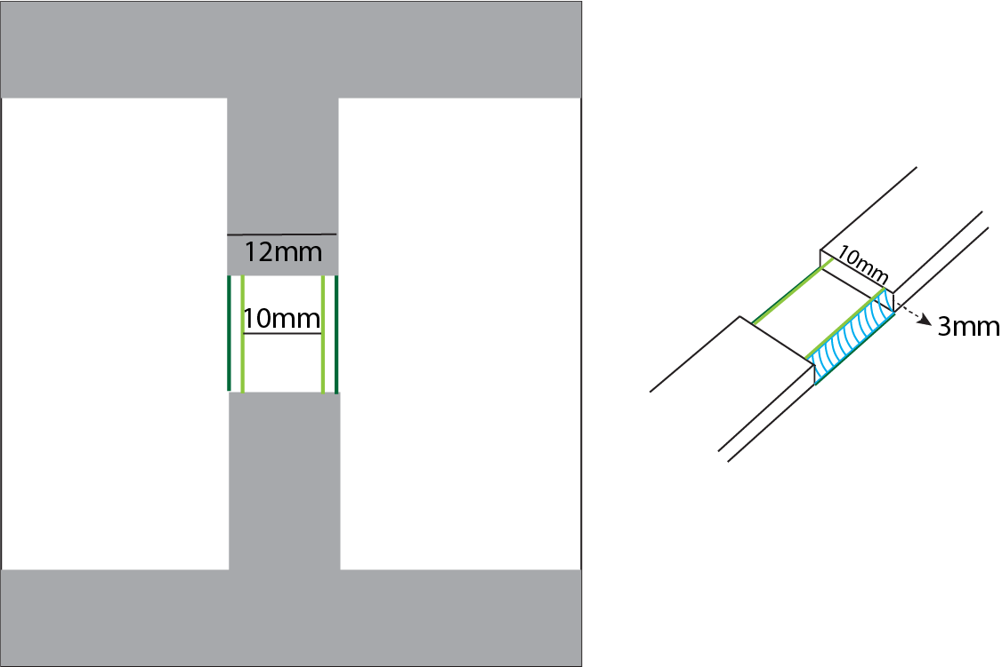

Confocal spinning disk imaging and optical tweezers setup

Confocal spinning disk imaging was performed using a Yokogawa CSU10-X1 spinning disk system connected to a Nikon Eclipse Ti inverted microscope (Nikon, Japan). A DPSS laser stack with 488 nm, 561 nm and 640 nm laser lines (3i, Denver, Colorado USA) is used for illumination and an Andor Ixon Ultra 512 × 512 EMCCD camera for fluorescence detection. 3i-Slidebook software controlled lasers, filter selection, microscope, xy stage and acquisition (3i, Denver, Colorado USA). For simultaneous FtsZ-YFP-mts and ATTO655-DOPE excitation, 488 nm and 640 nm lasers were rapidly switched by an AOTF. For image detection, the use of an appropriated quad-band-filter avoided mechanical filter switch. Samples were images using a CFI Plan Apochromat Lambda 100X oil, NA=1.45 (Nikon, Japan).

The optical tweezers setup was built according to previous methods-reports (5-6). Briefly, a 3W 1064 nm DPSS laser (Cobolt, Sweden) was used as trapping laser. A half-wavelength plate ($λ/2$plate) and a polarizing beam splitter (PBS) control the laser power entry to the scope. A two-lens telescope expands the laser beam to fill the back aperture of -above mentioned- 100x objective. In addition, two mirrors adjust the laser-beam xy position. The force detection arm was mounted in the illumination pillar of the microscope, collecting (from above) the light from the laser using a -long working distance- condenser 20X, NA=0.6 (Edmund optics, USA). A micrometric xyz stage positions the condenser (and the detection arm) in -z- to achieve Köhler illumination and -xy- for centering. For alignment, once the proper laser-axis has been defined, the position of field diaphragm (having Köhler illumination) is imaged through an auxiliary camera DCC3240M (Thorlabs, USA) on the right port of the microscope. Using camera software options, a drawing masking the field diaphragm was saved in a file. This drawing can be re-used in such way that the drawing overlays the real-time camera acquisition. Therefore, xyz knobs are moved to position the field-diaphragm according to the drawing mask.
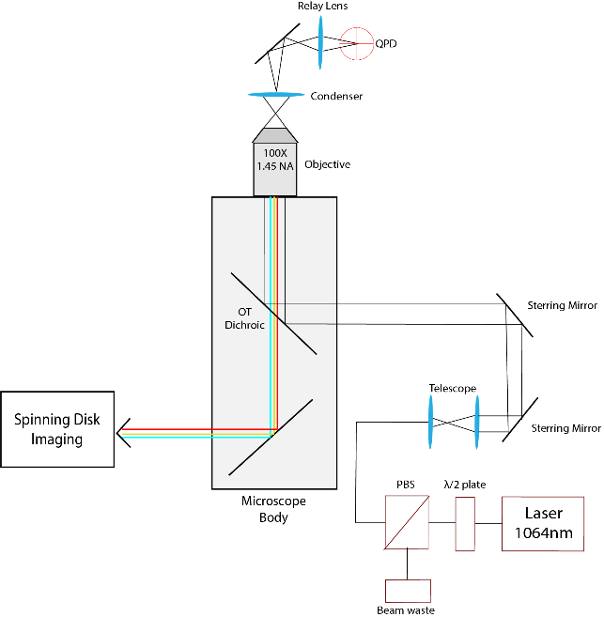

In the detection arm, a relay lens imaged the back focal plane of the condenser in a (QPD) quadrant positional detector PDQ80A (Thorlabs, USA). The signal voltage of the QPD defined the position of the trapped bead. The force detection module OTKBFM (Thorlabs, USA) was used for data acquisition. This DAQ acquired a voltage signal from the QPD at a maximum rate of 100 kHz. In addition, this module was customized to control a 20 x 20 µm range LT2 piezoelectric-stage (Piezoconcept, France) using an analog signal (1-10 volts). Position calibration and trap-stiffness determination was performed using the OTKBFM software (Thorlabs, USA). To calibrate position, beads were attached to a clean glass coverslip in high salt medium (1M NaCl). Here, the streptavidin-coated beads have a mean diameter of 1.71 µm (Spherotech, USA). The laser beam is focus over one bead. The xy position of the bead, relative to laser beam, was adjusted using the piezo-stage to maximize the signal in QPD. Similarly, the focus -z- position of the laser beam was adjusted to maximize QPD output. Then, the piezo-stage was moved 4 x 4 µm xy and changes in QPD signal were recorded. From the typical “s-shape” response curve, a straight line was fitted representing the volts to µm conversion. The trap stiffness was determined using the power-spectrum analysis. Using this, the frequency-corner of a xy Brownian motion subjected to a trapping potential was fitted from data. The stiffness of the trap was measured over different laser powers to determine the linear range. All experiments are performed at the same laser power of $200$ mW (before objective) with a $1.66$ volts/µm conversion and a trap stiffness of $74.4±2.5$ pN/µm. Experiment acquisition was performed using a Matlab script controlling the OTKBFM. This Matlab script set (for 60 seconds) an oscillatory motion for the piezo-stage with an amplitude of 3 µm and a frequency of 1 Hz. In parallel, QPD data was acquired at a rate of 10kHz.

FtsZ rings reconstitution in vesicles

FtsZ externally added to vesicles and tube experiments with force detection.

Giant unilamellar vesicles (GUVs) were produced using electro-swelling. E.coli lipid extract was dissolved in chloroform to reach a final concentration of 3mg/ml. To image lipids in the red channel, 0.05 % (mol) of ATTO655-DOPE (ATTO-Tech GmbH, Germany) was added to the lipid mixture. In addition, 0.15% of DSPE-PEG (2000) Biotin (Avanti, AL, United States) was also added to achieve binding between GUVs and streptavidin-coated beads. For experiments with Wt-FtsZ, 0.5% DGS-NTA lipids were also added to enable the attachment of sZipA protein. In our home-made Teflon chambers, 3 drops (~ 1 µl) were carefully seeded in Pt wires and rapidly air dried. After 1h vacuum of further chloroform drying, GUVs were swelled in 250 mOsm sucrose solution at 10Hz for 2 hours and 2Hz for 1 additional hour (detachment). Lipid concentration and electroformation times were carefully optimized to guarantee an appropriated GUV yield. Furthermore, to obtain similar GUV-lipid concentrations, two identical chambers underwent same procedure and mixed afterwards.

GUVs were mixed in buffer (120 mM KCl, 20 mM Tris-HCl, and 1.5 mM MgCl₂ pH 7.5) with an osmolarity of 250 mOsm. In details, 4 µl of GUVs were highly diluted in 360 ul of buffer in a reaction tube. FtsZ-YFP-mts and FtsZ-YPF-mts*[T108A] were added to reach a final concentration around 0.07 µM. For experiments with Wt-FtsZ and siZipA, the same procedure was used adding first siZipA at around 0.2 µM followed by addition of FtsZ reaching ~0.8 µM supplemented with ~0.2 µM wt-FtsZ-Alexa488. In both cases, polymerization is triggered by adding 1.25 mM of GTP (Sigma, Germany). Flaccid vesicles with FtsZ rings and inward deformation were observed after 20 minutes. On these vesicles, tubes were pulled and imaged for 10 minutes (1 fps) in two-colors: FtsZ-YFP-mts/ wt-FtsZ-Alexa 488 and lipid channel. This time was enough to obtain helical deformations and reach a steady state of protein entering the tube, at least for FtsZ-YFP-mts. Right after, force measurements (oscillations) were performed for 60 seconds. Experiments with pulled tubes longer than 10 minutes were prone to display contamination on the “force channel” (beads, small vesicles and protein clusters were attracted to the trapping-bead). This made force measurements with FtsZ-YFP-mts*[T108A] difficult since the time-scale of deformation was significantly longer. To analyze pitch, N=12 experiments for FtsZ-YFP-mts and N=10 for FtsZ-YFP-mts*[T108A] were analyzed (see Image Analysis below).

To measure forces and estimating spring-constants, we used the oscillation mode as described above. Force experiments were carried out in tubes without protein to be contrasted to experiments with FtsZ-YFP-mts and helical deformations. As mentioned above, data was acquired in Matlab (Mathworks, USA) and signal-amplitude determined by the amplitude of the FFT (Fast Fourier Transformation) at 1 Hz. Then, these values are converted to force using volts/µm conversion and the trap stiffness and further divided by the oscillation amplitude ($A=3 μm$). Figure 4C exhibited raw spring constants for only lipid contribution (N=11) and Lipid+FtsZ (N=36). To guarantee high/full protein coverage of the tube in FtsZ force experiments, we increased the protein sample concentration to 0.08 - 0.09 µM. To characterize single FtsZ ring brightness, we imaged vesicles (outside FtsZ) rings that have flattened over the glass surface. Using same light conditions as used for tube experiments, the brightness of FtsZ rings of N=421 rings was analyzed and plotted (Figure 2SE).

FtsZ encapsulated in lipid vesicles

FtsZ encapsulating vesicles were produced using droplet emulsion transfer (7). Lipid composition was EggPC/DOPG 80:20 (Avanti, AL, United States) with 0.05% mol ATTO655-DOPE (ATTO-Tech GmbH, Germany). Briefly, vacuum dried lipids were dissolved in mineral oil (Sigma, Germany) to reach a final concentration of 0.5 mg/ml. To form lipid vesicles, two interfaces are required: outer and inner interface. In a reaction tube (A), 500 µl of lipid+oil mixture was added to 500 µL of outer buffer (150 KCl 50 mM Tris-HCl pH 7.5). At the oil-water interface, a lipid monolayer was assembled after 30 minutes. In a second reaction tube, 15 µl of protein-master-mix was added 500 µl of lipid + oil and vigorously vortexed for two minutes to obtain a homogenous cloudy emulsion. The inner monolayer was rapidly formed (~ 2 minutes). This protein-master-mix was composed of inner buffer (125 mM KCl, 25 mM Tris-HCl, 2 mM MgCl₂ pH 7.5), 20% OptiPrep (Density Gradient Medium, Sigma, Germany), protein and GTP. FtsZ-YFP-mts (or FtsZ-YPF-mts*[T108A]) and GTP final concentrations were 1.65 µM and 1.4 mM respectively. Therefore, the emulsion was transferred to the reaction tube (A) and centrifuged at 100g for 7 minutes. Finally, the oil-based supernatant is discarded and 300 µl final vesicles are 1:2 or 1:3 diluted in fresh outer buffer.

PDMS Microfabrication and FtsZ assay
PDMS microstructures were fabricated using soft lithography. The inverse of the target 3D geometry was designed in SolidWorks (Dasault Systems SE), exported to STL format and converted into 3D print instructions using DeScribe (Nanoscribe GmbH) for 63x objective fabrication using default parameters. Master molds were then produced on a 4 inch silicon wafer (University Wafer) using IP-L resist on a Professional GT two photon 3D printer (both Nanoscribe GmbH) and finally developed using PGMEA and rinsed with isopropanol. To facilitate intact release of the small PDMS features, the developed master was surface-treated with a fluorophilic coating by spin coating about 200 µl of a 1:20 Cytop CTL-809AE in CTsolv.100E (both from Asahi Glass Co. Ltd., Japan) onto the master. For this the Cytop dilution was directly pipetted onto the SU8 features and then spin-coated at 3000 rpm for 1 min, using a 500 rpm/s ramp. We then hard-baked the wafer for 30 min at 453 K on a hot plate to simultaneously drive IP-S polymerization to completion while also covalently anchoring the fluorophilic coating. The master was then allowed to slowly cool down to room temperature by turning off the hot plate. PDMS base and curing agent (Sylgart 184, Dow Corning) was mixed at a ratio of 10:1. About 5-10 µl of this PDMS resin was then applied onto the features. After degassing for about 15 min, cleaned microscope slides where placed onto the PDMS droplet and gently pressed to squeeze the PDMS into a thin film, before cured the PDMS at 80 ºC for at least one hour. The coverside was then gently peeled off the silicon wafer using a razor blade and stored for further use.
Supported lipid bilayers (SLBs) over PDMS structures were prepared according to our recent study (1) with the difference that plasma-cleaner time was carefully chosen to not affect the PDMS structure (5 mins). FtsZ concentration was 0.2 $μ$M with 4mM GTP in buffer: 150 mM KCl, 50 mM Tris-HCl, 5 mM MgCl₂ pH 7.5.

Image Analysis

Image analysis and plotting was carried out in MATLAB (MathWorks, USA).

To generate kymographs (Figure 1), a script allows the user to define a circular section by providing 2 coordinates such as described in reference (1). This circular section is automatically fitted to a circle with radius r (in this case, $r=0.5 μm$). Then, 3 trajectories corresponding to 3 concentric circles having radii r, r+1, and r−1 pixels are determined. At this point, the script read the time-series data and calculate a kymograph for each time point and trajectory. The final kymograph corresponds to the average of the 3 different trajectories (1).

To determine tube diameter (Figure 2SA), the intensity over a representative tube section was normalized to be fitted to a Gaussian function. Then, the reported here diameter represented half-width of the Gaussian. To quantify the arc-length (helical shapes projection to an 2D image), tubes were binarized and fitted to a function using linear interpolation (Figure 3). Then, the arc-length of the function was calculated. The protein density was calculated by measuring, over the tube, the FtsZ-intensity-difference between initial and final acquisition. This difference was divided by the FtsZ intensity on the GUV (in the tube proximity) times the tube length. To measure the pitch in the spring-like tubes (Figure 3), a Gaussian-filter was applied. The tube red-lipid-intensity profile was integrated and normalized, in a perpendicular-direction (to the tube), to find the pixel-position where the normalized intensity was “1” and closer to “0.3”. The 1 (maximum) position pixel defined the center of the tube while “0.3” defined the upper and lower limit of the tube. The intensity profile, now in parallel direction to the tube, was plotted for these 3 locations: up, center and down. Using this intensity profile, peaks are automatically found and then pitch was calculated. Every experiment is manually inspected to avoid miscalculation.

To measure the size distribution of FtsZ encapsulated rings (Figure 5), TIRF imaging was used according to our previous work (1). The diameter was manually measured using intensity profile in ImageJ (NIH, USA). Diameters were exported and plotted in MATLAB. All shown images were adjusted in ImageJ. For both protein mutants, the number of analyzed rings was N > 100.

in vivo assays and sphaeroplasts generation.

For overexpression of FtsZ-YFP-mts in E. coli cells, the respective DNA sequence was amplified by polymerase chain reaction (PCR) using oligonucleotides SacI-mts (catGAGCTCttatcctccgaacaagcg) and SalI-ftsZ (catGTCGACatgtttgaaccaatggaacttacc), respectively. The pET11b-ftsZ-yfp-mts plasmid served as template DNA. The resulting PCR product was ligated into SacI/SalI opened pEKEx2-vector. The final plasmid pEKEXx2-ftsZ-YFP-mts was transformed into competent E. coli DH5α cells.

E. coli cells expressing FtsZ-YFP-mts were cultured in osmoprotective MLB-medium (1 % peptone, 0.5 % yeast extract, 1mM CaCl₂, 30mM glucose, 25 mM MOPS (pH 7,2), 340 mM NaCl) (8). Plasmid maintenance was ensured by addition of 25 µg/ml kanamycin and cultures were incubated at 37 °C with constant shaking (120 rpm). Expression was induced by adding 100 µM IPTG. The formation of sphaeroplasts was induced by addition of 0.5 mg/ml lysozyme, followed by an incubation of 30 min at 37 °C. For microscopy, a 0,1% agarose-pad in MLB-medium was used.

In order to improve sphaeroplasting efficiency, an adaptation of the method described in (9) was used. Therefore, single colonies were picked and cultivated overnight in 10 ml LB-medium (10 g/ l tryptone, 5 g/ l yeast extract and 10 g/ l NaCl), using environmental conditions like described above. The next day 200 µl of the overnight culture were used to inoculate the respective over day culture. For the mutant kanamycin (25 µg/ml) was used in both pre-cultures, induction with IPTG was performed on the over day culture only. After 4 h, 1 ml of exponentially growing cells were harvested at 3.000 g for one minute. The pellet was gently resuspended in 0,8 M sucrose, together with 30 µl Tris-HCl (pH 8.0), 24 µl 0,5 mg/ ml lysozyme, 6 µl 5 mg/ ml DNaseA and 6 µl EDTA-NaOH (pH 8,0) and incubated for 5 min at room temperature. 100 µl of a STOP-solution (10 mM Tris-HCl (pH 8,0), 0,7 M sucrose and 20 mM MgCl₂) were added to complex free EDTA. For one replicate, phospholipid membranes were stained for 5 min with 1 µg/ml nile red (Invitogen). For microscopy 2 µl of the suspension were directly applied on the sample-slide with a cropped pipet-tip and covered with a high-precision coverslip.

Fluorescence and phase contrast imaging for in vivo studies was performed on a Zeiss Axio Imager M1 microscope equipped with an immersion condenser, a 2,5x optovar and an EC Plan Neofluar 100x/ 1.3 Oil Ph3 objective (Zeiss). YFP fluorescence was imaged using filterset 46 HE shift free (EX BP 500/25, BS FT 515, EM BP 535/30) and nile red fluorescence was detected with filter 43 HE Cy 3 shift free (EX BP 550/25, BS FT 570, EM BP 605/70). Image acquisition was carried out using the AxioVision software-package (Zeiss). For image analysis FIJI was used (10).

References for supplementary

(1) D. A. Ramirez-Diaz et al., Treadmilling analysis reveals new insights into dynamic FtsZ ring architecture. PLOS Biology. 16, e2004845 (2018).
(2) Rivas, G. et al., Magnesium induced linear self-association of the FtsZ bacterial cell division protein monomer. The primary steps for FtsZ assembly. J. Biol. Chem. 275 (16), 11740−11749 (2000).
(3) Martos, A. et al., Characterization of self-association and heteroassociation of bacterial cell division proteins FtsZ and ZipA in solution by composition gradientstatic light scattering. Biochemistry 49 (51), 10780−10787 (2010).
(4) González JM. et al., Essential cell division protein FtsZ assembles into one monomer‐thick ribbons under conditions resembling the crowded intracellular environment. J Biol Chem 278: 37664–37671 (2003).
(5) W. M. Lee, P. J. Reece, R. F. Marchington, N. K. Metzger, K. Dholakia, Construction and calibration of an optical trap on a fluorescence optical microscope. Nat. Protocols. 2, 3226–3238 (2007).
(6) K. C. Neuman, S. M. Block, Optical trapping. Review of Scientific Instruments. 75, 2787–2809 (2004).
(7) S. Pautot, B. J. Frisken, D. A. Weitz, Production of Unilamellar Vesicles Using an Inverted Emulsion. Langmuir. 19, 2870–2879 (2003).
(8) Osawa M, Erickson HP. L form bacteria growth in low-osmolality medium. Microbiol (United Kingdom). 165(8):842-851 (2019).
(9) Renner, L. & Weibel, D, Cardiolipin microdomains localize to negatively curved regions of Escherichia coli membranes. PNAS 108(15): 6264-6269, (2011).
(10) Schindelin, J., Arganda-Carreras, I., Frise, E. et al. "Fiji: an open-source platform for biological-image analysis", Nature methods 9(7): 676-682, (2012).

Fig. S1.

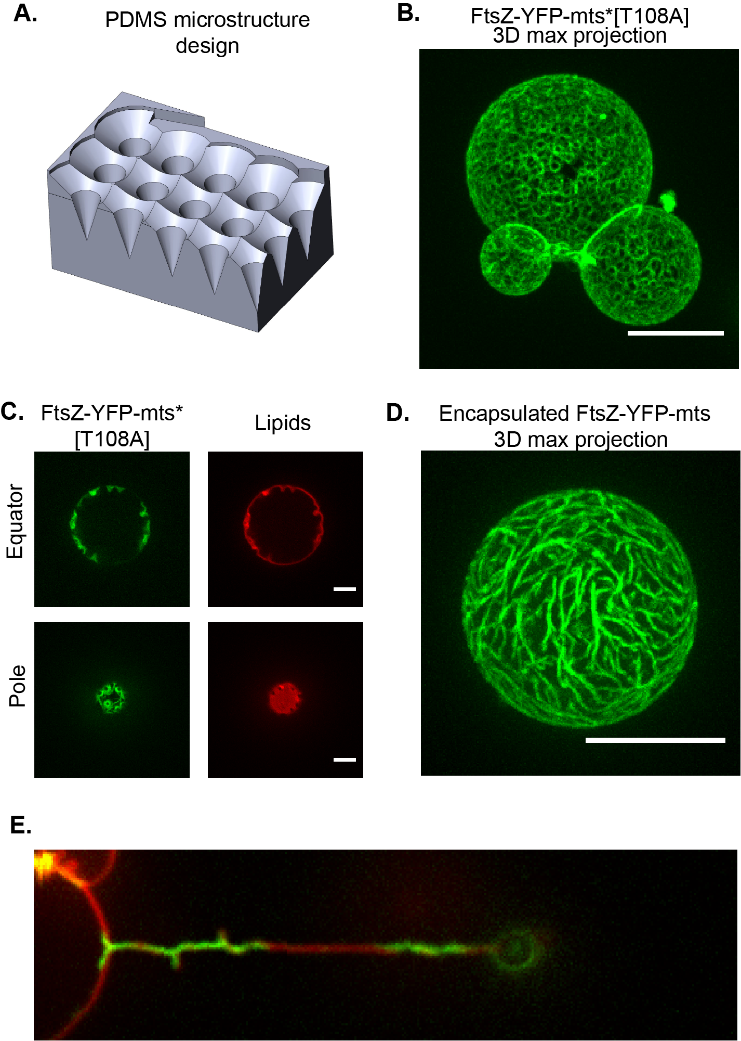

A) 3D sketch of the PMDS microstructure with inwards cone-like shapes. B) FtsZ-YFP-mts*[T108A] also self-assembled into ring-like structures under similar used conditions for FtsZ-YFP-mts rings (main text). C) After deflation, FtsZ-YFP-mts*[T108A] induced inwards conical deformations emerging from before mentioned rings. D) By encapsulating FtsZ-YFP-mts in GUVs, Mg⁺² and GTP content-conditions were fine-tuned to obtain either ring structures (Fig. 4) or nematic phases at a higher membrane protein density. E) Further evidence for FtsZ-torsion over lipid tubes can be found in (less frequent) experiments displaying plectonic/supercoiled regions. (Scale bar = 5 µm)

Fig. S2.

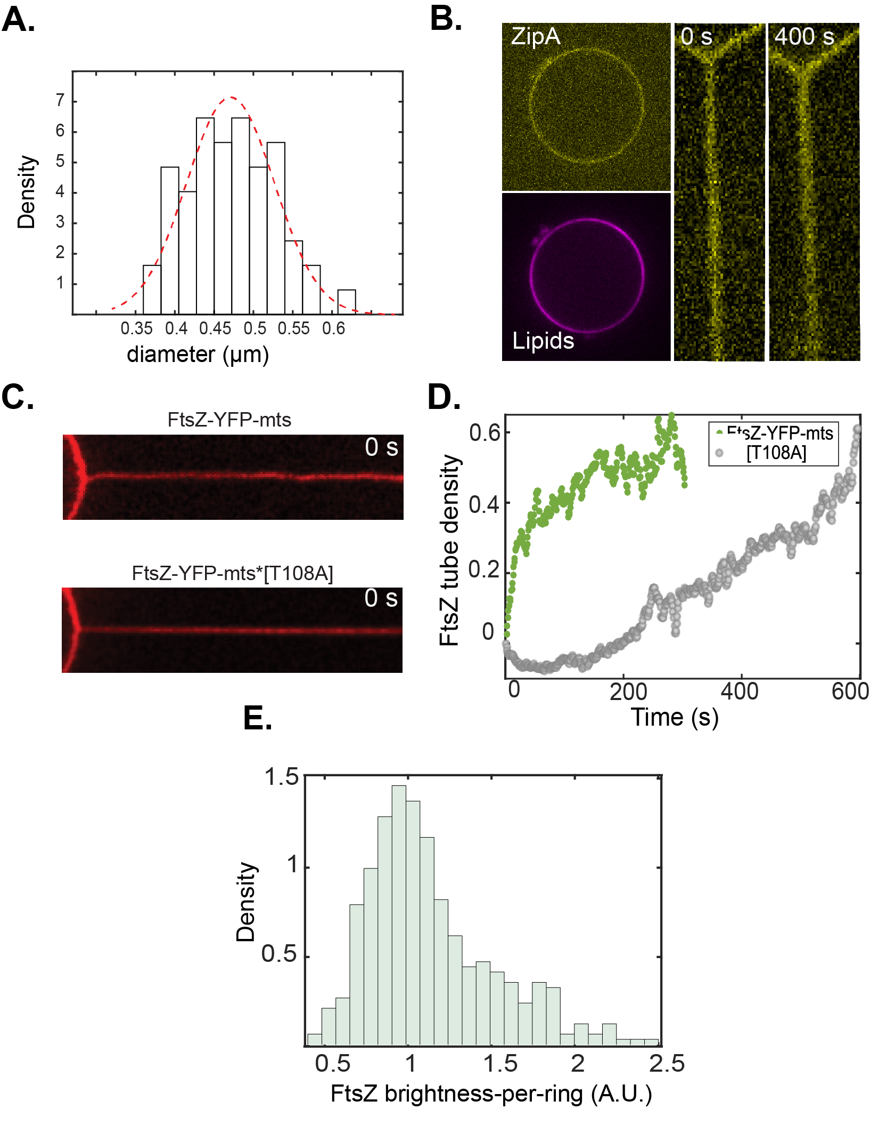
A) The diameter distribution (N=55) showed a Gaussian distribution with a mean of 0.47 µm. This implied that membrane tensions equivalent to this mean (± std) were highly frequent despite of precise control on the vesicle membrane tension. B) Vesicles decorated with ZipA and imaged under deflation conditions exhibited no deformations (N=14). In addition, we examined lipid tubes only coated with siZipA-Alexa 488. No deformations (N=10) were observed in the range of 400-600 seconds. C) Similar initial lipid tube diameter (0.44 µm) for experiments shown in Figure 3 A-B. D) For experiments shown in Fig. 3 A-B, FtsZ-YFP-mts entered rapidly to the lipid tube while the mutant without GTPase activity (slower). E). Distribution of FtsZ brightness-per-ring. The distribution’s mode value was chosen as the value for FtsZ brightness-per-ring.

Fig. S3.

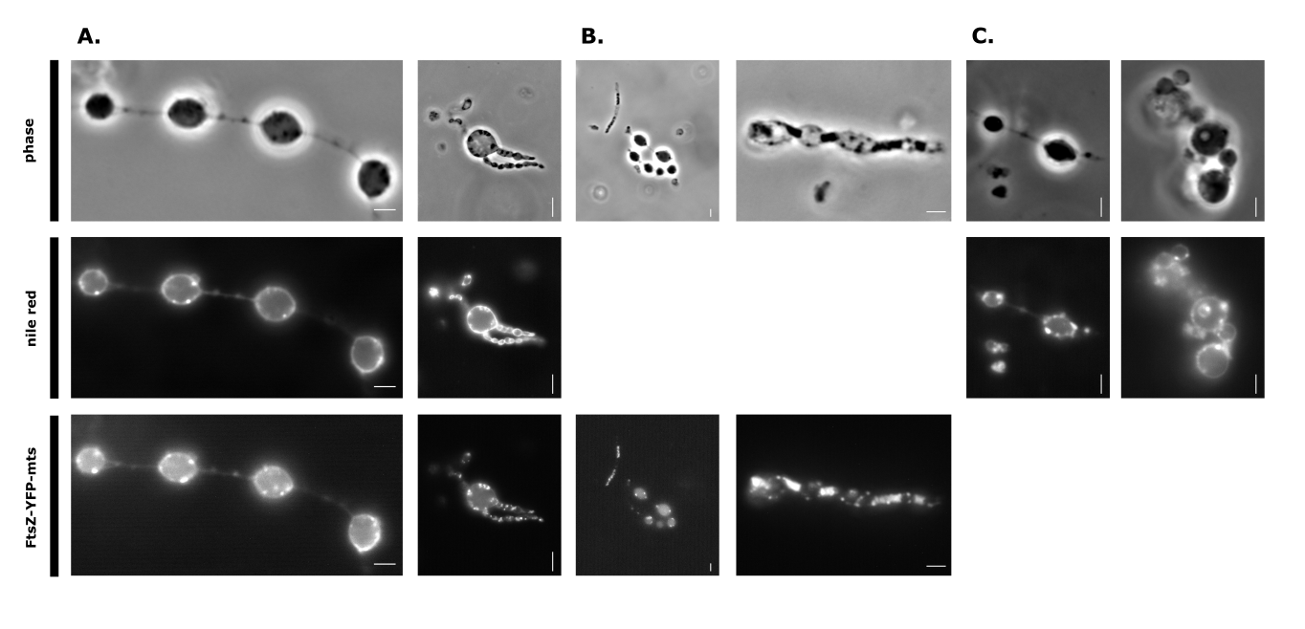

Observed phenotypes of E. coli FtsZ-YFP-mts after lysozyme treatment in sucrose-buffer. The first columns in A, B & C show a pearl necklace like appearance of the cells, while the second column in B might show an earlier stage of this chaining type of vesiculation. Nile red was used to prove that the observed vesicles and tubular connections are actually phospholipid-membranes. As a control unstained cells (B) and stained cells (C) were also imaged separately in the respective channel.

Movie S1.
Clockwise and counterclockwise FtsZ-YFP treadmilling inside PDMS cones

Movie S2.
Soft-vesicle exhibiting inwards deformations induced by FtsZ-YFP-mts

Movie S3.
After lipid tube pulling, FtsZ-YFP-mts induced coiling that resulted in the transformation of the lipid tube into a spring-like structure.

Movie S4.
After lipid tube pulling, FtsZ-YFP-mts*[T108A] induced helical transformations.

Movie S5.
Oscillation of GUV to measure the force response.

Movie S6.
Z-stacks of cell displaying vesiculation. Left. Phase. Right. FtsZ-YFP-mts

