Supplementary file
Effect of Erector Spinae Block on Postoperative Outcomes in Patients Undergoing Lung Surgical Procedures: A Systematic Review and Trial Sequential Analysis of Randomized Controlled Trials.
Vitaliy and Mouad et al. 2025
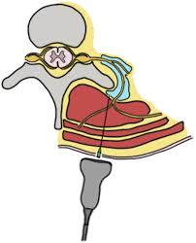

Table of Contents
Supplementary File S1: List of Literature Search strategies and keywords 3
Supplementary File S2: Protocol for postoperative outcomes of erector spinae block in lung surgery: A systematic review and meta-analysis. 3
Supplementary File S3: Erector Spinae Block in Lung Surgical Procedures: A Systematic Review of Randomized Controlled Trials in the tabular column. 7
Supplementary File S4: Publication Bias 15
Resting Pain Score at 6 hours 15
Resting Pain Score at 12 hours 17
Resting Pain Score at 24 hours 19
Movement Pain Score at 6 hours 21
Movement Pain Score at 12 hours 23
Movement Pain Score at 24 hours 25
24-hour Opioid Consumption in MME 27
Postoperative Nausea and Vomiting 28
Supplementary File S5: 12 Hour Resting and Movement Pain Scores. 31
Supplementary File S6: Postoperative Nausea and Vomiting. 32
Supplementary file S7: Exploratory outcomes 33
Supplementary file S8: Risk of Bias assessment by Cochrane ROB 2 tool 34
Supplementary File S9: Meta regression 34
Metaregression: Bubble Plots on Bupivacaine vs. Ropivacaine 34
Metaregression: Bubble Plots on Concentration 35
Metaregression: Bubble Plots on Volume 36
Metaregression: Bubble Plots on Adjuvants 37
Metaregression: Bubble Plots on the Level of Block 38

Supplementary File S1: List of Literature Search strategies and keywords
Ovid MEDLINE(R) ALL 1946 to August 28, 2025
# | Searches | Results
1 | exp Thoracic Surgery/ or exp Pneumonectomy/ or exp Thoracotomy/ or exp Lobectomy/ or exp Segmentectomy/ or (lobectom$ or pneumonectom$ or wedge resection$ or segmentectom$ or thoracotom$ or (video-assisted adj3 thoracoscop$) or VATS or (robotic adj2 (lobectom$ or lung$ or segmentectom$))).mp. | 112946
2 | exp *Anesthesia, Conduction/ or ((anesthe$ or anaesth$ or block$) adj2 conduction$).mp. | 65571
3 | exp Anesthesia, Local/ or ((anesthe$ or anaesth$) adj2 (local or regional$)).mp. | 94204
4 | exp Nerve Block/ or ((nerve$ or local or sensory$ or erector$ or spina$ or plane) adj2 block$).mp. or (blockade$ or block$1).mp. or ESPB.mp. | 577181
5 | 2 or 3 or 4 | 660390
6 | 1 and 5 | 3093
7 | exp Spine/ or exp Back Pain/ or backpain$.mp. or (back or spine$ or spinal$ or C-Spine$ or vertebra$).ti. or (back or spine$ or spinal$ or C-Spine$ or vertebra$).ab. /freq=2 | 555625
8 | 6 and 7 | 183
9 | ((erector$ and spinae$) or (spinalis$ or longissimus$ or iliocostalis$) or ESPB).mp. | 13598
10 | 1 and 9 | 229
11 | 8 or 10 | 405

Supplementary File S2: Protocol for postoperative outcomes of erector spinae block in lung surgery: A systematic review and meta-analysis.
S1 Protocol Study protocol for systematic review and meta-regression analysis to determine the postoperative outcomes of erector spinae block in lung surgery patients

Vitaliy Voznyy, Mouad Elganga, Salem Abu Alburak, Leya Tawfik, Mahesh Nagappa. “Efficacy of Erector Spinae Block on Postoperative Outcomes in Lung Surgery Patients: A Systematic Review and Meta-Analysis”

Objective:

In this systematic review and meta-analysis we aim to investigate the impact of erector spinae plane block on postoperative pain, opioid consumption and nausea/vomiting in adult patients undergoing lung surgery such as lobectomy, wedge resection, pneumonectomy, segmentectomy, or video-assisted thoracoscopic surgery (VATS) compared to conventional analgesic techniques or placebo.

Inclusion Criteria

Study Type

- Randomized control trials that present information on our primary outcomes (postoperative pain, postoperative opioid consumption and postoperative nausea/vomiting) in individuals receiving erector spinae plane block for lung surgery such as lobectomy, wedge resection, pneumonectomy, segmentectomy, video-assisted thoracoscopic surgery (VATS) or any other lung surgery procedure.

Participants

- Adult patients (>18 years old) undergoing lung surgery with erector spinae plane block

Definition of Exposure

- All studies that used erector spinae plane block for lung surgery and reported primary outcomes were included

Outcome variable

- All studies which reported postoperative pain scores (at rest or during cough), postoperative opioid usage, or postoperative nausea/vomiting were included

Publication type

- Full published papers excluding case reports, review articles, and editorials will be eligible. No language restrictions will be applied. No restrictions on year of publication.

Search Methods

We will search the following electronic databases:
- MedLine (via PubMed)
- EMBASE
- Scopus
- Web of Science
- Cochrane

There will be no restriction on the time or language of publication. In these databases, we will search according to the thesaurus of the NCBI MESH browser the following terms and combinations of keywords in full text:

The following keywords will be employed:

The search included the combination of the following MESH key words: “lobectomy,” “lobectomy surgery,” “Lobectomy Surgery,” “wedge resection,” “segmentectomy,” “pneumonectomy,” “thoracotomy,” “video-assisted thoracoscopic surgery,” “VATS,” “VATS lobectomy,” “robotic-assisted lobectomy,” “robotic lung surgery,” “robotic segmentectomy,” “Erector Spinae Plane Block,” “ESP block,” “Erector Spinae Analgesia,” “Erector Spinae Plane Regional Anesthesia,” “ESP regional block,” “Erector Spinae Plane Catheter,” “Erector Spinae Nerve Block,” “Nausea,” “Vomiting,” “Pain,” “Pain Management,” “Opioid Consumption,” “Opioid Analgesics,” “Opioid Use,” “Opioid Requirement,” “Opioid-Sparing,” “Morphine Equivalent,” “Opioid-Free Anesthesia,” “Fentanyl,” “Morphine,” “Oxycodone,” “Hydromorphone,” “Pulmonary Function,” “Respiratory Depression,” “Length of Stay,” “Hospital Stay,” “PACU,” and “recovery time.”

Additionally, bibliographies of identified publications and published reviews will be hand searched for potentially relevant articles. Authors will be contacted if data, methods and/or parameter definitions provided from the respective studies are unclear.

Reviews

All references cited in the identified reviews will be manually searched for potentially relevant studies.

Data collection

Two reviewers (LT, VV) will independently scrutinize the list of titles, and if available the abstracts, to determine potential usefulness of the article. Final selection will be based on the full text of potentially relevant articles by the two reviewers independently. In cases of disagreement, both authors will review the materials together until a consensus is reached.

The following study characteristics will be extracted: study ID, publication year, country, study design, cohort size, demographic data (age, gender, BMI), comorbidities, surgical procedures, level of block, postoperative pain scores (at rest and during cough), postoperative opioid usage, and postoperative nausea/vomiting. From all eligible studies, relevant data will be abstracted in duplicate, using a standardized data extraction sheet. An independent reviewer will confirm all data entries and will check at least twice for completeness and accuracy. The Cochrane Risk of Bias Tool (RoB 2) will be used to rate quality indicators.

Meta-analysis & Meta-regression

Dichotomous comparisons

- Data on the number of patients receiving the erector spinae plane block (ESPB) versus those receiving standard analgesia, along with corresponding crude odds ratios and 95% confidence intervals for postoperative outcomes, will be calculated.
- Random-effects models will be used to estimate the pooled odds ratios for the effect of ESPB on postoperative pain, opioid consumption, and postoperative nausea/vomiting across included studies. A random-effects Bayesian meta-analysis will be conducted to verify the results in case of sparse data. The value of the I² statistic will be used to select the appropriate pooling method: fixed-effects models if I² < 50% and random-effects models if I² ≥ 50%.

Assessment of heterogeneity

- Impact of heterogeneity will be assessed by calculating the I² according to Higgins et al. (Higgins JP et al. 2003). Confidence intervals around the I² will also be provided.

Influence analysis

- Robustness of the pooled estimates will be checked by influence analyses. Each of the studies will be individually omitted from the data set, followed in each case by recalculation of the pooled estimate of the remaining studies.

Subgroup/Sensitivity analyses

- To identify potential sources of heterogeneity and bias, patients will be stratified based on analgesic approach (ESPB vs. standard analgesia), study design, study quality scores, measured outcome definitions, patient loss to follow-up, and relevant medical comorbidities (e.g., obstructive sleep apnea, diabetes, cardiovascular disease).
- Further stratifications will be made based on adjustment for confounders, type of study (retrospective vs. prospective), and variations in ESPB technique (e.g., dosage, catheter vs. single-shot block). Meta-regression will be used to evaluate whether effect size estimates differ significantly by study characteristics and quality factors, with corresponding meta-regression coefficients and p-values reported. Galbraith and funnel plots will be used to assess potential sources of heterogeneity and identify outliers.
- Forest Plots: Forest plots will be generated to display pooled effect estimates with summary points.

Evaluation of bias and confounding

Publication bias

- Publication bias will be assessed by inspection of the funnel plot and formal testing for funnel plot asymmetry, using Begg’s test (Sterne JA et al. 2001). This will also be assessed with the Cochrane Risk of Bias Tool (RoB 2).

Discussion and Evaluating

- The results will be critically and integratively discussed.

Supplementary File S3: Erector Spinae Block in Lung Surgical Procedures: A Systematic Review of Randomized Controlled Trials in the tabular column.

Author [Country]  Journal Published Sample size (n) | Block characteristic  Timing  Guidance Local anesthetics, Adjuvants, Laterality, Level | Medical Co-morbidities | Other baseline data | Results
Zhang et al., 2022  [China]  • Insights Into Imaging  • control: n=23, ESPB: n=22, TPVB: n=22 | • Preoperative  • Ultrasound-guided  • 0.5% (30ml)  • Ropivacaine hydrochloride  • No adjuvants  • Unilateral  • T4-T5 | N/A | ESB vs. Control  • Anesthesia time (min)  163.23 ± 7.38 vs 161.57 ± 9.42, p = 0.635  • Surgery time (min)  126.82 ± 7.56 vs 124.87 ± 10.34, p = 0.737  • Intraoperative sufentanil consumption (μg)  33.86 ± 2.88 vs 41.09 ± 3.46, p < 0.001  • Anesthesia recovery time (min)  19.50 ± 4.30 vs 23.83 ± 4.17, p < 0.001  • Anesthesia extubation time (min)  24.64 ± 4.28 vs 29.22 ± 4.98, p < 0.001 | ESB vs. Control  • Postoperative sufentanil consumption (μg)  60.09 ± 3.05 vs 64.09 ± 7.07, p < 0.001  • Remediation dose of flurbiprofen axate (mg)  95.45 ± 43.40 vs 106.52 ± 52.88, p = 0.503  • Postoperative VAS score at rest and with a cough (at 1, 6, 12, 24, and 48 h); p<0.05  • Adverse events  PONV: 3 (13.64%) vs 6 (26.09%), p = 0.564  Dysphoria: 2 (9.09%) vs 5 (21.74%), p = 0.482
Wu et al., 2023  [China]  • BMC Anesthesiology  • control: n=46, ESPB: n=44, SAPB: n=47 | • Preoperative  • Ultrasound-guided  • 0.5% (20ml)  • ropivacaine  • No adjuvants  • Unilateral  • T5 | Smoking  HTN  DM Cardiovascular disease | ESB vs. Control  • Anesthesia time (minute)  123.7 ± 65.0 vs 113.5 ± 48.7  • Surgery time (min)  106.7 ± 63.0 vs 98.9 ± 50.5,  • Patient satisfaction  27 ± 61.36 vs 17 ± 36.96; p=0.02  • Patients receiving rescue analgesia  8 ± 18.18) vs 35 ± 76.09; p<0.01  • Preoperative pain (NRS score>3)  6(14%) vs 3(7%)  • Procedure type (LU/LL/RU/RM/RL)  17/3/17/1/6 vs 8/4/19/5/10  • Location of port (intercostal space)  4: 21(48%) vs 24(52%)  5: 23 (52%) vs 22(48%)  • Number of chest tubes  1: 20(45%) vs 31(67%)  2: 24(55%) vs 15(33%) | ESB vs. Control  • Postoperative sufentanil consumption at 24 hr (μg)  41.31 ± 8.52 vs 51.5 ± 6.13; p<0.01  • Postoperative NRS pain scores at rest and at movement (1, 6, 12, 18, and 24 hr)  • AUC NRS pain scores  At rest mean: 56.41 ± 18.17 vs 74.67 ± 22.38; p<0.01  Movement mean: 73.05 ± 15.86 vs 99.13 ± 19.32; p<0.01  • Postoperative adverse events  PONV: 5(10%) vs 6(12%), p = 0.8  Hypotension in PACU: 2(4%) vs 1(2%); p=0.81  Reported block complications: 0  Dizziness: 1(2%) vs 3(6%); p=0.59  ≥ 1 postoperative complications: 9(18%) vs 7(15%); p= 0.43  Pneumonia: 3(6%) vs 4(5%); p=0.36  Recurrent pneumothorax: 5(10%) vs 3(6%); p=0.76  Arrhythmia: 1(2%) vs 0(0%); p=0.36  Bleeding necessitating blood transfusion: 0(0%) vs 1(2%); p=0.6  • Time to initial sufentanil administration (0, 50, 100, 150, 200, 250, 300, 350, and 400 min); p<0.01  • Occurrence of moderate to severe pain (1, 6, 12, 18 and 24 hr postoperatively)
Zhang et al., 2023  [China]  • BMC Anesthesiology  • control: n=46, ESPB: n=48 | • Preoperative  • Ultrasound-guided  • 0.375% (30ml)  • Ropivacaine  • No adjuvants  • Unilateral  • T5 | N/A | ESB vs. Control  • Surgery time (minute)  118.56 ± 22.05 vs 120.48 ± 19.97; p=0.66  • Intraoperative blood loss (mL)  159.38 ± 32.90 vs 161.20 ± 27.55; p=0.772  • Patient satisfaction  9(8, 9) vs 8(7, 8); p<0.05 | ESB vs. Control  • Postoperative NRS pain score at rest and at cough (PACU, 2, 6, 12, 24, 48 hr); p<0.05  • Chronic post-surgical pain (CPSP) at 3 and 6 months  3: 19(39.6%) vs 20(43.5%); p=0.702  6: 12(25.0%) vs 14(30.4%); p=0.556  • CPSP effect on daily life rating at 3 and 6 months (no to serious)  • Adverse events  Incidence of Agitation: 6(12.5%) vs 14(30.4%); p=0.034  PONV: 4(8.3%) vs 13(28.3%); p=0.012  Pneumothorax, hematoma and local anesthetic poisoning: 0 vs 0  • Frequency of PCIA use (n)  2(1, 3) vs 4(3, 5); p<0.001  • Frequency of rescue analgesia (n)  0(0, 0) vs 0(0, 1); p<0.001
Xu et al., 2024  [China]  • Perioperative Medicine  • control: n=40, ESPB: n=40 | • Preoperative  • Ultrasound-guided  • 1% (25ml)  • Lidocaine  • Epinephrine and sufentanil  • Unilateral  • T5 | N/A | ESB vs. Control  • Anesthesia time (minute)  132.5 ± 37.5 vs 132.9 ± 43.4  • Surgery time (minute)  113.03 ± 37.1 vs 104 ± 41.2  • Intraoperative sufentanil consumption (µg)  52.63 ± 9.57 vs 58.63 ± 6.10; p=0.001  • Intraoperative estimated blood loss (mL)  59.5 ± 33.4 vs 52.75 ± 39.9  • Intraoperative Urine (mL)  281.25 ± 156.4 vs 233.75 ± 86.5  • Intraoperative Port number: 1/2  36/4 vs 36/4  • Operation: RUL/RML/RLL/LUL/LLL  15/3/4/11/7 vs 13/6/7/9/5  • Patient satisfaction  • MAP and HR overtime (at baseline, time of incision, 10 min, 20 min 40 min, 60 min, entering PACU, 1 hr at PACU); p > 0.05 | ESB vs. Control  • Postoperative sufentanil consumption (µg) (1, 6, 24 hr)  0–1 h: 1.10 ± 0.44 vs 1.90 ± 1.06; p<0.05  1–6 h: 4.75 ± 2.12 vs 6.10 ± 2.81; p<0.05  6–24 h: 18.98 ± 5.17 vs 18.98 ± 5.15; p>0.05  • Total Postoperative sufentanil consumption 0-24 hr (µg)  24.83 ± 4.30 vs 26.98 ± 6.43; p=0.083  • Postoperative VAS pain score at rest and with movement (at 1 hr, 6 hr, 24 hr, 1 week, and 1 month); p < 0.001 (1 h), p>0.05 (6 h, 24 h, 1 week, 1 month)  • Adverse events at 6 hr  Breathing depression: 0 vs 0  Nausea: 8 (20%) vs 16 (40%); p= 0.051  Vomiting: 6 (15%) vs 12 (30%); p=0.108  Dizzy: 5 (12.5%) vs 8 (20%); p=0.363  Intestinal exhaust: 2 (5%) vs 3 (7.5%); p=0.644  Itching: 0 vs 0  • Adverse events at 24 hr  Breathing depression: 0 vs 0  Nausea: 8 (20%) vs 14(35%); p=0.133  Vomiting: 6 (15%) vs 13 (32.5%); p=0.066  Dizzy: 10 (25%) vs 8 (20%); p= 0.592  Intestinal exhaust: 34 (85%) vs 32 (80%);p= 0.556  Itching: 0 vs 0
Klaibert et al., 2022  [Canada]  • Regional Anesthesia and Pain Medicine  • control: n=38, ESPB: n=38 | • Preoperative  • Ultrasound-guided  • 0.5% (30 ml for >50kg, 20ml for <50kg)  • Ropivacaine  • Epinephrine  • Unilateral  • T5 | Cardiac, respiratory, renal, vascular,  GI, and rheumatoid diseases  Diabetes | ESB vs. Control  • Anesthesia time (minute)  70.3 ± 18.7 vs 70.3 ± 21.8  • Surgical Indication, n (%)  Cancer: 25 (65.8%) vs 26 (68.4%)  Interstitial lung disease: 13 (34.2%) vs 12 (31.6%)  • Single wedge, n(%)  28 (73.7%) vs 24 (63.2%)  • Microcoil use, n(%)  7 (18.4%) vs 8 (21.1%)  • Median duration of PACU stay (min)  170.0 (120.0–225.0) vs 212.5 (175.0–335.0); p<0.01 | ESB vs. Control  • Quality of recovery (QoR)- 40 median score  169.5 (IQR 160–181) vs 72.5 (IQR 162–181)  • Adverse events  Block insertion-related pain: 1 (2.6%) vs 3 (7.9%); p=0.304  • Adverse events in PACU  Nausea: 7 (18.4%) vs 8 (21.0%); p=1  Vomiting: 1 (2.6%) vs 1 (2.6%); p=1  Delirium: 2 (5.3%) vs 2 (5.3%); p=1  New-onset cardiac arrhythmia: 1 (2.6%) vs 0; p=1  Hypotension: 1 (2.6%) vs 1 (2.6%); p=1  Airway complications: 0 vs 2(5.3%); p=0.493  • Adverse events on postoperative day 1  Nausea: 5 (13.2) vs 7 (18.4); p=0.754  Vomiting: 2 (5.3) vs 8 (21.0); p=0.086  Delirium: 1 (2.6) vs 0; p=1  New-onset cardiac arrhythmia: 0 vs 0  Hypotension: 0 vs 0  Airway complications: 1(2.6%) vs 0; p=1  • Median intraoperative oral morphine equivalent (OME) (mg)  35.5 (9.0–35.5) vs 36.3 (25.0–50.0); 0.36  • Median OME (mg)  PACU: 17.0 (5.0–31.0) vs 23.0 (10.0–37.0); p=0.23  At 24hr: 59.5 (31.85–93.0) vs 68.75 (39.0–118.5); p=0.18  • Median PACU stay duration (min)  170.0 (120.0–225.0) vs 212.5 (175.0–335.0); p<0.01  • VAS score at  1 hr postop: 21.0 (13.0–26.0) vs 40.0 (23.0–51.0); p=0.03  PACU arrival: 17.0 (5.0–31.0) vs 23.0 (10.0–37.0); p=0.23  Day 1 postop: 14.5 (6.0–34.0) vs 17.5 (9.0–38.0); p=0.54
Yao et al., 2020  [China]  • Journal of Clinical Anesthesia  • control: n=38, ESPB: n=37 | • Preoperative  • Ultrasound-guided  • 0.5% (25ml)  • ropivacaine  • No adjuvants  • Unilateral  • 2-3 cm lateral to T5 | N/A | ESB vs. Control  • Surgery time (minute) (IQR)  180 (175–190) vs 185 (177–198); p=0.09  • Surgery Type; p=0.516  Lobectomy: 31 (83.8%) vs 34 (89.5%)  Segmentectomy: 6 (16.2%) vs 4 (10.5%)  • Preoperative global QoR-40 score (IQR)  183 (178.5–186) vs 183.5 (180–186); p=0.259  • Patient satisfaction (IQR)  9 (8–9) vs 7 (6–8); p<0.001 | ESB vs. Control  • Postoperative (PO) global QoR-40 scores (at PO day 1 and 2)  POD1: 174 (170–177) vs 161.5 (160–165); p< 0.001  POD2: 181 (177–184) vs 169.5 (166–172); p< 0.001  • Postoperative cumulative sufentanil  consumption (μg)  0-24 h: 50 (48–54) vs 68 (66–72);p<0.001  24-48 h: 58 (55–61) vs 60 (56–63); p=0. 327  • Adverse events  PONV: 2 (5.4%) vs 7 (18.4%);p=0.153  ESPB-related AE: 0 vs 0  Pneumothorax, bleeding, or local anesthetic toxicity: 0 vs 0  • PACU discharge time (min)  30 (25–35) vs 45 (40–50); p<0.001  • Remifentanil dose (μg)  0.11 vs 0.14; p<0.001  • Postoperative NRS pain score at rest and during coughing (0.5, 1, 2, 4, 8, 24, 48 hr); p<0.001
Su et al., 2023  [China]  • Asian Journal of Surgery  • control: n=54, ESPB: n=54 | • Preoperative  • Ultrasound-guided  • 0.5% (20mL)  • ropivacaine  • No adjuvants  • Unilateral  • T4 | HTN,  DM, and smoking history | ESB vs. Control  • Anesthesia time (minute)  167.83 ± 40.08 vs 169.65 ± 41.29; p=0.817  • Surgery time (minute)  127.28 ± 36.28 vs 126.21 ± 34.86; p=0.876  • Single lung ventilation duration (min)  127.89 ± 32.19 vs 124.92 ± 31.98; p=0.481  • Operation type (lobectomy / lobectomy + wedge resection / segmentectomy / wedge resection / others)  46/3/2/2/1 vs 48/4/1/1/0; p= 0.762  • Operation Side  Left: 30 vs 28  Right: 24 vs 26  • Operation holes (3/4/5)  7/44/3 vs 9/44/1  • Intraoperative fluid volume (ml)  628.87 ± 38.98 vs 630.91 ± 39.27; p=0.787  • Intraoperative blood loss volume (ml)  151.96 ± 37.66 vs 150.87 ± 36.76; p=0.877  • Intraoperative urine volume (ml)  437.98 ± 23.98 vs 432.91 ± 25.87; p=45.68  • First postoperative oral feeding duration (hr)  6.08 ± 0.89 vs 6.12 ± 0.81; p=0.293  • Times of sitting up in bed on rst day after surgery  2.37 ± 0.23 vs 2.31 ± 0.25; p=1.298  • Times of ambulation on the next day after surgery  5.21 ± 1.28 vs 5.13 ± 1.18; p=0.736 | ESB vs. Control  • Postoperative VAS pain score (at 6, 12, 24, 48 hr); p>0.05 (12, 24, and 48h), p<0.001 (6h)  • Adverse events  Nausea: 8 (14.8) vs 21 (38.9); p=0.005  Vomiting: 12 (22.2) vs 29 (53.7); p=0.001  Atelectasis: 3 (5.6) vs 2 (3.7); p=0.647  Pneumonia: 0 vs 3 (5.6); p=0.079  Urinary retention: 2 (3.7) vs 0; p=0.153  • PCIA pressing times  3.56 ± 0.35 vs 4.21 ± 0.31; p<0.001  • Flurbiprofen dosage (mg)  103.92 ± 11.23 vs 124.39 ± 12.29; p<0.001  • Intraoperative remifentanil dosage (μg)  926.98 ± 56.98 vs 966.98 ± 52.19; p<0.001  • Postoperative sufentanil dosage (μg)  133.98 ± 15.29 vs 140.93 ± 15.39; p=0.020  • Recovery analgesia rate  13 (24.07) vs 31 (57.41); p<0.001  • Hospital stay days  11.46 ± 1.78 vs 11.51 ± 1.68; p=0.881  • NES, S100-b, ACTH, Cortisol and NE levels before surgery, 1d, 2d and 3d after surgery; p>0.05 (before, 2d, 3d)
Clairoux et al., 2024  [Canada]  • BMC Anesthesiology  • control: n=26, ESPB: n=26 | • Preoperative  • Ultrasound-guided  • 0.5% (30ml)  • Bupivacaine  • Epinephrine  • Unilateral  • T5 | N/A | ESB vs. Control  • Surgery Type  Lobectomy: 18 (69%) vs 17 (65%)  Segmentectomy: 4 (15%) vs 2 (8%)  Wedge: 4 (15%) vs 6 (23%)  Biopsy: 0 vs 1 (4%)  • 3-way ANOVA btw effect of…  Centre, randomized group, and time on cumulative hydromorphone consumption.  Centre, randomized group, and time on the QoR-Score. | ESB vs. Control  • Adverse events  PONV score: p=0.87  1: 14 (54%) vs 15 (60%)  2: 9 (35%) vs 8 (32%)  3: 3 (12%) vs 2 (8%)  Pruritus score: p=0.49  =0: 24 (92%) vs 25 (100%)  >0: 2 (8) vs 0  • RSS score (2-5)  • Thorax VNRS at rest  3.3 ± 1.5 vs 2.7 ± 1.3; p=0.12  • Thorax VNRS at cough  4.9 ± 2.1 vs 4.6 ± 2.0; p=0.54  • Shoulder VNRS at rest; p=0.4  =0: 11 (42%) vs 13 (54%)  >0: 15 (58%) vs 11 (46%)  • Shoulder VNRS at cough; p=0.26  =0: 11 (42%) vs 14 (58%)  >0: 15 (58%) vs 10 (42%)  • QoR-15 (preop, postop, >=8, < 8)  • Hydromorphone consumption (mg) (1, 6, 12, 18, and 24h); p=0.55  • Fentanyl (mcg)  231 ± 143 vs 255 ± 142; p=0.55
Shim et al., 2020  [South Korea]  • Journal of Thoracic Disease  • control: n=22, ESPB: n=24 | • Preoperative  • Ultrasound-guided  • 0.5% (25ml)  • Ropivacaine  • No adjuvants  • Unilateral  • T5 | HTN,  DM, coronary heart disease, cerebrovascular disease, COPD, and hepatic disease | ESB vs. Control  • Lobe resected (LUL/LLL/RUL/RUL+RML/RML/RLL)  6/2/10/1/2/3 vs 6/2/4/1/6/8  • Surgery time (minute)  124.8±34.2 vs 125.5±29.9; p=0.945  • Blood loss (ml)  136.2±71.1 vs 113.6±57.0; p=0.291  • Mean hospital stay (days)  ? (not visible) vs 10.6±4.6; p=0.053 | ESB vs. Control  • NRS score (PACU, 1, 6, 12 hr); p=0.030  • Postoperative pethidine consumption (mg)  25±25 vs 50±56.25; p=0.006  • Adverse events  PONV: 1 vs 0  Pneumothorax, LA systemic toxicity, or hematoma: 0 vs 0  • Length of PACU stay  25±10 vs 30±15; p=0.034  • Riker SAS score  4±1 vs 5±1.25; p<0.001
Çiftçi et al., 2020.  [Turkey]  • JARSS  • control: n=30, ESPB: n=30 | • Preoperative  • Ultrasound-guided  • 0.25% (20ml)  • Bupivacaine  • No adjuvants  • Unilateral  • T5 | N/A | ESB vs. Control  • Anesthesia time (minute)  169.66±29.62 vs 164.33±21.12; p=0.216  • Surgery time (minute)  135.50±29.13 vs 133.83±21.07; p=0.232  • Surgery type (Wedge resection / lobectomy)  13/17 vs 17/13; p>0.05  • Intraoperative Opioid Consumption (µg)  258.17±49.83 vs 427.67±81.90; p<0.001  • Rescue Analgesia (meperidine) (Yes/No)  10/20 vs 30/0; p<0.001 | ESB vs. Control  • Fentanyl Consumption (μg) (0-8, 8-16, 16-24, 24-48 hr, and total)  Mean total: 178.66 ± 129.39 vs 859.33 ± 198.99; p<0.001  • VAS pain score (0-10) at rest (passive) and during coughing (active) (1, 2, 4, 8, 16, 24, and 48 hr); p<0.001 (higher in control at all time points)  • Adverse events  Respiratory depression: 0 vs 0  Sedation/Confusion: 0 vs 0  Nausea: 5 vs 18; p<0.001  Vomiting: 4 vs 7; p=0.587  Itching: 6 vs 17; p=0.004  Constipation: 0 vs 0  Dyspepsia: 0 vs 0  Pneumothorax, vascular or neuraxial injury: 0 vs 0
Liu et al., 2020  [China]  • Journal of Anesthesia  • control: n=40, ESPB: n=40 | • Preoperative  • Ultrasound-guided  • 0.4% (25ml)  • Ropivacaine  • No adjuvants  • Unilateral  • T5 | N/A | ESB vs. Control  • Surgery type (wedge resection / lobectomy / segmentectomy / other)  25/10/2/3 vs 28/8/2/2; p=0.900  • Anesthesia time (minute)  165.5 ± 40.7 vs 169.0 ± 37.3; p=0.670  • Intraoperative sufentanil consumption (μg)  50 (50–50) vs 60 (50–70); p<0.001  • Intraoperative remifentanil consumption (mg)  1.1 ± 0.3 vs 1.2 ± 0.3; p=0.103  • Postoperative rescue analgesics  7 (15%) vs 13 (32.5%); p=0.121 | ESB vs. Control  • Postoperative NRS score (2, 4, 8, 24 hr); p<0.001 (lower in ESB)  • Postoperative sufentanil consumption (μg)  32.5 ± 6.3 vs 42.8 ± 7.6; p<0.001  • Adverse events  PONV: 7 (17.5%) vs 11 (27.5%); p=0.284  Respiratory depression: 1 (2.5%) vs 1 (2.5%); p=0.753  Pruritus: 2 (5%) vs 5 (12.5%); p=0.432  Hypotension: 1 (2.5%) vs 3 (7.5%); p=0.615  Bleeding, infection, local anesthetic toxicity, and pneumothorax: 0 vs 0  • Postoperative first out-of-bed activity time (hour)  23.88 ± 4.14 vs 27.73 ± 4.15; p< 0.001  • Postoperative hospital stay (day)  7 (6–10) vs 7 (6–8.75); p=0.879  • Postoperative and Intraoperative TNF-α, IL-6, IL-10 levels; p < 0.001
OrhonErgun et al., 2023  • Cureus  • control (opioid group): n=37, ESPB (opoid free group): n=37 | • Preoperative  • Ultrasound-guided  • 0.5% (20 ml)  • bupivacaine  • lidocaine  • T5 | N/A | Opioid free (ESPB) vs opioid group  • Mean heart rate  • Arterial pressure  • Oxygen saturation  p<0.05  • Bispectral index  • Analgesia Nociception Index  p<0.001 | Opioid free (ESPB) vs opioid group  • QoR-40 score  184.3±7.5 vs 171.2±6.4; p <0.001  • Time to mobilization (h)  5.5±0.8 vs 8.1±1.1; p <0.001  • Time to oral intake (h)  5.8±0.6 vs 6.4±0.6; p <0.001  • Duration of hospitalization (d)  4.2±1.0 vs 4.9±2.1; p=0.317  • First postoperative morphine consumption 24 hours (0-24)  7.3±3.4 vs 21.7±7.9; p<0.001  • Second postoperative morphine consumption 24 hours (24-48)  12.8±4.5 vs 18.7±10.9; p=0.103  • Mean VAS score (0, 6, 12, 24, 48 hr)  p<0.001  • Adverse events  Dyspnea: 0 (0.0%) vs 18 (48.6%); p<0.001  Urinary retention: 0 (0.0%) vs 17 (45.9%); p<0.001  Sleepiness: 0 (0.0%) vs 7 (18.9%); p= 0.011  Pruritis: 0 (0.0%) vs 13 (35.1%); p<0.001  Nausea: 4 (10.8%) vs 15 (40.5%); p=0.003  Vomiting: 3 (8.1%) vs 12 (32.4%); p=0.009  Any opioid-related side effect: 4 (10.8%) vs 32 (86.5%); p<0.001
Hu et al., 2025  • International Journal of Surgery  • control: n=25, ESPB: n=25 | • Preoperative  • Ultrasound-guided  • 0.375% (20 ml)  • ropivacaine  • No Adjuvant  • T5 | Hypertension, Diabetes, COPD, Cardiovascular disease, Anemia | ESPB vs control  • Intraoperative sufentanil (μg)  40 (40–50) vs 50 (40–50); p=0.140  • Predicted percentages of FVC (%)  105±15 vs 107±9.8; p=0.150  • Predicted percentages of FEV1 (%)  101±17.7 vs 102±10.; p=0.444  • FEV1 to FVC ratio (%)  98.6±10.4 vs 98.2±6.6; p= 0.723  • Predicted percentages of MVV (%)  96.7±23.1 vs 101±21.6; p=0.396  • Surgical type (wedge / Segmentectomy / Lobectomy)  12 / 9 / 4 vs 13 / 8 / 4  • Surgical time (min)  124±39 vs 143±53; p=0.219 | ESPB vs control  • QoR-15 score at 24 h  105.4±4.5 vs 109.7±6.2; p=0.033  • QoR-15 score at 48 h  115.4±3.9 vs 119.2±5.2; p=0.004  • QoR-15 score at hospital discharge  133.9±3.9 vs 135.1±4.2; p=0.342  • VAS pain scores at rest (in pacu, 24, 48 hrs)  • VAS pain scores on coughing (in pacu, 24, 48 hrs)  • Fentanyl consumption 0–48 h (μg)  635 (500–860) vs 600 (428–900) ; p=0.497  • Rescue analgesia 0–48 h  13 (26) vs 9 (18) ; p=0.617  • Adverse events: 14 (28)  PONV: 17 (34) vs 18 (36); p=0.280  Tachycardia: 5(10) vs 5 (10) ; p=0.715  Hypotension: 12 (24) vs 9 (18) ; p=0.799  Hypertension: 6 (12) vs 7 (14) ; p=0.525  Bradycardia: 11 (22) vs 7 (14) ; p=0.425  • Length of postoperative hospital stay (days)  4 (2.75–5) vs 4 (3–5); p=0.062
Pallu et al., 2022 [Brazil]  • Journal of Brazilian College of Surgeons  • Control (BAL): n=45, ESPB: n=36 | • Preoperative  • Ultrasound-guided  • 0.25% (20ml)  •levobupivacain  • No adjuvant  • T4 |  | BAL vs ESPB  • Surgery Time (minutes)  132.5 (±8.4) vs 133.9 (±88.5)  • Drain usage  31 (68.9%) vs 22 (61.1%)  • Type of Surgical Procedure  • Surgery side (left)  24 (53.3%) vs 19 (52.8%) | BAL vs ESPB  • Mean opioid consumption (mg)  12.9 (± 10.4) vs 14.9 (±10.2); p = 0.416  • No. of people who did not use opioids in the first 24 hr  17 vs 16  • Pain (≥1 VNS) at some point in the PO  29 (64.4%) vs 29 (80.6%); p=0.110  • Absence of pain (0)  30 (66.7%) vs 23 (63.9%); p=0.081  • Mild Pain (1-4)  13 (28.9%) vs 9 (25%)  • Moderate Pain (5-7)  0 (0%) vs 4 (11.1%)  • Severe Pain (8-10)  2 (4.4%) vs 0 (0%)  • Number of patients who used opioids in the PO  28 (62.2%) vs 20 (55.6%); p=0.544  • Total postoperative opioid consumption (mg) in 24h  12.9 (±10.4) vs 14.9 (±10.2); p=0.416
Hassan et al., 2022 [Egypt]  • Indian Journal of Anaesthesia  • Control: n=30, ESPB: n=30 | • Preoperative  • Ultrasound-guided  • 0.5% (20 ml)  • Bupivacaine  • No adjuvants  • T5 | N/A | Control vs ESPB  • Duration of Surgery (min)  283.2±45.4 vs 271.1±57.1; p=0.674  • Hypertension  5 (16.7%) vs 5 (18.5%); p=0.700  • Type of surgery (Segmentectomy/Lobectomy/Metastasectomy)  10 (33.3%) / 9 (30%) / 11 (36.7%) vs 12 (44.44%) / 7 (25.93%) / 8 (29.63%); p= 0.855 | Control vs ESPB  • NRS score at rest (30 min, 2, 4, 8, 12, 24 hr)  P=0.313  • NRS score at cough (30 min, 2, 4, 8, 12, 24 hr)  p<0.001  • Postoperative morphine consumption (mg)  36.37 ± 8.27 vs 8.52 ± 4.29; p<0.001  • Mean intraoperative fentanyl requirement (µg)  368.33 ± 92.13 vs 225.93 ± 59.03; p <0.001  • FVC  Best in ESPB compared to control; p<0.001  • FEV1  Best in ESPB compared to control; p <0.001  • Adverse events  Intraoperative hypotension: 4(13.3%) vs 2 (7.1%); p= 0.453  Intraoperative bradycardia: 1(3.3%) vs 1 (3.6%); p = 0.724  PONV: 9(30%) vs 3 (10.7%); p = 0.088  Pruritus: 1 vs 0
Albayrak et al., 2024 [Turkey]  • Acta Chirurgica Belgica  • control: n=36, ESPB: n=36 | • Preoperative  • Ultrasound-guided  • 0.5% (20ml)  • Bupivacaine  • No adjuvants  • T5 | N/A | ESPB vs control  • Mean operation time (min)  195 (151.25-258.75) vs 207.5 (80-420); p=0.286  • B-MEPS (IQR) (measures preoperative stress levels)  13(12–16) vs 13(12–16)  • Incision (cm) (IQR)  15(9–18) vs 18(15–20); p=0. 553  • Surgery type  • Intraoperative Remifentanil consumption (mcg/kg/min)  0.111 vs 0.097; P=0.008  • Satisfaction  • SpO2, heart rate, systolic and diastolic blood pressures (pre-operation, post-block, intraoperatively, and at the end of the operation)  p>0.05  • Time to extubation (min)  190±56 vs 175±50, p=0.576 | ESPB vs control  • Total Fentanyl Consumption  P<0.001  • Passive VAS score (After extubation 3rd hr, 24th hr, 48th hr)  p<0.001  • Coughing VAS score (After extubation 3rd hr, 24th hr, 48th hr)  p<0.001  • Change in the serum IL-6, TNFα, CRP, cortizol, insülin and glucose levels  • Tramadol, Dexketoprofen trometamol, and morphine usage (3-24 hr, 24-48 hr)
Zhang et al., 2021  • BMC Anesthesiology  • Group C: n=40, Group E: n=40 | • Preoperative  • Ultrasound-guided  • 0.1875% (5 mL)  • ropivacaine  • No adjuvants  • T5 | N/A | Group C vs E  • Duration of surgery (min)  80 (26.2) vs 84.9 (34.8)  • Surgical procedures (n [%])  (Wedge resection / Segmentectomy / Lobectomy)  11 (27.5) / 11 (27.5) / 18 (45) vs 9(22.5) / 12 (30) / 19 (47.5)  • Intraoperative Sufentanil consumption (µg)  P < 0.001  • Preoperative QoR-15 | Group C vs E  • Postoperative Sufentanil consumption (µg)  P=0.001  • VAS score at rest (T1-T4)  P < 0.05  • VAS score at coughing (T1-T4)  P < 0.05  • Postoperative QoR-15  • Adverse events  PONV: 7 (17.5) vs 2 (5)  Dizzy: 5 (12.5) vs 4 (10)  Pruritus: 0 (0) vs 0 (0)  No hypotension or respiratory depression
Küçün et al., 2025  • General Thoracic and Cardiovascular Surgery  • Group P: n=19, Group ESPB: n=19 | • Preoperative  • Ultrasound-guided  • 0.25% (20 ml)  • bupivacaine  • No adjuvants  • T5 | N/A | Control vs ESP  • Duration of Anesthesia (min)  181.42 ±82.60 vs 184.74 ±57.17; p=0.658  • Duration of Surgery (min)  130 (90–210) vs 150 (115–195); p=0.288  • Operation type (Wedge / Pneumonectomy / Lobectomy / Nonresection / Sleeve)  6/1/3/8/1 vs 15/1/1/2/0; p=0. 277  • Type of thoracotomy (Lateral / Posterolateral / Anterolateral)  14/5/0 vs 12/7/0; p=0.303  • Length of skin incision (cm)  11 (8–12) vs 12 (10–14); p=0.058  • Length of thorax wall incision (cm)  12 (14–15) vs 15 (12–17); p= 0.168  • Rib retraction time (min)  85 (60–120) vs 90 (60–150); p=0.444  • Rib retraction length (cm)  7 (5–8) vs 9 (6–10); p=0.057  • Number of chest tube (I/II)  14/5 vs 12/7; p=0.205  • Chest tube removal time (day)  5 (5–5) vs 5 (5–5); p=0.944  • Rib fracture (yes/no)  2/17 vs 2/17; p=0.896  • Thorax wall resection (yes/no)  0/20 vs 1/18; p=0.371 | Control vs ESP  • VAS scores at rest (1, 2, 4, 8, 12, 24 hr)  p< 0.001  • VAS scores during movement (1, 2, 4, 8, 12, 24 hr)  p< 0.001  • Intraoperative Remifentanil Consumption (µg)  1000 (400–1500) vs 1100 (800–1500); p=0.285  • Intraoperative Sevoflurane Consumption (mL)  70 (55–100) vs 70 (60–82); p=0.028  • Rescue Analgesia (Y/N)  18/1 vs 9/10; p=0.005  • Patient controlled analgesia (mg) (0-4, 4-8, 8-12, 12-24 hr)  • Total 24 hr patient controlled analgesia (mg)  31.6 (28.4–37.2) vs 29.6 (26.4–33.2); p=0.024
Simek et al., 2022 [Turkey]  • Annals of Clinical and Analytical Medicine  • Control: n=25, ESPB: n=25 | • Preoperative  • Ultrasound-guided  • 0.25% (20 ml)  • bupivacaine  • No adjuvants  • T5 | N/A | Control vs ESPB  • Operation duration (Median) (Min-Max)  210 (140-380) vs 230 (135-300); p=0.798 | Control vs ESPB  • Adverse events n(%)  PONV (none/mild/moderate): 18(72)/5(20)/2(8) vs 21(84)/3(12)/1(4); p=0.494  • Needs rescue analgesic n(%) (no/yes)  2(8)/23(92) vs 9(36)/16(64)  • Mean tramadol consumption quantity (mg)  204 ± 44.06 vs 124 ± 29.08; p=0.004  • VAS score (1, 3, 6, 9, 12, 18, 24 hr)  P=0.003
Shreeram et al., 2022 [India]  • National Journal of Physiology, Pharmacy and Pharmacology  • control: n=20  ESPB: n=20 | •Preoperative  • Ultrasound-guided  • 0.25% (15mL)  •Bupivicaine  • 1% lignocaine and adrenaline (15mL)  •T5 | N/A | ESPB vs Control  • Operative time (min)  47.25 vs 46.25; P = 0.694  • SpO2  • Heart rate, blood pressure, and respiratory rate (0, 1, 5, 15, 30, 45, 60, 240, 360, 720, 1440 min) P<0.001  • Patient satisfaction (Highly dissatisfied / Somewhat dissatisfied / Neither dissatisfied nor satisfied / Somewhat satisfied / Highly satisfied)  1 / 1 / 1 / 10 / 7 vs 1 / 7 / 10 / 1 / 1 | ESPB vs Control  • Postoperative VAS pain score  (0, 1, 5, 15, 30, 45, 60, 240, 360, 720, 1080, 1440 min) P < 0.001  • Time to first rescue analgesic (min) 1235.5 vs 207.5; P < 0.05  • Total rescue analgesics requested (mg) 80 vs 370; P < 0.001  • Adverse events  PONV: 3 vs 11; P<0.008

Median(IQR/range); Mean±S; Number(%)

Supplementary File S4: Publication Bias

Resting Pain Score at 6 hours

Funnel Plot
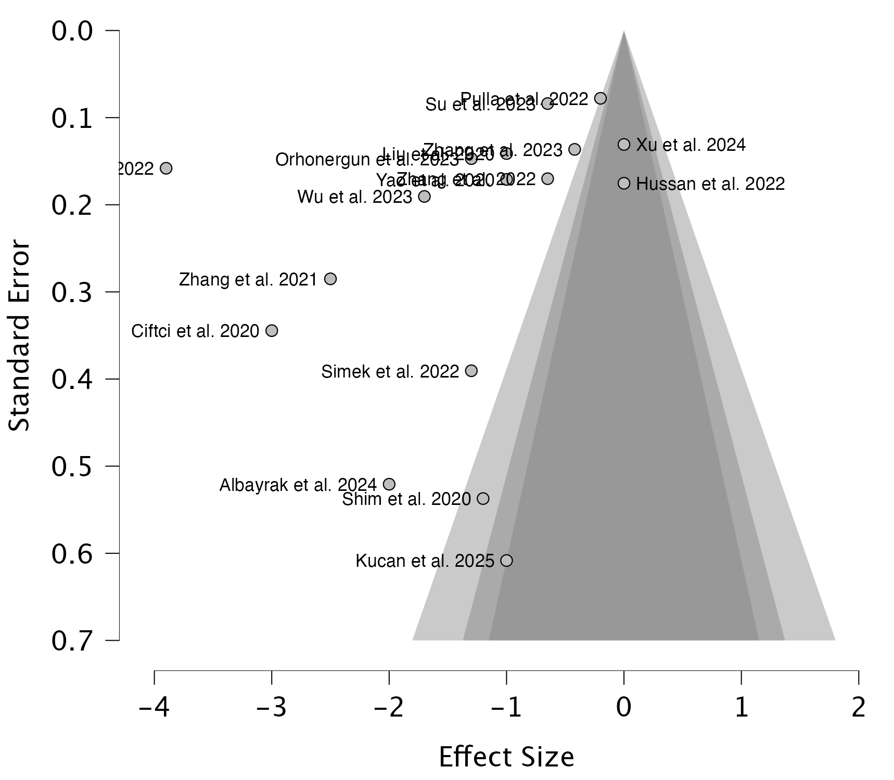

Funnel Plot Asymmetry Tests
Meta-Regression Test for Funnel Plot Asymmetry
 | Asymmetry Test |  | Limit Estimate μ
Estimates | z | p | Estimate | Lower 95% CI | Upper 95% CI
17 | -1.116 | .265 | -0.817 | -1.759 | 0.125

Weighted Regression Test for Funnel Plot Asymmetry
 | Asymmetry Test |  |  | Limit Estimate μ
Estimates | t | df | p | Estimate | Lower 95% CI | Upper 95% CI
17 | -1.779 | 15 | .096 | -0.116 | -1.088 | 0.856

Rank Correlation Test for Funnel Plot Asymmetry
Estimates | 𝜏 | p
17 | -0.294 | .109

Fail-Safe N
Fail-Safe N Summary Table
 | Fail-Safe N
Estimates | Rosenthal
17 | 3762

Resting Pain Score at 12 hours

Funnel Plot
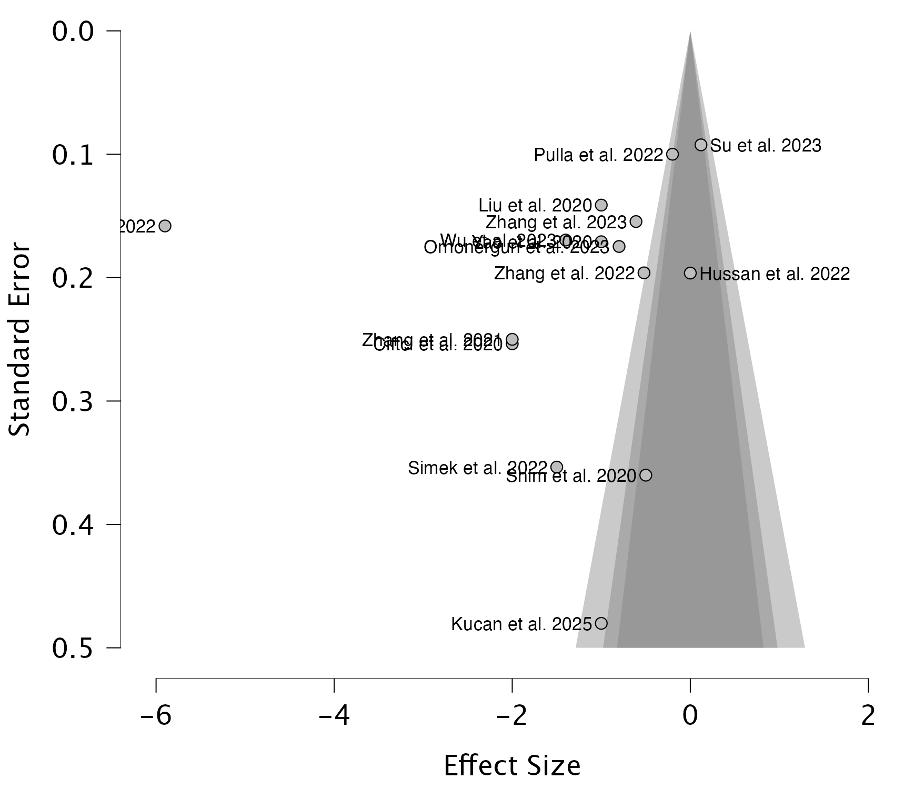

Funnel Plot Asymmetry Tests
Meta-Regression Test for Funnel Plot Asymmetry
 | Asymmetry Test |  | Limit Estimate μ
Estimates | z | p | Estimate | Lower 95% CI | Upper 95% CI
15 | -0.110 | .912 | -1.130 | -2.920 | 0.660

Weighted Regression Test for Funnel Plot Asymmetry
 | Asymmetry Test |  |  | Limit Estimate μ
Estimates | t | df | p | Estimate | Lower 95% CI | Upper 95% CI
15 | -1.031 | 13 | .321 | 0.032 | -2.189 | 2.253

Rank Correlation Test for Funnel Plot Asymmetry
Estimates | 𝜏 | p
15 | -0.181 | .379

Fail-Safe N
Fail-Safe N Summary Table
 | Fail-Safe N
Estimates | Rosenthal
15 | 3250

Resting Pain Score at 24 hours

Funnel Plot
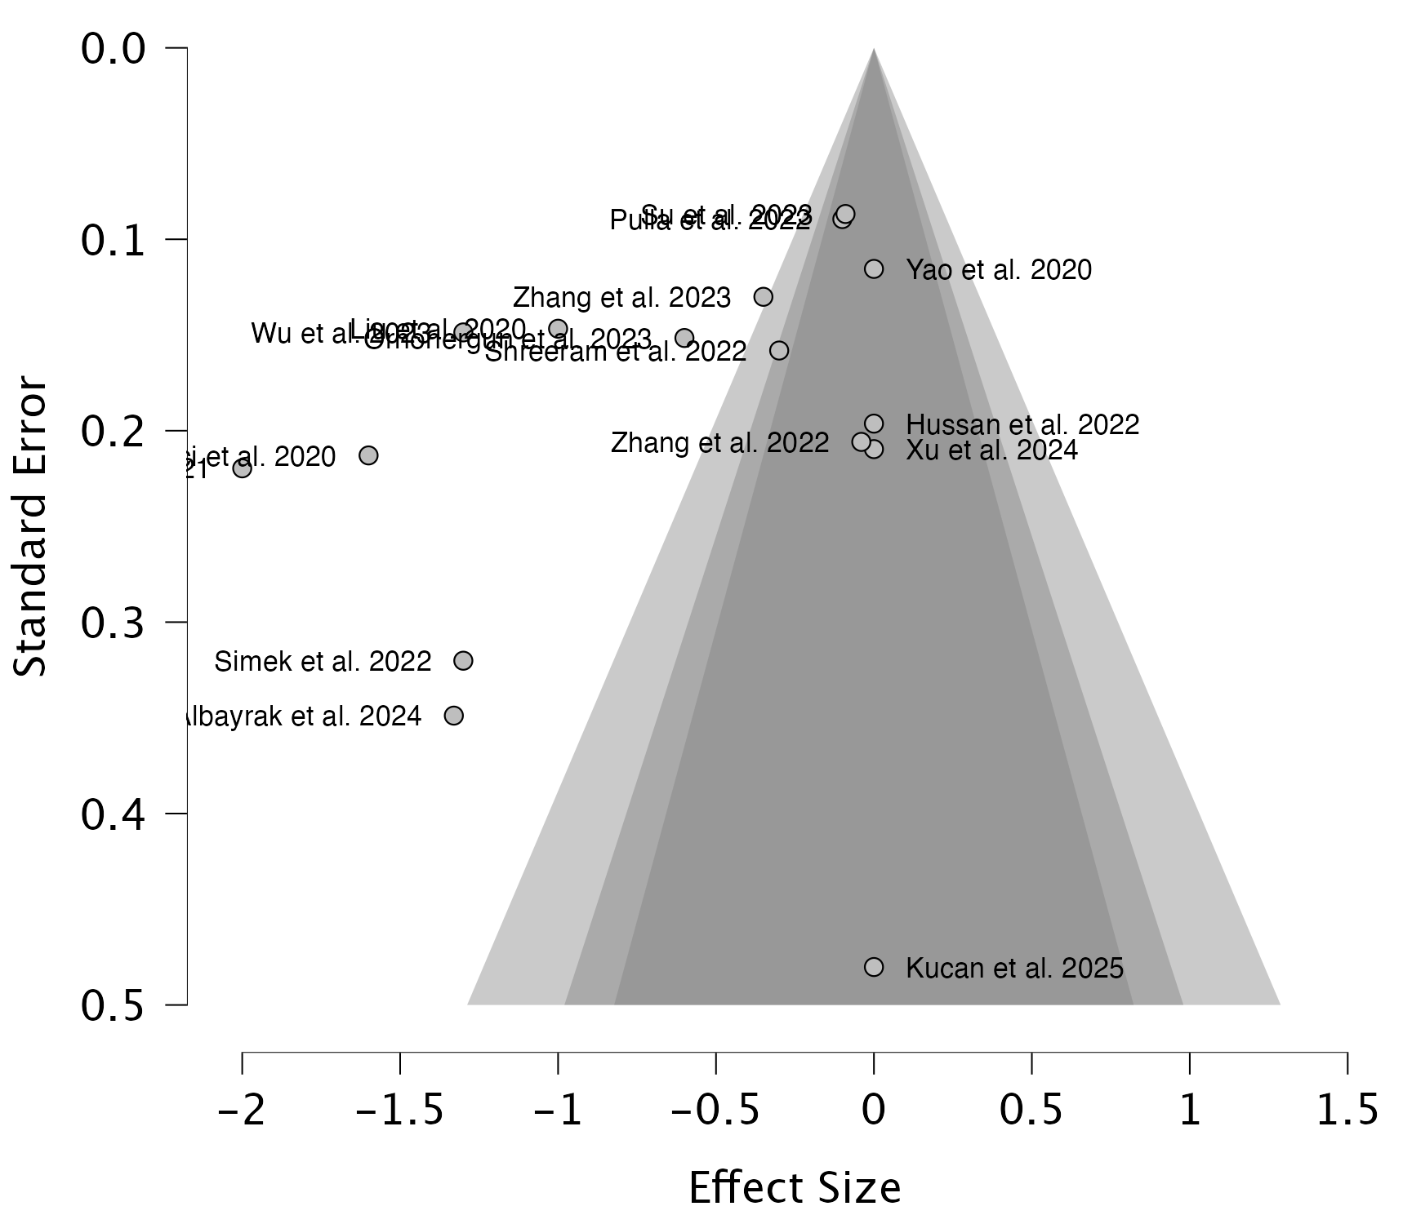

Funnel Plot Asymmetry Tests
Meta-Regression Test for Funnel Plot Asymmetry
 | Asymmetry Test |  | Limit Estimate μ
Estimates | z | p | Estimate | Lower 95% CI | Upper 95% CI
16 | -0.945 | .345 | -0.290 | -1.042 | 0.462

Weighted Regression Test for Funnel Plot Asymmetry
 | Asymmetry Test |  |  | Limit Estimate μ
Estimates | t | df | p | Estimate | Lower 95% CI | Upper 95% CI
16 | -2.053 | 14 | .059 | 0.190 | -0.494 | 0.874

Rank Correlation Test for Funnel Plot Asymmetry
Estimates | 𝜏 | p
16 | -0.317 | .096

Fail-Safe N
Fail-Safe N Summary Table
 | Fail-Safe N
Estimates | Rosenthal
16 | 944

Movement Pain Score at 6 hours

Funnel Plot
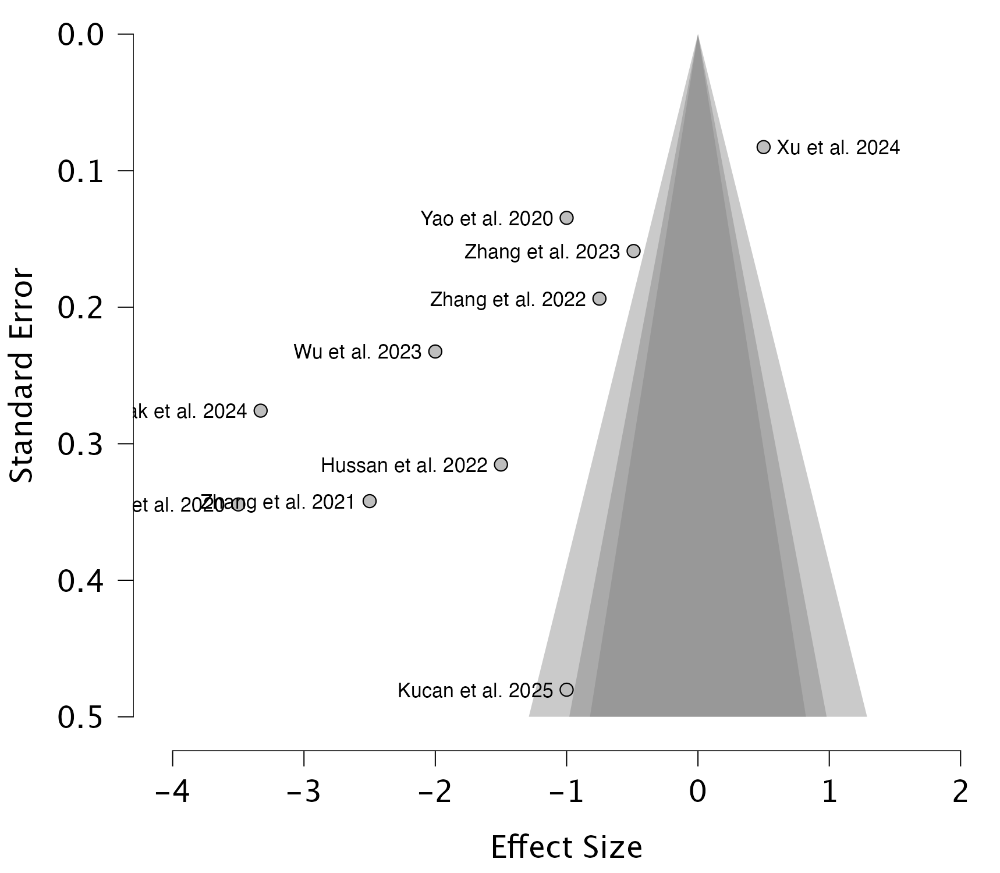

Funnel Plot Asymmetry Tests
Meta-Regression Test for Funnel Plot Asymmetry
 | Asymmetry Test |  | Limit Estimate μ
Estimates | z | p | Estimate | Lower 95% CI | Upper 95% CI
10 | -1.958 | .050 | 0.001 | -1.679 | 1.681

Weighted Regression Test for Funnel Plot Asymmetry
 | Asymmetry Test |  |  | Limit Estimate μ
Estimates | t | df | p | Estimate | Lower 95% CI | Upper 95% CI
10 | -4.388 | 8 | .002 | 1.163 | 0.144 | 2.181

Rank Correlation Test for Funnel Plot Asymmetry
Estimates | 𝜏 | p
10 | -0.333 | .216

Fail-Safe N
Fail-Safe N Summary Table
 | Fail-Safe N
Estimates | Rosenthal
10 | 1042

Movement Pain Score at 12 hours

Funnel Plot
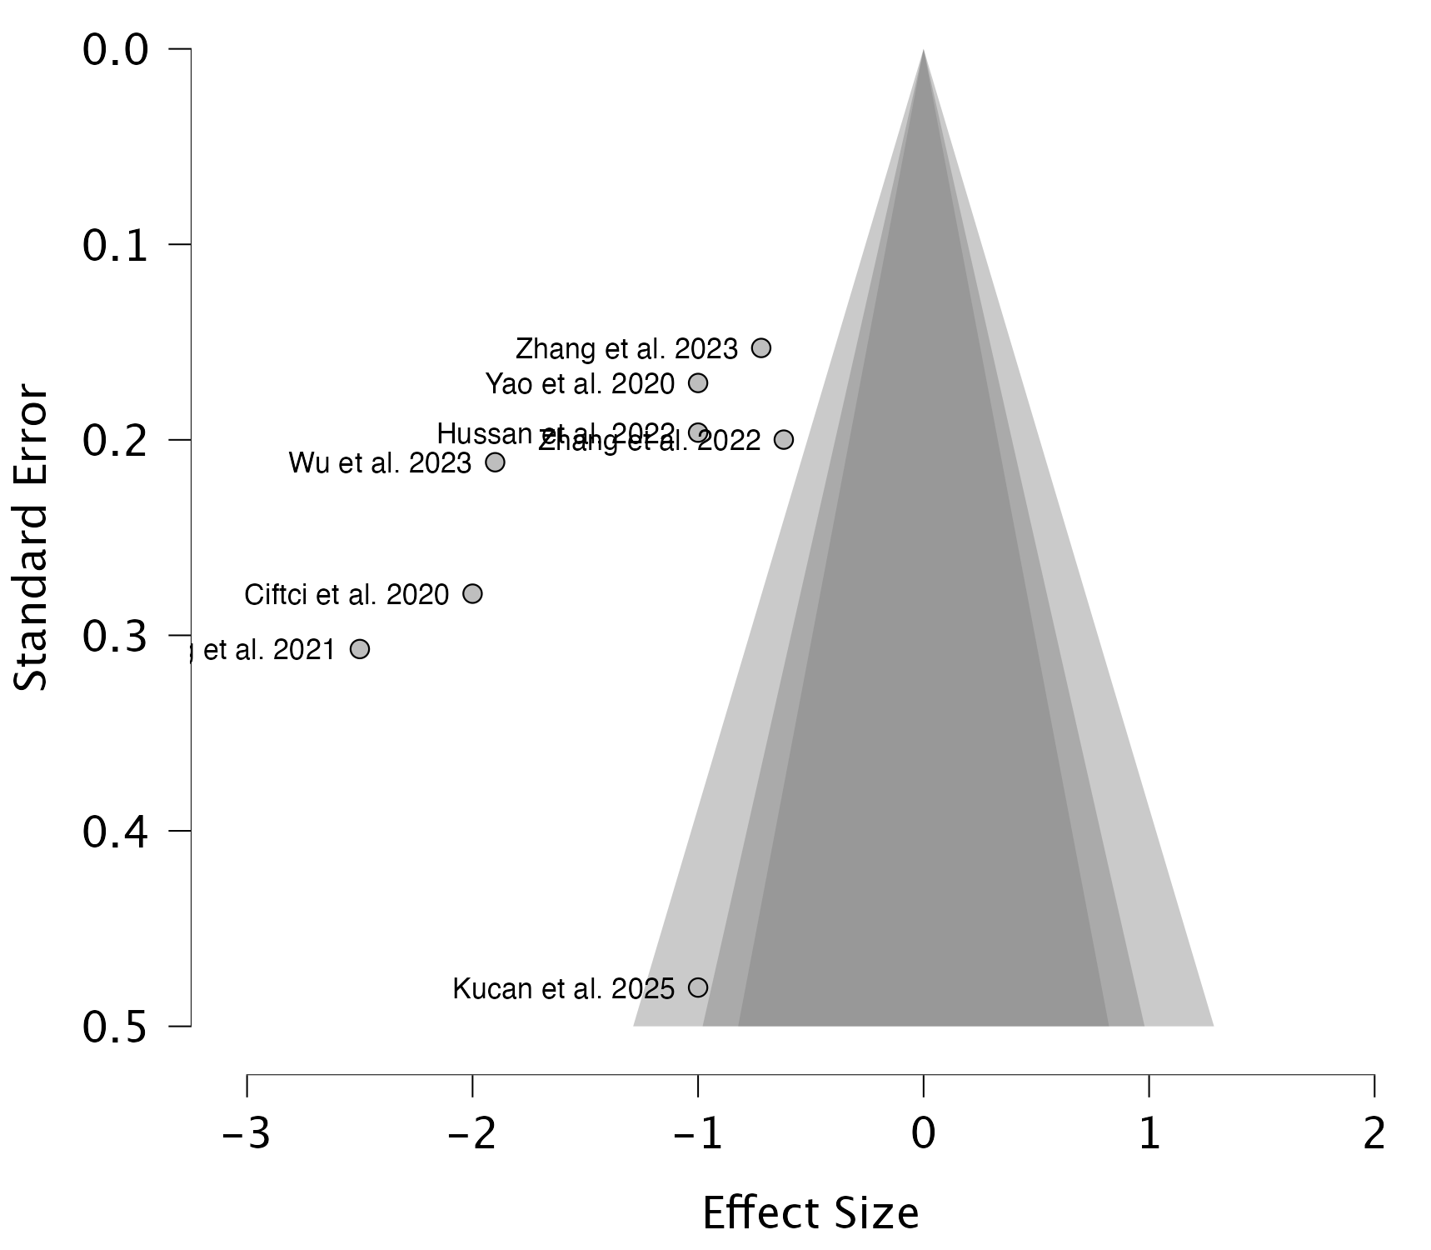

Funnel Plot Asymmetry Tests
Meta-Regression Test for Funnel Plot Asymmetry
 | Asymmetry Test |  | Limit Estimate μ
Estimates | z | p | Estimate | Lower 95% CI | Upper 95% CI
8 | -0.873 | .383 | -0.778 | -2.096 | 0.540

Weighted Regression Test for Funnel Plot Asymmetry
 | Asymmetry Test |  |  | Limit Estimate μ
Estimates | t | df | p | Estimate | Lower 95% CI | Upper 95% CI
8 | -1.628 | 6 | .155 | -0.110 | -1.749 | 1.528

Rank Correlation Test for Funnel Plot Asymmetry
Estimates | 𝜏 | p
8 | -0.571 | .061

Fail-Safe N
Fail-Safe N Summary Table
 | Fail-Safe N
Estimates | Rosenthal
8 | 746

Movement Pain Score at 24 hours

Funnel Plot
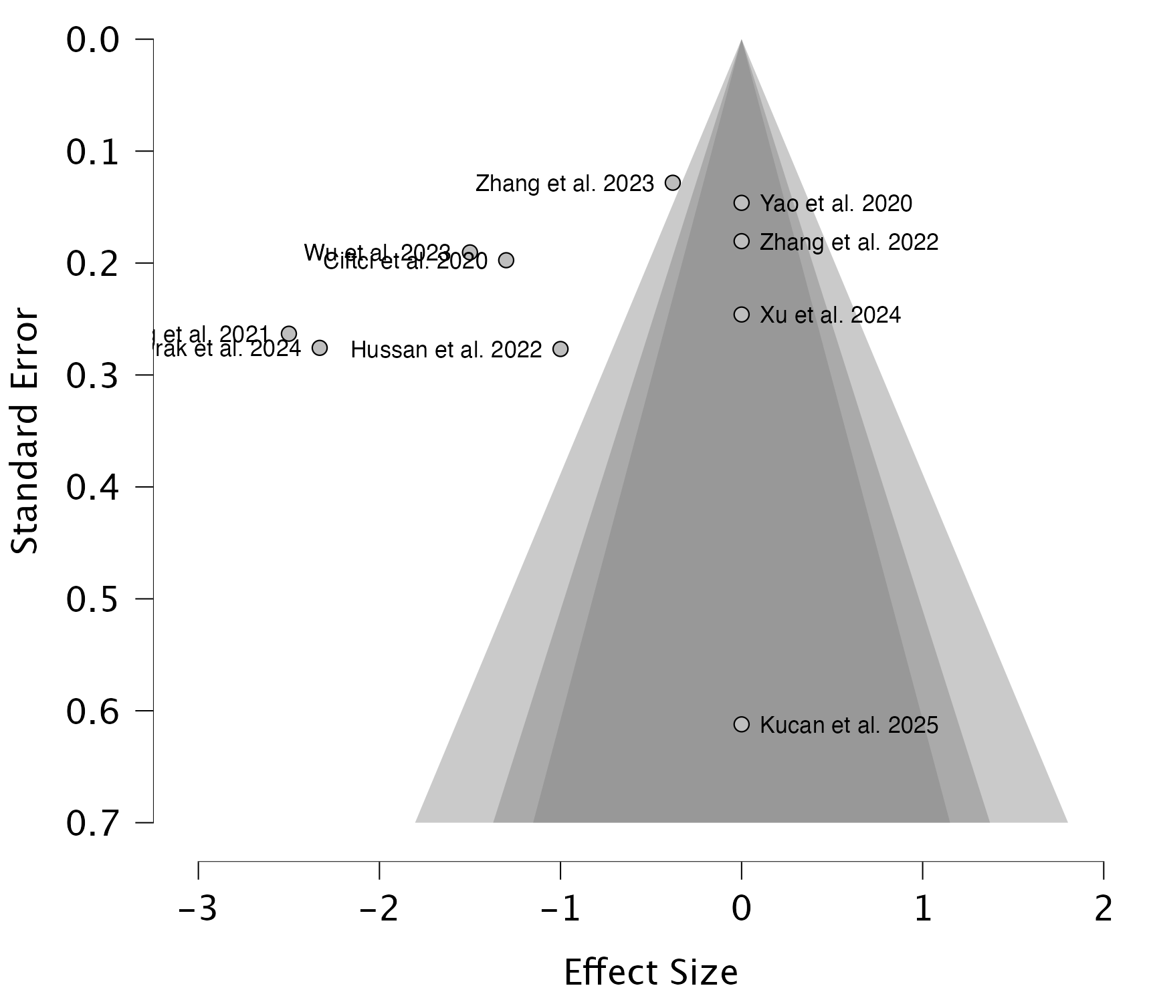

Funnel Plot Asymmetry Tests
Meta-Regression Test for Funnel Plot Asymmetry
 | Asymmetry Test |  | Limit Estimate μ
Estimates | z | p | Estimate | Lower 95% CI | Upper 95% CI
10 | 0.043 | .966 | -0.941 | -2.381 | 0.500

Weighted Regression Test for Funnel Plot Asymmetry
 | Asymmetry Test |  |  | Limit Estimate μ
Estimates | t | df | p | Estimate | Lower 95% CI | Upper 95% CI
10 | -1.287 | 8 | .234 | 0.232 | -1.553 | 2.016

Rank Correlation Test for Funnel Plot Asymmetry
Estimates | 𝜏 | p
10 | -0.289 | .291

Fail-Safe N
Fail-Safe N Summary Table
 | Fail-Safe N
Estimates | Rosenthal
10 | 552

24-hour Opioid Consumption in MME

Funnel Plot
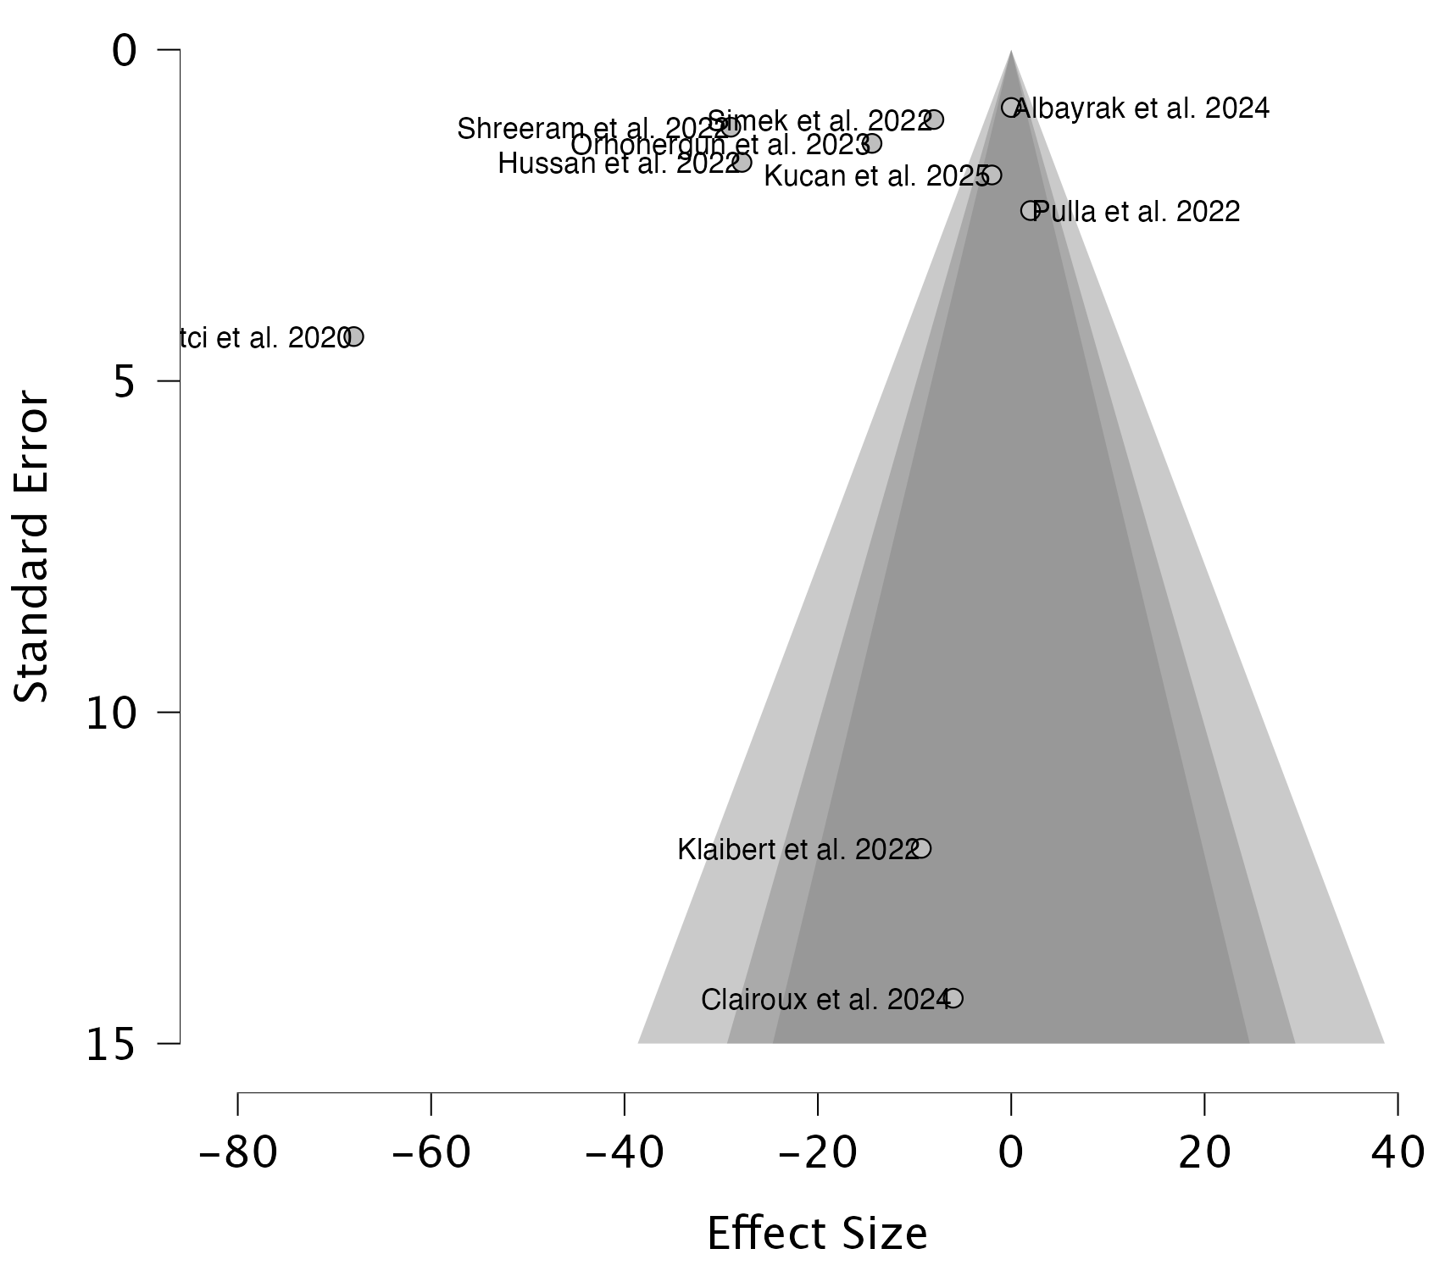

Funnel Plot Asymmetry Tests
Meta-Regression Test for Funnel Plot Asymmetry
 | Asymmetry Test |  | Limit Estimate μ
Estimates | z | p | Estimate | Lower 95% CI | Upper 95% CI
10 | 0.085 | .932 | -17.10 | -35.61 | 1.419

Weighted Regression Test for Funnel Plot Asymmetry
 | Asymmetry Test |  |  | Limit Estimate μ
Estimates | t | df | p | Estimate | Lower 95% CI | Upper 95% CI
10 | -0.812 | 8 | .440 | -5.640 | -24.96 | 13.68

Rank Correlation Test for Funnel Plot Asymmetry
Estimates | 𝜏 | p
10 | -0.067 | .862

Fail-Safe N
Fail-Safe N Summary Table
 | Fail-Safe N
Estimates | Rosenthal
10 | 2129

Postoperative Nausea and Vomiting

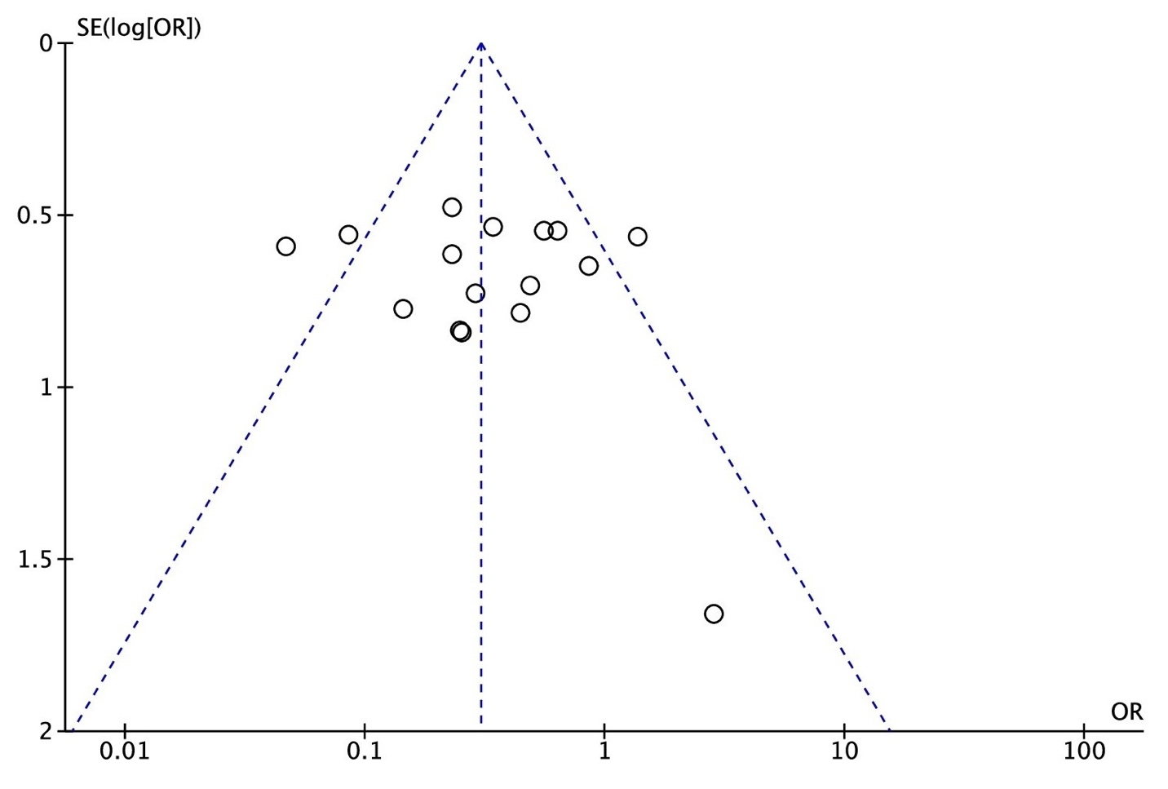
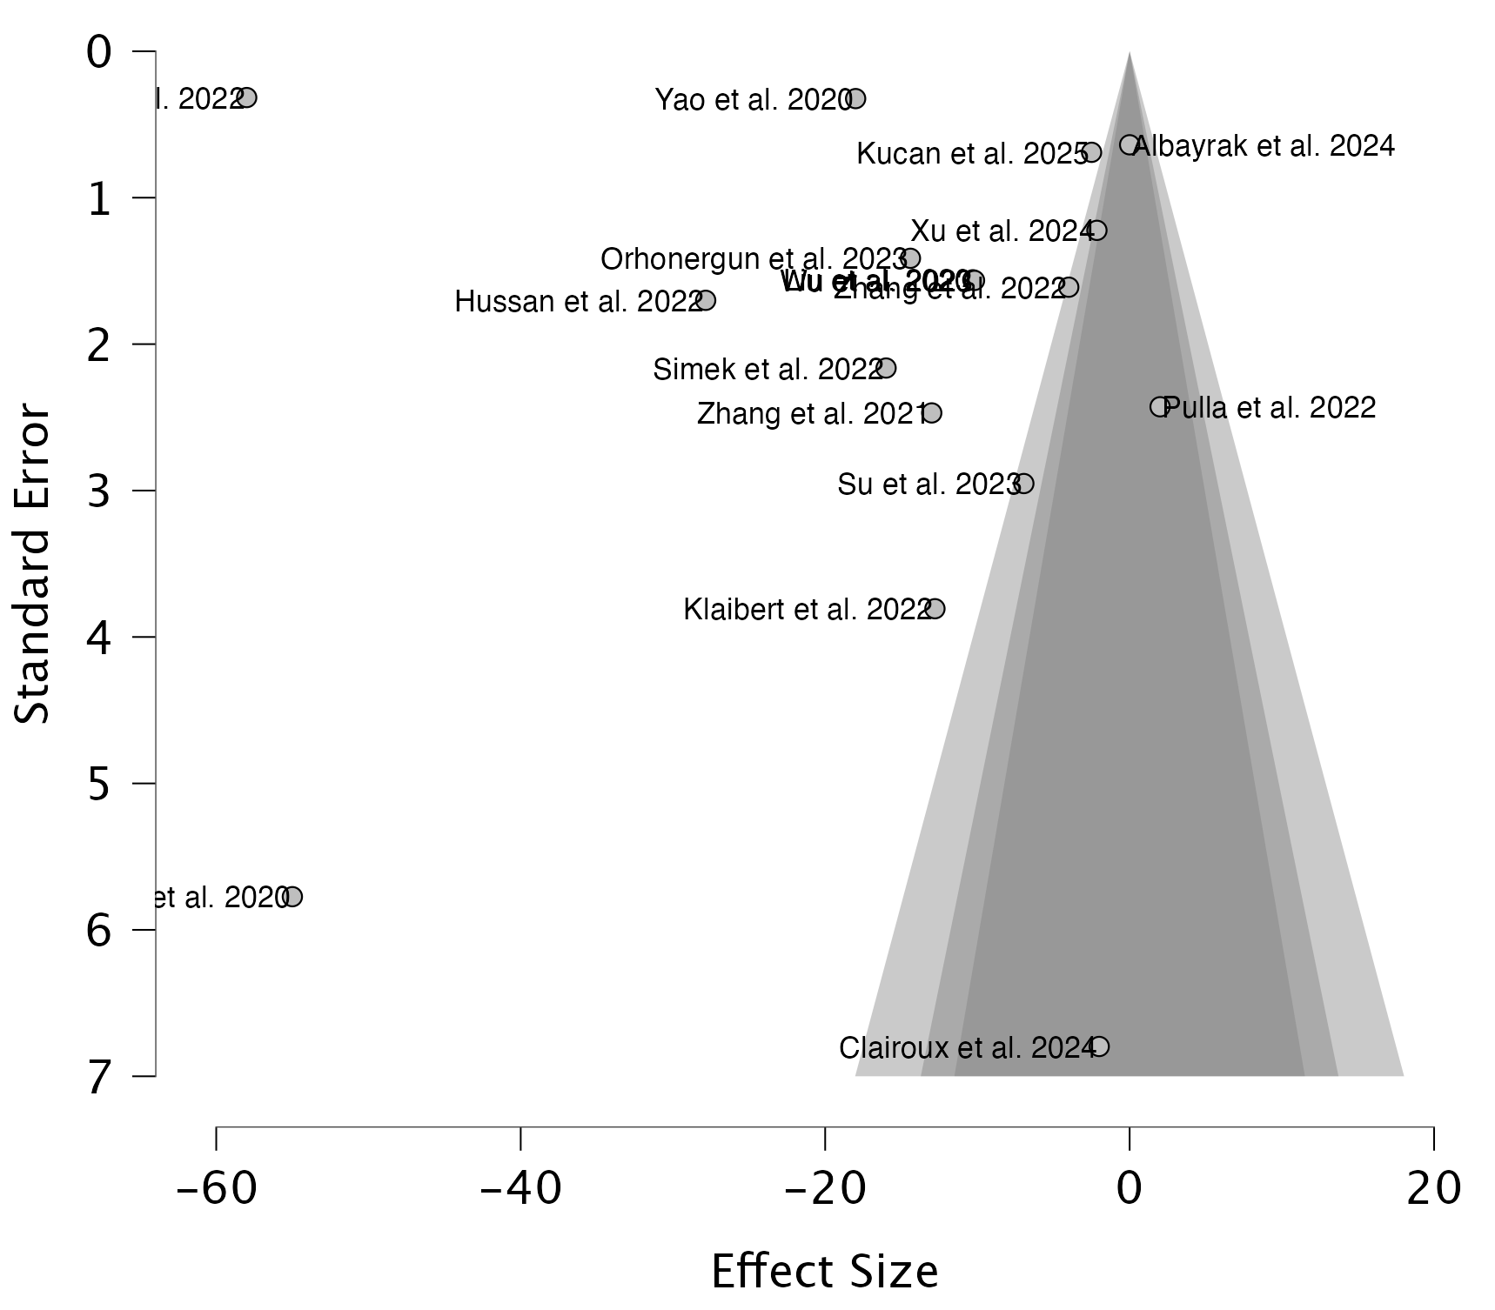

Funnel Plot Asymmetry Tests
Meta-Regression Test for Funnel Plot Asymmetry
 | Asymmetry Test |  | Limit Estimate μ
Estimates | z | p | Estimate | Lower 95% CI | Upper 95% CI
17 | -0.313 | .755 | -12.99 | -26.52 | 0.536

Weighted Regression Test for Funnel Plot Asymmetry
 | Asymmetry Test |  |  | Limit Estimate μ
Estimates | t | df | p | Estimate | Lower 95% CI | Upper 95% CI
17 | 1.577 | 15 | .136 | -37.61 | -54.34 | -20.87

Rank Correlation Test for Funnel Plot Asymmetry
Estimates | 𝜏 | p
17 | -0.456 | .010

Fail-Safe N
Fail-Safe N Summary Table
 | Fail-Safe N
Estimates | Rosenthal
17 | 36421

Supplementary File S5: 12 Hour Resting and Movement Pain Scores.
Panel of meta-analysis forest plots displaying Mean Difference (MD) for postoperative resting and movement pain scores in panel (A) Resting pain Score at 12 hours; Panel (B) Movement pain Score at 12 hours; The MD of each included study is plotted. A pooled estimate of overall MD (diamonds) and 95% confidence intervals (represented by the width of the diamonds) summarizes the effect size using the random-effects model. CI = confidence interval; IV = Inverse Variance statistical method.
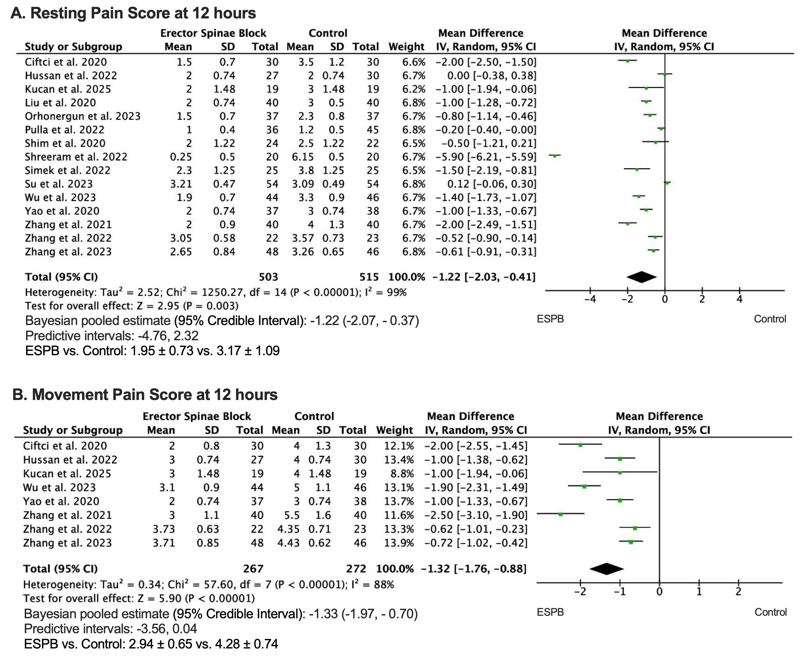

Supplementary File S6: Postoperative Nausea and Vomiting.
Forest plot displaying Odds Ratio (OR) for postoperative nausea and vomiting; The OR of each included study is plotted. A pooled estimate of overall OR (diamonds) and 95% confidence intervals (represented by the width of the diamonds) summarizes the effect size using the random-effects model. CI = confidence interval; MH = Mantel-Haenszel.
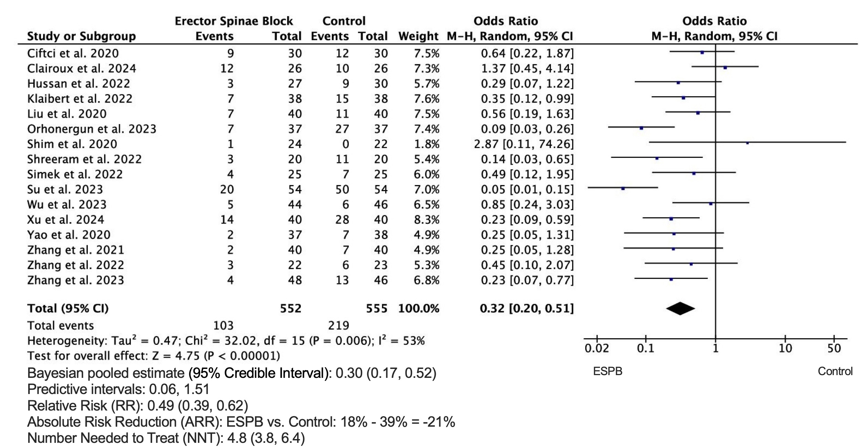

Supplementary file S7: Exploratory outcomes

A.Quality of Recovery (QoR-40) | n | Mean±SD | n | Mean±SD | Mean Difference  IV, Random effect, 95% CI
Klaibert et al. 2022 | 38 | 170.0±4.9 | 38 | 172.0±4.4 | -2.00 [-4.09, 0.09]
Orhonergun et al. 2023 | 37 | 184.3±7.5 | 37 | 171.2±6.4 | 13.10 [9.92, 16.28]
Yao et al. 2020 | 37 | 173.0±1.6 | 38 | 162.0±1.17 | 11.00 [10.36, 11.64]
B.Length of Stay (LOS)
Hu et al. 2025 | 25 | 4.0±0.5 | 25 | 3.25±0.25 | 0.75 [0.53, 0.97]
Liu et al. 2020 | 40 | 7.5±0.92 | 40 | 7.18±0.63 | 0.32 [-0.03, 0.67]
Orhonergun et al. 2023 | 37 | 4.2±1.0 | 37 | 4.9±2.1 | -0.70 [-1.45, 0.05]
Su et al. 2023 | 54 | 11.46±1.78 | 54 | 11.51±1.68 | -0.05 [-0.70, 0.60]
C.Time to 1st Rescue analgesia
Shreeram et al. 2022 | 20 | 1235.5±148.5 | 20 | 207.5±35.8 | 1028.00 [961.05, 1094.95]
IV = Inverse Variance statistical method.

Supplementary file S8: Risk of Bias assessment by Cochrane ROB 2 tool

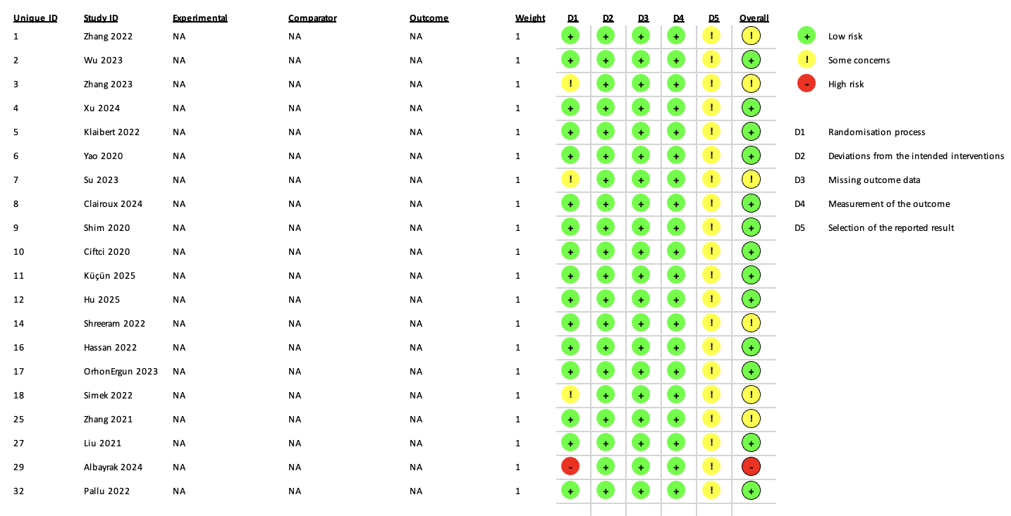

Supplementary File S9: Meta regression

Effect Size Meta-Regression Coefficients
 |  |  | 95% CI
 | Estimate | Standard Error | Lower | Upper | t | df | p
Intercept | -3.119 | 1.383 | -6.164 | -0.075 | -2.255 | 11.00 | .045
drug (Ropivacaine) | -0.362 | 0.509 | -1.483 | 0.759 | -0.711 | 11.00 | .492
concentration | 4.291 | 1.082 | 1.910 | 6.673 | 3.966 | 11.00 | .002
volume | 0.092 | 0.062 | -0.044 | 0.229 | 1.491 | 11.00 | .164
adjuvants (Yes) | -1.393 | 0.580 | -2.670 | -0.115 | -2.400 | 11.00 | .035
Level (T5) | -1.785 | 0.698 | -3.322 | -0.248 | -2.556 | 11.00 | .027

Metaregression: Bubble Plots on Bupivacaine vs. Ropivacaine

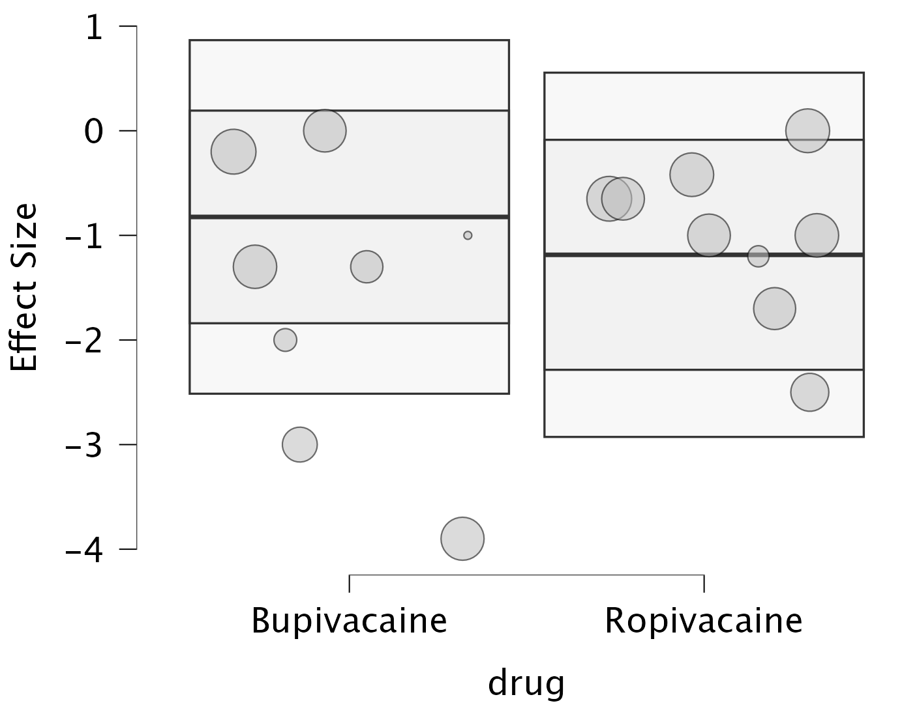

Metaregression: Bubble Plots on Concentration

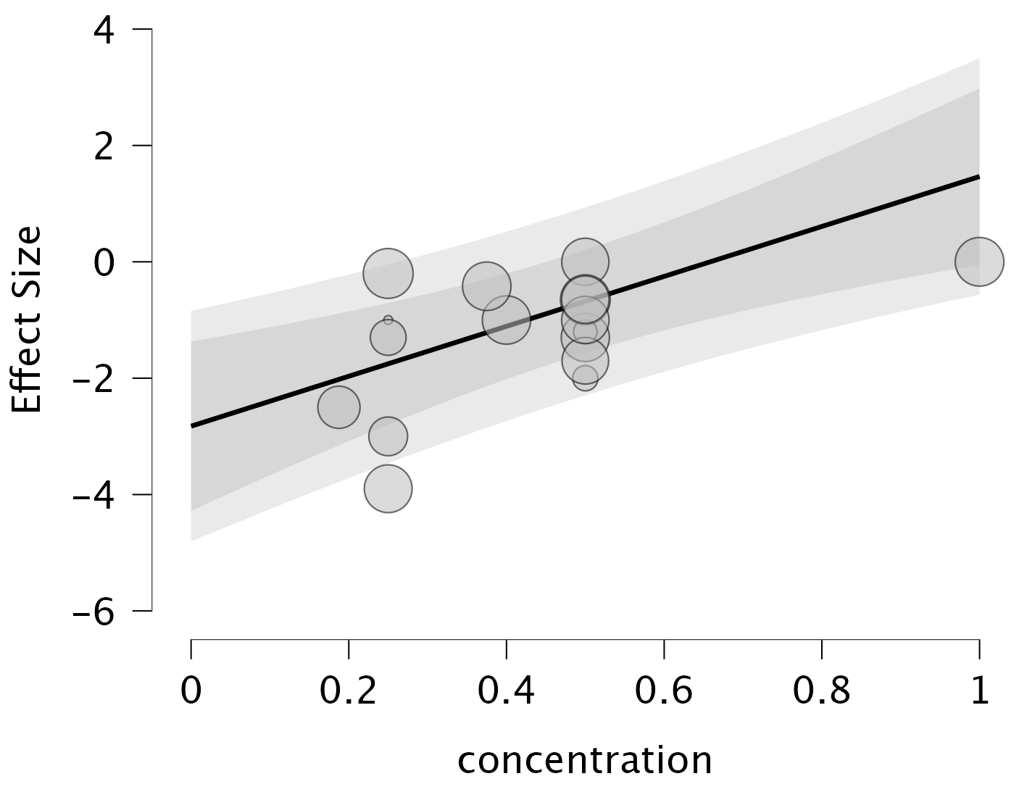

Metaregression: Bubble Plots on Volume

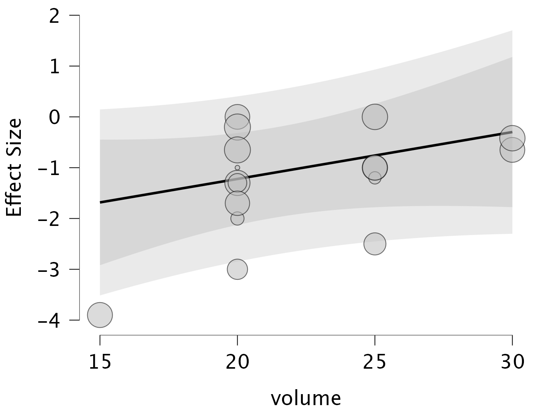

Metaregression: Bubble Plots on Adjuvants

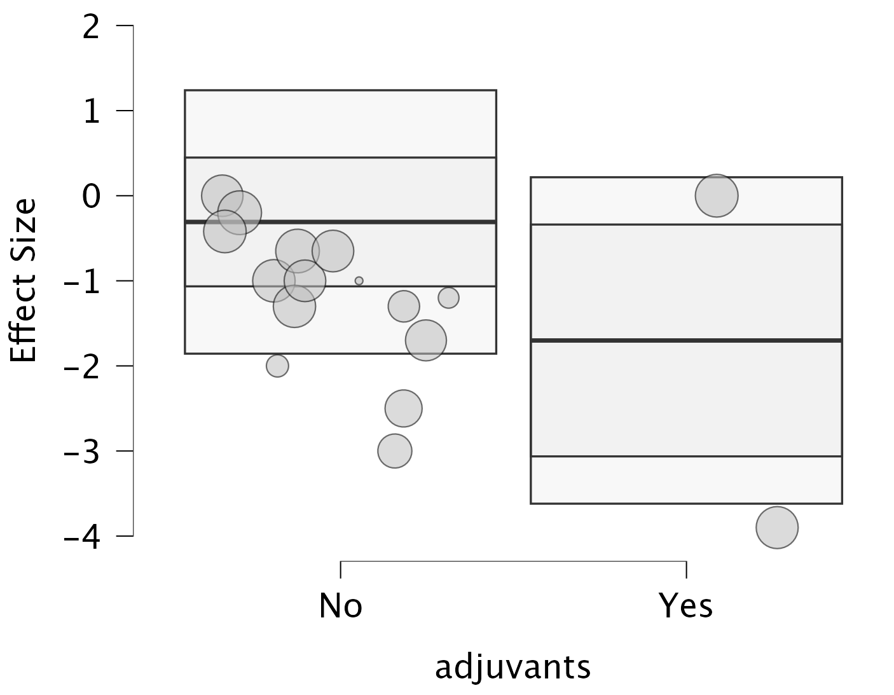

Metaregression: Bubble Plots on the Level of Block

