Supplementary Figure 1.
Impact of the TBCK c.782+46A>G variant on cDNA.
cDNA Sanger sequencing was performed upon extraction of RNA from a short term lymphocyte culture from both P6 and her father, using following primers :
Forward : 5’-GCTTACTTTGGATTGTGTAGATGAC-3’, Reverse: 5’- ACCTCCAGCCAAACACCAAA -3’.
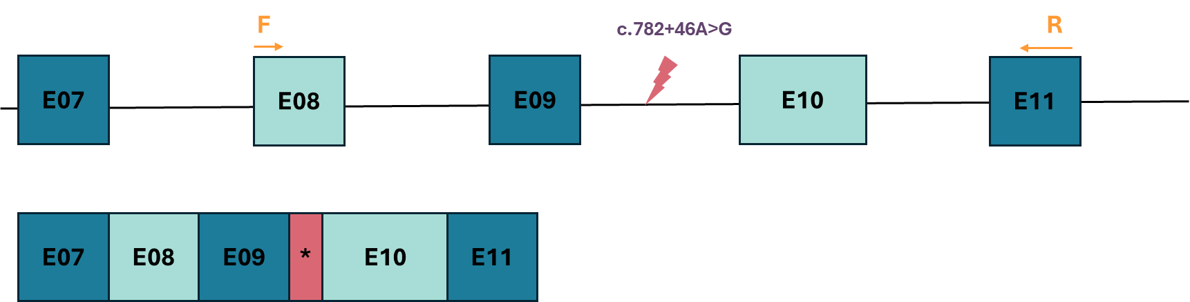

Supplementary Figure 2.
Comparison of exome (ES), short-read genome (SR GS) and long-read genome sequencing (LRS) data surrounding the c.388-1_388insT, c.394_402del variant in SYNGAP1 (chr6:33432684 G>GT, chr6:33432688 GGCTTCCTGA>G).
- Comparison of the ES and LRS data of P27, the variant location is highlighted with a red box.
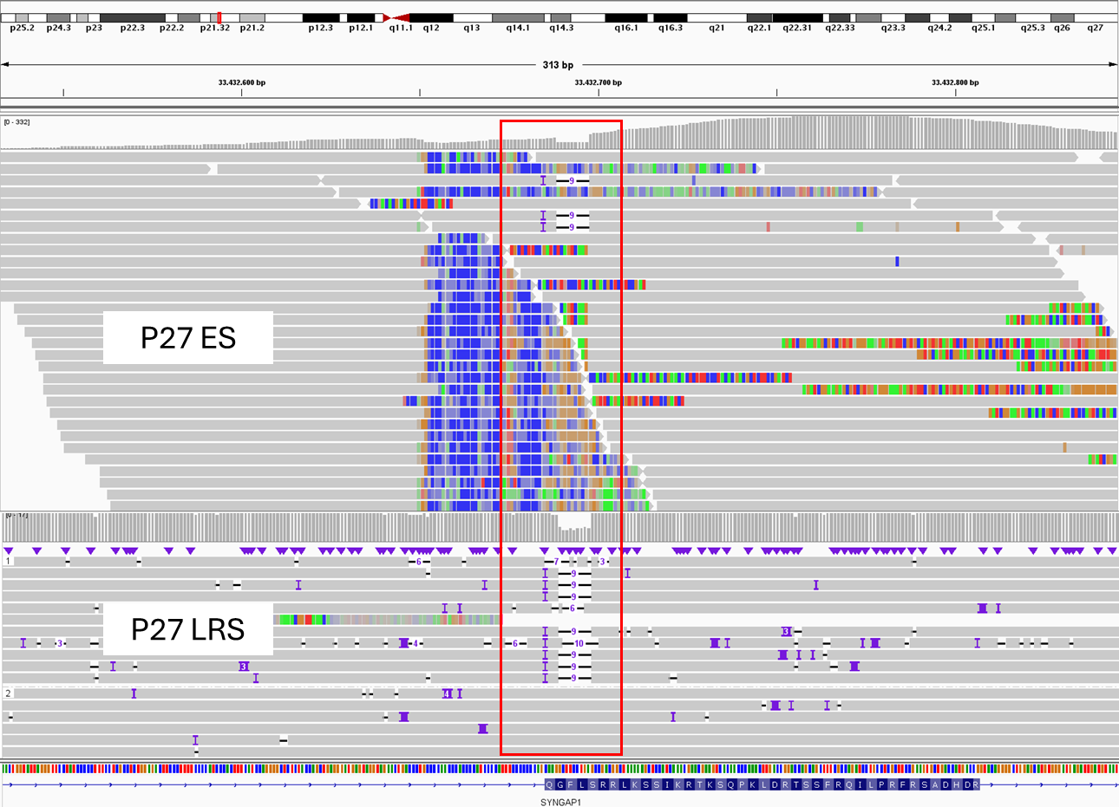

- Similar sequencing issues using ES, as compared to LRS, in the absence of the variant, as exemplified with the data of P27’s mother.
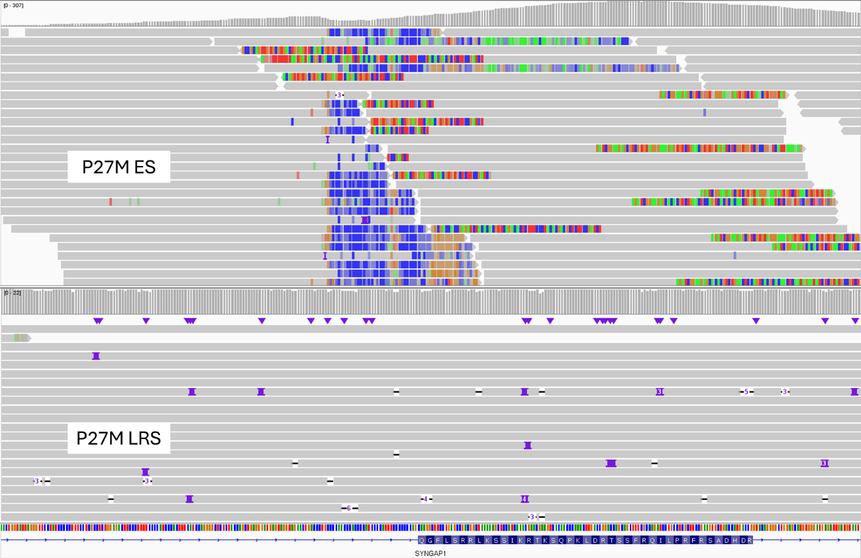
- Sequencing of the region is also difficult using SR GS, as exemplified with the SR GS data of two other cases, compared with ES data from a third case, and in comparison with their respective LRS data (bottom plots).
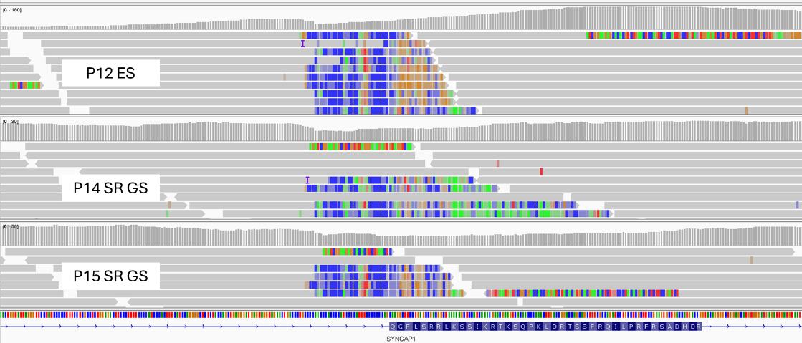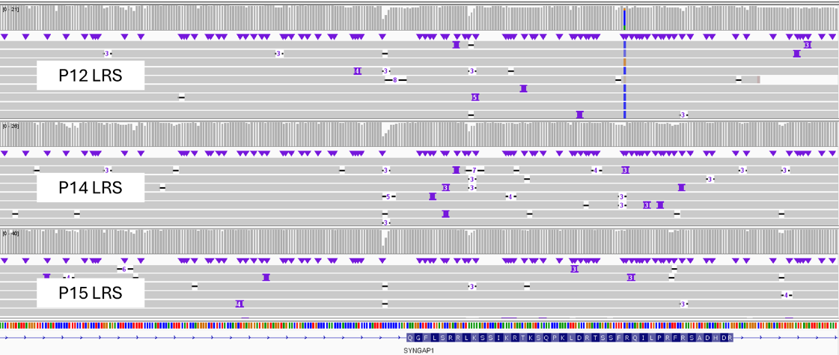
Supplementary Figure 3.
The impact of the supporting read threshold using Sniffles2 for SV calling was evaluated using the HG002 cell line, sequenced using the LSK114 chemistry using the same protocol as for the other study samples (cfr methods).
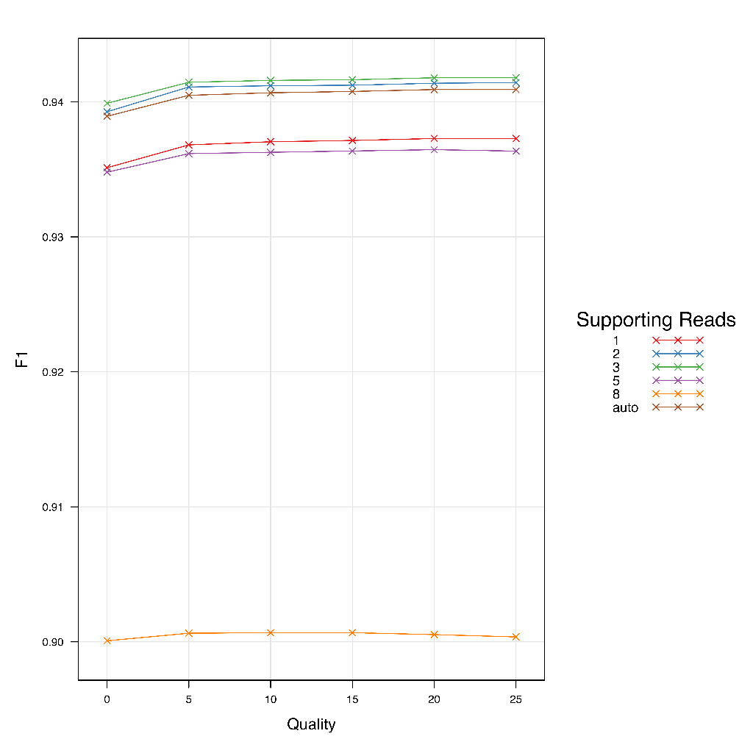
Impact of minimum supporting read threshold on the precision (F1 score) of SV calls using Sniffles2.

Supplementary Figure 4.
Validation of the 3 de novo deletions detected both with hg38 and T2T.
4A. chr4:43797202-43811895 deletion (hg38) – P2
Visualization of the ONT data in IGV.
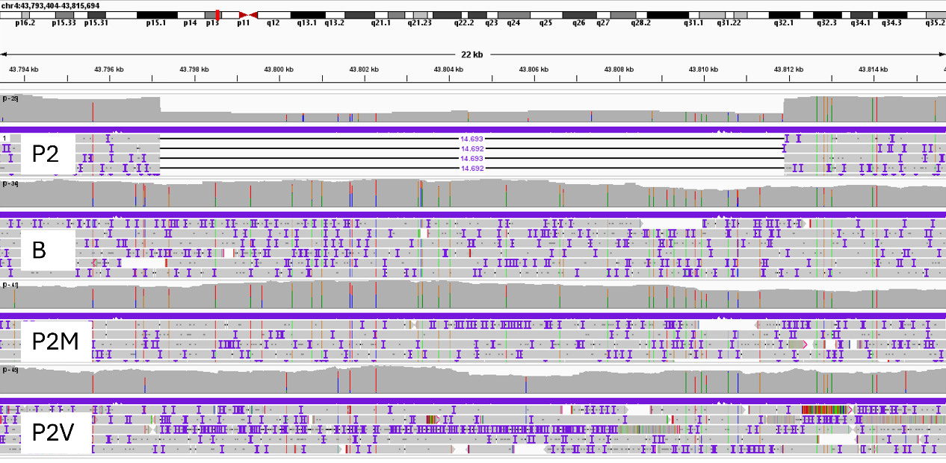
Confirmation through PCR and gel electrophoresis.

Primer 1: Forward AACACCTTCATGAGAACCAGAA
Primer 2: Reverse TGTCCCCTAGTCCACTGTCT
Primer 3: Reverse GTCTTTGAGGAATCACCACACTG
Set-up 1 : primer 1 and primer 2. – 485 bp amplicon in all individuals
Set-up 2 : primer 1 and primer 3. – 1002 bp amplicon in individuals with the chr4:43797202-43811895 deletion, and no amplicon in individuals without the deletion.
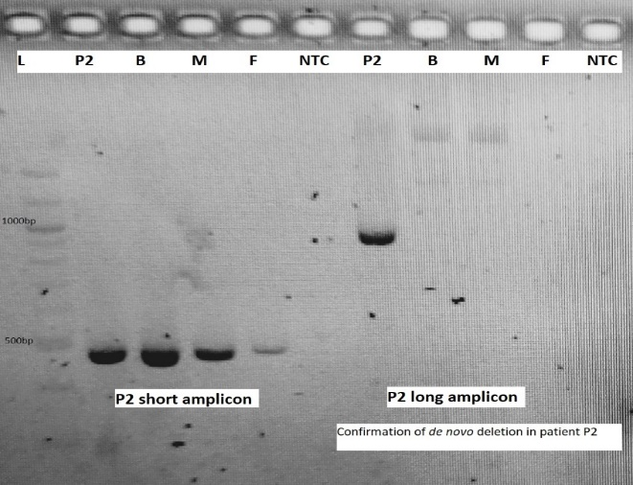
set-up 1
set-up 2
L: ladder,
P2,
B = brother of P2 or P2B,
M = mother of P2 or P2M,
F = father of P2 or P2V,
NTC = no-template control.

4B. chr2:47919650-47929780 deletion (hg38) – P8
Visualization of the ONT data in IGV.
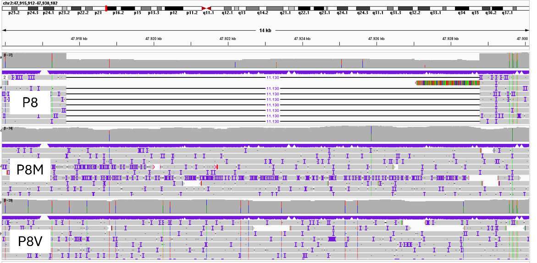

Confirmation through PCR using the following primers:
Primer 1: Forward TCCTCCCCCACTTCAAGACA
Primer 2: Reverse CTGCCTGCTTACTTCCCCAA
Primer 3: Reverse ACCCTTTACTATGGAGCTTTACGA

Set-up 1 : primer 1 and primer 2. – 538 bp amplicon in all individuals
Set-up 2 : primer 1 and primer 3. – 1534 bp amplicon in individuals with the chr2:47919650-47929780 deletion, and no amplicon in individuals without the deletion.
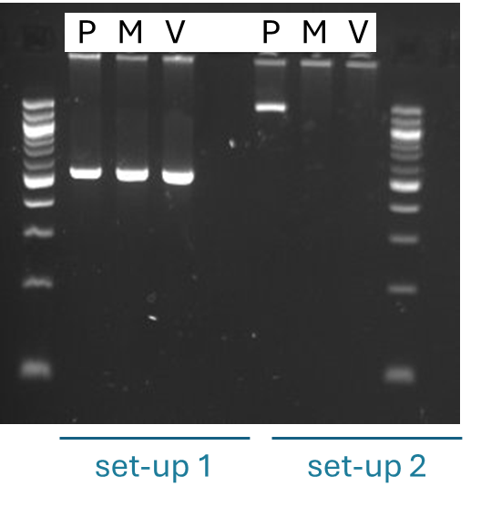
P= P8,
M = mother of P8 or P8M
V = father of P8 or P8V

4C. chr6:105489795-105493731 deletion (hg38) – P10
Visualization of the ONT data in IGV.
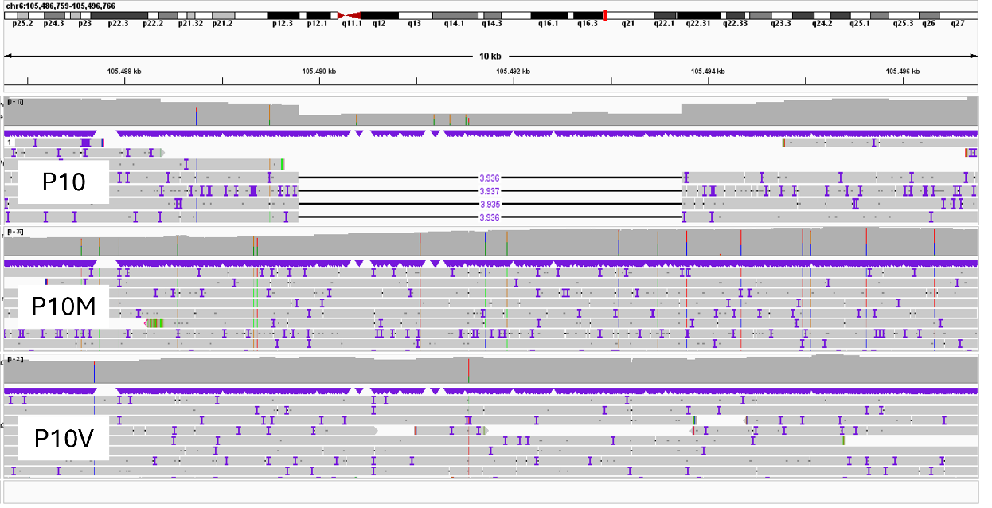

Confirmation through PCR using the following primers:
Primer 1: Forward TGTTTTGCAATCTGGGGCTTAA
Primer 2: Reverse AGGAAAGCAGAAAGGACAGATGA
Primer 3: Reverse AGCTTTGTACTGAGGACTGGA
Set-up 1 : primer 1 and primer 2. – 417 bp amplicon in all individuals
Set-up 2 : primer 1 and primer 3. – 937 bp amplicon in individuals with the chr6:105489795-105493731 deletion, and no amplicon in individuals without the deletion.
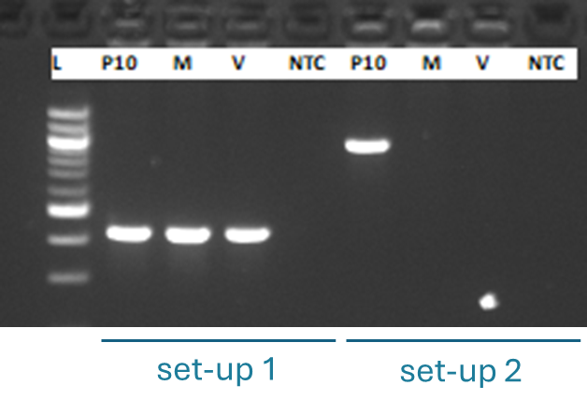
L: ladder,
P10,
M = mother of P10 or P10M,
F = father of P10 or P10V,
NTC = no-template control

4D. chr21:37022957-37467808 inversion (hg38) – P22
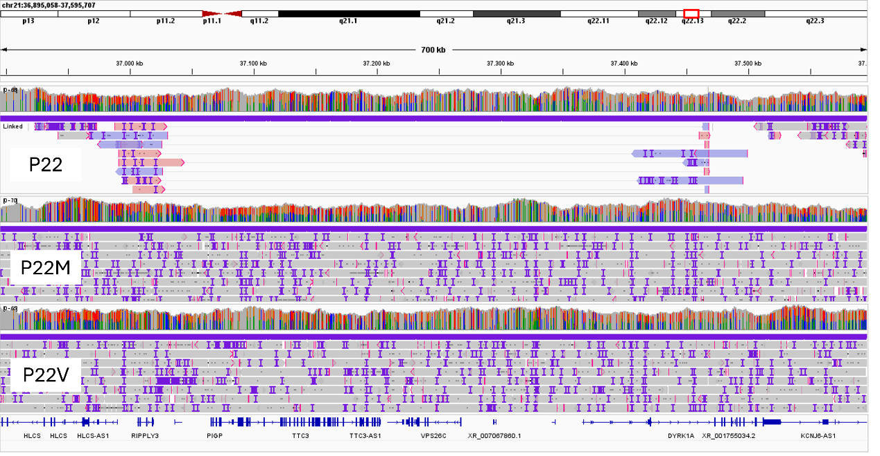
Validation of the inversion disrupting DYRK1A
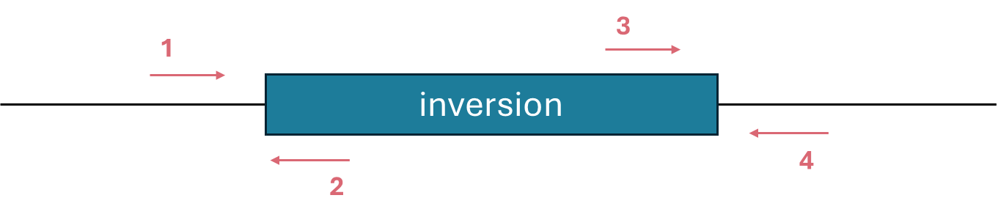
Primer 1: Forward: ACCATAAAGACACGCACTGGA
Primer 2: Reverse: CCTCCTCCCTCCATCCTCAA
Primer 3 : Forward: TGGTGCCCAACAGAATTTTCC
Primer 4 : Reverse: GCTGGTCTCAAACTCCTGGG
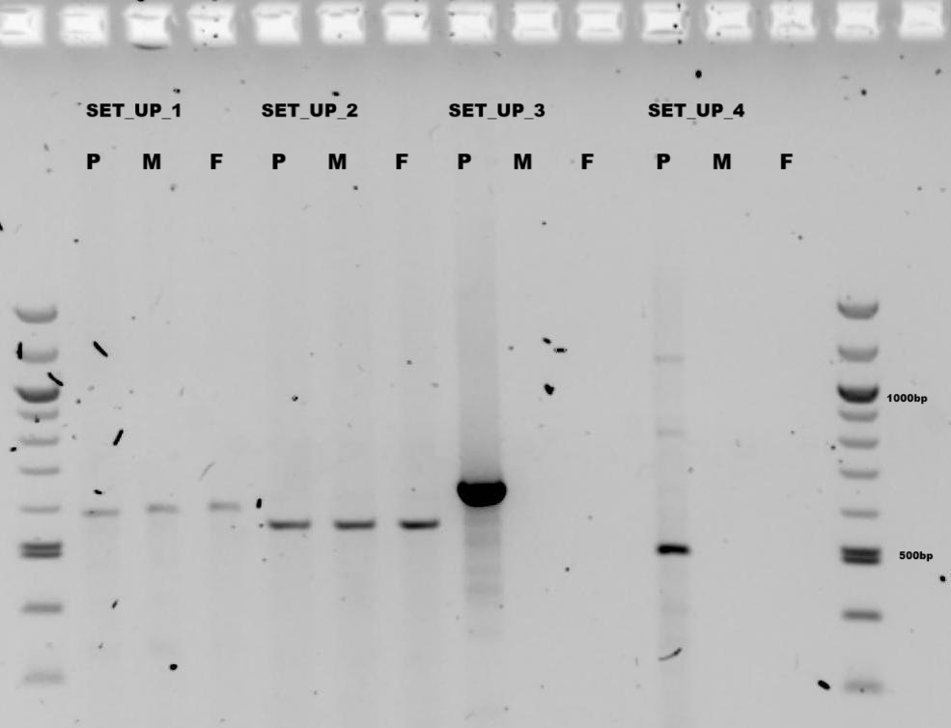
P= P22,
M = mother of P22 or P22M,
F = father of P22 or P22V

Set up 1 included primers flanking breakpoint 1 (primer 1 & 2) - product of 581bp
Set up 2 included primers flanking breakpoint 2 (primer 3 & 4) - product of 561bp
Set up 3: Forward primers of set-up 1 & 2 (primer 1 & 3) - product of 648bp, only if inversion
Set up 4: Reverse primers of set-up 1 & 2 (primer 2 & 4) - product of 494bp, only if inversion

4E. chrX:155326442-155441024 inversion (hg38) – P23
Visualization of the ONT data in IGV.
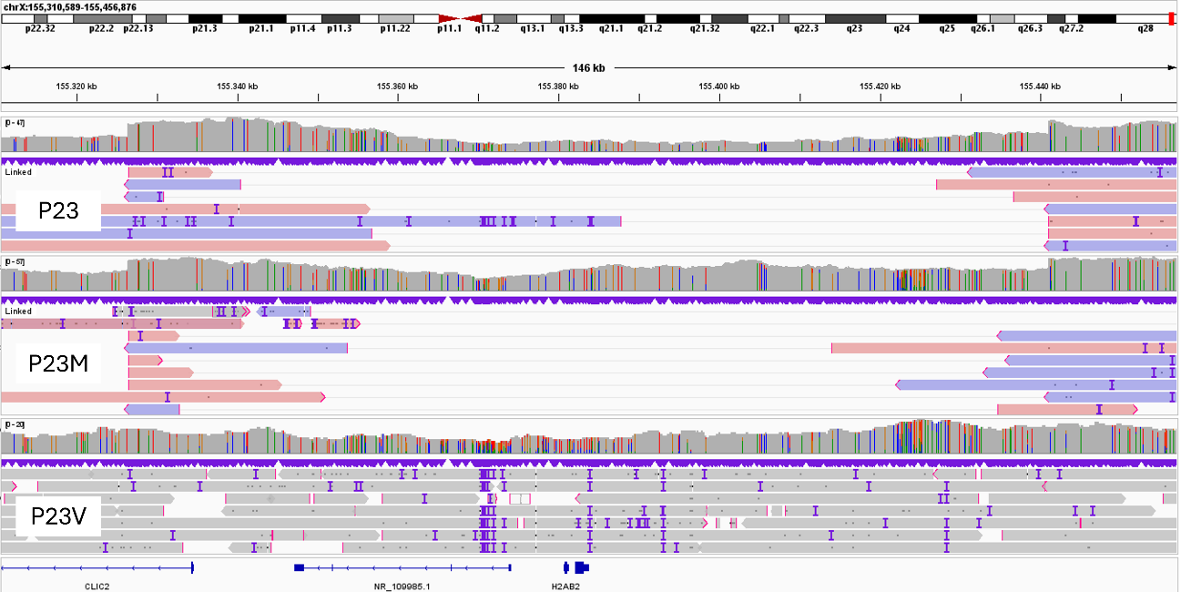

Validation of the inversion disrupting CLIC2
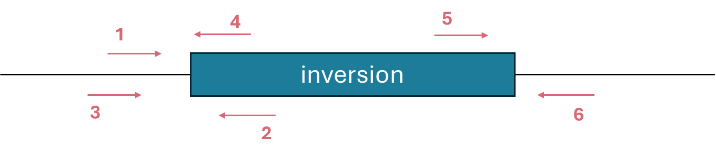
Primer 1: Forward: GCAGATGACAAATAAGCAGACAAAA
Primer 2: Reverse: GCTGCATGTTTAGATTTGGAAGAAAT
Primer 3: Forward: TTTGGTTGTCACTAGTTTTGGGTTAT
Primer 4: Reverse: ATGAGCAAAGGACATGGACAGACAT
Primer 5: Forward: AGAGGCTACAGTCCCCATGA
Primer 6: Reverse: CTCTCCCATCACAGGCCCAG

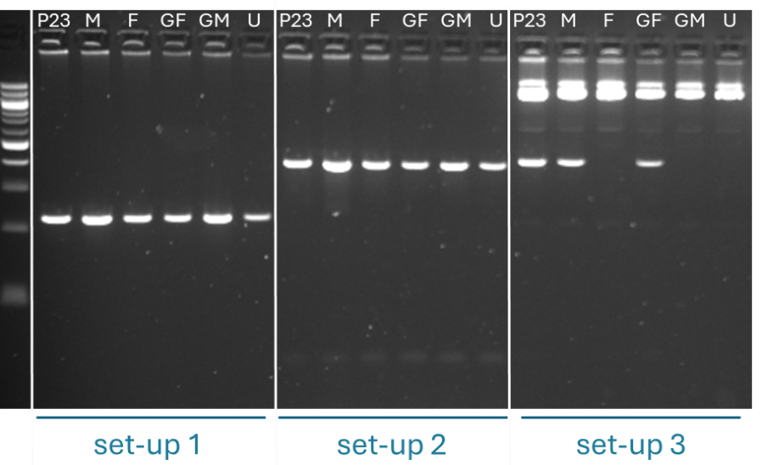
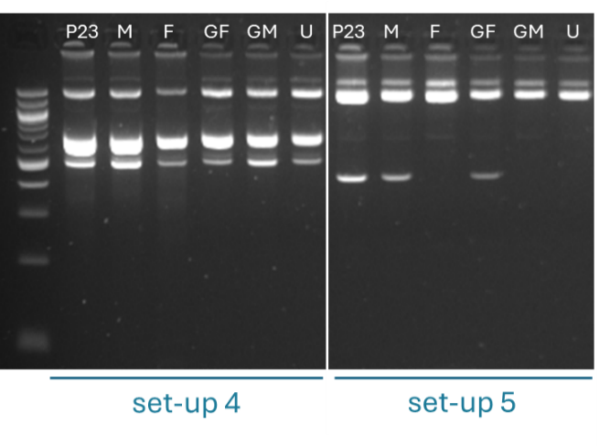
P23,
M = mother of P23 or P23M,
F = father of P23 or P23V,
GF = maternal grandfather of P23
GM = maternal grandmother of P23
U = maternal uncle of P23

Set up 1: included primers flanking breakpoint 1 (A) (primer 1 & 2) - product of 227 bp
Set up 2: included primers flanking breakpoint 1 (B) (primer 3 & 4) - product of 401 bp
Set up 3: Reverse primers of set-up 1 & 4 (primer 2 & 6) - product of 424 bp, only if inversion
Set up 4: included primers flanking breakpoint 2 (primer 5 & 6) - product of 507 bp
Set up 5: Reverse primers of set-up 1 & 4 (primer 2 & 6) - product of 424 bp, only if inversion

Supplementary Figure 5.
Results of the qPCR evaluating the expression of FBXO11 in EBV cells from P8.
The experiment was performed comparing gene expression in EBV transformed lymphocytes from P8, a patient with a nonsense mutation in FBXO11, and five controls. All cell lines were cultured and harvested, RNA was extracted and transcribed in the same batch with the same reagents, by the same person.
ACTB, HPRT and TBP were tested as housekeeping genes.
The primers were the following:
ACTB: Forward: CACCCTGAAGTACCCCATCG – Reverse: TGCCAGATTTTCTCCATGTCG
HPRT: Forward TGACACTGGCAAAACAATGCA – Reverse: GGTCCTTTTCACCAGCAAGCT
TBP: Forward: GAGCTGTGATGTGAAGTTTCC – Reverse: TCTGGGTTTGATCATTCTGTAG
FBXO11(A): Forward: CAAAGAACAGTATGGAGGGCG – Reverse : TGTGATTTTCCAGACACTCTTGC
FBXO11(B): Forward: CGGCGAGCGGGATGATG – Reverse : CACGCTGTTCTTTTCGGCAA
Upon evaluation of efficiency, the following primers were used for the experiment: FBXO11(A) (300nM) 96.3% with ACTB (300nM) 93.7% and FBXO11(B) (200nM) 102.06% with TBP (200nM) 103.5%.
For both sets of primers the experiment was performed twice, applying 3 technical replicates in each experiment (total of 6 replicates).
The standard deviation of the Ct between replicates was too high to interpret the results of the experiment applying FBXO11(B) and TBP primers.
Applying FBXO11(A) and ACTB primers the following results were obtained:

The patient (P8) did not present lower expression of FBXO11 as compared to control samples (NEG1-5) and presented almost twice the expression of the positive control sample (patient heterozygous for the c.1825_1829delGAGAA (p.Glu609*) variant in FBXO11) that was analyzed. A high variability of expression was observed among negative controls.

Supplementary Figure 6.
Expression of the different FBXO11 isoforms across tissues in the GTex database.
https://gtexportal.org/home/gene/FBXO11/exonExpressionTab (last consulted on 22-02-2026)

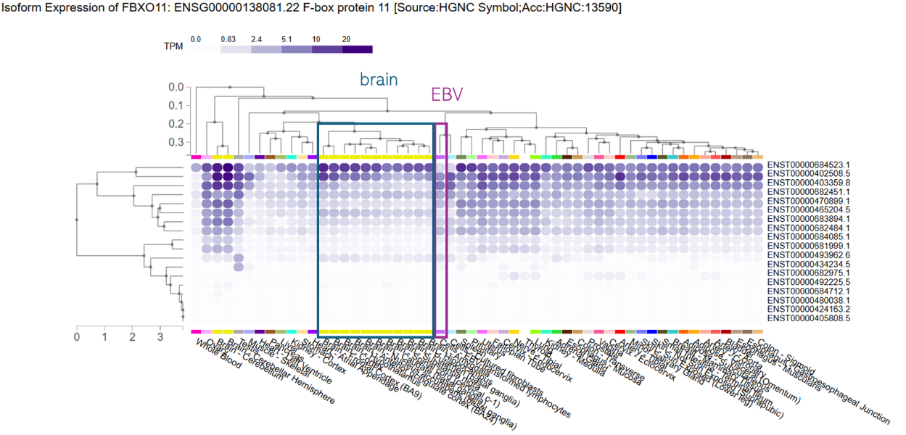

Supplementary Figure 7.
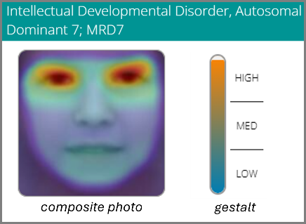
Analysis of the facial phenotype of P22 using Face2Gene. The highest gestalt score was retrieved for Intellectual developmental disorder 7 “MRD7”, or DYRK1A syndrome. Only the composite photo is shown as we did not obtain consent for publication of patient’s pictures, the heatmap pointing to highly similar orbital ridges.

Supplementary Figure 8.
Methylation at the promotor loci of the AFF2, AFF3 and DIP2B genes for the samples in which outlier repeat length were identified, visualized in IGV. Methylated CpGs are represented in red, unmethylated CpGs in blue. The upper data from each plot is from the index, followed by the mother “M” and the father “V”. AFF2 is located on the X-chromosome and undergoes X-chromosome inactivation, explaining the methylation of part of the reads in the mother (P16 being a male). The other genes are located on the autosomes and present biallelic expression.
- AFF2 (P16 n=42, P16M n=42)
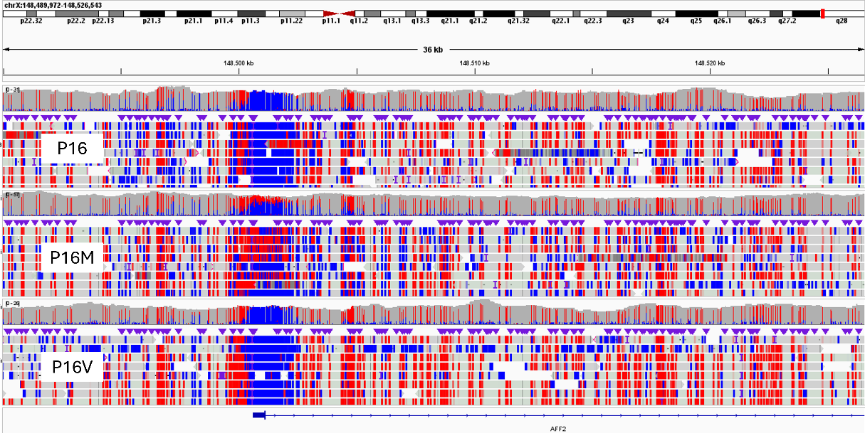

- AFF3 (P17 n=29, P17V n=29)
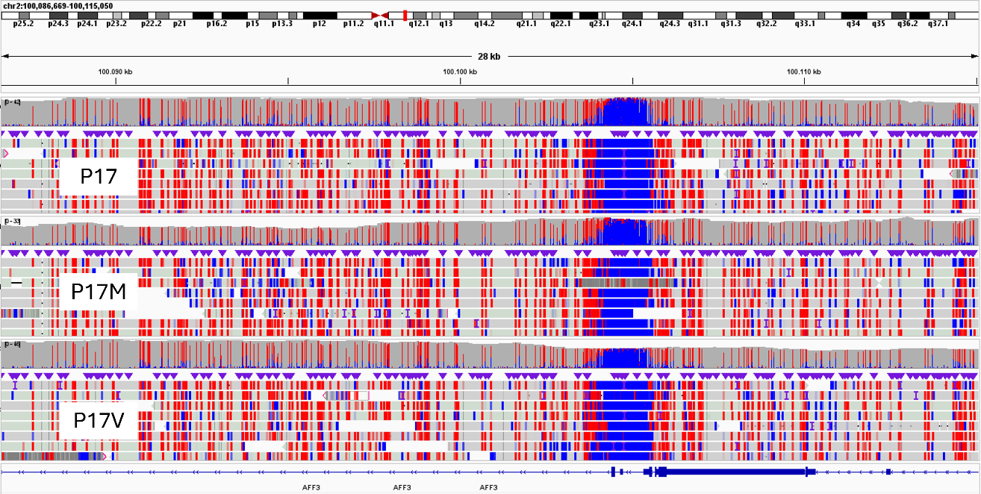

- DIP2B (P27 n=46, P27M n=43)
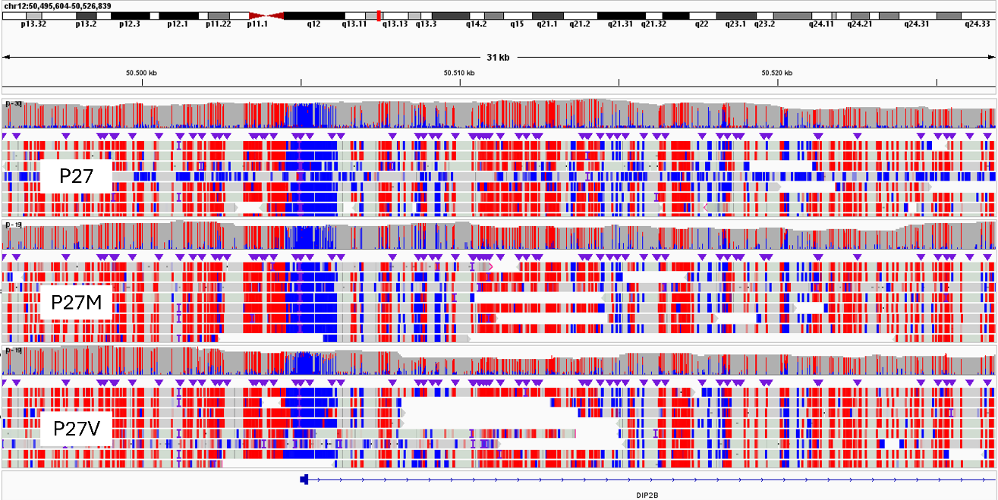

Supplementary Figure 9.
Increased variability of CpG methylation at loci undergoing X-chromosome inactivation compared to imprinted loci, illustrated by the data of P12 at two loci undergoing X-chromosome inactivation (top) and two imprinted loci (bottom). The following regions are illustrated (hg38) : chrX:67538000-67552000, chrX:46835000-46843000, chr11:2698155-2701028, chr15_24954564-24956828.
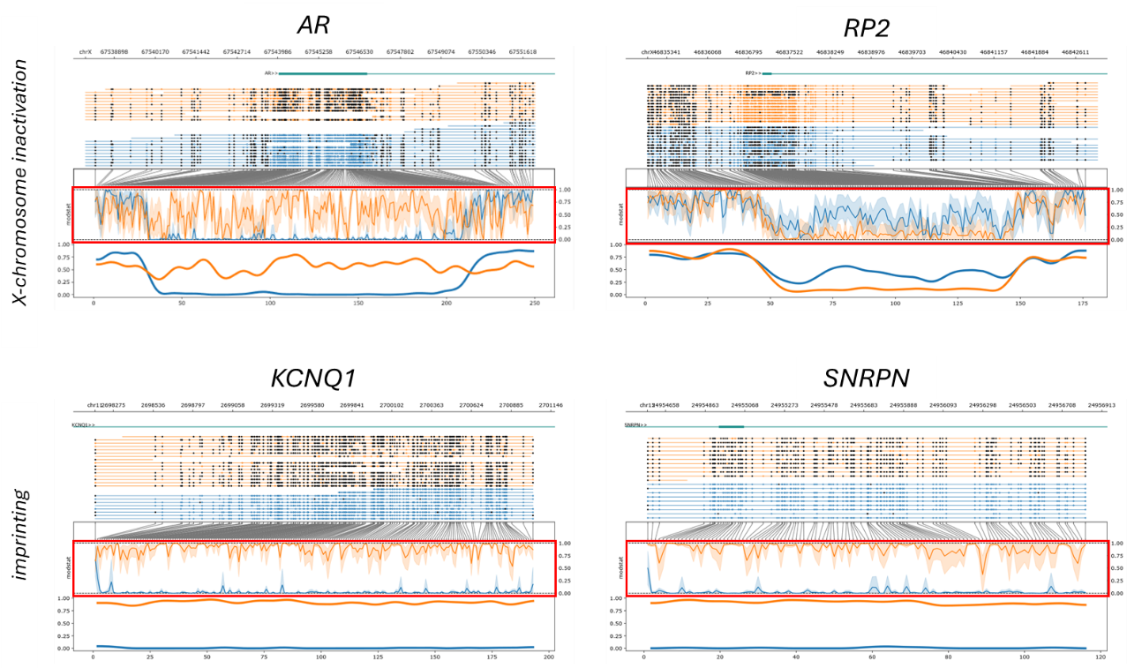
The upper part of each Methylartist plot represents the reads, with methylated CpGs visualized as black circles. In the lower part of each plot, after translation from genome to CpG-only coordinate space, raw log-likelihood ratios are plotted above a smoothened graph of methylation fraction.
CpG methylation across loci subject to X-chromosome inactivation (eg AR and RP2 promotor loci) is often heterogeneous across individual CpG sites and sequencing reads, contrasting with imprinting regions, where monoallelic DNA methylation is very consistent along en across the reads, resulting in nearly binary methylation patterns between parental alleles.

Supplementary Figure 10.
10A. Tatton-Brown Rahman syndrome episignature loci
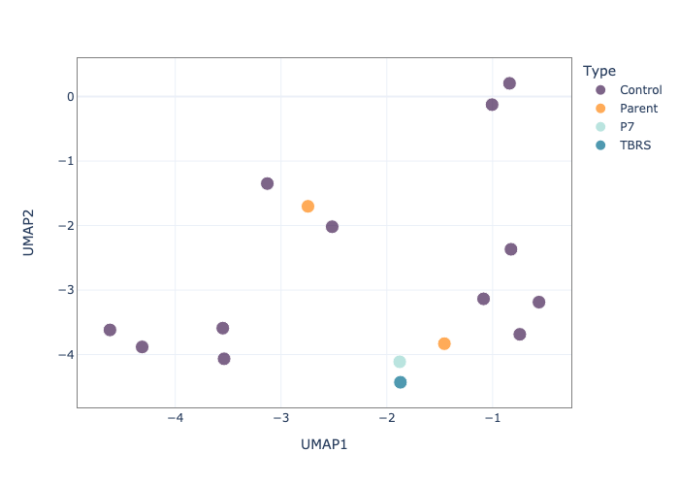
UMAP scatter plot evaluating methylation levels at TBRS syndrome episignature loci (shared by Aref-Esghi et al., Am J Hum Genet, 2020). Nanopore sequencing data of P7 (light blue), the two parents of P7 (orange), one positive control with a pathogenic variant in DNMT3A (dark blue) as well as twelve healthy controls (purple) is represented. We don’t observe clear clustering, but P7 is closest to the TBRS positive control, which is consistent with the results of the SVM-based classifier.

10B. KBG syndrome episignature loci
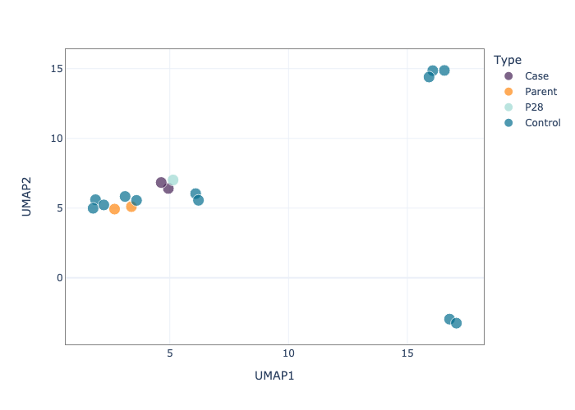
UMAP scatter plot evaluating methylation levels at KBG syndrome episignature loci (shared by Awamleh et al. Human Molecular Genetics, 2023). Nanopore sequencing data of P28 (light blue), the two parents of P28 (orange), two positive controls with pathogenic variants in ANKRD11 (purple) as well as twelve healthy controls (dark blue) is represented. P28 clusters closer to the two KBG positive controls.

