Support material-Coastal lowlands exposure estimations of buildings, roads, and population under lower, equal, and upper exposure estimate scenarios.

Exposed buildings

Scenario 1 – lower exposure estimate
Table 1 Coastal lowlands buildings exposed to shallow (<=1 m) and deeper (>1 m) groundwater by region (NZD$ 2025): Scenario 1 – lower exposure estimate

Region | Buildings Exposed to shallow groundwater | Replacement Cost of buildings exposed (NZD$) | Buildings not exposed to shallow groundwater | Replacement Cost of buildings not exposed (NZD$)
Auckland Region | 15,082 | 9,078,779,307 | 52,459 | 31,046,770,324
Bay of Plenty Region | 7,461 | 2,013,500,222 | 41,145 | 3,892,931,758
Canterbury Region | 40,805 | 11,951,874,795 | 63,289 | 17,276,092,801
Gisborne Region | None | None | 9,974 | 4,160,992,828
Hawke's Bay Region | 2,121 | 22,717,630 | 32,885 | 206,750,960
Manawatū-Whanganui Region | 1,670 | 405,252,201 | 7,637 | 2,155,984,266
Marlborough Region | 5,754 | 1,968,297,601 | 12,619 | 4,598,144,247
Nelson Region | 32 | 906,051 | 3,776 | 211,613,765
Northland Region | 1,579 | 714,965,431 | 13,599 | 5,482,043,424
Otago Region | 2,611 | 3,011,248 | 7,713 | 442,935,811
Southland Region | 21 | 38,776,113 | 16,800 | 9,528,737,567
Taranaki Region | 73 | 21,067,236 | 2,781 | 1,445,468,921
Tasman Region | 400 | 48,126,450 | 11,875 | 1,009,579,810
Waikato Region | 4,480 | 39,511,075 | 30,143 | 162,189,863
Wellington Region | 1,410 | 3,311,106,898 | 20,629 | 6,803,063,242
West Coast Region | 49 | 14,852,001 | 11,291 | 3,489,379,415
Grand Total | 83,548 | 29,632,744,259 | 338,615 | 91,912,679,002

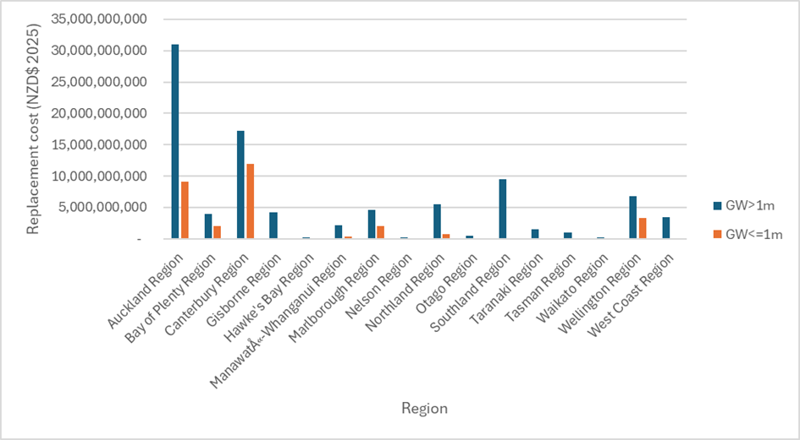
Fig. 1 Estimated replacement cost of exposed and unexposed buildings in the coastal lowlands by region (NZD$ 2025): Scenario 1 – lower error estimate, generated our own from this study

Scenario 2 – equal error estimate
Around 211,972 coastal lowlands buildings are estimated to be exposed to shallow groundwater using this equal error estimate scenario. These buildings represent an estimated replacement cost of NZD$ 71 billion. The Canterbury Region has the greatest level of building exposure, with approaching 63,528 buildings exposed, with an estimated replacement cost of NZD$ 18 billion. Auckland, Bay of Plenty, Waikato, Hawke's Bay regions follow as the top five regions exposed to shallow groundwater in New Zealand coastal lowland areas, with estimated replacement ranging from NZD$ 90 million to NZD$30 billion (Table 3-2 &Figure 3-2). Although Auckland region has the second highest exposure, the replacement cost of exposed coastal lowland buildings is highest overall. Compared to exposed buildings, an estimated 210,191 buildings across New Zealand are not exposed to shallow groundwater under this scenario. In other words, more buildings are estimated to be exposed to groundwater compared to those that are not exposed to groundwater using this estimate (Table 3-2).
Table 3 Coastal lowlands buildings exposed to shallow (<=1 m) and deeper (>1 m) groundwater by region (NZD$ 2025): Scenario 2 – equal error estimate

Region | Buildings Exposed to shallow groundwater | Replacement Cost of buildings exposed (NZD$) | Buildings not exposed to shallow groundwater | Replacement Cost of buildings exposed (NZD$)
Auckland Region | 50,637 | 29,941,639,468 | 16,904 | 10,183,910,163
Bay of Plenty Region | 23,115 | 4,668,633,286 | 25,491 | 1,237,798,694
Canterbury Region | 63,528 | 17,636,486,567 | 40,566 | 11,591,481,029
Gisborne Region | 238 | 80,834,196 | 9,736 | 4,080,158,632
Hawke's Bay Region | 13,784 | 90,363,712 | 21,222 | 139,104,878
Manawatū-Whanganui Region | 5,518 | 1,755,102,677 | 3,789 | 806,133,790
Marlborough Region | 12,314 | 4,483,651,107 | 6,059 | 2,082,790,741
Nelson Region | 1,426 | 106,883,594 | 2,382 | 105,636,222
Northland Region | 8,074 | 3,265,771,932 | 7,104 | 2,931,236,923
Otago Region | 5,045 | 19,969,192 | 5,279 | 425,977,867
Southland Region | 745 | 270,761,471 | 16,076 | 9,296,752,209
Taranaki Region | 881 | 474,281,070 | 1,973 | 992,255,087
Tasman Region | 2,151 | 228,735,893 | 10,124 | 828,970,367
Waikato Region | 16,682 | 150,174,362 | 17,941 | 51,526,576
Wellington Region | 5,117 | 6,585,566,486 | 16,922 | 3,528,603,654
West Coast Region | 2,717 | 777,763,729 | 8,623 | 2,726,467,687
Grand Total | 211,972 | 70,536,618,742 | 210,191 | 51,008,804,519

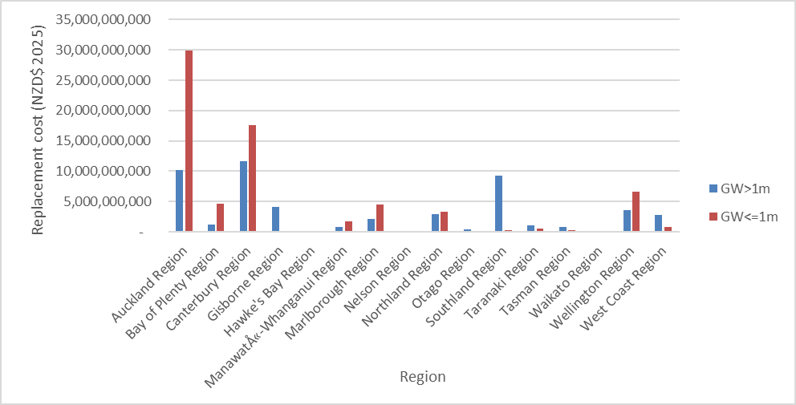
Fig. 2 Estimated replacement cost of exposed and unexposed buildings in the coastal lowlands by region (NZD$ 2025): Scenario 2 – equal error estimate, generated our own from this study

Scenario 3 – upper exposure estimate
Around 286,859 buildings are estimated to be exposed to shallow groundwater under an upper exposure estimate scenario. These buildings represent a combined estimated replacement cost of NZD$ 89 billion. The Canterbury Region contains the largest share of building exposure, accounting for 72,730 exposed buildings with an estimated replacement cost of NZD$ 20 billion. Auckland, Bay of Plenty, Hawke's Bay, and Waikato region follow, with an estimated replacement cost range from NZD$ 122 million to NZD$ 36 billion (Table 3-3 & Figure 3-3). By comparison, around 135,304 buildings nationally estimated to remain unexposed to shallow groundwater. In another words, the number of exposed buildings far exceeds the number of unexposed buildings using this scenario (Table 3-3).
Table 4 Coastal lowland buildings exposed to shallow (<=1 m) and deeper (>1 m) groundwater by region (NZD$ 2025): Scenario 3 – upper exposure estimate

Region | Buildings exposed to shallow groundwater | Replacement Cost of buildings exposed (NZD$) | Buildings not exposed to shallow groundwater | Replacement cost of buildings not exposed (NZD$)
Auckland Region | 61,562 | 36,861,957,478 | 5,979 | 3,263,592,153
Bay of Plenty Region | 32,879 | 5,388,906,105 | 15,727 | 517,525,875
Canterbury Region | 72,730 | 20,305,754,068 | 31,364 | 8,922,213,528
Gisborne Region | 925 | 458,550,547 | 9,049 | 3,702,442,281
Hawke's Bay Region | 24,047 | 122,067,618 | 10,959 | 107,400,972
Manawatū-Whanganui Region | 7,975 | 2,290,859,698 | 1,332 | 270,376,769
Marlborough Region | 15,603 | 5,619,074,663 | 2,770 | 947,367,185
Nelson Region | 2,647 | 182,147,678 | 1,161 | 30,372,138
Northland Region | 11,727 | 4,637,689,878 | 3,451 | 1,559,318,977
Otago Region | 7,985 | 58,160,778 | 2,339 | 387,786,281
Southland Region | 4,218 | 1,909,823,693 | 12,603 | 7,657,689,987
Taranaki Region | 2,106 | 1,046,759,836 | 748 | 419,776,321
Tasman Region | 3,845 | 383,657,449 | 8,430 | 674,048,811
Waikato Region | 23,989 | 177,346,213 | 10,634 | 24,354,725
Wellington Region | 8,857 | 7,514,545,573 | 13,182 | 2,599,624,567
West Coast Region | 5,764 | 1,768,782,613 | 5,576 | 1,735,448,803
Grand Total | 286,859 | 88,726,083,888 | 135,304 | 32,819,339,373

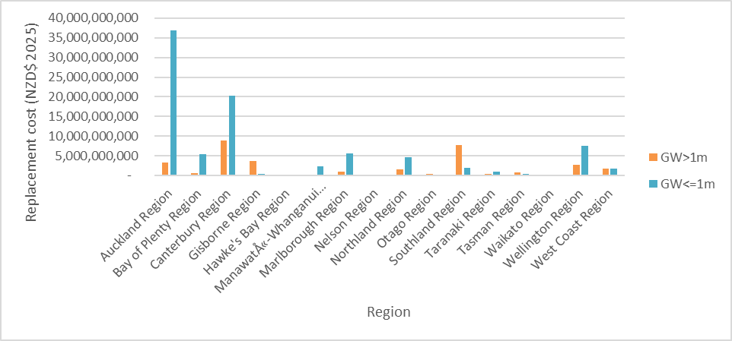
Fig. 3 Estimated replacement cost of exposed and unexposed buildings in the coastal lowlands by region (NZD$ 2025): Scenario 3 – upper exposure estimate, generated our own from this study

Road

Scenario 1 – lower exposure estimate
Approximately 13 per cent of New Zealand’s exposed roads are located in the coastal lowlands. 1,368 kilometres of road are estimated to be exposed to in areas of shallow groundwater with an estimated construction cost of NZD$ 1.4 billion (Table 3-8). The Canterbury Region contains the largest level of exposure, with 567 kilometres of exposed roading, at a total construction value of NZD$ 287 million (based on an average unit cost of NZD$ 506/metre) (Ministry of Transport New Zealand. 2023) (Figure 3-5&6). The following other top four exposed regions are Bay of Plenty, Auckland, Waikato, and Marlborough regions with a range of exposure varying from 83-204 kilometres, and a potential replacement cost of NZD$ 49-556 million (Table 3-8, Figure 3-5&6). Compared to exposed roading, over 51,000 kilometres of roading nationally is estimated to be unexposed and 6,430 kilometres of roading in the coastal lowland is estimated to be unexposed (Table 3-8).
Table 8 Coastal lowland roading exposed to shallow (<1 m) and deeper (>1 m) groundwater by region (NZD$ 2025): Scenario 1 – lower exposure estimates

Region | Kilometres of road exposed to shallow groundwater | Kilometres of road not exposed | Average unit value (NZD/m) | Total cost of road exposed (NZD$) | Total cost of road not exposed (NZD$)
Auckland Region | 200 | 679 | 2,778 | 555,936,167 | 1,886,043,314
Bay of Plenty Region | 204 | 556 | 1,231 | 251,255,590 | 683,676,123
Canterbury Region | 567 | 1,157 | 506 | 287,272,799 | 585,863,326
Gisborne Region |  | 188 | 1,075 |  | 201,610,470
Hawke's Bay Region | 28 | 540 | 1,072 | 29,796,058 | 578,343,621
Manawatū-Whanganui Region | 30 | 197 | 684 | 20,485,962 | 134,407,066
Marlborough Region | 83 | 250 | 594 | 49,449,237 | 148,823,184
Nelson Region | 1 | 66 | 1,648 | 2,059,862 | 109,172,677
Northland Region | 50 | 428 | 599 | 29,960,505 | 256,295,508
Otago Region | 30 | 343 | 573 | 17,270,599 | 196,564,047
Southland Region | 2 | 500 | 489 | 954,149 | 244,751,486
Taranaki Region | 1 | 56 | 784 | 1,137,298 | 43,687,922
Tasman Region | 10 | 193 | 516 | 5,058,822 | 99,860,116
Waikato Region | 136 | 590 | 968 | 131,759,913 | 571,330,734
Wellington Region | 25 | 337 | 2,132 | 52,239,713 | 719,095,646
West Coast Region | 0 | 350 | 486 | 194,527 | 170,284,410
Grand Total | 1,368 | 6,430 |  | 1,434,831,202 | 6,629,809,650

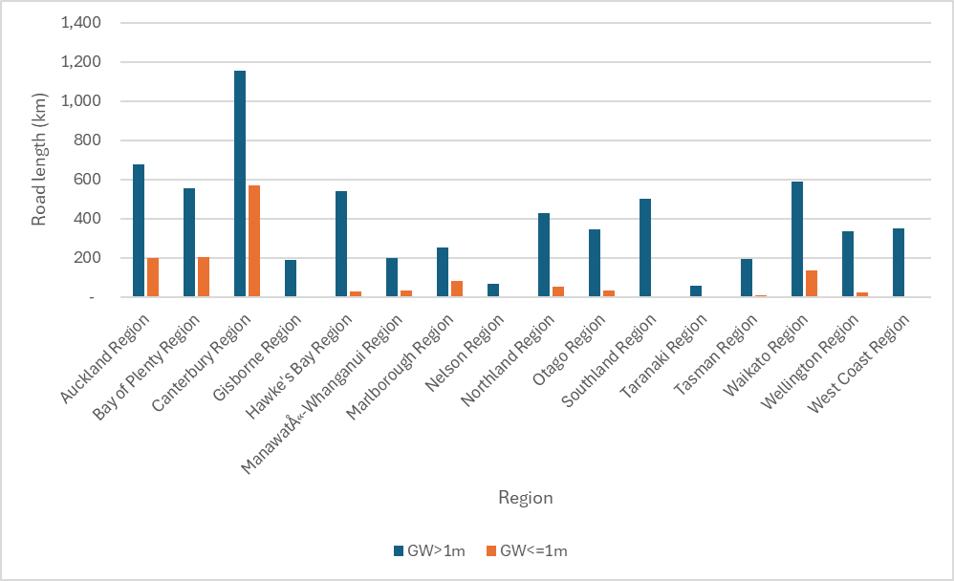
Fig. 4 Coastal lowlands exposed road length by region (unit:km): Scenario 1 – lower exposure estimate, generated our own from this study

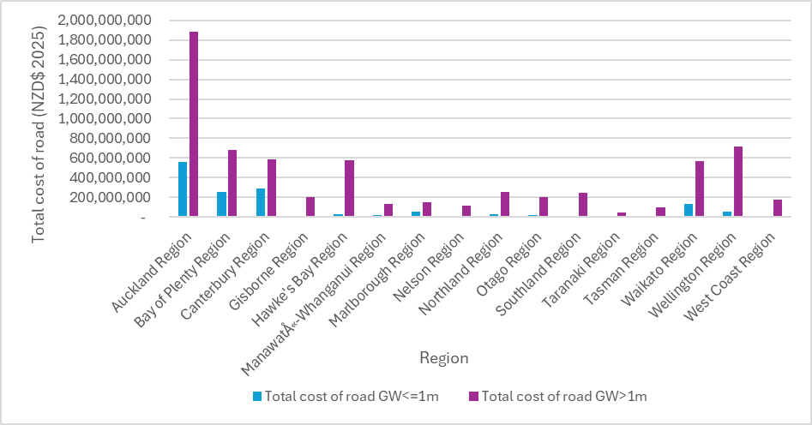
Fig. 5 Coastal lowlands exposed road replacement cost GW by region (NZD$ 2025): Scenario 1 – lower exposure estimates, generated our own from this study

Scenario 2 – equal error estimate
Around 3,832 kilometres of coastal lowlands road are estimated to be exposed under an equal error estimate, with an estimated replacement construction cost of NZD$ 4.5 billion (Table 3-9). The Canterbury Region contains the largest share of this exposure, with over 900 kilometres of road exposed, at a total replacement construction value of NZD$ 504 million (based on an average unit cost of NZD$ 506/metre) (Ministry of Transport New Zealand. 2023). Auckland, Waikato, Bay of Plenty, and Northland Regions represent the other top five largest shares of exposed roading, with roading ranging from 267-676 kilometres exposed at an estimated replacement value of NZD$159 million to NZD$ 1.8 billion (Figure 3-6&7). Around 3,966 kilometres of national roading are estimated to be un-exposed to shallow groundwater with an estimated replacement construction cost of NZD$ 3.6 billion (Table 3-9).
Table 9 Coastal lowland roading exposed to shallow (<=1 m) and deeper (>1 m) groundwater by region (NZD$ 2025): Scenario 2 – equal error estimate

Region | Kilometres of road exposed to shallow groundwater | Kilometres of road not exposed | Average unit value (NZD/m) | Total cost of road exposed (NZD$) | Total cost of road not exposed (NZD$)
Auckland Region | 676 | 203 | 2,778 | 1,877,569,524 | 564,409,957
Bay of Plenty Region | 437 | 323 | 1,231 | 537,341,125 | 397,590,588
Canterbury Region | 996 | 729 | 506 | 504,107,300 | 369,028,825
Gisborne Region | 4 | 184 | 1,075 | 4,352,465 | 197,258,005
Hawke's Bay Region | 210 | 357 | 1,072 | 225,024,543 | 383,115,136
Manawatū-Whanganui Region | 155 | 71 | 684 | 106,260,242 | 48,632,786
Marlborough Region | 177 | 157 | 594 | 105,168,780 | 93,103,642
Nelson Region | 23 | 45 | 1,648 | 37,819,063 | 73,413,476
Northland Region | 267 | 211 | 599 | 159,679,614 | 126,576,399
Otago Region | 128 | 246 | 573 | 73,149,436 | 140,685,211
Southland Region | 29 | 473 | 489 | 14,140,980 | 231,564,656
Taranaki Region | 15 | 43 | 784 | 11,372,978 | 33,452,242
Tasman Region | 42 | 161 | 516 | 21,603,235 | 83,315,703
Waikato Region | 484 | 242 | 968 | 468,517,341 | 234,573,306
Wellington Region | 146 | 216 | 2,132 | 311,199,435 | 460,135,924
West Coast Region | 45 | 306 | 486 | 21,884,331 | 148,594,606
Grand Total | 3,832 | 3,966 |  | 4,479,190,392 | 3,585,450,460

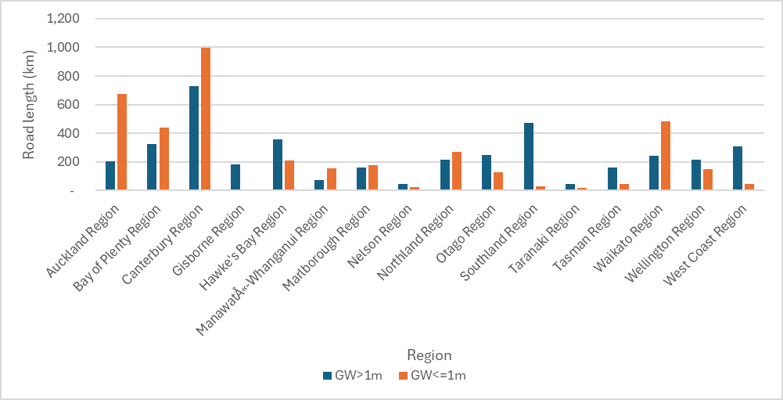
Fig. 6 Coastal lowland roads exposed to GW by region: Scenario 2 – equal error estimate at coastal lowlands, generated our own from this study

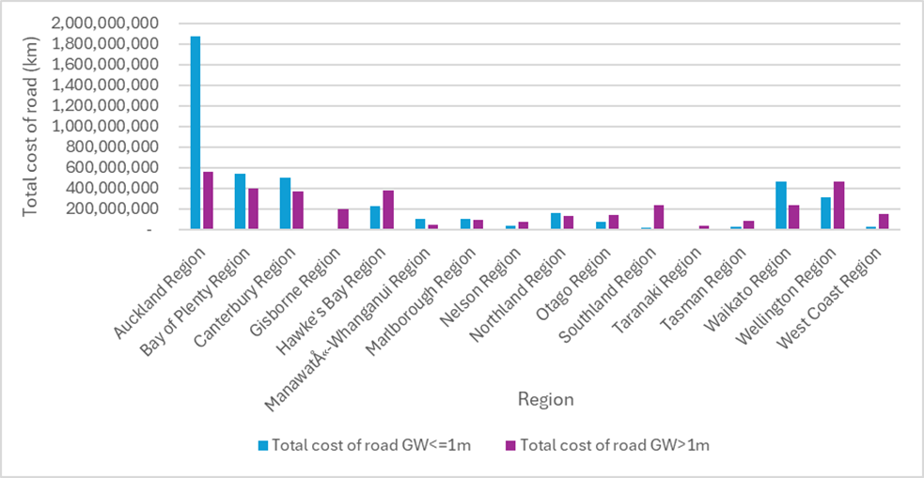
Fig. 7 Coastal lowlands exposed road replacement cost GW by region (NZD$ 2025): Scenario 2 – equal error estimate, generated our own from this study

Scenario 3 – upper exposure estimate
5,271 kilometres of coastal lowlands roads are estimated to be exposed to shallow groundwater using an upper exposure estimate scenario with an estimated construction value of NZD$ 6 billion (Table 3-10). The Canterbury Region contains the largest share of roading, with over 1,000 kilometres of road exposed, representing a total replacement construction value of NZD$ 600 million (based on an average unit cost of NZD$ 506/metre) (Ministry of Transport New Zealand. 2023) (Table 3-10). The Auckland, Waikato, Bay of Plenty, and Northland regions contain the next top four most exposed roading level, containing a range of 385-813 kilometres of road exposed at an estimated construction value range of NZD$230 million to NZD$ 2 billion (Figure 3-8&9). Overall, more roading in the coastal lowlands remains unexposed using this estimate (around 2,500 kilometres) (Table 3-10).
Table 10 Coastal lowland roading exposed to shallow (<=1 m) and deeper (>1 m) groundwater by region (NZD$ 2025): Scenario 3 – upper exposure estimates

Region | Kilometres of road exposed to shallow groundwater | Kilometres of road not exposed | Average unit value (NZD/m) | Total cost of road exposed | Total cost of road not exposed
Auckland Region | 813 | 66 | 2,778 | 2,258,751,144 | 183,228,337
Bay of Plenty Region | 563 | 196 | 1,231 | 693,460,506 | 241,471,207
Canterbury Region | 1,188 | 537 | 506 | 601,460,016 | 271,676,109
Gisborne Region | 30 | 158 | 1,075 | 32,079,278 | 169,531,192
Hawke's Bay Region | 363 | 204 | 1,072 | 389,010,039 | 219,129,639
Manawatū-Whanganui Region | 204 | 22 | 684 | 139,810,708 | 15,082,320
Marlborough Region | 261 | 73 | 594 | 155,093,490 | 43,178,931
Nelson Region | 49 | 19 | 1,648 | 80,417,006 | 30,815,533
Northland Region | 384 | 94 | 599 | 229,866,811 | 56,389,202
Otago Region | 253 | 120 | 573 | 144,952,738 | 68,881,908
Southland Region | 99 | 403 | 489 | 48,539,279 | 197,166,356
Taranaki Region | 45 | 12 | 784 | 35,413,100 | 9,412,120
Tasman Region | 81 | 122 | 516 | 41,786,903 | 63,132,035
Waikato Region | 620 | 106 | 968 | 600,035,226 | 103,055,421
Wellington Region | 210 | 152 | 2,132 | 447,982,195 | 323,353,164
West Coast Region | 108 | 243 | 486 | 52,546,710 | 117,932,227
Grand Total | 5,271 | 2,527 |  | 5,951,205,151 | 2,113,435,701

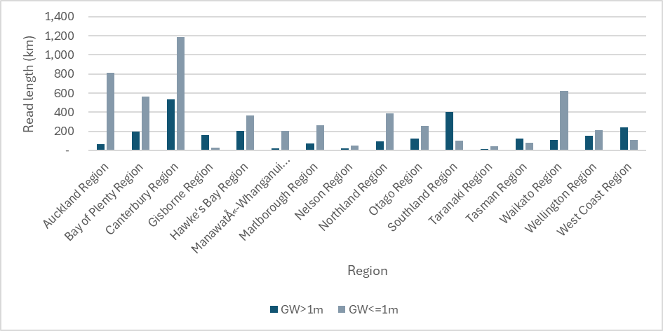
Fig. 8 Coastal lowland roads exposed to shallow groundwater by region: Scenario 3 – upper exposure estimates, generated our own from this study

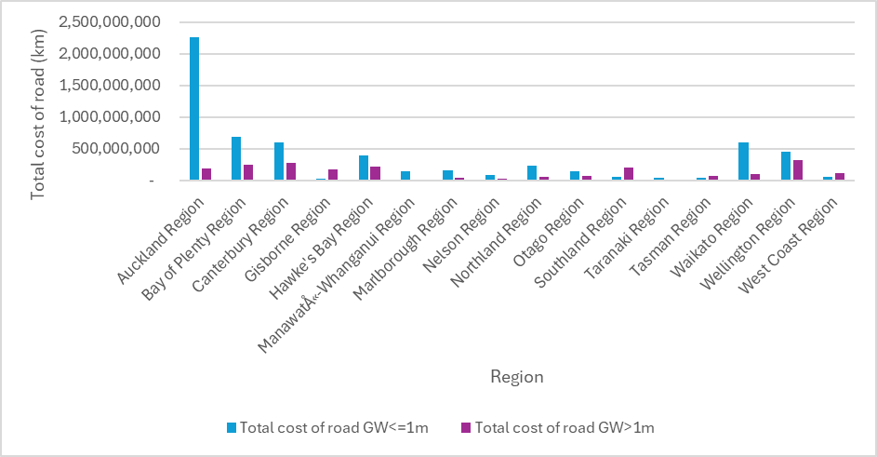
Fig. 9 Coastal lowlands exposed road replacement cost GW by region (NZD$ 2025): Scenario 3 – upper exposure estimates at coastal lowlands, generated our own from this study

Population

Scenario 1 – lower exposure estimate
Approximately 17 per cent of people nationally exposed to shallow groundwater are located in New Zealand’s coastal lowlands. Around 190,000 people are estimated to be exposed to under this low exposure estimate scenario (Table 3-12). The top five exposed regions are Canterbury, Auckland, Bay of Plenty, Wellington, and Otago Regions with population exposed ranging 6,000-73,000 (Table 3-12 & Figure3-10).
Table 12 Coastal lowlands population exposed to shallow (<=1 m) and deeper (>1 m) groundwater by region (2022 figures): Scenario 1 – lower exposure estimate

Region | Population exposed to shallow groundwater | Population not exposed | Lower exposure estimate total
Auckland Region | 63,826 | 208,786 | 272,612
Bay of Plenty Region | 15,329 | 91,776 | 107,105
Canterbury Region | 73,030 | 116,018 | 189,048
Gisborne Region |  | 15,748 | 15,748
Hawke's Bay Region | 3,637 | 64,425 | 68,063
Manawatū-Whanganui Region | 1,914 | 9,162 | 11,076
Marlborough Region | 7,139 | 18,911 | 26,050
Nelson Region | 169 | 10,482 | 10,651
Northland Region | 2,606 | 24,904 | 27,510
Otago Region | 6,425 | 14,263 | 20,687
Southland Region | 16 | 31,865 | 31,881
Taranaki Region | 420 | 7,004 | 7,425
Tasman Region | 546 | 15,909 | 16,455
Waikato Region | 4,145 | 28,077 | 32,222
Wellington Region | 8,721 | 47,618 | 56,339
West Coast Region | 32 | 12,242 | 12,273
Grand Total | 187,955 | 717,190 | 905,145

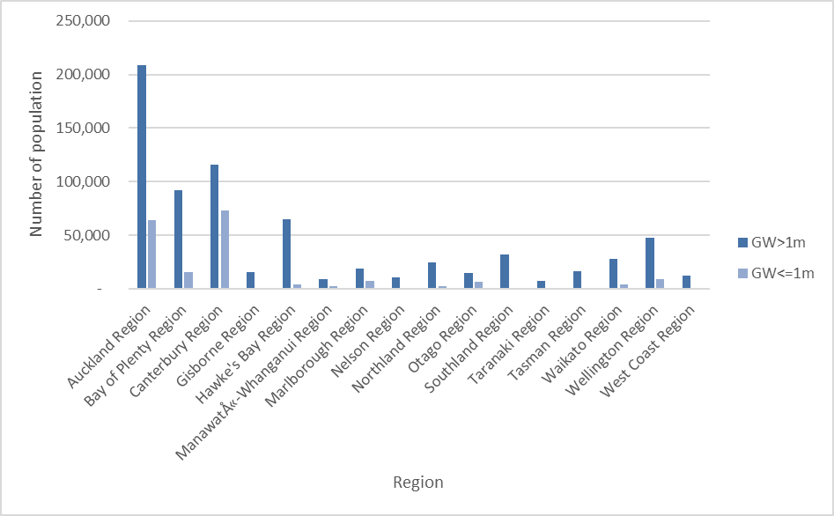
Fig. 10 Coastal lowlands population exposed to GW by region: Scenario 1 – lower error estimate, generated our own from this study

Scenario 2 – equal error estimate
504,000 people cross New Zealand’s coastal lowlands are estimated to be exposed to shallow groundwater less than 1 metre from the gound surface when using an equal error scenario estimate. The top five most exposed regions are Auckland, Canterbury, Bay of Plenty, Hawke's Bay, and Wellington Regions with a range of population exposed ranging from 21,000-204,000 (Table 3-13 & Figure 3-11). Under this scenario, more people across New Zealand’s coastal lowlands are exposed (504,000) to shallow groundwater than not (400,000) (Table 3-13).
Table 13 Coastal lowlands population exposed to shallow (<=1 m) and deeper (>1 m) groundwater by region (2022 figures): Scenario 2 – equal error estimate

Region | Population exposed to shallow groundwater | Population not exposed to shallow groundwater | Equal error estimate total
Auckland Region | 204,730 | 67,882 | 272,612
Bay of Plenty Region | 50,118 | 56,987 | 107,105
Canterbury Region | 116,661 | 72,386 | 189,048
Gisborne Region | 536 | 15,213 | 15,748
Hawke's Bay Region | 26,553 | 41,510 | 68,063
Manawatū-Whanganui Region | 6,883 | 4,192 | 11,076
Marlborough Region | 16,127 | 9,923 | 26,050
Nelson Region | 4,406 | 6,244 | 10,651
Northland Region | 15,918 | 11,592 | 27,510
Otago Region | 12,519 | 8,169 | 20,687
Southland Region | 1,457 | 30,423 | 31,881
Taranaki Region | 2,263 | 5,162 | 7,425
Tasman Region | 3,544 | 12,911 | 16,455
Waikato Region | 17,844 | 14,378 | 32,222
Wellington Region | 21,222 | 35,117 | 56,339
West Coast Region | 3,758 | 8,515 | 12,273
Grand Total | 504,539 | 400,606 | 905,145

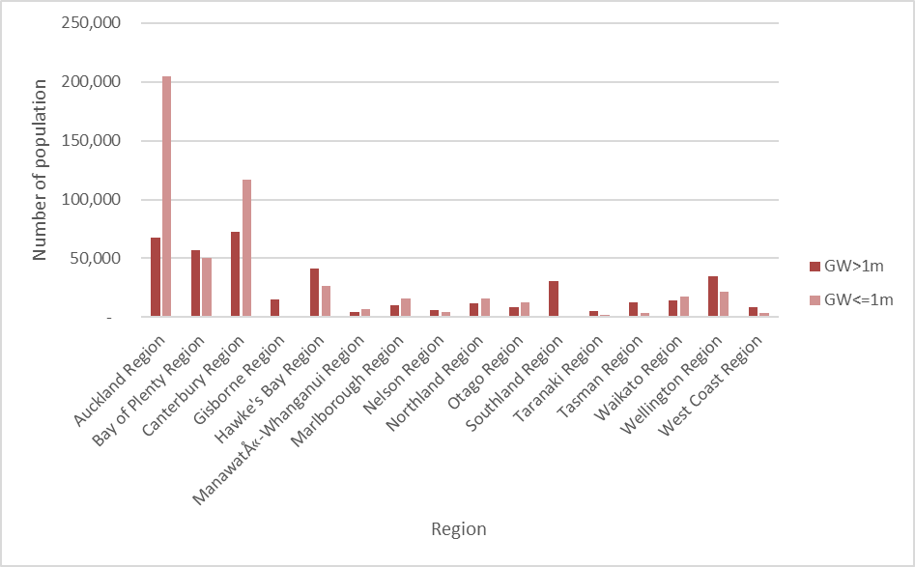
Fig. 11 Coastal lowlands population exposed to GW by region: Scenario 2 – equal error estimate, generated our own from this study

Scenario 3 – upper exposure estimate
668,000 people across New Zealand’s coastal lowlands are estimated to be exposed to shallow groundwater when an upper exposure estimate is used (Table 3-4). The top five regions most exposed are Auckland, Canterbury, Bay of Plenty, Hawke's Bay, and Wellington Regions with a range of population exposed ranging from 30,000-250,000 (Table 3-11 & Figure 3-12). Using this estimate scenario, three times as many people across New Zealand are exposed to shallow groundwater than not (236,000) (Table 3-14).
Table 14 Coastal lowlands population exposed to shallow (<1 m) and deeper (>1 m) groundwater by region (2022 figures): Scenario 3 – upper exposure estimate

Region | Population exposed to shallow groundwater | Population not exposed to shallow groundwater | Upper exposure estimate total
Auckland Region | 250,256 | 22,355 | 272,612
Bay of Plenty Region | 71,726 | 35,379 | 107,105
Canterbury Region | 135,855 | 53,193 | 189,048
Gisborne Region | 1,316 | 14,433 | 15,748
Hawke's Bay Region | 47,918 | 20,145 | 68,063
Manawatū-Whanganui Region | 10,369 | 707 | 11,076
Marlborough Region | 21,635 | 4,415 | 26,050
Nelson Region | 7,839 | 2,812 | 10,651
Northland Region | 22,036 | 5,474 | 27,510
Otago Region | 16,826 | 3,861 | 20,687
Southland Region | 8,518 | 23,363 | 31,881
Taranaki Region | 5,213 | 2,211 | 7,425
Tasman Region | 6,094 | 10,361 | 16,455
Waikato Region | 25,741 | 6,481 | 32,222
Wellington Region | 30,239 | 26,100 | 56,339
West Coast Region | 6,974 | 5,299 | 12,273
Grand Total | 668,554 | 236,591 | 905,145

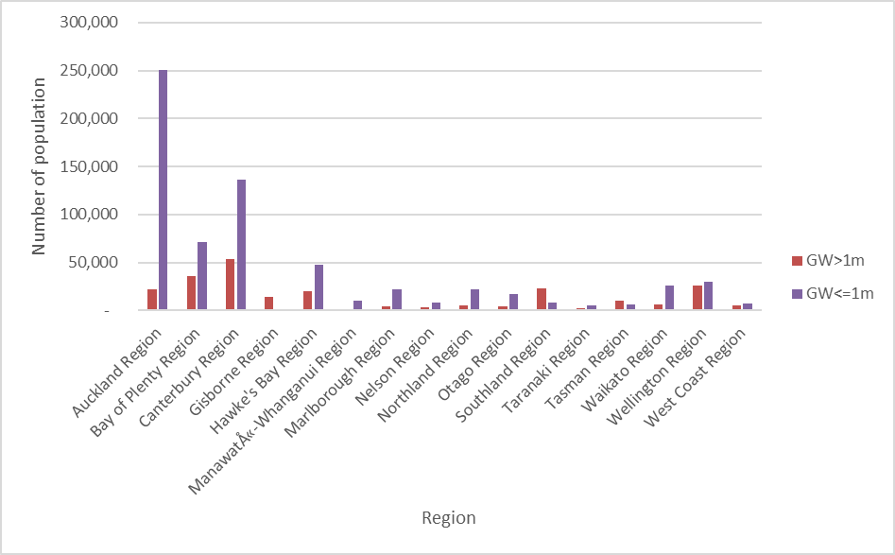
Fig. 12 Coastal lowlands population exposed to GW by region: Scenario 3 – upper exposure estimate, generated our own from this study

