Supplementary Information
Enhanced Coupling Efficiency in Geometric Terahertz Rectennas Based on Scalable CVD Graphene
Andreas Hemmetter^{1,2}, Jakob Holstein³, Michael Möller¹, Jens Bolten¹, Bárbara Canto¹, Lisa Ehlert¹, Abraham Ginzburg¹, Davide Truccolo⁴, Davide Mencarelli⁵, Michele Midrio⁴, Luca Pierantoni⁵, Alvydas Lisauskas^{3,6}, Hartmut Roskos³, Zhenxing Wang^{1,*}, Max C. Lemme^{1,2,*}
¹ AMO GmbH, 52074 Aachen, Germany
² Chair of Electronic Devices, Faculty of Electrical Engineering and Information Technology, RWTH Aachen University, 52074 Aachen, Germany
³Physikalisches Institut, Goethe University Frankfurt, 60438 Frankfurt am Main, Germany
⁴Dipartimento Politecnico di Ingegneria e Architettura (DPIA), University of Udine, 33100 Udine, Italy
⁵Information Engineering Department, Marche Polytechnic University, 60131 Ancona, Italy
⁶Institute of Applied Electrodynamics and Telecommunications, Vilnius University, 10222 Vilnius, Lithuania
*E-mail: wang@amo.de, max.lemme@rwth-aachen.de

S1 - Quality control during fabrication
The reactive ion etching process of the electron beam lithography alignment marks left organic residue, which was found to be a major cause of graphene delamination. The resist residue was removed by cleaning in organic solvents and Piranha solution (H₂SO₄:H₂O₂). We performed atomic force microscopy (AFM) on the substrate after resist cleaning (but before graphene transfer). The substrate had a root mean square roughness (rms) of 0.24 nm and showed no residues in the measured region (Figure S1a). For comparison, the rms of standard thermally grown SiO₂ without any treatment was 0.19 nm.
We verified that the transferred graphene adhered well to the substrate by AFM (Figure S1b) and scanning electron microscopy (SEM, Figure S1c). Typical defects of large-scale transferred graphene, such as wrinkles, are visible in both AFM and SEM images. AFM and SEM revealed no evidence of graphene delamination. The rms after graphene transfer was 1.62 nm.
The graphene quality was further assessed by Raman spectroscopy. A Horiba XPlora Raman spectrometer with a 100x microscope objective was used for Raman measurements. The laser power was set to 1 mW at an excitation wavelength of 532 nm. The median spectra in different regions can be seen in Figure S1d where a D peak in the Raman signal with a low I_{D}/I_{G} ratio of 0.083±0.055 indicated minimal damage during the transfer.

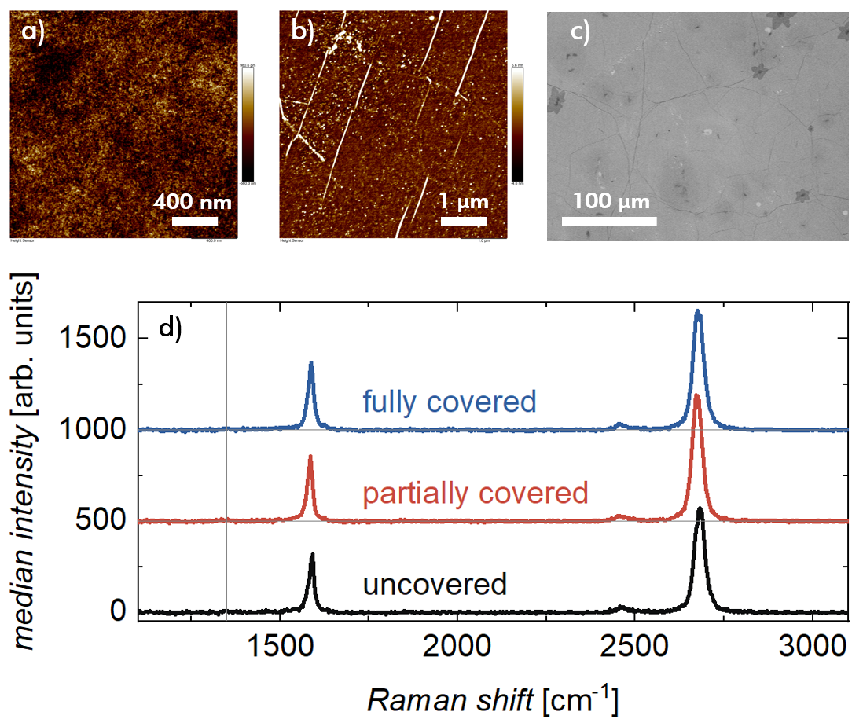
Figure S1 Material characterization of the substrate and transferred CVD graphene. a) AFM scan of the SiO₂ substrate after marker etching. b) AFM scan of a larger area of transferred CVD graphene. Wrinkles are visible as brighter diagonal lines. c) SEM image of a larger graphene area after transfer. d) Median Raman spectra of the transferred graphene with a low I_{D}/I_{G} ratio. The black, red, and blue curves correspond to transferred graphene that is not, partially, or fully covered by HSQ resist, respectively. The vertical line marks the position of the D peak.

S2 - Antenna Simulation and estimation of the incident power
To estimate the incident power, we determined 1) the directivity of the antenna in substrate direction, 2) the spot size of the focused beam, 3) the output power of the THz source, and 4) the losses in the beam path.
The impedance and directivity of the bowtie antenna was simulated with the commercial Maxwell-solver CST Microwave Studio. We included the substrate as a half-infinite Si layer (dielectric constant ε_{r} = 11.9) with 300 nm SiO₂ (ε_{r} = 3.9). The antenna was excited with a lumped-element port at the feedpoint. The complex impedance was modeled up to 2 THz (see Figure S2a).
We considered bowtie antennas with a total length of 150 μm (solid lines) and 92 μm (dotted lines). The impedances of these antennas are shown in Figure S2a. The impedance of the 150 μm antenna was not affected by DC pads near the antenna (dashed lines, Figure S2a). The frequency at which the maximum real-part impedance occurs is marked with vertical lines. For the 150 μm antennas (with and without DC pads) it is around 573 GHz and for the 92 μm antennas it is around 940 GHz.
The directivity of the 150 μm antenna was extracted from the radiation pattern in the substrate direction at a target frequency of 0.6 THz. We found a maximum directivity of 13 dBi in substrate direction (no Si-lens included).
Next, we estimated the spot size of the THz beam immediately behind the hyperhemispherical lens. This quantity was simulated with the commercial ray optics software ZEMAX, using the manufacturer’s reported characteristics of the Si lens (diameter 12 mm, height 6.8 mm, dielectric constant ε_{r} = 11.9). Based on these values, we estimated the spot to have a diameter of 650 μm (Figure S2b). The spot size is thus smaller than the effective antenna area calculated from the directivity. Hence, it is justified to calculate the responsivity simply from the total transmitted power from the source.
The available power from the THz source was measured directly at the waveguide flange with a PTB-calibrated pyroelectric detector. The output power spectrum is shown in Figure S2c. We considered losses in the beam path to total 30% for devices on high-resistivity Si substrates. The doped substrate introduces an additional 30% absorption, resulting in a total attenuation of -3 dB in the beam path.
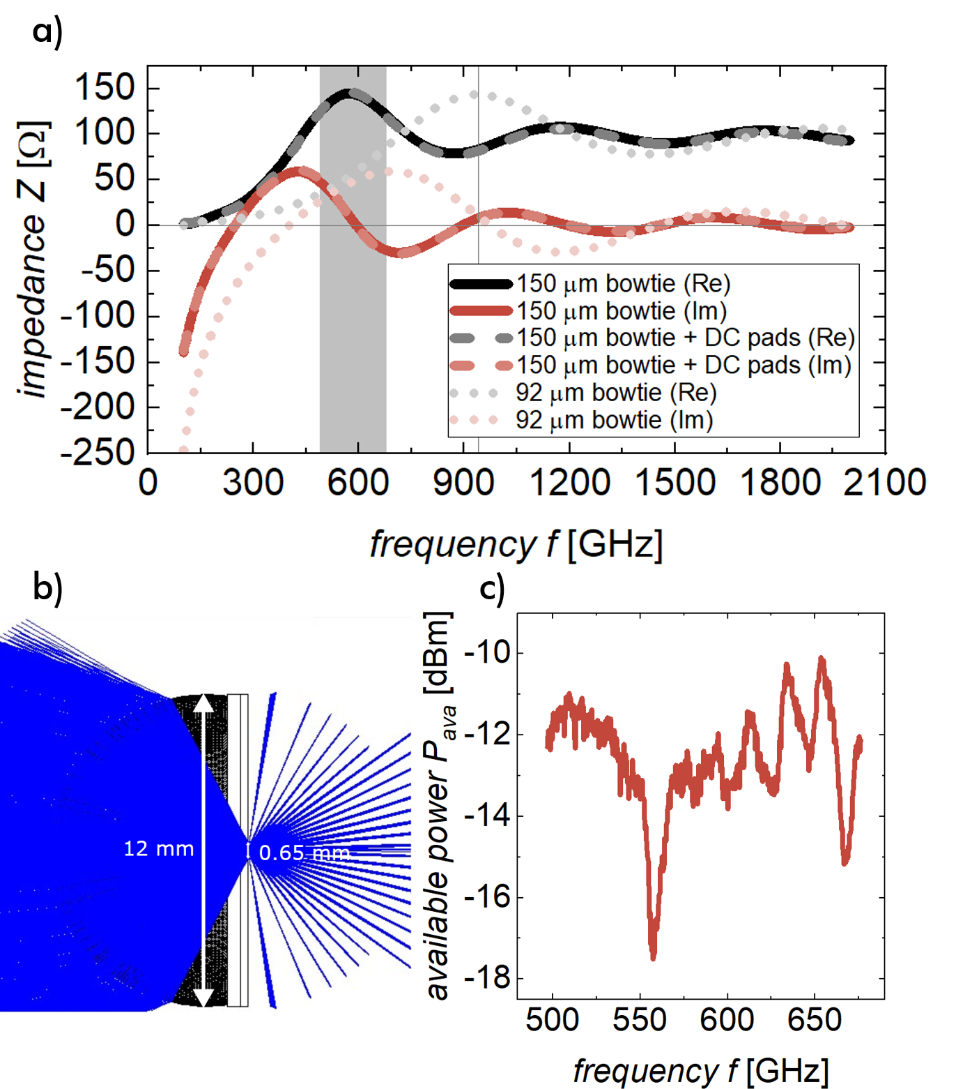
Figure S2 Simulation of the bowtie antenna. a) Complex impedance vs frequency for the antennas with a length of 150 μm with and without DC pads (solid and dashed lines) and with a length of 92 μm (dotted lines). The frequency at which the respective peak impedance occurs is marked with a vertical line. The measured frequency range is highlighted by a vertical grey bar. b) Simulated spot size behind the hyperhemispherical Si lens. c) Available power of the THz source, measured directly at the waveguide flange with a PTB-calibrated pyroelectric detector.

S3 - Gated transfer-length measurements
We extracted key device properties such as mobility and the mean free path from gated transfer-length measurements.
Transfer-length measurements (TLM) were performed on dedicated test structures in a Cascade probe station connected to a HP4156B precision semiconductor parameter analyzer under ambient conditions. We measured the gate-dependent resistance of graphene channels with patterned and unpatterned Ti/Au contacts from gated TLM structures, i.e., graphene channels that contain many triangular holes below the metallic contact (see the inset in Figure 1d in the main text). We have used separate devices for each channel length from 10 μm to 82 μm with an equal width of 10 μm, shown in the optical micrograph in Figure S3a. For each channel length of the TLM structures we performed a gate sweep from -50 to +50 V, measured the current through the two-terminal device at a source-drain voltage of 100 mV, and calculated the total device resistance $R$ from the ratio of source-drain voltage to current.
The measured $R$-$V_{g}$ (resistance vs gate voltage) curves were recentered on the charge neutrality point $V_{CNP}$ located between +5 and +10 V (shown in a contour plot for both device types in Figures S3b and c). For each $V_{g}-V_{CNP}$, we performed a linear fit of the resistance with respect to the channel length $l$. The R-intercept $R_{i}$ (at l = 0 μm) of the linear regression of the resistance vs channel length yielded the contact resistance via $R_{C}=R_{i}\frac{w}{2}$, where $w$ is the channel width (w = 10 μm). From the slope $\frac{R}{l}$ , we extracted the sheet resistance of the graphene channel via $R_{□}= \frac{R}{l}w$. The gate-dependent contact and sheet resistances are shown in Figures S3d and e, respectively. The patterned contact (red line) has a significantly lower contact resistance at negative $V_{g}-V_{CNP}$, i.e., in the p-type conduction region, compared with that of the unpatterned contact (black line). The extracted sheet resistances between both sets of TLM structures correspond well with each other, indicating consistent electrical graphene quality across different devices.
Next, we extracted the charge carrier mobility from the transfer length measurements¹. The mobility $μ$ can be calculated from the sheet resistance $R_{□}$ as follows:
$$μ= \frac{1}{qnR_{□}}$$ | (1)
Here, $q$ is the electron charge and $n= \sqrt{n_{i}^{2}+n_{g}^{2}}$ is the total charge carrier concentration in graphene, consisting of an intrinsic² carrier density $n_{i}= \frac{π}{6}{\left(\frac{k_{B}T}{ℏv_{F}}\right)}^{2}$ ($v_{F}$: Fermi velocity) and a gate-induced carrier density $n_{g}$. The gate-induced carrier density can be calculated as $n_{g}= \frac{C_{ox} \left|V_{g}-V_{CNP}\right|}{q}$, where we have used the normalized oxide capacitance $C_{ox}= \frac{ε_{r}ε_{0}}{t_{ox}}$ with the dielectric constant $ε_{r}$= 3.9 for SiO₂ and the oxide thickness $t_{ox}$= 90 nm.
The mobility of unpatterned and patterned devices reaches a mobility of 2787 and 3464 cm²/Vs, respectively, without applied gate voltage ($V_{g}-V_{CNP} =$ -5 V) (Figure S3f). Overall, the hole mobility is larger than the electron mobility, which we attribute to effects of the remaining HSQ resist layer on top of the channel³.
The mean free path length
$$λ= \frac{h}{2q}μ\sqrt{\frac{n}{π}}$$ | (2)
($h$: Planck’s constant) is about 40 nm near the CNP and increases for holes up to 72 (unpatterned) and 65 nm (patterned), as shown in Figure S3g.

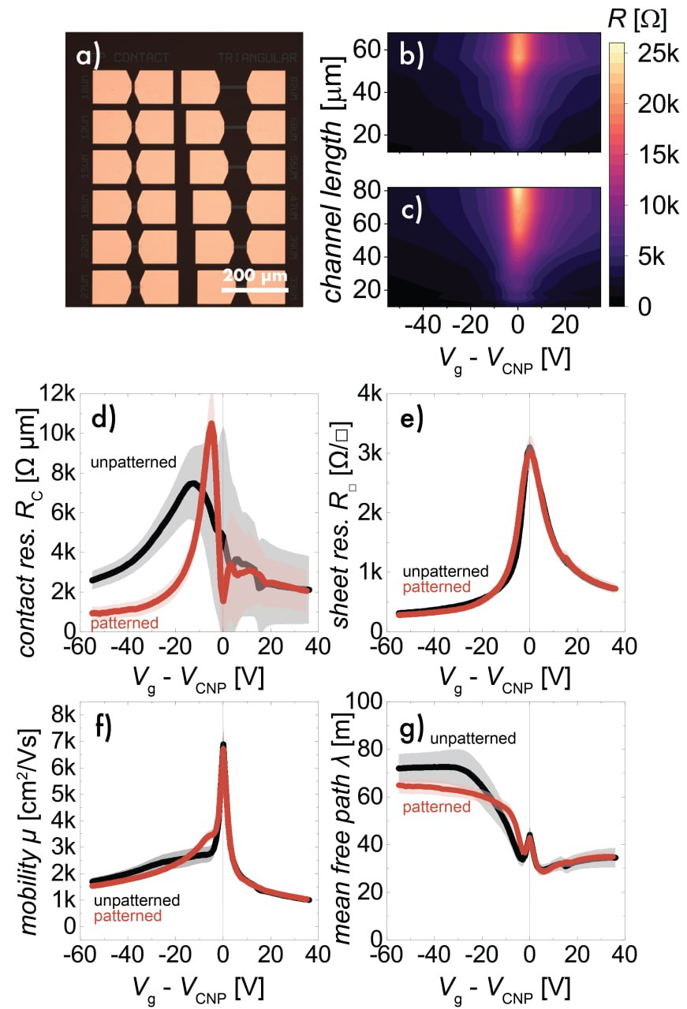
Figure S3 Measurements of the CVD graphene mean free path length on 90 nm SiO₂ at room temperature. We measured the resistance of separate two-terminal devices with different channel lengths (transfer-length measurement). Some of the devices are shown in an optical micrograph in a) (scale bar: 200 μm). The resistances at different gate voltages (normalized to the charge neutrality point) and different channel lengths are shown in b) and c) for unpatterned and patterned contacts, respectively. The contact resistance in d) and sheet resistance in e) are extracted from these measurements through a set of linear regressions. We used the sheet resistance to calculate the channel mobility at different carrier densities in f), which allowed us to estimate the mean free path of the charge carriers in the graphene channel in g). The hole mean free path reached about 65-72 nm, and the electron mean free path reached about 35 nm.

S4 – Discussion of alternative rectification mechanisms
If the rectification was due to a rectifying graphene–metal contact at one of the input terminals, the curvature should show the same polarity regardless of the applied gate voltage. In older two-terminal devices that had been exposed to air for several months, we indeed observed this effect. Previously fabricated two-terminal graphene devices that had been exposed to air for an extended period of time showed oxidation at random graphene/metal contact or both. We attribute this effect to the oxidation of the Ti adhesion layer by oxygen diffusion through the relatively thin Au layer on top, thereby forming a rectifying metal-insulator-graphene junction. An example of how such an oxidation changes the two-terminal resistance measurement of a graphene device is shown in Figure S4a. There, strong diode-like behavior has been observed in two-terminal I‒V sweeps; however, this behavior does not depend on the applied gate voltage. Importantly, the sign of the rectifying behavior is flipped in some devices.
The rectennas reported in this work do not exhibit this oxidation (Figure S4b), as evidenced by the linear current-voltage curves for the input and output of the single- and triple-funnel rectennas between -100 mV and +100 mV DC. Although the contact metal and fabrication processes for the samples (corresponding to Figures S4a and S4b) were identical, the rectenna sample presented here (Figure S4b) was not exposed to air long enough to oxidize.
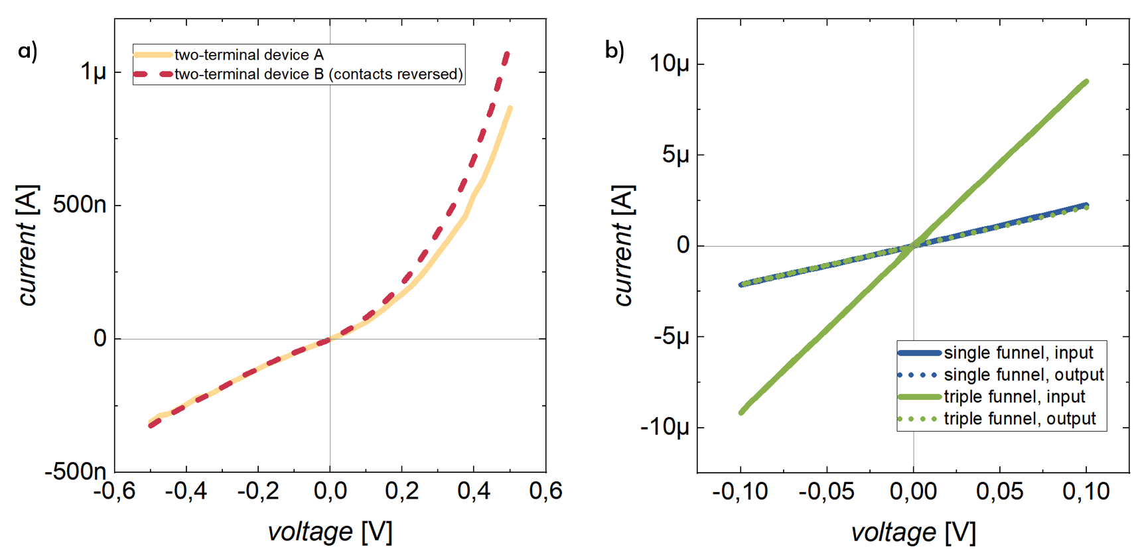
Figure S4 Current-voltage characteristics of graphene-metal contacts. a) Previously fabricated graphene/metal two-terminal devices that were exposed to air for a long time show oxidation either at one or the other contacts, which leads to asymmetric current-voltage curves. b) The devices we present in this work (single-funnel and triple-funnel rectifiers) do not show such an asymmetry, indicating that the graphene/metal contacts are not oxidized. The current-voltage characteristics measured at DC at the input and output terminals are entirely linear.
Moreover, because of the sign reversal of the curvature (Figure 2), we can discard the formation of an oxide layer as a cause of rectification in these devices. Furthermore, we do not expect photothermal effects or plasma-wave mixing effects to play a role in DC, as the measurements were performed both in the dark and under illumination with a microscope light without a change in the output voltage.
Next, we considered whether the rectification could be a simple effect arising from the conductance modulation by an applied gate voltage. The source–drain voltage required to drive the current $I_{SD}$ is approximately 1–5 V, depending on the overall source–drain resistance of the device. This value is within one order of magnitude of the gate voltage required to reach the CNP. Hence, the source–drain voltage can tune the resistivity of the graphene channel to a significant extent. For a CNP at +5 to +10 V, applying a voltage of +1 V at the source while grounding the drain would induce an electric field of 0.48 MV/m in the channel. Assuming a horizontal offset of 25 nm between the L and U terminals in this geometry, the electric field should result in a measured voltage difference of 12 mV, which is much smaller than the voltage required to shift the charge carrier concentration by a significant amount. The sign of the voltage difference follows that of the applied source voltage. Of note, the relationship between the measured L-U voltage difference and the applied source voltage (in the push-fix configuration where the drain is grounded) should be linear, not quadratic. The linear term is indeed observed in our measurements, as described above. However, it does not account for the quadratic component, which, in some measurements, can yield a voltage difference of the same polarity regardless of the input voltage polarity. While the modulation of graphene conductivity certainly plays a role, it is evidently not the primary cause of the rectification observed in our device.

S5 - Drift-Diffusion Model of the dc rectifier
We used a drift-diffusion model to verify the operation of our rectifier at DC. Figure S5a and b show the simulated and the fabricated device. The quadratic voltage component of the measured output at room temperature is compared to the simulated values in Figure S5c. The connected dots show only the quadratic voltage component, which has been derived from the measured output voltage (shown in the main text in Figure 2b) by forming the average at each symmetric current bias:
$$V_{LU,q}= \frac{V_{LU}\left(I_{SD}\right)+V_{LU}(-I_{SD}) }{2}$$ | (3)
This effectively eliminates the linear component we observe in all measurements. The black line corresponds to the simulated open circuit voltage output difference close to the CNP. The drift-diffusion model used here has many open parameters, which we have estimated here as well as possible from experimental measurements. Near the CNP, we assume a mobility of 5000 cm²/Vs and a charge density of 0.25·10¹⁶ m⁻².
Near the CNP (which we determined at +5 to +10 V applied gate in our samples), we see good qualitative agreement between the simulation and the experimentally determined values.
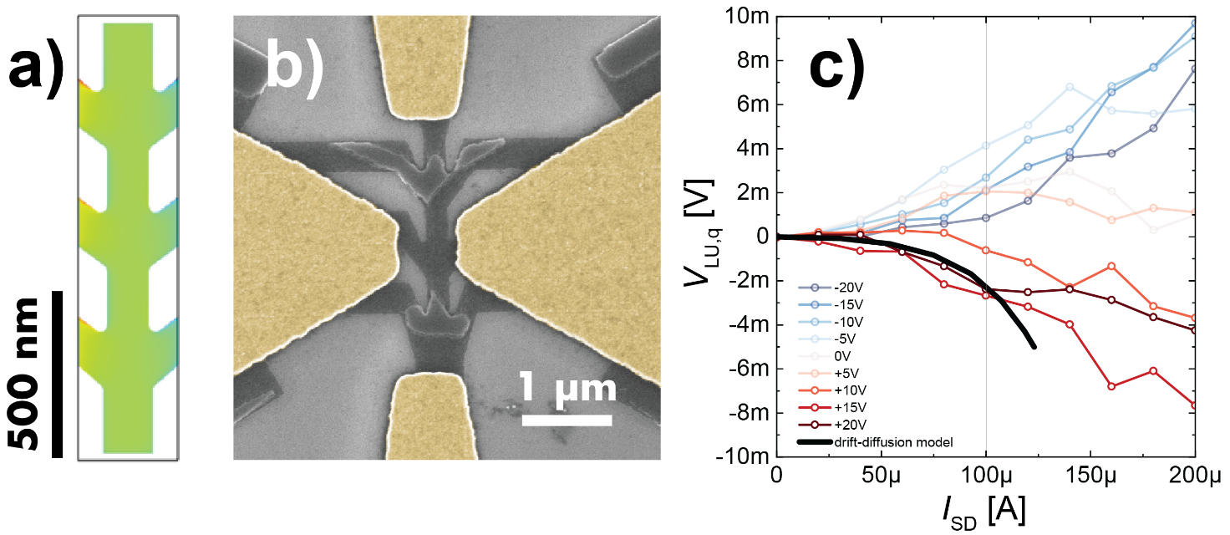
Figure S5 Drift-diffusion model of the dc rectifier. a) Simulated device dimensions. The input current is applied at the left and right terminals, and the voltage output is measured under open circuit conditions at the upper and lower terminals. b) SEM image of the fabricated device, which has been characterized in the main article. c) Comparison of experimental (connected circles) and simulated (black line) voltage output under similar assumptions.

S6 - Additional THz measurements
The measured voltage output from the single- and triple-funnel rectennas with 150 μm antennas on high-resistivity Si/SiO₂ is presented in Figure S6a. The absolute voltage output with a blocked THz beam is reduced by a factor of ~100. The voltage output shows a clear dip in the region around 557 GHz, which corresponds to the absorption of water in humid air.
We measured the voltage output from additional single-funnel devices on a different high-resistivity wafer. The antennas on this additional wafer have a length of 92 μm. The voltage responsivity is shown in Figure S6b. Compared with the relatively flat frequency response of the 150 μm rectennas, the 92 μm rectennas show a slightly increasing response towards higher frequencies. This observation is explained by the higher resonance frequency of the shorter antenna, which we estimated from simulations (Figure S2a) to be at 940 GHz and thus outside of our measurement window. We attribute the peak in the responsivity at approximately 557 GHz to the difference in air humidity between the power measurement with a calibration detector and rectenna voltage measurement.
Furthermore, we fabricated additional samples on doped Si substrate to enable gated measurements. The doped substrate adds an additional 30% absorption loss. We performed two measurements on a triple-funnel rectenna (150 μm bowtie length), with a gate-sweep at a fixed frequency at 653 GHz and a frequency sweep at fixed gate voltages of 0 V and +20 V. The measured voltage output is shown in Figures S6c and d. Voltages up to 40 V had to be applied to move the graphene towards the charge neutrality point, which we attribute to an imperfect contact between the contact needle and the substrate. Qualitative agreement can be found in the expected maximum responsivity close to the CNP (red dots in Figure S6c).
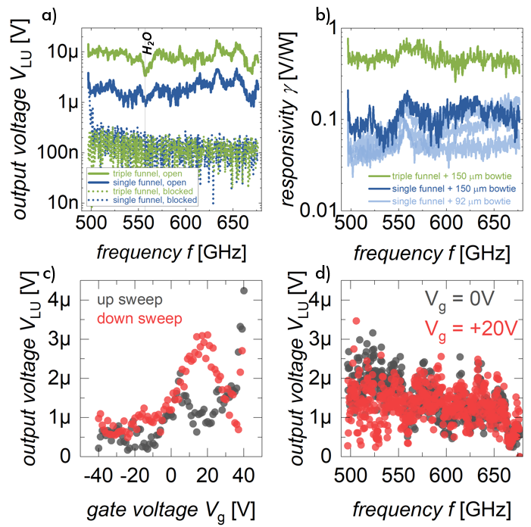
Figure S6 Additional THz measurements. a) Open circuit voltage output of both 150 μm rectennas with open and blocked THz beam. The line at 557 GHz marks the absorption line of water in humid air. b) Open circuit voltage output of additional rectennas. The rectennas in light blue were fabricated on a separate wafer and have a shorter bowtie antenna (92 μm). This design results in a responsivity that increases slightly with frequency, as the peak impedance of the shorter antenna is expected at 940 GHz instead of 573 GHz. c) and d) Measured voltage output under gate and frequency sweeps on a lightly doped substrate.

References
1. Zhong, H., Zhang, Z., Xu, H., Qiu, C. & Peng, L.-M. Comparison of mobility extraction methods based on field-effect measurements for graphene. AIP Adv. 5, 057136 (2015).
2. Lee, C.-J. et al. Extraction of intrinsic field-effect mobility of graphene considering effects of gate-bias-induced contact modulation. J. Appl. Phys. 127, 185105 (2020).
3. Lemme, M. C. et al. Towards Graphene Field Effect Transistors. ECS Trans. 11, 413–419 (2007).
4. Urcuyo, R., Duong, D. L., Jeong, H. Y., Burghard, M. & Kern, K. High Performance Graphene–Oxide–Metal Diode through Bias-Induced Barrier Height Modulation. Adv. Electron. Mater. 2, 1600223 (2016).
5. Shaygan, M. et al. High performance metal–insulator–graphene diodes for radio frequency power detection application. Nanoscale 9, 11944–11950 (2017).

