Supplement of
Weak, low-level dry convection over Angola determines offshore stratocumulus cloud droplet number concentrations
Tyler Tatro¹ and Paquita Zuidema¹
1 Rosenstiel School of Marine, Atmospheric, and Earth Science, University of Miami, Miami, FL, USA.

Correspondence to: Tyler Tatro (tyler.tatro@miami.edu) and Paquita Zuidema (pzuidema@miami.edu)

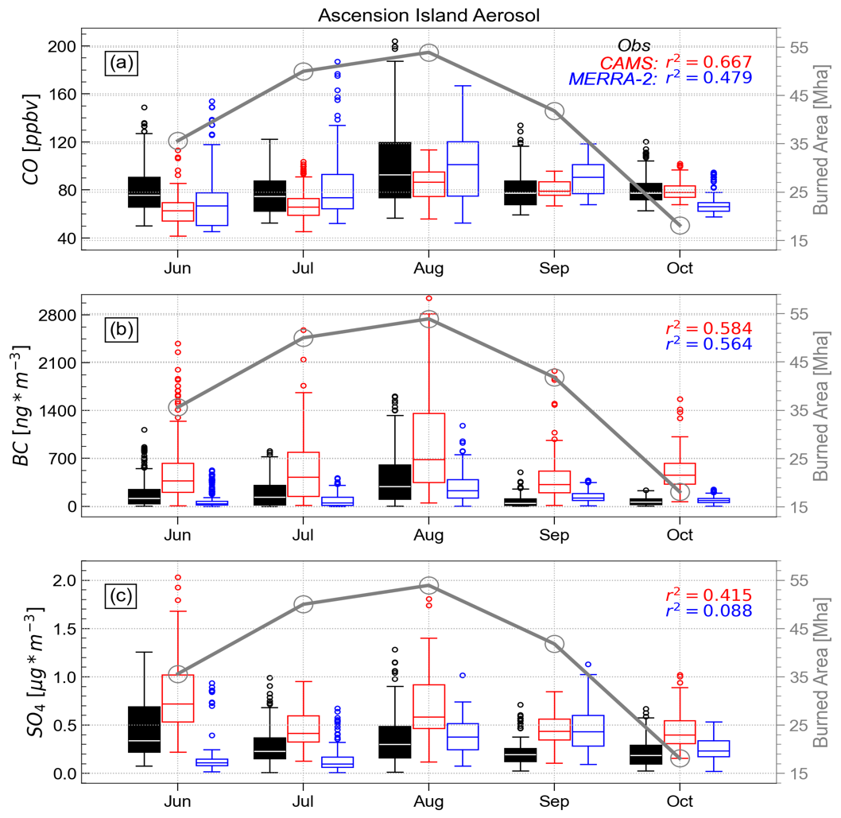
Figure S1. June-October monthly distributions of mass concentration of black carbon (a) and sulfate (b) aerosols at Ascension Island between June 2016 to August 2017 compared between observations (black; Dobracki et al. 2025), CAMS (red) and MERRA-2 (blue). Monthly mean (2003-2020) burned area (GFED5) over southern Africa (gray circles; 5°-35°S, 12°-40°W) highlights the preferential placement of aerosol in the MBL.

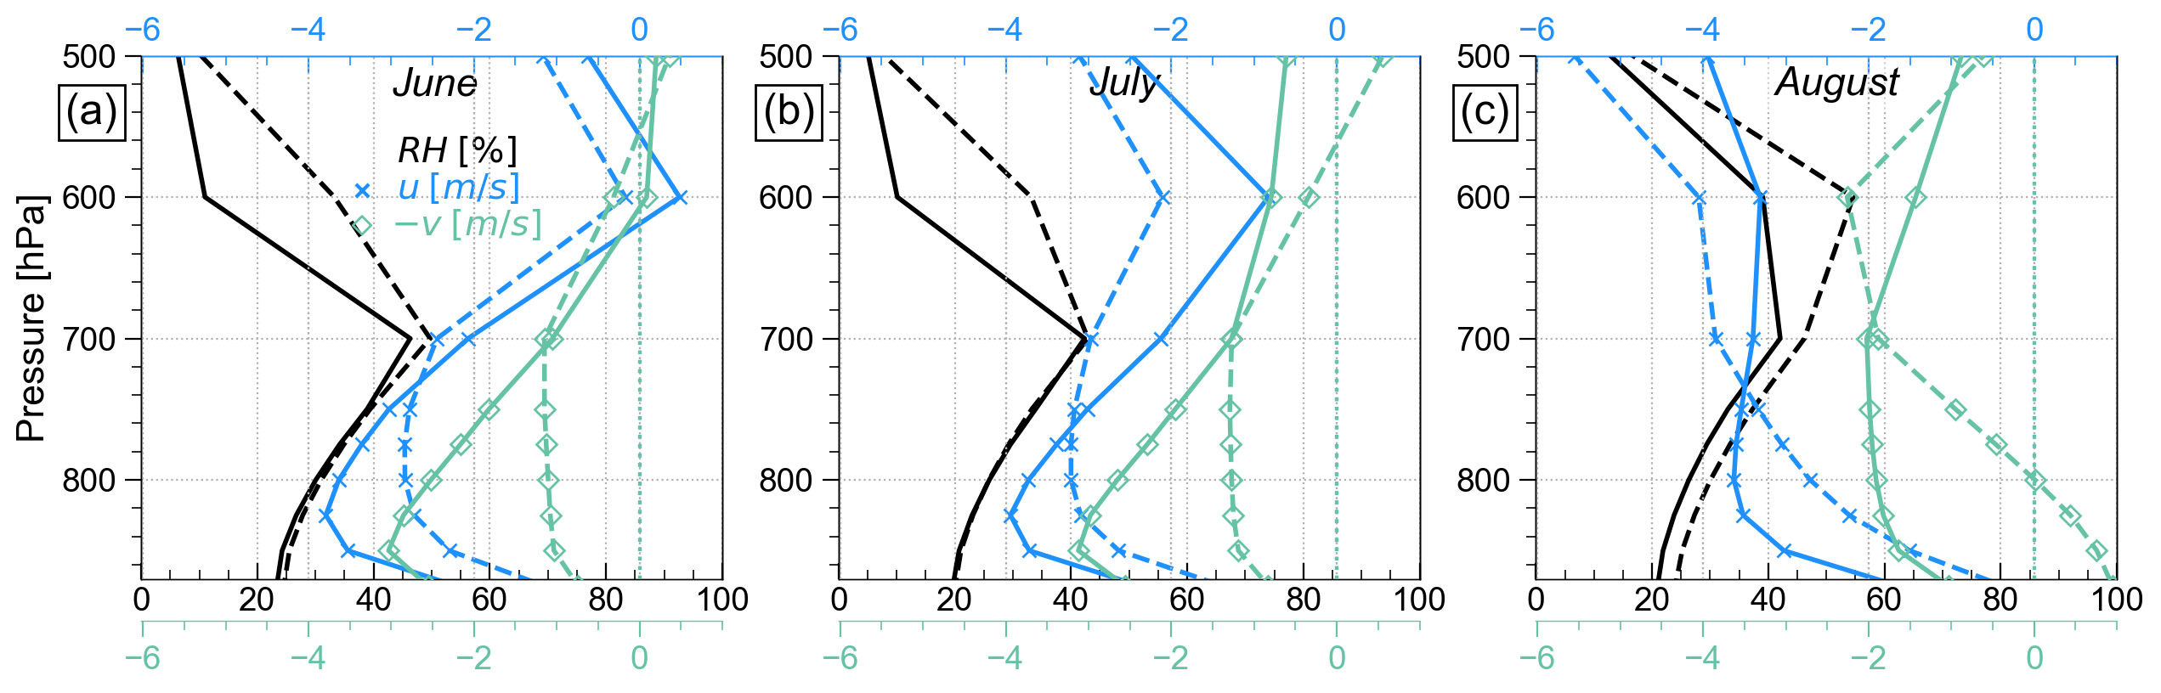
Figure S2. Average profiles of relative humidity (black), zonal wind (blue hatches) and the negative of the meridional wind (green diamonds) for the highest (solid) and lowest (dashed) terciles of LLAT ) at 18Z over the Angola Low region (8°-12°S, 15°-20°W).

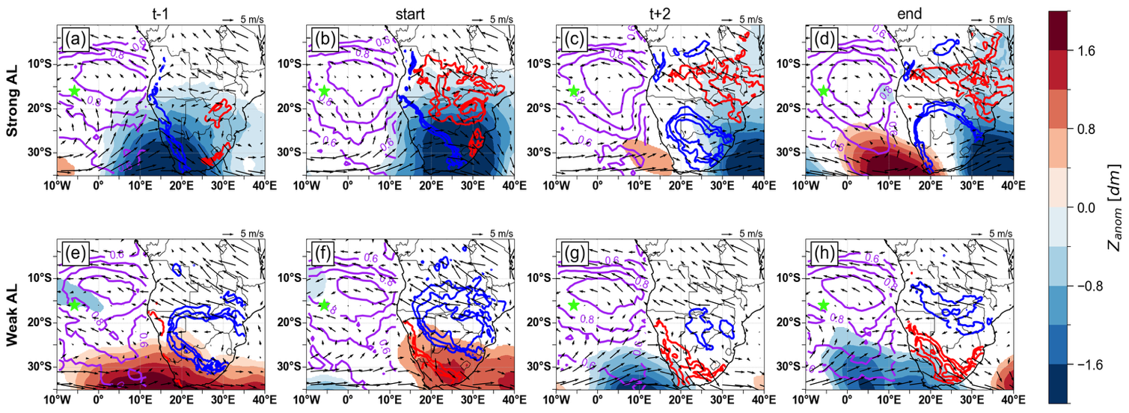
Figure S3. Daily-averaged composites of top row: strong Angolan heat low anomalous geopotential height (blue-red shading), mean 800 hPa winds (arrows), CERES LCF (purple contours, 0.6-0.8), and continental 850 hPa temperature (blue and red contours where the temperature anomaly at 850 hPa is less than -1K or greater than 1K, respectively) at a) one day prior, b) maximum LLAT, c) two days after, and at end of event (three to five days later). Only z anomalies with an absolute value greater than 0.5 dm are shown for clarity. Bottom row: same as the top row but for weak Angolan heat low events. Only August events are included. Synoptic anomalies are computed by subtracting the respective monthly mean meteorology (averaged over 2003-2023; June-July only) from each event before averaging.

T-3 | T-2 | T-1 | T=0
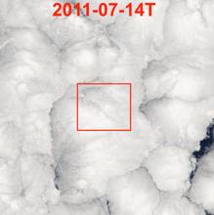 | 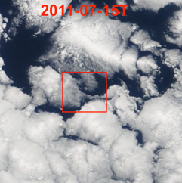  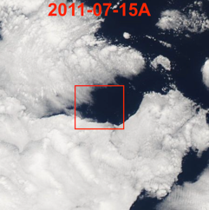 | 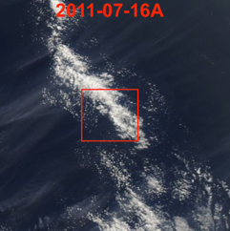 | 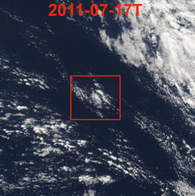
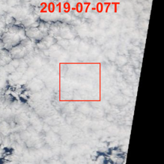  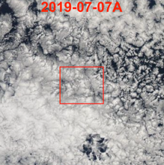 | 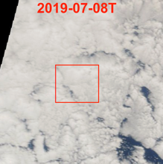  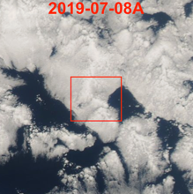 | 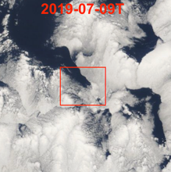 | 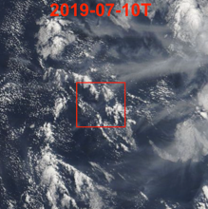  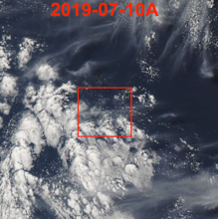
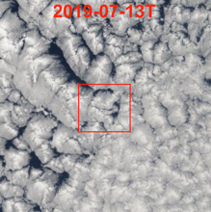  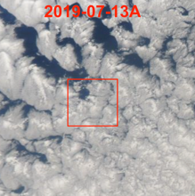 | 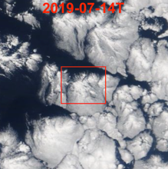  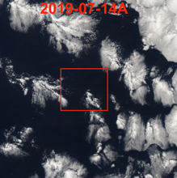 | 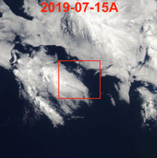 | 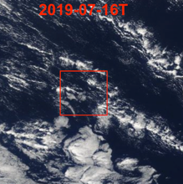
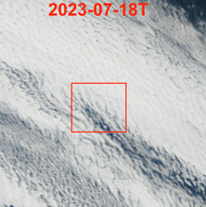  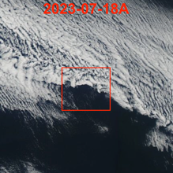 | 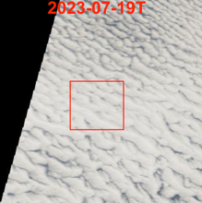  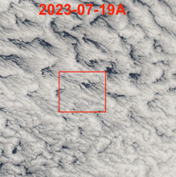 | 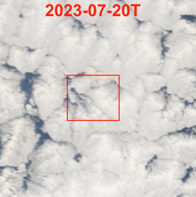  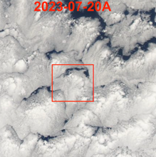 | 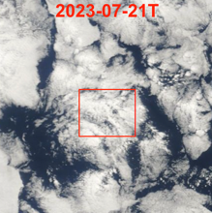  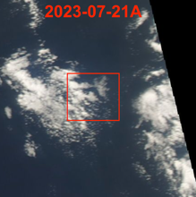
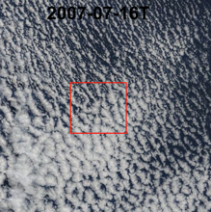 | 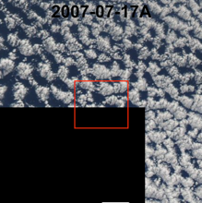 | 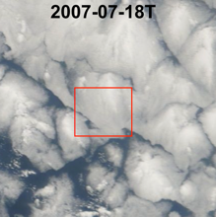 | 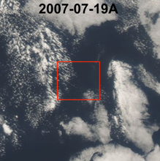
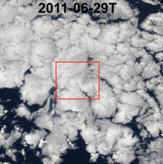  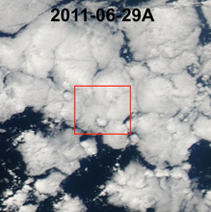 | 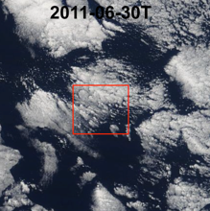  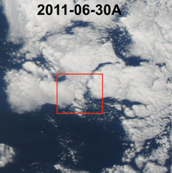 | 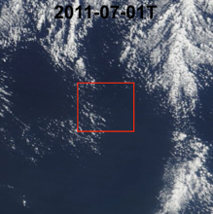  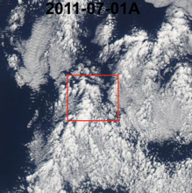 | 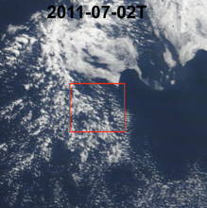
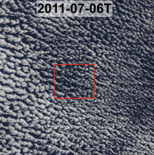  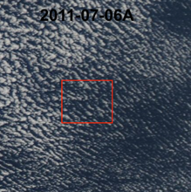 | 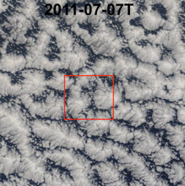 | 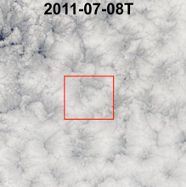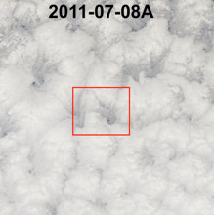 | 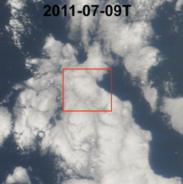  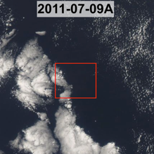
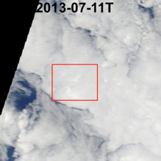  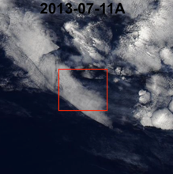 | 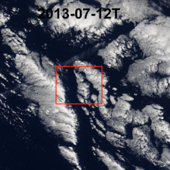 | 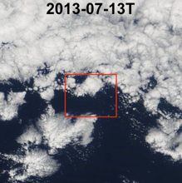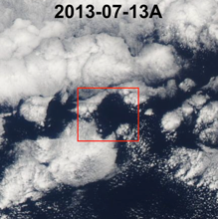 | 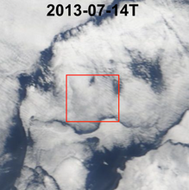  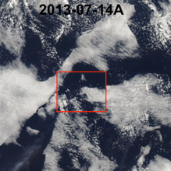
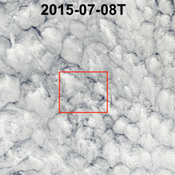  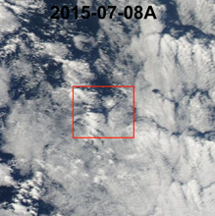 | 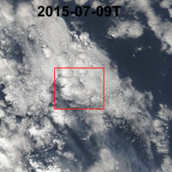  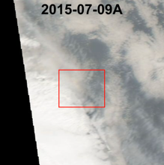 | 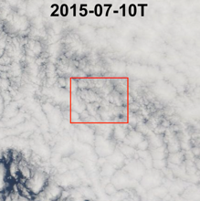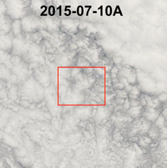 | 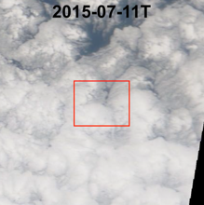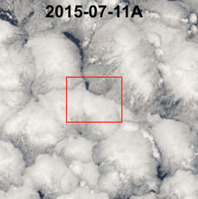
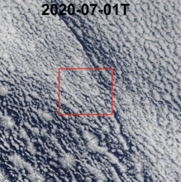  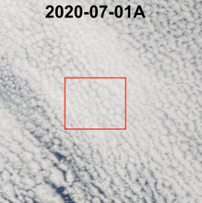 | 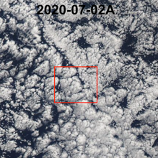 | 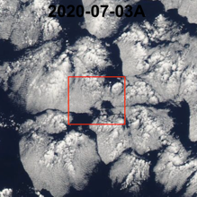 | 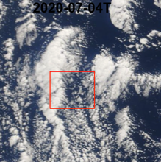  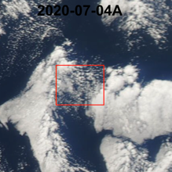

Figure S4. NASA Worldview 2°x2° Terra and Aqua Imagery (when available) for low-Nd (red dates, first 4 rows) and high-Nd (black dates, last 6 rows) cases from Figure 8. A 50x50-km red square indicates the location of the isobaric trajectory.

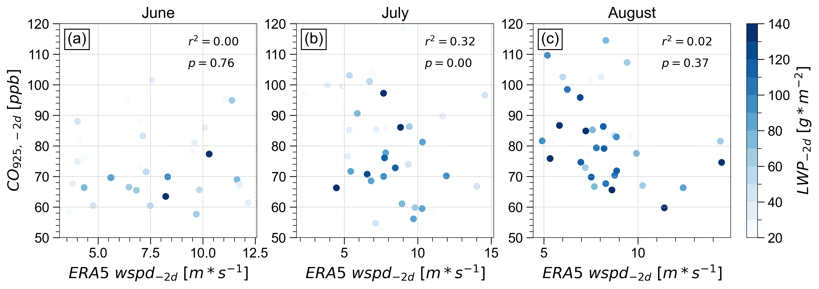
Figure S5. Correlations of back-trajectory ERA5 windspeed averaged from 1000 to 925 hPa, 2 days before arrival at Ascension with CAMS CO at 925 hPa, colored by liquid water path (light to dark blue shading). Only cases with cloud fractions greater than 50% at 3 days prior are included.

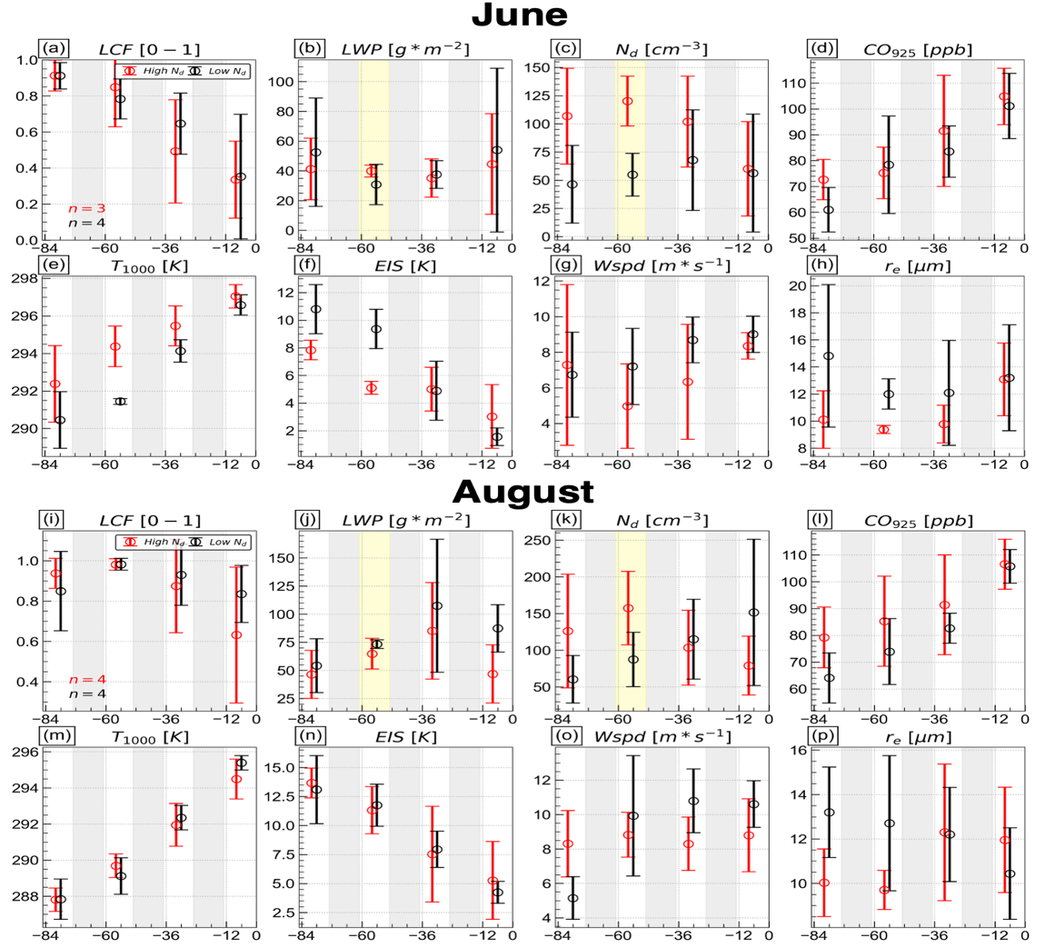

Figure S6. Same as Figure 8, but for June (a-h) and August cases (i-p). Note that surface temperature (T₁₀₀₀) serves as a proxy for SST.

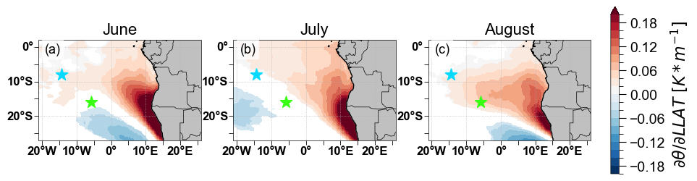
Figure S7. Significant (p<0.05) daily correlations between LLAT over the Angola Low and ERA5 lower tropospheric stability.

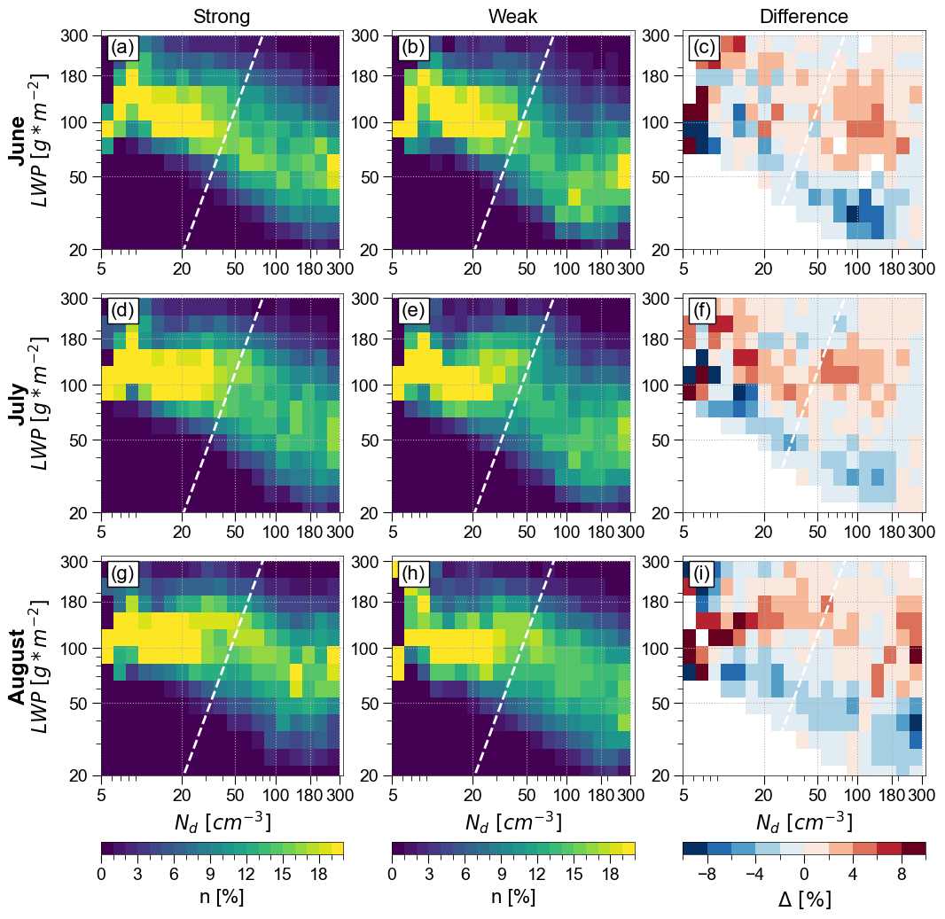
Figure S8. The same as Figure 10 but the frequency is normalized by N_{d} bins, so each column sums to 100%.

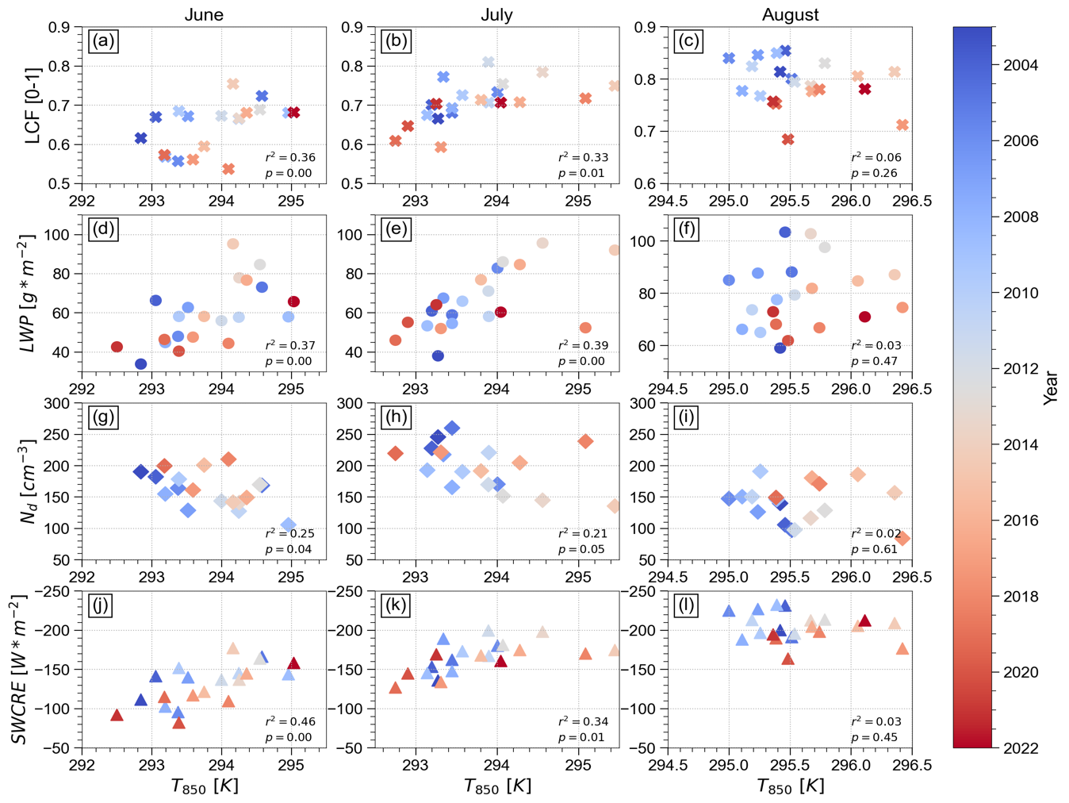
Figure S9. Monthly correlations between continental temperature at 850 hPa (10°-15°S, 15°-20°E) and stratocumulus (10°-20°S, 0°-10°W) LCF (first row) LWP (second row), N_{d} (third row), and the SWCRE (fourth row) for June (first column), July (second column) and August (third column) during 2003-2023. MODIS N_{d} values are limited to 2003-2020. Markers are colored by year

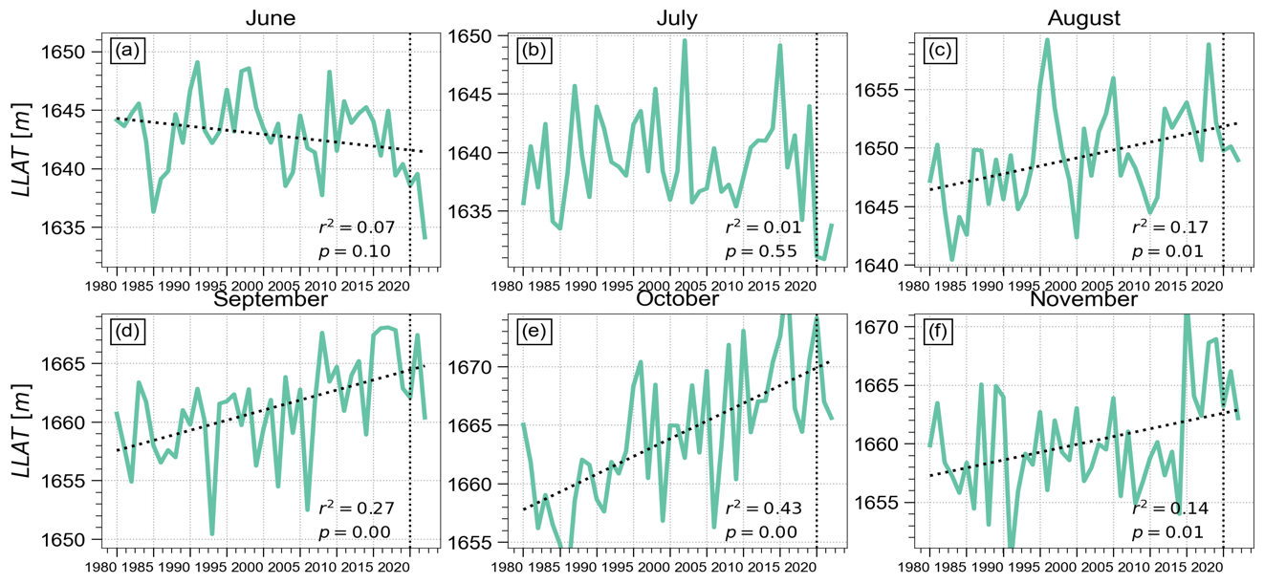
Figure S10. LLAT derived from monthly ERA5 temperature during 1980-2022, averaged over the Angola Low region in each month, moving from (8-13°S,15-20°E) in June to (19-24°S, 15-20°E) in November.

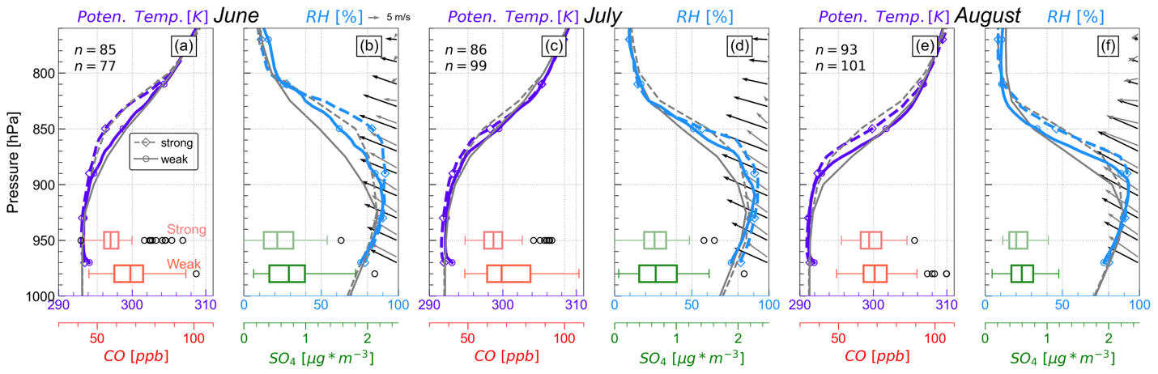
Figure S11. Profiles of potential temperature (purple, a,c,e) and relative humidity (blue, b,d,f) at St. Helena composited over strong (dashed, diamonds) and weak (solid, circles) Angola heat low events for June (a,b), July (c,d), and August (e,f). Thin gray dashed and solid lines show the ERA5 averaged strong and weak profiles. Black and gray arrows depict the observed strong and weak winds, respectively. Box and whisker plots show the average CAMS CO (a,c,e; red) and sulfate (b,d,f; greens) at 950 hPa for strong (top) and weak (bottom) AHLs.

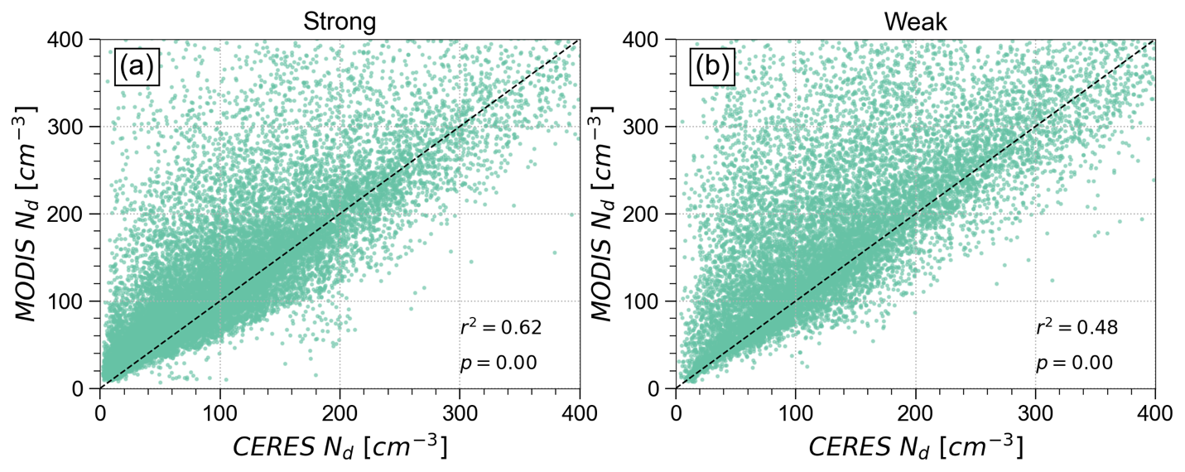
Figure S12. Daily correlations between cloud droplet number concentration (N_{d}) calculated using CERES and N_{d} from Terra MODIS over the cloud deck (10°-20°S, 0-10°W) for strong (a) and weak (b) heat low periods.

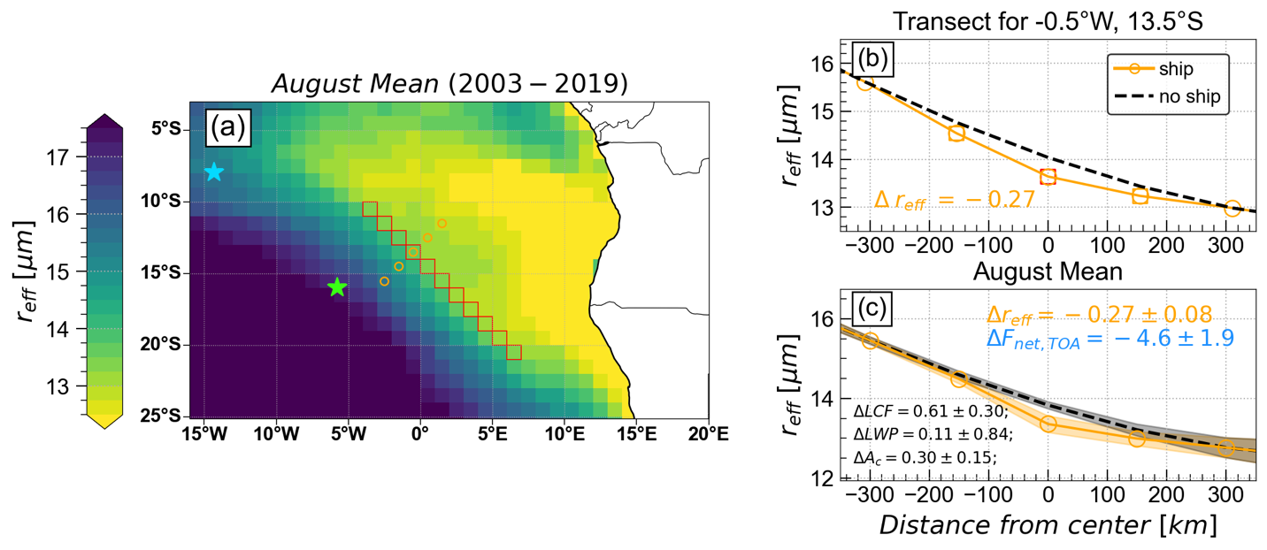
Figure S13. (a) Location of a major shipping corridor (red squares) and example cross section passing through 12.5°S, -0.5°E (orange dots), used to estimate the magnitude of the shipping influence on r_{e} (b), and (c) the average reductions in r_{e} across the ship track during August (2003-2019). Values in the lower left corner of panel c indicate the 95% confidence intervals (assuming a t-distribution) of shipping corridor differences in LCF (%), LWP (g*m²) and cloudy scene albedo (%). Ascension Island and St. Helena are noted by the blue and green stars, respectively.

