Gamma activity temporally dissociates sensory encoding from perceptual decision-making in human olfactory circuits

Zhu et al.

SUPPLEMENTARY MATERIAL

Methods
Subjects:
We acquired intracranial electrophysiological recordings from 19 subjects undergoing phase II monitoring for refractory epilepsy at Massachusetts General Hospital (Table S4; two subjects had two study sessions). The subjects were implanted with depth electrodes, with targets determined solely by clinical need. All procedures were approved by the Massachusetts General Hospital Institutional Review Board, and subjects provided written informed consent before participation.
Olfaction screen:
Olfactory function was assessed using the Brief Smell Identification Test (BSIT; Sensonics International), a validated 12-item, forced-choice odor-identification test (Fig. S5). The test was administered either self-guided or with experimenter supervision according to the manufacturer’s instructions. For each item, participants used a provided pencil to scratch the odorized label to release the odorant, sniffed the label, and selected the response option that best matched their perceptual experience from four alternatives. If the perceived odor was unclear or absent, participants were instructed to select the closest match or to indicate a guess if no odor was perceived; a response was required for every item. The total BSIT score was calculated as the number of correctly identified odors (range: 0-12) and was used to confirm intact odor identification ability prior to experimental testing.
Intracranial recording setup:
Local field potentials were acquired at a sample rate of 1 kHz from PMT electrodes using the 256-channel clinical Natus system. Coverage of the entire cohort is provided in Figure 5E and was typically most dense in the frontal and temporal lobes.
Anatomical labeling:
As previously described, the locations of the sEEG leads were determined using CT imaging, preoperative in-frame CT, and preoperative MRI ¹. A posteriori normalization of each subject's MRI to MNI brain space and automatic identification of sEEG electrode and gyri location were performed with FreeSurfer and the Destrieux atlas ^{2,3}. DICOM images were coregistered using Advanced Normalization Tools (ANTs) and hybrid statistical parametric mapping (SPM) algorithms, and then normalized to the International Consortium for Brain Mapping (ICBM) 152 nonlinear 2009b template.
Hardware:
We presented our participants with pulses of odorants that were time-locked to the onset of inspiration via a custom 3-channel olfactometer. The output of the olfactometer was connected to a nasal cannula that outputs a constant stream of room-temperature, humidified air at 3 L/min, verified by a flow sensor. Upon triggering of our online inspiration onset detection algorithm, the airflow is diverted into one of three jars, containing either an artificial rose scent, carbon dioxide, or odorless air. The artificial rose scent (phenethyl alcohol, CAS N° 60-12-8) was chosen as it is generally a scent with positive valence, and it selectively activates the olfactory nerve in low concentrations. Carbon dioxide was chosen to complement this, as it generally has a negative valence, and it selectively activates the trigeminal nerve. Other than the contents of the jar, the condition of odorless air shared equivalent circuitry to the odor conditions and was included as a control for any pressure changes due to the switching of the circuit.
Photo-ionization detector calibrations:
To quantify the temporal profile and effective dose of odorant delivery, we measured time-resolved odorant concentration at the nasal cannula using a photo-ionization detector (PID). In a separate calibration experiment, ten trials of 250-ms PEA pulses were delivered through the olfactometer while the PID recorded the resulting concentration trace. Across trials, odorant signals exhibited an approximately 250-ms latency from valve opening to the initial rise in detected concentration, followed by an additional ~250-ms rise time to peak concentration at the cannula. For all experimental trials, the cumulative inhaled odorant dose was estimated as the integral of the PID concentration trace over the inspiration window, providing a scalar measure of delivered odorant quantity.
Online inspiration onset detection algorithm:
The participants’ respiration was tracked during the experiments via two sensors: (1) a thoracic respiration belt and (2) a thermistor embedded in the nasal cannula to measure the temperature of the airflow at the nostril. Both signals were processed by a National Instruments data acquisition system, then read in real-time by MATLAB. Every 50 ms, a packet of 100 Hz data from each sensor was sent to MATLAB, where a generalized linear model would predict whether the subject was currently within the inspiratory phase, based on the preceding five seconds of respiration data. If the model output was above a predefined threshold, simultaneous electrical triggers were sent to the olfactometer’s solenoid valves to deliver the pulse of odorants, as well as the Natus system and the olfactometer’s data acquisition system for synchronization. This inspiration detection model was trained individually for each participant by collecting one minute of training data during passive respiration and manually verifying the inspiration beginning and end times. Model accuracy was then validated on a 30 second testing interval.
Passive perception design:
Prior to beginning the task, we screened participants for their ability to smell with a twelve-item brief smell identification task. Afterwards, the participant was equipped with the olfactometer’s nasal cannula as well as noise-cancelling headphones and instructed to remain awake and focused on their perception of smells. They were given a podcast as a distraction audio through their headphones to maintain a constant level of attention. Throughout the task, pulses of PEA, CO₂, or Blank were delivered at the beginning of the first inspiration following a 10-15 second refractory period. Following the task, participants were surveyed on their experience and all patients that were normosmic per screening reported sensations that were attributable to the PEA and CO₂ scents.
Dose response task design:
The dose response task followed a similar design as the passive perception task in terms of screening, model training, noise-cancelling, and stimulus timing. However, participants were given a push button and instructed to press the button any time they detected the onset of an odor during the task, while minimizing extraneous movements. Odor stimuli in this task were randomly selected from six discrete intensities that were modulated by varying the amount of time that the olfactometer’s output flow was diverted through the scented jar. The maximum intensity (500 ms) was consistently detected by all normosmic trial subjects during laboratory benchmark testing. The remaining five levels were determined by halving the pulse duration until the minimal dose of 15.6 ms, where the majority of normosmic participants could detect the scent less than 25% of the time. Benchmark testing with a photoionization detector confirmed that this method of odor intensity modulation resulted in pulses of increased odorant concentration that were consistent in duration and onset time, but variable in amplitude.
Preprocessing of electrophysiological data:
We applied notch filters at 60 Hz and its harmonics (60, 120, 180, 240 ± 1 Hz) to reduce line noise, a 5th-order Butterworth high-pass filter at 1 Hz to reduce low-frequency drift across trials, and a low-pass filter at 250 Hz to reduce aliasing. We then bipolar re-referenced each contact to its neighboring contact.
To compute the time-frequency objects, we split the data into epochs of 3-5 seconds relative to the valve opening of each trial, as identified by an electrical trigger from an Arduino MEGA on the olfactometer to the Natus system. The valve opening time corresponds to the moment the olfactometer’s control valve switched airflow from clean air to the odorized channel; this electronic trigger was used as the temporal reference point (time = 0) for all time-locked analyses.
Cluster-based permutation test:
To assess the significance of the neural response in each band to odor presentation, we conducted a cluster-based permutation test. At each time point relative to odor delivery, a paired t-test of band power was performed for each trial, comparing it with the preceding inspiration. We used a cluster p-value of 0.05 and weighted the clusters by their t-values. The trial labels were then permuted 1,000 times to create a null distribution, and a p-value of 0.05 was used to determine significant clusters.
Single-trial estimation of gamma activity:
Onset and offset of gamma activity were determined using a dual-thresholding approach. Wavelet-derived time-frequency representations of the LFPs were first filtered to broadband gamma power (30-200 Hz). Then, the onset of gamma activity was defined as the first time the power exceeded 2.5 standard deviations above the mean of the baseline window (-3 to -2 s) following odor delivery, and the offset was defined as the next time the signal fell below 1.0 standard deviations above the mean. For a single-trial estimate of the gamma response to odor delivery, we used the average power over a time-frequency window of 0.5-2.5 seconds following inspiration onset and 30-200 Hz.

Additional reference
1 Randazzo, M. J. et al. Three-dimensional localization of cortical electrodes in deep brain stimulation surgery from intraoperative fluoroscopy. Neuroimage 125, 515-521, doi:10.1016/j.neuroimage.2015.10.076 (2016).
2 Dale, A. M., Fischl, B. & Sereno, M. I. Cortical surface-based analysis: I. Segmentation and surface reconstruction. Neuroimage 9, 179-194 (1999).
3 Destrieux, C., Fischl, B., Dale, A. & Halgren, E. Automatic parcellation of human cortical gyri and sulci using standard anatomical nomenclature. Neuroimage 53, 1-15, doi:10.1016/j.neuroimage.2010.06.010 (2010).

Supplementary Figure 1 | Conceptual framework for dissociating sensory chemosensory responses from motor and attentional confounds in human olfaction. Schematic illustrating how prior human olfaction paradigms necessarily entangle chemosensory processing with breathing- and report-related motor and attentional components, and how the fully passive, inspiration-locked design of the present study enables their separation.
In most previous human studies (blue outline), olfactory stimulation co-activates olfactory and trigeminal pathways while also engaging active sensing (sniffing) and explicit perceptual report, making it difficult to isolate stimulus-locked sensory responses. In contrast, the present study employs a passive, inspiration-locked intranasal delivery paradigm to independently probe predominantly olfactory (orange outline) and predominantly trigeminal (green outline) stimulation without requiring volitional sniffing or overt behavioral report during stimulus presentation.
Breathing-related motor and attentional influences (bottom left) and reporting-related motor and attentional processes (bottom right) are explicitly separated from stimulus-locked neural activity. This design enables isolation of chemosensory stimulus-locked electrophysiological responses in olfactory cortex (center), facilitating dissociation of genuine sensory-evoked activity from action- and attention-related high-frequency responses. Colored outlines denote experimental regimes rather than anatomical or causal pathways.

Supplementary Figure 2 | Custom-designed olfactometer setup. A. Olfactometer diagram. Air is conditioned and mixed with CO2 or odorants (stored in pressure-tight jars) and delivered to the participant through a nasal cannula. Solenoid valves activated by a microcontroller control the air flow. Online analysis of the respiration sensor and thermistor near the nostrils allows to time-lock odor presentation to inhalation. A flow sensor is included to assess the precise timing of stimulus presentation. B. Olfactometer during a benchmarking run of the task.
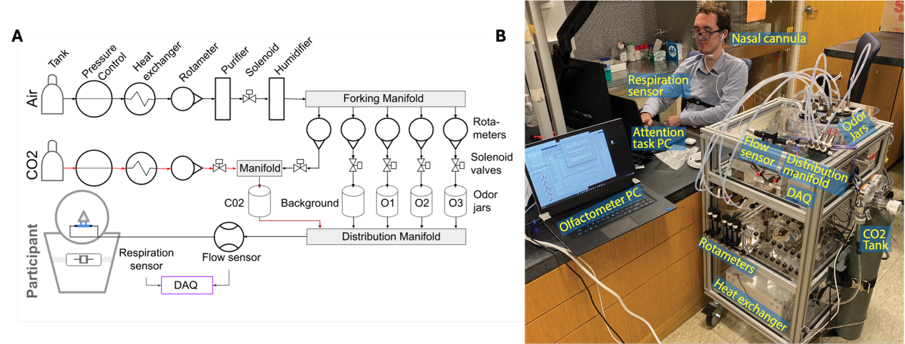

Supplementary Figure 3 | Controlled olfactory stimulation. A-B. Baseline respiration pattern as acquired by the thermistor and respiration sensor, used to train the decoding model. C. Histogram of stimulus onset time (red, measured from flow sensor) and inspiration end times (gray) relative to the inspiration onset time (t=0, manually identified from the thermistor and respiration belt data).
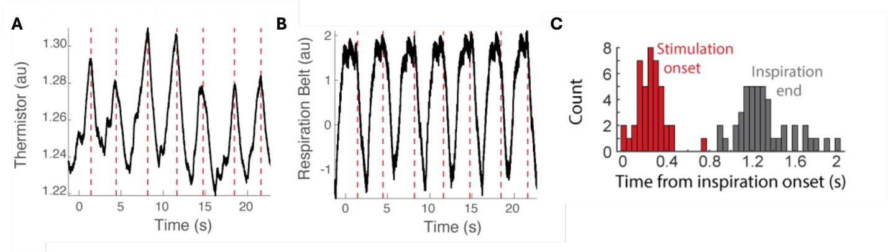

Supplementary Figure 4 | Spatial distribution of intracranial sEEG electrode coverage. Distribution of sEEG electrode contacts across all participants included in the study. Electrode contacts are projected onto a standard anatomical brain surface and shown from multiple viewpoints to illustrate overall coverage. Each dot represents a single electrode contact, with colors corresponding to individual participants. Electrodes were implanted solely based on clinical considerations for seizure localization in patients with refractory epilepsy, resulting in heterogeneous but extensive coverage across frontal, temporal, parietal, and insular regions. This coverage enabled sampling of olfactory- and trigeminal-related brain regions, including piriform cortex, amygdala, insula, orbitofrontal cortex, and adjacent temporal and frontal areas.

Supplementary Figure 5 | Olfactory screening using the Brief Smell Identification Test (BSIT).
A. Front instruction page of the BSIT booklet. B. Example test item showing an odorized scratch-and-sniff label and the corresponding multiple-choice response options. C. Answer sheet used to record responses for all test items. The BSIT is a standardized, forced-choice odor identification test used to screen olfactory function prior to experimental testing.
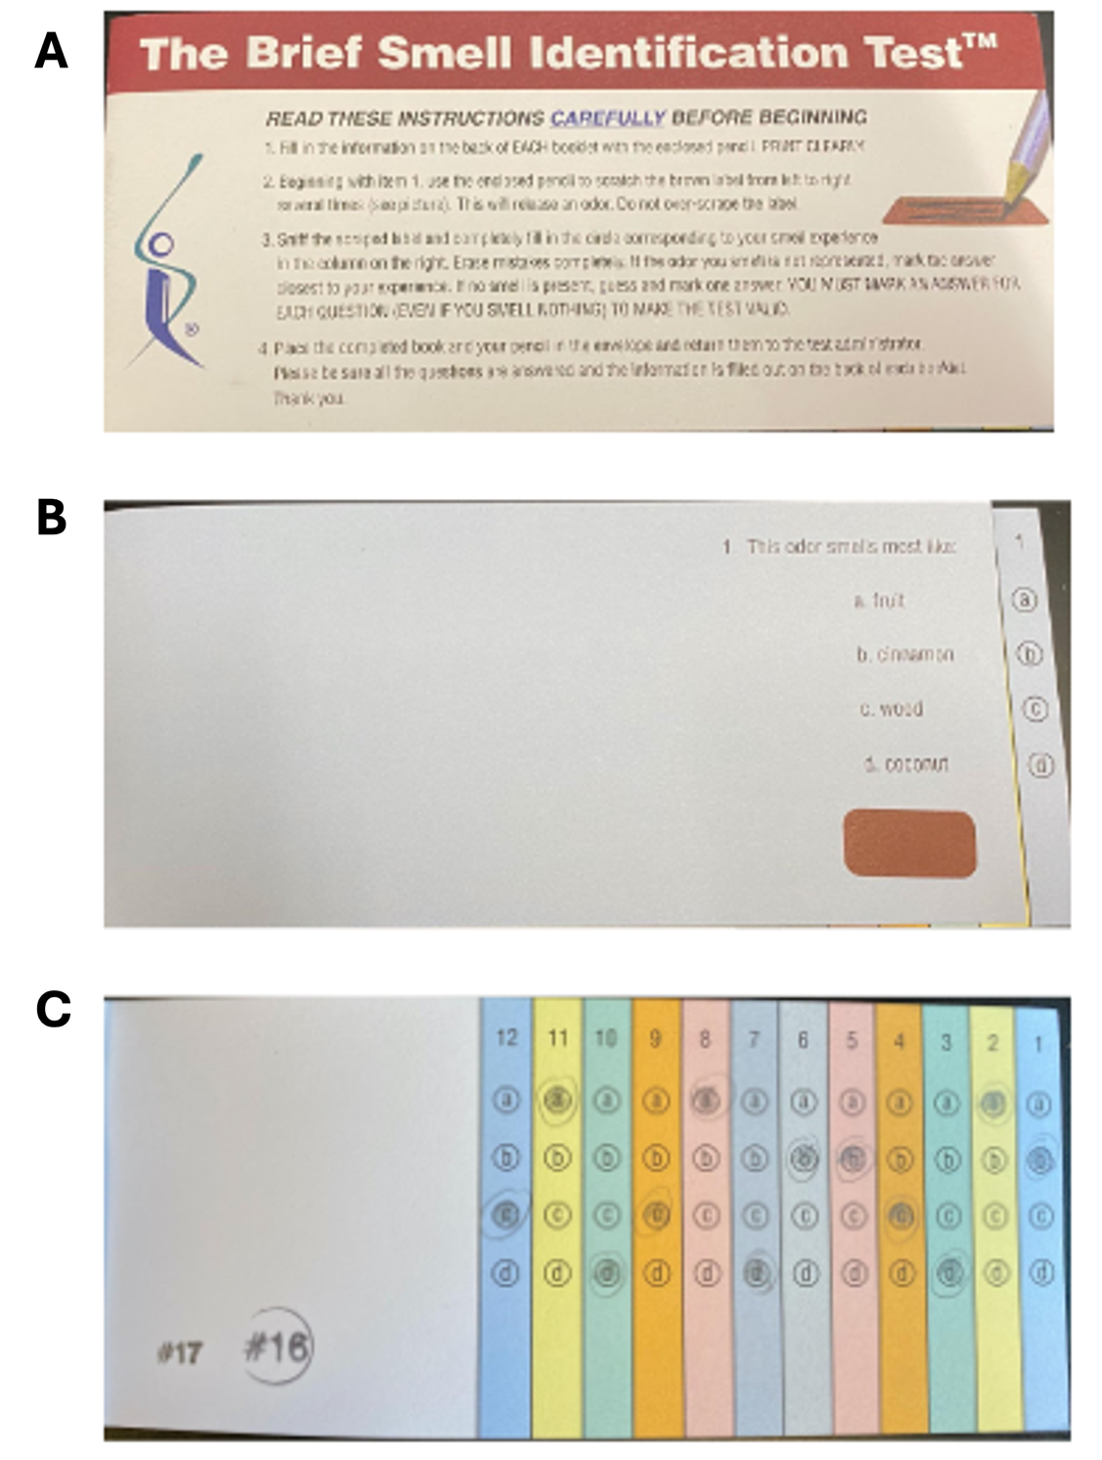

Supplementary Figure 6 | Inspiration-locked olfactometer valve timing and airflow dynamics. A. Representative respiration trace from a single participant illustrating the timing of online inspiration detection and stimulus triggering. The black trace shows the continuous respiration signal (arbitrary units), with inspiration (“insp”) and expiration (“exp”) phases indicated above. Colored traces represent model-predicted inspiration segments across multiple trials, aligned to the detected inspiration onset. The red dashed vertical line (“trigger”) indicates the time point at which the online prediction crossed the threshold and triggered the olfactometer solenoid valve. Gray dashed vertical lines mark the estimated end of inspiration (“insp. end”) for each cycle.
B. Trial-averaged prediction error of the inspiration detection model as a function of time relative to the end of inspiration (t = 0 s). Prediction error is expressed as the temporal offset between the model-predicted trigger time and the true inspiratory phase, estimated from post hoc respiration labeling. The red dashed vertical line indicates the trigger time relative to the inspiration end.
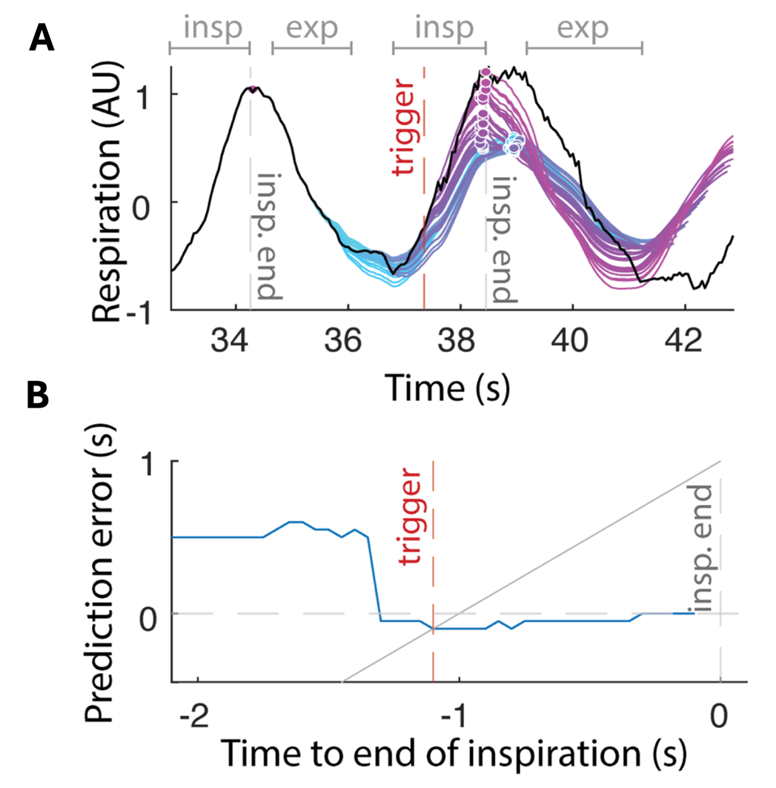

Supplementary Figure 7 | Calibration of nasal flow sensor responses across stimulus conditions. Calibration traces from the nasal flow sensor during delivery of phenyl ethyl alcohol (PEA; red), carbon dioxide (CO₂; blue), and odorless air (Blank; black). Traces are time-aligned to valve opening (t = 0 s; vertical red line) and represent repeated calibration trials for each stimulus type.
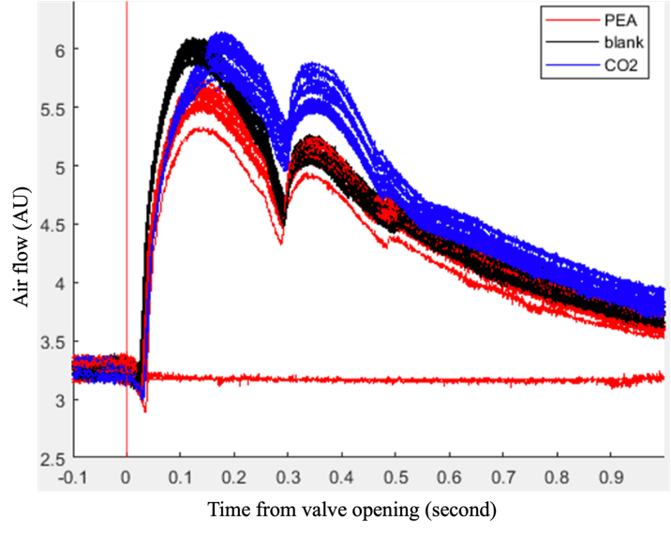

Supplementary Figure 8 | Respiration belt traces during inspiration-locked passive chemosensory stimulation. Respiration belt recordings from individual participants during passive chemosensory stimulation. Each column corresponds to a single participant (IDs shown above panels), and each row corresponds to a stimulus condition: phenyl ethyl alcohol (PEA; top), carbon dioxide (CO₂; middle), and odorless air (Blank; bottom). Within each panel, individual traces represent single trials, time-aligned to the predicted onset of inspiration (red vertical line at t = 0).
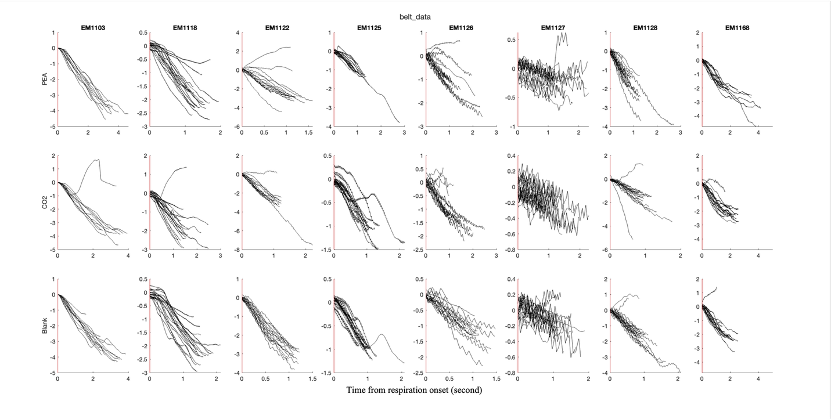

Supplementary Figure 9 | Thermistor traces during inspiration-locked passive chemosensory stimulation. Nasal thermistor recordings from individual participants during passive chemosensory stimulation. Each column corresponds to a single participant (IDs indicated above panels), and each row corresponds to a stimulus condition: phenyl ethyl alcohol (PEA; top), carbon dioxide (CO₂; middle), and odorless air (Blank; bottom). Within each panel, individual traces represent single trials, time-aligned to the predicted onset of inspiration (red vertical line at t = 0).
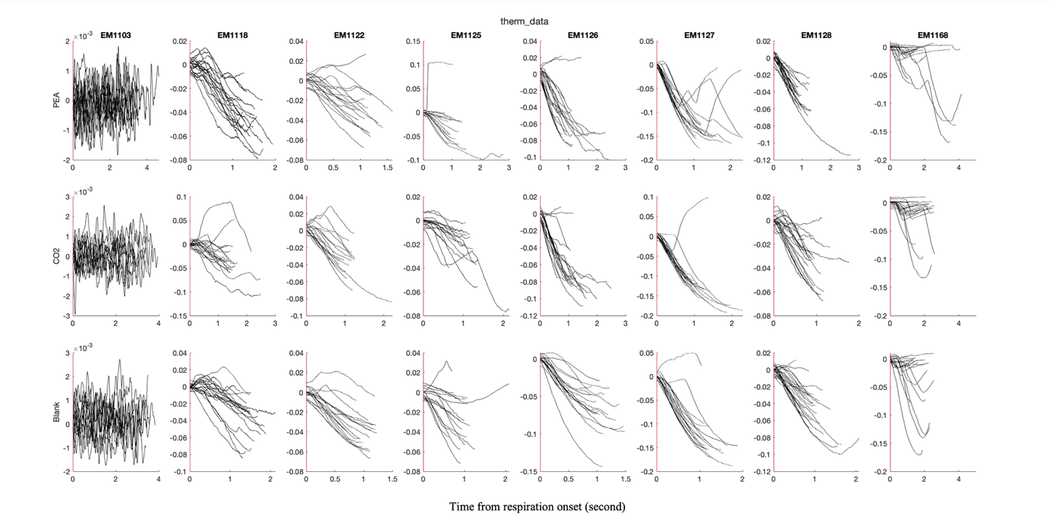

Supplementary Figure 10 | Respiratory timing and amplitude metrics are comparable across chemosensory conditions. Trial-by-trial respiratory metrics extracted from respiration belt and nasal thermistor recordings during passive chemosensory stimulation. Each column corresponds to a single participant (IDs indicated above panels). Data are shown separately for phenyl ethyl alcohol (PEA; blue), carbon dioxide (CO₂; red), and odorless air (Blank; yellow). Top row: Inspiration duration, computed from respiration belt signals for each trial. Middle row: Nasal thermistor amplitude. Bottom row: Respiration belt amplitude.
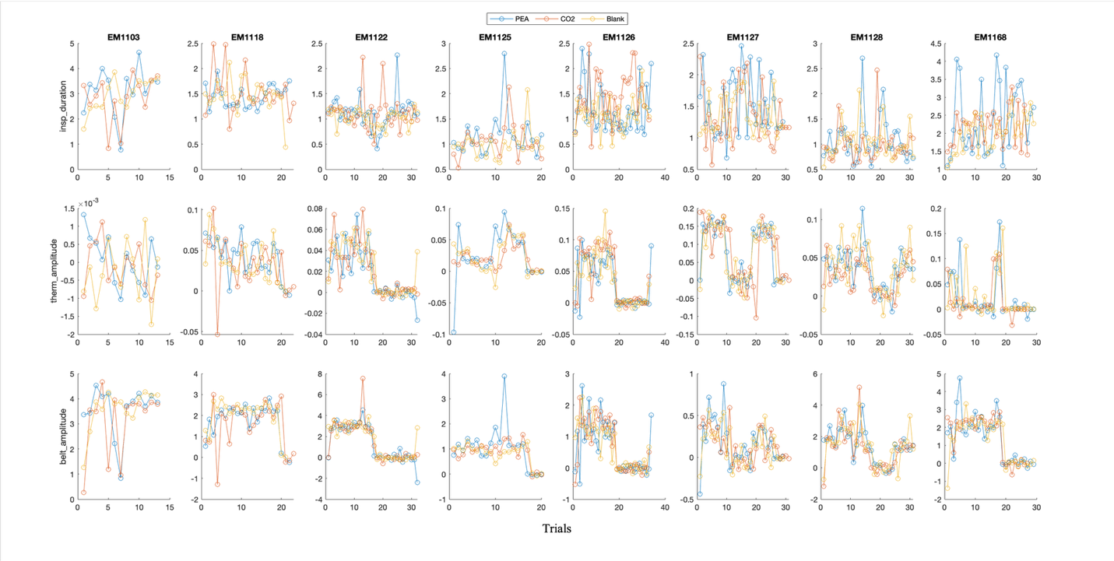

Supplementary Figure 11 | Traces of odorants using a photo-ionization detector. Time-resolved odorant concentration was measured using a photo-ionization detector (PID) positioned at the nasal cannula during offline calibration. A. Overlaid traces from ten trials of 250-ms PEA pulses, aligned to valve opening (time = 0). The solenoid valve control signal (black line, left y-axis) is shown alongside the corresponding PID signal (purple lines, right y-axis). Odorant concentration exhibited an approximately 250-ms latency from valve opening to initial detection, followed by a ~250-ms rise time to peak concentration, with highly consistent temporal profiles across trials. B. Continuous PID recording across repeated odorant pulses illustrates the reproducibility and stability of odorant delivery over time. For all analyses, the cumulative inhaled odorant dose was estimated as the integral of the PID concentration trace over the delivery window.
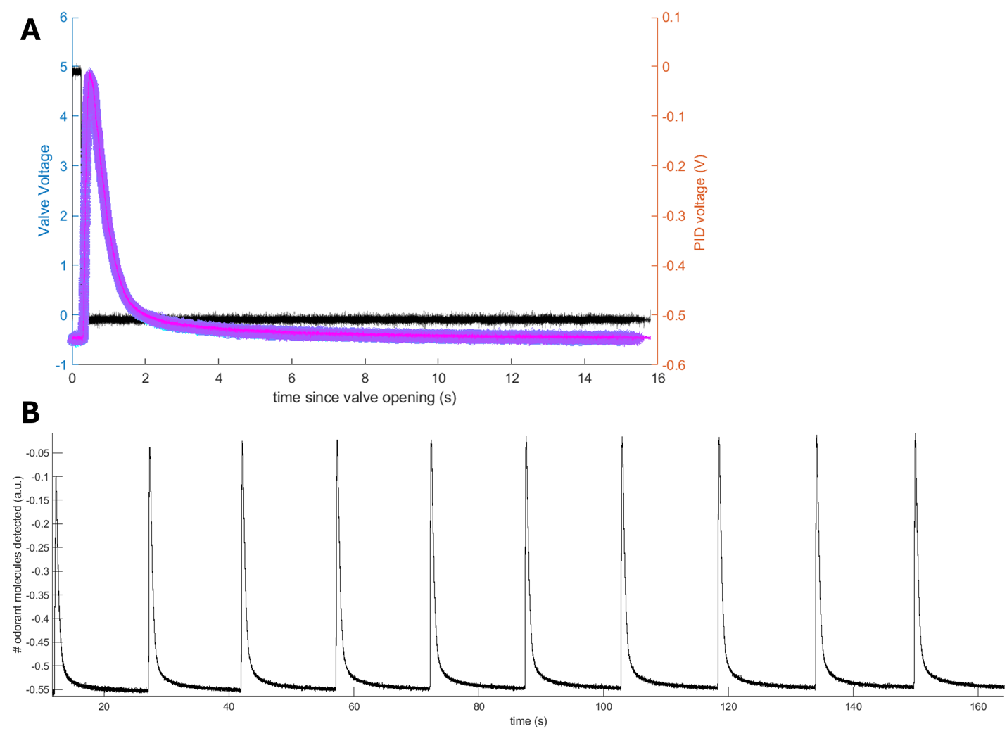

Supplementary Figure 12 | Timing of odor presentation relative to inspiration across participants. Distributions of odor presentation timing relative to the onset and offset of inspiration for each participant (IDs shown on the left). Histograms show the timing of odor onset (blue) and odor offset (orange) aligned to inspiration onset (t = 0 s; black vertical line), measured using respiratory signals and olfactometer control logs. The x-axis indicates time relative to inspiration onset.
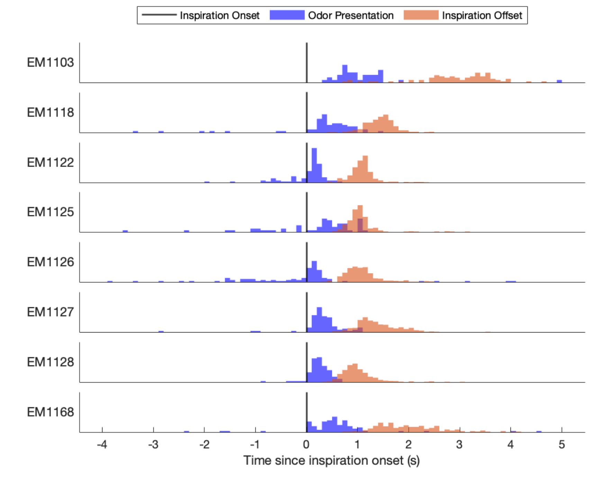

Supplementary Figure 13 | Controls for dissociating chemosensory responses from respiration-related activity. Schematic illustration of the four airflow and stimulation conditions used to isolate genuine chemosensory neural responses from respiration-related, mechanical, and acoustic confounds associated with olfactometer operation. From top to bottom: Preceding inspiration: Continuous, odorless airflow delivered without valve opening, providing a respiration-only control condition with no mechanical or acoustic perturbation. Blank: Odorless air delivered with a solenoid valve opening, introducing identical airflow diversion, pressure transient, and valve sound as odor trials but without chemosensory stimulation. PEA: Phenyl ethyl alcohol delivered during inspiration via valve opening, producing olfactory stimulation alongside airflow and valve-related mechanical and acoustic effects. CO₂: Carbon dioxide delivered during inspiration via valve opening, selectively engaging trigeminal chemosensory pathways while preserving identical airflow dynamics and valve-related artifacts.

Supplementary Figure 14 | Additional analyses for the representative electrode shown in Fig. 1F. A. Baseline-normalized power spectral density (PSD) averaged across trials for Blank (left), PEA (middle), and CO₂ (right) conditions. Shaded regions indicate canonical frequency bands used throughout the study: theta (4–8 Hz), beta (13–30 Hz), and gamma (30–200 Hz). Power is expressed relative to a pre-stimulus baseline. B. Time-resolved power in theta, beta, and gamma bands for Blank (left), PEA (middle), and CO₂ (right) trials, aligned to valve opening (t = 0 s). Solid lines indicate the trial-averaged power, and shaded envelopes denote ± SEM across trials. PEA and CO₂ elicit sharp, stimulus-locked increases in beta and gamma power, whereas Blank trials show weaker or absent high-frequency modulation. C. Trial-by-trial power dynamics for the same electrode, shown separately for theta (top), beta (middle), and gamma (bottom) bands. Each row corresponds to an individual trial, aligned to valve opening (t = 0 s; dashed vertical line). For each band, panels show Blank (left), PEA (middle), and CO₂ (right) conditions. Red dashed lines indicate the estimated inspiration window for each trial. Consistent, stimulus-locked beta and gamma responses are observed during inspiration for PEA and CO₂ trials, with substantially reduced modulation during Blank trials.
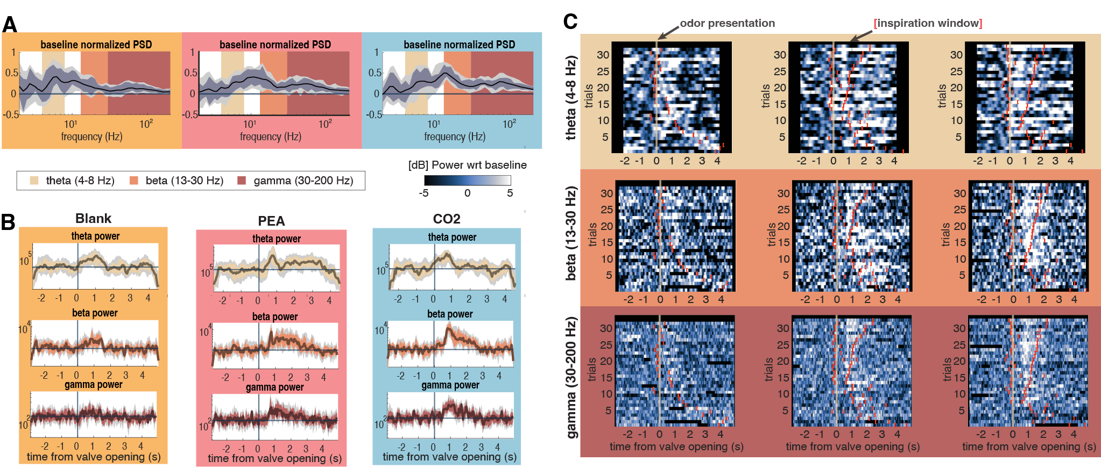

Supplementary Figure 15 | Band power across stimulus classes stratified by electrode classification. Violin plots show the distribution of baseline-normalized gamma band power across stimulus conditions (Blank, CO₂, PEA) for electrodes stratified by classification group (colors). Each point represents one electrode, and thin lines connect measurements from the same electrode across conditions, illustrating within-electrode changes.
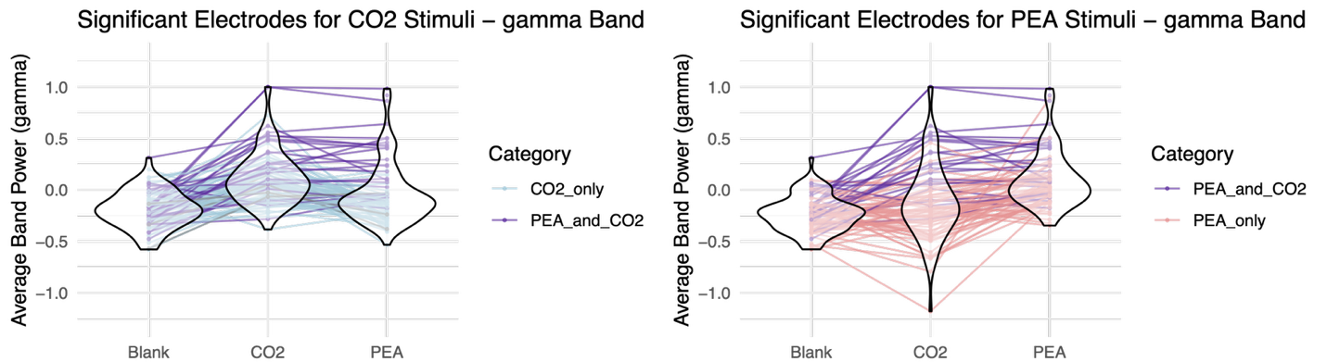

Supplementary Figure 16 | Distributions of chemosensory-responsive electrodes in Beta and Theta bands. Anatomical distributions of sEEG electrodes exhibiting significant stimulus-evoked responses in the theta (4–8 Hz; top row) and beta (13–30 Hz; bottom row) frequency bands during passive chemosensory stimulation. Panels show electrodes localized to the amygdala (left), piriform cortex (middle), and insula (right), projected onto representative anatomical slices in MNI space.

Supplementary Figure 17 | Electrode responses types by location and frequency band. sEEG electrode response types stratified by anatomical location and oscillatory frequency band. Columns correspond to gamma (30–200 Hz), beta (13–30 Hz), and theta (4–8 Hz) activity, and rows correspond to anatomically defined regions, including amygdala, hippocampus, insula, piriform cortex, and putamen. Within each panel, horizontal bars represent individual electrode contacts, sorted by the latency of their peak stimulus-evoked response relative to odor valve opening (x-axis). Bars are color-coded by response type based on cluster-based permutation testing (p < 0.05): CO₂-selective responses (blue), PEA-selective responses (red), and joint PEA∩CO₂ responses (purple). Electrodes without significant stimulus-locked responses in the corresponding band are not shown.
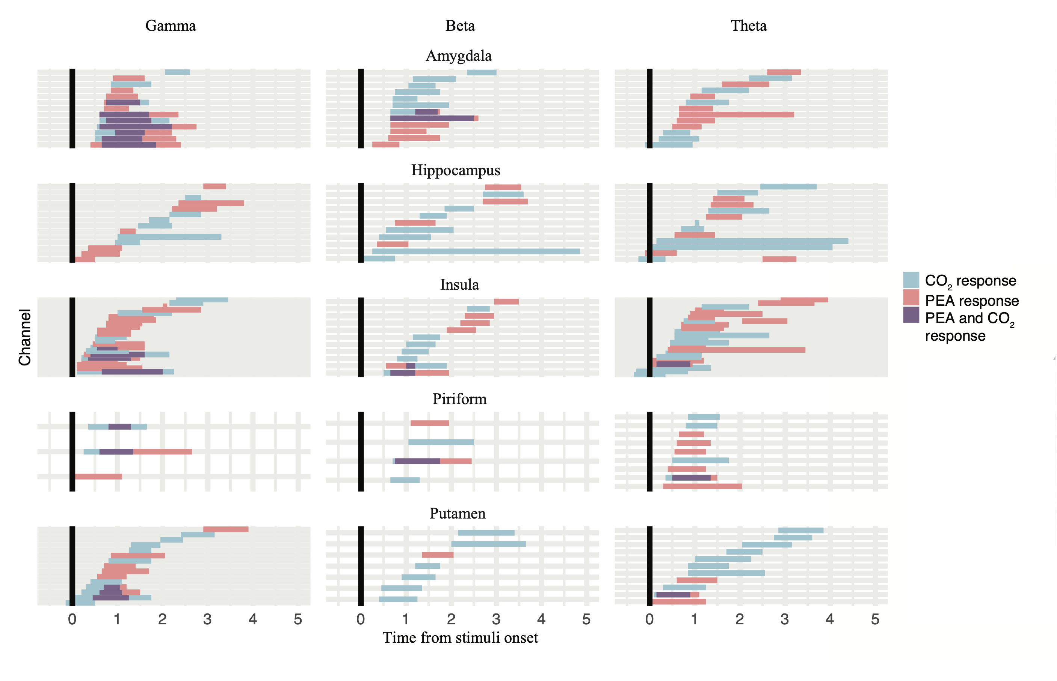

Supplementary Figure 18 | Modulation and calibration of odorant intensity by solenoid valve open time. A. Averaged time-resolved photo-ionization detector (PID) recordings at the nasal cannula for representative trials with increasing solenoid valve open durations (15.6–500 ms). The black trace indicates the valve control signal (on/off), showing precise control of valve open time, while the colored traces show the corresponding PID-measured odorant concentration. Right: Quantification of odorant delivery across trials. B. peak PID voltage as a function of valve open time. C. time to peak PID response relative to valve opening. D. cumulative inhaled odorant dose estimated as the integral of the PID signal, demonstrating a monotonic increase in delivered odorant intensity with valve open duration.
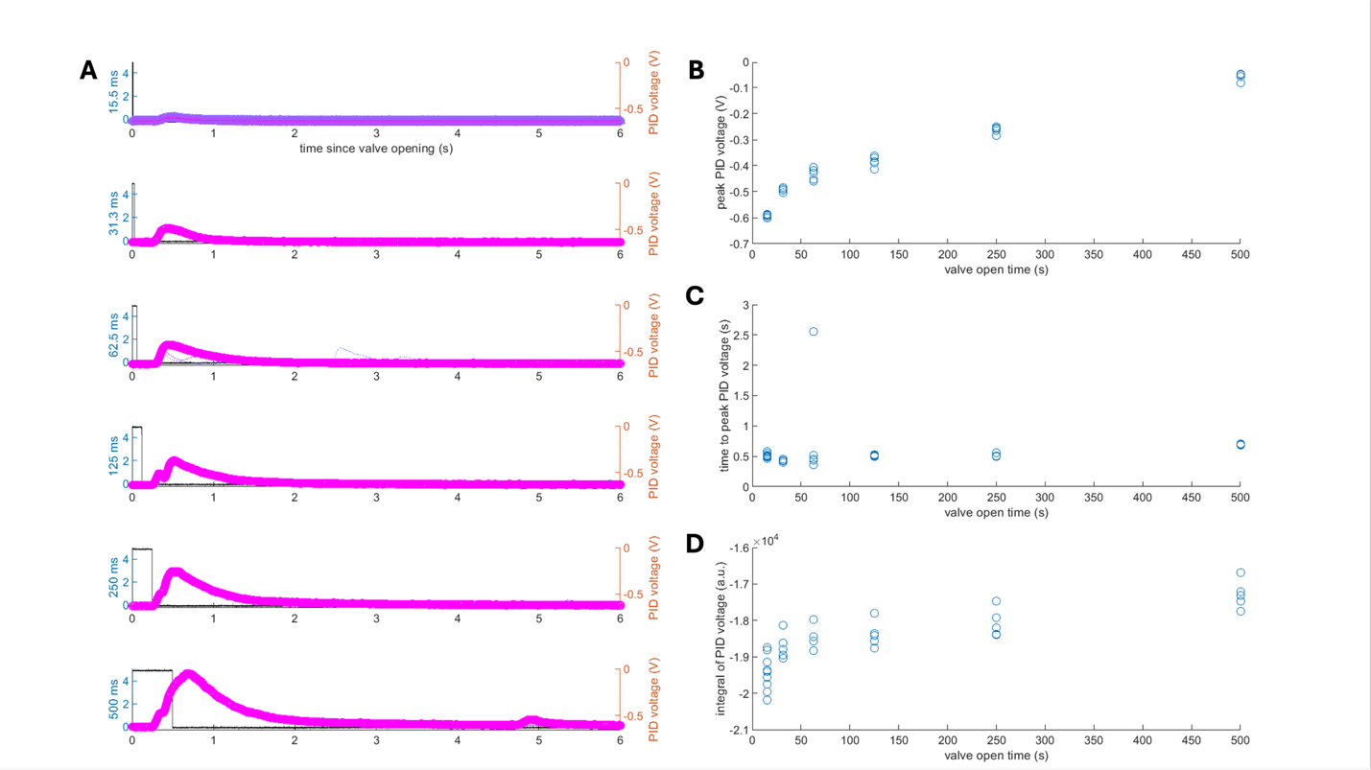

Supplementary Figure 19 | Odor detection as a function of stimulus dose quantified by odorant AUC. Trial-level binary odor detection responses plotted as a function of delivered odor dose, quantified as the area under the curve (AUC) of odorant concentration. Each panel corresponds to a single participant (ID indicated above each plot). The x-axis shows odorant AUC for individual trials, and the y-axis indicates binary detection outcome (1 = detected, 0 = not detected).

Supplementary Figure 20 | Detection accuracy as a function of relative odor dose. Detection accuracy as a function of relative odor dose for individual participants. Each panel corresponds to one participant (ID shown above each plot). The x-axis denotes relative odor dose, defined as the trial-wise odorant dose normalized to the maximum delivered dose within each participant. The y-axis shows detection accuracy, defined as the proportion of trials in which the participant correctly detected the odor.

Supplementary Figure 21 | Distribution of electrodes exhibiting graded dose–response or reporting-related effects across brain regions. Distribution of sEEG electrodes classified according to their sensitivity to stimulus dose (graded response) and/or reporting-related effects across anatomically defined brain regions. For each electrode, binary detection responses were modeled as a function of stimulus dosage (quantified as odorant AUC) using a generalized linear model. Electrodes were categorized based on the statistical significance of the dose-dependent slope term (graded sensory response) and the intercept term (dose-independent response offset consistent with reporting or decision-related effects). Bars indicate the number of electrodes in each brain region falling into one of four categories: neither slope nor intercept significant (FALSE.FALSE), slope only significant (TRUE.FALSE; graded dose–response), intercept only significant (FALSE.TRUE; reporting-related or switch-like response), or both slope and intercept significant (TRUE.TRUE). Counts are shown separately for each region to illustrate the relative prevalence of graded sensory encoding versus dose-independent reporting effects across the sampled brain areas. The brain region is wrapped to the HCPex template.

Supplementary Figure 22 | Dose-dependent gamma responses in report-locked electrodes. Gamma band neural responses from all electrodes classified as button-locked, shown as a function of stimulus dose and separated by behavioral report. Each panel corresponds to a single electrode (participant ID and contact label indicated above each plot). The x-axis shows odorant dose, quantified as the area under the curve (AUC) of odorant concentration measured at the nasal cannula, and the y-axis shows baseline-normalized gamma band-power extracted from the response-locked time window. Individual points represent single trials and are colored by behavioral outcome (reported vs. not reported). Solid lines show locally smoothed moving-mean estimates for each outcome, with shaded regions indicating variability across trials.

