Sensitivity variation on soil health indicators linked to arbuscular mycorrhizae in a highly disturbed urban basin of Buenos Aires, Argentina
Guerra Moreno, Mailen¹; Silvani, Vanesa Analía^{1,2}; Godeas, Alicia Margarita^{1,2}; Colombo, Roxana Paula^{1,2,3}*
¹ Universidad de Buenos Aires (UBA), Facultad de Ciencias Exactas y Naturales, Departamento de Biodiversidad y Biología Experimental, Buenos Aires, Argentina
² Consejo Nacional de Investigaciones Científicas y Técnicas, Instituto de Biodiversidad y Biología Experimental y Aplicada (CONICET-UBA), Buenos Aires, Argentina
¹ Universidad Nacional de Avellaneda (UNDAV), Departamento de Ambiente y Turismo, Avellaneda, Argentina

*Corresponding author: Dra. Colombo, Roxana Paula (roxanacolombo@bg.fcen.uba.ar)

Supplementary Tables
Supplemental Table S1: List of sampled plants per site
Site and associated watercourse | Sampled plants
Site A: Riachuelo River (Sup.Fig. 1a) | Taraxacum officinale; Eryngium sp.
Site P: Riachuelo River (Sup.Fig. 1b) | Abutilon grandiflorum
Site C: Cildañez Stream (Sup.Fig. 1c) | Conium maculatum
Site M: Matanza River (Sup.Fig. 1e) | Portulaca oleracea
Site O: Ortega Stream (Sup.Fig. 1d) | Salpichroa origanifolia; Ipomea sp.; Ranunculus sp.; Poa annua
Site S: San Vicente Lagoon (Sup.Fig. 1f) | Eichhornia crassipes; Enydra fluctuans
The sampled plants were the most abundant mycorrhizal plant species recognized at each site

Supplemental Table S2: Arbuscular mycorrhizal fungal species per site.
Taxonomy |  | Site
Family | Species | A | P | C | M | O | S
Glomeraceae | Rhizoglomus intraradices | SS  PTC | SS PTC | SS PTC | -  PTC | SS  - | SS PTC
Glomeraceae | Rhizophagus irregularis | -  - | -  - | SS  - | -  - | -  - | -  -
Glomeraceae | Rhizophagus fasciculatus * | SS | -  PTC | -  - | -  - | -  - | -  -
Glomeraceae | Funneliformis mosseae | SS  - | -  PTC | - | SS PTC | - | SS
Glomeraceae | Funneliformis geosporus * | -  - | -  - | -  - | SS  - | -  - | SS PTC
Glomeraceae | Septoglomus constrictus | SS  - | -  - | -  - | SS  - | -  - | -  -
Glomeraceae | Septoglomus viscosum | SS  - | SS  - | -  - | SS  - | -  - | SS  -
Glomeraceae | Glomus sinuosum * | SS  - | SS  - | -  - | -  - | -  - | SS  -
Glomeraceae | Rhizoglomus microaggregatum | SS  - | SS  - | -  - | SS  - | -  - | SS  -
Entrophosporaceae | Enthophospora etunicata * | SS  - | SS PTC | -  - | SS  - | -  - | -  -
Entrophosporaceae | Enthophospora infrequens | -  - | -  - | -  - | SS  - | SS  - | -  -
Entrophosporaceae | Entrophospora claroidea * | -  - | -  - | -  - | -  PTC | -  - | -  PTC
Gigasporaceae | Dentiscutata heterogama * | -  - | -  - | -  - | -  - | -  - | SS  -
Gigasporaceae | Gigaspora decipiens | -  - | -  - | -  - | -  - | -  - | SS  -
Diversisporaceae | Sieverdingia  tortuosa * | -  - | -  - | -  - | -  - | -  - | SS  -
Paraglomeraceae | Paraglomus laccatum * | -  - | -  - | -  - | -  - | -  - | SS  -
 | Total | 8 | 7 | 2 | 9 | 1 | 11

Site A: Riachuelo River; Site P: Riachuelo River; Site C: Cildañez Stream; Site M: Matanza River; Site O: Ortega Stream; Site S: San Vicente Lagoon. Spores isolated from Soil Samples (SS); Spores isolated from pot trap cultures (PTC); Absence of spores (-); Species mentioned for the first time in the MRB (*).

Supplemental Table S3: Arbuscular mycorrhizal (AM) fungal richness probability per site.
Site | Predicted probability of AM fungal richness ($±$SE) | Group
S | 0.69$±$0.12 | a
O | 0.06$±$0.06 | b
M | 0.56$±$0.12 | ab
C | 0.13$±$0.08 | b
P | 0.44$±$0.12 | ab
A | 0.50$±$0.12 | ab
Values are estimated marginal means ± SE. Different letters indicate significant differences among sites (Tukey post hoc test, α = 0.05). Lower basin (Site A, Site P, and Site C), middle basin (Site O and Site M), upper basin (Site S).

Supplementary Figures
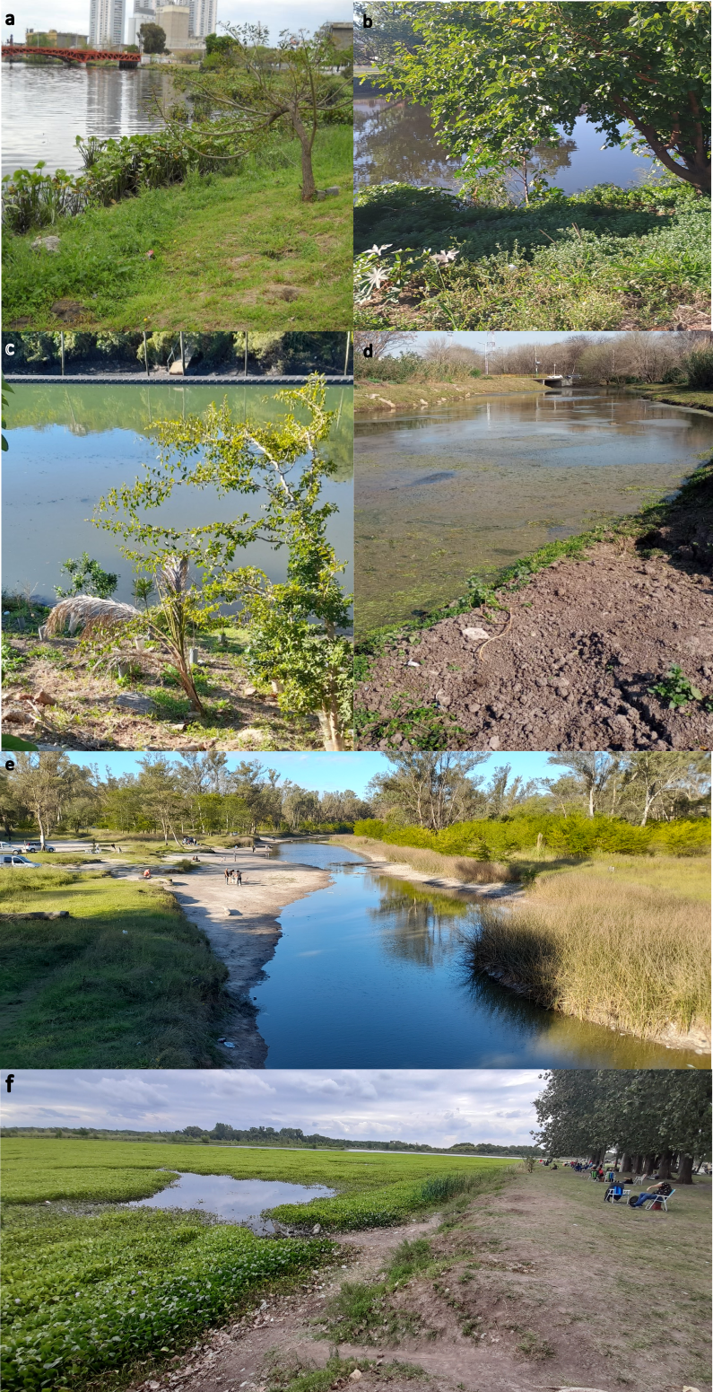
Supplementary Figure S1: Sampling sites. (a) Site A: Riachuelo River; (b) Site P: Riachuelo River; (c) Site C: Cildañez Stream; (e) Site M: Matanza River; (d) Site O: Ortega Stream and (f) Site S: San Vicente Lagoon.
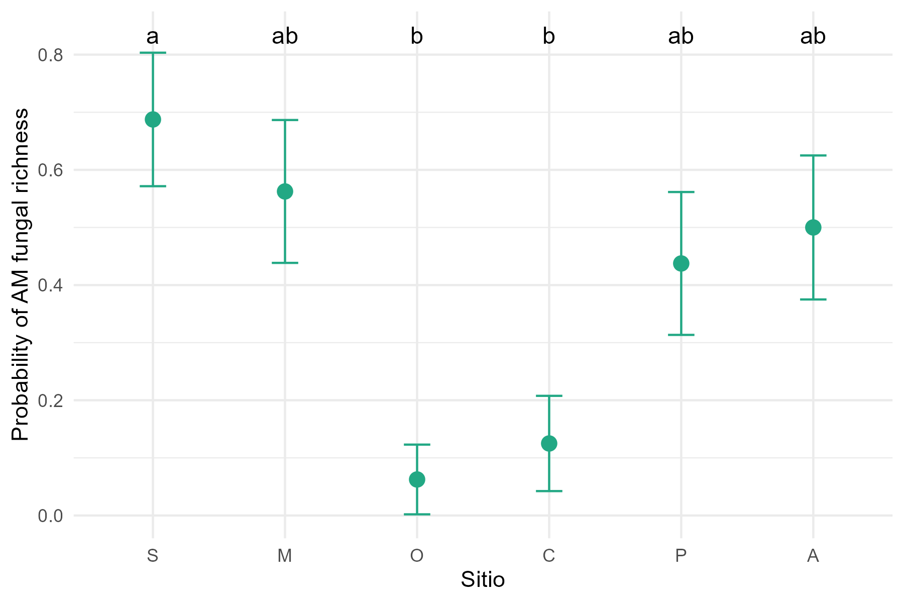
Supplemental Figure S2: AM fungal richness probability per site. Different letters among columns indicate significant differences between sites' richness probability according to the Tukey test (α = 0.05). Site A: Riachuelo River; Site P: Riachuelo River; Site C: Cildañez Stream; Site M: Matanza River; Site O: Ortega Stream; Site S: San Vicente Lagoon

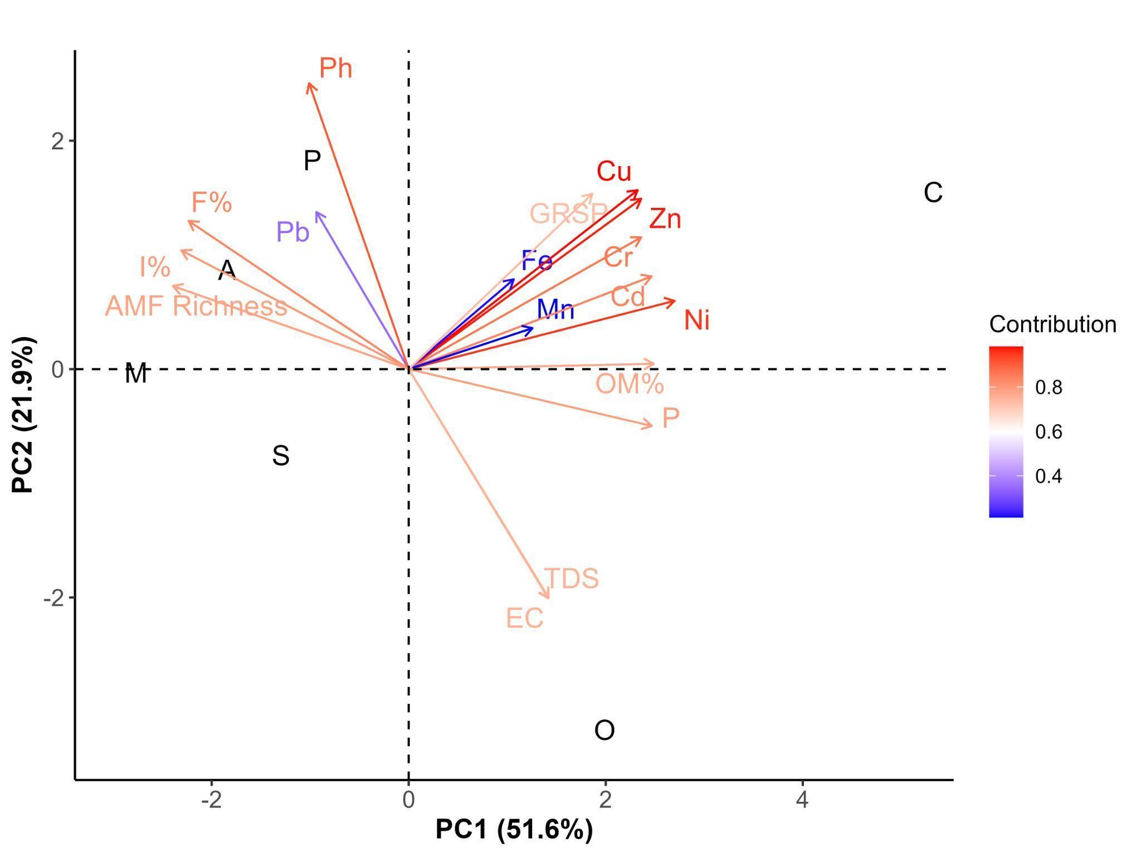
Supplemental Figure S3: PCA plot of different soil physicochemical and mycorrhizal parameters, and MRB sampled sites. Colors represent individual parameter contributions to PC1 and PC2.Site A: Riachuelo River Central Town, Site P: Riachuelo River Borough, Piñeyro Town, Site C: Cildañez Stream, Site O: Ortega Stream, Site M: Matanza River, Site S: San Vicente Lagoon
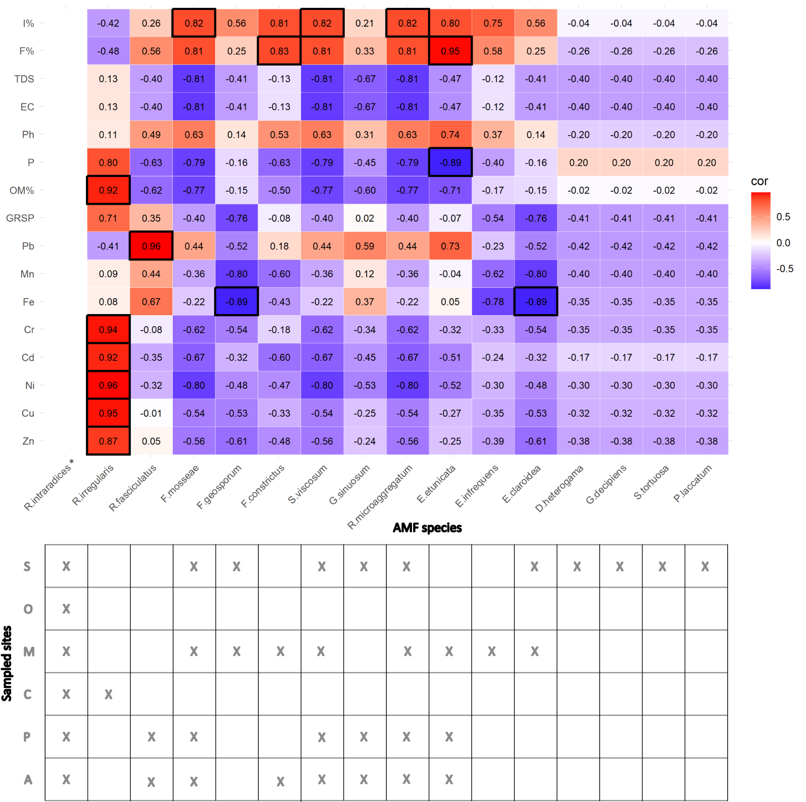
Supplemental Figure 4: Pearson correlation heatplot of environmental soil conditions and arbuscular mycorrhizal (AM) fungal species. Colors indicate positive (red) and negative (blue) correlations. Framed squares show significant results (p-value < 0.05). Table with presence of the species per site. (*) R. intraradices was not included in the analysis due to its presence in all sites.

